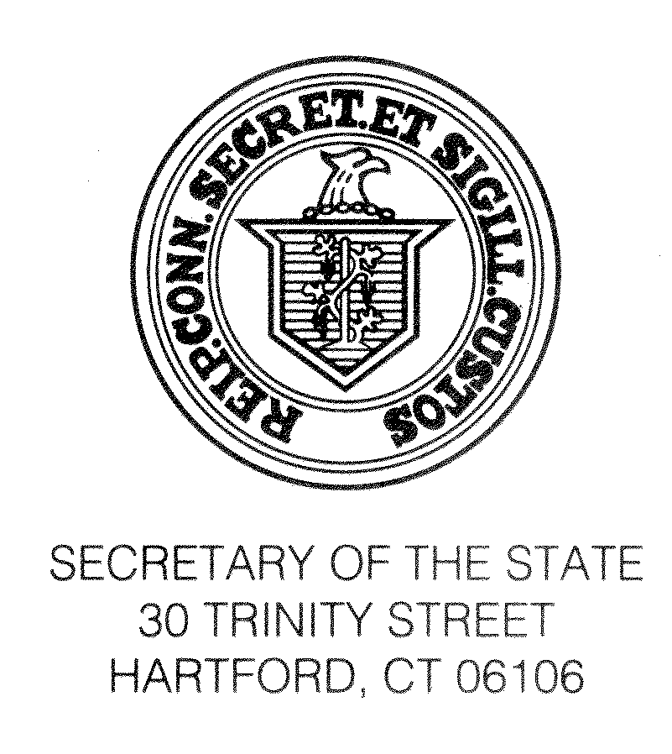

April 28, 2015

TO: MUNICIPAL CLERKS OF MUNICIPALITIES HOLDING REGULAR ELECTIONS ON MAY 4, 2015

For all May-election municipalities (towns, boroughs and city), we enclose for your use the "List of Elected Municipal Officers" (form ED-136A) and the "Certificate to the Secretary of the State Concerning Receipt and Disposition of Absentee Voting Forms" (form ED-628e). These reports must be returned to this office by May 14, 2015 under CGS §§9-320 and 9-139c. (Note to towns: if the Town Clerk is not ex officio registrar of vital statistics in your town, please check the box so indicating on the List of Elected Municipal Officers.)

The forms discussed below pertain to, and are enclosed for, towns only (not boroughs and city).

Form ED-636.2 relates to the appointment of Assistant Town Clerk and Assistant Registrar of Vital Statistics. It is important that our office maintain current records of these officials, as we are regularly asked to certify to their identity. Please complete this form whenever you appoint an Assistant Town Clerk or Assistant Registrar of Vital Statistics, and return it to us as soon as possible after the appointment. Note: the term should indicate a beginning and ending date if possible; however, if the appointment is for an indefinite period of time please provide the beginning date of appointment followed by the word "indefinite".

In towns where applicable: form ED-636a enclosed is to be used under §19a-204 when the Director of Health is also Registrar of Vital Statistics; and form ED-636b enclosed is to be used when a vacancy occurs in the appointive offices of Town Clerk, Assistant Town Clerk, Registrar of Vital Statistics and Assistant Registrar of Vital Statistics. For your information if the Town Clerk or Registrar of Vital Statistics in your town is an appointed official, we are also enclosing form ED-636.1 for use by the appointing authority under §§7-16a and 7-37.

As always, thanks very much for your assistance.

Sincerely,

DENISE MERRILL

Secretary of the State
By

Theodore E. Bromley
Staff Attorney

Enclosures: ED-136A, ED-628e; Towns Only - ED-636a, ED-636b, ED-636.1, ED-636.2

(g\massmail\2015\04-15\Mayforms - Officials, List of Elected Officials, Municipal Election)

