Name of institution:
Agreement number:
Address:
City |  |  |  | State: |  | Zip code:

Juvenile detention center: Yes No Correctional facility: Yes No

In compliance with the meal pattern exception requirements of the U.S. Department of Agriculture (USDA), the above named residential child care institution (RCCI) is requesting an exception to the National School Lunch Program (NSLP) meal pattern, as defined by the Healthy, Hunger-Free Kids Act of 2010. This request is based on the reasons below.

1. Indicate the age/grade groups and meal service times for each location.

Age/grade group | - Location | - Location | - Location
Age/grade group | Service time | Service time | Service time
K-5
6-8
9-12

2. Describe your legitimate safety concerns (or state juvenile justice laws or regulations) related to offering meals with varying amounts of food within the same meal period:

2. Describe your operational limitations to separating students in the three age/grade groups
(K-5, 6-8 and 9-12):

3. Due to the safety concerns and operational limitations specified above, the above named institution agrees to serve meals meeting the highest age/grade group represented to all students in the location(s) identified above.
Yes No

In accordance with USDA Policy Memorandum SP 38-2012: Residential Child Care Institutions Exception for Safety if Serving Multiple Age/Grade Groups and the Connecticut State Department of Education’s (CSDE) Operational Memorandum No. 36-12: Residential Child Care Institutions Exception for Safety if Serving Multiple Age/Grade Groups and Operational Memorandum No. 40-13: Extending Flexibility for Residential Child Care Institutions (RCCIs) in the National School Lunch Program (NSLP), the above named institution requests an exception to the new meal patterns due to the safety concerns specified above. The individual signing below certifies that all information on this form is complete and accurate.

Any change to the safety concerns related to the serving of different age/grade groups will be communicated to the CSDE within 15 days.

Director/administrator | Signature | Date
CSDE staff | Approval signature | Date

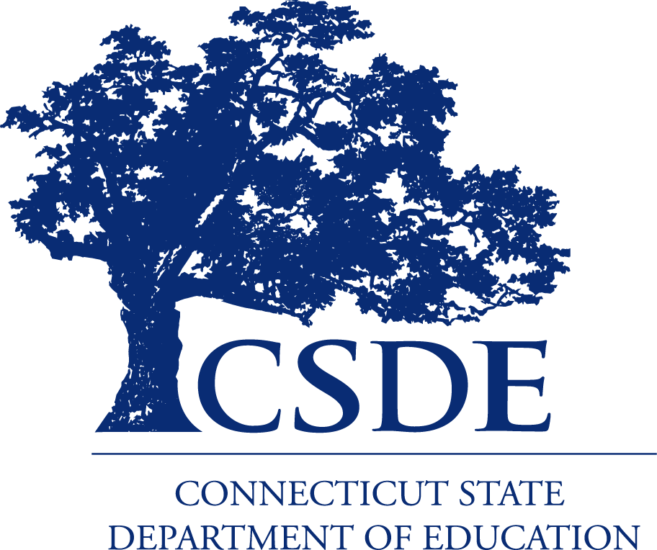
For information on the school nutrition programs, visit the CSDE’s School Nutrition Programs webpages or contact the school nutrition programs staff in the Connecticut State Department of Education, Bureau of Health/Nutrition, Family Services and Adult Education, 450 Columbus Boulevard, Suite 504, Hartford, CT 06103.
This form is available at https://portal.ct.gov/-/media/SDE/Nutrition/NSLP/Forms/Waivers/RCCIWaiver.doc.

In accordance with Federal civil rights law and U.S. Department of Agriculture (USDA) civil rights regulations and policies, the USDA, its Agencies, offices, and employees, and institutions participating in or administering USDA programs are prohibited from discriminating based on race, color, national origin, sex, disability, age, or reprisal or retaliation for prior civil rights activity in any program or activity conducted or funded by USDA.  Persons with disabilities who require alternative means of communication for program information (e.g. Braille, large print, audiotape, American Sign Language, etc.), should contact the Agency (State or local) where they applied for benefits. Individuals who are deaf, hard of hearing or have speech disabilities may contact USDA through the Federal Relay Service at (800) 877-8339. Additionally, program information may be made available in languages other than English.  To file a program complaint of discrimination, complete the USDA Program Discrimination Complaint Form, (AD-3027) found online at: How to File a Complaint, and at any USDA office, or write a letter addressed to USDA and provide in the letter all of the information requested in the form. To request a copy of the complaint form, call (866) 632-9992. Submit your completed form or letter to USDA by:  (1) mail: U.S. Department of Agriculture  Office of the Assistant Secretary for Civil Rights  1400 Independence Avenue, SW  Washington, D.C. 20250-9410;  (2) fax: (202) 690-7442; or  (3) email: program.intake@usda.gov.  This institution is an equal opportunity provider. | The Connecticut State Department of Education is committed to a policy of equal opportunity/affirmative action for all qualified persons. The Connecticut Department of Education does not discriminate in any employment practice, education program, or educational activity on the basis of age, ancestry, color, criminal record (in state employment and licensing), gender identity or expression, genetic information, intellectual disability, learning disability, marital status, mental disability (past or present), national origin, physical disability (including blindness), race, religious creed, retaliation for previously opposed discrimination or coercion, sex (pregnancy or sexual harassment), sexual orientation, veteran status or workplace hazards to reproductive systems, unless there is a bona fide occupational qualification excluding persons in any of the aforementioned protected classes.  Inquiries regarding the Connecticut State Department of Education’s nondiscrimination policies should be directed to: Levy Gillespie, Equal Employment Opportunity Director/Americans with Disabilities Coordinator (ADA), Connecticut State Department of Education, 450 Columbus Boulevard, Suite 607, Hartford, CT 06103, 860-807-2071, levy.gillespie@ct.gov.

