Recipe Name: |  | Category: |  | Recipe Number:

Ingredients | For _______ Servings |  | Directions
Ingredients | Weight | Measure | Directions

Serving Size and Yield |  |  | Cooking Time and Temperature |  |  |  | Meal Pattern Contribution (Based on Serving Size)
Serving Size: |  |  |  | Temperature | Time |  | Meat/Meat Alternates (ounce equivalents):
Serving Size: |  |  | Conventional: |  |  |  | Grains (ounce equivalents):
Yield: |  |  | Convection: |  |  |  | Fruits (cups):
Yield: |  |  |  |  |  |  | Vegetables (cups):

Nutrients Per Serving
Calories |  | Total Fat (g) |  | Cholesterol (milligrams (mg)) |  | Sodium (mg) |  | Calcium (mg)
Protein (grams (g)) |  | Saturated Fat (g) |  | Total Sugars (g) |  | Vitamin A (international units (IU) |  | Iron (mg)
Carbohydrate (g) |  | Trans Fat (g) |  | Dietary Fiber (g) |  | Vitamin C (mg)
The U.S. Department of Agriculture (USDA) defines a standardized recipe as a recipe that “has been tried, adapted, and retried several times for use by a given foodservice operation and has been found to produce the same good results and yield every time when the exact procedures are used with the same type of equipment and the same quantity and quality of ingredients.” For guidance on developing standardized recipes and sample standardized recipe, review the resources on page 3.
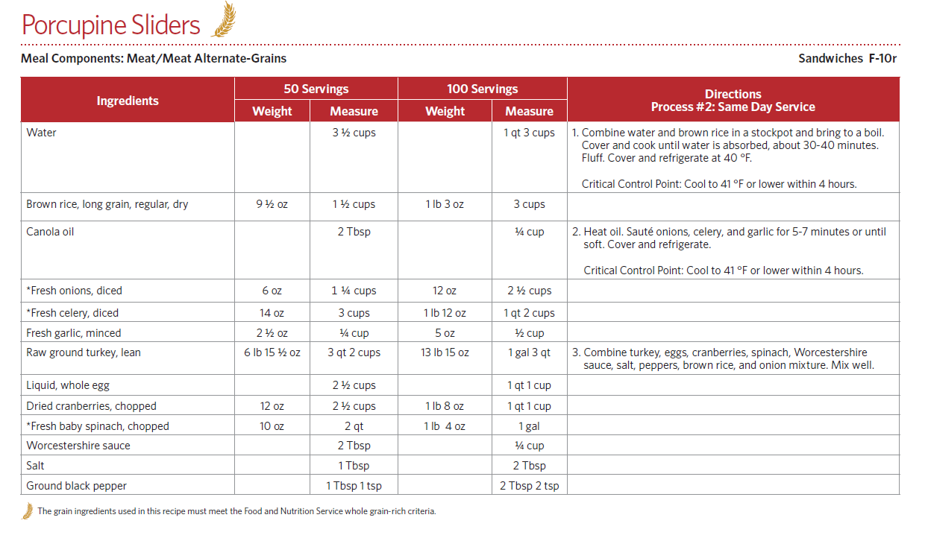
- Recipe Information: List the recipe name, category (e.g., entrées, vegetables, fruits, grains), and number.
- Ingredients: List the ingredients in the order of preparation. For each ingredient, indicate the specific type and form of food, e.g., “rice, long-grained, cooked,” “corn, canned,” “macaroni, uncooked,” “cheese, cheddar, grated,” and “ground beef, raw.”
- Weight and Measure: List the weight and volume measure of each ingredient. Use standard abbreviations for units of measure, e.g., teaspoon (tsp), tablespoon (Tbsp), cup (cup), quart (qt), gallon (gal), ounce (oz), pound (lb), and fluid ounces (fl oz). List quantities in common units, e.g., 1 lb 4 oz instead of 20 oz, 2 gal 3 cups instead of 35 cups, and ½ cup instead of 8 Tbsp.
- Directions: List detailed step-by-step instructions for preparation, cooking, and serving, including equipment (e.g., number and size of pans), oven temperature and cooking time, and serving directions and utensils. Include food safety guidelines for proper thawing, internal cooking, holding, serving, and storage temperatures. Indicate Critical Control Points (CCPs) as appropriate for the recipe, e.g., “CCP: Cool to 41 °F or lower within 4 hours,” “CCP: Heat to 165° F or higher for at least 15 seconds,” and “CCP: Hold for hot service at 135° F or higher.”
- Serving Size and Yield: Indicate serving size, i.e., the amount of a single portion in volume or weight, such as ½ cup or 2 ounces. Indicate yield, i.e., the total weight or volume and number of servings available for service after production is complete, such as “50 servings: 23 pounds 4 ounces” and “50 servings: 1 quart 2 ¼ cups.” Determine the yield and servings by measuring and counting the actual servings made from the recipe.
- Cooking Time and Temperature: Indicate the oven temperature and cooking time for conventional and convection ovens, if applicable,
- Meal Pattern Contribution (Based on Serving Size): Indicate the contribution of one serving toward the CACFP meal patterns.
- Nutrient Information: Indicate the nutrients per serving. Additional nutrients can be included.
Resources
Basics at a Glance Portion Control Poster (ICN):
https://theicn.org/icn-resources-a-z/basics-at-a-glance/
Food Buying Guide for Child Nutrition Programs (USDA):
https://www.fns.usda.gov/tn/food-buying-guide-for-child-nutrition-programs
Manager’s Corner: Standardized Recipes (ICN):
https://theicn.org/resources/176/managers-corner/107624/managers-corner-standardized-recipes.pdf
Menu Planning for Child Nutrition Programs (CSDE webpage):
https://portal.ct.gov/SDE/Nutrition/Menu-Planning.
Recipes for Healthy Kids: Cookbook for Child Care Centers (USDA):
https://www.fns.usda.gov/tn/recipes-healthy-kids-cookbook-child-care-centers
Recipes for Healthy Kids Cookbook for Schools (USDA):
https://www.fns.usda.gov/tn/recipes-healthy-kids-cookbook-schools
On the Road to Professional Food Preparation eLearning: Portion Control (ICN)
https://theicn.docebosaas.com/learn/course/external/view/elearning/16/portion-control
On the Road to Professional Food Preparation eLearning: Recipe Adjustments (ICN)
https://theicn.docebosaas.com/learn/course/external/view/elearning/17/recipe-adjustments
On the Road to Professional Food Preparation eLearning: Weights and Measures (ICN)
https://theicn.docebosaas.com/learn/course/external/view/elearning/19/weights-and-measures
USDA Recipes for Child Care:
https://www.fns.usda.gov/usda-recipes-child-care
USDA Recipes for Child Care Booklet:
https://fns-prod.azureedge.net/sites/default/files/ccrecipes_bk.pdf
USDA Standardized Recipes:
https://www.fns.usda.gov/usda-standardized-recipe
What’s Cooking? USDA Mixing Bowl:
https://whatscooking.fns.usda.gov/
Why Use Standardized Recipes? Fact Sheet (ICN):
https://theicn.org/resources/527/food-service-management-skills/107291/why-use-standardized-recipes.pdf

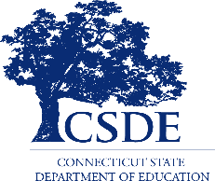
For more information, review the CSDE’s guides, Menu Planning Guide for School Meals for Grades K-12 or Menu Planning Guide for Preschoolers in the NSLP, SBP, and ASP, and visit the CSDE’s Crediting Foods in School Nutrition Programs webpage or contact the school nutrition programs staff in the CSDE Bureau of Health/Nutrition, Family Services and Adult Education, 450 Columbus Boulevard, Suite 504, Hartford, CT 06103
This form is available at https://portal.ct.gov/-/media/SDE/Nutrition/NSLP/Crediting/StdRecipeSchools.doc.

In accordance with Federal civil rights law and U.S. Department of Agriculture (USDA) civil rights regulations and policies, the USDA, its Agencies, offices, and employees, and institutions participating in or administering USDA programs are prohibited from discriminating based on race, color, national origin, sex, disability, age, or reprisal or retaliation for prior civil rights activity in any program or activity conducted or funded by USDA.  Persons with disabilities who require alternative means of communication for program information (e.g. Braille, large print, audiotape, American Sign Language, etc.), should contact the Agency (State or local) where they applied for benefits. Individuals who are deaf, hard of hearing or have speech disabilities may contact USDA through the Federal Relay Service at (800) 877-8339. Additionally, program information may be made available in languages other than English.  To file a program complaint of discrimination, complete the USDA Program Discrimination Complaint Form, (AD-3027) found online at: http://www.ascr.usda.gov/complaint_filing_cust.html, and at any USDA office, or write a letter addressed to USDA and provide in the letter all of the information requested in the form. To request a copy of the complaint form, call (866) 632-9992. Submit your completed form or letter to USDA by:  (1) mail: U.S. Department of Agriculture  Office of the Assistant Secretary for Civil Rights  1400 Independence Avenue, SW  Washington, D.C. 20250-9410;  (2) fax: (202) 690-7442; or  (3) email: program.intake@usda.gov.  This institution is an equal opportunity provider. | The Connecticut State Department of Education is committed to a policy of equal opportunity/affirmative action for all qualified persons. The Connecticut State Department of Education does not discriminate in any employment practice, education program, or educational activity on the basis of race, color, religious creed, sex, age, national origin, ancestry, marital status, sexual orientation, gender identity or expression, disability (including, but not limited to, intellectual disability, past or present history of mental disorder, physical disability or learning disability), genetic information, or any other basis prohibited by Connecticut state and/or federal nondiscrimination laws. The Connecticut State Department of Education does not unlawfully discriminate in employment and licensing against qualified persons with a prior criminal conviction. Inquiries regarding the Connecticut State Department of Education’s nondiscrimination policies should be directed to: Levy Gillespie, Equal Employment Opportunity Director/Americans with Disabilities Act Coordinator, Connecticut State Department of Education, 450 Columbus Boulevard, Suite 607, Hartford, CT 06103, 860-807-2071, Levy.Gillespie@ct.gov.

