Pacing: 4 weeks (plus 1 week for reteaching/enrichment)
Mathematical Practices
Mathematical Practices #1 and #3 describe a classroom environment that encourages thinking mathematically and are critical for quality teaching and learning.

Practices in bold are to be emphasized in the unit.
1. Make sense of problems and persevere in solving them.
2. Reason abstractly and quantitatively.
3. Construct viable arguments and critique the reasoning of others.
4. Model with mathematics.
5. Use appropriate tools strategically.
6. Attend to precision.
7. Look for and make use of structure.
8. Look for and express regularity in repeated reasoning.

Domain and Standards Overview
Counting and Cardinality K.CC
- Know number names and the count sequence.
- Count to tell the number of objects.
- Compare numbers.

Operations and Algebraic Thinking K.OA
- Understand addition as putting together and adding to, and understand subtraction as taking apart and taking from
.

Priority and Supporting CCSS | Explanations and Examples*
K.CC.3. Write numbers from 0 to 20. Represent a number of objects with a written numeral 0-20 (with 0 representing a count of no objects). | K.CC.3. Students should be given multiple opportunities to count objects and recognize that a numeral represents a specific quantity. Once this is established, students begin to read and write numerals (numerals are the symbols for the quantities). The emphasis should first be on quantity and then connecting quantities to the written symbols.  - A sample unit sequence might include:  - Counting up to 20 objects in many settings and situations over several weeks.  - Beginning to recognize, identify, and read the written numerals, and match the numerals to given sets of objects.  - Writing the numerals to represent counted objects.  Since the teen numbers are not written as they are said, teaching the teen numbers as one group of ten and extra ones is foundational to understanding both the concept and the symbol that represents each teen number. For example, when focusing on the number “14,” students should count out fourteen objects using one-to-one correspondence and then use those objects to make one group of ten and four extra ones. Students should connect the representation to the symbol “14.”
K.CC.1. Count to 100 by ones and by tens. | K.CC.1.The emphasis of this standard is on the counting sequence (rote counting).  When counting by ones, students need to understand that the next number in the sequence is one more. When counting by tens, the next number in the sequence is “ten more” (or one more group of ten).  Instruction on the counting sequence should be scaffolded (e.g., 1-10, then 1-20, etc.).  Counting should be reinforced throughout the day, not in isolation.  Continued on next page  K.CC.1 Continued  Examples:  - Count the number of chairs of the students who are absent.  - Count the number of stairs, shoes, etc.  - Counting groups of ten such as “fingers in the classroom” (ten fingers per student).  When counting orally, students should recognize the patterns that exist from 1 to 100. They should also recognize the patterns that exist when counting by 10s.
K.CC.2. Count forward beginning from a given number within the known sequence (instead of having to begin at 1). | K.CC.2. The emphasis of this standard is on the counting sequence to 100. Students should be able to count forward from any number, 1-99.
K.CC.4. Understand the relationship between numbers and quantities; connect counting to cardinality.  - When counting objects, say the number names in the standard order, pairing each object with one and only one number name and each number name with one and only one object.  - b. Understand that the last number name said tells the number of objects counted. The number of objects is the same regardless of their arrangement or the order in which they were counted.  - c. Understand that each successive number name refers to a quantity that is one larger. | K.CC.4. This standard focuses on one-to-one correspondence and how cardinality connects with quantity.  - For example, when counting three bears, the student should use the counting sequence, “1-2-3,” to count the bears and recognize that “three” represents the group of bears, not just the third bear. A student may use an interactive whiteboard to count objects, cluster the objects, and state, “This is three” (Cardinality tells “how many”).  In order to understand that each successive number name refers to a quantity that is one larger, students should have experience counting objects, placing one more object in the group at a time.  - For example, using cubes, the student should count the existing group, and then place another cube in the set. Some students may need to re-count from one, but the goal is that they would count on from the existing number of cubes. S/he should continue placing one more cube at a time and identify the total number in order to see that the counting sequence results in a quantity that is one larger each time one more cube is placed in the group.  A student may use a clicker (electronic response system) to communicate his/her count to the teacher.
K.CC.5. Count to answer “how many?” questions about as many as 20 things arranged in a line, a rectangular array, or a circle, or as many as 10 things in a scattered configuration; given a number from 1–20, count out that many objects. | K.CC.5. Students should develop counting strategies to help them organize the counting process to avoid re-counting or skipping objects.  Examples:  - If items are placed in a circle, the student may mark or identify the starting object.  - If items are in a scattered configuration, the student may move the objects into an organized pattern.  - Some students may choose to use grouping strategies such as placing objects in twos, fives, or tens (note: this is not a kindergarten expectation).  - Counting up to 20 objects should be reinforced when collecting data to create charts and graphs.  A student may use a clicker (electronic response system) to communicate his/her count to the teacher.
K.OA.1. Represent addition and subtraction with objects, fingers, mental images, drawings*, sounds (e.g., claps), acting out situations, verbal explanations, expressions, or equations.  * Drawings need not show details, but should show the mathematics in the problem. (This applies wherever drawings are mentioned in the Standards.) | K.OA.1. Using addition and subtraction in a word problem context allows students to develop their understanding of what it means to add and subtract.  Students should use objects, fingers, mental images, drawing, sounds, acting out situations and verbal explanations in order to develop the concepts of addition and subtraction. Then, they should be introduced to writing expressions and equations using appropriate terminology and symbols which include “+,” “–,” and “=”.  - Addition terminology: add, join, put together, plus, combine, total  - Subtraction terminology: minus, take away, separate, difference, compare  Students may use document cameras or interactive whiteboards to represent the concept of addition or subtraction. This gives them the opportunity to communicate their thinking.
K.OA.2, Solve addition and subtraction word problems, and add and subtract within 10, e.g., by using objects or drawings to represent the problem. | K.OA.2. Using a word problem context allows students to develop their understanding about what it means to add and subtract. Addition is putting together and adding to. Subtraction is taking apart and taking from. Kindergarteners develop the concept of addition/subtraction by modeling the actions in word problem using objects, fingers, mental images, drawings, sounds, acting out situations, and/or verbal explanations. Students may use different representations based on their experiences, preferences, etc. They may connect their conceptual representations of the situation using symbols, expressions, and/or equations. Students should experience the following addition and subtraction problem types (see Table 1).  - Add To word problems, such as, “Mia had 3 apples. Her friend gave her 2 more. How many does she have now?”  o A student’s “think aloud” of this problem might be, “I know that Mia has some apples and she’s getting some more. So she’s going to end up with more apples than she started with.”  - Take From problems such as:  o José had 8 markers and he gave 2 away. How many does he have now? When modeled, a student would begin with 8 objects and remove two to get the result.  - Put Together/Take Apart problems with Total Unknown gives students opportunities to work with addition in another context such as:  o There are 2 red apples on the counter and 3 green apples on the counter. How many apples are on the counter?  - Solving Put Together/Take Apart problems with Both Addends Unknown provides students with experiences with finding all the decompositions of a number and investigating the patterns involved.  o There are 10 apples on the counter. Some are red and some are green. How many apples could be green? How many apples could be red?  Continued on next page  K.OA.2. Continued Students may use a document camera or interactive whiteboard to demonstrate addition or subtraction strategies. This gives them the opportunity to communicate and justify their thinking.
K.OA.3. Decompose numbers less than or equal to 10 into pairs in more than one way, e.g., by using objects or drawings, and record each decomposition by a drawing or equation (e.g., 5 = 2 + 3 and 5 = 4 + 1). | K.OA.3. This standard focuses on number pairs which add to a specified total, 1-10. These number pairs may be examined either in or out of context.  Students may use objects such as cubes, two-color counters, square tiles, etc. to show different number pairs for a given number. For example, for the number 5, students may split a set of 5 objects into 1 and 4, 2 and 3, etc.  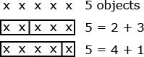  Students may also use drawings to show different number pairs for a given number. For example, students may draw 5 objects, showing how to decompose in several ways.  Sample unit sequence:  - A contextual problem (word problem) is presented to the students such as, “Mia goes to Nan’s house. Nan tells her she may have 5 pieces of fruit to take home. There are lots of apples and bananas. How many of each can she take?”  - Students find related number pairs using objects (such as cubes or two-color counters), drawings, and/or equations. Students may use different representations based on their experiences, preferences, etc.  - Students may write equations that equal 5 such as:  o 5=4+1  o 3+2=5  o 2+3=4+1  Continued on next page  K.OA.3. Continued  This is a good opportunity for students to systematically list all the possible number pairs for a given number. For example, all the number pairs for 5 could be listed as 0+5, 1+4, 2+3, 3+2, 4+1, and 5+0. Students should describe the pattern that they see in the addends, e.g., each number is one less or one than the previous addend.
K.OA.4. For any number from 1 to 9, find the number that makes 10 when added to the given number, e.g., by using objects or drawings, and record the answer with a drawing or equation. | K.OA.4. the number pairs that total ten are foundational for students’ ability to work fluently within base-ten numbers and operations. Different models, such as ten-frames, cubes, two-color counters, etc., assist students in visualizing these number pairs for ten.  Example 1:  Students place three objects on a ten frame and then determine how many more are needed to “make a ten.”  Students may use electronic versions of ten frames to develop this skill.  Example 2:  The student snaps ten cubes together to make a “train.”  - Student breaks the “train” into two parts. S/he counts how many are in each part and record the associated equation (10 = ___ + ___).  - Student breaks the “train into two parts. S/he counts how many are in one part and determines how many are in the other part without directly counting that part. Then s/he records the associated equation (if the counted part has 4 cubes, the equation would be 10 = 4 + ___).  Continued on next page  K.OA.4 Continued  Examples Continued:  - Student covers up part of the train, without counting the covered part. S/he counts the cubes that are showing and determines how many are covered up. Then s/he records the associated equation (if the counted part has 7 cubes, the equation would be 10 = 7 + ___).  Example 3:  The student tosses ten two-color counters on the table and records how many of each color are facing up.
K.OA.5. Fluently add and subtract within 5.  (This priority standard is only supporting in this unit.) | K.OA.5. This standard focuses on students being able to add and subtract numbers within 5. Adding and subtracting fluently refers to knowledge of procedures, knowledge of when and how to use them appropriately, and skill in performing them flexibly, accurately, and efficiently.  Strategies students may use to attain fluency include:  - Counting on (e.g., for 3+2, students will state, “3,” and then count on two more, “4, 5,” and state the solution is “5”)  - Counting back (e.g., for 4-3, students will state, “4,” and then count back three, “3, 2, 1” and state the solution is “1”)  - Counting up to subtract (e.g., for 5-3, students will say, “3,” and then count up until they get to 5, keeping track of how many they counted up, stating that the solution is “2”)  - Using doubles (e.g., for 2+3, students may say, “I know that 2+2 is 4, and 1 more is 5”)  - Using commutative property (e.g., students may say, “I know that 2+1=3, so 1+2=3”)  - Using fact families (e.g., students may say, “I know that 2+3=5, so 5-3=2”)  Students may use electronic versions of five frames to develop fluency of these facts.

Concepts  What Students Need to Know | Skills  What Students Need To Be Able To Do | Bloom’s Taxonomy Levels
Number  Relationship between:  - Number and quantity  - Counting & cardinality  - Number names  Number of objects zero to twenty  Written numerals zero to twenty  Addition  Subtraction  Numbers (operations and algebraic thinking)  - Less than ten  - Equal to ten  - Pairs  Drawings and Equations  Addition and sub traction within zero to five | COUNT (objects)  SAY numbers (in order)  PAIR (each object with one number)  UNDERSTAND  - (last number name tells objects counted)  - (number of objects is the same regardless of arrangement)  - (number of objects is the same regardless of order)  - (each successive number refers to a quantity that is one larger)  WRITE (numbers zero to twenty)  REPRESENT number of objects  REPRESENT (addition and subtraction) with:  - Objects  - Fingers  - Drawings  - Sounds  - Equations  - Expressions  ACT out addition and subtraction situations  EXPLAIN (addition and subtraction)  DECOMPOSE (numbers)  RE CORD (decompositions)  ADD (fluently)  SUBTRACT fluently) | 1  2  3  1  3  2  3  3  1  1  3

Essential Questions

Corresponding Big Ideas

Standardized Assessment Correlations
(State, College and Career)
Expectations for Learning (in development)
This information will be included as it is developed at the national level. CT is a governing member of the Smarter Balanced Assessment Consortium (SBAC) and has input into the development of the assessment.

Unit Assessments
The items developed for this section can be used during the course of instruction when deemed appropriate by the teacher.
TASK 1

Read the following problem to student. Student may use fingers, objects, drawings or write an equation to solve the problem.
There are 5 pumpkins on a vine.
There are 5 pumpkins on the ground.
How many pumpkins are there in all?
Answer: 10

TASK 2
Read the following problem to student. Student may use fingers, objects, drawings or write an equation to solve the problem.
There are 7 counters on the ten-frame below.
How many more counters do we need to make 10?
■ | ■ | ■ | ■ | ■
■ | ■

Answer: 3

TASK 3
Read the following problem to student. Student may use fingers, objects, drawings or write an equation to solve the problem.
I have 6 cookies.
My friend has 4 cookies.
How many cookies are there in all?
Answer: 10

TASK 4
Read the following problem to student. Student may use fingers, objects, drawings or write an equation to solve the problem.
How many fingers are pointing up in the picture below?
How many more will make 10 fingers pointing up?
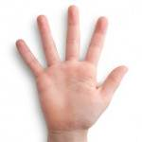
(Replace images as needed - hands should show 5 fingers up and 4 fingers up.)
Answer: 1
TASK 5
Read the following problem to student:
8 birds are in the yard.
2 birds fly away.
How many birds are left?

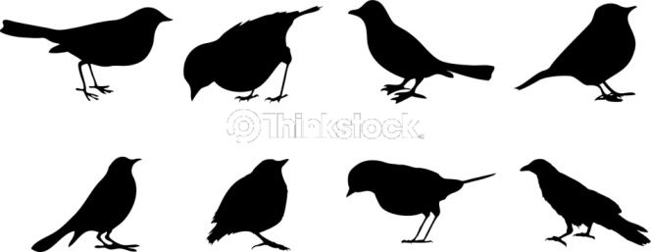
(Replace these images as needed- problem should show a set of 8 birds that are not overlapping each other)
Answer: 6

TASK 6
Read the following problem to student:
I had 10 gingerbread cookies.
I gave 6 away.
How many do I have left?


(Replace these images as needed- problem should show a set of 10 cookies that are not overlapping each other)
Answer: 4

TASK 7
Show student the expression below. Ask student to draw a picture and tell a story that matches the expression and then solve the problem.

5 + 2

Answer: Student correctly addresses all 3 criteria: draws a picture, tells a matching story and has the correct solution.
(Example of story: I have 5 trucks. My friend has 2 trucks. We have 7 trucks in all.)

Partial Credit: Student correctly addresses 1 or 2 criteria.

No Credit: Student does not address any of the criteria correctly.

TASK 8

Read the following problem to student:

There are 10 jelly beans in a jar.

Some jelly beans are red. Some jelly beans are blue.

- How many of each color could be in the jar?


______ red jelly beans ______ blue jelly beans

- Find a different answer.

______ red jelly beans ______ blue jelly beans

(Replace this image as needed - problem should show an empty jar that students can use as a work mat to solve the problem)

Answer: Student finds 2 appropriate combinations of red and blue jelly beans that total 10.

Partial Credit: Student finds 1 appropriate combination of red and blue jelly beans that total 10.

No Credit: Student is unable to find an appropriate combination of red and blue jelly beans that totals 10.

TASK 9

Have dot cards shown below cut out and available for students to use.

 | ■ | ■   | ■     | ■    
■       | ■        | ■         | ■          | ■          

*Make 5 rows of the table above to complete the card set- so that students have multiple cards with the same number.
Dot cards should be enlarged (approx.: 2 inches x 2 inches)

TASK 9 (Cont.)

Read the following problem to student:
9
Use the dot cards to help you find different ways to make 9.

Show as many different ways to make 9 as you can.

Note: This problem can be repeated using different numbers (example: find ways to make 6)

Answer: Student finds 7 or more different ways to make 9.

Partial Credit: Student finds 1 to 6 different ways to make 9.

No Credit: The student does not find a correct way to make 9.

Note: This problem can be repeated using different numbers (example: find ways to make 6)

TASK 10

Read the following problem to student. Student may use fingers, objects, drawings or write an equation to solve the problem.

There are 7 puppies in the park.

4 puppies run away.

How many puppies are left?

Answer: 3

TASK 11

Read the following problem to student. Student may use fingers, objects, drawings or write an equation to solve the problem.

Emma has 8 apples.

She gave 1 apple away.

How many apples does she have left?

Answer: 7

TASK 12

Read the following problem to student. Student may use fingers, objects, drawings or write an equation to solve the problem.

Kate had 7 pencils.
She lost some.
Now she has 2 pencils left.

How many pencils did she lose?

Answer: 5

TASK 13
Read the following problem to student. Student may use fingers, objects, drawings or write an equation to solve the problem.

Tell a subtraction story about the 8 children and solve the problem.


(Replace this image as needed, problem should have 8 children standing next to each other.)

Answer: Student tells an appropriate subtraction story with an appropriate answer.
(Example of story: There are 8 children on a school bus. Six of the children got off the bus. There are 2 children left on the bus.)

Partial Credit: Student correctly addresses 1 criterion (Tells an appropriate story problem with an incorrect or missing answer.)
No Credit: Student is unable to tell a correct subtraction story problem.

TASK 14

Read the following problem to student. Student may use fingers, objects, drawings or write an equation to solve the problem.

Tell a subtraction story about the 7 teddy bears and solve the problem.

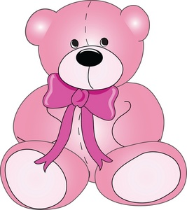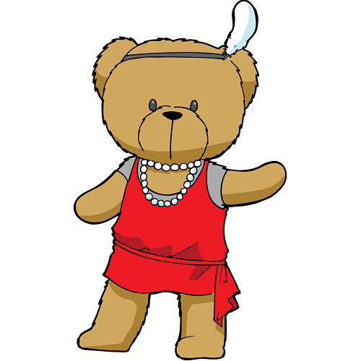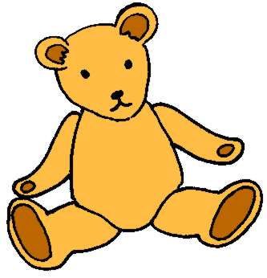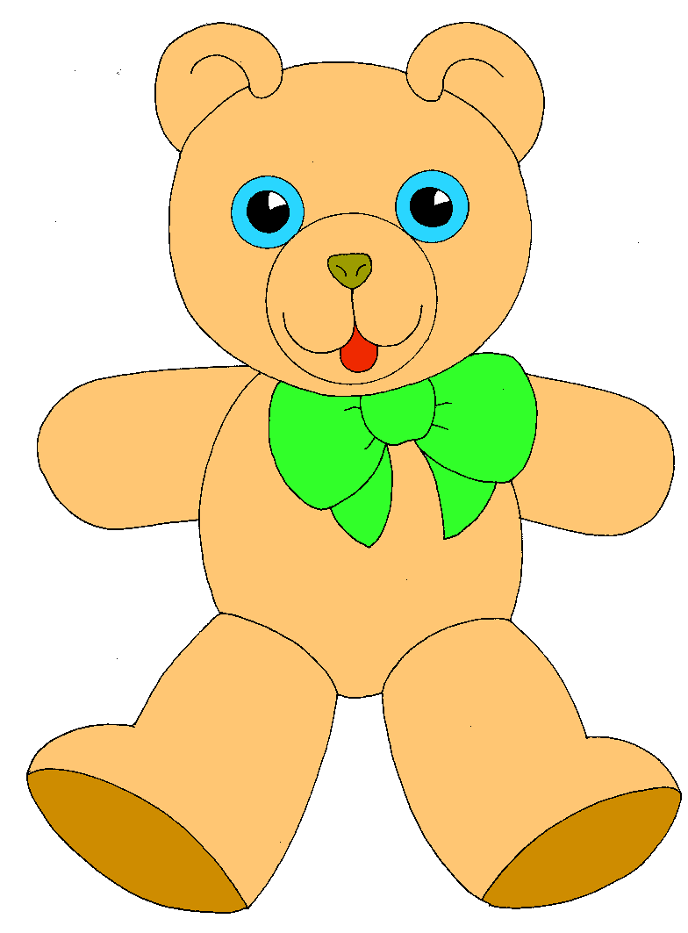

(Replace this image as needed; problem should have 7 teddy bears next to each other.)

Answer: Student tells an appropriate subtraction story with an appropriate answer.
(Example of story: A toy store had 7 teddy bears. Four of the teddy bears were sold. There are 3 teddy bears left in the store.)

Partial Credit: Student correctly addresses 1 criterion (Tells an appropriate story problem with an incorrect or missing answer.)

No Credit: Student is unable to tell a correct subtraction story problem.

TASK 15

Show student the expression below. Ask student to draw a picture and tell a story that matches the expression and then solve the problem.

6 – 3
Answer: Student correctly addresses all 3 criteria: draws a picture, tells a matching story and has the correct solution.
(Example of story: I have 6 bears. I gave 3 to my sister. I have 3 bears left.)

Partial Credit: Student correctly addresses 1 or 2 criteria.
No Credit: Student does not address any of the criteria correctly.

TASK 16

Show student the expression below. Ask student to draw a picture and tell a story that matches the expression and then solve the problem.

8 – 8

Answer: Student correctly addresses all 3 criteria: draws a picture, tells a matching story and has the correct solution.
Example of story: I saw 8 bees on the flower. The 8 bees flew away, now there are 0 bees left.

Partial Credit: Student correctly addresses 1 or 2 criteria.

No Credit: Student does not address any of the criteria correctly.

TASK 17

Show student the expression below. Ask student to draw a picture and tell a story that matches the expression and then solve the problem.
■ 
■ 
■ 

10 - =

Answer: Student correctly addresses all 3 criteria: draws a picture, tells a matching story and has the correct solution.
(Example of story: I saw 10 bees on the flower. 6 bees flew away, now there are 4 bees left.)

Partial Credit: Student correctly addresses 1 or 2 criteria.

No Credit: Student does not address any of the criteria correctly.

TASK 18

Read the following problem to student.

a) Using the fingers on both your hands, show me a way to make 6.

b) Show me a different way to make 6.

Note: This item can be used to identify number pairs for other sums in this unit as well.

Answer: Student correctly shows at least 3 different representations for the number 6 using his/her fingers on both hands. For example, student shows 4 fingers on left hand and 2 fingers on the right hand, and then shows 5 fingers on the left hand and 1 finger on the right hand.

Partial Credit: Student correctly identifies only one representation for the number 6.

No Credits: Student is unable to represent the number 6 using his/her fingers on both hands.

