Pacing: 5 weeks (plus 1 week for reteaching/enrichment)
Mathematical Practices
Mathematical Practices #1 and #3 describe a classroom environment that encourages thinking mathematically and are critical for quality teaching and learning.

Practices in bold are to be emphasized in the unit.
1. Make sense of problems and persevere in solving them.
2. Reason abstractly and quantitatively.
3. Construct viable arguments and critique the reasoning of others.
4. Model with mathematics.
5. Use appropriate tools strategically.
6. Attend to precision.
7. Look for and make use of structure.
8. Look for and express regularity in repeated reasoning.

Domain and Standards Overview
Number and Operations in Base Ten 1.NBT
- Extend the counting sequence
- Understand place value
- Use place value understanding and properties of operations to add and subtract

Priority and Supporting CCSS | Explanations and Examples*
1. NBT.1. Count to 120, starting at any number less than 120. In this range, read and write numerals and represent a number of objects with a written numeral. | 1.NBT.1. Students use objects to express their understanding of numbers. They extend their counting beyond 100 to count up to 120 by counting by 1s. Some students may begin to count in groups of 10 (while other students may use groups of 2s or 5s to count). Counting in groups of 10 as well as grouping objects into 10 groups of 10 will develop students understanding of place value concepts.  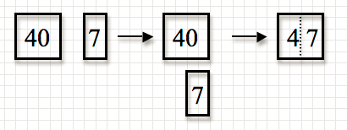  Students extend reading and writing numerals beyond 20 to 120. After counting objects, students write the numeral or use numeral cards to represent the number. Given a numeral, students read the numeral, identify the quantity that each digit represents using numeral cards, and count out the given number of objects.  Students should experience counting from different starting points (e.g., start at 83, count to 120). To extend students’ understanding of counting, they should be given opportunities to count backwards by ones and tens. They should also investigate patterns in the base 10 system.
1. NBT.3. Compare two two-digit numbers based on meanings of the tens and ones digits, recording the results of comparisons with the symbols >, =, and <. | 1.NBT.3. Students use models that represent two sets of numbers. To compare, students first attend to the number of tens, then, if necessary, to the number of ones. Students may also use pictures, number lines, and spoken or written words to compare two numbers. Comparative language includes but is not limited to more than less than, greater than, most, greatest. least, same as, equal to and not equal to
1. NBT.2. Understand that the two digits of a two-digit number represent amounts of tens and ones. Understand the following as special cases:  a. 10 can be thought of as a bundle of ten ones — called a “ten.”  b. The numbers from 11 to 19 are composed of a ten and one, two, three, four, five, six, seven, eight, or nine ones.  c. The numbers 10, 20, 30, 40, 50, 60, 70, 80, 90 refer to one, two, three, four, five, six, seven, eight, or nine tens (and 0 ones). | 1.NBT.2. Understanding the concept of 10 is fundamental to children’s mathematical development. Students need multiple opportunities counting 10 objects and “bundling” them into one group of ten. They count between 10 and 20 objects and make a bundle of 10 with or without some left over (this will help students who find it difficult to write teen numbers). Finally, students count any number of objects up to 99, making bundles of 10s with or without leftovers.  As students are representing the various amounts, it is important that an emphasis is placed on the language associated with the quantity. For example, 53 should be expressed in multiple ways such as 53 ones or 5 groups of ten with 3 ones leftover. When students read numbers, they read them in standard form as well as using place value concepts. For example, 53 should be read as “fifty-three” as well as five tens, 3 ones. Reading 10, 20, 30, 40, 50 as “one ten, 2 tens, 3 tens, etc.” helps students see the patterns in the number system.  Students may use the document camera or interactive whiteboard to demonstrate their “bundling” of objects. This gives them the opportunity to communicate their counting and thinking.
1. NBT.5. Given a two-digit number, mentally find 10 more or 10 less than the number, without having to count; explain the reasoning used. | 1.NBT.5. This standard requires students to understand and apply the concept of 10 which leads to future place value concepts. It is critical for students to do this without counting. Prior use of models such as base ten blocks, number lines, and 100s charts helps facilitate this understanding. It also helps students see the pattern involved when adding or subtracting 10.  Examples:  • 10 more than 43 is 53 because 53 is one more 10 than 43  • 10 less than 43 is 33 because 33 is one 10 less than 43  Students may use interactive versions of models (base ten blocks,100s charts, number lines, etc.) to develop prior understanding.
1.MD.4. Organize, represent, and interpret data with up to three categories; ask and answer questions about the total number of data points, how many in each category, and how many more or less are in one category than in another. (This standard is embedded in this unit) | 1.MD.4. Students create object graphs and tally charts using data relevant to their lives (e.g., favorite ice cream, eye color, pets, etc.). Graphs may be constructed by groups of students as well as by individual students.  Counting objects should be reinforced when collecting, representing, and interpreting data. Students describe the object graphs and tally charts they create. They should also ask and answer questions based on these charts or graphs that reinforce other mathematics concepts such as sorting and comparing. The data chosen or questions asked give students opportunities to reinforce their understanding of place value, identifying ten more and ten less, relating counting to addition and subtraction and using comparative language and symbols.  Students may use an interactive whiteboard to place objects onto a graph. This gives them the opportunity to communicate and justify their thinking.

Concepts  What Students Need to Know | Skills  What Students Need To Be Able To Do | Bloom’s Taxonomy Levels
Numbers to 120  Numerals  Number of objects  Place value:  Two-digit numbers represent amounts of tens and ones (place value) | COUNT to 120  READ and WRITE numerals (to 120)  REPRESENT (a number of objects with numerals)  COMPOSE numbers (using tens and ones) | 1  2  3

Essential Questions

Corresponding Big Ideas

Standardized Assessment Correlations
(State, College and Career)
Expectations for Learning (in development)
This information will be included as it is developed at the national level. CT is a governing member of the Smarter Balanced Assessment Consortium (SBAC) and has input into the development of the assessment.

Unit Assessments
The items developed for this section can be used during the course of instruction when deemed appropriate by the teacher.
Test Mode: Administer one on one

Teacher directions: Read bolded statement aloud to child and record results on Interview Recording sheet.

Counting and Writing Numerals

TASK 1
Teacher: Start counting on from:
- 28* (stop student when he/she reaches 41)
- 67 (stop student when he/she reaches 82)
- 93 (stop student when he/she reaches 113)
*If student seems unsure, give a running start by saying “24, 25, 26, 27, 28.” Repeat strategy for b & c if necessary.

TASK 2
Preparation: Teacher shows the following number cards one at a time Teacher will need to make number cards for the numbers indicated.
Teacher: Can you tell me what these numbers are? ( or - )
- 46
- 80
- 102
Teacher: Listen as I tell you a number. Write the number I say. ( or - )
- 19
- 70
- 112

TASK 3
Preparation: Teacher provides student with 37 counters (bears, snap cubes, etc.)
Teacher: Count and write the amount.
Student counts, states the number and records the total number of the collection.

- Student is able to count accurately ( or - )

- Write the amount.

_______ objects counted

Place Value
TASK 4
Preparation: Use the numeral card showing 43.
Teacher:
- Tell me what is ten more than this number. Record student response.

- Tell me what is ten less than this number. Record student response.

- Tell me how you got that. Teacher records  for student response that supports an understanding of place value.
Ex: I thought about the 100 chart, 10 more than 40 is 50 so 10 more than 43 is 53, etc.

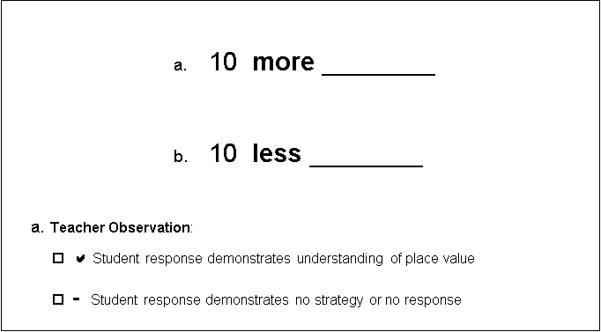
43

TASK 5
Preparation: Give student a set of 26 objects (popsicle sticks, buttons, snap cubes, bears, etc.). Do not tell the student how many there are.

Teacher: Count these objects by making groups of ten.
- Ask student to answer and record:

  - How many groups of ten?

  - How many left over ones?

  - How many total?

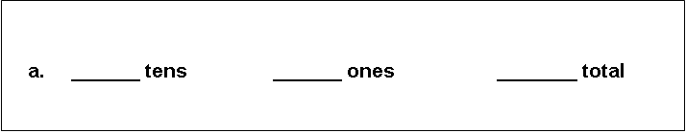

TASK 6
Preparation: Have available place- value manipulatives that have pre-bundled tens and single ones, amounting to more than 54 (snap cubes in sticks of 10 and loose ones, popsicle sticks in bundles of ten and loose sticks, and a number card displaying the number 54, etc.)

Teacher:
- Show me this number using the manipulatives (show student numeral card 54).
Record students’ ability to represent 54 using bundles of tens and ones ( or - ).

- Count the (bundles of 10) two different ways.
Record ( or - ) students’ ability to count by tens in two different ways (ten, twenty, thirty, forty… and 1 ten, 2 tens, 3 tens, 4 tens)

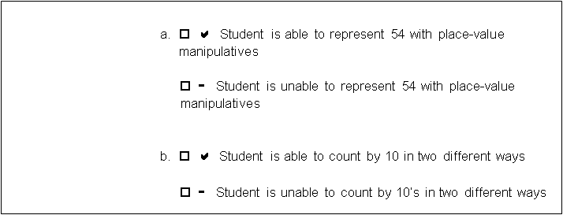

TASK 7

Preparation: Make number cards displaying 39 and 52. Show student the numeral cards with 39 and 52.

Teacher:

- Tell me which number is more. Record student response ( or - ).

- How do you know? Record student response ( or - ).
(Ex: 5 tens is more than 3 tens)

- Write the symbol in the box to show which is more.
Show student the card with the >, =, < symbols. Record students’ response ( or - ).

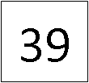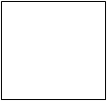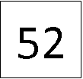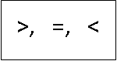

◻ or - Student correctly states the number that is more

◻ or - Explanation supports understanding of place value

◻ or - Student writes the correct symbol to show which is more

TASK 8

Preparation: Show student the number strips.

Teacher: Write the missing numbers on the strips.

Write the missing numbers on the strip.

17 | 18 | 19

56 | 57 | 58

94 | 95 | 96

