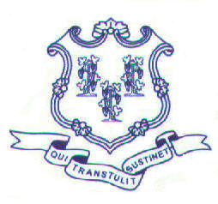
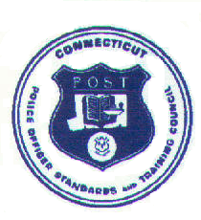
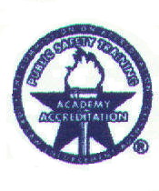

S T A T E OF C O N N E C T I C U T
DEPARTMENT OF EMERGENCY SERVICES AND PUBLIC PROTECTION
Police Officer Standards and Training Council
Connecticut Police Academy

Council Meeting Agenda
Thursday, November 8, 2012
9:30 A.M.

CALL TO ORDER

Meeting will be held in the Conference Room at the Connecticut Police Academy

ACTION ITEMS

- Minutes of the September 6, 2012 Meeting
- Consideration of Proposed Council 2013 Meeting Dates
- Chiefs/Public Comment

CERTIFICATION COMMITTEE

Request for Comparative Certification

- Keith W. Baker – Rocky Hill Police Department – (Police Officer position)
- Andrew A. Green – Norwalk Police Department – (Police Officer position)
- Michael P. Guillot – Groton City Police Department – (Police Captain position)
- Mashantucket Pequot Tribal Nation Police Department:
- Robert J. Witherspoon – (Major position, Second-in-Command)
- Katy L. Tougas – (Detective Sergeant position)
- Lance P. Brown – (Sergeant position)
- Jonathan A. Greer – (Sergeant position)
- Brett D. Mallon – (Police Officer position)
- William A. Rose – (Police Officer position)
- Devon T. Dupuis – (Police Officer position)
- Mark J. Boulanger, Jr. – (Police Officer position)
- Michael T. Gouvin, Jr. – (Police Officer position)

Revocation of Police Officer Certification

- Michael Koistinen – Windsor Locks Police Department (Felony Conviction)

Request for an Extension of the One-Year Probationary Candidate Status

- Jeffrey P. Lund – Stamford Police Department

ACCREDITATION COMMITTEE

- Norwalk Police Department – Re- Accreditation – Tier III
- Informational – Darien Police Department Conditions Review

INFORMATION ITEMS

- Executive Director’s Report
- Retirement of Training Officer Stanley Konesky
- Directors Reports
Basic Training
In-Service Training
- Accreditation Manager’s Report
- Compliance Officer’s Report
- Audit Reports
- Correspondence

OLD BUSINESS

NEW BUSINESS

- Request Council Adoption of a Mandatory Uniform Policy – Eyewitness Identification Procedures pursuant to Public Act No. 12-111

