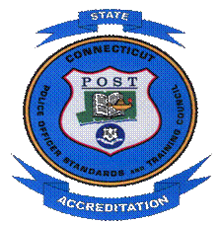
(On agency letterhead)

PUBLIC NOTICE

(date)

The (name of agency) is scheduled for an on-site assessment as part of a program to achieve Tier (number) (accreditation or re-accreditation) by verifying it continues to meet professional standards.

Administered by the Police Officer Standards and Training Council, the state accreditation program requires agencies to comply with state of the art standards.

As part of the on-site assessment, agency employees and members of the community are invited to offer comments. Comments can be directed to:

William E. Tanner, III POST-C Accreditation Division 285 Preston Ave. Meriden, Ct 06450, telephone at 203-427-2602, by fax at 203-238-6643 or by email Accreditation.Compliance@ct.gov Please enter the name of the agency in the subject line of the email.

A copy of the Standards is available at the (name of agency and address). Local contact is (accreditation manager), (their phone number).

