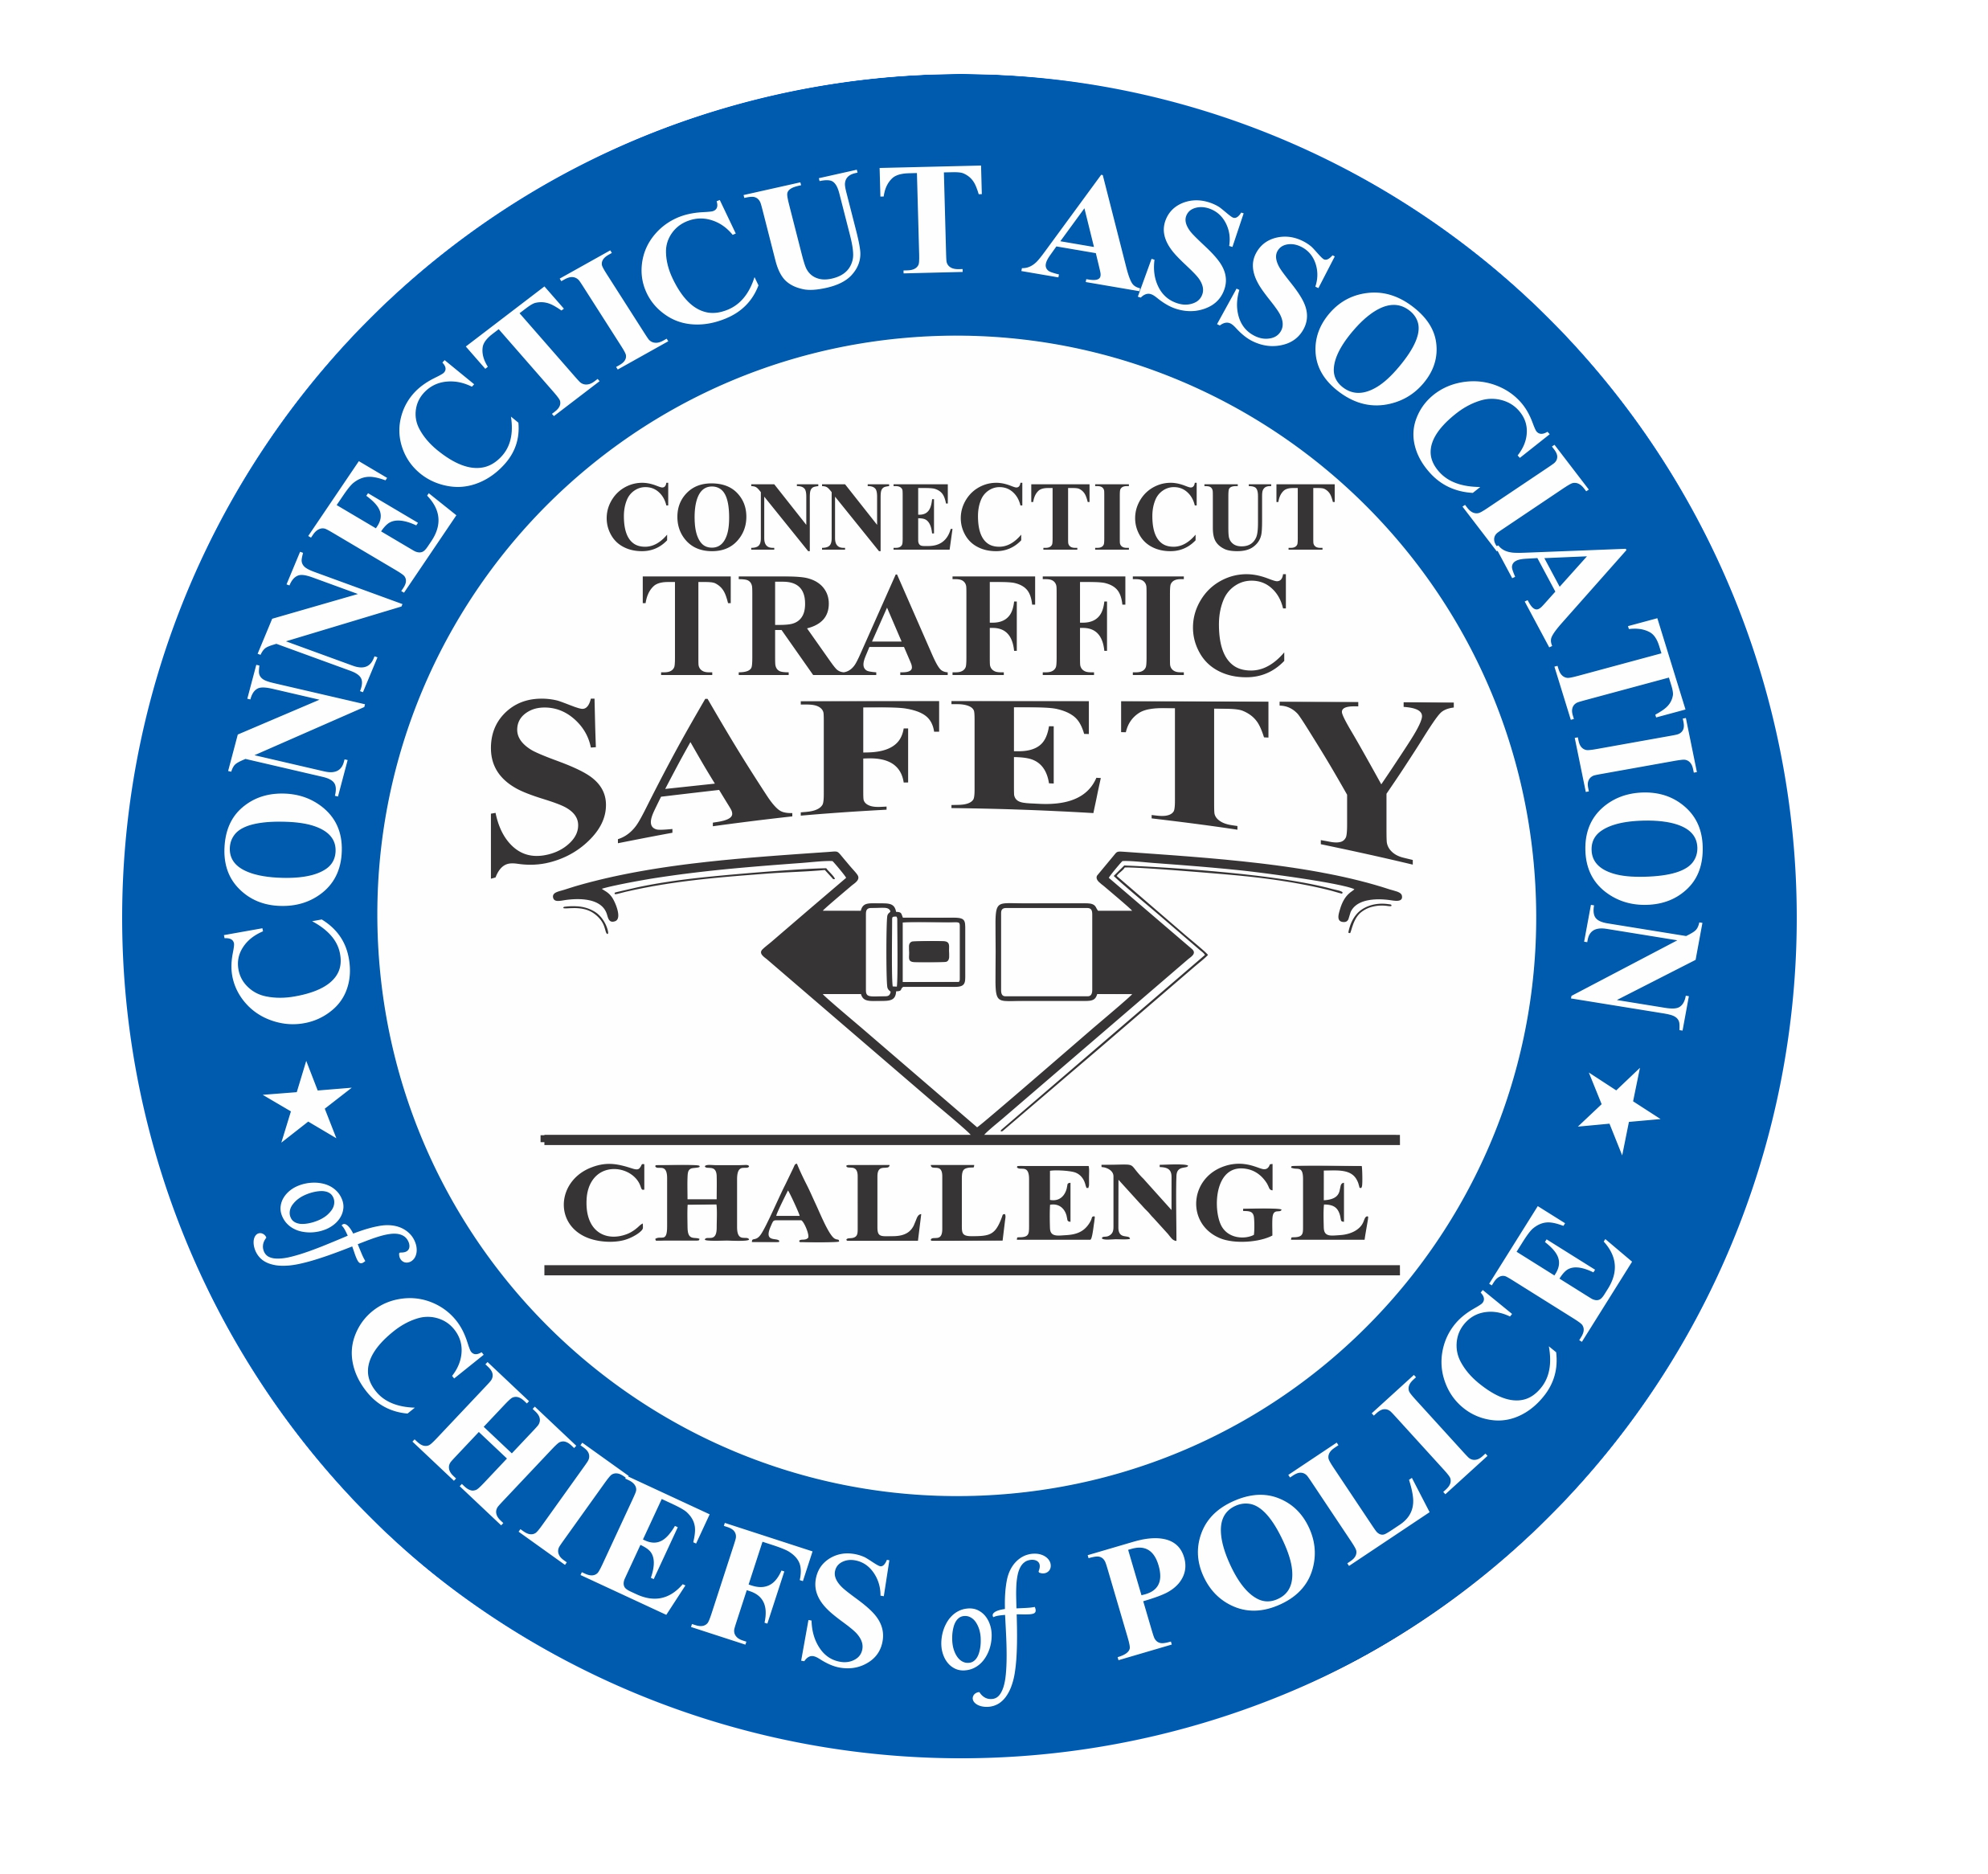

A Step by Step Guide to Completing
The
Connecticut Traffic Safety Challenge Application

Connecticut Department of Transportation
PO Box 317546
2800 Berlin Turnpike
Newington, CT. 06131
860-594-2386

Program Manager

LEL Edmund M. Hedge
Connecticut DOT – Highway Safety Office
Edmund.hedge@ct.gov
860-594-2386

The “Traffic Safety Challenge”

What is the Traffic Safety Challenge?

It is a program coordinated by the Connecticut Highway Safety Office and the Connecticut Police Chiefs Association (CPCA) Highway Safety Committee and supported by a NHTSA grant administered through the Connecticut Department of Transportation (CTDOT), as well as much-appreciated funding from private entities, and recognizes the best overall traffic safety programs in the state. Main areas of concentration are;
Occupant Restraint
Speed
Impaired Driving
Distracted Driving

Throughout the rest of the guide, these will be referred to as the target areas.

Agencies submit an application documenting their efforts and effectiveness in these areas at a minimum, but are encouraged to include their work in all areas. Winning programs effectively combine many different strategies to reduce crashes and injuries in their jurisdiction.

Why does the CTDOT and CPCA do this?

CTDOT, CPCA, & NHTSA believe increased traffic enforcement and education in a community result in a decrease in motor vehicle crashes, injuries, and fatalities; and they have the studies to prove it. The Traffic Safety Challenge complements all the other training, enforcement and public information programs that NHTSA and CTDOT use to promote traffic safety.

What's in it for my department?

This competition is a unique way for law enforcement to increase and focus its attention on traffic safety. It provides recognition for exemplary programs, incentives for continuing traffic safety activities, and documentation of effectiveness that can be used in many ways to advocate for the agency. Every department participates to some degree in traffic safety programs; so entering the Challenge doesn’t require a great deal of extra commitment on an agency’s part. Merely taking the time to document current activity has produced many winners.

Being recognized as a winner brings a great deal of positive recognition to a department, may yield benefits at budget time, and enhances an agency’s reputation as one which is “tough on crime" yet prioritizes safety on its roadways.

Completing a Challenge Application

This guide is designed to assist you in assembling an application for the Connecticut Traffic Safety Challenge (CTSC) program only. The National Law Enforcement Challenge (NLEC) only accepted on line applications. It is a different format from Connecticut; see www.theiacp.org for further information.

Connecticut Traffic Safety Challenge Application

By following these simple recommendations it will be much easier for the judges to locate necessary information, thus giving your application an edge that could make the difference.

Participating agencies submit a bound application or a binder, which must document their overall traffic safety efforts in the categories of;
        - Policies and Guidelines
        - Officer Training
        - Public Information & Education
        - Officer and Citizen Recognition
        - Enforcement Activities
        - Effectiveness of Efforts
Go to the Connecticut Traffic Safety Challenge website at CPCANET.org for additional information on the Challenge.

How are the Applications Judged?

After placing agencies into categories based on size and type, a panel of judges reviews each application and assigns points based on certain established criteria. The judges’ points are then averaged to arrive at a final result. Agencies are then ranked by score. A minimum of 75 points MUST be earned to receive an award. There may be categories where no awards are presented due to either a lack of entries or not enough agencies achieving a minimum score.

All of the judges are members of the law enforcement community, public safety, and/or corporate partners who have demonstrated advanced knowledge of and familiarity with highway safety issues as well as strategies, initiatives and methods to address them.

General Tips on What Makes a Winning Submission

- First impressions count. A neat, well-organized application that is easy to follow and contains only necessary information makes a big difference.

- Maximum of one-inch thick presentation. (Bound or binder)

  - Make sure all the information is securely attached. If anything falls out, it may end up out of order when being put back together.

  - Organize the categories in the same order they are listed in the application, and label the sections with the category name; include and highlight only the appropriate information in your documentation. (Tabs work well)

- Make sure you address every question asked – do not say N/A or leave blank without an explanation.

  - Sometimes the difference between 1st and 3rd place is two or three points, so every piece of information is important. If you fail to include one policy or one piece of data, it can make the difference between placing and not placing at all.
- Lists and graphs/charts are very helpful to document topics such as training. Graphics are much better than lengthy, densely written text.

- Scan your articles and photos; avoid photocopying if at all possible. Do not forget to use captions to explain your pictures and how they apply to your program. Make sure to include dates on pictures, press releases, articles, etc. Undated information is suspect.

- Do not include minutiae – only what counts. Quality is more important than quantity.

- Do not include actual handouts, key rings, pencils, brochures, etc. – scan or photograph.

- No videos, audio or computer-based presentations will be considered.

- Proper spelling and grammar cannot be overstressed.

Organizing Your Application

There is no standard format; however there are some things you can do to make your entry more noteworthy. Most importantly, follow the application format and sequence. The actual application form should be the first item in your submission; entries without an application form are considered incomplete and will not be judged. Next are the necessary six sections or chapters, following the order of the application form, one for each of the judging criteria.

Include an additional, separate section at the end of your entry for each special award category for which you want to be considered.

Introduction

The minimum areas that must be addressed are occupant protection, speed, and impaired driving; but you should include any other traffic safety aspect you have addressed, along with the solution(s) developed to combat these problems. Provide one to three years of data, any traffic studies, or other relevant information used to back up your problem identification.

Policies & Guidelines

Applicants MUST provide an actual copy of their polices and guidelines for - safety belt use within the agency, and then enforcement policies and guidelines for safety belt, child passenger safety restraints, speed and impaired driving. Critical information such as the date it was written, title, etc., are mandatory. DO NOT just rephrase or replicate the wording of your policy – a copy of the actual policy is required.
  - Include only the page(s) with the necessary information, not the entire policy. If your belt use policy is one page of a fourteen-page policy, include only that page, and highlight the pertinent language.

- If your agency does not have a policy for the target area(s), provide a brief statement saying so – do not make the judges search for something that isn’t there.

- Do not say that you have a policy, and then neglect to include it. You will not receive points for a missing policy.

- Enforcement policies and/or guidelines are clear directives emphasizing the importance of definitive actions to address seat belt, and child safety seat violations, speeding and impaired driving not suggestions or recommendations.

  - Enforcement guidelines should be specific - one for each area listed.

  - Guidelines may be part of a policy/procedure statement; agency goals and objectives; operational plans; or internal memoranda.

  - The policies should be directed to ALL agency members, not just a traffic unit, for example.

  - Neither a copy of state law nor a memorandum “recommending” belt use by employees or enforcement in the target areas is considered a policy.

  - Do not include operational plans or procedures (DUI checkpoints or arrest processing, etc.) unless necessary for the application.

Training

Outline training conducted/received during the year in occupant protection, speed enforcement, impaired driving (detection and apprehension) or any other comprehensive traffic safety topic. Provide a brief narrative about the training your agency conducted/received during the past year, but the use of graphics to document the information is highly recommended. Include the percentage of officers trained in each category. Also include other recent training over the past few years that still may be applicable today (child passenger safety technicians, crash reconstructionists, etc.)

- DO NOT include training that has nothing to do with the categories or did not occur in the current year (unless it is under “recent” traffic safety training).
- DO NOT include basic academy training or FTO training.
- DO NOT include entire training manuals, certificates, or rosters of each class conducted.
- You MUST show documentation for each claim made.
- Be sure to provide the percentage of sworn personnel trained and the type of training conducted. (SFST, user updates, and many other programs can be presented over several roll call sessions – take advantage of this type of training.
- Provide a brief narrative of all of your training activities – how were they conducted? Roll call, training bulletins, cross-training, formal and informal schools, seminars and conferences should all be included.
- Consider including a matrix of the types of training provided and how many officers were trained or updated during the year.
- For past training – include only what is still relevant today i.e. child seat techs, crash reconstructionists, etc. Past 3-4 years would be sufficient if that training is up to date, and is still being utilized by that person today.

Incentives & Recognition (Officer and Public)

Additional points are earned by agencies that reward officers for a job well done and citizens who practice safe driving. Rewards and incentives are important elements in letting people know that traffic safety is a priority in the community and the agency.

- Participation in Saved by the Belt programs . You MUST include specifics on how many were recognized in that past year as well as supporting documentation – photos, certificates, etc. Compare to the number of total crashes.

Agencies must provide examples of recognition of officers who excel in occupant restraint, speed enforcement and impaired driving enforcement. Letters of commendation, uniform pins or ribbons, plaques, certificates, etc., are examples of recognition. Do not include recognition that is not traffic safety related.

Public Information & Education

This section is very important. It is where agencies provide detailed information about the ways they explain the issues of occupant protection, speed enforcement, impaired driving, and overall traffic safety. Show your creativity in presenting your programs, public information and education efforts and of your efforts to publicize high visible enforcement throughout the year.

This is where all “non-enforcement” activities during the year are highlighted. Activities should include: citizen police academies (if traffic was a topic), high school mock DUI crashes, posters, signs, billboards, educational pamphlets and brochures, child seat programs, press releases, web site information, newspaper articles, social media, photos and other similar items.

Agencies should also include their non-enforcement participation in state and national campaigns such as Click It or Ticket, National Drunk and Drugged Driving Prevention Month, National Child Passenger Safety Week, etc. in this section.

- Show the judges what you have done: Photos/news articles/letters/etc. Use pictures to highlight your narrative (make sure they all have captions and dates).
- Give details on each activity/program and how well it worked. Who was involved? Did you build community partnerships?
- Make sure you include all of the areas you covered in addition to the target areas; pedestrian/bicycle, railroad crossing, teen distracted driving, etc.

Enforcement Activity

On the Application page, provide the number of citations/warnings issued by your department during routine patrol and during special enforcement efforts for the last three (3) years.

- Safety belt citations
- Child restraint citations
- Speed related citations (including too fast for conditions and failure to reduce speed)
- Impaired driving arrests (including DUI Campaigns)
- Distracted Driving Citations ( includes total cell phone+ distracted driving+texting)
- Number and type of special enforcement efforts not only in target areas, but any other traffic enforcement detail. Show not only the number of special enforcement efforts but give specifics, how many officers participated, for how many hours, how many citations were written, how many arrests made?
- Special enforcement efforts would typically include the following:
  - DUI Sobriety Checkpoints or DUI saturation patrols as part of a special assignment (assigning an officer to concentrate on impaired driving enforcement each night does NOT equal 365 special enforcement efforts).
  - Seat Belt Enforcement Zones (Focused patrols or targeted enforcement during campaigns)
  - Speed Enforcement Zones (targeted enforcement at specific locations)
  - Any other special enforcement such as; a citizen requests speed enforcement in a problem area and an officer is specifically assigned there for one week, that is one special enforcement effort. Same would hold true for stop sign violations, targeted enforcement at high crash intersections, pedestrian concerns, etc.

- The numbers should make sense compared to the number of officers in your department. (If you issued 250 citations for seat belt violations that’s great, unless you have 200 officers, then it isn’t good at all.)
- Provide a narrative explaining in detail what you accomplished in these waves.
- If you have shown an improvement over previous periods or years (recent data – not from 10 years ago), show it. The application page should show 3 years worth of numbers, but your attached narrative should explain annual numbers and any improvement or setback over the years. Maybe there’s a reason why crashes are up; did you have major road construction, large numbers of new residents, more retail?

How Effective Were You?

The secret to this section is very simple: do the research and find the numbers. This is not only important to complete your application but this data will also help you evaluate and build your entire traffic safety program(s). This information can be used as a barometer of how well your agency is doing.

At a minimum, address your traffic program’s effectiveness in the following areas:

- Change in safety belt use.
  - You must show the difference. What was the change in the belt use rate during the year? You are required to conduct seat belt use surveys as close to the start and the end of the year as possible.
- You must show the numbers of speed and alcohol related fatality and injury crashes.
  - How do they compare to previous years?
  - Use graphs and charts to illustrate this change.
- If you state “unknown” you will not get credit. Do the research. Analyze the numbers.
- Your effectiveness documentation should also include results of some of your enforcement programs.
- Provide a narrative of your effectiveness. How did the programs affect your results and did the community support your efforts?
- How many total crashes during the year and how does that compare to previous years?
- Are you conducting analyses?
  - Where are your top 5 problem crash areas?
  - What is causing these crashes?
  - Are you directing proactive enforcement to target the violations?
  - Is there a correlation between enforcement and belt use?
  - What about in the number of personal injury crashes?

While this may seem difficult for smaller departments, it is always a good idea to keep track of this data no matter your size. It can be used to help plan and make program decisions in your agency and help you determine how to allocate resources. Judges will be looking for information such as:

- Did your safety belt use rate increase?
- Did your total crashes decrease?
- Did your total injury crashes decrease?
- Did your alcohol or speed-related crashes decrease?
- Did your enforcement of seat belts, child seats, speeding or impaired driving increase?
- Did you increase your number of special enforcement efforts?
- Did you increase your public education initiatives?

If the answer to any of these questions is no; this is your opportunity to explain why.

Quality of Submission

The following questions will be considered and a score for presentation will be awarded by the judges.

- How well did you organize your application? (Your submission should follow the order of the application.) The judges will look at how much effort you expended in preparing your application.
- Make things easy to find. Remember, there will be dozens of applications for the judges to consider. Use properly labeled tabs to locate important items.
- DO NOT send more than 1-one inch binder, you will not be judged by weight or volume, but by quality, accomplishments, and completeness. Submissions larger than one inch will not be judged.
- Do not send video or audio media – they will not be considered.
- If you have audio/video PSA’s, summarize them in narrative form. For the video PSA, if possible, include a “freeze-frame” shot, or for the audio, a script.
- Remember to explain all acronyms, especially if it’s a homegrown program.
- Is all the information clearly provided and is it creatively presented?

  - Make the submission clear, concise, and easy to follow.
  - Make use of bullets and highlight critical points

Special Awards

There are several special awards for which your agency can compete. If you wish to be considered, a separate tab or section is required for each award. Your presentation should highlight your efforts in the category area(s).

- Do not check all the special award categories; only check the special awards that you have provided the additional data and information about for the award.
- Place these special award sections at the rear of your presentation/book.

Conclusion

If you do not “place” in the awards program, it does not mean that you did not do a good job - it only means that another agency in your category did somewhat better. Please strive to do more the following year. Interact with others who have successful programs and learn from them.
Talk to the directors or to one of the judges. Above all, remember that what you have done has made a difference! The community that you serve has benefited from your work and is a safer place to drive and live.

Don’t give up.

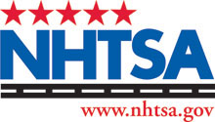

Updated February 29, 2016

