NOTICE TO CONTRACTOR – NOISE POLUTION CONTROL

[Retain this NTC when required. The following sample is based on AMTRAK requirements. Revise as necessary for Metro-North Railroad.]

The Contractor is hereby advised that the requirements set forth in Form 816 Article 1.10.05 apply to any residential building adjacent to the Project Site. All costs associated with noise pollution control shall be included in the Major Lump Sum Item for the project. The Contractor shall use whatever means necessary to meet the requirements of Article 1.10.05 including, but not limited to, the following:

- To the maximum extent possible, the Contractor shall power electrical equipment, construction lighting, and electric power tools using a temporary electrical service tied to the local power grid. The use of portable electrical generators shall be minimized.
- The Contractor shall maintain equipment mufflers and lubrication to reduce sound emissions.
- The Contractor shall attach intake and exhaust mufflers, shields, or shrouds to individual pieces of equipment and tools as necessary.
- The Contractor shall use noise-deadening material on the inside of hoppers, conveyor transfer points and chutes.
- To the maximum extent possible, the Contractor shall limit the number and duration of equipment idling on the Project Site. The use of annunciators or public address systems and the use of air or gasoline driven hand tools shall be kept to a minimum.
- The Contractor shall erect noise barriers and/or noise curtain systems to intervene between the noise source and the noise receptor locations.
- The Contractor shall minimize the noise of backup alarms using measures that meet OSHA regulations. This includes the use of self-adjusting ambient-sensitive backup alarms, manually-adjustable alarms on low settings, and the use of observers.

Noise Reduction Materials and Equipment

Noise reduction materials may be new or used. Used materials shall be of a quality and condition to perform their designed function.

Noise reduction equipment and materials may include, but not be limited to:

- Shields, shrouds, or intake and exhaust mufflers.
- Noise-deadening material to line hoppers, conveyor transfer points, storage bins, or chutes.
- Noise barriers using materials consistent with the Temporary Noise Barrier materials specified below.
- Noise curtains using materials consistent with the Noise Control Curtains materials specified below.

All equipment with backup alarms operated by the Contractor, vendors, suppliers, and subcontractors on the Project Site shall be equipped with either audible self-adjusting ambient-sensitive backup alarms or manually-adjustable alarms. The ambient-sensitive alarms shall automatically adjust to a maximum of 5 dBA over the surrounding background noise levels. The manually-adjustable alarms shall be set at the lowest setting required to be audible above the surrounding noise. Installation and use of the alarms shall be consistent with the performance requirements of the current revisions of Society of Automotive Engineering (SAE) J994, J1446, and OSHA regulations.

All equipment used on the Project Site, including jackhammers and pavement breakers, shall have exhaust systems and mufflers that have been recommended by the manufacturer as having the lowest associated noise.

The local power grid shall be used wherever feasible to limit generator noise. No generators larger than 25 KVA shall be used and, where a generator is necessary, it shall have maximum noise muffling capability and meet the noise emission limits specified in Form 816 Article 1.10.05.

Temporary Noise Barriers

Temporary barriers shall be constructed of ¾-inch Medium Density Overlay (MDO) plywood sheeting, or other material of equivalent utility and appearance having a surface weight of 2 pounds per square foot or greater. The temporary noise barriers shall have a Sound Transmission Class of STC-30, or greater, based on certified sound transmission loss data taken according to ASTM Test Method E90.

The temporary barriers shall be lined on one side with glass fiber, mineral wool, or other similar noise curtain type noise-absorbing material at least 2-inch thick and have a Noise Reduction Coefficient rating or NRC-0.85, or greater, based on certified sound absorption coefficient data taken according to ASTM Teat Method C423.

The materials used for temporary barriers shall be sufficient to last through the duration of construction for this Contract, and shall be maintained in good repair.

Barrier panels shall be attached to support frames constructed in sections to provide a moveable barrier capable of withstanding wind loads in accordance with current building codes.

When barrier units are joined together, the mating surfaces of the barrier sides shall be flush with each other. Gaps between barrier units, and between the bottom edge of the barrier panels and the ground, shall be closed with material that will completely fill the gaps, and be dense enough to attenuate noise.

The barrier height shall be designed to break the line-of-site and provide at least a 5 dBA insertion loss between the noise producing equipment and the upper-most story of the receptor(s) requiring noise mitigation. If for practicality or feasibility reasons, which are subject to the review and approval of the Engineer, a barrier can not be built to provide noise relief to all stories, then it must be built to the tallest achievable height.

Prefabricated acoustic barriers are available from various vendors. An equivalent barrier design can be submitted in lieu of the plywood barrier described above.

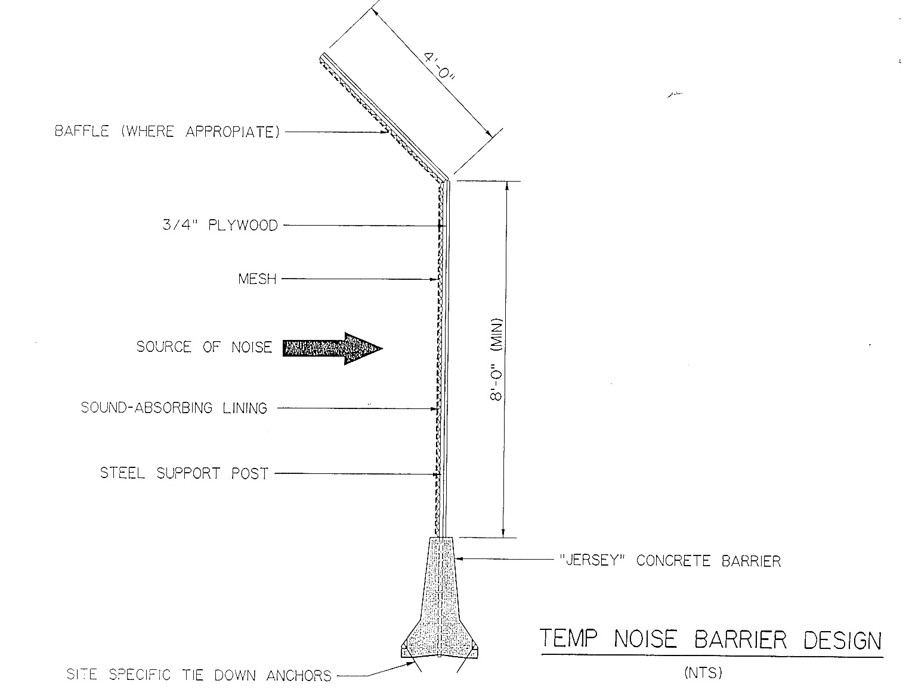

Acoustical Barrier Enclosures

The acoustical barrier enclosure shall consist of durable, flexible composite material featuring a noise barrier layer bonded to sound-absorptive material on one side.

The noise barrier layer shall consist of rugged, impervious material with a surface weight of at least one pound per square foot. The sound absorptive material shall include a protective face and be surely attached to one side of the flexible barrier over the entire face.

The acoustical material used shall be weather and abuse resistant, and exhibit superior hanging and tear strength during construction. The material shall have a minimum breaking strength of 120 lb/in. per FTMS 191 A-M5102 and minimum tear strength of 30 lb/in. per ASTM D117. Based on the same test procedures, the absorptive material facing shall have a minimum breaking strength of 100 lb/in. and a minimum tear strength of 7 lb/in.

The acoustical material shall be corrosion resistant to most acids, mild alkalies, road salts, oils, and grease.

The acoustical material shall be fire retardant, mildew resistant, vermin proof, and non-hygroscopic.

The acoustical material shall have a Sound Transmission Class of STC-25 or greater, based on certified sound transmission loss data taken according to ASTM Test Method E90. It shall also have a Noise Reduction Coefficient rating of NRC-0.70 or greater, based on certified sound absorption coefficient data taken according to ASTM Test Method C423.

The acoustical material shall be installed in vertical and horizontal segments with the vertical segments extending the full enclosure height. All seams and joints shall have a minimum overlap of 2 inches and be sealed using double grommets. Construction details shall be performed according to the manufacturer’s recommendations.

The Contractor shall be responsible for the design, detailing and adequacy of the framework and supports, ties, attachment methods, and other appurtenances required for the proper construction of the acoustical barrier enclosure.
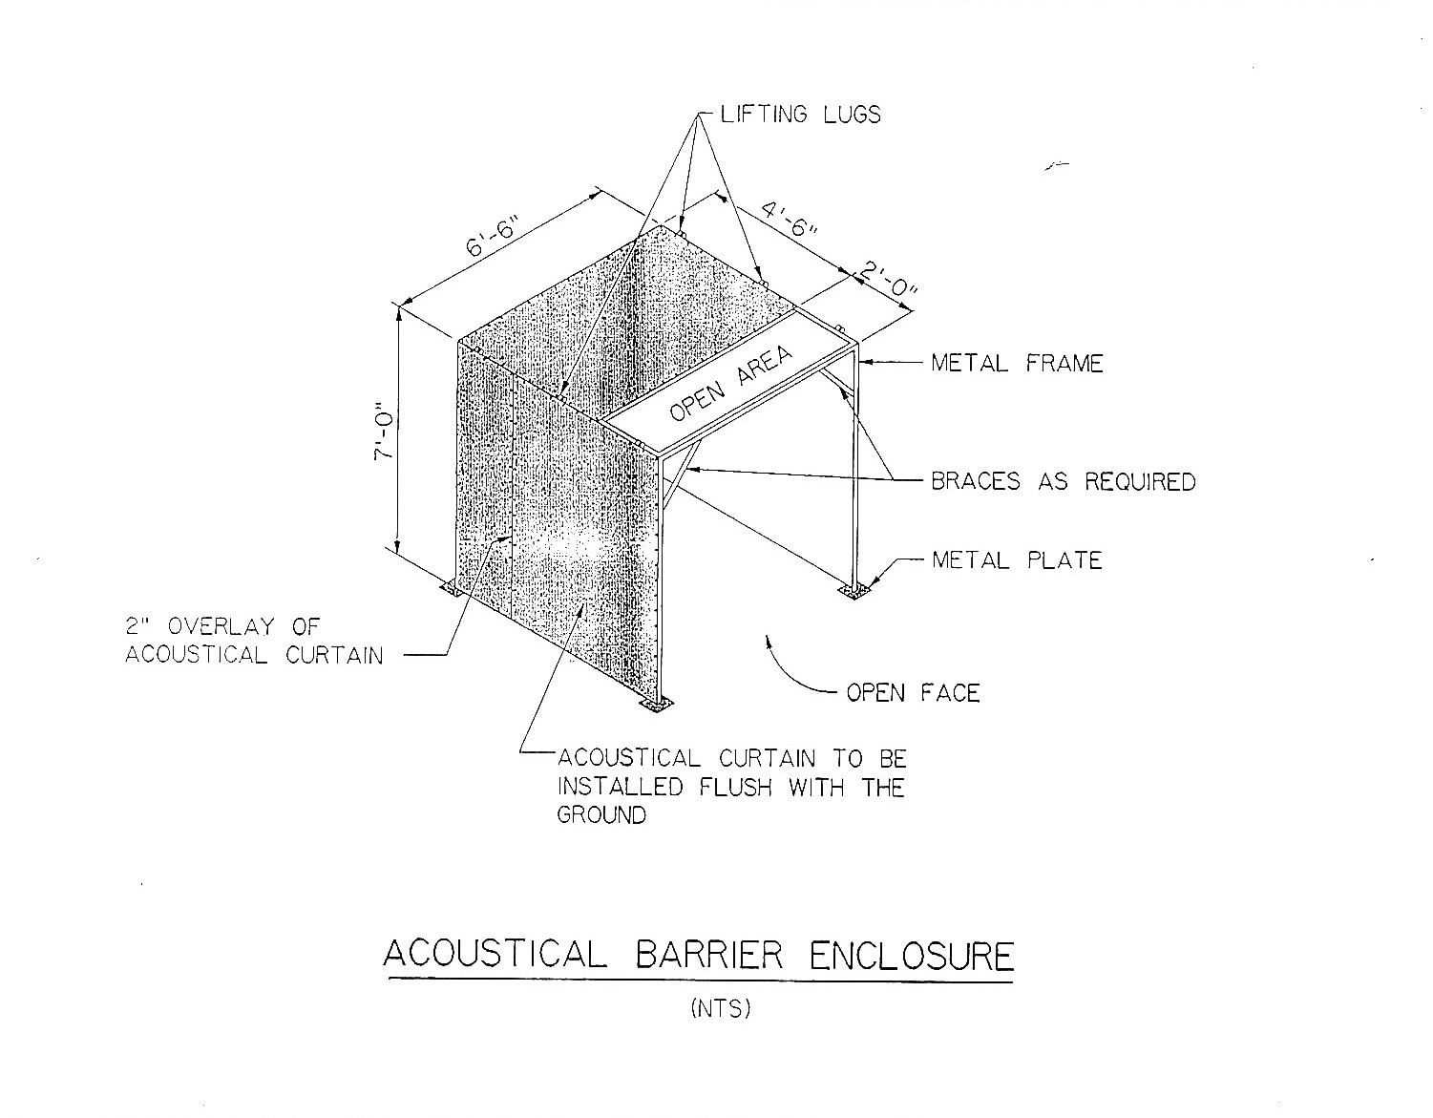

Noise Control Curtains

The noise control curtain shall consist of durable, flexible composite material featuring a noise barrier layer bonded to sound-absorptive material on one side. The noise barrier layer shall consist of a rugged, impervious material with a surface weight of at least one pound per square foot. The sound absorptive material shall include a protective face and be securely attached to one side of the flexible barrier over the entire face.

The noise curtain material used shall be weather and abuse resistant, and exhibit superior hanging and tear strength during construction. The curtain’s noise barrier layer material shall have a minimum breaking strength of 120 lb/in. per FTMS 191 A-M5102 and minimum tear strength of 30 lb/in per ASTM D117. Based on the same test procedures, the noise curtain absorptive material facing shall have a minimum breaking strength of 100 lb/in and a minimum tear strength of 7 lb/in.

The noise curtain material shall be corrosion resistant to most acids, mild alkalies, road salts, oils, and grease. It also shall be mildew resistant, vermin proof, and non-hygroscopic.

The noise curtain material shall be fire retardant.

The noise control curtain shall have a Sound Transmission Class of STC-30 or greater, based on certified sound transmission loss data taken according to ASTM Test Method E90. It shall also have a Noise Reduction Coefficient rating of NRC-0.85 or greater, based on certified sound absorption coefficient data taken according to ASTM Test Method C423.

The noise control curtains shall be designed to withstand wind loads in accordance with current building codes.

The curtains shall be installed in vertical and horizontal segments with the vertical segments extending the full curtain height to the ground. All seams and joints shall have a minimum overlap of 2 inches and be sealed using Velcro or double grommets spaced 12 inches on center. Curtains shall be fastened to framework and guardrails with wire cable 12 inches on center. Construction details shall be performed according to the manufacturer’s recommendations.

The curtain height shall be designed to break the line-of-site and provide at least a 5 dBA insertion loss between the noise producing equipment and the upper-most story of the receptor(s) requiring noise mitigation. If for practicality or feasibility reasons, which are subject to the review and approval of the Engineer, a curtain system can not be built to provide noise relief to all stories, then it must be built to the tallest achievable height.

The Contractor shall be responsible for the design, detailing and adequacy of the framework and supports, ties, attachment methods, and other appurtenances required for the proper construction of the noise control curtains.

