Connecticut Department of Transportation
Methodology for Developing a Connecticut Based Transit Score and Mapping Procedure
Transit Score Procedure
September 2011

Prepared By: Travel Demand Modeling Unit Systems Modeling & Forecasting Bureau of Policy and Planning Connecticut Department of Transportation

DRAFT

Methodology for Developing a Connecticut Based Transit Score and Mapping Procedure

Introduction:

The purpose of this project was twofold:

- Review the transit score methodology developed by the Delaware Regional Planning Commission (DRPC) and the New Jersey (NJ) Transit Authority for appropriateness for1 Connecticut’s use in evaluating transit viability.

- Based on the results of the above evaluation, develop a method specific for the State of Connecticut.

Transit Score Definition:

A Transit Score is a policy tool utilized to assess or measure the “transit friendliness” of a community or region. It is only a means to inform and appraise managers and transportation planners of the relative viability of possible transit investments. Transit Scores have been used in other geographical areas to assist in the following areas:

- Quantify characteristics of different locations to determine the relative potential usage of transit.
- Determine whether or not an area should increase transit development.
- Determine which type(s) of transit services may be most viable for a particular area.

The Connecticut Transit Score was classified into five categories ranging from “High” to “Low”:

High: > 7.5
Medium-High: 2.5 - 7.5
Medium: 1.0 - 2.4
Marginal: 0.6 - 0.9
Low: < 0.6

A higher Transit Score indicates that the relative population and employment density in the area may support some form of transit system or an increase in level of transit services. It in no way suggests that there should or will be transit service, or if the public expense of providing such service, is justified. It could serve as an important screening means in the overall planning process, particularly in reviewing and/or planning for land use changes; transportation project planning; project prioritization and evaluating funding strategies. The Transit Score would become an even more effective measure when coupled with economic growth modeling. These two means would reinforce the underlying socio-economic dynamics of study areas. The Transit Score alone should not be considered the sole determining factor in transit development decisions in an area.

Connecticut’s Transit Score, as presented in this paper, was based upon review of both New Jersey (NJ) Transit and Delaware Valley Regional Planning Commission’s existing transit score methods. Several regression analyses were performed to test the relationships between assorted variables and the existing transit mode share within Connecticut. Based upon the results of this evaluation, a modified transit score equation was developed for potential use by the State of Connecticut.

The proposed Connecticut Transit Score Tool is as follows:

Transit Score = (0.47 * (Population per acre)) + (0.58 * (Jobs per acre))

Summary of Score Development Methods:

The first step in the evaluation of Delaware and New Jersey’s Transit Score was to review available literature published by the two sources.

Prior to collecting any demographic data the appropriate geographic level for analysis needed to be determined. Town level was too large to provide an adequate analysis for rail or bus transit routing, while Census track level was inconsistent in size across the towns of Connecticut. Census tract data was not recommended as many rural Connecticut towns are assigned only one Census tract for the entire town. Census block level data can provide population, the number of households, and the number of zero-car households, but not the number of jobs. Therefore, census block level was also not recommended to be employed in the analysis.

The geographic level determined for this analysis was the Traffic Analysis Zone (TAZ) system created by the Connecticut Department of Transportation for use in the statewide travel demand model. This geographic level is small enough to realize localized densities without being too restrictive. The data is also readily available from the CTDOT Landuse files employed as input during the Trip Generation phase of the statewide travel demand model. Projected data is also available for selected future modeled years up to 2040.

Individual TAZ land area was calculated by excluding acreage containing larger bodies of water in order to more accurately determine density measures. For example, a TAZ containing a large lake would have a population density “watered down” if the lake area was included in the density calculation.

In order to calculate densities for each TAZ, an excel spreadsheet was created listing the land area in acres by TAZ; population and number of zero-car households by TAZ, both derived from the 2000 U.S. Census; and town employment from the Connecticut Department of Labor disaggregated to TAZ level. Each factor was divided by the individual TAZ acreage to develop “density” values. An initial set of Connecticut based transit scores were calculated using the same factors, variables and score ranges as developed by NJ Transit, but based upon Connecticut 2000 demographic data.

Results from this procedure provided a reasonable graphical representation of areas where transit is currently being provided or where service would be feasible. Based upon the above outcome, the next step in the process was to develop factors specific for the State of Connecticut. Additional variables, such as labor force and employed residents, were evaluated.

Following the NJ Transit protocol, the number of rail, bus and total trips by town were compiled from the 2000 Journey to Town Census data by origin and destination (O & D) sort tables. The transit mode share for all origin and destinations by town was then calculated by summing the rail and bus trips and then dividing this sum by the total number of trips. This value was then multiplied by 100 per the NJ Transit methodology. Appendix A contains transit mode share and Land Use data by town, as well as the Demographic data listed below.

A series of linear and multiple regression calculations were performed based on several variable combinations. These variables included:

- Population
- Employment
- Zero-car households
- Labor force
- Employed residents

The above five variables were assessed as independent (X) variables while the transit mode share (x 100) was maintained as the dependent, or (Y), variable. A single regression analysis was performed at the town level for each of the five dependent variables listed above to determine the level of correlation between each independent variable and the dependent variable. Please refer to Appendix B for the resultant data. The findings can be summarized as follows:

- All correlation values were found to be higher when the y-intercept was forced to ‘zero’.

- For origin-related variables (population, zero-car households, labor force, and employed residents), the population per acre variable was observed to have the highest correlation to the independent variable. While labor force and employed residents followed closely behind, it was decided that population would serve as a proxy for these two variables. Zero-car households per acre by far had the lowest correlation value to the dependent variable, and therefore was considered suspect as a viable transit score determining variable. (Please refer to the “Zero-Car Household” section for a more detailed discussion.)

- For the destination-related variable (employment), the correlation was found to be on par with the higher rated origin-related variables, and therefore a reasonable candidate for transit score determination.

The next step involved performing multiple regression analyses, at the town level, for various combinations of the independent variables. For these analyses, the Y-intercept was forced to ‘zero’. The subsequent findings show that all but two of the tested combinations resulted in at least one negative variable coefficient. The first set of variables producing all positive coefficients was calculated using employment and labor force. The second outcome was calculated utilizing population and employment. The latter was deemed the most viable as population accounts for all possible trips, as opposed to narrowing down to work trips typically generated by labor force. Appendix C shows the data results for each of the above combinations.

The calculated factors were applied to population per acre and employment per acre at the TAZ level. The resulting sums were then totaled for each TAZ to create a new, refined TAZ level Transit Score based on new Connecticut factors. The next step involved preparing several GIS based maps showing the range of Transit Scores by employing various shading techniques. All transit score maps are located in Appendix D, while the map descriptions are listed below:

    - Connecticut Transit scores based on original variables (population, employment, and zero-car households) with New Jersey factors and New Jersey symbology. New Jersey symbology consists of five transit score classes with color symbol ranging from dark blue (high) to white (low). The following maps were created using New Jersey transit score factors:

- 2000 Connecticut Transit scores (by TAZ) using New Jersey factors and New Jersey symbology.

- 2000 Connecticut Transit scores (by TAZ) using New Jersey factors and Connecticut symbology (explained below).

    - Connecticut Transit scores using currently chosen variables (population and employment) with new Connecticut factors and updated Connecticut symbology. The symbology chosen highlighted the medium-high and high categories clearer and had a visual clarification between ranges. Connecticut symbology consists of five transit score classes (it was determined there was no need to change the New Jersey transit score classifications) with the following symbols:

          - High – dark blue fill
          - Medium-High – light blue fill
          - Medium – light blue cross-hatch fill
          - Marginal – light blue sand fill
          - Low – white fill

    - Various iterations were implemented to achieve the visual aspects of the final maps including possible adjustments to symbology and transit score classifications. The resulting maps are listed below:

- 2000 Connecticut Transit Scores (by TAZ) using Connecticut factors and Connecticut symbology.

- 2030 Connecticut Transit Scores (by TAZ) using Connecticut factors and Connecticut symbology.

- 2000 to 2030 Change in Connecticut Transit Scores using Connecticut factors and symbology (note on change symbology: this was based on previously existing guidance (page 121 of Transit Score: Screening Model for Evaluating Community Suitability for Transit Investments, from New Jersey Transit), with the middle three classifications combined for map simplification purposes).

The next step included creating various supporting data files for additional information and more detailed analysis. These files include:

- Pie charts were created to show the percentage of TAZs that fall within the different transit score ranges and are located in Appendix E. Each of the final maps described above has a corresponding pie chart.

Calculating a Transit Score:

Based upon the above discussion, Connecticut’s Transit Score employs two factors, each of which influences the potential for transit ridership:

- Population Density
- Employment Density

U.S. Census population data and the State of Connecticut Department of Labor’s employment data is used to calculate a base year Transit Score. Population and employment projections from the Connecticut Department of Transportation’s (CT DOT), Office of Policy & Planning, Systems Modeling and Forecasting Division, Travel Demand Modeling Unit, LandUse Series 28 were used for calculating future year transit scores.

The Transit Score is as follows:

Transit Score = (0.47 * (Population per acre)) + (0.58 * (Jobs per acre))

The Connecticut Transit Score was classified into five score categories ranging from “High” to “Low”:

Table 1: Transit Score Intervals

Category Ranges

High: > 7.5
Medium-High: 2.5 – 7.5
Medium: 1.0 – 2.4
Marginal: 0.6 – 0.9
Low: < 0.6

Based upon the 2000 U.S. Bureau of the Census Block level population data and the 2000 town level employment from the Connecticut Department of Labor, the following facts are noted for areas with a Transit Score of Medium – High and above:

- Comprises 46.6% of the total statewide population.
- Comprises 63.6% of the total statewide employment.
- Comprises 7.8% of the total land area of the state.
- Comprises 78.3% of the total number of zero-car households in the state.

Table 2 shows the distribution of Connecticut’s population, employment, zero-car households, and land area by each of the above transit score categories for the year 2000.

Table 2.

Zero-Car Households:

While the number of zero-car households indicate a population basically dependent on transit, this variable did not correlate as closely in the Connecticut scoring as it had in the New Jersey Transit methodology. There are two major reasons for a large percentage of zero-car households. One is a household with a low income level which makes purchasing, maintaining and repairing a vehicle extremely difficult due to such expenditures consuming a large percentage of household income. The other reason is choice. Residing in or near an area served by good, reliable and affordable transit often eliminates the need for vehicle ownership.

While the overall statewide percentage of zero-car households in the two states is close, 9.6% in Connecticut vs. 12.7% in New Jersey, there may be other factors influencing or negating the effect of zero-car households in Connecticut.

In Connecticut; New Haven, Hartford and Fairfield counties have 12.3, 11.2 and 8.6 percent zero-car households, respectively. In New Jersey, the counties with the highest percentage of zero-car households are Hudson (35.1%), Essex (25.4%) and Passaic (16.2%).

The percentage of zero-car households in Connecticut ranges from a low of 4.4% in Tolland County to a high of 12.3% in New Haven County. In New Jersey, Hunterdon County has a low of 3.4% while Hudson County has the highest percentage at 35.1%. Hudson County is close to New York City and has excellent transit service. While only two Connecticut counties have over a 10.0% rate for zero-car households, in New Jersey eight of the twenty-one counties have greater than 10.0% zero-car households. Table 3 on the next page shows the percentage of zero-car households by county for each State as well as each State’s total.

Further investigation revealed that the New Jersey counties with a high percent of zero-car households have an above average income as well as access to very good transit service, while most Connecticut counties do not have similar mass transit opportunities and therefore must rely on a private vehicle. This may account for the zero-car household variable having a more relevant or significant role in the transit score in the State of New Jersey. New Jersey also “has one of the most extensive rail and bus services in the country…”. For example, Hudson County which is adjacent to New York City, has 35.1% zero car households and nearly 40% of county residents had a 1999 household income of or greater than $50,000. Hudson County also had 20.4 persons per acre and 7.72 households per acre in 2000. The next densest New Jersey County is Essex with 9.82 persons per acre and 3.51 households per acre of land and just over a quarter of its households have zero-car households. In fact, one-third of all New Jersey counties have a population density over 3.00 persons per acre, while no counties in Connecticut reach that level. Fairfield County in Connecticut has the highest density at 2.20. Therefore, the zero-car household variable was not included in the final revised transit score formula for the State of Connecticut.

Table 3

Bibliography

Transit Score: New Jersey’s Unique Planning Tool. New Jersey Transit Corporation by PlanSmart NJ & URS, March 2011

Transit Scoring Toronto’s “Three Cities”, Martin Prosperity Institute, January 2011

Transportation Research Record: Journal of the Transportation Research Board, No 2063, Transportation Research Board of the National Academies, Washington, D.C., pp 115-124.

Creating a Regional Transit Score Protocol: Full Report. Delaware Valley Regional Planning Commission, Philadelphia, Pa., 2007.

Appendix A:
Land Use and Demographic Data By Town

Appendix A continued:
Land Use and Demographic Data By Town

Appendix A continued:
Land Use and Demographic Data By Town

Appendix B:
Single Regression Analysis Results

Appendix C:
Multiple Regression Analysis Results

Appendix D:
Transit Score Maps

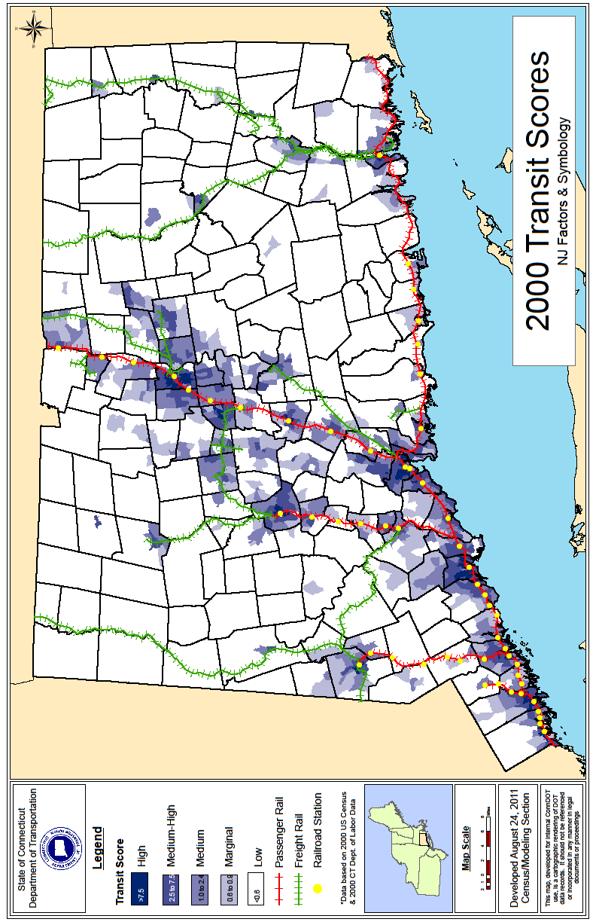
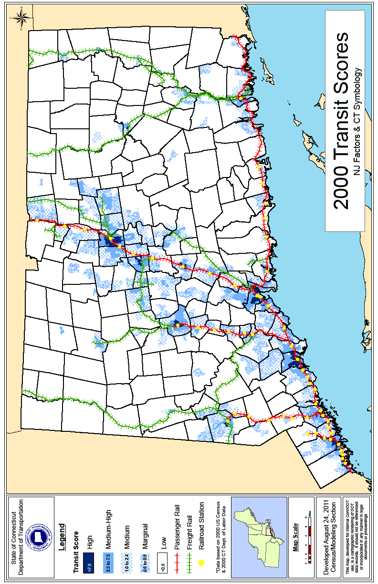
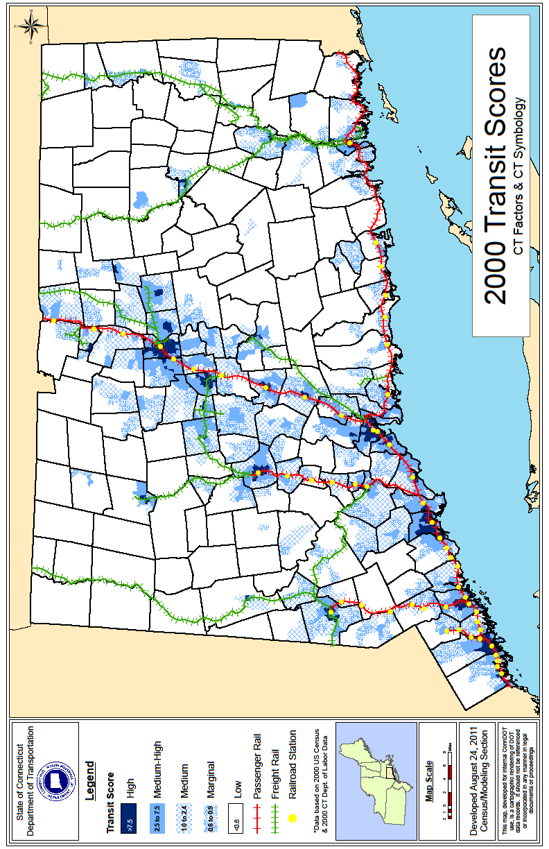
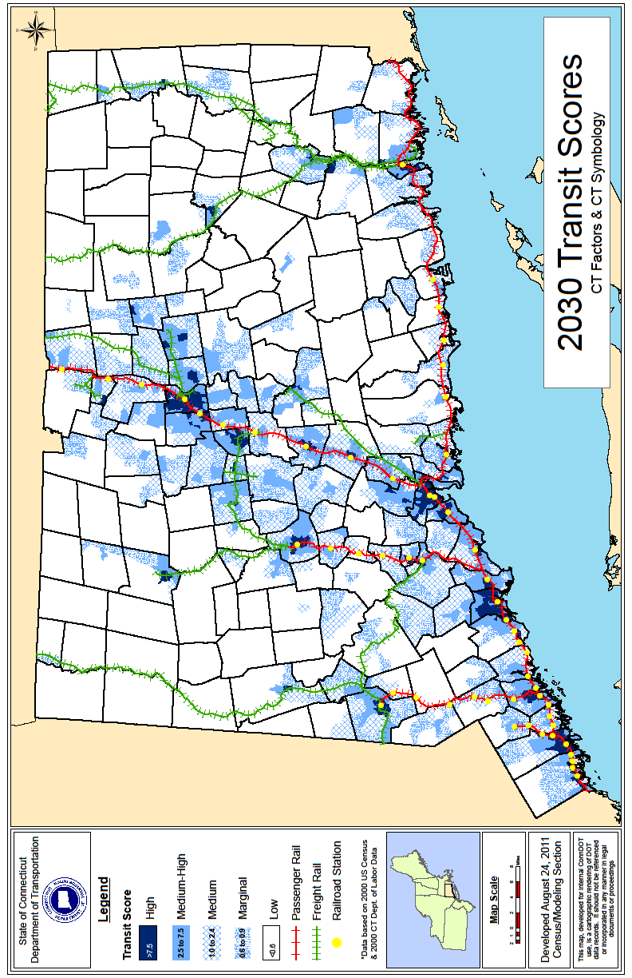
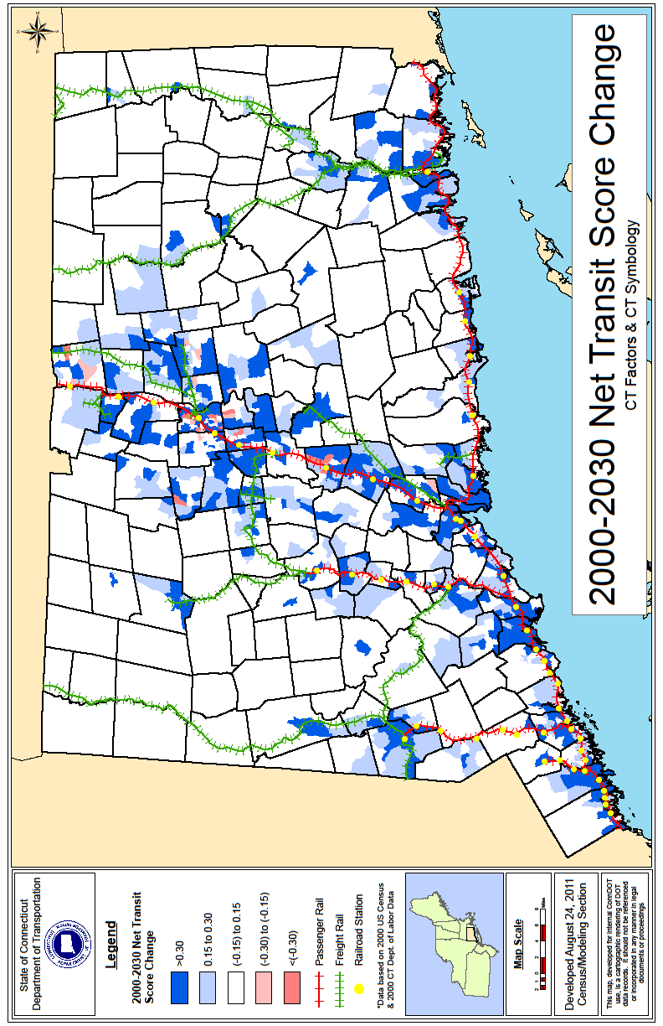

Appendix E:
Percent of TAZs within Transit Score Ranges

Appendix E continued:
Percent of TAZs within Transit Score Ranges

Appendix E continued:
Percent of TAZs within Transit Score Ranges

The Connecticut travel demand model has 1858 traffic analysis zones: 1807 internal and 52 external zones. There is a minimum of four TAZs per rural town.
Transit Score: New Jersey’s Unique Planning Tool for NJ Transit. PlanSmart nj & URS, March 2011, page 1.

