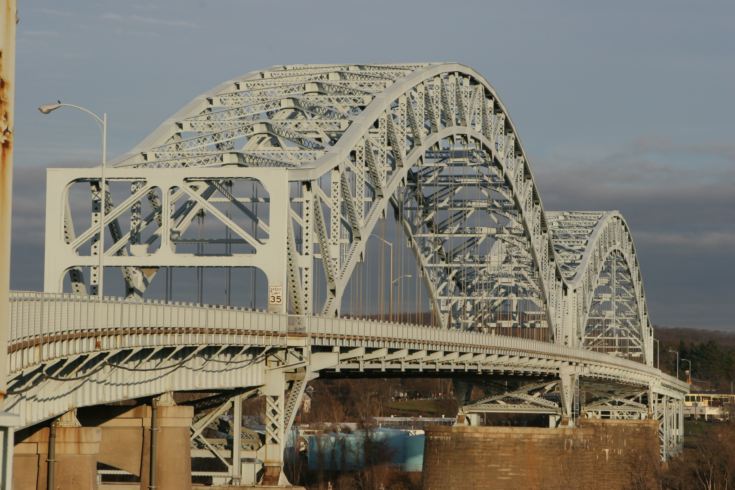
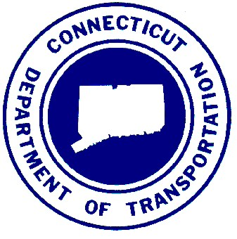
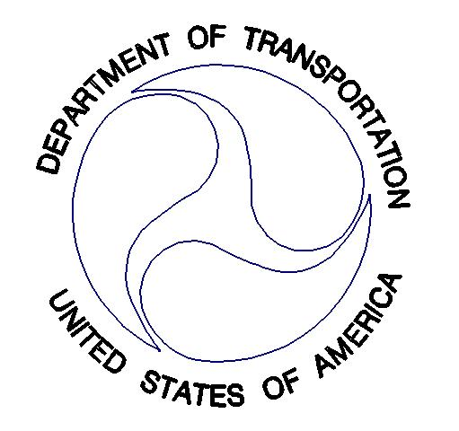
Middletown Area
River Crossing Study
Prepared by the Connecticut Department of Transportation in
Cooperation with the Federal Highway Administration

Existing Conditions
And
Future No Build Report
11/16/2007

Environmental
And
Social Tables

Environmental
And
Social Figures

Study Area
Map
Questions pertaining to this document should be submitted to:
Carmine P. Trotta
Assistant Director of Intermodal Planning
Bureau of Policy and Planning
Connecticut Department of Transportation
P.O. Box 317546
Newington, CT 06131-7546

Preliminary Alternatives Development
Technical Report No. 2
July 2008

