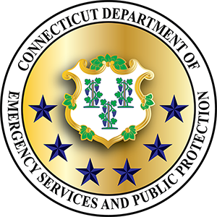 | State of Connecticut  Department of Emergency Services and Public Protection Division of Emergency Management & Homeland Security  Strategic Planning & Grant Administration Unit | 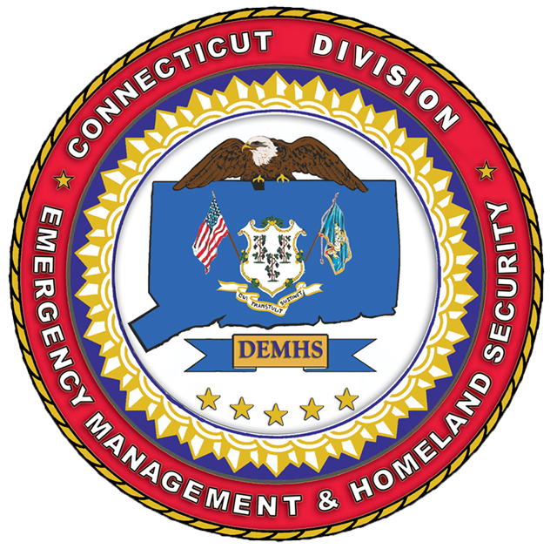
Completion Report for Citizen Corps Program Funding
Training (Cat. A & B), Equipment (Cat. D) and Statewide Applications (Cat. E)
(Revised: May, 2016)
Please refer to the Connecticut Statewide Citizen Corps Program Handbook for application and program guidance

- Name, title and address of eligible applicant:

- Federal Employer Identification Number (FEIN):

- Eligible applicant telephone number and email:

- Name and email address of person completing form:

- Project title: Approval Date: (DEMHS e-mail approval)
- Date completion report submitted:

- Select type of approval received:
- Category A: Initial CERT Training. Maximum funding: $1,200*
- Category B: Advanced Training. Maximum funding $1,000
Category C: Please see separate Planning Completion Report on DESPP/DEMHS website

- Category D: CERT Equipment Max Funding: $1,000 Eligible applicants can apply for one Equipment Grant per calendar year
- Category E: Statewide Applications
Please note: training must have started within 180 days of approval and completed within 270 days to be eligible for reimbursement.

- Summary of completed project: (for training include dates of training, number of students etc.)

- Financial Report
Category | Approved Budget | Amount Expended
Instructor Costs
Travel
Training Equipment
Training Supplies
Facility Fees
Other Eligible Items
Total

- Amount of Citizen Corps Program funding being requested:
- Attachments:
- Copies of invoices and proof of payment (copies of checks, financial system generated reports showing payment date, check number, vendor name, and payment amount).
- For training (Category A and B): Please attach the final class roster

I hereby certify that the project outlays shown have been made in accordance with the applicable grant terms and conditions of the Citizen Corps Program funding (Homeland Security Grant Program).

________________________________________________ ______________________
Signature of Eligible Applicant Date

_________________________________________________ _______________________
Name (Print) Title (Print)

Please mail the completion report with original signatures to: Grants Unit, 3rd Floor North, 1111 Country Club Road, Middletown, CT 06457. Please send a copy of this request to your local or regional Citizen Corps Council.

