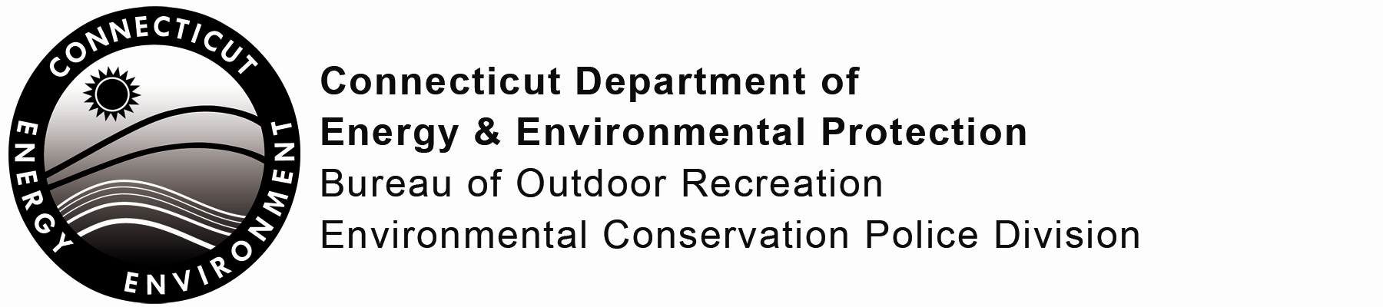

Request Commendation or File Complaint

This form provides a means of recognizing commendable activities by Connecticut Environmental Conservation (EnCon) Police Officers. This form may also be used to file a written complaint regarding actions or activities conducted by an EnCon Officer.

If this form is submitted as a commendation, it will be reviewed and recognition of the appropriate level will be afforded the officer(s) involved in accordance with Law Enforcement Division General Orders.

If this form is submitted as a complaint, it will be reviewed to determine if further investigation is required. If the complaint is sustained, the officer(s) involved may be subject to disciplinary action in accordance with Law Enforcement Division General Orders, DEEP’s Policies and Regulations of Connecticut State Agencies.

Part I: Form Type
Check the appropriate box identifying the application type.
This form is for (check one):
Commendation Complaint

Part II: Submitter Information
Name:
Mailing Address:
City/Town: State: Zip Code:
Daytime Phone: Evening Phone:

Part III: Details of the Commendation or Complaint
Please describe the actions of the officers (involved), including date, time, location, and incident or ticket number, if appropriate.
Check here if additional sheets are necessary, and label and attach them to this sheet.

Part III: Officer(s) Involved in the Commendation or Complaint
Please indicate name of officer, any other department employee or witnesses to the activity and include addresses and telephone numbers of witnesses if known.
Check here if additional sheets are necessary, and label and attach them to this sheet.

IV. Certification
The individual submitting this form must complete this Part. *Note: If this form is submitted by e-mail, the Signature does not need to be provided.
“I have personally examined and am familiar with the information submitted in this document and all attachments thereto, and I certify that the submitted information is true, accurate and complete to the best of my knowledge and belief.

I understand that a false statement in the submitted information may be punishable as a criminal offense, in accordance with section 22a-6 of the General Statutes, pursuant to section 53a-157b of the General Statutes, and in accordance with any other applicable statute.”

* Signature of Submitter |  | Date
Name of Submitter (print or type)

I wish to remain anonymous (Do not sign or print name above.)

Note: Please submit the completed signed form to:
ENVIRONMENTAL CONSERVATION POLICE DIVISION
BUREAU OF OUTDOOR RECREATION
DEPARTMENT OF ENERGY AND ENVIRONMENTAL PROTECTION
79 ELM STREET
HARTFORD, CT 06106-5127

or submit the completed form via e-mail to:
DEEP.EnConPolice@ct.gov

The Connecticut Department of Energy and Environmental Protection is an Affirmative Action/Equal Opportunity Employer that is committed to complying with the requirements of the Americans with Disabilities Act. Please contact us at (860) 418-5910 or deep.accommodations@ct.gov if you: have a disability and need a communication aid or service; have limited proficiency in English and may need information in another language; or if you wish to file an ADA or Title VI discrimination complaint.

