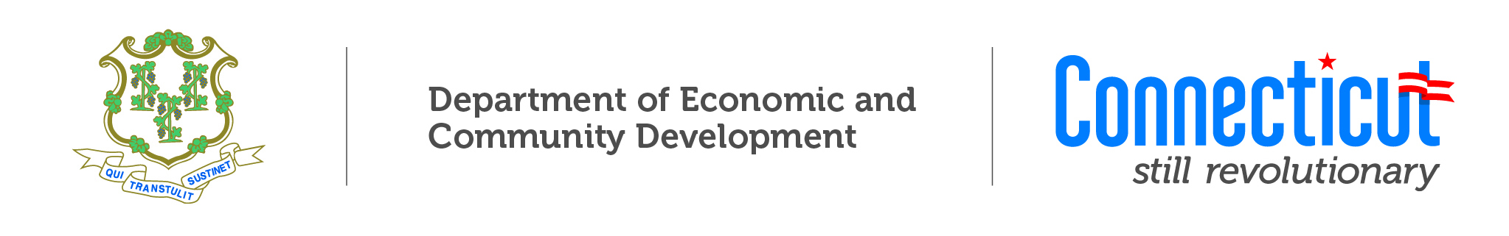
Dry Cleaning Establishment Remediation Fund
Application Intake Form

State of Connecticut
Department of Economic and Community Development
[PLEASE NOTE THAT DECD IS NOT ACCEPTING ANY NEW APPLICATIONS AT THIS TIME]

Program Description

The program is funded through a 1% surcharge on the gross receipts collected from Connecticut dry cleaners. DECD provides grants of up to $300K for the environmental assessment and cleanup of eligible sites.
Note

This is a State of Connecticut funded program for which eligibility of the applicant and/or project will be determined upon completion of the application process.

Upon completion of this intake form, DECD will provide applicants with a notification of their place in line on the waiting list to receive funding as it becomes available. Prior to receiving funds, applicants will need to fill out a supplemental application form with further details on the proposed project.

Projects funded under this program may be subject to environmental regulations. Please contact DECD at drycleaning@ct.gov for further information on program requirements.

Applications will be accepted via drycleaning@ct.gov when a funding round is announced.

APPLICANT INFORMATION: AMOUNT REQUESTED: $

Applicant Name: First Time Applicant
Property Owner
Dry Cleaning Business Owner
Dry Cleaning Operator/Tennant
How long has dry cleaning taken place at the site:
Applicant Mailing Address:

Telephone #: Email Address:

Applicant FEIN #/SS#: CT Tax Registration #:

DRY CLEANING BUSINESS INFORMATION:

Establishment/Business Name:

Establishment/Business Address:

Telephone #: Email Address:

Applicant FEIN #/SS#: CT Tax Registration #:

PROJECT INFORMATION:

Please check off which of the following will be addressed by this project:
Environmental Site Assessment
Site Remediation
Other (describe)

Provide a brief project description and land use history of the site including:
- Historic uses (including a discussion of hazardous dry cleaning chemical/waste handling, storage, and disposal practices);
- Identified and potential contamination at the site;
- Extent of pollution that has been identified;
- Current operational practices;
- List of all environmental reports prepared for the property site;
- Proposals, scope of work and/or estimates for proposed environmental work

REQUIRED DOCUMENTS:

Connecticut dry cleaning surcharge Form OP-374 for the last four quarters
(if applicable)
Letter from applicant certifying that they are current on all taxes

