DOCKET NO. 431 – South Norwalk Electric and Water application for a Certificate of Environmental Compatibility and Public Need for the construction, maintenance, and operation of an electrical substation and its connection to an existing 115 kV transmission line, located at 180 Dr. Martin Luther King, Jr. Drive, Norwalk, Connecticut. | }  }  }  } | Connecticut  Siting  Council  March 21, 2013

Findings of Fact

Introduction

1. The Second Taxing District of the City of Norwalk, Connecticut, South Norwalk Electric and Water (SNEW), in accordance with provisions of Connecticut General Statutes (CGS) Sections 16-50g et seq., and Section 16-50j-1 et seq. of the Regulations of Connecticut State Agencies, applied to the Connecticut Siting Council (Council) on September 11, 2012 for the construction, maintenance, and operation of an electric substation at 180 Dr. Martin Luther King, Jr. Drive, Norwalk, Connecticut (refer to Attachment 1). (SNEW 1, pp. 1, 32)

2. SNEW is franchised to provide electric service within Norwalk’s Second Taxing District. SNEW serves 6,700 customer accounts (i.e. meters) within its service area. SNEW’s service area generally includes the South Norwalk area that is bounded by the Norwalk River on the east; Interstate 95 and Connecticut Avenue on the north; Francis Avenue/Arbor Drive/Glasser Street/Bouton Street on the west; and Knapp Street/Neptune Avenue on the south (refer to Attachment 2). (SNEW 1, p. 9)

3. The purpose of the proposed facility is to improve reliability and increase capacity to meet forecast load growth in the South Norwalk area. (SNEW 1, p.1)

4. Pursuant to CGS § 16-50m, the Council, after giving due notice thereof, held a public hearing on December 11, 2012, beginning at 3:00 p.m. and continuing at 7:00 p.m. at the Norwalk City Hall, 125 East Avenue, Norwalk, Connecticut. (Transcript 1 – December 11, 2012 at 3:00 p.m. [Tr. 1], p. 3; Transcript 2 – December 11, 2012, at 7:00 p.m. [Tr. 2], p. 3)

5. The Connecticut Light and Power Company (CL&P) is a party to the proceeding. (Tr. 1, p. 4)

6. The Council and its staff made an inspection of the proposed site on December 11, 2012, beginning at 2:00 p.m. (Council’s Hearing Notice dated October 19, 2012)

7. Pursuant to CGS § 16-50l(b), public notice of the filing of the application to the Council was published in The Norwalk Hour. (SNEW 1, pp. 105-106)

8. On November 30, 2012, SNEW erected a sign on the eastern side of the subject property describing the proposed project. The sign included the date and location of the Council’s public hearing, and contact information for the Council. (Tr. 1, p. 13)

9. Pursuant to CGS § 16-50l (b), notice of the application was provided to all abutting property owners by certified mail. (SNEW 1, p. 106)

10. Of the 33 abutters who were sent notices, return receipts were initially received from all but six abutters. Two notices were resubmitted to new forwarding addresses and receipts were received. Four notices were returned as “unclaimed” and “unable to forward.” (SNEW 2, response 1; Tr. 1, pp. 13-14)

11. Pursuant to CGS § 16-50l(b), SNEW provided notice to all federal, state and local officials and agencies listed therein. (SNEW 1, pp. 104-105)

12. SNEW provided a copy of the application to the Connecticut Energy Advisory Board (CEAB). Pursuant to CGS § 16-50l(a)(2), the project is exempt from the CEAB mandatory request for proposal process. No comment from the CEAB was received. (SNEW 1, p. 107)

State Agency Comment

13. Pursuant to CGS § 16-50j(h), on October 19, 2012, the following State agencies were solicited by the Council to submit written comments regarding the proposed facility: Department of Agriculture, Department of Energy & Environmental Protection (DEEP), Department of Public Health, Council on Environmental Quality, Public Utilities Regulatory Authority, Office of Policy and Management, Department of Economic and Community Development, the Department of Transportation (DOT), and the Department of Emergency Services and Public Protection. (Record)

14. No State agencies commented on the proposal. (Record)

Municipal Consultation

15. On February 21, 2012, SNEW met with City of Norwalk officials (Mayor, Director of Planning and Zoning, and Corporation Council) to initiate the presentation of the proposed substation project. (SNEW 1, p. 100)

16. In March 2012, SNEW met with Norwalk’s Planning and Zoning Director to provide a project update and schedule. SNEW also met with CL&P and Metro-North Railroad representatives to discuss the project, schedule, and restrictions. (SNEW 1, p. 100)

17. On April 19, 2012, SNEW submitted a technical report to the Mayor of Norwalk thereby initiating the formal municipal consultation process. (SNEW 1, p. 103-104)

18. On May 10, 2012, SNEW appeared before the City of Norwalk Plan Review Committee. (SNEW 1, p. 101)

19. On May 16, 2012, SNEW attended a public hearing for the Norwalk Planning and Zoning Commission. SNEW received favorable feedback from the City of Norwalk. (SNEW 1, p. 101)

Project Need

20. SNEW’s peak forecast summer load (based on an existing customer base) is expected to increase from 20.4 megawatts (MW) in 2013 to 22.0 MW in 2021. This is an increase of approximately 7.8 percent. (SNEW 1, p. 17)

21. SNEW’s peak demand, which was recorded in July 2011, was 21.8 MW. (SNEW 1, p. 12)

22. SNEW’s current power factor is approximately 0.91. (Tr. 1, pp. 18-19)
23. 21.8 MW divided by the current power factor of 0.91 results in approximately 24 megavolt-amperes (MVA). (Tr. 1, pp. 18-19)

24. In addition to existing customer load growth predicted in SNEW’s forecast, additional growth is expected as a result of proposed new urban development projects including the 95/7 District and Spinnaker Development, both endorsed by the City of Norwalk. These projects would each increase the forecast loads by 7 to 10 MW and 2 MW, respectively. (SNEW 1, pp. 12 and 13)

25. Currently, SNEW’s sole source of outside power depends on two 27.6 kilovolt (kV) circuits that originate at CL&P’s Flax Hill Substation and serve SNEW’s existing State Street Substation. (SNEW 1, pp. 13, 20)

26. SNEW does not presently have the capacity to reliably serve the new urban development initiatives. (SNEW 1, p. 13)

27. SNEW’s State Street Substation has a total base capacity of 30 MVA. Thus, the existing SNEW system could not accommodate any new major loads in the South Norwalk Area. (SNEW 1, p. 20)

28. The proposed substation would provide 40 MVA firm capacity in the event that only one transformer is in service or 80 MVA redundant capacity with both transformers in service. (SNEW 1, p. 13)

29. SNEW’s existing system presently includes two different distribution voltages: 13.8 kV and 4.16 kV. The proposed substation allows conversion to one uniform system-wide distribution voltage of 13.8 kV. (SNEW 1, p. 20)

30. SNEW presently pays CL&P $750,000 per year for the use of CL&P’s 27.6 kV circuits. The proposed substation would connect directly to the 115 kV transmission system, and thus, it would eliminate this cost for SNEW’s ratepayers. (SNEW 1, p. 14)

31. The existing State Street Substation was built in the early 1960s. Its three 27.6 kV oil circuit breakers are approximately 47 years old. The outdoor 15 kV switchgear is at least 40 years old. (SNEW 1 p. 10)

32. The long term reliability of the substation equipment at State Street Substation is a concern given the age. Specifically, two separate 13.8 kV transformers failed within two years of each other. (SNEW 1, p. 14)

Alternatives

33. Expansion of the existing State Street Substation was considered by SNEW, but was rejected because the layout and limited size of the site are not conducive to expansion. (SNEW 1, p. 27)

34. SNEW considered several alternatives suggested by CL&P.

a) Construction of two new 27.6 kV overhead lines to link SNEW with CL&P.
b) Construction of two new 13.8 kV overhead lines to link SNEW with CL&P.
c) Construction of new 27.6 kV underground cables to link SNEW with CL&P.
d) Construction of a new 115 kV transmission line to link SNEW with CL&P.

However, all of these alternatives were rejected because they would require SNEW to upgrade CL&P’s facilities at SNEW’s expense. (SNEW 1, pp. 23-24)

35. SNEW investigated three raw land sites as possible substation locations. These properties and the determinations of their suitability are listed below.

a) 85 Martin Luther King Jr. Drive Site – SNEW rejected this site because clearance space to fence line is an obstacle. In addition, extension of transmission lines to the site would be required.
b) 1 Bates Court Site – SNEW rejected this site because a mobile substation (transformer) would not fit on this site. In addition, this site is not owned by SNEW.
c) 180 Martin Luther King Jr. Drive – This is the proposed site.
(SNEW 1, pp. 30-32)

Site Location

36. The proposed site is 1.07 acres and is owned by SNEW. (SNEW 1, p. 1)

37. The proposed site includes two adjoining parcels located adjacent to and west of Dr. Martin Luther King, Jr. Drive in the southwestern portion of Norwalk’s Second Taxing District. (SNEW 1, p. 1)

38. SNEW currently uses the northern half of the site for outdoor storage of materials and equipment for its electric distribution system operation. (SNEW 1, p. 1)

39. The proposed site is zoned industrial. (SNEW 1, p. 1)

40. The southern portion of the site was formerly occupied by a residence and garage that were recently demolished. (SNEW 1, p. 2)

41. Surrounding land uses include Dr. Martin Luther King, Jr. Drive to the east, Metro-North Railroad tracks and a CL&P 115 kV transmission line to the west, a United Parcel Service warehouse to the south, and residences to the east. Residences and commercial land uses are also present to the west of the Metro-North tracks. (SNEW 2, response 2; Tr. 1, p. 37)

42. The nearest residence is located at 20 Bouton Street, approximately 183 feet northwest of the proposed substation (refer to Attachment 3). (SNEW 2, response 6)

43. There are approximately 262 residences within 1,000 feet of the center of the proposed substation site. (SNEW 2, response 4)

Proposed Substation Description

44. The substation would be roughly trapezoid-shaped with sides approximately 100 feet long on the north side, 175 feet long on the south side, 240 feet long on the east side, and 300 feet long on the west side (refer to Attachment 4). (SNEW 1, Tab 3)

45. The substation would be surrounded by a seven-foot high chain link fence with an additional foot of barbed wire on top. (SNEW 1, pp. 37)

46. The proposed distribution-related substation equipment would be owned and operated by SNEW. This includes two 24/32/40 MVA power transformers, associated circuit breakers, circuit switchers, and disconnect switches. SNEW would also have a connection for a mobile transformer if one is ever needed. (SNEW 1, p. 38)

47. SNEW would also have a fabricated metal control house approximately 25 feet by 20 feet by 15 feet high. The control house contains the distribution substation’s relaying, control, metering, substation batteries, chargers, and monitoring equipment, including the distributed Supervisory Control and Data Acquisition (SCADA) system. (SNEW 1, p. 38)

48. SNEW would also have a 40-foot by 20-foot building to house the 15-kV switchgear. (SNEW 1, p. 39)

49. SNEW would design the substation for six distribution feeders. Each transformer would support three distribution feeders. New underground ducts would be installed to connect the substation to SNEW’s existing distribution system, which is located within Dr. Martin Luther King, Jr. Drive south of the railroad bridge. (SNEW 1, p. 41)

50. The proposed substation would connect to the existing CL&P 115 kV transmission line #1890 located in the Metro-North Railroad right-of-way directly west of the site. (SNEW 1, Tab 3 and p. 37)

51. CL&P would own, operate, and maintain the transmission-related equipment at the substation, including three new approximately 90-foot transmission line steel poles that would be installed in the railroad right-of-way. The new poles would facilitate realignment of the current lines so as to allow their horizontal configuration within the proposed substation. (SNEW 1, p. 39; Tr. 1, pp. 55-56; CL&P 1)

52. CL&P’s new poles would be comparable in height to existing 100-foot pole height on the railroad right-of-way. (Tr. 1, p. 55-56)

53. CL&P would also own, operate, and maintain two new steel A-frame terminal structures within the new substation. These structures would complete the transition of the transmission lines from vertical in the DOT right-of-way to horizontal within the proposed substation. These terminal structures would be approximately 60 to 70 feet high and would also support line disconnect and line monitoring and protection. (SNEW 1, p. 39; CL&P 1)

54. CL&P’s transmission control house would be approximately 36 feet by 24 feet and contain the transmission communication, control, and monitoring and protection systems. CL&P’s control house would also contain the transmission SCADA system for control, status reporting and recording. Power panels for the station and its own direct current (DC) power system, including DC panels, batteries and charger, as well as heating, ventilation and air conditioning would be included. (SNEW 1, p. 39)

55. The substation would have two separate access asphalt driveways. Each would have its own gate. One access drive would be for SNEW to access its area. The other would be for CL&P to access its area. Both gates would be located on the eastern portion of the site to provide access from Dr. Martin Luther King Jr. Drive. (SNEW 1, p. 42; Tr. 1, p. 16)

56. The construction phase of the project is expected to take approximately 13 months. (SNEW 1, p. 52)

57. The nominal service life of the substation equipment is 40 years. (SNEW 1, p. 42)

58. The estimated cost of the proposed substation facility is:

Engineering/project team $1,005,000.
Materials $5,574,000.
Construction $12,282,000.

Total $18,861,000.
(SNEW 1, p. 51)

Environmental Considerations

59. There are no Connecticut-regulated inland wetlands or watercourses at the proposed site or proximate to the site. The nearest wetlands are located over one-half mile southeast of the proposed site. (SNEW 1, p. 72 and Tab 6)

60. There are no known state or federal endangered, threatened, or species of special concern in the vicinity of the proposed project. (SNEW 1, p. 64)

61. There are no reported archaeological or historic architectural properties within or adjacent to the project area. (SNEW 1, Tab 7)

62. The site is located over 4,000 feet from the nearest 500-foot flood zone and almost 2,000 feet from the nearest 100-year flood zone. No special design or construction measures are required to address possible flooding. (SNEW 2, response 7)

63. The subject property is not located within the coastal zone or coastal boundary area. (SNEW 1, p. 82)

64. The total amounts of cut and fill required for the proposed project would be 1,300 cubic yards and 2,770 cubic yards, respectively. (SNEW 2, response 10)

65. Erosion and sedimentation controls would be consistent with the 2002 Connecticut Guidelines for Erosion and Sedimentation Control. (Tr. 1, p. 16)

66. Bedrock beneath the site ranges in depth from approximately 15 feet in the southern portion to more than 50 feet in the northern portion, so it is not expected that significant rock removal would be necessary. (SNEW 2, response 12)

67. Mechanical methods of rock removal would be used in lieu of blasting to the extent necessary and feasible. (SNEW 2, response 12)

68. Each transformer would contain approximately 6,000 gallons of insulating oil, and an oil containment system consisting of a sump with the capacity to contain 200 percent of the oil volume in the event of an oil spill or leak. (SNEW 1, p. 38)

69. There are three classes of noise zones and are listed as follows.
a) Class A – Land uses generally designated for residential use or areas where serenity and tranquility are essential to the intended use.
b) Class B – Land uses generally of a commercial nature, including transportation, communication, and utilities.
c) Class C – Land uses generally of an industrial nature.

(SNEW 1, Tab 10, p. 2; CSC Admin Notice No. 22)

70. DEEP sound level limits are listed below.

Sound Level Limits (dBA) | Class A receptor (daytime) | Class A receptor (nighttime) | Class B receptor (day and night) | Class C receptor (day and night)
Class A Emitter | 55 | 45 | 55 | 62
Class B Emitter | 55 | 45 | 62 | 62
Class C Emitter | 61 | 51 | 66 | 70
(SNEW 1, Tab 10, p. 1; CSC Admin Notice No. 22)

71. The City of Norwalk noise control ordinance sets limits identical in level and format to DEEP. (SNEW 1, Tab 10, p. 2)

72. DEEP sound level limits and nearest receptors are listed below.

Location | DEEP Sound Limit | Class A receptor (nighttime)
Residence - North | 40 | 27
Residence - East | 40 | 33
Commercial - South | 57 | 41
Residence - West | 40 | 32
(SNEW 1, Tab 10, p. 4)

73. Noise levels at the nearest receptors are expected to be in compliance with DEEP and City of Norwalk noise regulations. (SNEW 1, Tab 10, p. 4)

Visibility

74. Existing visibility of the site from the west includes views of the Metro-North railroad line with associated catenary structures and CL&P’s transmission structures. Existing views of the site from the east include views of CL&P transmission and Metro-North Railroad structures as well as existing vegetation east of the railroad tracks. (SNEW 1, Tab 4)

75. The proposed substation would be visible from abutting properties on the Metro-North side of the site. The substation would also be visible from residences abutting its side along Dr. Martin Luther King, Jr. Drive. (refer to Attachment 5). (SNEW 1, Tab 9)

76. Vinyl strips would be used on the chain link fence on the south and west sides as a visual shield from adjacent properties. (SNEW 1, p. 48; Tr. 1, p. 16)

77. The east and northern sides of the substation would be landscaped with vegetation. (Tr. 1, p. 16)

78. The existing trees and shrubs along the southern and western boundaries would be maintained to the extent practical. (SNEW 1, p. 48)

79. The nearest State-designated scenic road is Route 15 in the Town of Easton, approximately 10.7 miles northeast of the proposed substation. (SNEW 2, response 6)

80. The substation yard would contain manually-operated floodlights affixed to substation terminal structures. These lights would be used to facilitate work at night or during inclement weather. (SNEW 1, p. 82)

81. Additional lighting would be installed on the control house and switching buildings facing towards the doors. These lights would be operated from dusk to dawn. (SNEW 1, p. 82)

82. The substation lighting is not expected to impact existing residences in the vicinity of the property. (SNEW 1, p. 82)

Magnetic Field Levels

83. Electric fields (EF) and magnetic fields (MF) are two forms of energy that surround an electrical device. Transmission lines are a source of both EF and MF. (Council Admin. Notice No. 10)

84. EF is produced whenever voltage is applied to electrical conductors and equipment. Electric fields are typically measured in units of kilovolts/meter. As the weight of scientific evidence indicates that exposure to electric fields, beyond levels traditionally established for safety, does not cause adverse health effects, and as safety concerns for electric fields are sufficiently addressed by adherence to the National Electrical Safety Code, as amended, health concerns regarding Electric and Magnetic Fields focus on MF rather than EF. (Council Admin. Notice No. 10)

85. MF is produced by the flow of electric currents. The magnetic field at any point depends on the characteristics of the source, including the arrangement of conductors, the amount of current flow through the source, and the distance between the source and the point of measurement. Magnetic fields are typically measured in units of milligauss (mG). (Council Admin. Notice No. 10)

86. The highest levels of EF and MF around the perimeter fence of a substation typically occur where transmission and distribution lines cross over or under the substation boundary. (SNEW 1, p. 95)

87. The MF field levels from substation equipment decrease rapidly with distance, reaching very low levels at relatively short distances beyond the fenced-in equipment. (SNEW 1, p. 95)

88. At the site of the proposed substation, the highest existing MF was measured in the southwest corner of the proposed fence line, which is close to the existing transmission line and railroad catenary. (SNEW 1, p. 95)

89. Existing and predicted post-construction magnetic field levels are listed below.

Location | Existing MF Levels (mG) | Predicted MF Levels (mG)
Northern edge of fence line | 9 | 139
Eastern edge of fence line | 2 | 35
Southern edge of fence line | 15 | 29
Western edge of fence line | 15 | 39
(SNEW 1, Tab 11, p. 15)

90. The highest predicted MF level of 139 mG would be directly over the 13.8 kV underground distribution lines, but would decrease rapidly with distance. (SNEW 1, Tab 11, p. 1)

91. The nearest home, approximately 183 feet away, would experience a 5 mG increase in MF during worst-case peak load conditions. (Tr. 1, p. 40-41)

92. The project would be consistent with the Council’s Electric and Magnetic Fields Best Management Practices for the Construction of Electric Transmission Lines in Connecticut, dated December 14, 2007. (Tr. 1, p. 40)

93. International health and safety agencies, including the World Health Organization, the International Agency for Research on Cancer (IARC), and the International Commission on Non-Ionizing Radiation Protection (ICNIRP), have studied the scientific evidence regarding possible health effects from MF produced by non-ionizing, low-frequency 60-Hertz alternating currents in transmission lines. Two of these agencies attempted to advise on quantitative guidelines for mG limits protective of health, but were able to do so only by extrapolation from research not directly related to health: by this method, the maximum exposure advised by the International Committee on Electromagnetic Safety (part of IARC) is 9,040 mG, and the maximum exposure advised by the ICNIRP is 2,000 mG. Otherwise, no quantitative exposure standards based on demonstrated health effects have been set world-wide for 60-Hertz MF, nor are there any such state or federal standards in the U.S. The existing and calculated MF levels for this project are well below these recommended exposure levels. (Council Administrative Notice Item 10; SNEW 1, Tab 11)

Safety and Reliability

94. Construction of the proposed substation would comply with the standards of the National Electrical Safety Code. (SNEW 1, p. 78)

95. ISO New England, Inc. has determined that the project would not have a significant adverse effect upon the reliability or operating characteristics of the transmission system. (SNEW 1, Tab 7)

96. In the event of a 115 kV transmission line fault, the loop-through substation design would allow the faulted section of the transmission line to be isolated. (SNEW 1, p. 78)

97. In the event of an outage of one new 115 kV circuit, the loop-through configuration would allow SNEW to obtain power for the substation from the other circuit. (SNEW 1, p. 38)

98. In the event of equipment failure, protective relaying equipment would remove the equipment from service. (SNEW 1, p. 78)

99. Other devices installed within the substation would constantly monitor the substation equipment to alert SNEW and CL&P to any abnormal or emergency situations. (SNEW 1, p. 97)

100. The protective relaying scheme has fully redundant primary and backup equipment so that an outage of one relay scheme does not require that portion of transmission being monitored to be removed from service. (Tr. 1, pp. 78-79)

101. Appropriate signage would be posted at the substation to alert the public to a high-voltage substation facility. (SNEW 1, p. 80)

102. The gates at each entrance would be locked. (SNEW 1, p. 97)

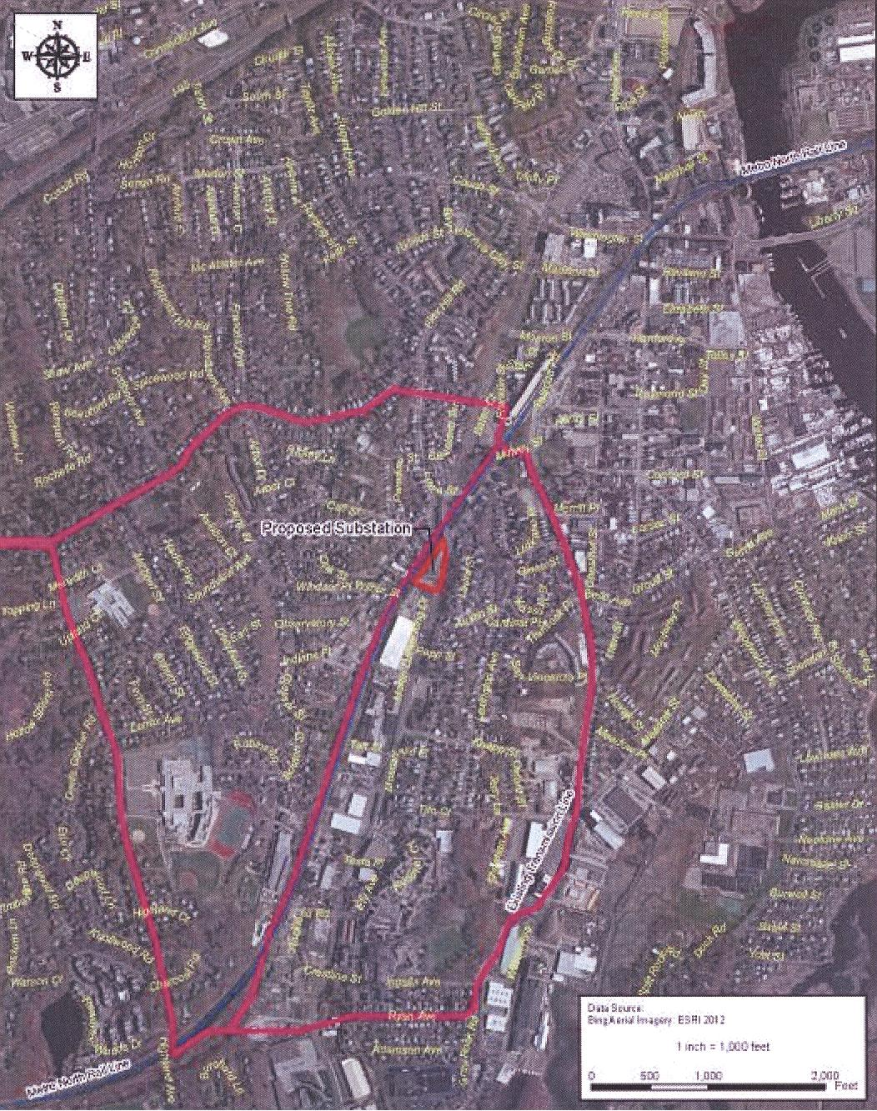
Attachment 1: Site Location at 180 Dr. Martin Luther King Jr. Drive, Norwalk
(SNEW 1, Tab 1)
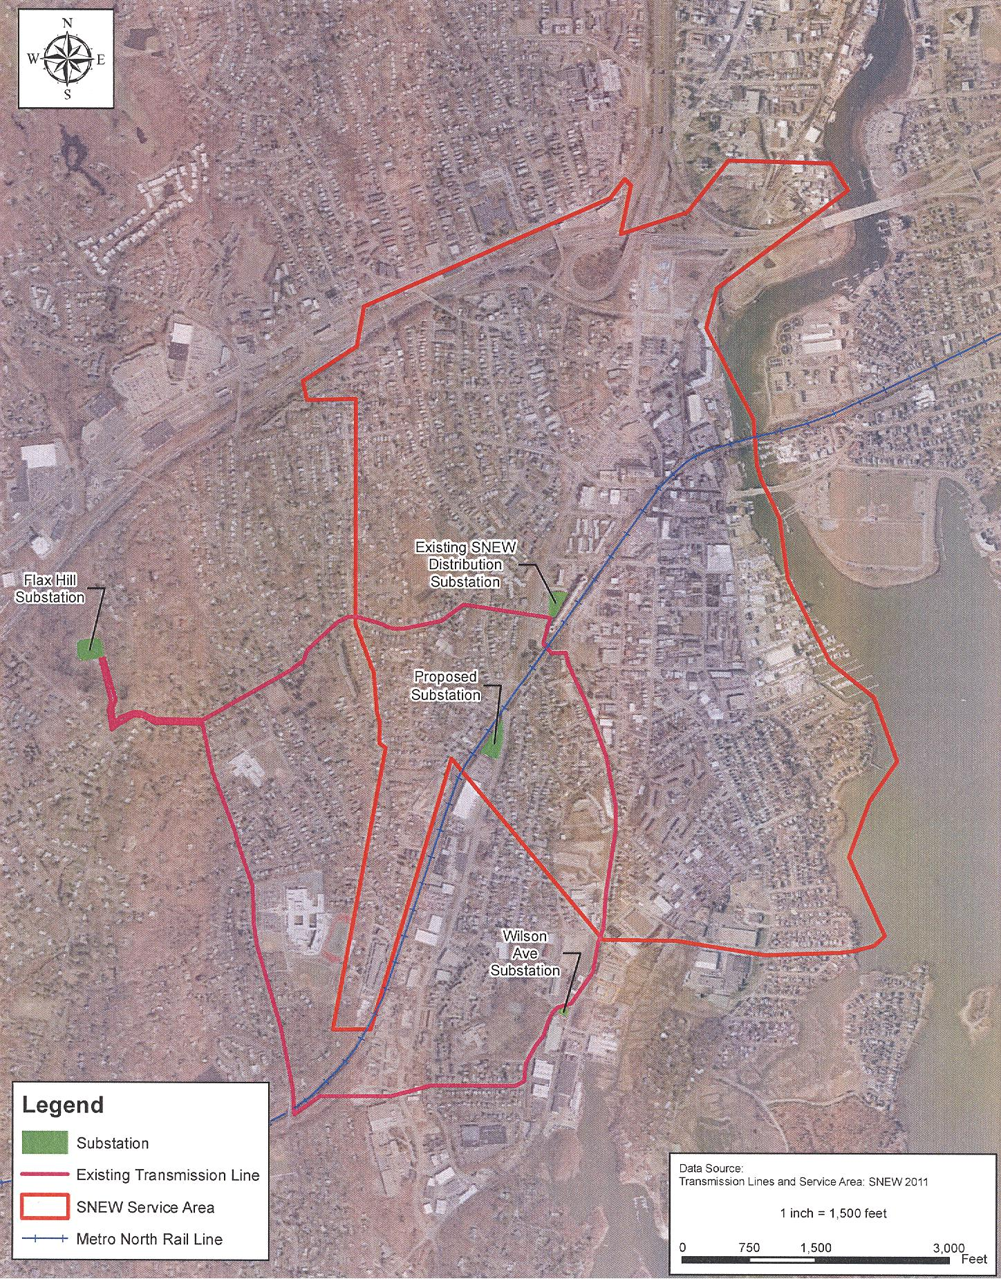
Attachment 2: SNEW service area
(SNEW 1, Tab 1)
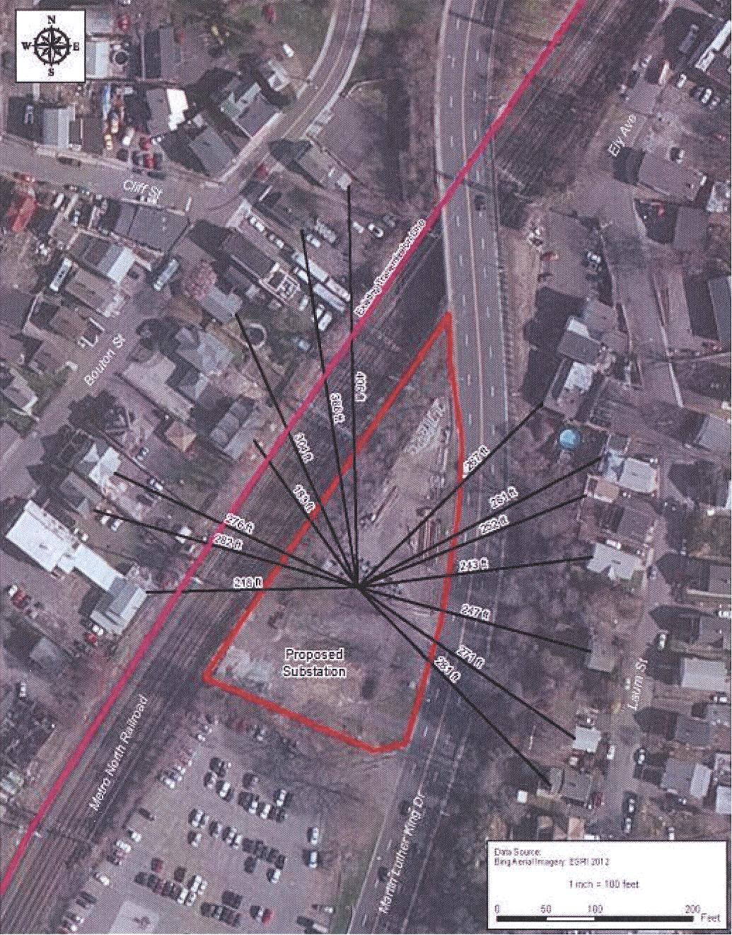
Attachment 3: Site Location with Distances to Residences
(SNEW 1, p. 88)
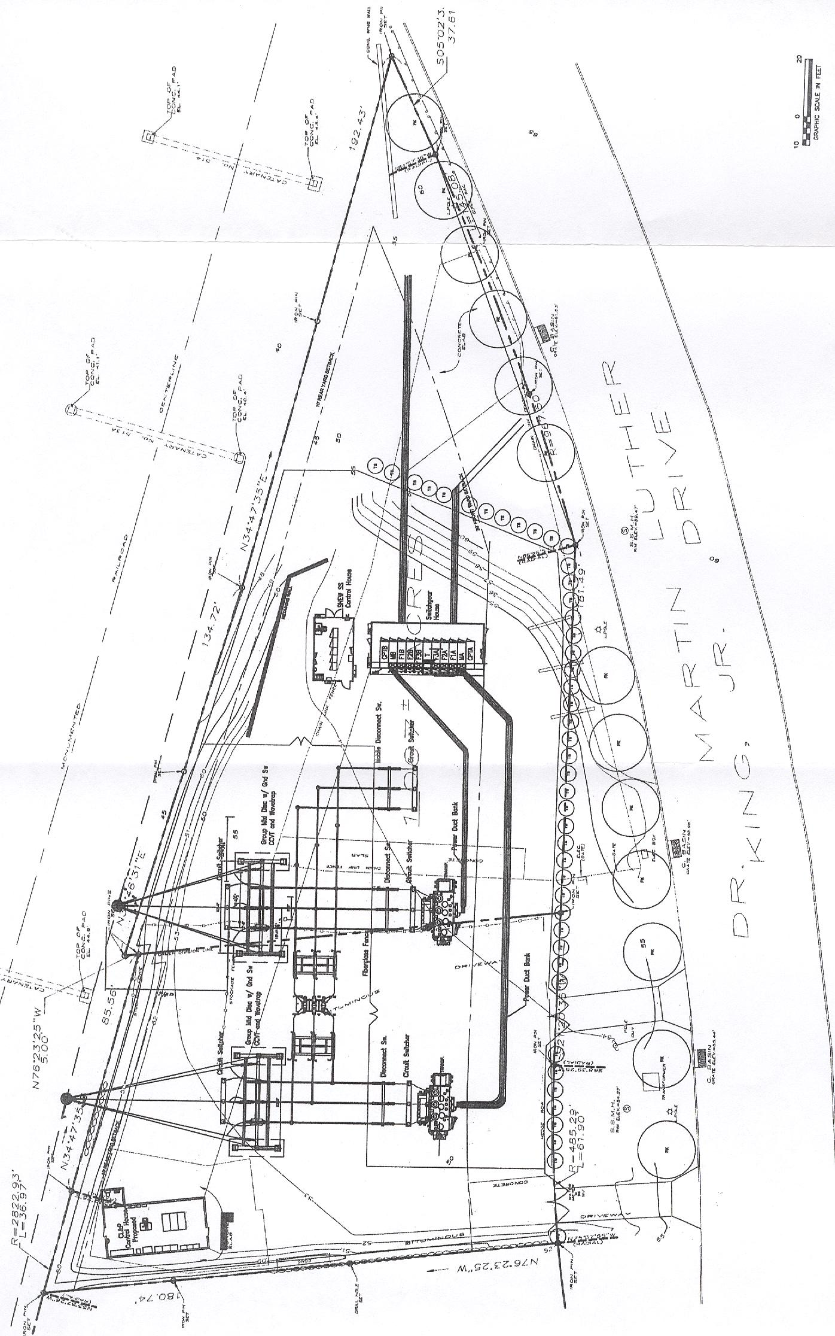
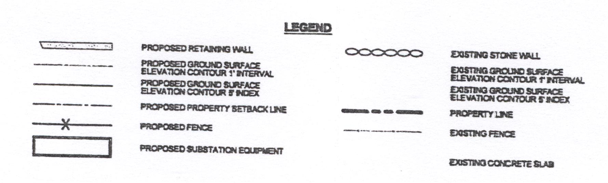
Attachment 4: Proposed Substation Site Plan (not to scale)
(SNEW 1, Tab 3)

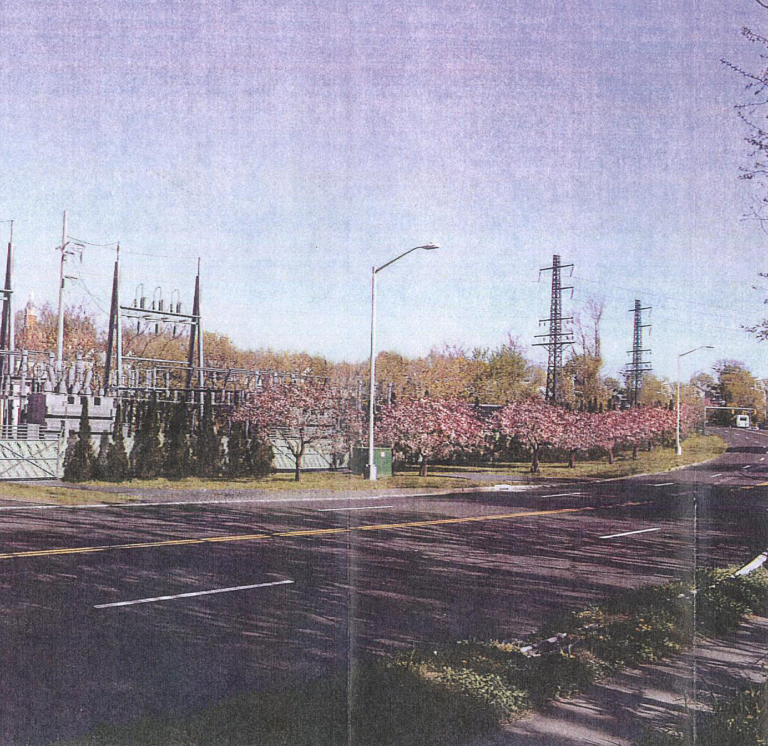
Attachment 5: Photo-simulation of Proposed Substation as viewed from Dr. Martin Luther King, Jr. Drive

(SNEW 1, Tab 9)

