DOCKET NO. 425 – Message Center Management application for a Certificate of Environmental Compatibility and Public Need for the construction, maintenance, and operation of a replacement telecommunications facility located at 4 Dittmar Road, Redding, Connecticut. | }  }  } | Connecticut  Siting  Council  June 21, 2012

Findings of Fact

Introduction

- Message Center Management, Inc. (MCM), in accordance with provisions of Connecticut General Statutes (CGS) § 16-50g et. seq., applied to the Connecticut Siting Council (Council) on January 9, 2012 for the construction, maintenance, and operation of a telecommunications facility, which would replace an existing 110-foot tall guyed lattice tower with a 120-foot tall monopine telecommunications tower, at 4 Dittmar Road in the Town of Redding (Town), Connecticut. (MCM 1, pp. 1-3)

- MCM is a Connecticut corporation with offices at 40 Woodland Street, Hartford, Connecticut. MCM owns and/or operates numerous telecommunications facilities in Connecticut, including the facility at 4 Dittmar Road. (MCM 1, p. 4)

- The parties in this proceeding are MCM and the Town of Redding. T-Mobile Northeast LLC (T-Mobile) is an intervenor. (Transcript, March 27, 2012, 3:00 p.m. [Tr. 1], p. 5)

- The purpose of this application is to replace an existing tower that has reached the end of its useful life and lacks the structural capacity to accommodate additional antennas. The replacement tower would enable T-Mobile to add antennas to the tower to provide service in the vicinity of Route 107, Route 58 (Black Rock Turnpike) and other local roads. The tower replacement would also allow the carriers currently on the existing tower to upgrade their equipment. (MCM 1, pp. 1-2)

- Pursuant to CGS § 16-50l(b), MCM published public notice of its intent to submit this application on December 29, 2011 and January 5, 2012 in the Redding Pilot. (MCM 1, p. 5, Attachment 8; MCM 3 – Affidavit of Publication submitted 03/16/12)

- Pursuant to CGS § 16-50l(b), MCM sent, via certified mail, notices of its intent to file an application with the Council to each person appearing of record as owner of property abutting the property on which the proposed site is located. (MCM 1, p. 6; Attachment 8)

- MCM received return receipts from seven of the nine abutting property owners to whom it sent notices. MCM sent follow up letters via first class mail to Douglas Yeomans to an address available from the Redding Assessor’s records and to a post office box in Bethel obtained through www.whitepages.com. The letter sent to the address obtained through the Assessor’s office was returned as undeliverable. The letter sent to the post office box was not returned. MCM also sent a first class, follow up letter to Anthony and Marsha Arzt, from whom it did not receive a return receipt. (MCM 2- Responses to CSC Interrogatories, A1)

- Pursuant to CGS § 16-50l (b), MCM provided copies of its application to all federal, state and local officials and agencies listed therein. (NAT 1, p. 5; Attachment 8)

- On March 10, 2012, a representative of the applicant posted a sign notifying the general public of the pending application, the time and place of the scheduled public hearing, and contact information for the Council. (NAT 6 - Affidavit of Sign Posting, dated March 10, 2012)

- The Council and its staff conducted an inspection of the proposed site on March 27, 2012, beginning at 2:00 p.m. The applicant attempted to fly a balloon at the site to simulate the height of the proposed tower but could not due to high winds and concerns about getting the balloon string entangled in the existing tower. (Tr. 1, p. 13)

- Pursuant to CGS § 16-50m, the Council, after giving due notice thereof, held a public hearing on March 27, 2012, beginning at 3:00 p.m. and continuing at 7:00 p.m. in the Community Room of the Redding Community Center, 37 Lonetown Road in Redding, Connecticut. (Tr. 1, p. 3 ff.)

State Agency Comment

- Pursuant to CGS § 16-50j(h), on February 3 and March 29, 2012, the Council solicited comments on this application from the following state agencies: Department of Agriculture, Department of Energy & Environmental Protection (DEEP), Department of Public Health, Council on Environmental Quality, Public Utilities Regulatory Authority, Office of Policy and Management, Department of Economic and Community Development, the Department of Transportation (ConnDOT), and the Department of Emergency Management and Homeland Security. (CSC Hearing Package dated February 3, 2012; CSC Letter to State Department Heads dated March 29, 2012)

- The Council did not receive any comments from any state agencies. (Record)

Municipal Consultation

- MCM first contacted Redding’s First Selectman about its plans to replace its existing tower and modify the facility at 4 Dittmar Road early in 2011. MCM representatives met with the First Selectman on May 5, 2011 to discuss the proposed tower replacement. At this meeting, MCM provided a visual analysis of the proposed tower replacement. An updated visual analysis, based upon inquiries about various tower designs made by the First Selectman, was forwarded to the Town on May 24, 2011. This updated analysis included photo simulations of a monopine tower. MCM formally submitted a Technical Report summarizing its replacement plans to the Town of Redding on August 2, 2011. On this same date, MCM also submitted a Technical Report to town officials in Bethel, due to the proximity of this town’s boundary to the MCM facility. (MCM 1, p. 17)

- Upon receiving the MCM Technical Report, the Redding First Selectman convened a series of meetings with abutting property owners to elicit input on various alternative tower locations, tower designs, and screening. The property owners expressed various requests and preferences, many of which were incorporated into MCM’s application to the Council. (MCM 1, pp. 17-18)

- In a letter to the Council, the Town of Redding stated that it had concerns about the potential noise from air conditioning compressors and backup generators, screening of the facility, the final appearance of the monopine, the possibility of future expansion of the tower, and safety as it relates to the fall zone of the tower and wind effects on the proposed monopine. (Town of Redding Letter to Council, dated March 12, 2012)

- The Town of Redding has indicated an interest in locating antennas on the proposed tower. (Tr. 1, p. 14)

- The Town of Bethel did not seek any consultation from MCM after receiving its Technical Report. (MCM 1, p. 17)

Public Need for Service

- In 1996, the United States Congress recognized a nationwide need for high quality wireless telecommunications services, including cellular telephone service. Through the Federal Telecommunications Act of 1996, Congress seeks to promote competition, encourage technical innovations, and foster lower prices for telecommunications services. (Council Administrative Notice Item No. 4 - Telecommunications Act of 1996; NAT 1, p. 5)

- In issuing cellular licenses, the Federal government has preempted the determination of public need for cellular service by the states, and has established design standards to ensure technical integrity and nationwide compatibility among all systems. (Council Administrative Notice Item No. 4 - Telecommunications Act of 1996)

- The Telecommunications Act of 1996 prohibits local and state bodies from discriminating among providers of functionally equivalent services. (Council Administrative Notice Item No. 4 - Telecommunications Act of 1996)

- The Telecommunications Act of 1996 prohibits any state or local entity from regulating telecommunications towers on the basis of the environmental effects, which include human health effects, of radio frequency emissions to the extent that such towers and equipment comply with FCC’s regulations concerning such emissions. This Act also blocks the Council from prohibiting or acting with the effect of prohibiting the provision of personal wireless service. (Council Administrative Notice Item No. 4 - Telecommunications Act of 1996)

- In December 2009, President Barack Obama recognized cell phone towers as critical infrastructure vital to the United States. (Council Administrative Notice Item No. 9 - Barack Obama Presidential Proclamation 8460, Critical Infrastructure Protection)

- In recognition of the public safety benefits enhanced wireless telecommunications networks can provide, Congress enacted the Wireless Communications and Public Safety Act of 1999 (the 911 Act). The purpose of this legislation was to promote public safety through the deployment of a seamless, nationwide emergency communications infrastructure that includes wireless communications services. (Council Administrative Notice Item No. 5 - Wireless Communications and Public Safety Act of 1999, as amended)

- Pursuant to the tower sharing policy of the State of Connecticut under C.G.S. §16-50aa, if the Council finds that a request for shared use of a facility by a municipality or other person, firm, corporation or public agency is technically, legally, environmentally and economically feasible, and the Council finds that the request for shared use of a facility meets public safety concerns, the Council shall issue an order approving such shared use to avoid the unnecessary proliferation of towers in the state. (Conn. Gen. Stat. §16-50aa)

- The proposed replacement tower would enable T-Mobile to provide Enhanced 911 (E911) services in the surrounding area, in compliance with the 911 Act. (MCM 1, p. 8)

Existing and Proposed Wireless Coverage

T-Mobile

- In the area that would be covered by this facility, T-Mobile is licensed to use the following frequencies:

GSM Transmit: 1940 MHz to 1950 MHz
GSM Receive: 1860 MHz to 1870 MHz
UMTS Transmit 1: 2140 MHz to 2145 MHz
UMTS Transmit 2: 2110 MHz to 2120 MHz
UMTS Receive 1: 2140 MHz to 2145 MHz
UMTS Receive 2: 2110 MHz to 2120 MHz

(T-Mobile 2 - Responses to Council Interrogatories, A9)

- For its GSM network, T-Mobile uses -84 dBm for its minimum design threshold for in-vehicle coverage and -76 dBm for its minimum design threshold for in-building coverage. For its UMTS network, T-Mobile uses -98 dBm for its minimum design threshold for in-vehicle coverage and -91 dBm for its minimum design threshold for in-building coverage. (T-Mobile 2 - Responses to Council Interrogatories, A11)

- T-Mobile’s existing signal strengths in the area it is seeking to cover from this facility range from -76 dBm to -110 dBm for its GSM network and -84 dBm to -110 dBm for its UMTS network. (T-Mobile 2 - Responses to Council Interrogatories, A12)

- T-Mobile would utilize some of its licensed bandwidth for Long Term Evolution (LTE) technology. T-Mobile’s LTE bandwidth would be used only for data transmission and not for voice transmission. (Tr. 1, pp. 88-89)

- T-Mobile experiences an average dropped call rate of 8.15% for the major serving cells oriented toward the proposed facility’s coverage footprint. (T-Mobile 2 - Responses to Council Interrogatories, A13)

- T-Mobile considers a dropped call rate of more than two percent to be indicative of poor service in an area. (Tr. 1, p. 87)

- T-Mobile experiences coverage gaps of 8.5 miles along Route 58 and 4.8 miles along Route 107. (T-Mobile 2 - Responses to Council Interrogatories, A14)

- T-Mobile would be able to cover 3 miles along Route 58 and 2 miles along Route 107 from this facility. (T-Mobile 2 - Responses to Council Interrogatories, A15)

- T-Mobile would be able to cover 14.39 square miles at both GSM and UMTS frequencies from this facility. (T-Mobile 2 - Responses to Council Interrogatories, A16)

- From this facility, T-Mobile would hand off signals to existing facilities in the following locations:

Site Location | Distance and Direction from Site
38 Spring Hill Road, Bethel | 1.6 miles, N
90 Hattertown Road, Newtown | 3.6 miles. NE
845 Ethan Allen Highway, Ridgefield | 4.6 miles, SW
275 North Street, Easton | 4.4 miles, SE
36 Sugar Hill Road/Lake Road, Danbury | 4.1 miles, W
746 Danbury Road, Ridgefield | 4.2 miles, W
239 Greenwood Avenue, Bethel | 2.6 miles, NW
(T-Mobile 2 - Responses to Council Interrogatories, Attachment A)

- The proposed replacement facility is one of four facilities on which T-Mobile plans to install antennas in order to provide service for the Redding area. The other three facilities are located at 34 Great Oak Lane, 22 Wayside Lane, and 186 Black Rock Turnpike. (Tr. 1, p. 87)

- The lowest height at which T-Mobile would be able to fulfill its coverage objective at this facility is 120 feet above ground level. (T-Mobile 2 - Responses to Council Interrogatories, A17)

Site Selection

- From the beginning of its search for a site to serve this area, T-Mobile was aware of MCM’s facility at 4 Dittmar Road. T-Mobile’s radiofrequency engineers determined that available heights on the existing tower would not meet their radiofrequency objectives for this area. Accordingly, T-Mobile approached MCM about developing a modified facility at the Dittmar Road location. (MCM 1, p. 9)

- T-Mobile first contacted MCM about locating antennas on its facility at 4 Dittmar Road in June, 2008. MCM and T-Mobile entered into an agreement in March of 2009. (MCM 2- Responses to CSC Interrogatories, A2)

- Repeaters, microcell transmitters, distributed antenna systems (DAS) and other types of transmitting technologies would not be practicable or feasible means for providing equivalent service in the area surrounding the proposed facility, which contains large coverage gaps and terrain challenges. (MCM 1, p. 9)

Facility Description

Existing Facility

- MCM’s existing facility is located on a 5.6-acre residential property owned by Robert Paradise. It consists of a 110-foot guyed lattice tower within a compound that measures approximately 35 feet by 35 feet. The compound is enclosed by a chain link fence behind a wood stockade fence. In addition to a residence, there is also a small Christmas tree farm on the Paradise property. (MCM 1, p. 2; Attachment – Sheet SP-2)

- The Paradise property is zoned R-2, a rural residential zone with a minimum lot size of two acres. Wireless telecommunications facilities are permitted in residential zones subject to the issuance of a Special Permit. (MCM 1, p. 15; MCM Bulk File – Zoning Regulations of the Town of Redding)

- The original tower was approved by the Redding Planning and Zoning Commission as a paging and communications tower. It received a modified zoning approval in 1992. The Council approved AT&T’s shared use of the tower in 2002. In 2005, the Council denied a petition (Petition 735) from Nextel seeking to extend the tower’s height by ten feet. Nextel did receive approval to place antennas on the tower in 2006. The existing tower currently supports the antennas of AT&T and Sprint/Nextel. The Sprint/Nextel antennas reach an overall height of 116 feet. (MCM 1, p. 2)

Proposed Facility

- MCM would replace the existing tower with a 120-foot monopole designed to resemble an evergreen tree (monopine). The replacement tower would be erected approximately four feet from the location of the existing tower. The top of the tower, with the artificial branches in place, would extend to a height of 127 feet above ground level (AGL). MCM would expand the existing compound by approximately 2,360 square feet to an overall dimension of approximately 87 feet by 42 feet. The expanded compound would be enclosed behind a wood stockade fence to match the existing fence. (MCM 1, p. 10; Attachment 3 – Sheet SP-2; Tr. 1, p. 22)

- In addition to the wood stockade fence, MCM proposes to plant arborvitaes around the perimeter of the compound and in a location to the north of the compound to screen the facility from the view of the neighboring property at 8 Dittmar Road. MCM would surround the arborvitaes with deer fence to prevent deer from browsing on the plantings. (Tr. 1, pp. 18-19)

- MCM would utilize a temporary mounting facility, such as a cell-on-wheels, or a ballasted monopole structure, to maintain the existing carriers’ service while the replacement tower is being erected. (Tr. 1, pp. 17-18)

- On the replacement tower, T-Mobile would install nine antennas, six tower mounted amplifiers, and six remote radio heads on a low-profile platform at a centerline height of 120 feet AGL; AT&T would place six antennas at a centerline height of 95 feet AGL; and Sprint/Nextel would place three flush-mounted antennas at a centerline height of 110 feet AGL. AT&T’s and Sprint’s antennas would be located at the same heights at which they are located on the existing tower. (MCM 1, pp. 3, 10)

- T-Mobile would utilize battery backup power for its equipment. (T-Mobile 2 - Responses to Council Interrogatories, A19)

- T-Mobile’s battery backup system would provide 12 to 16 hours of service. (T-Mobile 4 – Responses to Town of Redding’s Interrogatories, A3)

- The proposed replacement tower would be located at 41º 20’ 23.42” North latitude and 73º 23’ 30.62” West longitude. Its elevation at ground level would be approximately 806 feet above mean sea level. (MCM 1, Attachment 3 – Sheet T-1)

- MCM’s replacement tower would be designed in accordance with the specifications of the Electronic Industries Association Standard EIA/TIA-222-F “Structural Standards for Steel Antenna Towers and Antenna Support Structures” for Fairfield County. The diameter of the tower would be approximately five feet at its base and two feet at its top. (MCM 1, Attachment 3 – Facilities and Equipment Specification)

- The 127-foot replacement tower would be designed to accommodate three wireless carriers. (MCM 2 - Responses to CSC Interrogatories, A8)

- MCM’s replacement tower would be designed to be extendable by 20 feet to an overall height of 147 feet with the stealth branches in place. An extended tower could accommodate a total of five wireless carriers. (MCM 1, p. 10; MCM 2 - Responses to CSC Interrogatories, A8)

- Sprint/Nextel has an existing 12-foot by 30-foot equipment shelter and AT&T has an eight-foot by 12-foot equipment pad, both of which would remain. T-Mobile’s ground equipment would be located on a 10-foot by 20-foot concrete pad that would be installed next to the Sprint/Nextel equipment shelter. (MCM 1, Attachment 3 – Sheet SP-2)

- The proposed facility improvements would require approximately 80 cubic yards of cut material and 180 cubic yards of fill material. (MCM 1, Attachment 4)

- MCM’s existing facility has an existing, separate access drive from Dittmar Road. (MCM 1, p. 2; Attachment 3 – Sheet A-1)

- There is underground utility service at the existing site. It would be upgraded as required. (MCM 1, Attachment 3 – Sheet SP-2)

- Based on the findings of a geotechnical survey undertaken at the request of surrounding neighbors, MCM anticipates that any need for blasting would be minimal. (MCM 2- Responses to CSC Interrogatories, A4)

- The setback radius of the 127-foot monopine tower would extend five feet onto the property at 15 Bartram Drive, located to the southeast. (MCM 4, Responses to Town of Redding Interrogatories, A9(a))

- MCM would design a yield point into the monopine tower if requested by the Council. (MCM 4, Responses to Town of Redding Interrogatories, A9(a))

- There are 23 residences within 1,000 feet of the location of the replacement tower. (MCM 1, Attachment 4)

- The nearest residence to the location of the replacement tower is 145 feet to the west on the Paradise property. The nearest off-site residence is located 216 feet to the southeast at 11 Bartram Drive. It is owned by Yuriy and Galina Ignatenko. (MCM 1, Attachments 4 and 8)

- Land use in the vicinity of the Paradise property is predominantly residential. (MCM 1, Attachment 3 – Site Evaluation Report)

- The estimated cost of the proposed facility is:

Tower and foundation $135,000
Site development costs 27,500
Utility installation 27,000
Facility installation 30,000
Antennas and equipment (T-Mobile) 75,000
Total cost (MCM) $294,500
(MCM 1, p. 18; T-Mobile 2 - Responses to Council Interrogatories, A20)

Environmental Considerations

- The proposed facility would have no adverse effect, according to the State Historic Preservation Office. (MCM 1, pp. 12-13; Attachment 4 – Letter stamped by State Historic Preservation Office)

- The proposed replacement tower would not impact any extant populations of Federal or State Endangered, Threatened or Special Concern Species. (MCM 1, Attachment 4 – Letter from Dawn McKay, DEEP)

- No wetlands were identified on the Paradise property. (MCM 1, p. 16)

- MCM would establish and maintain appropriate soil erosion and sedimentation control measures, in accordance with the 2002 Connecticut Guidelines for Soil Erosion and Sediment Control established by the Connecticut Council for Soil and Water Conservation, in cooperation with the Connecticut Department of Energy and Environmental Protection, throughout the construction period of the proposed facility. (MCM 1, p. 17)

- Seven trees with a diameter at breast height of 10 inches or greater would be removed for the replacement facility. (MCM 1, Attachment 4)

- MCM’s replacement facility would comply with the recommendations of the U.S. Fish and Wildlife Service for minimizing the potential for telecommunications towers to impact bird species. (MCM 2- Responses to CSC Interrogatories, Attachment 2)

- MCM’s replacement facility is not located near an Important Bird Area (IBA) as designated by the Connecticut Audubon Society. The closest IBA to the replacement facility is located approximately 4.1 miles to the south. (MCM 2- Responses to CSC Interrogatories, Attachment 2)

- MCM utilized the Federal Communications Commission’s (FCC) TOWAIR program to determine if the proposed replacement tower would require registration with the Federal Aviation Administration (FAA). The TOWAIR results indicated that FAA registration was not required. As a result, no lighting or marking would be required for the replacement tower. (MCM 1, p. 14; Attachment 4)

- The levels of noise that could be expected to be generated by the operation of the proposed facility would not exceed the allowable noise levels established by State of Connecticut noise regulations. (MCM 1, Attachment 6, p. 2; MCM 4, Responses to Town of Redding Interrogatories, A(1)(b)(iii))

- MCM would conduct a post-construction noise study to determine if its facility complies with the state’s noise regulations. If the study determines that the facility does not comply, MCM would implement noise abatement measures. (MCM 4, A1)

- The cumulative worst-case maximum power density from the radio frequency emissions from the operation of the antenna systems to be installed on the replacement tower has been calculated to be 36.98% of the standard for Maximum Permissible Exposure, as adopted by the FCC, at the base of the proposed tower. This calculation was based on methodology prescribed by the FCC Office of Engineering and Technology Bulletin No. 65E, Edition 97-01 (August 1997) that assumes all antennas would be pointed at the base of the tower and all channels would be operating simultaneously, which creates the highest possible power density levels. Under normal operation, the antennas would be oriented outward, directing radio frequency emissions away from the tower, thus resulting in significantly lower power density levels in areas around the tower. (MCM 1, Attachment 4 – T-Mobile Worst Case Power Density)

Visibility

- MCM’s replacement monopine tower would be visible above the tree canopy, which averages approximately 65 feet in the surrounding area, on a year-round basis, from approximately 17 acres. The majority of this acreage occurs on or in the immediate vicinity of the Paradise property. Other areas of year-round visibility occur on hilltops to the south, southwest and southeast of the proposed replacement tower. (MCM 1, Attachment 5, p. 5)

- Approximately five residential properties would have at least partial year-round views of the replacement tower. (MCM 1, Attachment 5, pp. 5-6)

- MCM’s replacement tower would be seasonally visible from approximately 34 acres. (MCM 1, Attachment 5, p. 6)

- Approximately 10 additional residential properties would have at least partial seasonal views of the replacement tower. (MCM 1, Attachment 5, p. 6; Tr. 1, p. 15)

- Limited portions of Putnam Memorial State Park and the Plishner Wildlife Preserve would have seasonal views of the replacement tower. (MCM 1, Attachment 5, p. 6)

- The visibility of MCM’s replacement monopine tower from different vantage points in the surrounding vicinity is summarized in the following table. The vantage points listed are identified by their corresponding number in the Visual Resource Evaluation Report contained in Attachment 5 of MCM’s application (Figure 6).

Location | Site  Visible | Approx. Portion of (127’) Tower Visible | Approx. Distance and Direction to Tower
1 – 4 Bartram Drive | Seasonal | 100’ | 630 feet; NE
2 – 10 Bartram Drive | Seasonal | 80’ | 580 feet; N
3 – 150 Bartram Drive | Seasonal | 80’ | 480 feet; NW
4 – End of Bartram Drive | Seasonal | 80’ | 530 feet; NW
5 – 17 Dittmar Road | Seasonal | 100’ | 580 feet; SE
6 – Dittmar Road, Host Property | Yr-round | 80’ | 420 feet; SE
7 – Dittmar Road, at access drive | Yr-round | 100’ | 420 feet; NE
8 – Dittmar Road and Lonetown Road | Seasonal | 70’ | 580 feet; NE
9 – 235 Lonetown Road | Yr-round | 70’ | 580 feet; NE
10 – Plishner Preserve Trail | Seasonal | 60’ | 530 feet; NW
11 – Plishner Preserve Trail | No | n/a | 580 feet; W
12 – Putnam Memorial State Park (next to  Youth Group Area | Seasonal | 50’ | 2,270 feet; NW
13 – Putnam Memorial State Park (at  Memorial Monument) | No | n/a | 2,640 feet; NW
14 – End of Sunnyview Drive | No | n/a | 7,760 feet; NW
15 – John Read Road | No | n/a | 6,440 feet; NW
16 – Lonetown Road and Putnam Park  Road | No | n/a | 3,800 feet; N
17 – 196 Lonetown Road | No | n/a | 2,380 feet; N
(MCM 1, Attachment 5 – Photographic Simulations)

Figure 1: Aerial View of Site Location
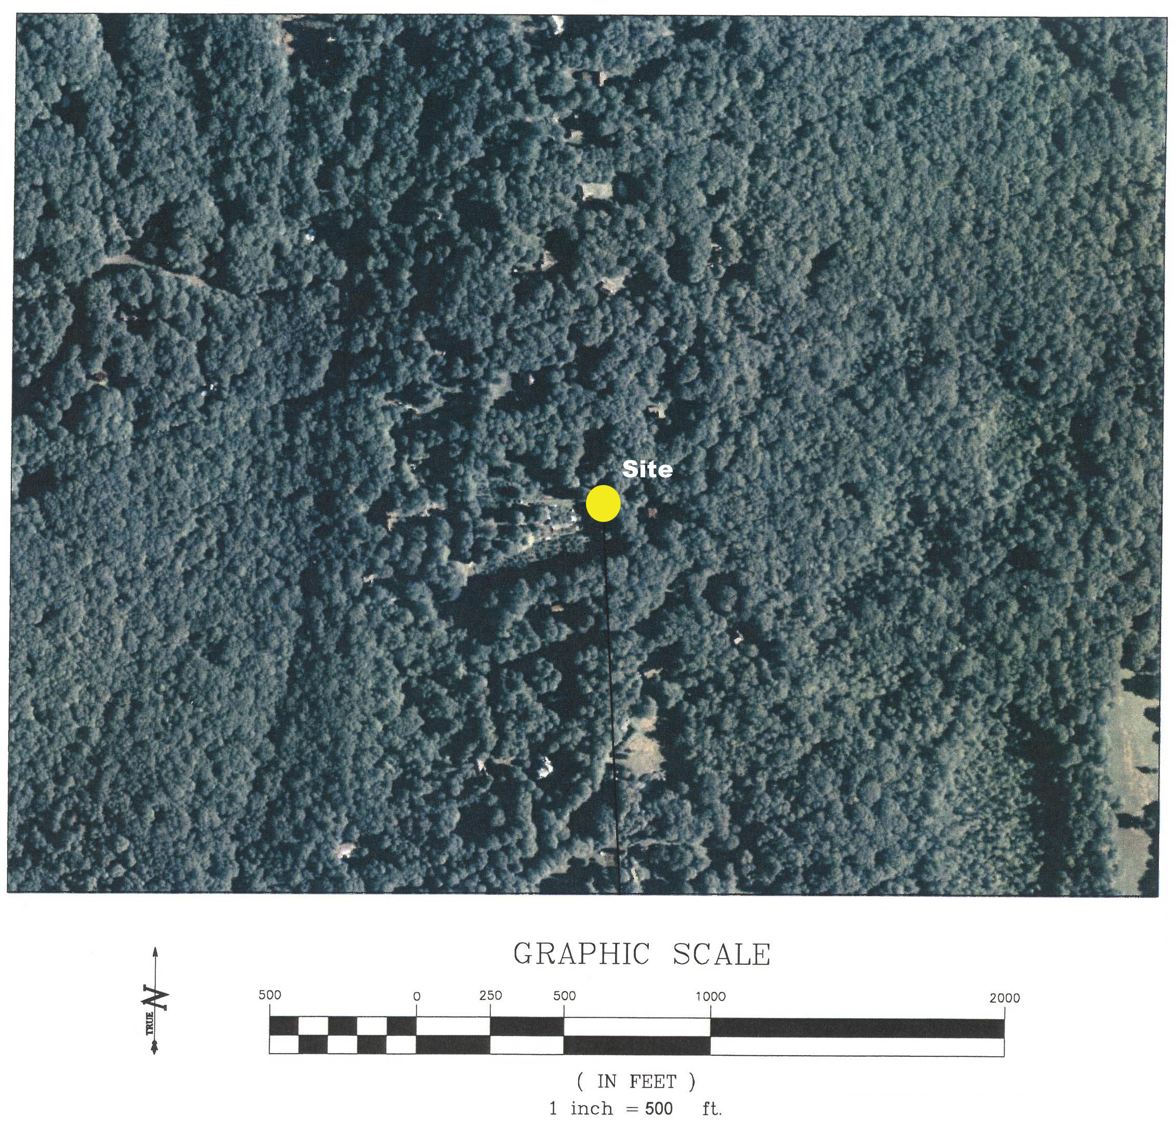
(MCM 1, Attachment 3)

Figure 2: Proposed Site Plan
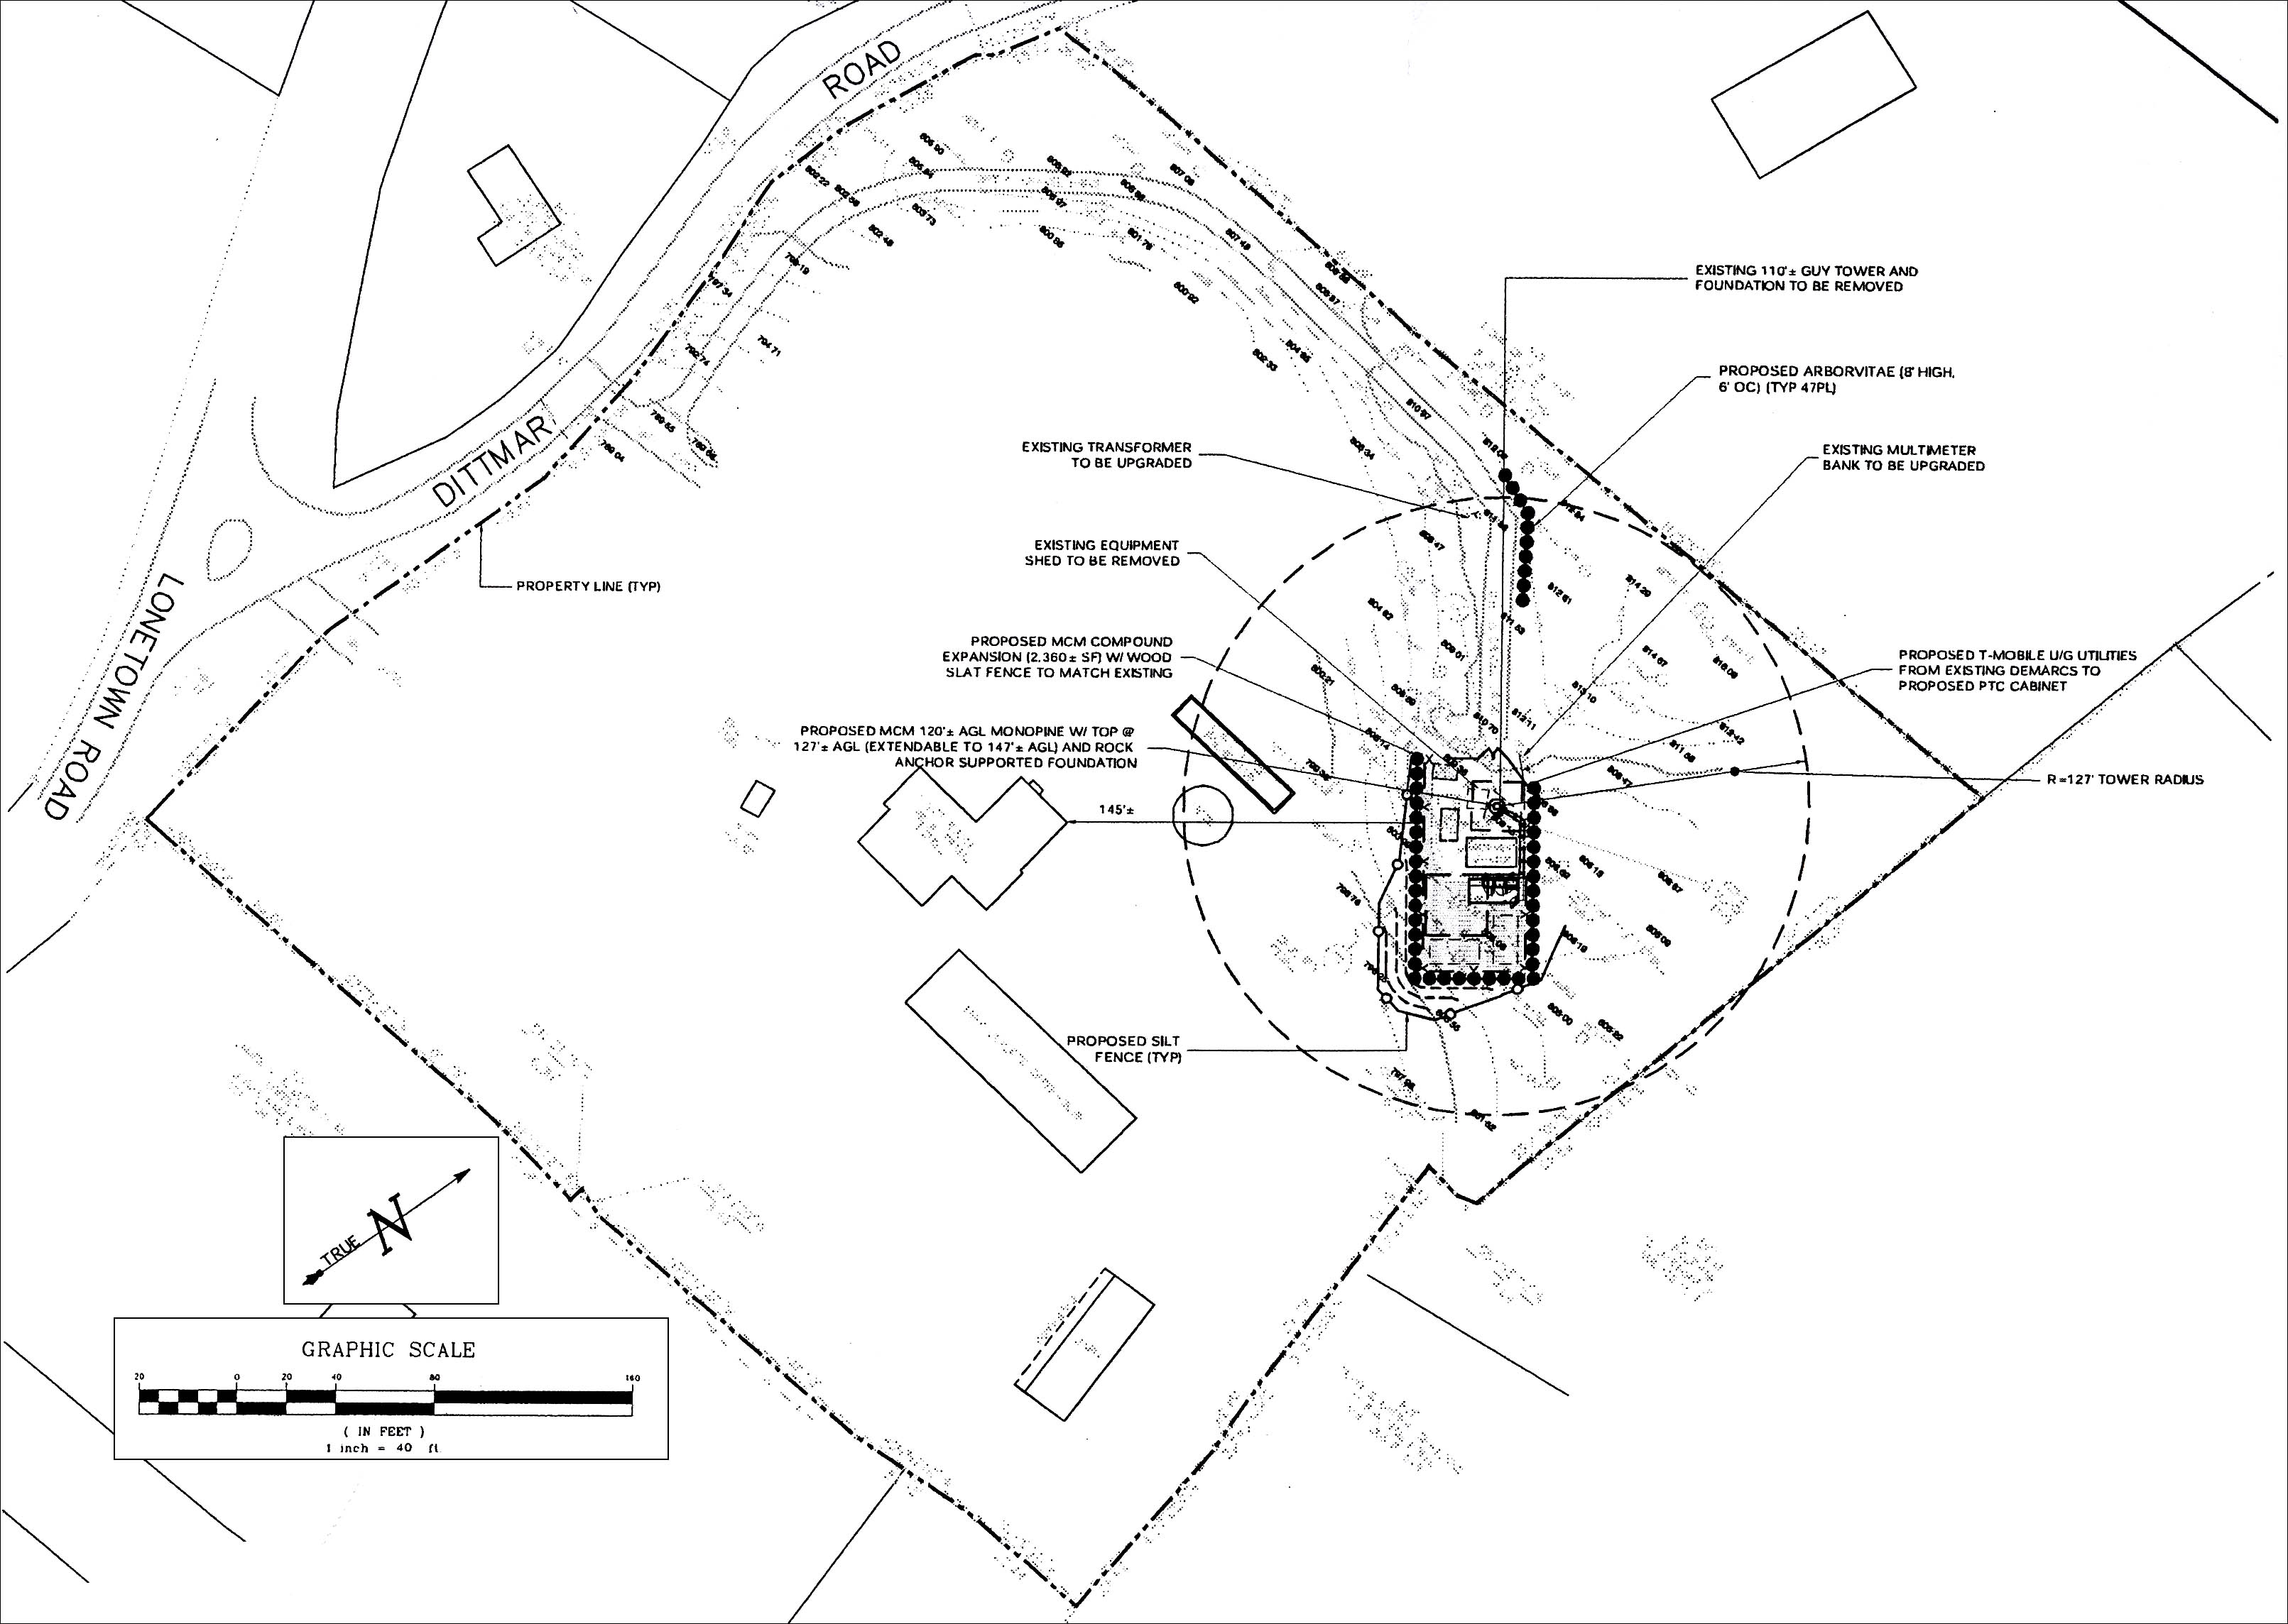
(MCM 1, Attachment 3, Sheet SP-1)

Figure 3: T-Mobile Existing Coverage
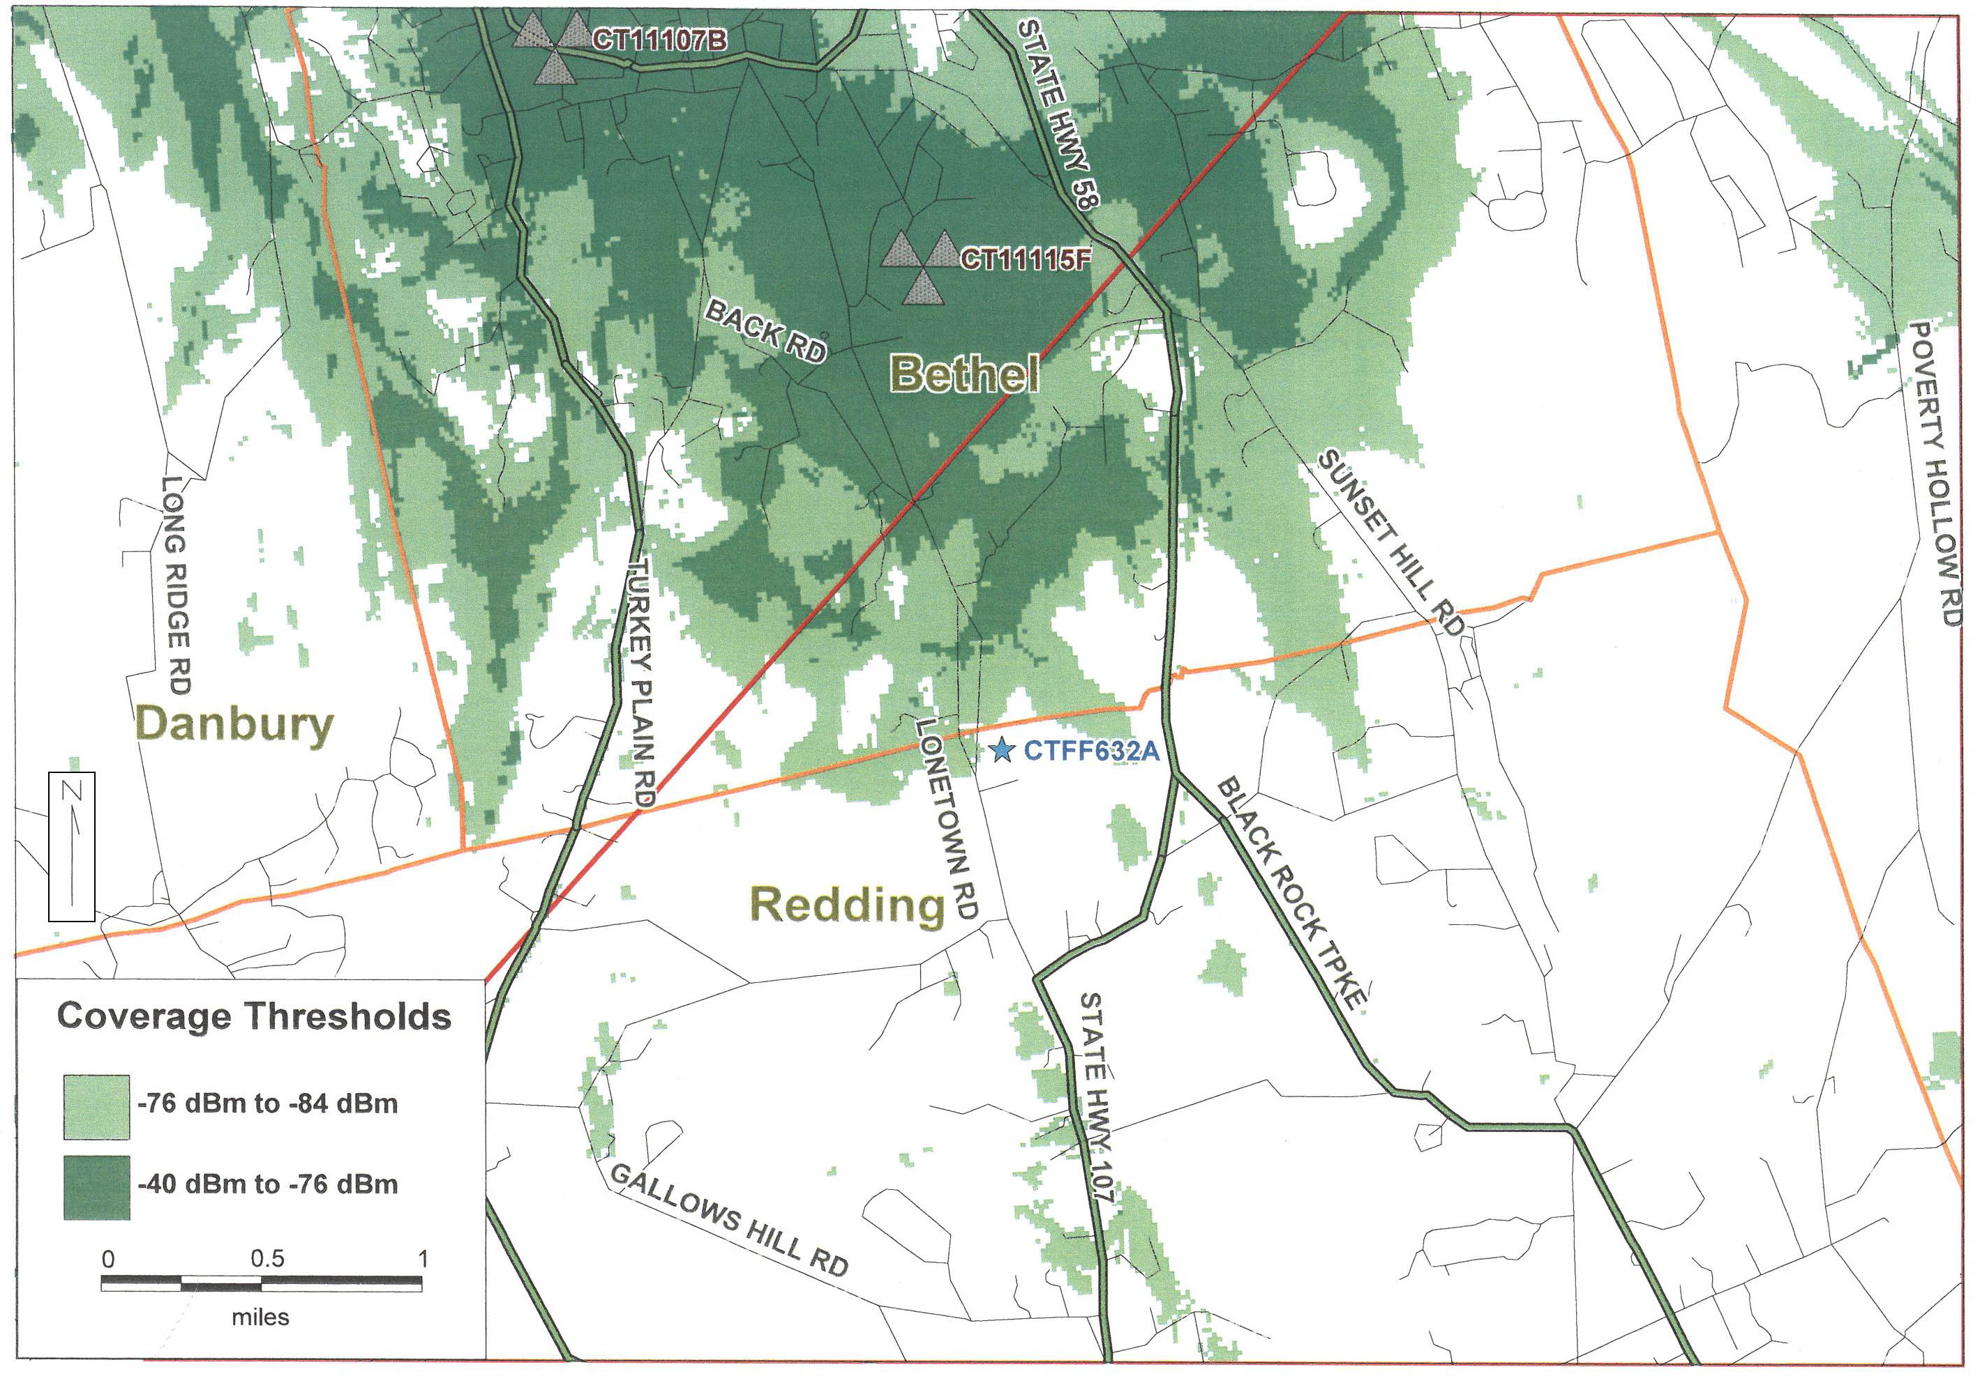
(MCM 1, Attachment 1)

Figure 4: T-Mobile Coverage from Site at 120 feet
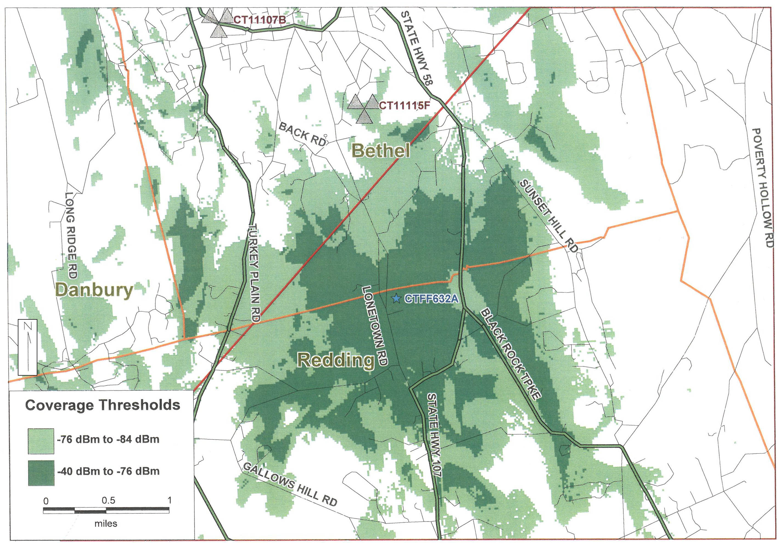
(MCM 1, Attachment 1)

Figure 5: T-Mobile Composite Coverage
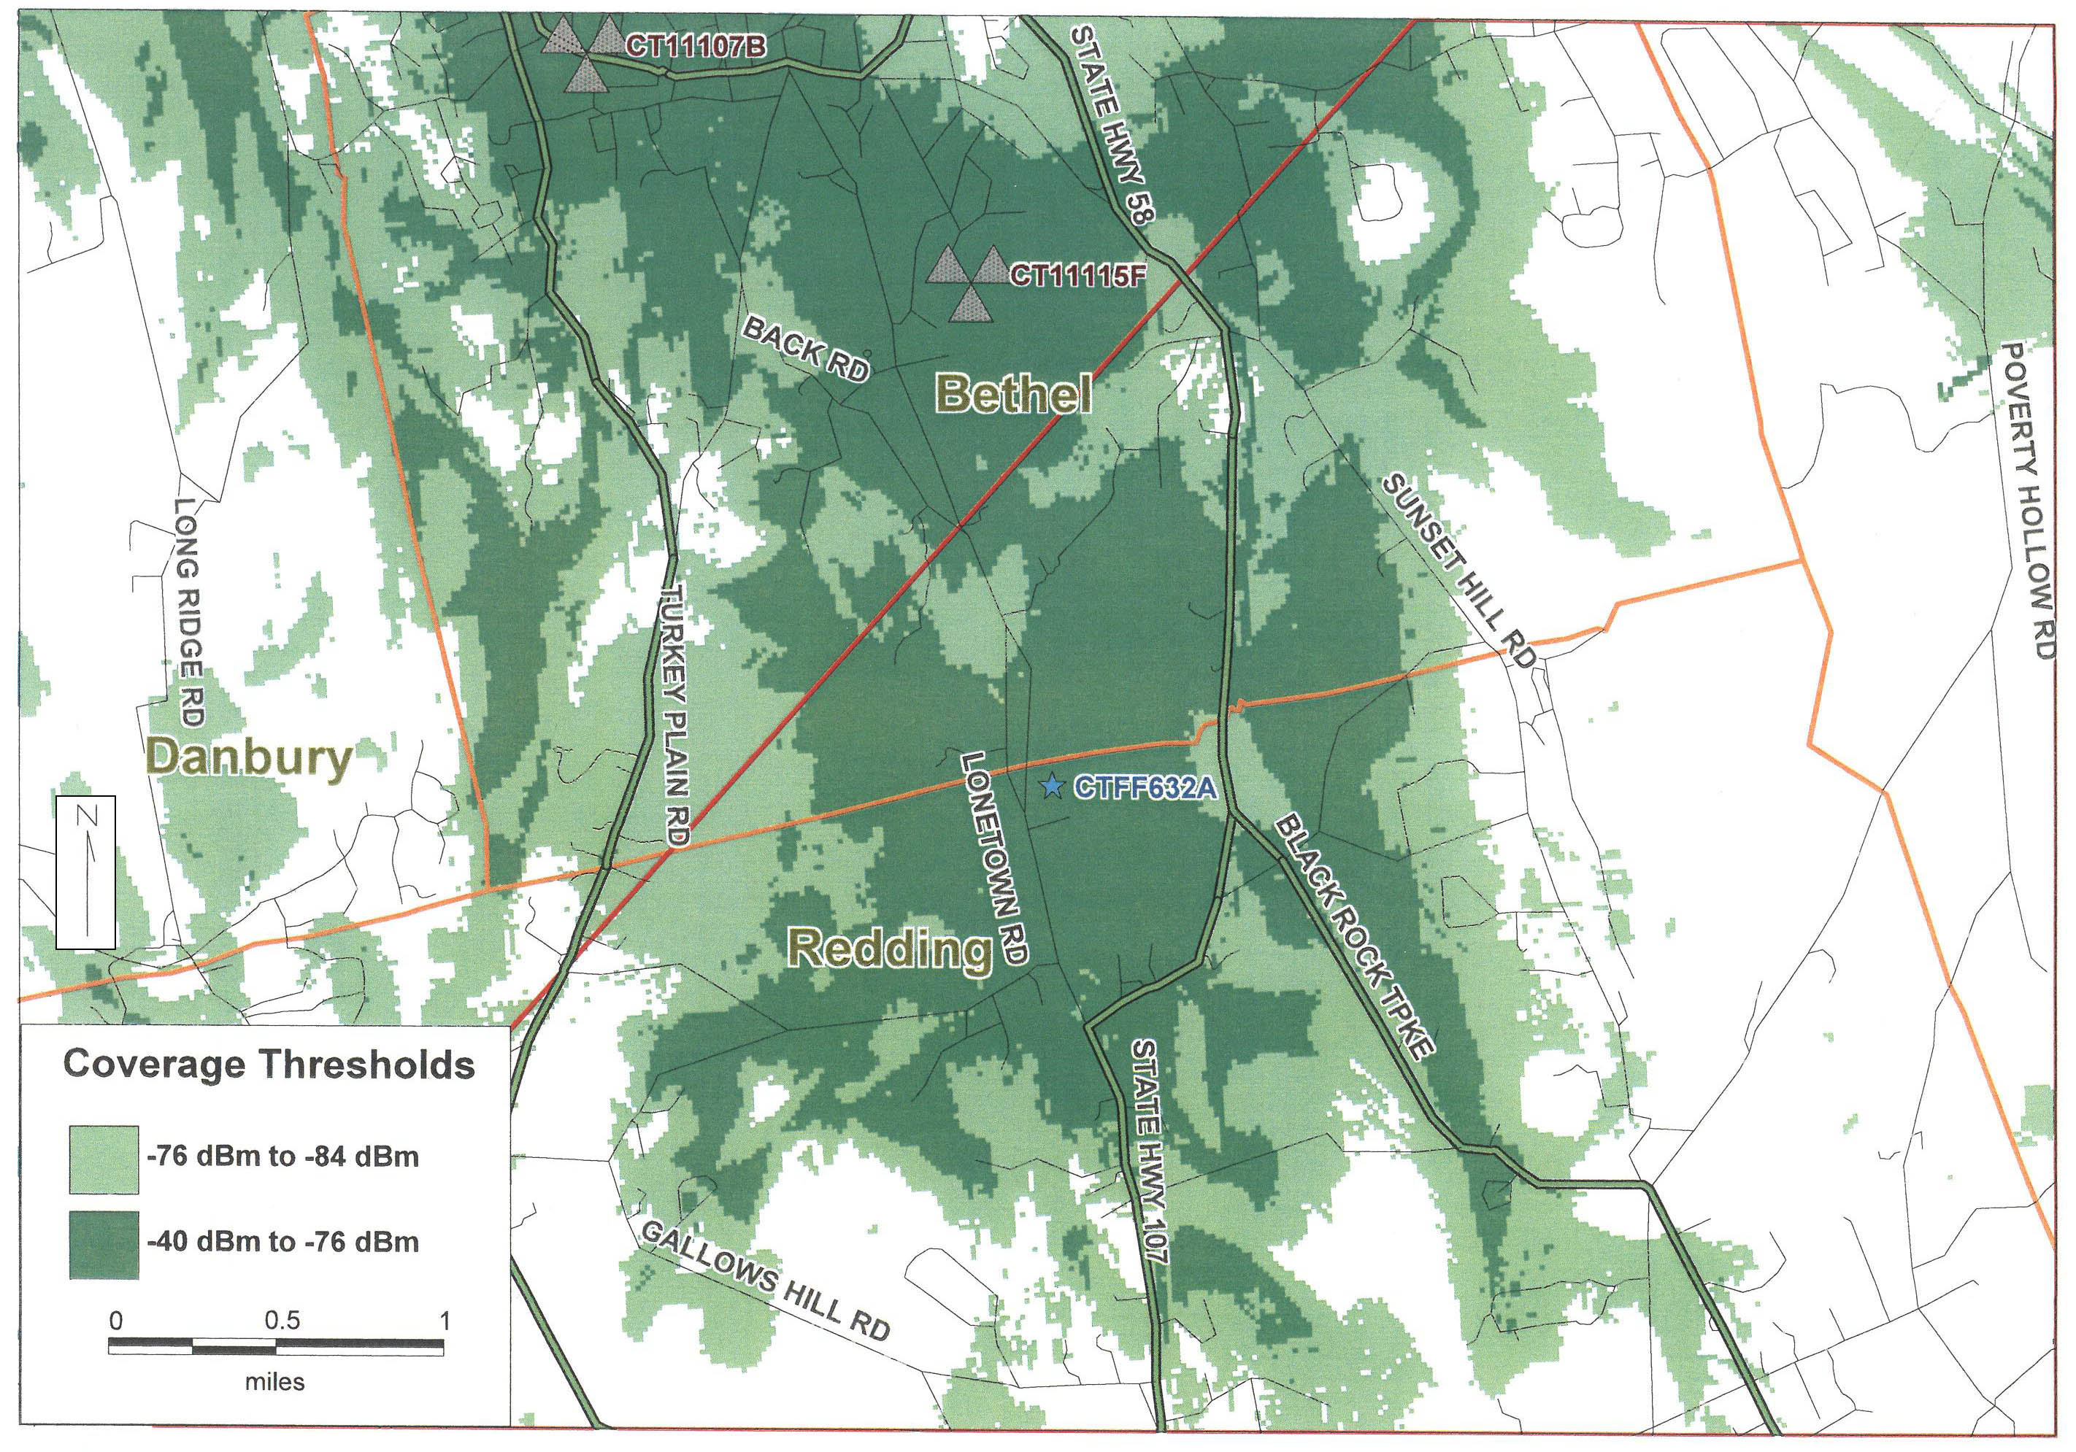
(MCM 1, Attachment 1)

Figure 6: Visibility Analysis Map
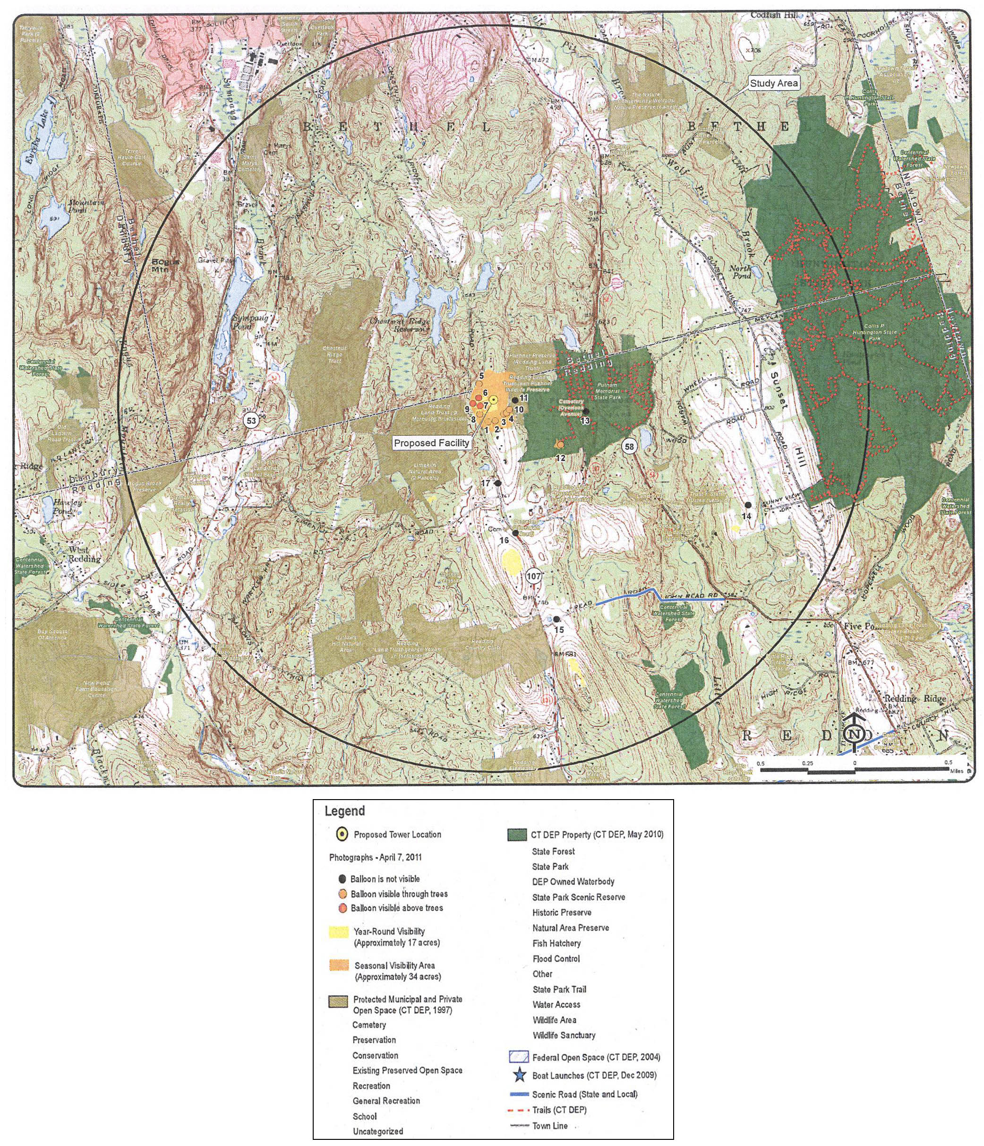

(MCM 1, Attachment 5 – Visual Resource Evaluation Report)

