DOCKET NO. 401 - T-Mobile Northeast LLC application for a Certificate of Environmental Compatibility and Public Need for the construction, maintenance and operation of a telecommunications facility located at 208 Valley Road, New Canaan, Connecticut. | }  }  } | Connecticut  Siting  Council  February 2, 2012

Findings of Fact

Introduction

- T-Mobile Northeast LLC (T-Mobile), in accordance with provisions of Connecticut General Statutes (CGS) §§ 16-50g through 16-50aa, applied to the Connecticut Siting Council (Council) on April 6, 2010 for the construction, maintenance and operation of a 120-foot wireless telecommunications facility at 208 Valley Road in New Canaan, Connecticut. Refer to Figure 1. (T-Mobile 1, p. 1)

- T-Mobile originally received a Certificate of Environmental Compatibility and Public Need for a 120-foot monopole with internal antennas at the proposed site on October 26, 2004 in Docket No. 243. Order No. 9 in the Council’s Decision and Order (D&O) document approving the proposed facility states that the decision shall be void unless the facility is operational “within one year of the effective date of this Decision and Order or within one year after all appeals to this Decision and Order have been resolved.” The D&O further states that, if an extension of time is necessary to make the facility operational, the Certificate holder should ask the Council in writing at least 60 days prior to the expiration date. The expiration date lapsed without T-Mobile requesting an extension of time; the Certificate therefore became void. (Council Admin. Notice 23, D&O; T-Mobile 1, p. 2)

- T-Mobile is a limited liability company, organized under the laws of Delaware, with an office in Connecticut. T-Mobile and its affiliated entities are licensed by the Federal Communications Commission (FCC) to construct and operate a personal wireless services system in Connecticut. (T-Mobile 1, p. 3)

- The party in this proceeding is the applicant. Cellco Partnership d/b/a Verizon Wireless (Cellco) is an intervenor in this proceeding. (Transcript 1, July 13, 2010, 3:00 p.m. [Tr. 1], p. 7; Transcript 2, July 13, 2010, 7:00 p.m. [Tr. 2], pp. 7, 8)

- The purpose of the proposed facility is to provide service to coverage gaps identified by T-Mobile along Valley Road and Silvermine Road, just east of Route 123, as well as the surrounding area. (T-Mobile 1, p. 6)

- Pursuant to CGS § 16-50l (b), public notice of the application was published in The Stamford Advocate on March 24 and March 26, 2010 and in The Norwalk Hour on March 26 and March 29, 2010. (T-Mobile 1, p. 5, Tab F)

- Pursuant to CGS § 16-50m, the Council, after giving due notice thereof, held a public hearing on July 13, 2010, beginning at 3:00 p.m. and continuing at 7:00 p.m. in the auditorium of New Canaan Town Hall, 77 Main Street, New Canaan, Connecticut. (Tr. 1, p. 3; Tr. 2, p. 3)

- The Council and its staff conducted an inspection of the proposed site on July 13, 2010, beginning at 2:00 p.m. The applicant flew a balloon from 12:00 p.m. to 7:00 p.m. to simulate the height of the proposed tower. Weather conditions during the balloon float were windy and rainy, which made it difficult to keep the balloon at the intended height. (Tr. 1, p. 25)

- On November 2, 2010, T-Mobile submitted a Motion to Reopen the Evidentiary Hearing in this proceeding in accordance with CGS § 4-181a for the limited purpose of: submitting a reconfiguration of the monopole to accommodate three wireless carriers while also providing a more narrow tower structure; and allowing New Cingular Wireless PCS, LLC (AT&T) to intervene in this proceeding. (T-Mobile’s Motion to reopen hearing, p. 1)

- On November 18, 2010, the Council voted to reopen the evidentiary hearing for this docket and to make AT&T an intervenor in this proceeding. On August 25, 2011, AT&T withdrew its intervenor status in this proceeding. (Minutes of November 18, 2010 Council meeting; Record)

- On December 8, 2011, the Council held a public hearing for the reopened record of this application. The hearing was held at the offices of the Council, Ten Franklin Square, New Britain, Connecticut. (Transcript 3, December 8, 2011, [Tr. 3], p. 3)

- Pursuant to CGS § 16-50l(b), notice of the application was provided to all abutting property owners by certified mail. T-Mobile received return receipts from all adjacent landowners. (T-Mobile 1, p. 5, Tab G; T-Mobile 2, R. 1)

- Pursuant to CGS § 16-50l (b), T-Mobile provided notice to all federal, state and local officials and agencies listed therein. (T-Mobile 1, p. 5, Tab E)

State Agency Comment

- Pursuant to CGS § 16-50j (h), on May 24, 2010, July 14, 2010 and December 12, 2011 the following state agencies were solicited by the Council to submit written comments regarding the proposed facility: Department of Energy and Environmental Protection, Department of Public Health, Council on Environmental Quality, Public Utility Regulatory Authority, Office of Policy and Management, Department of Economic and Community Development, Department of Agriculture, Department of Transportation; and Department of Emergency Management and Homeland Security. (Record)

- None of the agencies listed above responded with comment on the application. (Record)

Municipal Consultation

- On January 29, 2010, T-Mobile submitted a technical report regarding the proposed facility to New Canaan’s First Selectman, the Honorable Jeb Walker. T-Mobile also submitted a technical report to Wilton’s First Selectman, the Honorable William F. Brennan, because the proposed facility is within 2,500 feet of the Wilton town boundary. (T-Mobile 1, pp. 18, 19, Tab R)

- On March 3, 2010, T-Mobile met with First Selectman Walker and Administrative Officer Thomas R. Stradler, regarding the proposed facility. (T-Mobile 1, p. 19)

- In a letter dated March 25, 2010, the First Selectman’s Office expressed support for the proposed tower and co-location of other carriers on the structure. The letter also indicated that the town would be interested in installing municipal antennas on the structure. (T-Mobile 2, Attachment A)

- T-Mobile would provide space on the tower for the New Canaan municipal public safety communications antennas, for no compensation. (T-Mobile 1, p. 10)

Public Need for Service

- In 1996, the United States Congress recognized a nationwide need for high quality wireless telecommunications services, including cellular telephone service. Through the Federal Telecommunications Act of 1996, Congress seeks to promote competition, encourage technical innovations, and foster lower prices for telecommunications services. (Council Admin. Notice 7)

- In issuing cellular licenses, the federal government has preempted the determination of public need for cellular service by the states, and has established design standards to ensure technical integrity and nationwide compatibility among all systems. The FCC licensed T-Mobile to provide personal wireless communication service to Fairfield County, Connecticut. (Council Admin. Notice 7; T-Mobile 1, p. 8)

- The Telecommunications Act of 1996 prohibits local and state entities from discriminating among providers of functionally equivalent services. (Council Admin. Notice 7)

- The Telecommunications Act of 1996, a federal law passed by the United States Congress, prohibits any state or local entity from regulating telecommunications towers on the basis of the environmental effects, which include human health effects, of radio frequency emissions to the extent that such towers and equipment comply with FCC’s regulations concerning such emissions. This Act also blocks the Council from prohibiting or acting with the effect of prohibiting the provision of personal wireless service. (Council Admin. Notice 7)

- In 1999, Congress passed the Wireless Communications and Public Safety Act (the 911 Act) to facilitate and encourage the prompt deployment of a nationwide, seamless communication infrastructure for emergency services. (T-Mobile 1, p. 7)

- Following the enactment of the 911 Act, the FCC mandated wireless carriers to provide enhanced 911 services (E911) to allow public safety dispatchers to determine a wireless caller’s geographical location within several hundred feet. T-Mobile uses Time Difference of Arrival (TDOA) network technology to comply with E911 requirements. The proposed facility would become a component of T-Mobile’s and Cellco’s E911 network in this part of the state. (T-Mobile 1, p. 7; Cellco 3, R. 5)

Existing and Proposed Wireless Coverage

T-Mobile

- T-Mobile operates a personal communications service network within the 1900 and 2100 MHz frequency signals allocated by the FCC. T-Mobile designs the system for in-vehicle coverage with a minimum signal level threshold of -84 dBm, and in-building coverage with a minimum signal level threshold of -76 dBm. (T-Mobile 1, Tab H, Tab P)

- T-Mobile seeks to provide coverage to Valley Road and Silvermine Road, just east of Route 123, as well as the surrounding area. (T-Mobile 1, p. 6)

- The existing signal strength in the area of the proposed facility ranges from -80 dBm to -110 dBm. (T-Mobile 2, R. 15)

- In the area of the proposed facility, T-Mobile’s service has an average dropped call rate of 4.11 percent. (T-Mobile 2, R. 14)

- T-Mobile would install three antennas at the 117-foot level of the revised structure. (T-Mobile 5, R. 22, R. 24; Tr. 3, pp. 20, 21)

- T-Mobile would provide approximately 3.2 square miles of coverage from the proposed tower at a signal strength of -84 dBm. (T-Mobile 2, R. 16)

- At -84 dBm, T-Mobile currently has an approximately 2-mile coverage gap along Valley Road and Silvermine Road, which travels from the northwest to southeast; and an approximately 1.7-mile coverage gap along Route 106 (Silvermine Road and New Canaan Road), which travels from northeast to southwest. Refer to Figure 2. (T-Mobile 2, R. 17)

- The proposed tower would provide T-Mobile with approximately 2.6 miles of coverage along Valley Road and Silvermine Road (northwest to southeast) at -84 dBm, including approximately 1.6 miles of new coverage; and 1.7 miles of coverage along Route 106 (Silvermine Road and New Canaan Road), including approximately 1.4 miles of new coverage. Refer to Figure 3. (T-Mobile 2, R. 18)

- None of the existing facilities within a three-mile radius of the proposed site provides adequate coverage to the target area. Adjacent T-Mobile facilities that would interact with the proposed facility include:

Location | Antenna Height above ground level | Approximate Distance from Site
46 Fenwood Lane, Wilton | 122 feet | 2.0 miles northeast
39 Locust Ave, New Canaan | 46 feet | 1.5 miles southwest
95 Country Club Road,  New Canaan | 106 feet | 1.6 miles northwest
187 Danbury Road, Wilton | 65 feet | 2.9 miles northeast
15 Old Danbury Road, Wilton | 96 feet | 2.9 miles northeast
(T-Mobile 1, Tab J; T-Mobile 2, R. 20)

- T-Mobile currently has no additional search rings beyond the proposed site to provide coverage within New Canaan. (Tr. 1, p. 24)

Cellco

- Cellco is licensed to operate in the cellular (850 MHz), long-term evolution (LTE) (700 MHz) and personal communications system (PCS) (1900 MHz) frequency ranges. Cellco designs its system for
-85 dBm signal level threshold. (Cellco 2, p. 2; Cellco 3, R. 2)

- Cellco currently has cell sites located at 39 Locust Street in New Canaan, Waveny Park in New Canaan, 173 West Rocks in Norwalk, 50 Danbury Road in Wilton, and 187 Danbury Road in Wilton. The nearby existing facilities do not provide Cellco with adequate coverage to the target area. (Cellco 2, p. 2)

- Cellco would install three dual band dual-pole PCS/cellular antennas at a centerline height of 106 feet agl and three LTE antennas at a centerline height of 96 feet agl on the revised structure. (Cellco 5, R. 1)

- At -85 dBm, Cellco would provide approximately 3.2 square miles of PCS coverage, approximately 6.7 square miles of cellular coverage and approximately 8.1 square miles of LTE coverage. (Cellco 3, R. 3)

- At cellular frequencies, Cellco currently has an approximately 3.5-mile coverage gap along Valley Road and Silvermine Road; and an approximately 3.8-mile coverage gap along Route 106 (Silvermine Road and New Canaan Road). Refer to Figure 4. With the installation of Cellco antennas at the proposed site, an approximately 0.4 mile gap would remain in Cellco’s cellular coverage along Valley Road. Refer to Figure 5. (Cellco 2, Tab 1)

- At LTE frequencies, Cellco currently has an approximately 3.1 mile coverage gap along Valley Road and Silvermine Road, and an approximately 3.2 mile coverage gap along Route 106. Refer to Figure 6. With the installation of Cellco antennas at the proposed site, an approximately 0.3 mile gap would remain in Cellco’s LTE coverage along Valley Road. Refer to Figure 7. (Cellco 2, Tab 1)

- At PCS frequencies, Cellco currently has an approximately 4.2 mile coverage gap along Valley Road/Silvermine Road, and an approximately 3.8 mile coverage gap along Route 106. Refer to Figure 8. Following the installation of Cellco’s PCS antennas at the proposed site, an approximately 2.4 mile coverage gap would remain along Valley Road and an approximately 2-mile coverage gap would remain along Route 106. Refer to Figure 9. (Cellco 2, Tab 1)

- If Cellco were to reduce the height of its antennas to 87 feet agl, its coverage would be significantly reduced from what Cellco has proposed for the target area. (Tr. 1, p. 97)

- Cellco’s dropped call rate in the area of the proposed site is 2.59 percent. (Tr. 1, p. 101)

Changes to the Originally Approved Facility of Docket No. 243

- The currently proposed monopole is approximately 26.5 feet north of the previously approved monopole at an elevation approximately 4.5 feet lower. In addition, the tower would be located within a 25-foot by 50-foot equipment compound/lease area rather than the 40-foot by 60-foot compound within the 75-foot by 75-foot lease area that was negotiated for Docket No. 243. (T-Mobile 2, R. 2)

- The utility route would be shorter than originally proposed in Docket No. 243. (T-Mobile 2, R. 2)

- T-Mobile would remove five trees with a diameter of six inches or greater instead of eight, as proposed in Docket No. 243. (T-Mobile 2, R. 2)

- Changes to the proposed facility approved in Docket No. 243 were the result of T-Mobile’s consultation with the property owner. (T-Mobile 2, R. 2)

Site Selection

- No existing structures are suitable for co-location in this area of New Canaan. (T-Mobile 1, p. 9)

- The only feasible alternative to the proposed site that T-Mobile found was the water company property, which was the originally proposed site in Docket 243. During those proceedings, the Town of New Canaan and intervenors in the proceeding agreed that the Silver Hill Hospital property was superior to the Water Company property. (T-Mobile 1, p. 9)

- Microcells, repeaters, distributed antenna systems (DAS) and other transmitting technologies are not practical alternatives to the proposed facility as a means of providing service to the coverage gap in this area. Terrain, topography and tree cover limit coverage provided by these technologies and preclude their use as alternatives. A DAS would not provide adequate coverage to the area due to variable terrain. (T-Mobile 1, p. 8; Tr. 1, pp. 66, 67)

Facility Description

- The proposed site is located on an approximately 42-acre parcel owned by Silver Hill Hospital, Inc., a psychiatric hospital, at 208 Valley Road in New Canaan. The host property actually consists of two smaller parcels (parcel A is 23.26 acres; parcel B is 18.79 acres). The proposed facility would be located in the north-central portion of the Silver Hill Hospital property. (T-Mobile 1, pp. 4, 10, Tab C)

- In the original Docket No. 401 proceeding, the Council was to consider a 120-foot monopole with a diameter of 76 inches at the base tapering to 54 inches at the top. On December 1, 2011, T-Mobile submitted a revised site plan with a narrower diameter monopole for Council consideration. (T-Mobile 7; Cellco 2, p. 3)

- In the revised site plan, T-Mobile would construct a 120-foot monopole painted brown with antennas concealed within the structure. T-Mobile would install panel antennas within the structure at a centerline height of 117 feet agl. Cellco would locate three dual band antennas at each of two levels of antennas within the proposed structure at centerline heights of 106 feet and 96 feet agl. (T-Mobile 1, p. 10, Tab C; T-Mobile 6, p. 2; Cellco 3, R. 1; Tr. 3, p. 10)

- The antennas are proposed to be mounted inside the monopole structure at the request of Silver Hill Hospital. (Tr. 1, p. 32)

- Any municipal whip antennas located on the structure would extend off the top of the proposed structure. (Tr. 1, p. 38)

- The monopole would have a diameter of 62 inches at the base of the structure tapering to a diameter of 40 inches at the top. (T-Mobile 7)

- The diameter of the structure would be determined not only by the size of the antennas, but by the size of the associated coaxial cables. The cables and antennas have to be spaced apart to avoid radiofrequency interference. T-Mobile would install ⅞-inch diameter cable and Cellco would install 1⅝-inch diameter cable. (Tr. 1, p. 14, 18, 19, 77)

- The Silver Hill Hospital property is zoned two-acre residential. The town allows towers and antennas under town jurisdiction by Special Permit. New Canaan’s Zoning Regulations do not address telecommunications facilities that are under Council jurisdiction. (T-Mobile 1, p. 17; Zoning Regulations dated June 16, 2007, p. 141)

- The New Canaan Plan of Conservation and Development identifies a need for enhanced communications, particularly for emergency services. (T-Mobile 1, p. 17)

- The site is on a slope. Construction of the facility would require approximately 375 cubic yards of cut and 10 cubic yards of fill. (T-Mobile 2, R. 11)

- T-Mobile does not anticipate a need for blasting for the construction of the proposed site. (T-Mobile 2, R. 12)

- A 25-foot by 50-foot equipment compound enclosed by an eight-foot brown cedar board fence would be established at the base of the tower. T-Mobile would install equipment and its battery backup system on a 15-foot by 15-foot concrete pad. The battery backup would provide power to T-Mobile’s equipment for 12 to 16 hours. The size of T-Mobile’s battery backup system is similar to the size of a fuel cell cabinet in order to accommodate potential future replacement by a fuel cell. (T-Mobile 1, p. 10, Tab C; T-Mobile 7; Tr. 1, pp. 42, 65; Tr. 3, pp. 10, 11)

- T-Mobile could use a generator to provide backup power. This would require noise mitigation techniques to be used and the installation of the generator within a separate structure. (Tr. 3, p. 32)

- Cellco would install a 12-foot by 24-foot equipment shelter and diesel emergency backup generator within the equipment compound that would provide backup power to the site for 72 hours. (Cellco 2, p. 3; Cellco 3, R. 6; Tr. 1, pp. 28, 29, 101; Tr. 3, p. 40)

- One generator could be installed at the site to provide backup power for both carriers. (Tr. 3, p. 47)

- The equipment compound would include a retaining wall extending on all sides. The retaining wall would be approximately six feet on the west side of the compound and approximately two feet on the east side of the compound with the north and south sides tapering from west to east. (T-Mobile 7; Tr. 3, pp. 11, 12)

- T-Mobile would install a double row of six to eight foot arborvitae trees along the eastern side of the compound. (T-Mobile 6, p. 2)

- To handle drainage, T-Mobile would construct a swale along the western and northern edges of the compound that would discharge into a new level spreader at the northeast corner. In addition, two level spreaders would be installed on the eastern side of the compound area and one level spreader would be installed adjacent to the existing driveway. Also, a drainage outlet would extend from the mid-point of the eastern side of the compound to the northeast and end at a proposed riprap energy dissipater. (T-Mobile 7)

- The tower setback radius would extend approximately 49 feet onto the property at 270 Valley Road, owned by the First Taxing District of the City of Norwalk. The nearest portion of the proposed compound is approximately 39 feet from the nearest property boundary. The tower would be approximately 71 feet from the nearest property boundary. (T-Mobile 1, Tab C; T-Mobile 2, R. 8)

- T-Mobile could install a yield point in the monopole at approximately 70 feet to allow the structure to remain on the host property in the event of a structure failure. (Tr. 1, p. 56)

- Access to the site would extend from Valley Road, along the existing Silver Hill Hospital driveway. T-Mobile would create a 29-foot by 13-foot parking area along the side of the existing driveway. The site plan includes a 10-foot wide driveway extending 60 feet from the proposed parking area to the site. (T-Mobile 1, p. 11; T-Mobile 2, R. 10; T-Mobile 7)

- The estimated construction cost of the facility, not including antennas, is:

Tower and foundation (including installation) $ 72,000.
Site development 70,000.
Utility installation 45,000.
Total $187,000.
(T-Mobile 1, p. 20; T-Mobile 5, R. 29)

- The estimated cost of T-Mobile antennas and associated ground equipment for the proposed facility is between $55,000 and $65,000. (T-Mobile 5, R. 29)

Environmental Considerations

- The proposed facility would have no effect upon historic, architectural, or archaeological resources listed on or eligible for the National Register of Historic Places. (T-Mobile 1, Tab O)

- T-Mobile consulted with four Native American Indian tribes regarding potential impact of the proposed facility, including Delaware Nation, Mashantucket Pequot Tribe, Narragansett Indian Tribe, and Delaware Tribe of Indians of Oklahoma. With the exception of the Narragansett Indian Tribe, all responded that they do not have interests that would be affected by the proposed facility. The FCC attempted further contact with the Narragansett Indian Tribe and received no response. The FCC concluded that the proposed facility would not affect the interests of the Narragansett Indian Tribe. (T-Mobile 1, p. 16)

- Two federally endangered species (piping plover and roseate tern) and one federally threatened species (bog turtle) are found in Fairfield County. The proposed facility would not be located in habitat for any of these species. (T-Mobile 1, p. 15)

- There are no known state listed endangered, threatened or special concern species within the vicinity of the proposed site. (T-Mobile 1, Tab O)

- The proposed site is in an upland forested area dominated by sugar maple, tuliptree and Eastern hemlock. (T-Mobile 1, Tab K)

- The nearest wetland is approximately 400 feet northeast of the proposed site. (T-Mobile 1, p. 11)

- The nearest public airfield is the Westchester County Airport in White Plains, New York, which is approximately 14 miles southwest of the proposed facility. The nearest private airfield is the Flying Ridge Airstrip in Newtown, Connecticut, which is approximately 16.9 miles northeast of the proposed facility. Obstruction marking and lighting of the tower would not be required. (T-Mobile 1, p. 19; T-Mobile 2, R. 6)

- The cumulative worst-case maximum power density from the radio frequency emissions from the operation of T-Mobile’s and Cellco’s proposed antennas is 29 percent of the standard for Maximum Permissible Exposure, as adopted by the FCC, at the base of the proposed tower. This calculation was based on methodology prescribed by the FCC Office of Engineering and Technology Bulletin No. 65E, Edition 97-01 (August 1997) that assumes all antennas would be pointed at the base of the tower and all channels would be operating simultaneously, which creates the highest possible power density levels. Under normal operation, the antennas would be oriented outward, directing radio frequency emissions away from the tower, thus resulting in significantly lower power density levels in areas around the tower. (T-Mobile 1, pp. 14, 15; Tr. 2, pp. 58, 59; T-Mobile 5, R. 28; Cellco 5, R. 4)

Visibility

- The proposed tower would be visible year-round from approximately eight acres within a two-mile radius of the site (refer to Figure 10 of this document). Most of the year-round visibility of the tower would be on the host property and along the nearby portion of Valley Road. There would also be areas of year-round visibility of the tower from the north, northeast and southeast of the facility. The tower would be seasonally visible from an additional 16 acres within a two-mile radius of the site. (T-Mobile 1, Tab N)

- The tower would be visible year-round from approximately four residences, including three along Valley Road and one on Wardwell Drive. Year-round visibility would also extend onto the adjacent Norwalk water treatment facility property. (T-Mobile 1, Tab N)

- The tower would be seasonally visible from approximately one-tenth of a mile along Valley Road, adjacent to the host property; portions of Wardwell drive northwest of the facility; portions of Turning Mill Lane; and along Huckleberry Hill Road. (T-Mobile 1, Tab N)

- The proposed tower would be seasonally visible from eight additional residences, including three along Valley Road, two along Turning Mill Lane, one along Huckleberry Hill Road, one along Thayer Drive and one along Wardwell Drive. (T-Mobile 1, Tab N)

- There are 23 residences within 1,000 feet of the proposed tower. The nearest residence is approximately 290 feet east of the facility at 253 Valley Road, owned by Christopher Starr Jones. (T-Mobile 1, Tab C, Tab L)

- The adjacent property to the north is a City of Norwalk water treatment facility. Land use in the remaining surrounding area is medium-density residential. (T-Mobile 1, Tab N)

- Visibility of the proposed tower from specific locations within a two-mile radius of the site is shown in the table below (the location numbers correspond with the numbers on the Viewshed Analysis map in Figure 10):

Location | Visible | Approx. Portion of Tower Visible | Approx. Distance and direction from Tower
1. Valley Road (across from Silver Hill Hospital admission building) | Yes | 45 feet – above trees | 0.23 miles southeast
2. Host Property (Silver Hill Hospital) | Yes | 35 feet – above trees &  35 feet – through trees | 0.19 miles southeast
3. Valley Road (adjacent to #270) | Yes | 35 feet – above trees & 15 feet – through trees | 0.09 miles north
4. Valley Road (adjacent to #225) | No | - | 0.1 miles southeast
5. Valley Road (adjacent to #229) | Yes | 45 feet – through trees | 0.09 miles southeast
6. Valley Road (adjacent to #229) | Yes | 70 feet – above trees | 0.07 miles southeast
7. Valley Road (adjacent to #253) | Yes | 45 feet – above trees | 0.05 miles northeast
8. Valley Road (adjacent to #269) | Yes | 40 feet – above trees | 0.07 miles northeast
9. Turning Mill Road (at bend) | Yes | 20 feet – through trees | 0.21 miles northeast
10. End of Turning Mill Road | No | - | 0.21 miles northeast
11. Huckleberry Hill Road (adjacent to #80) | Yes | 20 feet – through trees | 0.36 miles north
12. End of Wardwell Drive | Yes | 10 feet – through trees | 0.09 miles west
13. Intersection of Route 106 and Old Kings Highway | No | - | 0.55 miles southeast
14. Valley Road (adjacent to #58) | No | - | 0.44 miles southeast
15. Devonwood Lane (adjacent to #79) | No | - | 0.39 miles southwest
16. Intersection of Huckleberry Hill Road and Valley Road | No | - | 0.27 miles northwest
17. Thayer Drive (adjacent to #113) | No | - | 0.16 miles west
18. End of Parkers Glen | No | - | 0.2 miles southwest
(T-Mobile 1, Tab N)

- The facility location is within a wooded area, which would cover the majority of the bottom of the tower from nearby receptors. (Tr. 1, pp. 46, 47)

- The site plan includes a narrower monopole than was contemplated in the previous proceeding. The visibility of the structure would not change substantially. The profile would be narrower, which would result in an improvement in near-field views. (Tr. 3, p. 9)

- The equipment compound is designed to eliminate the view of Cellco’s equipment shelter from the nearest down-gradient residential structure on the property. (T-Mobile 6, p. 2)

Figure 1. Revised Site plan for the proposed facility at 208 Valley Road in New Canaan. (T-Mobile 7)
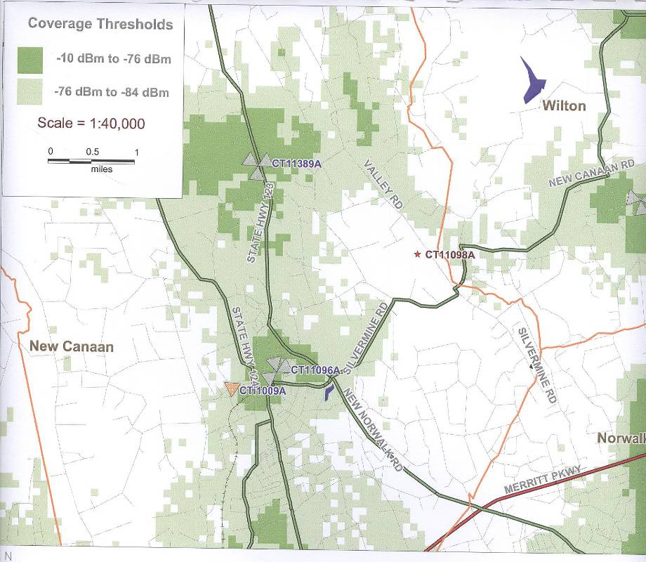

Figure 2. T-Mobile’s existing coverage in the area of the proposed site. (T-Mobile 1, Tab H)

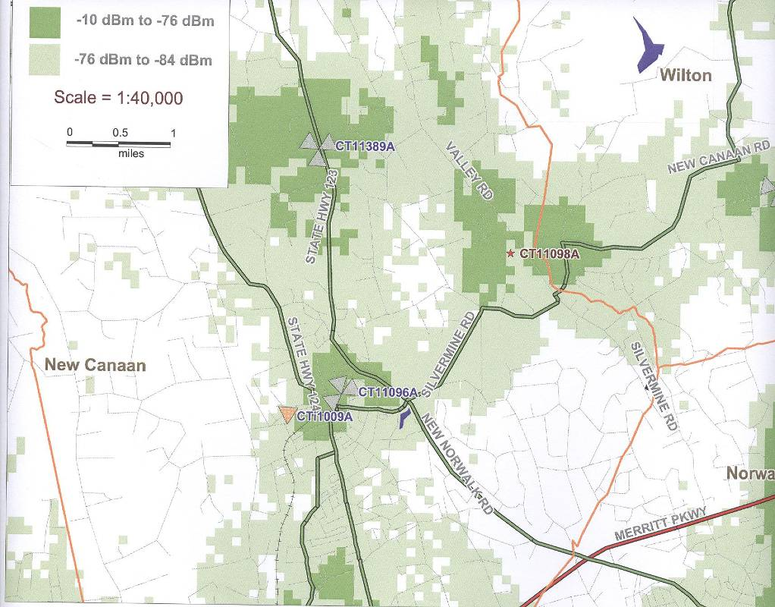

Figure 3. T-Mobile’s existing coverage and proposed coverage at 117 feet agl. (T-Mobile 1, Tab H)
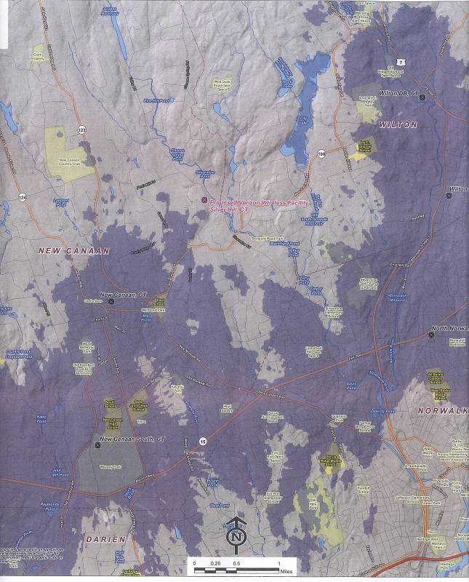
Figure 4. Existing Cellco cellular coverage near the proposed site. (Cellco 2, Tab 1)

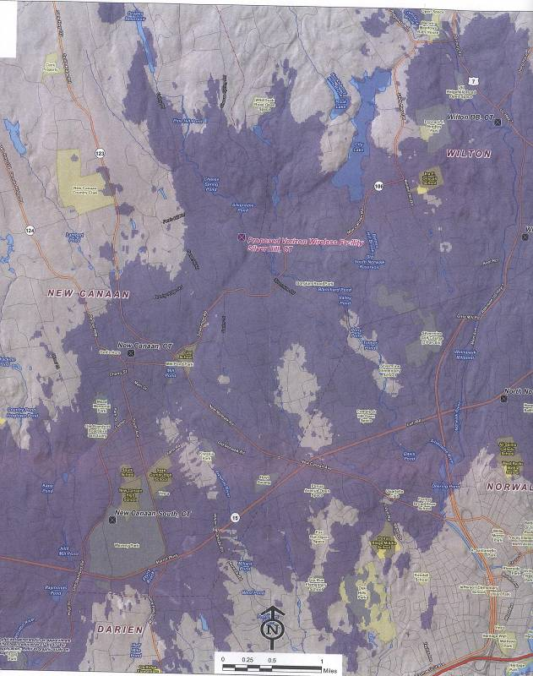
Figure 5. Existing Cellco cellular coverage and coverage from the proposed site. (Cellco 2, Tab 1)
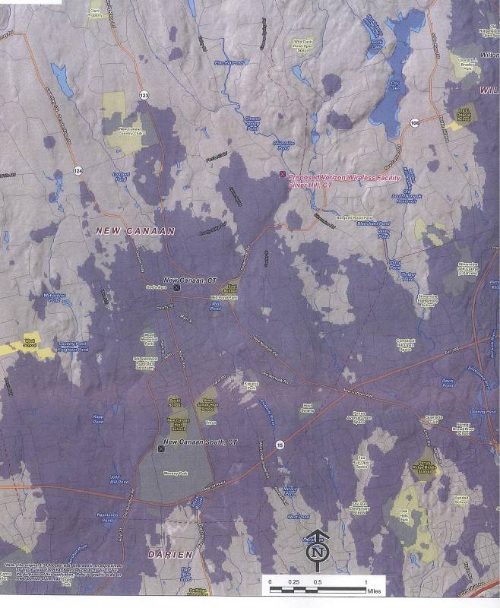
Figure 6. Existing Cellco LTE coverage near the proposed site. (Cellco 2, Tab 1)

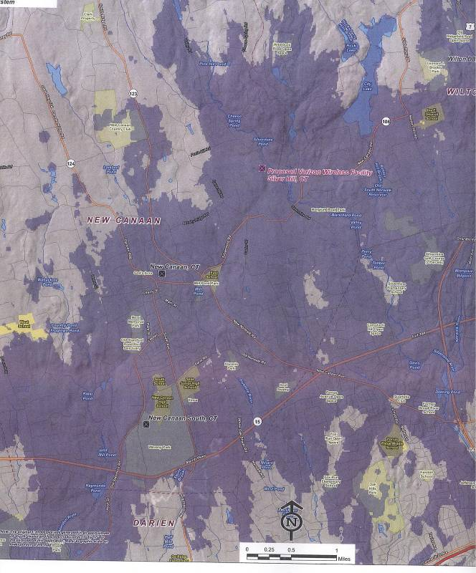
Figure 7. Existing Cellco LTE coverage and coverage from the proposed site. (Cellco 2, Tab 1)
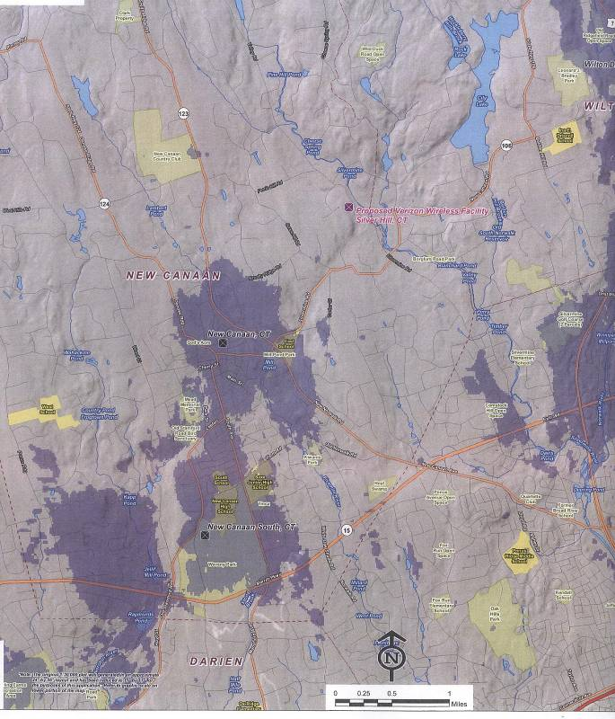
Figure 8. Existing Cellco PCS coverage near the proposed site. (Cellco, Tab 1)

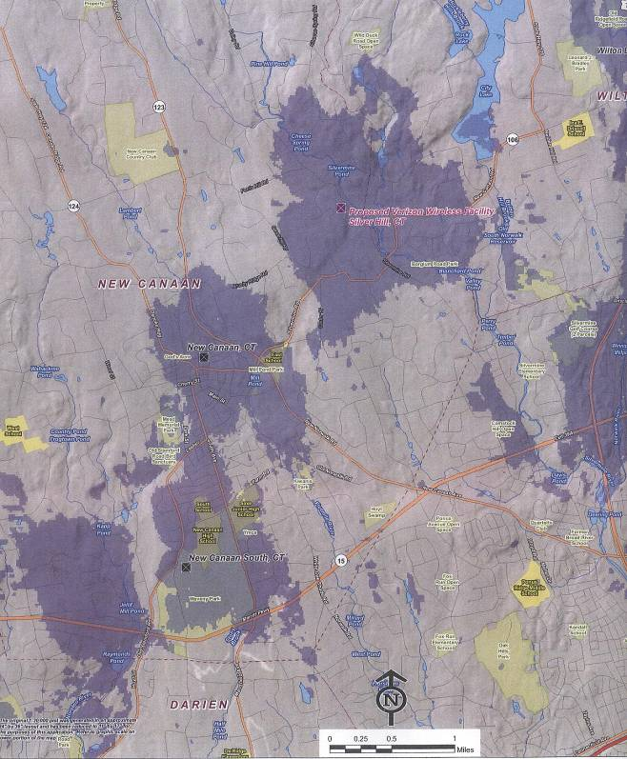
Figure 9. Existing Cellco PCS coverage and coverage from the proposed site. (Cellco 1, Tab 2)
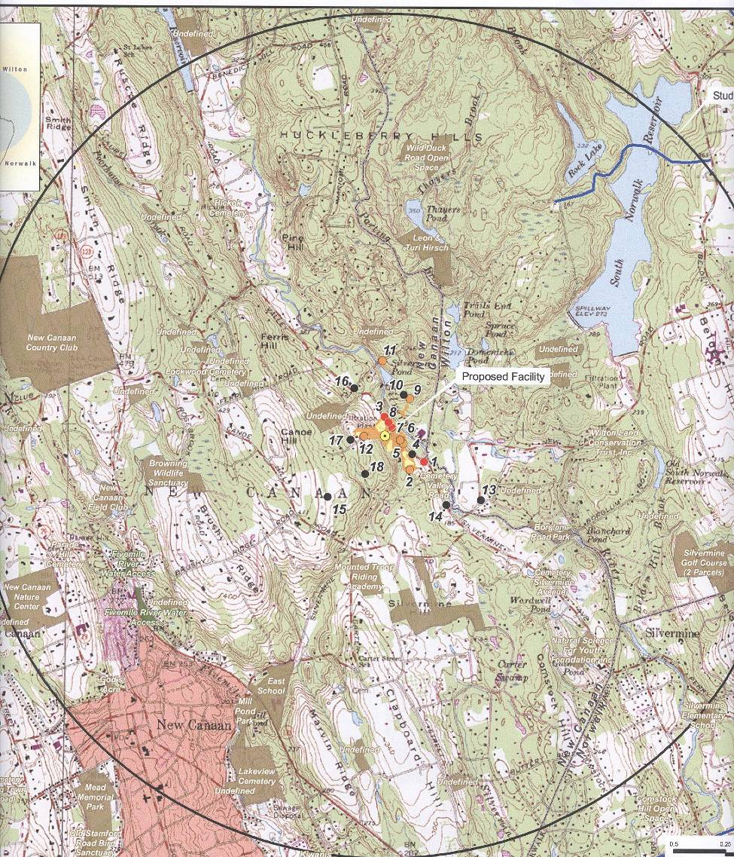
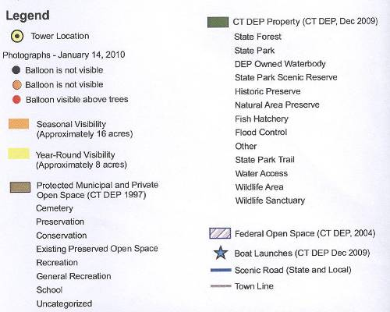
Figure 10. Viewshed analysis of the proposed 120-foot monopole structure. (T-Mobile 1, Tab N)

