DOCKET NO. 398 - Northeast Utilities Service Company, on behalf of The Connecticut Light and Power Company application for a Certificate of Environmental Compatibility and Public Need for the construction, maintenance and operation of the proposed Sherwood Substation located at 6 New Creek Road, Westport, Connecticut. | }  }  }  } | Connecticut  Siting  Council  May 18, 2010

Findings of Fact

Introduction

1. The Connecticut Light and Power Company (CL&P), in accordance with provisions of Connecticut General Statutes (CGS) Sections 16-50g et seq., and Section 16-50j-1 et seq. of the Regulations of Connecticut State Agencies, applied to the Connecticut Siting Council (Council) on December 29, 2009 for the construction, operation, and maintenance of a bulk power substation at 6 New Creek Road, Westport, Connecticut (refer to Figure 1). (CL&P 1, Vol. I, p. A-1)

2. The purpose of the proposed facility, designated by CL&P as the Sherwood Substation, is to improve reliability and add capacity to the electric power distribution system in the Town of Westport. (CL&P 1, Vo1. I, p. A-1)

3. Pursuant to CGS § 16-50m, the Council, after giving due notice thereof, held a public hearing on March 31, 2010, beginning at 3:00 p.m. and continuing at 7:00 p.m. at the Westport Town Hall, 110 Myrtle Avenue, Westport, Connecticut. (Council’s Hearing Notice dated February 17, 2010; Transcript 1 – March 31, 2010 at 3:00 p.m. [Tr. 1], p. 3; Transcript 2 – March 31, 2010, at 7:00 p.m. [Tr. 2], p. 2)

- The Council and its staff made an inspection of the proposed site on March 31, 2010, beginning at 2:00 p.m. (Council’s Hearing Notice dated February 17, 2010)

- Pursuant to CGS § 16-50l(b), public notice of the application was published in The Norwalk Hour on December 4, 8, 17, and 22, 2009 and in the Westport News on December 4, 9, 18 and 23, 2009. (CL&P 2)

6. On March 16, 2010, CL&P erected two, four-foot by six-foot signs on the property that described the proposed project; one at the location of the proposed access drive and one adjacent to the existing driveway. The signs included the Applicant’s name, type of facility proposed, the date and location of the public hearing, and contact information of the Applicant and the Council. (CL&P 5, p. 29)

7. Pursuant to CGS § 16-50(b), notice of the application was provided to all abutting property owners by certified mail. (CL&P 1, Vol. I, p. Q-5; CL&P 5, p. 29)

8. Pursuant to CGS § 16-50l(b), CL&P provided notice to all federal, state and local officials and agencies listed therein. (CL&P 1, Vol. I, pp. Q-3, 4; CL&P 8)

9. Pursuant to CGS § 16-50l(a)(2), the project is exempt from the Connecticut Energy Advisory Board (CEAB) mandatory request for proposal process. As a courtesy, CL&P notified the CEAB of the project on October 14, 2009 and provided a full copy to CEAB on December 29, 2009. (CL&P 1, Vol. 1, p. R-2)

State Agency Comment

10. Pursuant to CGS § 16-50l, on February 17, and April 5, 2010, the following State agencies were solicited by the Council to submit written comments regarding the proposed facility: Department of Environmental Protection (DEP), Department of Public Health (DPH), Council on Environmental Quality (CEQ), Department of Public Utility Control (DPUC), Office of Policy and Management (OPM), Department of Economic and Community Development (DECD), Department of Agriculture (DOAg), Department of Emergency Management and Homeland Security (DEMHS) and the Department of Transportation (DOT). (Record)

- The Council received written comments from the DEP on March 16, 2010. Relevant comments are included in Findings 75, 81 & 82. (Record)

12. The following agencies did not respond with comment on the application: CEQ, DPH, DPUC, OPM, DEMHS, DOAg, DOT and DECD. (Record)

Municipal Consultation

- CL&P representatives began discussing local electric reliability issues with Town of Westport officials in mid-2008. After deciding a new substation was the only viable option, CL&P filed location review submissions with the Westport Conservation Commission (WC Commission) and the Planning and Zoning Commission (P&Z Commission) on May 14, 2009. (CL&P 1, Vol. I, p. O-1)

- CL&P conducted public outreach effort by mailing information packages to 28 area residences in May 2009. The residences were primarily located to the east, west and south of the site. CL&P did not send information to residences to the north because an active railroad, Interstate 95 (I-95), and Greens Farms Road are located between the site and the residential area. CL&P concentrated outreach efforts in the most affected residential areas. (CL&P 1, Vol. I, p. R-1, Figure H-2; Tr. 2, pp. 49-50)

- CL&P conducted a site walk with members of both the WC Commission and P&Z Commission on June 8, 2009. CL&P attended P&Z Commission meetings on June 11 and November 19, 2009 and WC Commission meetings on June 17 and November 18, 2009 where the substation was discussed. Correspondence between the town agencies and CL&P was ongoing prior and subsequent to the meetings. (CL&P 1, Vol. I, pp. O-1-3)

- Ongoing correspondence between CL&P and town agencies included discussion regarding landscaping, berms, drainage, building demolition, erosion and sedimentation controls, grading, leak detection and safety. (CL&P 1, Vol. II, Tab 6)

- On June 9, 2009, CL&P presented information to the Greens Farms Academy, a school with its academic building approximately 850 feet south of the site, and the Greens Farms Association, a local neighborhood group. (CL&P 1, Vol. I, p. R-1, Figure H-2; CL&P 4, Q. 3)

- At the request of the Green Farms Academy, CL&P provided preliminary landscape designs and electric and magnetic field information. Based on feedback from the Green Farms Academy, CL&P relocated the driveway to the location proposed in the application to reduce the visual impact of the proposed facility. (CL&P 1, Vol. I, p. R-1; CL&P 3)

- The Green Farms Academy also requested that CL&P explore safety improvements for pedestrians along New Creek Road between the railroad station and Maple Lane. CL&P is in ongoing discussion with the town regarding lighting and guardrails/walking path improvements along this route. (CL&P 1, Vol. I, p. R-1; CL&P 3; CL&P 5, p. 26)

- CL&P met with the Westport Architectural Review Board on July 14, 2009 and incorporated suggested painting schemes and landscaping recommendations into the substation design. (CL&P 1, Vol. I, p. O-2)

- On October 14, 2009, CL&P submitted the Municipal Consultation Filing to the First Selectman Gordon Joseloff, pursuant to CGS 16-50l(e). (CL&P 1, Vol. I, p. O-1)

- On December 7, 2009, the P&Z Commission submitted a letter to CL&P indicating satisfaction with the design of the proposed facility. (CL&P 1, Vol. I, p. O-3)

- On December 10, 2009, the First Selectman submitted a letter to CL&P indicating support for the proposed facility. (CL&P 1, Vol. II, Tab 6)

- On March 31, 2010, the WC Commission submitted correspondence to the Council indicating acceptance of the proposed planting plan and construction erosion and sediment control plan. (Record)

- The First Selectman made limited appearance statements into the record at the March 31, 2010 hearing expressing support for the project. (Tr. 1, pp. 6-8; Tr. 2, pp. 6-7)

- Public notification also included postings to CL&P’s and the town’s website, public notice of the WC Commission and P&Z Commission meetings, televising of the WC Commission and P&Z Commission meetings, and articles regarding the project published in the local newspapers. (Tr. 2, p. 50)

- The WC Commission commended CL&P for undergoing a transparent and collaborative project review process. (CL&P 1, Vol. II, Tab 6)

Project Need

- The proposed substation would address the need for additional distribution system capacity and reliability in Westport by increasing the capacity to deliver electric power from the existing 115,000 volt (115-kV) transmission system to the local 13,800 volt (13.8-kV) distribution system. The existing distribution system is not properly configured to meet short-term (2013) demands reliably or to accommodate projected long term demands (2015 and beyond). (CL&P 1, Vol. I, p. G-7; CL&P late file of April 15, 2010)

- Electric load in Westport is currently served from two small distribution substations (27.6-kV to 13.8-kV), Green Farms Substation, and Westport Substation, and three bulk power substations (115-kV to 13.8-kV), two in Westport and one in Weston (refer to Figure 2). (CL&P 1, Vol. I, pp. G-1, 5)

- In 2005, one of the two 12.5 megavolt ampere (MVA) transformers at the Greens Farms facility failed due to loading issues. CL&P repaired the transformer and added an additional 9.3 MVA transformer at the substation. CL&P then installed a 17.9 MVA temporary transformer at the Sasco Creek Substation, a bulk power facility owned by the DOT that serves the Metro-North Railroad. A temporary 20-MVA transformer was also installed at the Weston Substation to alleviate load at that station and to backup the Greens Farms facility. (CL&P 1, Vol. I, pp. G-4, 5)

31. The existing distribution and bulk-power substations in Westport, including the two temporary installations, currently serve a peak load of 114 MVA and are capable of serving 120 MVA. (CL&P 1, Vol. I, pp. G-6, 7)

- The temporary transformer at the Sasco Creek Substation is scheduled to be removed in 2012. (CL&P 1, Vol. I, pp. G-5, 6)

- CL&P estimates load growth in Westport would increase by 2% per year, reaching 128 MVA by 2015. The estimate is based on current and proposed residential construction in the area. (CL&P 1, Vol. I, pp. G-6, 7; CL&P 5, p. 13; CL&P late file of April 15, 2010)

- The proposed substation would allow CL&P to remove the temporary transformers at the Sasco Creek and Weston Substations, retire the Greens Farms Substation, which is over 50 years old and space constrained, and allow for additional capacity to meet projected demand growth in Westport. (CL&P 1, Vol. I, p. G-6, 7, 9)

- The proposed substation would provide a power source closer to load demands, reducing the length of distribution feeders (refer to Figure 3). (CL&P 1, Vol. I, p. G-1)

- The estimated load growth cannot be accommodated or delayed by energy efficiency or conservation and load management programs or by distributed generation (DG). (CL&P 1, Vol. I, pp. G-11-15)

- Various programs in conservation and demand management reduced demand by 1.8 MW in 2008. A comparable reduction cannot be predicted annually, since participation in such programs has declined as economic incentives have become less certain. Even if a 1.8 MW per year reduction were sustained through 2015, however, it would fall short of the estimated demand increase of 12.4 MW during the same period. (CL&P 1, Vol. I, pp. G-6, 14; CL&P 5, p. 13)

38. No DG programs are known to be under consideration by Westport customers, and economic incentives for DG programs are no longer available. (CL&P 1, Vol. I, G-12, 13).

39. Westport’s customer base does not lend itself to significant load reduction via projects such as DG. A majority of the growth in the electric demand in Westport results from the demolition of existing homes to build larger ones and building additions to existing homes. (CL&P, Vol. I, pp. g-6, 7; CL&P late-file of April 15, 2010)

  - A new substation servicing Westport has been listed in the Council’s Forecast of Loads and Resources since 2007. (CL&P 1, Vol. I, p. A-4)

  - ISO-New England approved the proposed project on January 7, 2009. (CL&P 5, p. 11)

42. After the proposed Sherwood Substation is placed into service, CL&P would remove the Greens Farms Substation from service, and expects to dismantle it within 12 to 18 months. (CL&P 4, Q. 4)
Site Alternatives

- Expansion of three area substations, Greens Farms, Westport, and Compo, would not be possible due to site constraints. CL&P rejected expansion at the Weston Substation because it has limited available space and is located over four miles from the load center. Installing a substation close to the load center increases reliability due to the use of shorter distribution feeder lengths. (CL&P 1, Vol. I, pp. G-8-11; Tr. 1, pp. 53-56)

- Future use of the Sasco Creek Substation is not possible because it is specifically reserved for use by the DOT and Metro-North Railorad to supply electricity to the railroad. The DOT and Metro-North allowed CL&P to use the substation on a temporary basis until a permanent solution was found. CL&P intends to remove the transformer by the end of 2012. (CL&P 1, Vol. I, p. G-10, Vol. II, Tab 10); Tr. 1, pp. 61-62)

- CL&P investigated six potential locations along the existing transmission line right-of-way in Westport and selected the proposed site as most preferable. The five rejected locations and the reasons for their rejection are as follows:
  - Post Office Lane – The site is between I-95 and Metro-North Railroad, resulting in limited expansion space. Landowner is unwilling to sell parcel.
  - Interstate right-of-way, east of Sherwood Island connector – The site is west of the load pocket and would require feeder connections that extend in excess of 3,500 feet. Access from highway ramp would require DOT approval.
  - DOT property west of existing Sasco Creek Substation (Clayton Street) – DOT and Metro-North would not allow substation development.
  - Saugatuck Avenue at Exit 17 – Site would require new infrastructure to connect to nearby transmission line. Residences are adjacent to south side of site.
  - Land south of Greens Farms Road and east of Beachside Avenue – Site would require new infrastructure and lines over I-95 to connect to nearby transmission lines. Site would require substantial earthwork and tree clearing that would result in removal of all site screening from a surrounding residential area. Two residences within 100 feet of site.
(CL&P 1, Vol. I, pp. I-4-8, Figure I-1)
Site Location

- The proposed substation would be located on a 2.56-acre parcel owned by CL&P at 6 New Creek Road in Westport. CL&P acquired the property in 2008. (CL&P 1, Vol. I, p. F-1)

- The property contains an unoccupied single family residence, a rear wooded area, and a wetland west of the residence. (CL&P 1, Vol. I, pp. H-2, 3; Vol. II, Site Plan C-5)

- The site is zoned residential, AAA: single family, two-acre lot. (CL&P 1, Vol. I, p. H-1, Bulk File a, b)

- New Creek Road is located south and east of the site, beyond which is a tidal marsh. A railroad parking lot is also located east of the site. An existing electric transmission and railroad corridor containing transmission poles and catenaries, a parking lot for the Greens Farms railroad station and I-95 are located north of the site. (CL&P 1, Vol. I, pp. F-1, H-3, Fig. H-2; CL&P 5, p. 19)

- The transmission corridor contains two 115-kV circuits: the #1130 circuit located north of the railroad tracks and the #1890 circuit located south of the railroad tracks. The #1130 circuit is mounted on 90-foot monopoles and the #1890 circuit is mounted on 35 foot metal poles attached to the top of the 35-foot high railroad catenaries. (CL&P 1, Vol. I, pp. F-1, Fig. F-1; CL&P 5, p. 19; Tr. 1, p. 92)

- One residential property, 1 Beachside Avenue, abuts the parcel to the west (Giunta Property). The Giunta residence is 404 feet from the proposed substation fence. (CL&P 1, Vol. I, Fig. H-2)

- Four residences are southeast of the site along Maple Lane, across New Creek road and the tidal marsh, approximately 406 to 420 feet from the proposed substation fence. The backyards of the residences are along the tidal marsh. (CL&P 1, Vol. I, Fig. K-1)

- The nearest developed recreational area is a soccer field owned by the Green Farms Academy approximately 690 feet south of the proposed substation. (CL&P 4, Q. 3)

Proposed Substation Description

- The proposed substation would be located in the western portion of the parcel, abutting the north property line (refer to Figure 4). The existing residence and associated paved driveway would be removed. (CL&P 1, Vol. I, P. F-3, Fig. K-1)

- The existing septic system associated with the abandoned house would be removed in accordance with Town of Westport Health Department criteria. (CL&P 1, Vol. II, Tab 6)

- The substation would be accessed by a new 50-foot- long, 15-foot wide paved driveway extending west from New Creek Road, across from the train station parking lot. A gate would be installed at the entrance to the driveway. (CL&P 1, Vol. I p. F-3; CL&P 5, p. 4)

- CL&P would use the existing driveway and new driveway areas for construction access. Once construction is completed, the existing driveway serving the hosue would be removed and the area landscaped. (CL&P 1, Vol. I, p. 4)

- The substation would occupy a 21,370 square foot area (generally 137 feet by 160 feet) enclosed by a seven-foot high chain link fence with one additional foot of barbed wire. CL&P would establish a trap-rock surface within the compound. A 12-foot wide gate would be installed across the driveway entrance. (CL&P 1, Vol. I, pp. F-1, M-13)

- Substation equipment would include two 60 MVA power transformers, four switchgear enclosures, five 115-kV circuit switchers, one 115-kV circuit breaker, seven 115-kV disconnect switches, a relay and control enclosure, and connections for a temporary transformer for emergency use. (CL&P 1, Vol. I, p. F-3)

- The switchgear enclosures would measure 21 feet long, 14 feet wide and 14 feet high. The control enclosure would measure 48 feet long, 14 feet wide and 14 feet high. The enclosures and transformers would be painted an earth-tone color. The switchgear would contain ten 13.8-kV feeder positions, six of which would be activated initially. (CL&P 1, Vol. I, p. F-3; CL&P 5, p. 5; Tr. 1, p. 31)

- The feeders would exit the substation via underground conduits and connect to existing overhead distribution lines on Greens Farms Road, New Creek Road, and Maple Lane. One new wood pole would be installed on Maple Lane to connect the feeder to the distribution system. The pole would be typical of others in the area. (CL&P 5, p. 6; Tr. 1, pp. 41-42, 86-87)

- The proposed substation would be supplied from the existing #1890 115-kV transmission circuit. This circuit would be bisected to connect with the substation. The segment west of the substation would retain the #1890 designation. The segment east of the proposed substation would be designated the #1578 circuit. (CL&P 1, Vol. I, pp. F-1-2)

- The interconnection would require the installation of two 50-foot line terminal structures and two new 70- foot steel monopoles. The monopoles would be approximately the same height as the monopoles used on the existing #1890 transmission line. (CL&P 1, Vol. I, p. F-3; Tr. 1, pp. 39-40)

- The construction phase of the project is expected to take approximately 12-18 months, with a tentative in-service date of January 2012. (CL&P 1, Vol. I, pp. K-6, N-1)

- The nominal service life of the substation equipment is 40 years. (CL&P 1, Vol. I, p. F-4)

- The estimated cost for the siting, design, and construction of the proposed substation and supporting infrastructure is $20,100,000. (CL&P 5, p. 7)

Environmental Considerations

- Site preparation, including clearing, grading and foundation installation, would take place over the first six months of the project. Site work would include lowering the grade of the substation area by four to eight feet. Grading would involve a net cut of 7,840 cubic yards. (CL&P 1, Vol. I, pp. K-6, 10; CL&P 4, Q. 2)

- Approximately 70 trees six inches or greater in diameter would be removed, primarily in the substation and grading areas. CL&P would leave a row of mature trees along New Creek Road south of the proposed substation. All trees along the east property line that fronts New Creek Road would be removed. (CL&P 4, Q. 1; CL&P 7; Tr. 1, pp. 24-27)

- Site clearing also includes the removal of existing lawn and ornamental landscaping west of the existing house. (CL&P 7)

- After construction, CL&P would install vegetation on the east, south and west sides of the substation. Plantings would include a mix of canopy trees, flowering trees, evergreens, and various meadow grasses. Extensive plantings would occur between the substation and the on-site wetland. (CL&P 7)

- CL&P would maintain a 10 to 14-foot buffer between the substation and any trees or tree canopy. (Tr. 1, p. 29)

- The on-site wetland is classified as a palustrine forested/emergent freshwater wetland that extends north-south through the eastern portion of the property. A wooded area exists to the west of the wetland along the property boundary. Dominant species include sensitive fern, red maple, white ash, cattail, silky dogwood, and tussock sedge. (CL&P 1, Vol. I, p. H-5)

- The substation and proposed construction areas would not be within any designated wetland area. Construction activities would disturb an approximate 13,800 square foot area within 50 feet of the wetland, with the closest work occurring within 15 feet. Once completed, the northwest corner of the substation, an area of 52 square feet, would be located within 50 feet of the wetland. (CL&P 1, Vol. I, pp. K-4, L-2, Vol. II, Fig. C-4)

- The site is within the Coastal Area Management zone, established to protect coastal resources. The project would not adversely affect coastal resources or the tidal marsh south of the site. (CL&P 1, Vol. I, pp. K-4, 8; Tr. 1, pp. 22-24)

- Stormwater runoff would be contained on-site using a bioswale, which would direct surface flows toward the on-site wetland. Rip-rap placed at the outflow of the swale would protect the wetland from flow velocity. (CL&P 1, Vol. I, p. L-2; DEP Comments of March 16, 2010)

- The project would have a minimal effect on wildlife and wildlife habitat. The property is used by wildlife species that are adaptable to habitat modifications. Once completed, native vegetation would be planted and the on-site wetland enhanced, increasing wildlife value. (CL&P 1, Vol. I, p. K-5)

- Construction of the site would not affect any state or federal endangered, or threatened, or species of special concern. (CL&P 1, Vol. I, p. K-5)

- The substation would be located outside of the 100-year and 500-year flood zones. (CL&P 1, Vol. I, p. K-7)

- Groundwater in the site area is classified as GB, requiring treatment if used for human consumption. There are no public water supply wells within two miles of the site. (CL&P 1, Vol. I, p. H-8)

- The transformers contain an insulation mineral oil and would feature a secondary containment system designed to hold 110 percent of the oil capacity, should oil accidentally be released from a transformer. Oil would collect in sumps and would be blocked from draining through the use of an Imbiber Bead containment system. Additionally, a low oil alarm would be installed as part of the substation control system. (CL&P 1, Vol. 1, p. L-4; Tr. 1, pp. 81-82)

- The proposed project would have no effect on historical or archaeological resources. A stone wall on the south side of the site would be preserved. (CL&P 1, Vol. I, p. K-6; Tr. 1, pp 71-72; DEP comments of March 16, 2010)

- The proposed project would have no effect on Sherwood Island State Park, located 0.3 miles southwest of the site. (DEP comments of March 16, 2010)

- Noise levels from normal substation operations would not exceed allowable levels at the property line. Construction noise would occur during work hours, generally Monday through Friday from 7:00 a.m. to 5:00 p.m. except during periods when critical transmission/distribution connections occur. (CL&P 1, Vol. I, pp. K-6, 7)

Visibility

- Views of the site are limited, since it is located in the eastern portion of the property, abutting the railroad/transmission line right of way to the north, while a natural wooded buffer exists on the property’s western edge, and New Creek Road forms the southern and eastern boundary. (CL&P 1, Vol. I, Fig. H-1)

- CL&P would plant various tree species to buffer views of the substation from New Creek Road and the adjacent residence at 1 Beachside Avenue. (CL&P 7)

- The substation would be four to eight feet below the present ground elevation of the property. Shallow berms would be located on the east, west, and south sides of the substation to provide additional screening from New Creek Road. (CL&P 1, Vol. I, p. K-10; Tr. 1, pp. 30, 50-51)

- The abutting residence to the west at 1 Beachside Avenue is approximately 20 feet higher in elevation than the proposed site. The substation would not be visible during full leaf-on conditions. Some portions of the substation infrastructure would be visible through trees during the winter months. The property owner, upon consultation with CL&P, installed appropriate plantings to increase screening. (Tr. 1, pp. 32-35)

- Four residences on Maple Lane approximately 400-420 feet from the site would have views of the substation from their backyards across a tidal marsh to the southeastern portion of the property. Some screening would be provided by an existing band of trees along New Creek Road. (CL&P 1, Vol. I, Fig. H-2; Tr. 1, pp. 36-37)

- Residences to the north of the site in the Turkey Hill Road South and Greens Farms Road area would be able to see the very tops of the two new 70-foot interconnecting transmission poles in the right-of-way. The tops of the new 50-foot terminal structures may also be visible from certain areas during leaf-off conditions. The nearest home in this area is approximately 670 feet north of the substation. A local road, existing vegetation, I-95, a parking lot, and the existing transmission/railroad corridor are located between the proposed substation and the edge of the residential area. (CL&P 1, Vol. I, Fig. H-2; Tr. 1, pp. 38-39; Tr. 2, pp. 47-49)

- Existing transmission structures (70-foot and 90-foot) and the railroad catenaries as well as I-95, which is elevated in this area, are all visible from the residential areas north of the proposed substation. (Tr. 1, pp. 38-39, 92-94; Tr. 2, pp. 47-49)

Magnetic Field Levels

- Magnetic field levels at the property boundaries from operation of the substation equipment would be in the same range as background levels typically found in homes, ranging up to 4 milliGauss (mG). Magnetic fields would decrease to low levels a short distance beyond the substation fence. The fence would be at least 40 feet from any property line. (CL&P 1, Vol. I, pp. M-1, 9; Tr. 1, pp. 94-96)

- The highest magnetic field levels from operation of the substation would be where the connecting transmission lines from the #1890 and the #1578 circuits cross over the north property line. Magnetic field levels from these lines, not including other sources, would range up to 16 mG; however, this area is largely inaccessible to the public. (CL&P 1, Vol. I, pp. M-1, 11, Fig. K-1)

- Magnetic field levels along New Creek Road emanating from the substation would be at background levels. (CL&P 1, Vol. I, pp. M-1, 9; Tr. 1, pp. 94-96)

- Existing sources of magnetic fields along New Creek Road include the existing transmission lines and the railroad catenaries. Magnetic field levels directly under the existing transmission lines range from 15 to 21 mG. Magnetic fields from the railroad at about 15 feet from the nearest tracks can range from 10 to 70 mG depending on railroad system operating conditions. (CL&P 1, Vol. I, pp. M-1-4; Tr. 1, pp. 77-78)

- The project would have no noticeable effect on magnetic field levels at the residence nearest the transmission lines and substation, 1 Beachside Avenue. The residence is approximately 300 feet south of the #1890 circuit and 400 feet west of the substation. (CL&P 1, Vol. I, Fig. H-2, pp. M-4, 11)

- International health and safety agencies, including the World Health Organization (WHO), the International Agency for Research on Cancer (IARC), and the International Commission on Non-Ionizing Radiation Protection (ICNIRP), have studied the scientific evidence regarding possible health effects from MF produced by non-ionizing, low-frequency 60-Hertz alternating currents in transmission lines. Two of these agencies attempted to advise on quantitative guidelines for mG limits protective of health, but were able to do so only by extrapolation from research not directly related to health: by this method, the maximum exposure advised by the International Committee on Electromagnetic Safety (part of IARC) was 9,040 mG, and the maximum exposure advised by the ICNIRP was 833 mG. Otherwise, no quantitative exposure standards based on demonstrated health effects have been set world-wide for 60-Hertz MF, nor are there any such state or federal standards in the U.S. (Council Administrative Notice Item No. 3; CL&P 5, p. 23)

Safety and Reliability

- Construction of the proposed substation would be performed in full compliance with the standards of the National Electrical Safety Code. (CL&P 1, Vol. I, p. J-1)

- In the event of equipment failure, protective relaying equipment would remove the equipment from service, thereby protecting the public and other equipment within the substation. (CL&P 1, Vol. I, p. J-1)

- Reliability would be improved by utilizing a loop-through design, transformer protection devices, and redundant automatic protective relaying equipment. Protective relaying equipment would provide automatic detection of abnormal conditions. If an abnormal condition occurred, a protective trip signal would be sent to the respective circuit breakers to isolate faulted equipment. CL&P plans to install redundant protective relaying schemes with continuous monitoring. (CL&P 1, Vol. I, p. J-1)

- The substation would be remotely controlled and monitored using digital metering systems and a Supervisory Control and Data Acquisition system. (CL&P 1, Vol. I, p. J-1)

- Appropriate signage would be posted at the substation to alert the public of a high voltage facility. (CL&P 1, Vol. I, p. K-1)

- CL&P met with Westport law enforcement and emergency response personnel to discuss the substation and related security efforts. (CL&P 1, Vol. I, p. M-13)

- CL&P conducts periodic training for substation fire response with local emergency response personnel on a periodic basis, usually every 12 to 18 months. (Tr. 1, pp. 40-41)

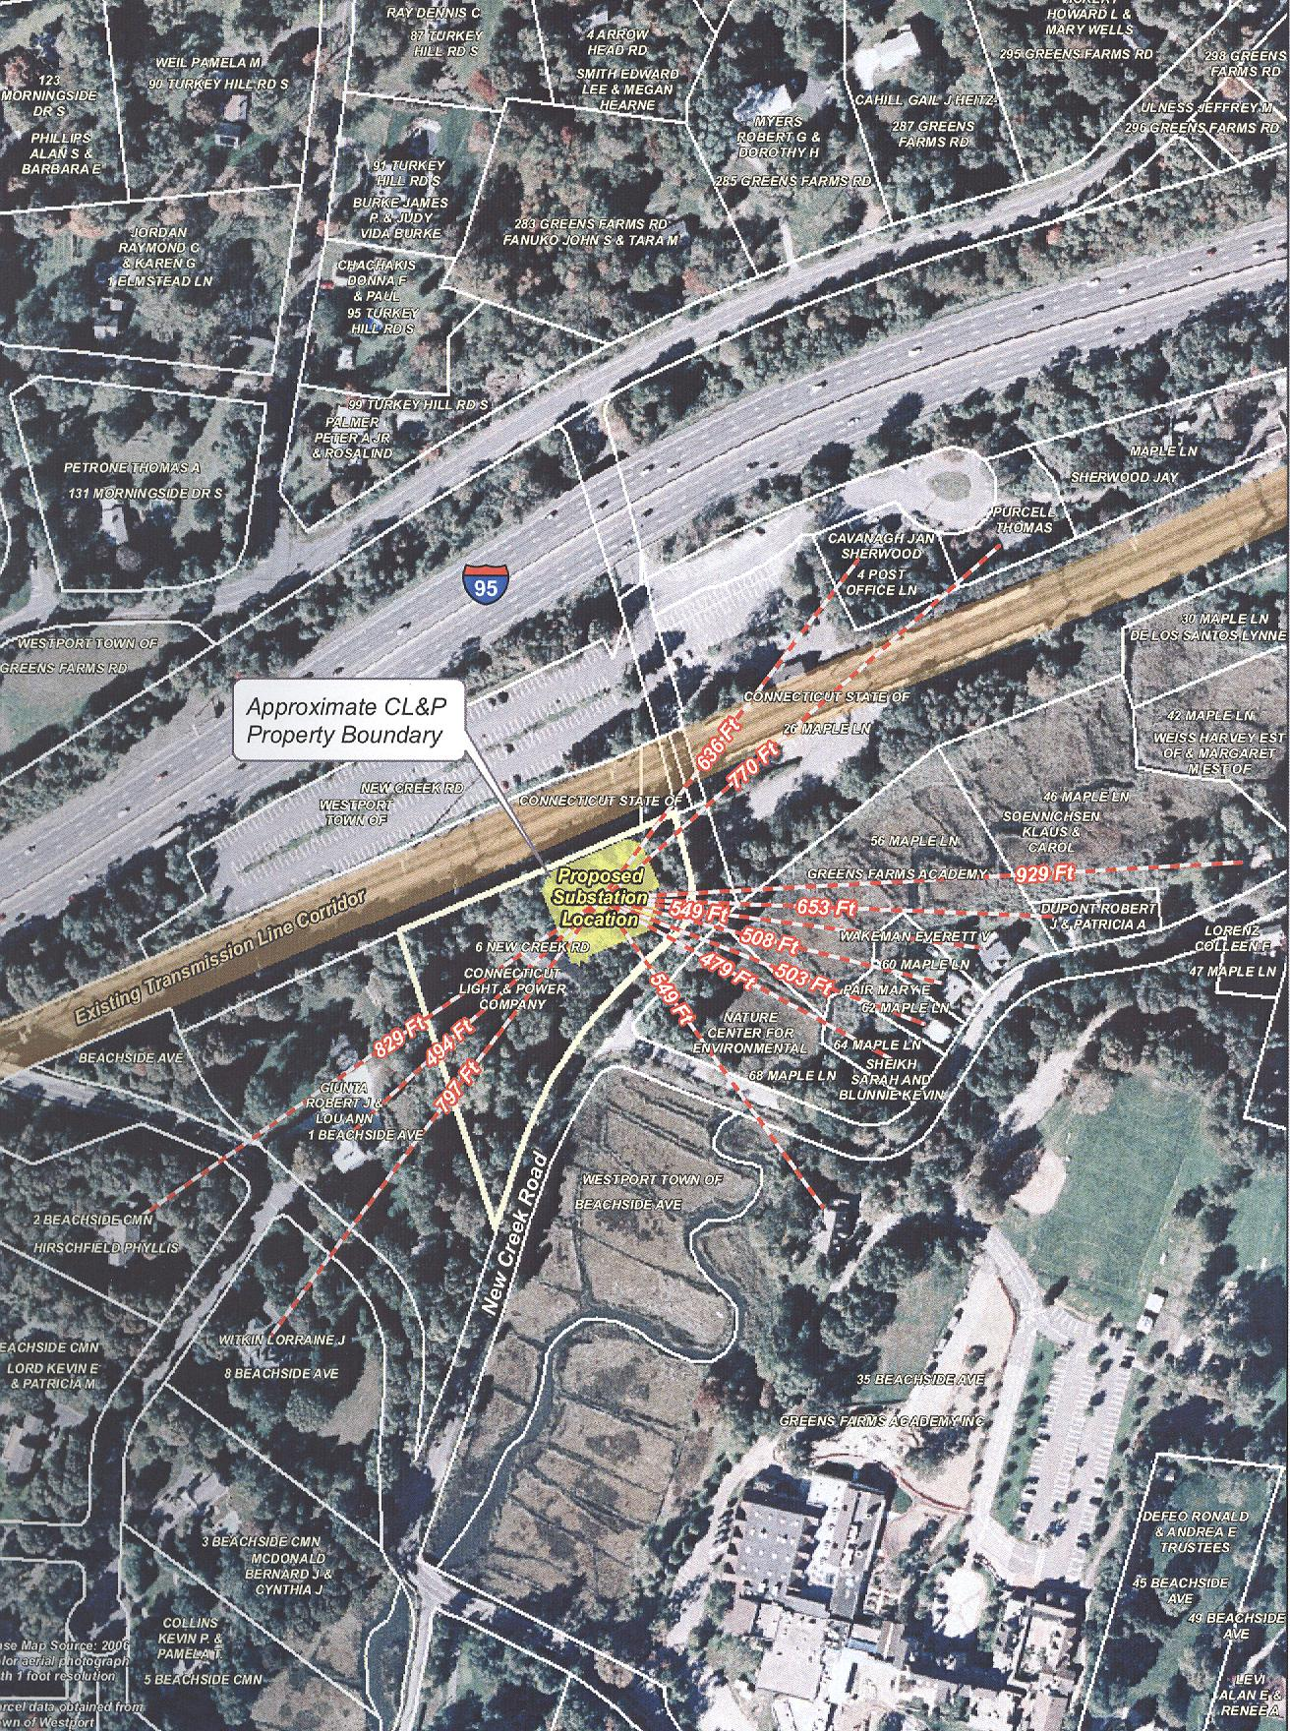
Figure 1: Site location at 6 New Creek Road in Westport. (CL&P 1, Vol. I, Fig. H-2)

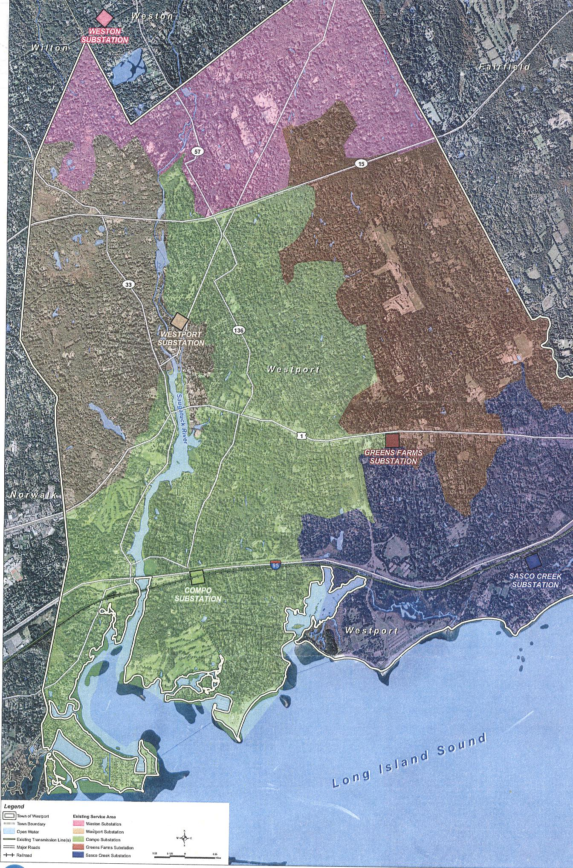
Figure 2: Existing Westport Area Substation System. (CL&P 1, Vol. I, Fig. G-1)

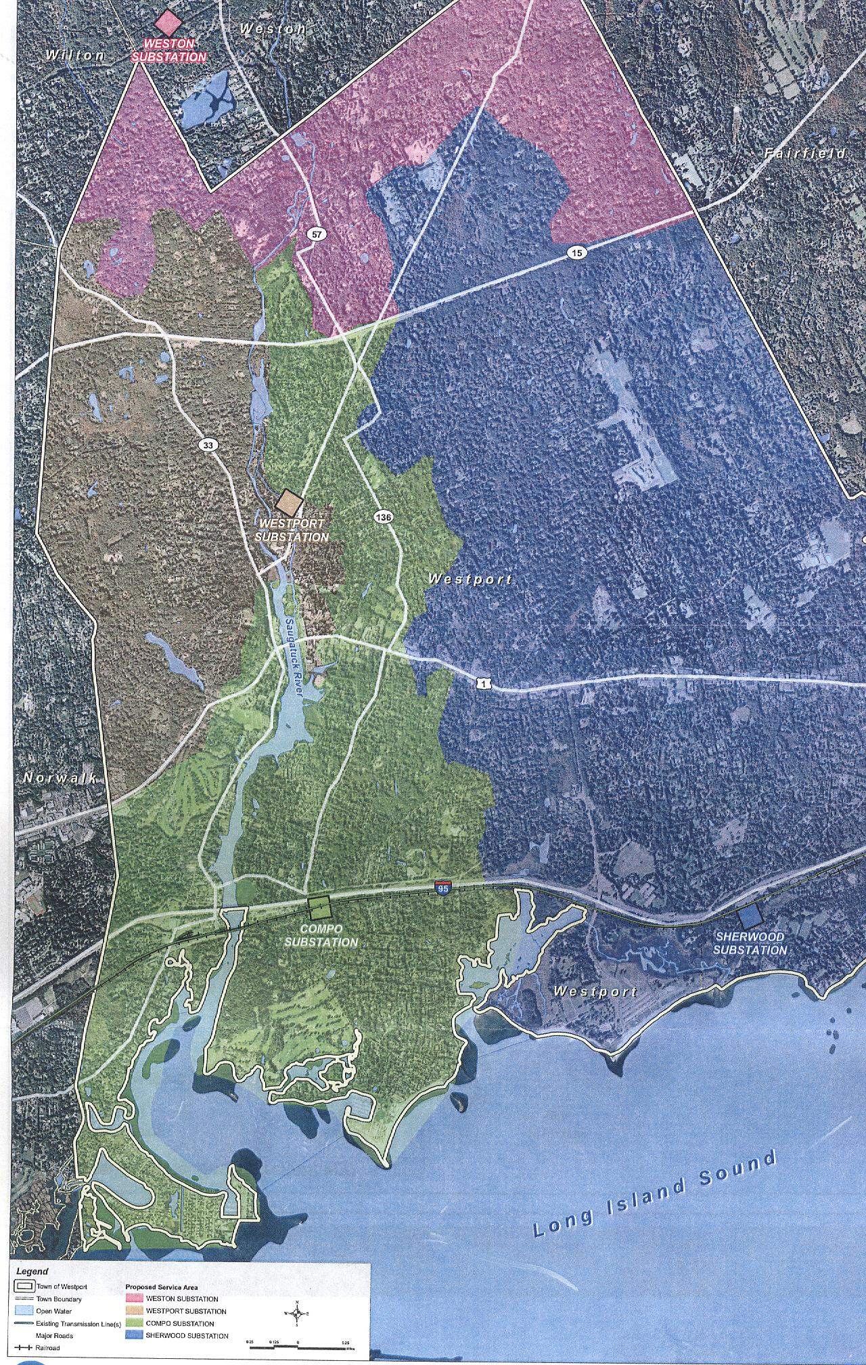
Figure 3: Westport Area Substation System after completion of proposed Sherwood Substation and removal of Green Farms Substation and temporary equipment at Sasco Creek Substation. (CL&P 1, Vol. I, Fig. G-2)

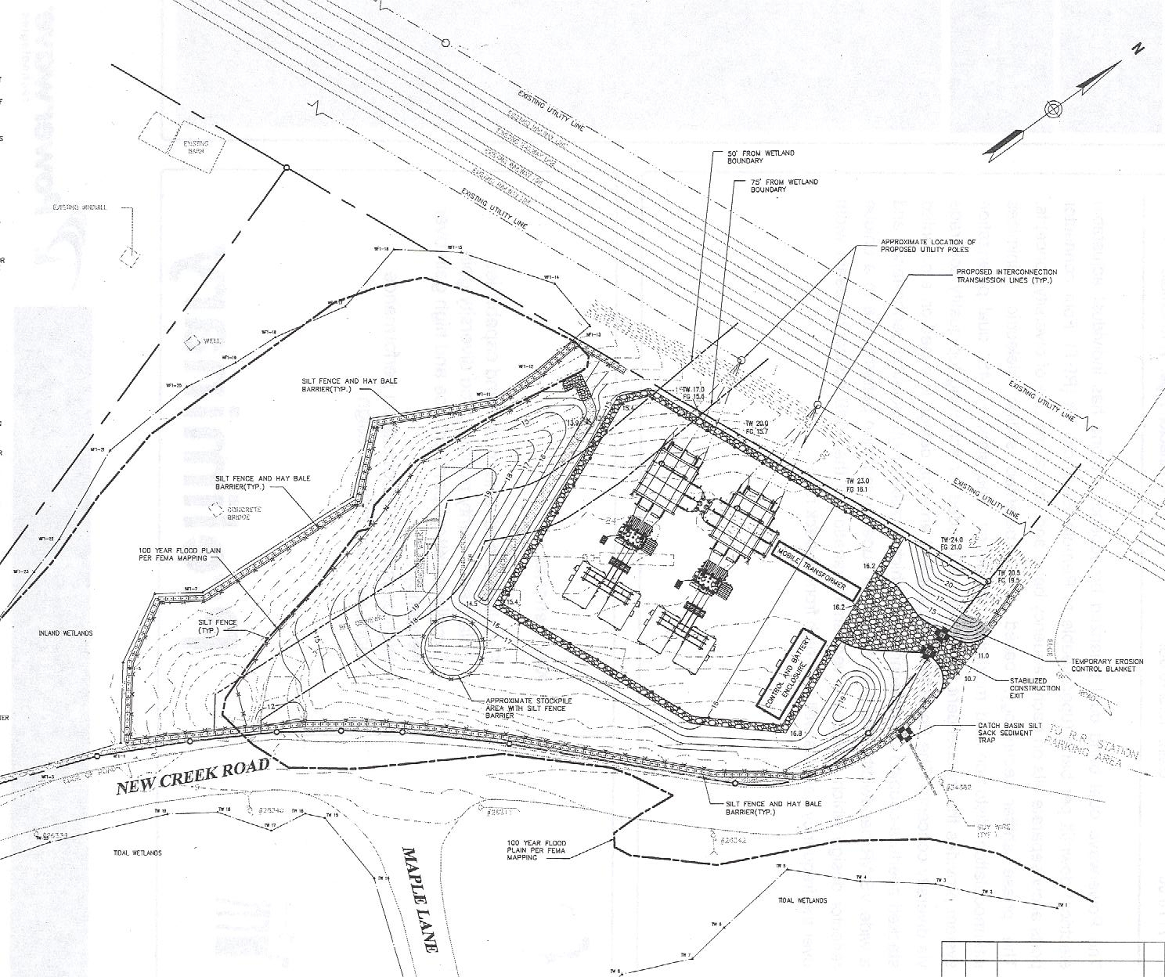

Figure 4: Proposed Sherwood Substation site plan. (CL&P 7)

