DOCKET NO. 380 - Bay Communications, LLC application for a Certificate of Environmental Compatibility and Public Need for the construction, maintenance and operation of a wireless telecommunications facility at 47 Garrett Ridge Drive, New Hartford, Connecticut. | }  }  } | Connecticut  Siting  Council  July 22, 2009

Findings of Fact

Introduction

- Bay Communications LLC (Bay), in accordance with the provisions of General Statutes §§ 16-50g through 16-50aa, applied to the Connecticut Siting Council (Council) on March 17, 2009 for the recertification of a wireless telecommunications facility originally approved at 170 Southeast Road, New Hartford, Connecticut. (Bay 1, p. 6)

- On November 20, 2003, the Council approved an application (Docket 251) from Sprint Spectrum, L.P. d/b/a Sprint PCS (Sprint) to construct a 150-foot monopole facility at this location with the condition that the facility be constructed within one year. (Council Administrative Notice 19)

- On February 3, 2004, the Council approved a petition (Petition 649) from Cellco Partnership d/b/a as Verizon Wireless (Cellco) to increase the height of the approved facility from 150 feet to 160 feet above ground level (agl). (Council Administrative Notice 20)

- On March 4, 2004, the Council approved a Development and Management (D&M) Plan for the approved 160-foot facility. (Council Administrative Notice 19)

- On August 12, 2004, the Council approved a transfer of the Certificate of Environmental Compatibility and Public Need (Certificate) from Sprint to Bay. While Bay and Sprint were finishing details of the transfer, the Certificate expired. (Council Administrative Notice 19)

- On March 13, 2006 Bay applied to the Council for a recertification of the site under Docket 314. The Council re-approved the facility on July 27, 2006. (Council Administrative Notice 18)

- On December 12, 2006, the Council approved a second D&M Plan for the site. The second D&M Plan was necessary to account for changes in the access road due to residential development of the host property. (Council Administrative Notice Item 18)

- On April 24, 2008, the Council approved an extension of time to September 30, 2008 to complete work at the site. Due to complications associated with the redesign of a bridge to the site, the limited availability of construction material and site conditions hindering construction, the Certificate expired before work was complete. (Council Administrative Notice Item No. 18; Bay 1, pp. 5, 10)

- The party in this proceeding is the applicant. An intervenor to the proceeding is Cellco Partnership d/b/a Verizon Wireless (Cellco). (Transcript 1, 5/21/09, 2:10 p.m. [Tr. 1], p. 5)

- Bay is a tower development company based in Massachusetts that owns and operates tower sites in Massachusetts, Connecticut, and Rhode Island. (Council Administrative Notice 18)

- Pursuant to General Statutes § 16-50m, the Council, after giving due notice thereof, held a public hearing on May 21, 2009, beginning at 2:10 p.m. at the Warren Town Hall, 7 Sackett Hill Road, Warren, Connecticut. (Council's Hearing Notice dated April 14, 2009; Tr. 1, p. 3)

- Public notice of the application was published in The Hartford Courant, the Republican-American, and The Register Citizen on January 29, 2009 and February 3, 2009. (Bay 1, p. 8)

- Pursuant to CGS § 16-50l(b), Bay notified abutting property owners by certified mail. All certified mail receipts were received. Bay also notified all homeowners on Garrett Ridge Drive. (Bay 1, p. 9; Bay 2, Q. 2; Tr. 1, p. 14)

- The Council received written comment on May 13, 2009 from the Metropolitan District Commission (MDC), an entity that owns the Nepaug Reservoir, a public water supply reservoir east of the site. (Specific comment is provided in Finding 33). (Record)

State Agency Comment

- Pursuant to General Statutes § 16-50j(h), on April 14, 2009, the following state agencies were solicited to submit written comments regarding the proposed facility: Department of Environmental Protection (DEP), Department of Public Health (DPH), Council on Environmental Quality (CEQ), Department of Public Utility Control (DPUC), Office of Policy and Management (OPM), Department of Economic and Community Development (DECD), Department of Agriculture (DOAg) and the Department of Transportation (DOT). (Record)

- The DPH provided written comment to the Council on June 26, 2009 requesting that Bay follow best management practices during construction activities that occur adjacent to Spruce Brook, a tributary to the Nepaug Reservoir. The DOT’s Bureau of Engineering and Highway Operations provided correspondence to the Council on May 11, 2009, indicating they had no comment. (Record)

- The following state agencies did not file written comment on the application: DEP, CEQ, DPUC, OPM, DOAg and the DECD. (Record)

Municipal Consultation

- Bay met with the New Hartford First Selectman Earl MacInnes on May 7, 2009 to discuss the recertification application. At the meeting, the Town recognized a need for service in the affected section of New Hartford and had no issues with the application. (Bay 2, Q. 7)

Public Need for Service

- In 1996, the United States Congress recognized a nationwide need for high quality wireless telecommunications services, including cellular telephone service. Through the Federal Telecommunications Act of 1996, Congress seeks to promote competition, encourage technical innovations, and foster lower prices for telecommunications services. (Council Administrative Notice Item No. 7)

- In issuing cellular licenses, the Federal government has preempted the determination of public need for cellular service by the states, and has established design standards to ensure technical integrity and nationwide compatibility among all systems. (Council Administrative Notice 7)

- The Telecommunications Act of 1996 prohibits local and state entities from discriminating among providers of functionally equivalent services. (Council Administrative Notice 7)

- The Telecommunications Act of 1996, a Federal law passed by the United States Congress, prohibits any state or local entity from regulating telecommunications towers on the basis of the environmental effects of radio frequency emissions to the extent that such towers and equipment comply with the Federal Communication Commission’s regulations concerning such emissions. This Act also blocks the Council from prohibiting or acting with the effect of prohibiting the provision of personal wireless service. (Council Administrative Notice Item No. 7)

Site Description

- The site was originally located on a 64-acre parcel designated as 170 Southeast Road in New Hartford. (Council Administrative Notice 18)

- The parcel was subdivided into 11 residential lots accessed by a new road, Garrett Ridge Drive, in 2006. The current subdivision is located west of Spruce Brook, a stream that traverses the eastern portion of the property in a north-south direction. (Council Administrative Notice 18; Bay 1, Tab 14; Bay 2, Q. 2)

- The remaining portion of the property containing the proposed site, approximately 15-acres, was assigned a new address, 47 Garrett Ridge Drive. (Record; Bay 2, Q. 1)

- The proposed tower site is located on the eastern side of the undeveloped parcel in a heavily wooded area. (Bay 2, Q. 1)

- Access to the tower site would be from an existing 870-foot long tower access drive originating from the Garrett Ridge Drive cul-de-sac, the route previously approved in the Docket 314 D&M Plan. From the cul-de-sac, the driveway proceeds downhill, crosses Spruce Brook on a concrete, prefabricated bridge, and proceeds uphill to the compound site. (Council Administrative Notice 18; Bay 1, Tab 14)

- Construction of the existing tower access drive began before the expiration of the D 314 Certificate. The driveway was constructed in accordance with the Council-approved D&M Plan with subsequent approved modifications. The road is complete except for the installation of waterbars and runoff deflectors within the roadbed. (Council Administrative Notice 18; Bay 1, Tab 14; Bay 2, Q 6)

- Bay proposes to construct a 160-foot monopole at the site. (Bay 1, p. 9)

- Bay would construct a 65-foot by 75-foot compound within a 100-foot by 100-foot lease area. The compound area has already been cleared and rough graded. (Council Administrative Notice 18; Bay 1, p. 9)

- Underground utilities would be installed from the end of the subdivision road along the new access road to the compound site. (Bay 1, Tab 14)

- The nearest abutting property, owned by the MDC, is 150 feet north of the tower site. (Bay 1, Tab 14)

- Two residences are within 1,200 feet of the site, located at 35 Garrett Ride Drive and 36 Garrett Ridge Drive. (Tr. 1, p 15; Bay late file of June 2, 2009)

- Cellco would install 12 panel antennas on a platform at a centerline height of 160 feet agl. (Cellco 1, Q. 3)

- Although Sprint did not intervene in this proceeding, Sprint is expected to locate at the 150-foot level of the tower. (Bay 1, p. 9)

- New Cingular Wireless PCS LLC (AT&T) intends to install six platform mounted panel antennas at the 130-foot level of the tower, through a Council-approved tower exempt modification filing (approved May 7, 2008). AT&T would install a 12-foot by 20-foot equipment shelter within the compound. (Council EM-CING-092-080403)

- Youghiogheny Communications-Northeast LLC (Pocket) intends to install three flush mounted antennas at the 110-foot level of the tower, through a Council-approved tower exempt modification filing (approved March 16, 2009). Pocket would install an equipment cabinet within the compound. (Council EM-POCKET-092-09226)

Environmental Considerations

- All clearing and roadwork at the site has been completed except for water control features in the road. (Bay 2, Tab 6; Tr. 2, p. 19)

- The MDC recommended the following:
  - paving the bridge and the approaches at each end to prevent loose sand and gravel from washing into Spruce Brook.
  - paving the steep grades along the access road if the water deflectors are ineffective in preventing erosion.
  - installing of guard rails on both sides of the bridge to prevent accidents and spills.
(MDC letter of May 11, 2009)

- The DPH recommended the following:
  - installing of guard rails on both sides of the bridge to prevent accidents and spills.
  - annual bridge inspections for erosion and structural deficiencies.
  - use of best management practices during construction activities to prevent contamination sedimentation of watershed.
(DPH letter of June 26, 2009)

- The proposed facility would have no effect upon historic or archaeological resources. (Council Administrative Notice 19)

- The Bald Eagle (Haliaeetus leucocephalus), a federally threatened and state endangered species, occurs in the site area, specifically using the shoreline of the Nepaug Reservoir as habitat. The nearest shoreline is approximately 1,900 feet east of the site. The proposed tower would have no effect on resident eagles. (Council Administrative Notice 19)

- Aircraft hazard obstruction marking or lighting of the proposed tower would not be required. (Council Administrative Notice 18)

- The cumulative worst-case maximum power density from the radio frequency emissions from the operation of all approved antennas and Verizon’s proposed antennas is 38.6% of the standard for Maximum Permissible Exposure, as adopted by the FCC, at the base of the proposed tower. This calculation was based on methodology prescribed by the FCC Office of Engineering and Technology Bulletin No. 65E, Edition 97-01 (August 1997) that assumes all antennas would be pointed at the base of the tower and all channels would be operating simultaneously, which creates the highest possible power density levels. Under normal operation, the antennas would be oriented outward, directing radio frequency emissions away from the tower, thus resulting in significantly lower power density levels in areas around the tower. (Bay 1, p. 9; Council Administrative Notice 18; Cellco 2, Q. 7; Council EM-CING-092-080403; Council EM-POCKET-092-09226)

Visibility

- The Council previously ruled that the proposed tower would not be visually obtrusive to the surrounding area. (Council Administrative Notice 18)

- Development of the Garrett Ridge subdivision altered near-range views of the tower through the clearing of approximately 13-acres of forest to create 11 residential building lots. Six of the lots were sold and five were developed. (Bay 2, Q. 2; Tr. 1, pp. 15-16)

- Portions of eight of the lots would have year-round views of the tower (refer to Figure 1). Views would range from the top of the tower to the upper 70 feet of the tower, depending on the viewer’s orientation. (Bay 5; Tr. 1, pp. 15-18)

Cellco – Existing and Proposed Wireless Coverage

- Cellco operates at a minimum signal level threshold of -85 dBm for in-vehicle coverage and -75 dBm for in-building coverage. Cellco intends to operate 800 MHz, 1900 MHz, and 700 MHz equipment at this site. (Cellco 1, Q. 1, Q. 2)

- Cellco has identified an approximate 2.5-mile cellular coverage gap and an approximate 2.7 mile PCS coverage gap on Route 202 in New Hartford between existing Cellco facilities in New Hartford and Canton (refer to Figures 2 & 3). (Cellco 1, Q. 1, Q. 4)

- Installing antennas at 160 feet agl would satisfy Cellco’s PCS and cellular coverage gaps on Route 202. (refer to Figures 4 & 5). (Cellco 1, Q. 1, Q. 5)

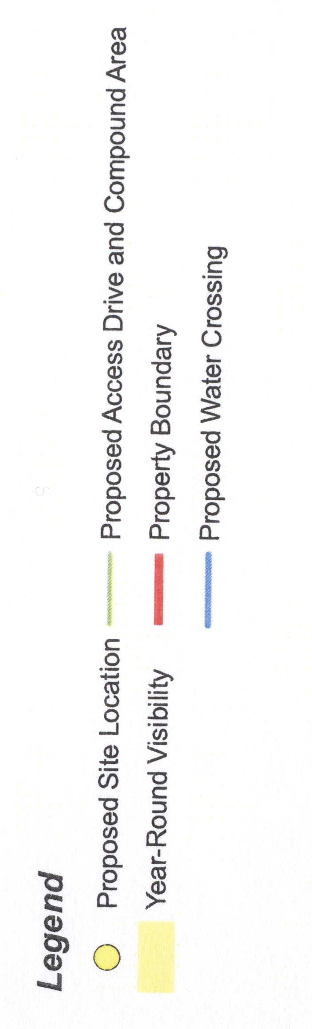
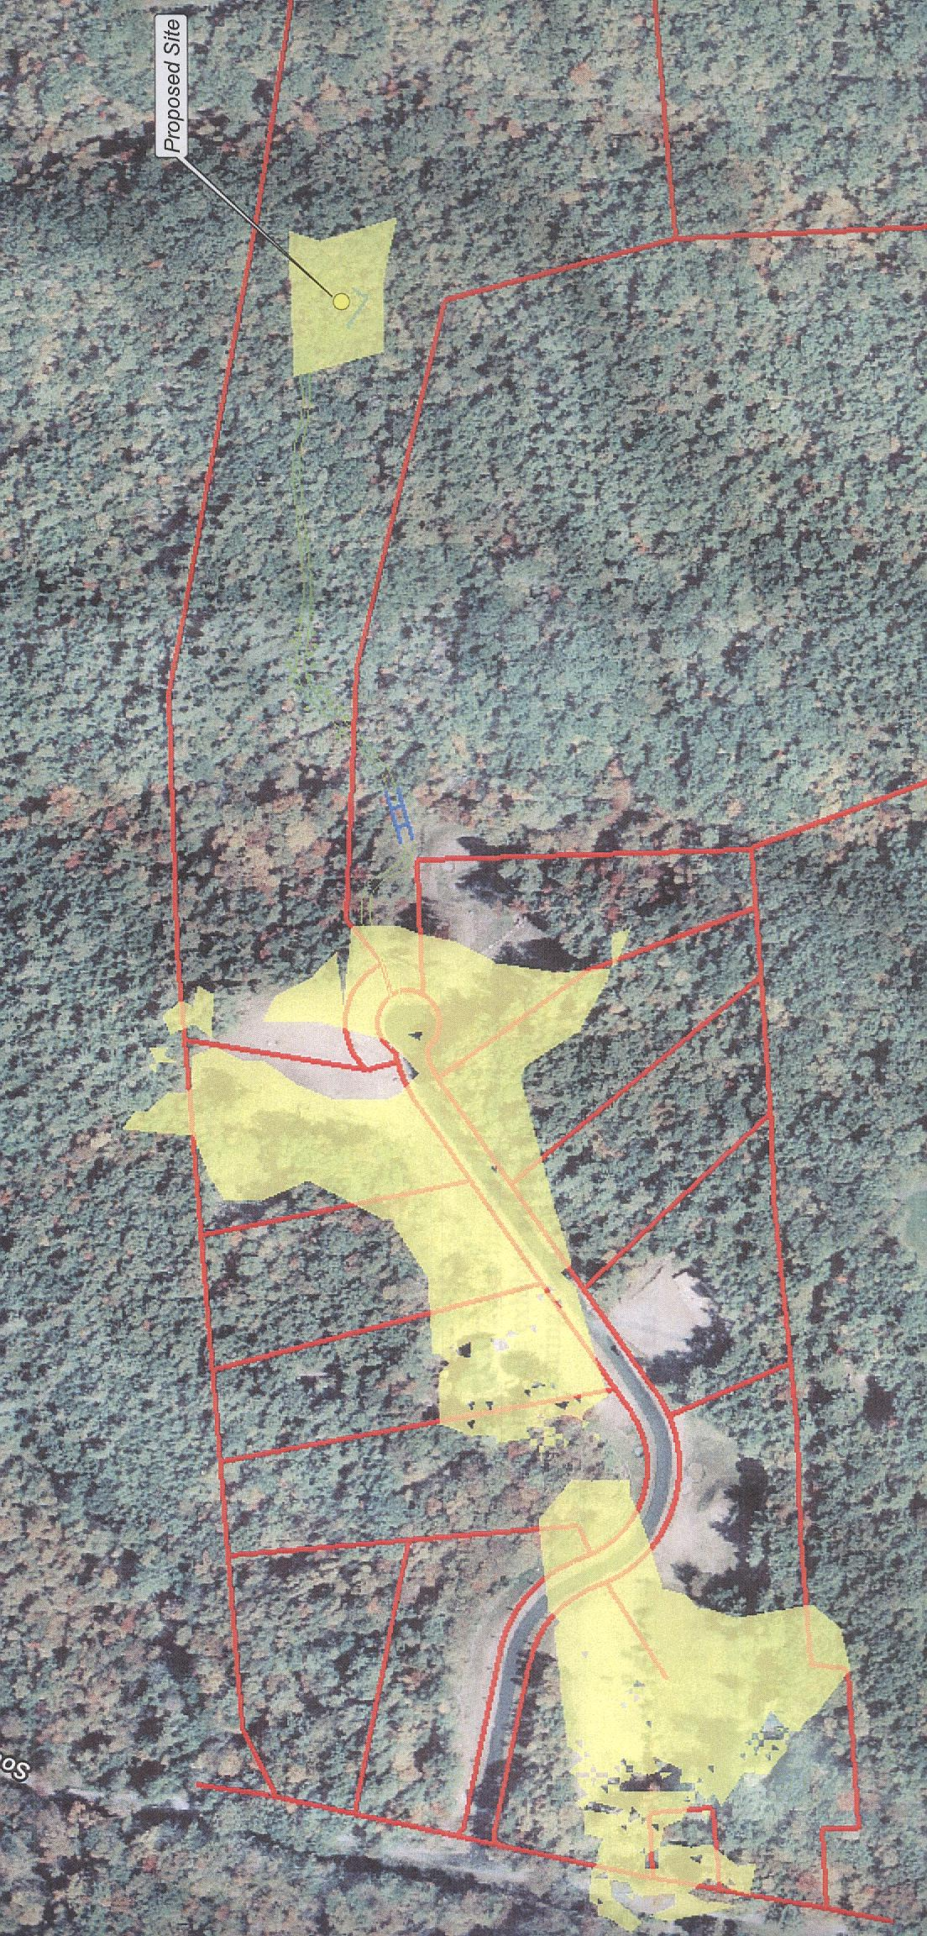
FIGURE 1
NEAR RANGE VISIBILITY OF PROPOSED 160-FOOT TOWER

(Bay 5)

FIGURE 2
CELLCO – EXISTING CELLULAR COVERAGE

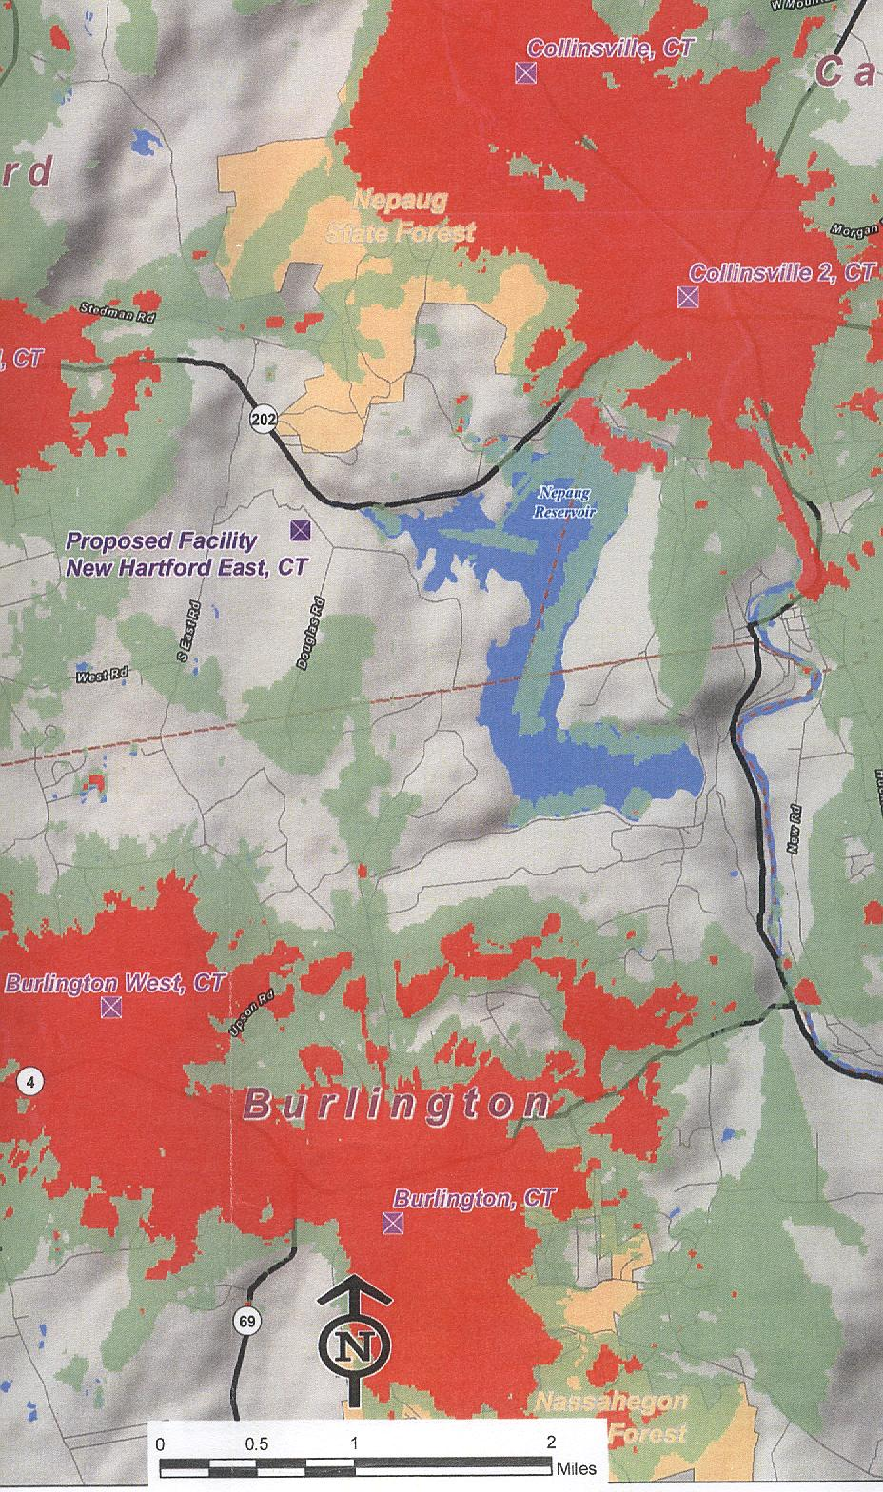
Green designation: - 76 dBm to - 85 dBm
Orange designation: - 75 dBm
(Cellco 1, Q. 4)
FIGURE 3
CELLCO – EXISTING PCS COVERAGE

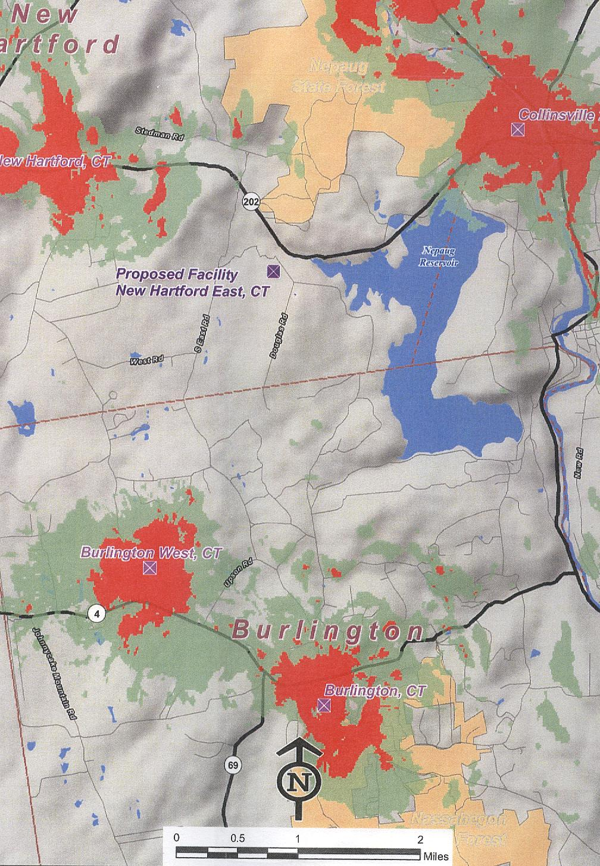

Green designation: - 76 dBm to - 85 dBm
Orange designation: - 75 dBm
(Cellco 1, Q. 4)
FIGURE 4
CELLCO – EXISTING AND PROPSOED CELLULAR COVERAGE

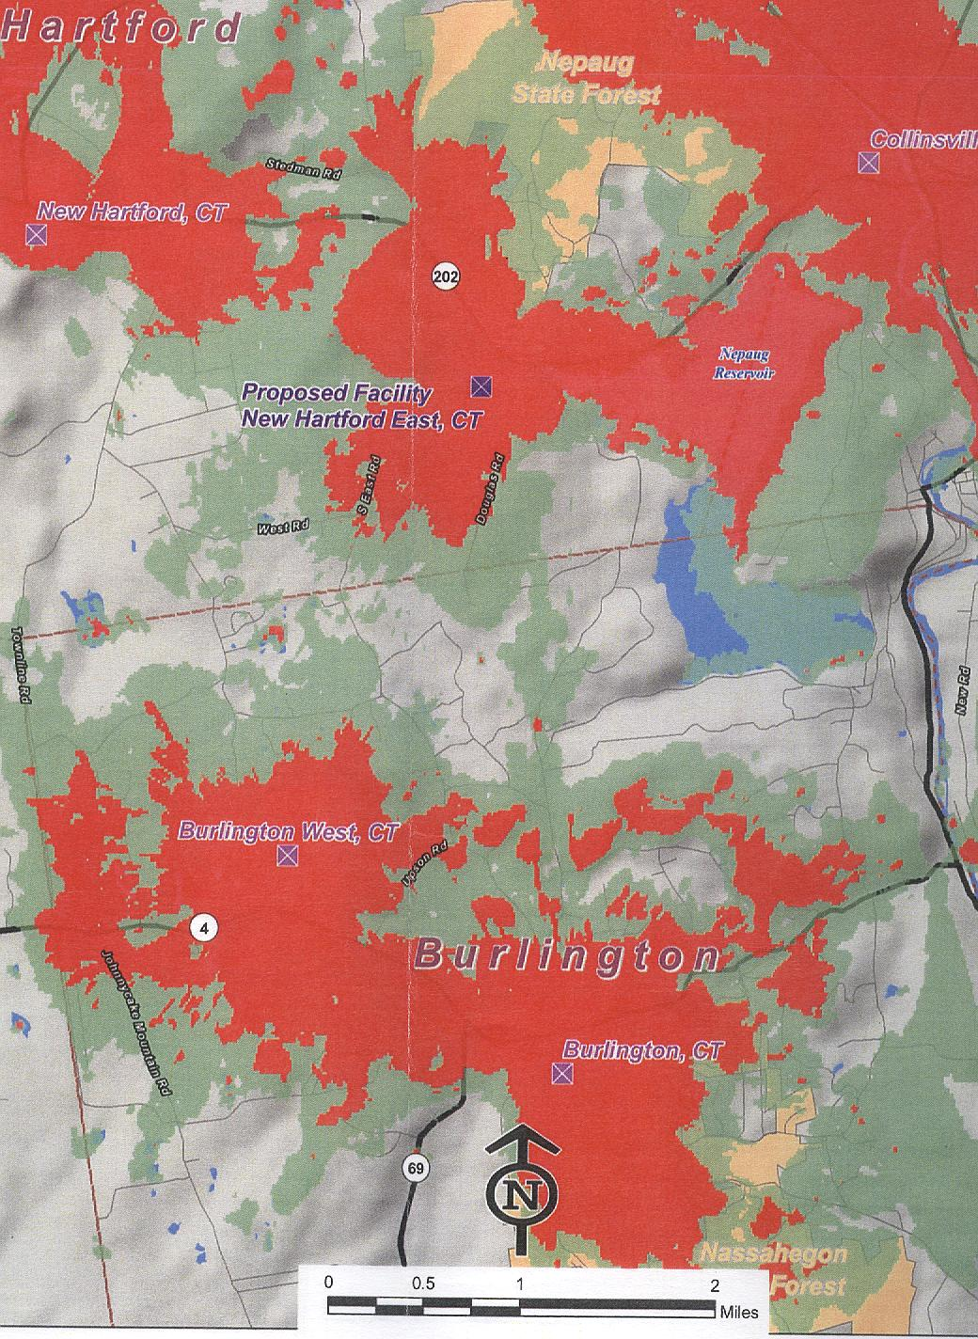
Green designation: - 76 dBm to - 85 dBm
Orange designation: - 75 dBm

(Cellco 1, Q. 5)
FIGURE 5
CELLCO – EXISTING AND PROPOSED PCS COVERAGE

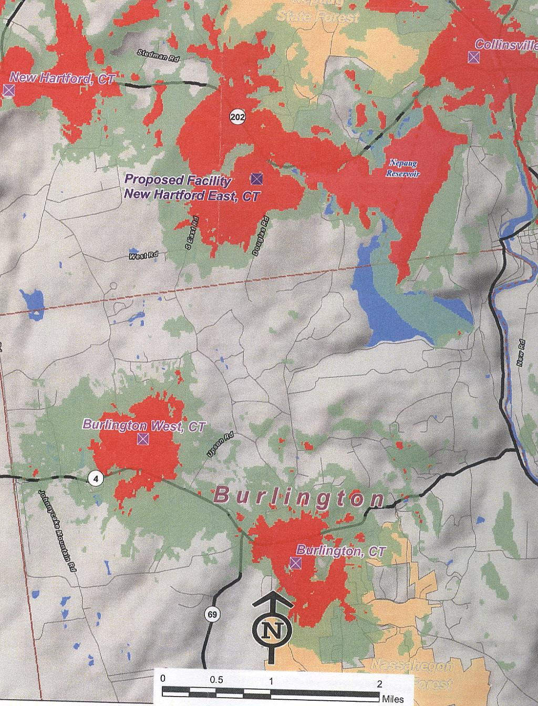

Green designation: - 76 dBm to - 85 dBm
Orange designation: - 75 dBm

(Cellco 1, Q. 5)

