DOCKET NO. 375 – New Cingular Wireless PCS, LLC application for a Certificate of Environmental Compatibility and Public Need for the construction, maintenance and operation of a telecommunications facility located at 85 Paper Mill Road, Woodbury, Connecticut. | }  }  } | Connecticut  Siting  Council  August 27, 2009

Findings of Fact

Introduction

- New Cingular Wireless PCS, LLC (AT&T), in accordance with the provisions of Connecticut General Statutes (CGS) §§ 16-50g through 16-50aa, applied to the Connecticut Siting Council (Council) on February 4, 2009 for the construction, operation, and maintenance of a 150-foot wireless telecommunications facility located at 85 Paper Mill Road in Woodbury, Connecticut. (AT&T 1, pp. 1-2)

- AT&T is a Delaware corporation with an office in Rocky Hill, Connecticut. AT&T is licensed by the Federal Communications Commission to construct and operate a personal wireless service system in Connecticut. (AT&T 1, p. 2)

3. The party in this proceeding is the applicant. (Transcript 1 – 05/12/09, 3:20 p.m. [Tr. 1], p. 5)

- The purpose of the proposed facility is to provide wireless service for AT&T to Routes 47 and 132 and adjacent areas in the northwest section of Woodbury. (AT&T 1, p. 1)

- Pursuant to CGS § 16-50m, the Council, after giving due notice thereof, held a public hearing on May 12, 2009, beginning at 3:20 p.m. and continuing at 7:00 p.m. at the Nonnewaug High School, 5 Minortown Road, Woodbury, Connecticut. (Council's Hearing Notice dated April 13, 2009; Tr. 1, p. 2; Transcript 2 – 05/12/09, 7:10 p.m. [Tr. 2], p. 2)

- The Council and its staff conducted an inspection of the proposed site on May 12, 2009, beginning at 2:00 p.m. The applicant flew a four-foot diameter balloon at the site from 10:45 a.m. to 7:00 p.m. to simulate the height of the proposed tower. Favorable weather conditions were present during the morning and evening hours. Windy condition prevailed during the afternoon, preventing the balloon from reaching its intended height of 150 feet above ground level (agl). (Council's Pre-Hearing Conference memo dated April 24, 2009; AT&T late file of June 12, 2009 )

- Notice of the application was provided to all abutting property owners by certified mail. Public notice of the application was published in the Republican-American on January 29 and 30, 2009. (AT&T 1, Tab 9; AT&T 2, Q. 1, Q. 15)

- AT&T installed a four-foot by six-foot sign describing the proposed project at the entrance to the site property driveway along Paper Mill Road. The sign also contained hearing and contact information. (AT&T late file of June 12, 2009)

- Pursuant to CGS § 16-50l(b), AT&T provided notice to all federal, state and local officials and agencies listed therein. (AT&T 1, Tab 8)

State Agency Comment

- Pursuant to General Statutes § 16-50j(h), on April 13, 2009 and May 15, 2009, the following State agencies were solicited to submit written comments regarding the proposed facility: Department of Environmental Protection (DEP), Department of Public Health (DPH), Council on Environmental Quality (CEQ), Department of Public Utility Control (DPUC), Office of Policy and Management (OPM), Department of Economic and Community Development (DECD), the Department of Transportation (DOT) and the Department of Agriculture (DOAg). (Record)

- The Council received a written response from the DOT’s Bureau of Engineering and Highway Operations on May 5, 2009, stating that the DOT has no comment. (Record)

- No response was received from the DPH, DOAg, DEP, CEQ, DPUC, OPM, or DECD. (Record)

Municipal Consultation

- AT&T filed a technical report with the Town of Woodbury on October 21, 2008. AT&T sent correspondence to the town on November 20, 2008, that stated AT&T would offer lease free space on the tower for emergency communications equipment. The town responded by indicating they were interested in placing equipment at the site in the future. (AT&T 1, pp. 7, 15-16, Tab 6)

- At the request of the Woodbury Zoning Commission, AT&T attended a public zoning meeting on March 10, 2009 to discuss the proposal. The zoning commission did not comment on the proposal at the hearing. (AT&T 4)

- The Woodbury Land Use office, through First Selectman Paul Hinckley, provided a limited appearance statement to the Council on June 10, 2009. The statement presented an analysis of how the proposed facility complies with the Town’s Zoning Regulations in regards to the siting of telecommunication facilities. (Town of Woodbury limited appearance statement of June 10, 2009)

Public Need for Service

- In 1996, the United States Congress recognized a nationwide need for high quality wireless telecommunications services, including cellular telephone service. Through the Federal Telecommunications Act of 1996, Congress seeks to promote competition, encourage technical innovations, and foster lower prices for telecommunications services. (Council Administrative Notice Item No. 7)

- In issuing cellular licenses, the Federal government has preempted the determination of public need for cellular service by the states, and has established design standards to ensure technical integrity and nationwide compatibility among all systems. (Council Administrative Notice Item No. 7)

- The Telecommunications Act of 1996 prohibits local and state entities from discriminating among providers of functionally equivalent services. (Council Administrative Notice Item No. 7)

- The Telecommunications Act of 1996, a Federal law passed by the United States Congress, prohibits any state or local entity from regulating telecommunications towers on the basis of the environmental effects of radio frequency emissions to the extent that such towers and equipment comply with FCC’s regulations concerning such emissions. This Act also blocks the Council from prohibiting or acting with the effect of prohibiting the provision of personal wireless service. (Council Administrative Notice Item No. 7)

- In an effort to ensure the benefits of wireless technologies to all Americans, Congress enacted the Wireless Communications and Public Safety Act of 1999. The purpose of this legislation was to promote public safety through the deployment of a seamless, nationwide emergency communications infrastructure that includes wireless communications services. (AT&T 1, pp. 5-6)

- AT&T would be able to provide enhanced 911 services to the target service area. (AT&T 1, p. 5)

Site Selection

22. AT&T established a search ring for the target service area in 2007. The search included identification of potential structures that could be used for telecommunications purposes, discussion with town officials regarding suitable land for development, and the examination of town records to identify potential telecommunications sites. (AT&T 1, pp. 6-7)

- The original search ring consisted of a 1.8-mile diameter circle centered north of the Hotchkissville section of Woodbury. The ring was revised to an approximate 0.5-mile diameter circle centered on the south end of Kavanaugh Hill in the Hotchkissville area. (AT&T 1, Tab 2, Tab 3)

- The nearest existing tower facility to the proposed site is a 150-foot monopole located at 478 Good Hill Road in Woodbury, approximately 1.8 miles southeast of the proposed site. AT&T is located at the 124-foot level of this facility; coverage does not extend to the target service area. (AT&T 1, Tab 1)

- AT&T did not identify any structures suitable to provide coverage to the target service area. (AT&T 1, p. 6)

- After determining there were no viable structures within the search area, AT&T searched for properties suitable for tower development. AT&T investigated 16 parcels and selected one for tower development. The 15 rejected parcels and reasons for their rejection are as follows:
- Firehouse on Route 47, Woodbury – parcel too small, visual impact high;
- Tufte Sites 1 & 2, Woodbury – would not achieve coverage objectives;
- Tietz Sites 1 & 2, Woodbury – would not achieve coverage objectives;
- Gibbons Property, Weekeepeemee Road, Woodbury – would not achieve coverage objectives;
- Flanders Land Trust (various locations), Woodbury - would not achieve coverage objectives;
- Green Property, Woodbury - no response from owner;
- Lizbro Inc. Property, Woodbury – parcel too small;
- Siemon Property, Woodbury - no response from owner;
- Graham Property, Woodbury – would not achieve coverage objectives;
- Good Property, Woodbury - would not achieve coverage objectives;
- Poskas Property, Woodbury - would not achieve coverage objectives;
- Palesty Property, Woodbury - would not achieve coverage objectives; and
- Ram Property (various), Woodbury – would not achieve coverage objectives.
(AT&T, Tab 2; Tr. 1, pp. 47-49)

Facility Description

- The proposed facility is located on a 34.1-acre parcel owned by Jodie Bryan at 85 Paper Mill Road in Woodbury (refer to Figure 1). The property is developed with a residence and several outbuildings (refer to Figures 1 & 2). (AT&T 1, p. 8; AT&T 2, Q. 3)

- The parcel is zoned Open Space-100, a designation for two-acre residential lots. (AT&T 1, p. 8; Tr. 1, pp. 49-50)

- The tower site is located in the central portion of the property, at the top of the southerly extension of Kavanaugh Hill, a north-south oriented ridge. (AT&T 1, Tab 3)

- The property is developed with a single-family residence and several outbuildings, accessed from Paper Mill Road. (AT&T 1, Tab 3)

- AT&T proposes to construct a 150-foot self-supporting monopole at the site in a level, semi-open area. (AT&T 1 p. 8, Tab 3)

- The tower would be designed to support four levels of antennas and Town of Woodbury emergency communication antennas. (AT&T 1 pp. 7-8; Tr. 1, p. 22)

- The tower and foundation would be designed to support a possible 10 to 20 foot extension but any such an extension would require Council approval. (AT&T pp. 20-22; pp. 33-36)

- AT&T proposes to construct a 50-foot by 75-foot equipment compound within a 60-foot by 100-foot lease area at the base of the tower, sufficient space to accommodate four telecommunication carriers. The compound would be enclosed by an eight-foot high chain link fence. (AT&T 1, pp.7-8, Tab 3)

- Access to the compound would originate from an existing 1,570-foot long gravel driveway off Paper Mill Road, which services not only the proposed site but also the residence of an abutting property owner (Montalbano). A new gravel drive, 12 feet wide and 135 feet long, would extend southward from the existing drive, beyond a barn and pasture, to the tower site. (AT&T 1, p. 8, Tab 3)

- AT&T’s lease for the site includes access via the existing driveway and the proposed new driveway. AT&T would perform certain upgrades of the existing driveway to make it passable for construction vehicles. These upgrades would be addressed in the Development and Management Plan to be submitted to the Council, should the tower application be approved. (Tr. 1, pp. 68-70)

- The property owner and the adjacent property owner (Montalbano) maintain the driveway. AT&T would not be responsible for maintaining the existing driveway once construction of the site is completed. (AT&T 1, pp. 70-71)

- Underground utilities would service the compound from an existing transformer and telecommunication pedestal located adjacent to the on-site barn. (AT&T 1, p. 8, Tab 3)

- AT&T proposes to install six panel antennas on a platform at a centerline height of 147 feet agl. (AT&T 1, p. 8)

- AT&T proposes to install a 12-foot by 20-foot equipment shelter on a concrete pad within the compound. Emergency power would be provided by a battery that could power the site for approximately eight hours. (AT&T 1, Tab 3; Tr. 1, pp. 27-28)

- The tower is approximately 720 feet from the north property line (Dolan property), 707 feet from the southern property line (Testanero property), 320 feet to the western property line (Takahshi property) and 405 feet from the east property line (Platt property). (AT&T 1, Tab 3; Tr. 1, p. 23)

- The tower radius would be contained within the site property. (AT&T 1, Tab 3)

- The nearest off-site residence to the proposed tower site is approximately 670 feet to the northeast, owned by Vincent and Catherine Montalbano, located at 83 Paper Mill Road. (AT&T 1, Tab 3; AT&T 2, Q. 4)

- There are fifteen residences within 1,000 feet of the tower site. (AT&T 1, Tab 3)

- Land use within a quarter-mile of the site is a mix of undeveloped land and residential parcels. (AT&T 1, Tab 3)

- The tower site is located at an elevation of 526 feet above mean sea level (amsl). Surrounding terrain consists of rolling hills with elevations ranging from 250 feet amsl in the valleys to 900 feet amsl on the surrounding hilltops. (AT&T 1, Tab 3)

- The estimated construction cost of the facility, not including AT&T’s antennas and radio equipment, is:

Tower and foundation $200,000.
Site development 60,000.
Utilities 40,000.

Total estimated cost $300,000.
(AT&T 1, p. 17)

Environmental Concerns

- The proposed site is approximately 0.25 miles north and west of the Hotchkissville National Register Historic District, which is located in portions of the Weekeepeemee River valley below the south end of Kavanaugh Hill. (AT&T 1, Tab 4; AT&T 2, Q. 9, Q. 11)

- The State Historic Preservation Office stated the proposed facility would have no adverse effect on cultural resources within the Hotchkissville Historic District. (AT&T 2, Q. 11)

- AT&T sent correspondence to the Old Woodbury Historical Society and the Woodbury Town Historian, soliciting comment regarding the proposed facility. No response was received from either request. (AT&T 1, Tab 6, Tab 7)

- The site is not within any designated area indicating the presence of Federally threatened or endangered species or State endangered, threatened or special concern species. (AT&T 1, p. 10)

- Two oak trees with a diameter of six inches or greater at breast height would be removed to develop the site. (AT&T 1, Tab 3)

- The site is not near any inland wetland or watercourse or within a designated flood zone. (AT&T 1, p. 16)

- Minimal filling and grading would be required. Site blasting is not anticipated; any ledge encountered could be removed through chipping. (AT&T 1, Tab 3; AT&T 2, Q. 12)

- Aircraft hazard obstruction marking or lighting of the tower is not required or proposed. (AT&T 1, Tab 3)

- The cumulative worst-case maximum power density from the radio frequency emissions from the operation of the proposed AT&T antennas is calculated to be 6% of the standard for Maximum Permissible Exposure, as adopted by the FCC, at the base of the proposed tower. This calculation was based on methodology prescribed by the FCC Office of Engineering and Technology Bulletin No. 65E, Edition 97-01 (August 1997) that assumes all antennas would be pointed at the base of the tower and all channels would be operating simultaneously, which creates the highest possible power density levels. Under normal operation, the antennas would be oriented outward, directing radio frequency emissions away from the tower, thus resulting in significantly lower power density levels in areas around the tower. (AT&T 1, Tab 3)

Visibility

- The proposed tower would be visible year-round from approximately 61 acres within two miles of the proposed site (refer to Figure 3). The tower would be seasonally visible from an additional 23 acres. (AT&T 1, Q. 7)

- The tower would not be visible from any known hiking trails maintained by the DEP or the Connecticut Forest and Parks Association. A private trail is located on a conservation parcel off Flanders Road, over a mile east of the site, but the tower would not be visible from this area. (AT&T 1, Tab 4; AT&T 2, Q. 6, Q. 7)

- The tower would be visible year-round from northern areas of the Hotchkissville Historic District, located approximately 0.25 miles southeast of the site. (AT&T 1, Tab 4; AT&T 2, Q. 7)

- Visibility of the proposed tower from specific locations within a two-mile radius of the site is as follows:

Specific Location and Area Receptors | Visible | Approximate Portion of Tower Visible | Approx. Distance from Tower
Route 47 and Cam Ave intersection  23 residences within this area.  750 feet of roadway. | Yes | 75 feet – unobstructed | 1.6 miles southeast
Route 47 at #308  1 residence within this area.  600 feet of roadway. | Yes | 30 feet – through trees | 0.6 miles southeast
Hoop Pole Hill Road at #187  1 residence within this area  320 feet of roadway | Yes | 10 feet – unobstructed with hillside as backdrop | 0.8 miles west
Hoop Pole Hill Road at #304  2 residences within this area.  440 feet of roadway. | Yes | 20 feet – unobstructed with hillside as backdrop | 1.2 miles west
Hazel Plain Road at #175 and #142  3 residences within this area.  Another 6 residences would have seasonal views.  Two sections of roadway totaling 940 feet. | Yes | 20 feet - unobstructed with hillside as backdrop | 1.3 miles west
Peter Road  360 feet of roadway. | Yes | 20 feet – unobstructed | 0.9 miles north
Route 132 and Bushy Hill Road intersection  1 residence within this area.  360 feet of roadway. | Yes | 75 feet - unobstructed | 0.9 miles north
Route 132 near # 74/76  2 residences within this area.  500 feet of roadway. | Yes | 75 feet unobstructed | 0.3 miles southeast
83 Paper Mill Road, rear deck | Yes | Through trees | 670 feet northeast
(AT&T 1, Tab 4; AT&T 2, Q. 7; Tr. 2, pp. 18-20; AT&T late file of June 11, 2009)

AT&T - Existing and Proposed Wireless Coverage

- AT&T operates in both the cellular (800 MHz) and PCS (1900 MHz) frequency bands. AT&T is designing the site with a signal level threshold of -82 dBm, sufficient for in-vehicle coverage. (AT&T 3, Q. 4; AT&T late file of June 12, 2009)

- AT&T currently has no reliable, continuous coverage in Woodbury along Routes 47 and 132 north of Hotchkissville (refer to Figure 4). AT&T’s existing signal level in this area ranges from -82 dBm to -105 dBm (800 MHz system). (AT&T 2, Q. 13)

- Installing antennas at the 150 feet agl would provide approximately 2.5 miles of reliable coverage (800 MHz) to Route 47 and approximately 2.8 miles of reliable coverage to Route 132 (refer to Figure 5). Coverage would also be provided to portions of Hoop Pole Bridge Road, Sprain Brook Road, Paper Mill Road, Peter Road, Cross Brook Road, Painter Hill Road, and Hazel Plain Road. (AT&T 2, Q. 13)

- The site would provide a cellular coverage footprint of 11.8 square miles with an antenna height of 150 feet. (AT&T late file of June 12, 2009)

- Reducing the antenna height to 140 or 130 feet agl would cause a slight degradation of coverage along the periphery of the cellular coverage footprint. The cellular coverage footprint at 140 feet and 130 feet is approximately 11.3 square miles and 10.8 square miles, respectively. (AT&T 2, Q. 13, Q. 14; AT&T late file of June 12, 2009; Tr. 1, pp. 30-31, 52-54)

- An antenna height of 130 feet would allow for cellular handoff to AT&T sites to the south and southeast. There are no AT&T sites to the north. (AT&T 2, Q. 13, Q. 14; Tr. 1, pp. 63-64)

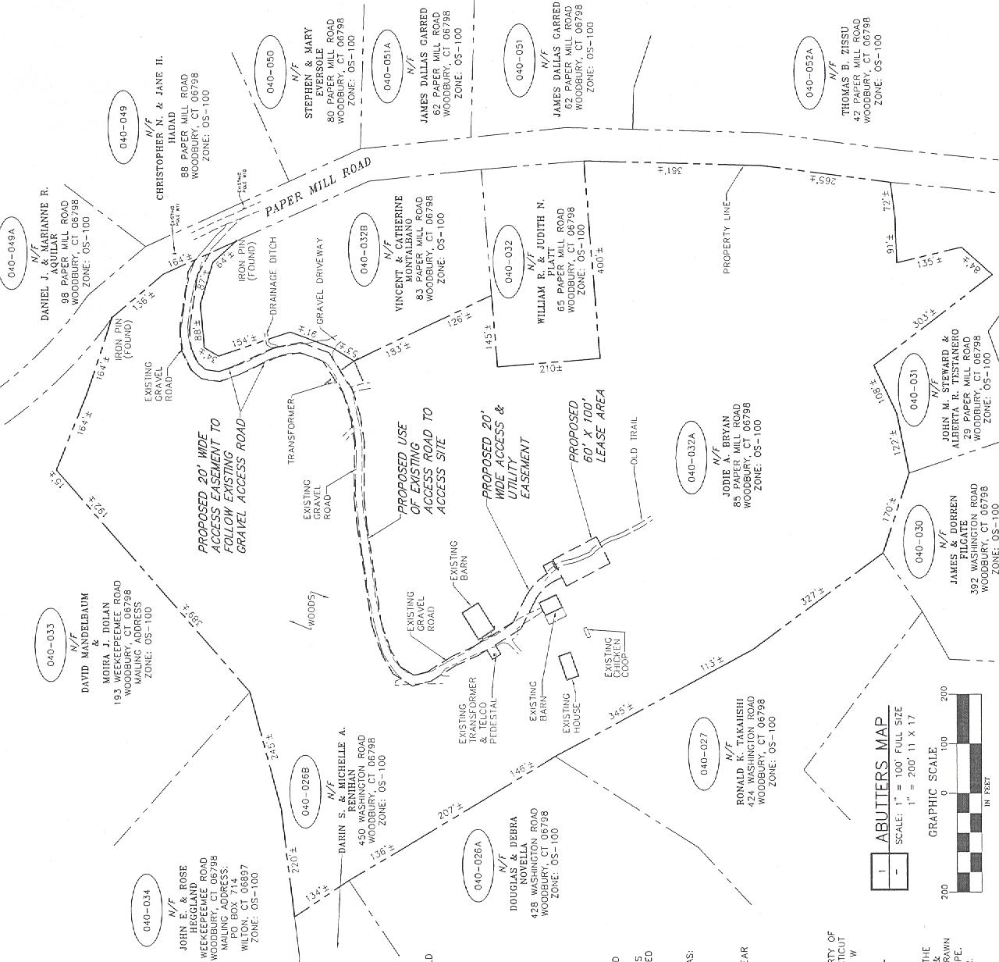

Figure 1: Location of site at 85 Paper Mill Road, Woodbury.
(AT&T 1, Tab 3)

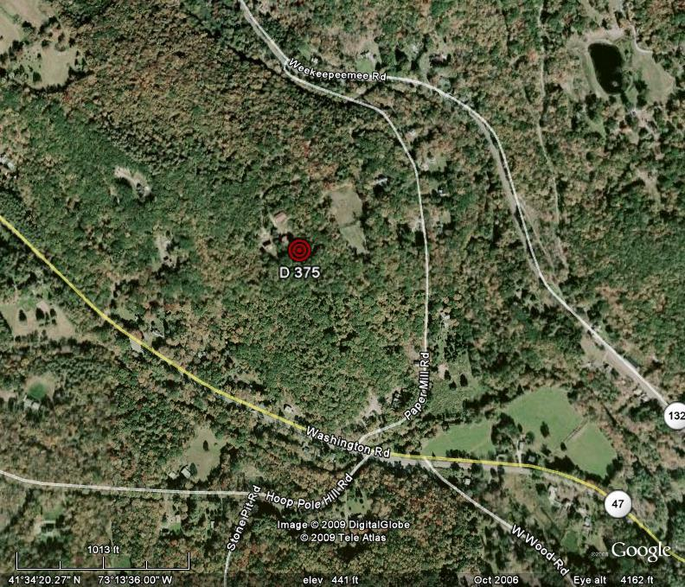


Figure 2: Location of site at 85 Paper Mill Road, Woodbury.
(AT&T 1, Tab 3)
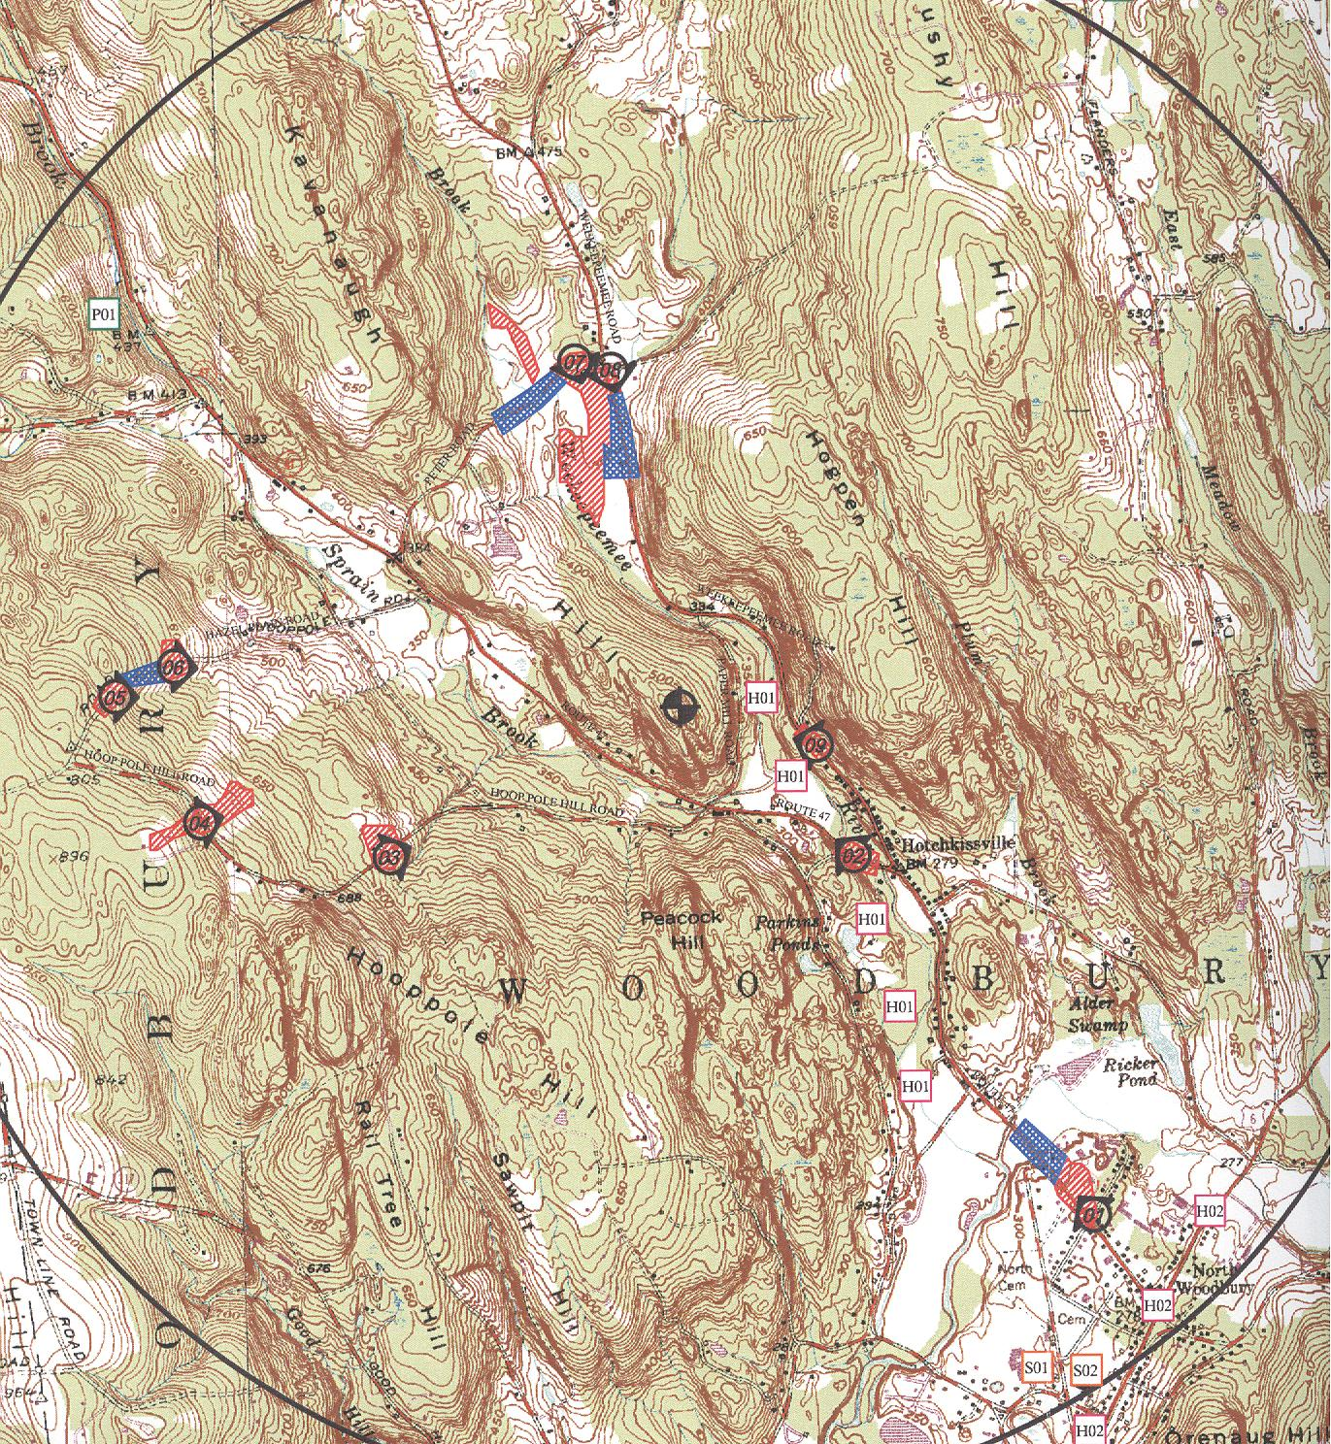

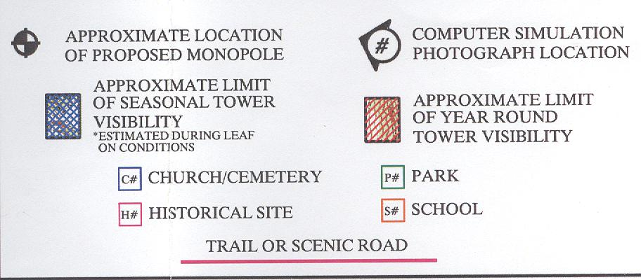

Figure 3: Projected visibility of proposed site. (AT&T 2, Tab D)

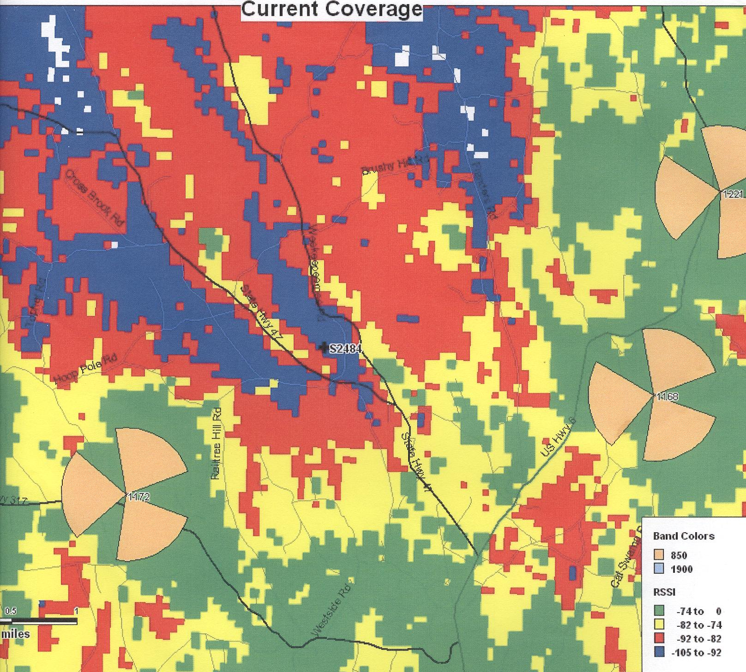

Figure 4: AT&T existing cellular coverage. (AT&T 2 , Tab I)

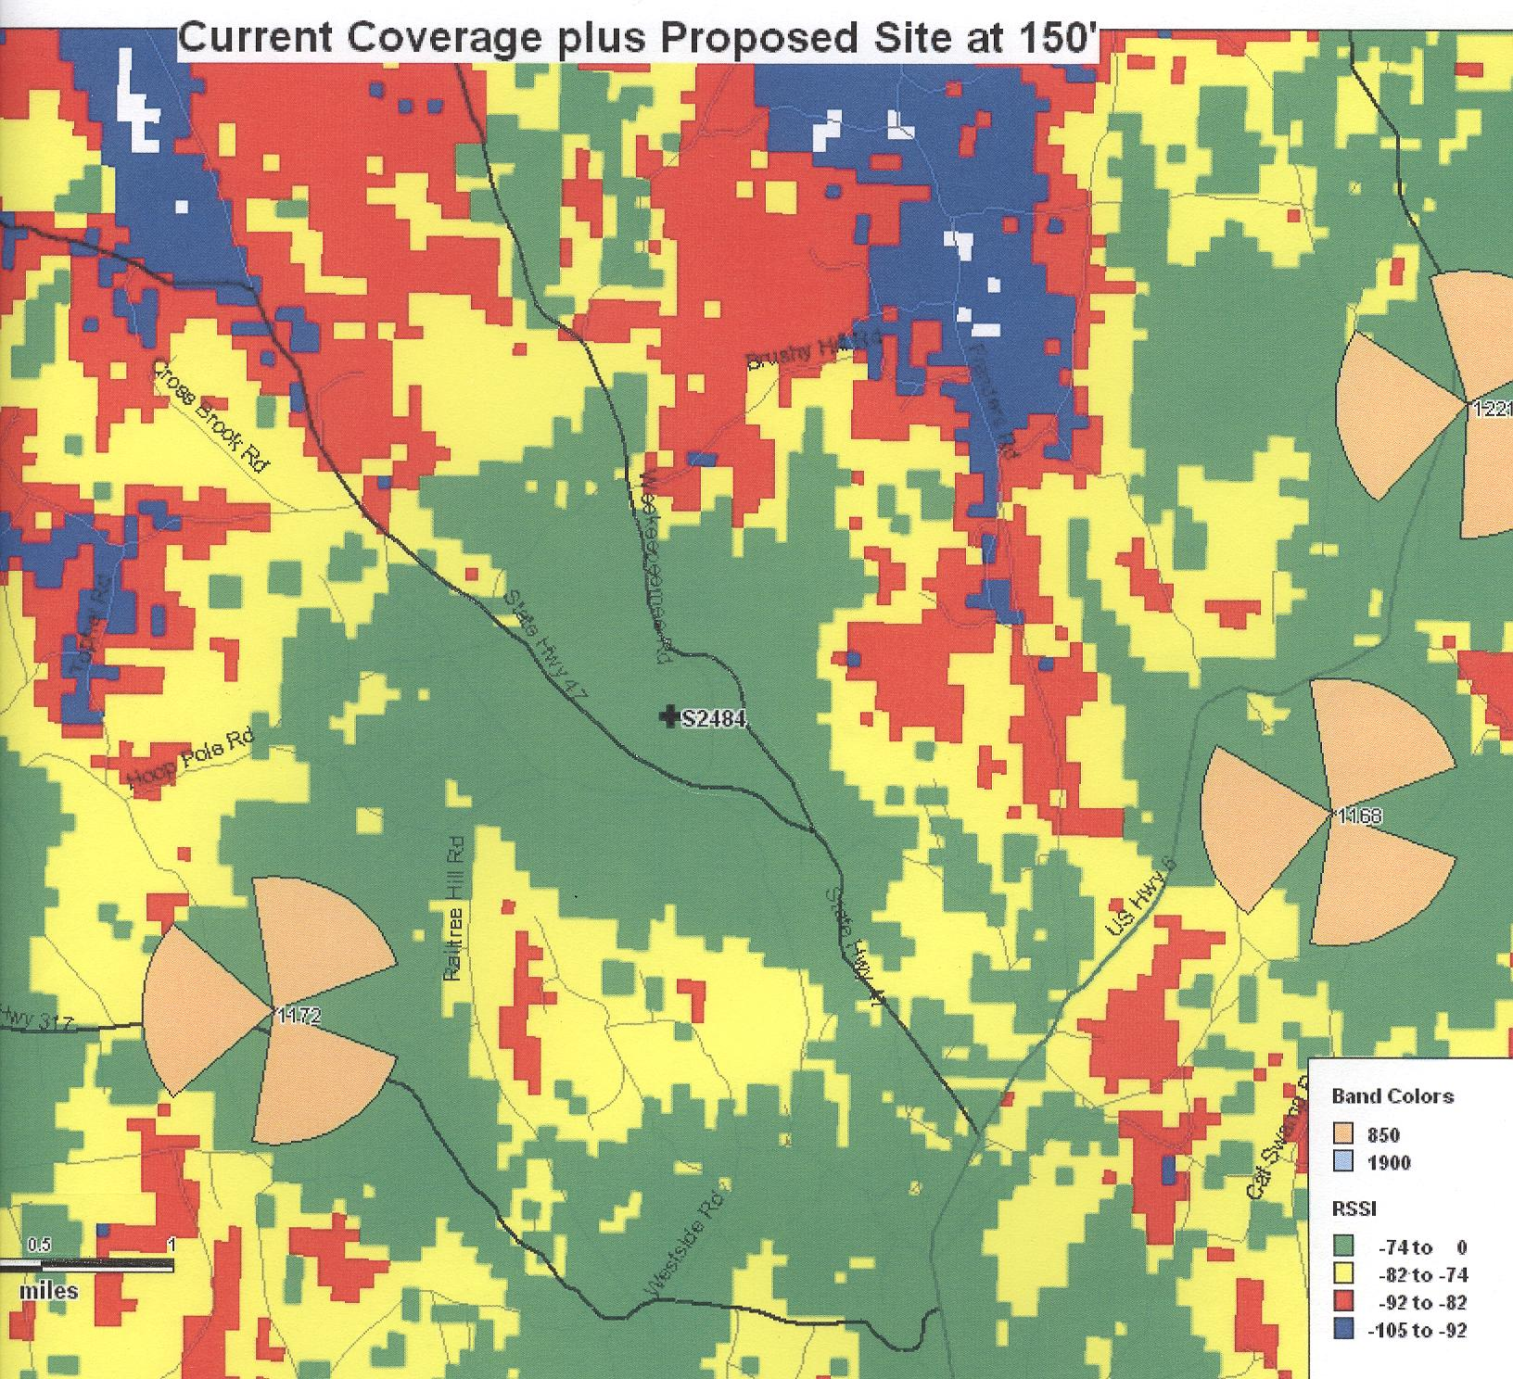
Figure 5: AT&T proposed cellular coverage with antennas mounted at 150 feet agl. (AT&T 1, Tab I)

