DOCKET NO. 316A - SBA Infrastructure LLC Certificate of Environmental Compatibility and Public Need for the construction, maintenance and operation of a telecommunications facility at 50 Fairchild Road in Middletown, Connecticut. Reopening. | }  }  } | Connecticut  Siting  Council  August 25, 2011

Findings of Fact

Introduction

- On February 28, 2011, New Cingular Wireless PCS, LLC (AT&T) filed a Petition (Number 988) for a Declaratory Ruling that no Certificate of Environmental Compatibility and Public Need is required for a ten-foot extension of an existing telecommunications facility located at 50 Fairchild Road in Middletown, Connecticut. In its petition, AT&T sought to install nine panel antennas, nine tower mounted amplifiers, and three remote radio heads on a low profile platform at a centerline height of 130 feet above ground level (agl). (AT&T 1 – Petition 988)

- The telecommunications facility at 50 Fairchild Road was approved by the Connecticut Siting Council (Council) on November 14, 2006 under Docket 316. The facility included a tower that was to be no taller than 120 feet agl. (Council Administrative Notice No. 43 – Docket 316; Decision and Order, dated November 14, 2006)

- Condition Number 2 of the Council’s Decision and Order stipulated that all telecommunications antennas providing cellular and/or PCS service would have to be flush-mounted on the approved tower. (Council Administrative Notice No. 43 – Docket 316; Decision and Order, dated November 14, 2006)

- At a meeting held on March 31, 2011, the Council voted to deny Petition 988 on the basis that the installation of platform-mounted antennas would not comply with Condition Number 2 of the Council’s Decision and Order in Docket 316. The Council then voted to reopen Docket 316 to determine if changed conditions exist which would warrant a modification to its original Decision and Order. (Petition 988 – Council Letter of Decision, dated April 1, 2011)

- AT&T is licensed by the Federal Communications Commission (FCC) to provide wireless services in the Middletown area of Connecticut. (AT&T 2 - SBA and AT&T Statement and Materials in Support of Reopened Docket No. 316A, dated May 25, 2011, p. 1)

- Pursuant to CGS § 16-50m and § 4-181(a)(b) of the Uniform Administrative Procedures Act, the Council, after giving due notice thereof, held a public hearing on the reopened docket, designated as Docket 316A, on June 21, 2011, beginning at 1:05 p.m. at the Council’s offices at Ten Franklin Square in New Britain, Connecticut. (Transcript, June 21, 2011, 1:05 p.m. [Tr. 1], p. 2 ff.)

- The party in this proceeding was the certificate holder, SBA Infrastructure LLC, which was grouped with AT&T, which was an intervenor. Intervenors in the original proceeding for Docket 316 included Nextel Communications of the Mid-Atlantic, Inc., Barbara Melia, Earle Roberts, and Debora and Michael Bagley. None of these intervenors in the original proceeding participated in the reopened proceeding. (Tr. 1, p. 4)

- In accordance with CGS § 16-50l(b), AT&T sent notices of the reopening of Docket 316A to each person appearing of record as owner of property abutting the 50 Fairchild Road site. (AT&T 5 - Proof of Notice to Abutters, dated June 14, 2011)

State Agency Comments

- Pursuant to CGS § 16-50j(h), the Council solicited comments on the reopened Docket 316A from the following state departments and agencies: Department of Environmental Protection, Department of Public Health, Council on Environmental Quality, Department of Public Utility Control, Office of Policy and Management, Department of Economic and Community Development, and the Department of Transportation. The Council’s letter requesting comments was sent on June 22, 2011. (Council Letter to State Department Heads, dated June 22, 2011)

- The Council received a letter from the Council on Environmental Quality (CEQ) stating that only exceptional circumstances should warrant a change in the Council’s original determination that antennas be flush-mounted on this tower. (Letter from CEQ dated May 25, 2011)

- Except for CEQ, no other state agency responded to the Council’s solicitation for comments. (Record)

Municipal Consultation

- On April 11, 2011, the Mayor of the City of Middletown (City), Sebastian Giuliano, submitted a letter to the Council in which he stated the City’s opposition to changes to the 50 Fairchild Road tower that would violate the original condition requiring flush-mounted antennas. (Letter from Sebastian Giuliano, dated April 11, 2011)

- On May 24, 2011, representatives of AT&T met with the Mayor of Middletown and representatives of the City’s planning department. AT&T representatives presented photosimulations of the proposed changes to the tower and answered questions from City officials. (Tr. 1, pp. 19-20)

- On June 7, 2011, the Mayor of Middletown submitted another letter to the Council in which he withdrew his objection to AT&T’s proposal based on his understanding that AT&T’s ten-foot extension with a platform would avoid extending the existing tower by 30 feet to accommodate flush-mounted antennas or the construction of a completely new tower in Middletown. (Letter from Sebastian Giuliano, dated June 7, 2011)

Existing and Proposed Wireless Coverage

- Currently AT&T deploys antennas that utilize multiple technologies: GSM, which is a 2G technology; UMTS, which is a 3G technology; and LTE, or Long Term Evolution, which is a 4G technology. In addition to antennas, AT&T typically deploys tower mounted amplifiers, which reduce signal loss in the coaxial cables bringing the signals received by the antennas to the ground equipment and remote radio heads, which convey the antenna signals to fiber optic cables. (Tr. 1, pp. 8 – 11)

- If AT&T had to use three separate placements for its antennas, it would have to raise the existing tower by 30 feet to a height of 150 feet agl. (Tr. 1, p. 9)

- AT&T has gaps in reliable service in the area of Middletown that would be served by the existing tower. (AT&T 2, p. 5)

- AT&T designs its system based on optimal signal strengths of -82 dBm for in-vehicle coverage and -74 dBm for in-building coverage. (Tr. 1, p.15)

- The best signal strengths in the area that would be covered from the 50 Fairchild Road tower range from -82 dBm to -92 dBm. (Tr. 1, p. 16; AT&T 2, Exhibit E, Current Coverage map)

- The 50 Fairchild Road tower is one of the initial sites on which AT&T plans to deploy its new Long Term Evolution (LTE) technology. (AT&T 2, p. 6)

- If AT&T were unable to utilize a platform to mount its different antennas, it would require three placements on the tower, each with a ten-foot separation, one for each of the three technologies being utilized. (Tr. 1, p. 9)

Site Selection

- AT&T initially sought new tower sites in an area southwest of the 50 Fairchild Road site near to the intersection of Route 9 and Randolph Road in Middletown. (AT&T 2, p. 5)

- A tower in the vicinity of the Route 9/Randolph Road intersection would have to be 140 feet tall in order to achieve the coverage AT&T is seeking to provide in this area. (Tr. 1, p. 12)

- AT&T’s radiofrequency engineers reviewed the 50 Fairchild Road tower and initially rejected it because the only available height of 80 feet agl would not achieve the desired coverage. (AT&T 2, p. 5)

- After much internal discussion, AT&T’s radiofrequency engineers agreed to locate on the 50 Fairchild Road tower at a height of 130 feet agl instead of proposing an entirely new tower near the Route 9/Randolph Road intersection, even though this location might provide better coverage. (AT&T 2, p. 5)

Facility Description

- The existing facility consists of a 120-foot tall monopole tower within a 70-foot by 70-foot compound. On the existing tower, Nextel has flush-mounted antennas at a centerline height of 120 feet agl, Verizon has flush-mounted antennas at a centerline height of 112 feet agl, Pocket has flush-mounted antennas at a centerline height of 101 feet agl, and Clearwire has flush-mounted antennas at a centerline height of 90 feet agl. (AT&T 2, Exhibit C, Sheets LE-1 and LE-2)

- AT&T seeks to raise the existing tower by ten feet to an overall height of 130 feet and to install nine antennas, nine tower mounted amplifiers, and three remote radio head units on a low-profile platform at a centerline height of 130’ agl. The overall height of the extended tower with AT&T’s antennas in place would be 133 feet agl. AT&T would also locate a 12-foot by 20-foot equipment shelter and a backup power diesel generator inside the existing compound. (AT&T 2, pp. 2-3, 9)

- The existing tower and its foundation can structurally support AT&T’s proposed ten-foot extension and antenna installation. (AT&T 2, p. 3; Exhibit D – FDH Structural Analysis, dated December 28, 2010)

Environmental Considerations

- Environmental conditions and land use patterns surrounding the tower site have remained largely unchanged since the Council’s original approval of this facility in 2006. (AT&T 2, p. 7)

- AT&T’s proposed extension of the existing tower would not require any Federal Aviation Administration obstruction marking or lighting. (AT&T 2, p. 8)

- The cumulative worst-case maximum power density from the radio frequency emissions from the operation of AT&T’s proposed antennas and the existing antennas on the tower has been calculated to total 35.37% of the standard for Maximum Permissible Exposure, as adopted by the FCC, at the base of the proposed tower. This calculation was based on methodology prescribed by the FCC Office of Engineering and Technology Bulletin No. 65E, Edition 97-01 (August 1997) that assumes all antennas would be pointed at the base of the tower and all channels would be operating simultaneously, which creates the highest possible power density levels. Under normal operation, the antennas would be oriented outward, directing radio frequency emissions away from the tower, thus resulting in significantly lower power density levels in areas around the tower. (AT&T 2, Exhibit F – Maximum Permissible Exposure Study)

Visibility

- The proposed extension should result in only marginal additional visibility from areas that already have views of the existing tower. (AT&T 2, p. 8)

Figure 1: Elevation of Proposed Tower Extension
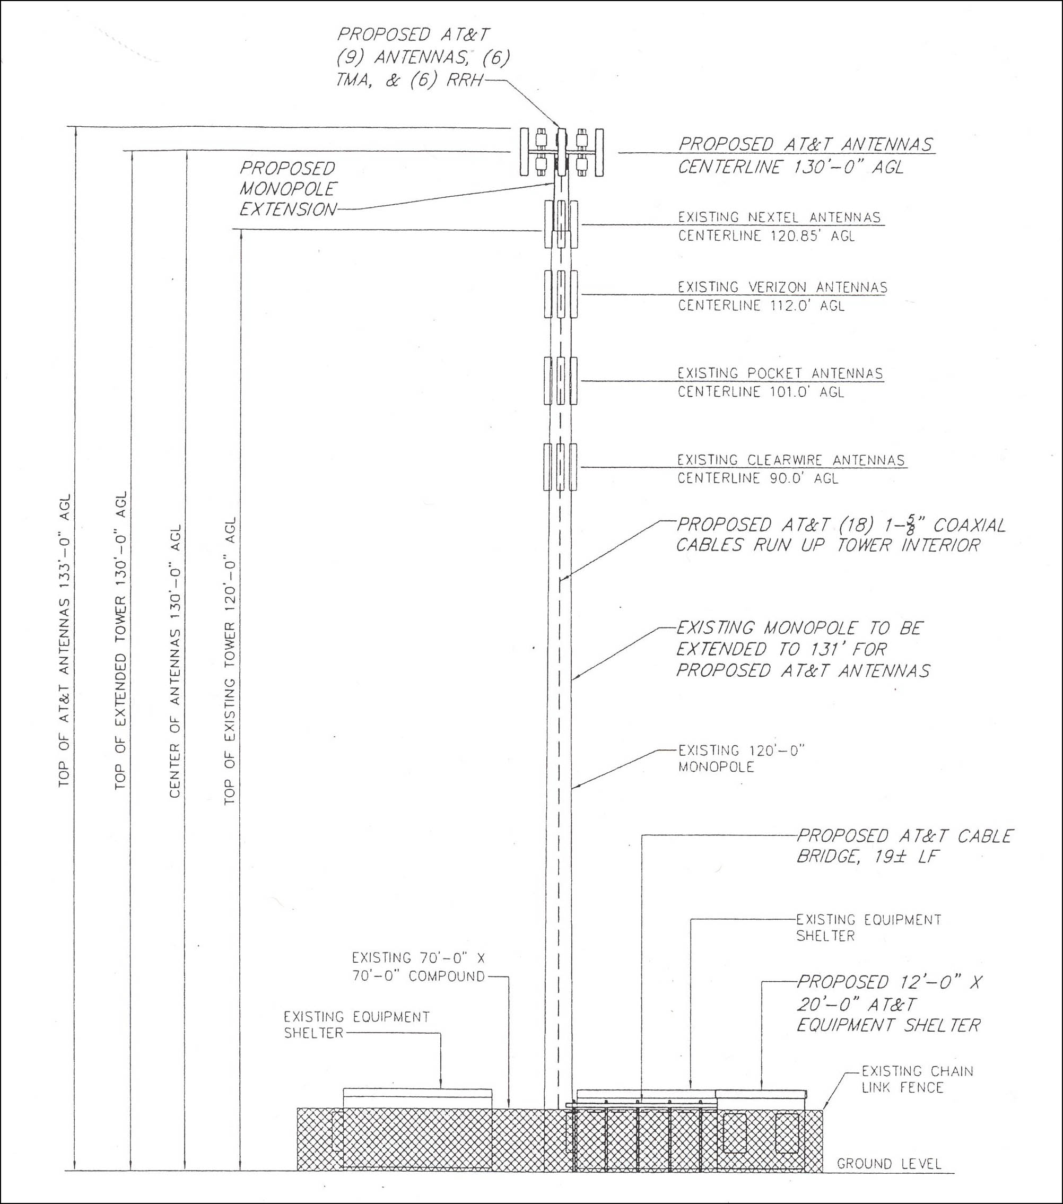
(AT&T 2, Exhibit C, Drawing LE-2)

Figure 2: AT&T Existing Coverage
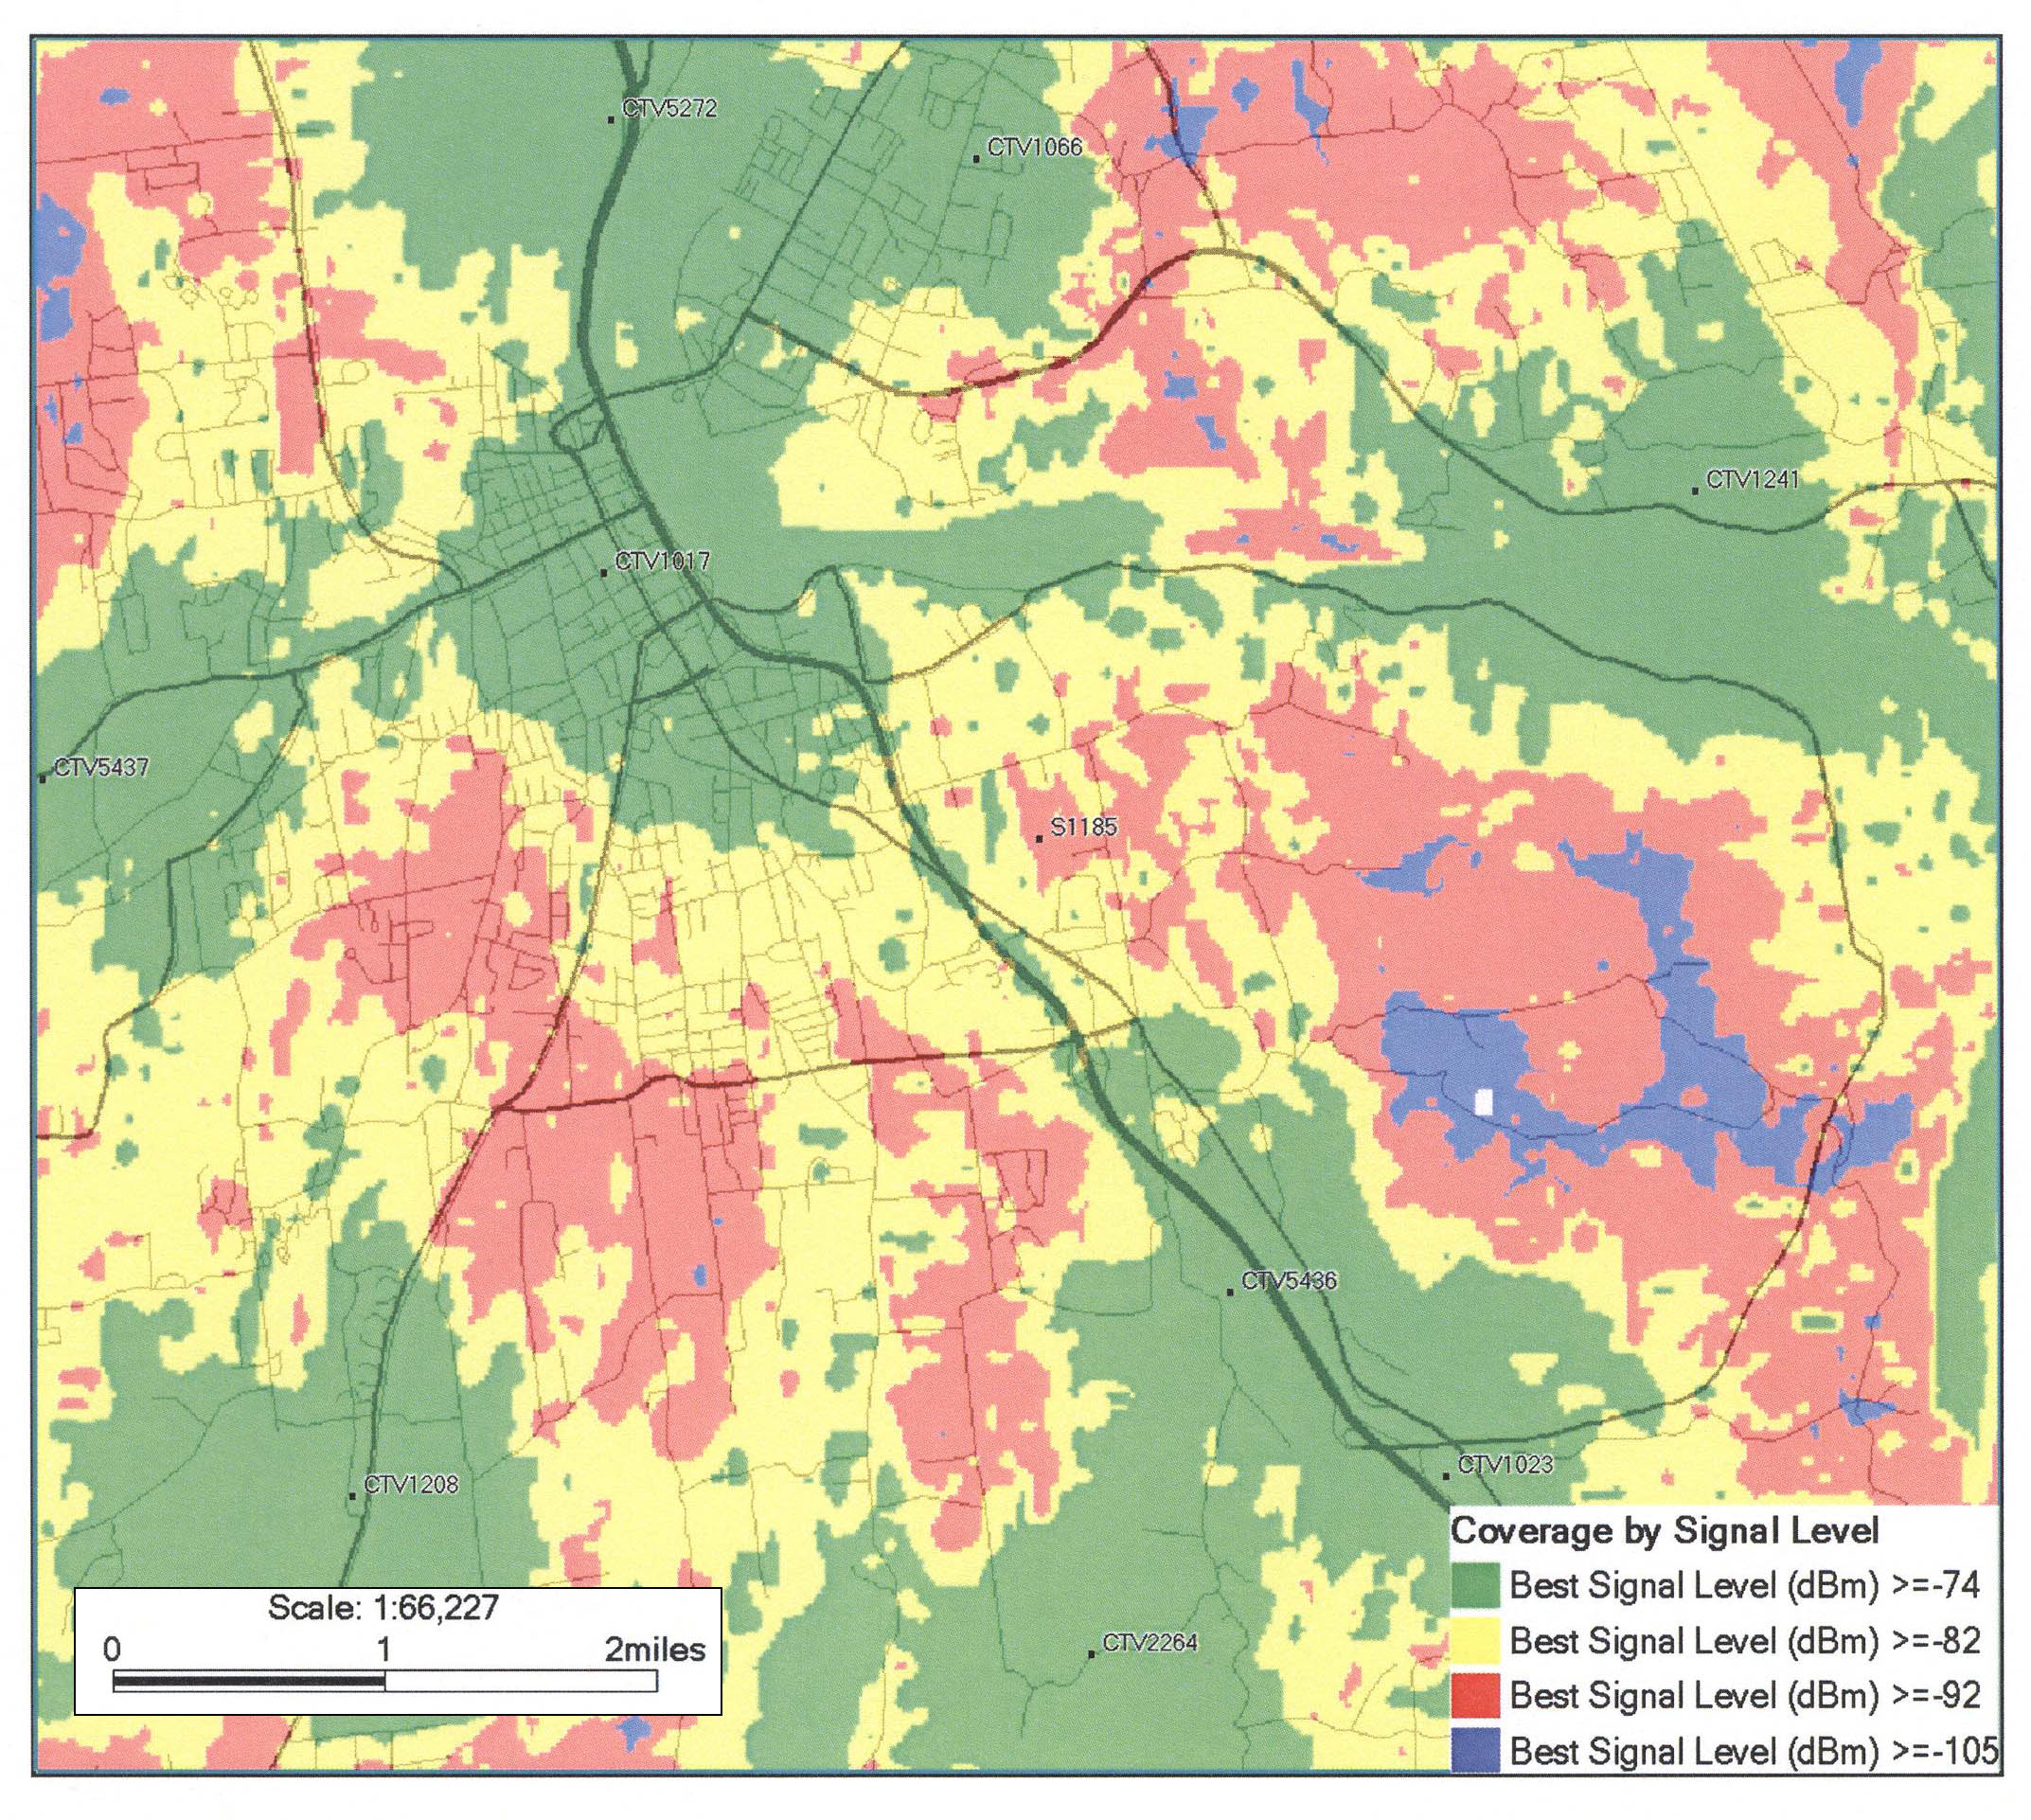
(AT&T 2, Exhibit E)

Figure 3: AT&T Coverage with Proposed Extension
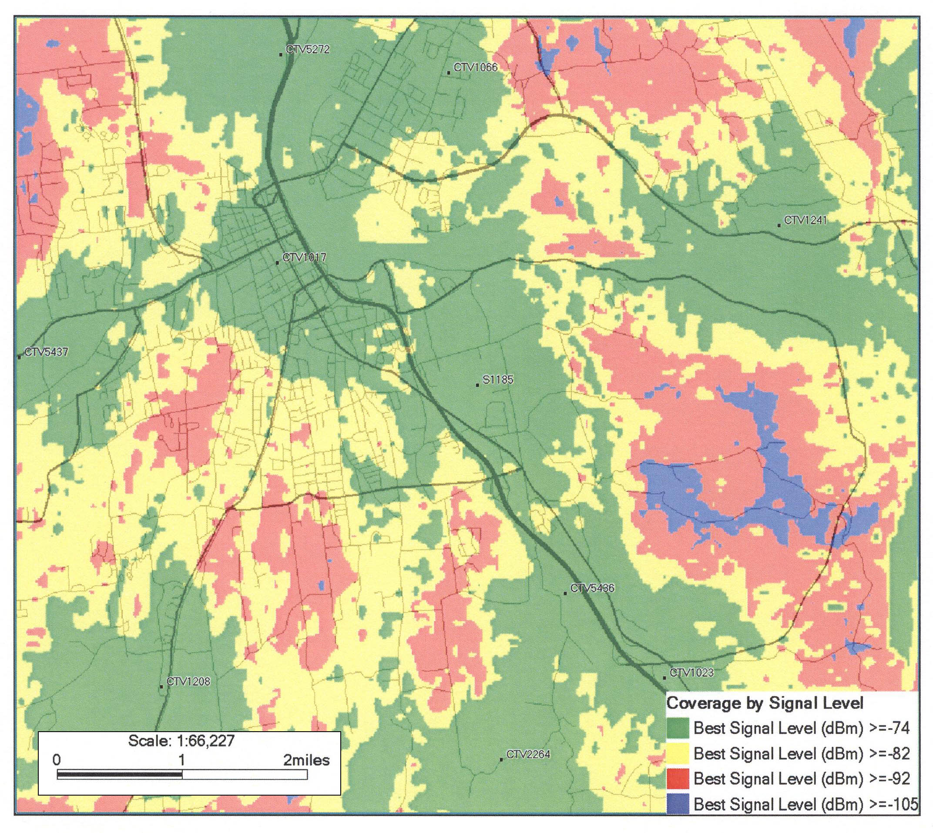
(AT&T 2, Exhibit E)

