DOCKET NO. 225B - Kleen Energy Systems, LLC Certificate of Environmental Compatibility and Public Need for the construction, maintenance and operation of a Electric Generating Facility and Switchyard on River Road, Middletown, Connecticut. Reopening of this docket pursuant to Connecticut General Statutes § 4-181a for the limited purpose of determining if changed conditions related to a revised route for the oil pipeline justify a modification of the Decision and Order. | }  }  } | Connecticut  Siting  Council  July 22, 2009

Findings of Fact

Introduction

- Kleen Energy Systems, LLC (Kleen) filed a Motion for Modification, pursuant to Connecticut General Statutes § 4-181(a) with the Council on April 9, 2009. The Motion pertains to a modification of the Council’s original decision regarding an oil pipeline that would supply fuel to Kleen’s facility. Kleen proposes to revise the pipeline route and this revision is the basis of the modification. (Kleen 1, p. 1)

- On November 21, 2002, the Council granted a Certificate of Environmental Compatibility and Public Need to Kleen for the construction of a 620-megawatt natural-gas fired combined cycle electric generating facility off of River Road in Middletown. The decision included a provision that allowed Kleen to use low sulfur diesel fuel oil as an alternative fuel for the facility. (Kleen 1, pp. 1-2)

- The original decision specified that the oil would be delivered by an underground pipeline along River Road from a take station at the Arrigoni Bridge to the Kleen site (Docket 225, Findings 73-78). Buckeye Partners L.P. (Buckeye) would construct and operate the pipeline. (Kleen 1, p. 2; Kleen 2, p. 2; Kleen 3, p. 1)

- Subsequent to the Council’s approval, on September 1, 2006, the City of Middletown, in conjunction with the Connecticut Department of Environmental Protection (DEP), formally delineated the City’s aquifer protection zone (refer to Figure 1). The previously approved pipeline route traversed the aquifer protection zone, which serves approximately 80% of the City’s water supply. (Kleen 1, pp. 2-3; Tr. 1, p. 10)

- Kleen and Buckeye elected to relocate the pipeline out of the aquifer protection zone to avoid any risk the pipeline could pose. (Kleen 1, p. 3)

- The party in this proceeding is the applicant. Intervenors to the proceeding include NRG Middletown Power LLC, The Connecticut Light and Power Company, the City of Middletown, Earle Roberts, and the Connecticut River Watershed Council, Inc. (Transcript 1, 06/18/09, 1:10 p.m. [Tr. 1], p. 6)

- Pursuant to General Statutes § 16-50m, the Council, after giving due notice thereof, held a public hearing on June 18, 2009, beginning at 1:10 p.m. at the Council’s office, 10 Franklin Square, New Britain, Connecticut. (Council's Hearing Notice dated May 20, 2009; Tr. 1, p. 4)

- Public notice of the hearing was published in the Middletown Press on May 21, 2009. (Record)

State Agency Comment

- Pursuant to General Statutes § 16-50j(h), on May 20 and June 19, 2009, the following state agencies were solicited to submit written comments regarding the proposed modification: Department of Environmental Protection (DEP), Department of Public Health (DPH), Council on Environmental Quality (CEQ), Department of Public Utility Control (DPUC), Office of Policy and Management (OPM), Department of Economic and Community Development (DECD), Department of Agriculture (DOAg) and the Department of Transportation (DOT). (Record)

- The DPH provided written comment to the Council on June 11, 2009 stating that the proposed relocation of the oil pipeline protects the public health more effectively that the original route. (DPH comments of June 11, 2009)

- The DOT’s Bureau of Engineering and Highway Operations provided comment on June 24, 2009 stating that Kleen must obtain an encroachment permit if the project would require any work within the right-of-way of Route 9, or other state routes. (DOT comments of June 24, 2009)

- The following state agencies did not file written comment on the application: DEP, CEQ, DPUC, OPM, DOAg and the DECD. (Record)

Municipal Consultation

- Kleen and Buckeye submitted technical reports to the Mayor’s office of the City of Middletown in December 2008. (Kleen 2, p. 4)

- Kleen appeared at a public meeting before the City’s Economic Development Committee (MEDC) to obtain easements for the project. The MEDC approved the easements and recommended approval of the project to the City’s Common Council. (Kleen 1, p.5)

- The City’s Common Council approved the easements at a public meeting on February 2, 2009. (Kleen 1, p. 5)

- The City’s Inland Wetlands Commission (MIWC) discussed the proposal at two public meetings held on February 4 and March 4, 2009. The MIWC approved the project on March 4, 2009 after Kleen and Buckeye agreed to install the pipeline under wetland areas using horizontal directional drill (HDD) methods. (Kleen 1, p. 5)

- The City’s Planning and Zoning Commission approved the project at a public meeting on March 11, 2009. (Kleen 1, p. 6)

- On June 16, 2009, the Mayor of the City of Middletown, Sebastian Giuliano, provided correspondence to the Council in support of the project. (Record)

Proposed Project

- The original pipeline route extended approximately 3 miles along Bridge Street, River Road, and the P&W Railroad from a Buckeye take station near the Arrigoni Bridge to the Kleen access road. (Council Administrative Notice 2)

- Kleen intends to follow the original pipeline route along or within Bridge Street, River Road and the P&W Railroad right-of-way for approximately 1.6 miles. The proposed pipeline route would then diverge from the original, Council approved route and follow Eastern Drive for 4,600 feet and Bow Lane for 4,100 feet. From the north side of Bow Lane the route would cross City-owned open space for 5,500 feet, and land of a private landowner for 100 feet before entering Kleen property (refer to Figure 2). (Kleen 4; Tr. 1, pp. 28,-29)

- The steel pipeline would be 12-inches in diameter and have an operational pressure of 250 psi. (Kleen 4; Tr. 1, p. 33)

- The pipeline would be installed by conventional trenching methods except for four horizontal directional drill (HDD) segments. Three of the HDD segments are along the original, approved pipeline route. The fourth segment is along the proposed route where it crosses Indian Brook. (Kleen 4; Kleen 5, Q. 1)

- Pipeline installed by conventional trenching would be constructed using 0.250-inch wall thickness with 12-14 mils of fusion bonded epoxy coating. The epoxy coating serves to prevent corrosion of the pipe sections. (Kleen 4; Tr. 1, pp. 35-36)

- Pipeline installed by HDD would be constructed using 0.375-inch wall thickness with 12-14 mils of epoxy coating and an additional 40 mils of Powercrete coating. (Kleen 4)

- The pipeline would be outfitted with a cathodic protection system to counteract the corrosion process. The system would be checked six times per year in accordance with regulatory criteria to ensure proper operation. In depth cathodic protection surveys are performed annually or every five years depending on the type of test. (Kleen 3, p. 4)

- Trenching within non-road areas would require a trench depth of approximately five to six feet and a width of three feet at the base of the trench. Side slopes would be cut into the trench to prevent collapsing and to provide adequate workspace for machinery. (Kleen 4)

- Trenching within road areas would be similar to non-road areas except that the trench width would be based on existing soil conditions. Excavated pavement and associated soils would be removed from the work area for proper disposal. The road bed and paved surfaces would be restored in accordance with City of Middletown regulations. (Kleen 4)

- Kleen would have a contingency plan if contaminated soils were encountered during construction. Suspect contaminated soils would be separated, tested, and disposed of properly, if necessary. (Tr. 1, pp. 54-55)

- Trenching in non-road areas would be accomplished within a 50-foot wide temporary workspace. All machinery would be contained within this area. Excavated soil would be stored on one side of the trench and used as backfill. Excess soils would be removed from the work area for disposal or used elsewhere. (Kleen 4; Tr. 1, p. 22)

- Kleen estimates approximately 200 feet of pipe can be installed per day. The entire project is anticipated to last 20 weeks. (Kleen 4)

- Buckeye, the entity constructing and operating the pipeline, would use six temporary staging areas during project construction, as follows;
- a city park on Green Street to support an HDD along a segment on River Road;
- a gravel area near Sumner Brook, currently used by Kleen for equipment staging;
- a gravel area along River Road owned by a corrugated box company;
- a field area off Field Road;
- a field area immediately west of Kleen property; and
- a grassy area just south of the Arrigoni Bridge.
(Tr. 1, pp. 23-24)

- Once the pipeline is installed, Buckeye would hydrostatically test the line to a pressure of 1,500 psi prior to operation. (Kleen 3, p. 5; Tr. 1, p. 37)

- Once construction is completed, the pipeline right-of-way would be marked using aerial and land markers placed approximately every 400-500 feet. Although the MIWC requested that no yellow markers be used within the open space area, Buckeye intends to install the markers to properly indentify the location of the line. (Kleen 3, p. 5; Kleen 5, Q. 5; Tr. 1, pp. 24-25)

- Buckeye would perform aerial inspections of the pipeline route at weekly or biweekly intervals. Formal ground inspections would be performed once every three years, with more frequent informal ground inspections occurring when Buckeye personnel are in the area. (Kleen 3, p. 5; Tr. 1, p. 38)

- Every five years, Buckeye would use a “smart-pig”, a device with sensors that is inserted within the pipeline, or hydrostatic testing to inspect the integrity of the pipeline. (Kleen 3, pp. 5-6)

- Buckeye would mail information regarding the pipeline to all landowners within 1/8-mile of the pipeline route and to the City of Middletown every two years. (Kleen 3, p. 5)

Environmental Considerations

- In overland areas, Buckeye would clear all vegetation within the designated 50-foot wide temporary workspace. Once construction is completed, Buckeye would maintain a 30-foot corridor seeded with grass. The corridor would be mowed annually to prevent the establishment of woody vegetation. (Tr. 1, pp. 55-56)

- Approximately two acres of woodland would be cleared to accommodate the pipeline, primarily in two areas, as follows:
- Approximately 1,100 feet on the south side of Duck Hill and within the City’s open space area. An existing forest edge would be expanded to accommodate the pipeline.
- Approximately 600-800 feet through woodland within Kleen’s property.
Remaining areas that would be cleared along the overland route consist of shrub and field areas.
(Kleen 5, Q. 1; Tr. 1, pp. 28-30)

- Buckeye would install and maintain erosion and sedimentation controls during construction. In areas with slopes greater than 5%, Buckeye would install water bars to control and divert runoff. The waterbars would not be maintained beyond the construction period. (Kleen 1; Tr. 1, pp. 49-50)

- At the request of the State Historic Preservation Office, Kleen conducted archeological and historical reconnaissance in the affected area. Based on this research, SHPO determined the project would have no effect on archeological or historic resources. (Kleen 5, Q. 2)

- Two species of special concern have been recorded in the area of the overland portion of the route; the Cobra clubtail dragonfly (Gomphus vastus) and the Eastern Box Turtle (Terrapene carolina). (Kleen 5, Q. 3)

- Trees and tree stumps along the Connecticut River are specific habitat requirements for the Cobra clubtail dragonfly, The proposed project would not impact any habitat that supports the dragonfly. (Kleen 5, Q. 3)

- Kleen performed a box turtle survey in May 2009 in the portion of the proposed route extending from Bow Lane through the open space area to the Kleen access road. The survey was accomplished through the establishment of turtle search cells arranged along the pipeline route. The cells were 150-foot by 30-foot areas enclosed by silt fencing. No turtles were identified during the survey. (Kleen late file of June 25, 2009; Tr. 1, pp. 18-19)

- The turtle search silt fencing would be maintained during the project to keep any turtles in the area from migrating into the work zone. (Tr. 1, p. 21)

- Wildlife observed during the turtle survey included eastern garter snake, northern black racer, green frog, chipping sparrow, red-winged blackbird, wild turkey, barred owls, voles, and white-tailed deer. (Kleen late file of June 25, 2009)

- The project would cross four wetland/watercourse areas that lie within culverts under roadways. Buckeye would install the pipeline within the roadway and above the culverts, thus not impacting the streams. A fifth wetland area consists of the Indian Brook wetland system located on the open space parcel. This wetland area would be crossed using HDD. (Tr. 1, pp. 16-18)

- At Indian Brook, the pipeline would be installed 25 feet below the bottom of the wetland using HDD. The HDD segment would be 700 feet long. The width of the wetland and associated 100-foot upland review areas is approximately 440 feet. (Tr. 1, pp. 16-18)

- The HDD process creates bentonite slurry, which would be contained within slurry pits located at either end of the drill area. (Kleen 4; Tr. 1, pp. 47-48)

- During drill operations, the bentonite slurry could migrate to the surface through cracks in the earth. Upon detection, the drilling contractor would immediately dispatch personnel to contain and clean up the material. If the wetland area was affected, the disturbed area of the wetland would be dug out and reseeded with a wetland seed mix. (Tr. 1, pp. 48, 51-53)

- Kleen elected not to route the pipeline eastward along Bow Lane to keep a commitment Kleen made early in the Docket 225 proceeding to avoid the neighborhood to the greatest extent possible. The Bow Lane area may contain a large amount of rock that would require blasting which could affect the neighborhood. Additionally, entering Kleen property from Bow Lane would directly impact an open space area set aside by Kleen for Middletown residences. (Tr. 1, pp. 26-28)

- Kleen did not pursue routing the pipeline from Bow Lane directly north to Farm Road because this route would require approval from Connecticut Valley Hospital and the DPH to cross their property. Additionally, the Farm Road route would have been longer than the proposed route. (Tr. 1, pp. 19-20)

- Kleen rejected bringing the oil in by truck to avoid traffic, impacts on area highways and local roads, environmental concerns associated with truck emissions, and logistical issues in shipping large quantities of oil. (Kleen 2, p. 3; Kleen 4)

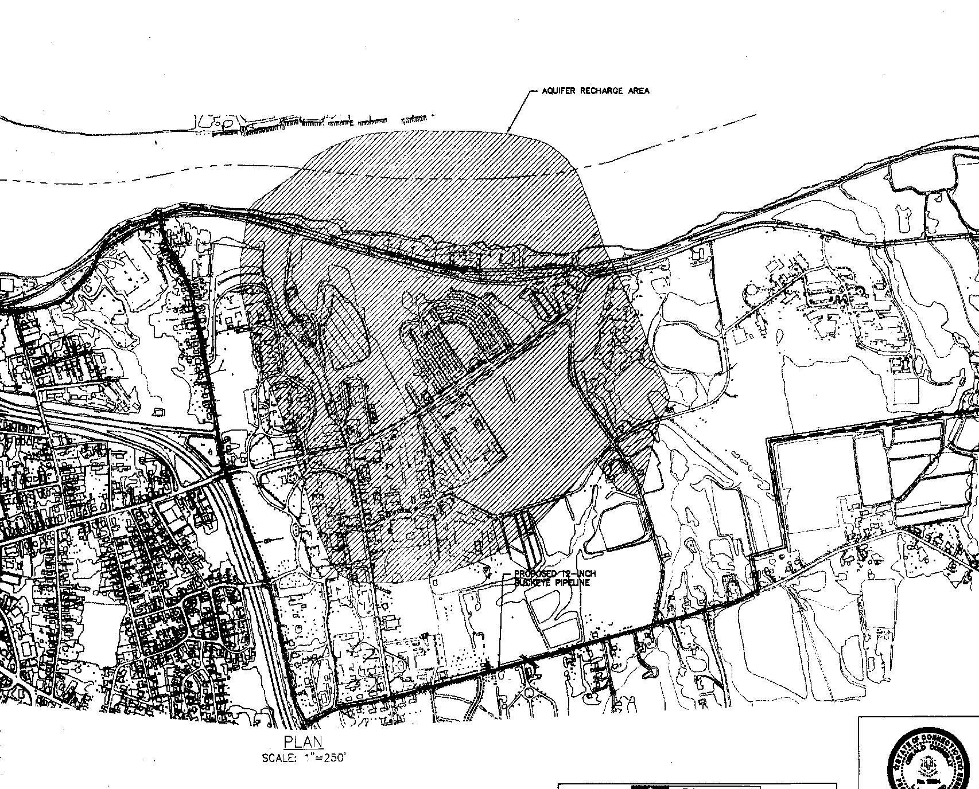
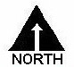

Figure 1: Location of aquifer protection zone (north of Bow Lane,
south of Portland side of the Connecticut River, east of Eastern Drive,
west of Farm Road)

(Kleen 1, C-100)

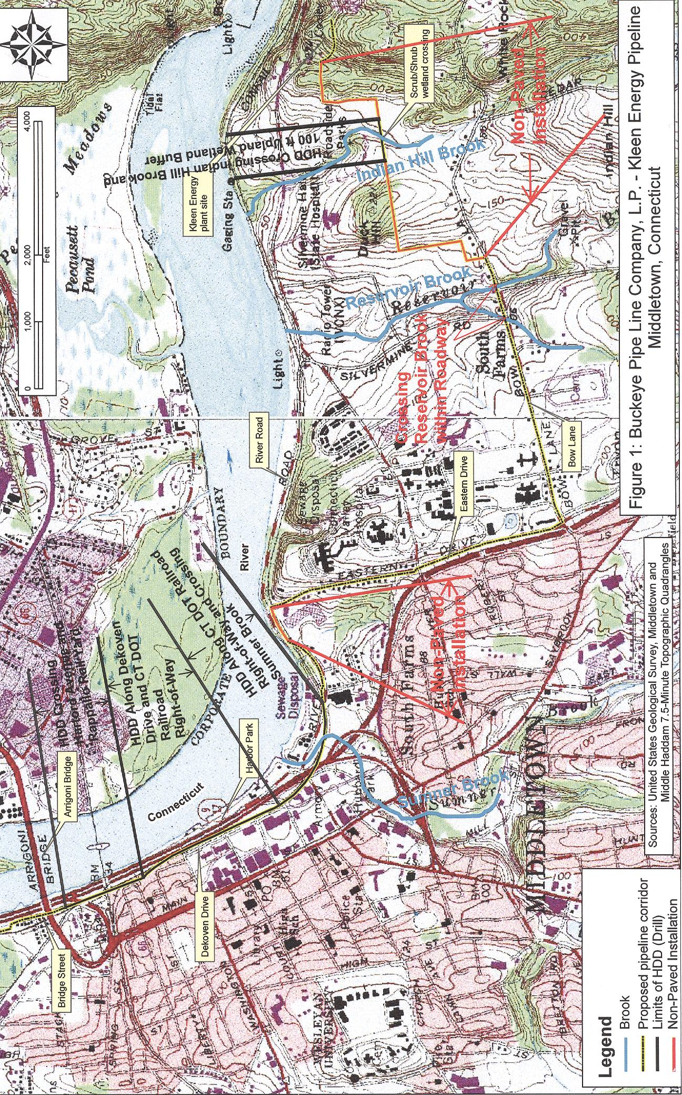
Figure 2: Route of oil pipeline. Relocated section uses Eastern
Drive, Bow Lane and City of Middletown property.

(Kleen 5, Q. 1)

