DOCKET NO. 327 - The Connecticut Light and Power Company application for a Certificate of Environmental Compatibility and Public Need for the construction, maintenance, and operation of a proposed substation located off Commerce Drive, Oxford, Connecticut. | }  }  }  } | Connecticut  Siting  Council  July 26, 2007

Findings of Fact

Introduction

1. The Connecticut Light and Power Company (CL&P), in accordance with the provisions of Connecticut General Statutes (CGS) Sections 16-50g et seq., and Section 16-50j-1 et seq. of the Regulations of Connecticut State Agencies (RCSA), applied to the Connecticut Siting Council (Council) on December 15, 2006 for the construction, operation, and maintenance of a new substation to be located on CL&P’s property located on Commerce Drive in Oxford, Connecticut. (CL&P 1, Vol. I, pp. 1, 8)

2. CL&P received Council approval to acquire the subject property and a related transmission line easement on June 28, 2005 (Docket 304) in accordance with CGS 16-50z (a). CL&P acquired the property and related easement on October 31, 2005. (CL&P 1, Vol. I, p. 11; CL&P 3, p. 7)

3. The purpose of the proposed facility is to increase the capacity and improve reliability of the electric power distribution system in Oxford. (CL&P 1, Vo1. I, p. 1)

4. Pursuant to General Statutes § 16-50m, the Council, after giving due notice thereof, held a public hearing on May 16, 2007, beginning at 3:30 p.m. and continuing at 7:00 p.m. at the Oxford Town Hall, 486 Oxford Road, Oxford, Connecticut. (Council’s Hearing Notice dated April 17, 2007; Transcript 1 – May 16, 2007 at 3:30 p.m. [Tr. 1], p. 3; Transcript 2 – May 16, 2007 at 7:00 p.m. [Tr. 2], p. 3)

5. The party in this proceeding is the applicant. (Tr. 1, p. 4)

6. The Council and its staff inspected the proposed substation site on May 16, 2007, beginning at 2:30 p.m. (Council’s Hearing Notice dated April 17, 2007)

7. Pursuant to CGS § 16-50l (b), public notice of the application was published in the Connecticut Post on November 29, 2007 and December 1, 2007. (CL&P Administrative Notice Item 1)

8. CL&P erected a sign describing the proposed project at the intersection of Commerce Drive and Christian Street on April 30, 2007. The sign included the Applicant’s name, type of facility proposed, the maximum heights for both the substation and transmission line structures, the date and location of the public hearing, and contact information. (Tr. 1, pp. 22-23)

9. Pursuant to CGS § 16-50l (b), notice of the application was provided to all abutting property owners by certified mail. (CL&P 1, Vol. I, p. 97)

10. Pursuant to CGS § 16-50l (b), CL&P provided notice to all federal, state and local officials and agencies listed therein. (CL&P 1, Vol. I, p. 96)

11. On October 2, 2006, CL&P provided copies of its proposal to the Connecticut Energy Advisory Board (CEAB). (CL&P 1, Vol. I, p. 98)

12. On December 29, 2006, the CEAB issued a Request for Proposals (RFP) seeking alternatives to the proposed substation, pursuant to CGS § 16a-7c. (Council Administrative Notice Item 30)

13. No proposals for alternatives to the proposed substation were received by the CEAB. (Council Administrative Notice Item 30)

14. On April 5, 2007, the CEAB issued its final report with the finding that there is no suitable alternative for the proposed substation. (Council Administrative Notice Item 30)

State Agency Comment

15. Pursuant to CGS § 16-50l, on April 17, 2007 and May 18, 2007, the following State agencies were solicited by the Council to submit written comments regarding the proposed facility: Department of Environmental Protection (DEP), Department of Public Health (DPH), Council on Environmental Quality (CEQ), Department of Public Utility Control (DPUC), Office of Policy and Management (OPM), Department of Economic and Community Development (DECD), and the Department of Transportation (DOT). (Record)

- The Council received a response from the DOT’s Office of Aviation and Port Planning on April 25, 2007, and a revised response on May 8, 2007. (DOT Comments dated April 25 and May 8, 2007)

- The DOT is opposed to the construction of the substation in its present location since it is located within or adjacent to the existing and future Runway Protection Zone (RPZ) of Runway 36 of the Waterbury-Oxford Airport, located immediately northwest of the proposed site. The DOT notes that the FAA does not consider a substation a prohibited land use but prefers that no development exist within the RPZ. The DOT also requests that CL&P lower the height of existing transmission towers located in the glide path of the airport and that an electronic noise survey be performed to ensure electronic noise from the substation does not affect airport equipment. (DOT Comments of April 25, 2007)

- The Council received a response from the DPH dated April 30, 2007. The DPH had no comment on the proposal. (DPH Comments dated April 30, 2007)

- The Council received a response from the DEP dated May 3, 2007. (DEP Comments dated May 3, 2007)

- The DEP states the proposed site is appropriate for a substation and will have little environmental impact on natural resources or the adjacent Larkin State Park Trail. (DEP Comments dated May 3, 2007).

21. The following agencies did not respond with comment on the application: CEQ, DPUC, OPM, and DECD. (Record)

Municipal Consultation

- CL&P representatives began discussing the project with the Town in 2005. Mr. Palmer expressed support for the project and the acquisition of the site parcel during the Council’s Docket 304 hearing on April 28, 2005. Mr. Palmer provided a letter of support to CL&P for the proposed substation on August 15, 2006. (CL&P 1, Vol. I, p. 89, Vol. 2, Appendix K)

- CL&P commenced the application municipal consultation process on October 2, 2006 by sending a technical report explaining the proposal to August Palmer III, the First Selectman of the Town of Oxford. (CL&P 1, Vol. 1, p. 89)

- The Oxford Board of Selectman passed a resolution in support of the project on October 19, 2006. (CL&P 1, Vol. II, Appendix K)

- The Oxford Conservation Commission/Inland Wetlands Agency approved a preliminary site plan, subject to conditions based on the final site layout, on August 23, 2006. (CL&P 1, Vol. II, Appendix K)

- The Oxford Planning and Zoning Commission approved a preliminary site plan on August 17, 2006. (CL&P 1, Vol. I, p. 90)

- Mr. Palmer made a limited appearance statement into the record at the May 16, 2007 hearing expressing support for the project. Mr. Palmer indicated the Town is actively promoting industrial growth in the region surrounding the Waterbury-Oxford Airport and views this project as essential to meeting current and future electrical demand. (Tr. 1, pp. 6-9)

Need

- The proposed substation would address the need for additional distribution system capacity and reliability in Oxford by increasing the capacity to deliver electric power from the existing 115-kV transmission system to the local 13.8-kV distribution system. (CL&P 1, Vol. I, p. 14)

- The Oxford electric load is currently served by three 115 to 13.8-kV substations; Beacon Falls Substation in Beacon Falls, Bates Rock Substation in Southbury, and South Naugatuck Substation in Naugatuck. These substations also serve the towns in which they are located. (CL&P 1, Vol. I, p. 14)

- The three substations serving Oxford have a combined rated capacity of 184 MVA. These substations experienced a combined peak load of 180.9 MVA in 2006. (CL&P 1, Vol. I, p. 16)

- The expected load growth in Oxford is forecasted to exceed available capacity by 2008. (CL&P 1, Vol. I, p. 16)

- Peak demand in Oxford in 2006 was 24.3 MVA. Demand in Oxford is expected to reach 60 MVA by the year 2012 due to residential and industrial development. (CL&P 1, Vol. I, pp. 14-16)

- The proposed substation would provide 70 to 75 MVA of substation capacity to the system, meeting the demand needs of Oxford and improving reliability of Oxford’s distribution system by eliminating reliance on the neighboring substations. (CL&P 1, Vol. 1. p. 17)

- Construction of the proposed substation would increase the capacity at neighboring substations to allow for reliability in serving localized load growth. (CL&P 1, Vol. I, p. 17)

- On January 26, 2006, ISO-New England approved the plan for the implementation of the Oxford substation. (CL&P 3, p. 10)

- A substation for the Oxford area has been listed in the Council’s Forecast of Loads and Resources since 2003. (CL&P 3, p. 10)

Site Alternatives

- CL&P examined the feasibility of expanding the neighboring substations to meet Oxford’s growing demand but determined expansion costs and costs associated with the installation of necessary distribution feeders would well exceed the cost of the proposed substation. Additionally, the expanded system would have a low reliability due to the long distances the distribution feeders would have to traverse. (CL&P 1, Vol. I, pp. 17-21)

- CL&P is actively promoting distributed generation in the areas served by the Beacon Falls, Bates Rock, and South Naugatuck substations. Although distributed generation has resulted in the peak-demand savings of 11 MW since 2005 and another 2.5 MW of generators are under consideration for the 2007-2009 timeframe, distributed generation is a limited source of power and would not alleviate the need for the substation. (CL&P 1, Vol. I, p. 20)

- The Council examined alternative substation locations as part of Docket 304 and determined the current site was appropriate. The Council approved the site on April 21, 2005. (CL&P 1, Vol. I, p. 22)

Description of Proposed Project

- The proposed substation would be located on a 15.77-acre property located on Commerce Drive in Oxford. This project would include the construction of a new 115-kV to 13.8-kV electric substation, construction of an access drive, and the installation of three new transmission poles. To facilitate the interconnection of the substation with the regional transmission grid, CL&P obtained a 4.4-acre easement abutting the north side of the parcel. (CL&P 1, Vol. I, pp. 11-12)

- The site is undeveloped except for an existing 110-foot wide transmission line right-of-way traversing the property in a north-south direction. Three 115-kV circuits are located on two rows of steel lattice towers in the right-of-way: #1575, #1585, and #1990. (CL&P 1 Vol. I, pp. 11, 32, 60)

- The site consists of old field areas, wetlands in succession to upland forests, and woodland. Upland areas comprise 9.4 acres of the site. The remaining 6.3-acres are classified as wetlands. (CL&P 1, Vol. 1, pp. 44-45)

- The site slopes downward to the northwest to a wetland area adjacent to the Larkin State Park Trail. (DEP comments of May 3, 2007)

- Development of the substation would occur on a 1.1-acre area located in the center of the parcel. Vegetation in the area consists of shrub/sapling thickets and old-field habitats with some fringes of upland forests. (CL&P 1, Vol. I, pp. 12, 39, 57)

- The site is located in a five-lot industrial zoned area known as Oxford Commerce Park. Abutting land includes the Larkin State Park Trail to the west, undeveloped, industrial-zoned parcels to the east, Oxford Science Park to the south, and the Waterbury-Oxford Airport to the north. (CL&P 1, Vol. I, pp. 60, 32)

- Land use in the surrounding area includes industrial, commercial, recreational, residential, and an airport. (CL&P 1, Vol. I, p. 49)

- Eleven residences are located within a ¼-mile of the site. The nearest residence is located 1,078 feet east of the center point of the proposed substation. (CL&P 1, Vol. I, p. 48)

- The substation would be located in a 226-foot by 229-foot area enclosed by an seven-foot high chain link fence with one additional foot of barbed wire. CL&P would establish a trap-rock surface within the compound. A locked gate would be installed across the driveway entrance. (CL&P 1, Vol. I, p. 51; CL&P 3, p. 21)

- Access to the site would be from a 600-foot long, 15-foot wide gravel drive of new construction. (CL&P 1, Vol. I, p. 11)

- Substation equipment would include two 47 MVA power transformers, two metal-clad switchgear enclosures, five 115-kV circuit switchers, one 115-kV circuit breaker, nine 115-kV disconnect switches, a 48-foot by 14-foot relay and control enclosure, and a 24-foot by 14-foot battery enclosure. (CL&P 1, Vol. I, p. 12)

- The transformers would be sized to allow each one to act as a backup. Electric load would automatically switch to the transformer in service in case one is switched out of service. The substation would also be fitted to facilitate the installation of a mobile transformer in case of a prolonged outage on one of the permanent transformers. (CL&P 1, Vol. I, p. 13)

- Switchgear equipment would be installed in two steel enclosures, each 22 feet long by 14 feet wide. The switchgear would contain six feeder positions, three of which would be activated upon completion of the substation. (CL&P 1, Vol. I, p. 13)

- The feeders would exit the substation in underground conduits to Commerce Drive, where the feeders would then be routed overhead on new wood poles. (CL&P 1, Vol. I, p. 12)

- The proposed substation would be supplied from the existing #1575 115-kV transmission circuit that traverses the eastern portion of the property. (CL&P 1, Vol. I, p. 11)

- The #1575 transmission line would be looped through the proposed substation and a new 115-kV circuit breaker would be installed to separate the circuit into two circuits. (CL&P 1, Vol. I, p. 11)

- Three new transmission structures would be installed adjacent to the substation to facilitate the loop-through design. Two 74-foot wood poles would be installed within the existing right-of-way, one to the north and one to the south of the substation. A third structure, a 55-foot H-frame, would be installed in the easement north of the substation. (CL&P 1, Vol. I, p. 11)

- The nominal service life of the substation equipment is 40 years. (CL&P 1, Vol. I, p. 13)

- The construction phase of the project is expected to take approximately 10 to 13 months. (CL&P 1, Vol. I, p. 88)

- The tentative in-service date is December 2008. (CL&P 1, Vol. I, p. 87)

- The estimated cost for the siting, design, and construction of the proposed substation and supporting infrastructure is $10,070,643. (CL&P 1, Vol. I, p. 13)

Environmental Considerations

- The proposed project would have no effect on archeological resources. (CL&P 1, Vol. II, Appendix E)

- Approximately 1,835 cubic yards of cut and 15,571 cubic yards of fill would be required for the project. (CL&P 2, Q. 5)

- The substation site is located on a knoll surrounded by wetlands. Construction of the substation, excluding the access road, would not impact any wetlands or town-designated upland review areas. (CL&P 1 Vol. I, p. 54, Vol. II, Appendix B)

- Approximately 24 trees with a diameter of six inches or greater at breast height would be removed to develop the substation and associated access drive. (CL&P 2, Q. 4)

- Since wetlands essentially surround the site, no access points to the substation exist that would avoid on-site wetland impacts. (CL&P 1, Vol. II, Appendix B; CL&P 4, p. 4)

- The proposed access road would cross two wetland areas and an intermittent watercourse associated with one of the wetlands. Both affected areas are within the existing transmission line right-of-way. (CL&P 1, Vol. 1, p. 55, Vol. II, Appendix B)

- One wetland area is adjacent to the north side of Commerce Drive. Construction activities would require the filling of 1,935 square feet of this wetland. An 18-inch diameter reinforced concrete pipe would be installed in the road bed to maintain local watershed flow characteristics. (CL&P 1, Vol. 1, pp 55-56, Vol. II, Appendix B)

- A second wetland area and associated intermittent watercourse is located approximately 200 feet north of Commerce Drive. Construction activities would include the temporary disturbance of 1,390 square feet and the permanent filling of 1,505 square feet of the wetland. Temporary disturbance would be primarily from grading activities. (CL&P 1, Vol. II, Appendix B; Tr. 1, p. 23)

- At the intermittent watercourse, CL&P proposes to install an 18-inch diameter reinforced concrete pipe with enough capacity to maintain ambient stream flow and anticipated storm flows. (CL&P 4, p. 5)

- After grading and installation of the culverts, CL&P would enhance wetland characteristics in the disturbed areas by planting native shrubs. (CL&P 2, Q. 6)

- Interconnection of the substation with the existing transmission line would require the clearing of a 90-foot corridor north and south of the substation site. Approximately 197 trees with a diameter of six inches or greater at breast height, would be removed from the new interconnection transmission right-of-way. (CL&P 1, Vol. 1, p. 56; CL&P 2, Q. 4)

- Approximately 0.6-acre of forested wetland in the right-of-way would be converted into a shrub/scrub wetland from the clearing of trees. Clearing activities would require a permit from the US Army Corps of Engineers. (CL&P 1, Vol. 1, p. 56; CL&P 4, p. 6)

- CL&P would remove the trees in the forested wetland during winter months to reduce impacts to wetland soils. CL&P would conduct mechanical and hand cutting in the wetland area. (Tr. 1, pp. 23-24)

- Construction of the access road would disturb approximately 22,700 square feet of locally designated 100-foot upland review areas. (CL&P 1, Vol. I, p. 54)

- Upland review areas disturbed by construction activities would be restored with topsoil and seeding with a New England conservation/wildlife mix that would provide both erosion control and enhanced wildlife habitat value. (CL&P 1, Vol. I, p. 66)

- The site is in the historic range of the American Kestrel, a state threatened species. Although no individuals were identified on site, development of the site could lead to a loss of potential kestrel hunting grounds. To compensate for this potential loss, the DEP recommends the installation of nesting boxes on the property and the maintenance of foraging habitat on the property. CL&P would install two nesting boxes on the north side of the property, monitor the boxes for a period of three years, and maintain grassland foraging habitat in the right-of-way area. (CL&P 1, Vol. I, pp. 58, 66, Vol. II, Appendix E)

- The site would not affect any other state endangered, threatened, or special concern species. (CL&P 1, Vol. II, Appendix E)

- The site would not affect any federally-listed or proposed, threatened or endangered species or critical habitat under jurisdiction of the U.S. Fish and Wildlife Service. (CL&P 2, Q. 3)

- The site is not located within a flood hazard area. (CL&P 1, Vol. I, p. 62)

- Site blasting would most likely not be required, due to favorable soil conditions. If blasting were required, CL&P would conduct pre-blast surveys of proximal buildings and wells. (CL&P 1, Vol. I, pp. 59, 61)

- Any potential release of transformer oil would be contained by a secondary containment, consisting of an underlying and surrounding polyvinyl-lined sump capable of holding 110 percent of the transformer’s oil capacity. (CL&P 4, p. 10)

- Noise levels from substation operations would be below 70 dBA at the property boundary, as required by state regulations. (CL&P I, Vol. I, p. 62)

Visibility

- The site is located in an industrial area where industrial uses are compatible with the substation. (CL&P 1, Vol. I, p. 59)

- Most of the site is surrounded by an existing vegetative buffer of uplands and forested wetlands. (CL&P 1, Vol. I, p. 59)

- The site is well isolated from nearby residences, none of which are visible from the site. (DEP Comments dated May 3, 2007)

- The Larkin State Park Trail is approximately 400 feet northwest of the substation site. Views of the substation through vegetation may be possible during winter months. (CL&P 1, Vol. I, p. 60; DEP Comments dated May 3, 2007)

- The only unobstructed view of the substation would be from Commerce Drive, a road that serves industrially zoned lots. (CL&P 1, Vol. I, p. 60, Vol. II, Appendix B)

- CL&P proposes to install landscaping on the west and south sides of the substation to mitigate any seasonal views from these areas. Plantings would include a staggered arrangement of red cedar, and two shrub species, arrow-wood and gray dogwood. (CL&P 1, Vol. I, p. 60; CL&P 2, Q. 7)

Magnetic Field Levels

- There are no state or federal limits for magnetic fields. CL&P incorporated the Council’s 1993 Electric and Magnetic Field Best Management Practices into the design of the substation. (CL&P 1, Vol. I, p. 75)

- The Institute of Electrical and Electronic Engineers has issued a guideline limit for long-term public exposure of 9,040 milliGauss (mG). The International Commission on Non-Ionizing Radiation Protection has issued a guideline limit for long-term public exposure of 833 mG. (CL&P, Vol. I, pp. 75-76)

- The existing transmission lines on the property produce magnetic fields. (CL&P 1, Vol. I, p. 69)

- To determine how the magnetic field from these lines would be altered by the proposed substation, CL&P performed pre and post-construction magnetic field calculations based on ISO New England’s 2013 peak-load day line currents. The interconnection of the substation would primarily affect current flows on the 1575 circuit. (CL&P 1, Vol. I, p. 71; CL&P 3, p. 26)

- The interconnection would change the configuration and spacing of the 115-kV line conductors near the north property line. This would lead to changes in the electric and magnetic fields along the north property line for a short distance on either side of the transmission lines. (CL&P 1, Vol. I, p. 71)

- After construction and through the year 2013, the highest calculated magnetic field levels at the north property line would increase to 25.8 mG under peak-day average load conditions and to 39.6 mG under peak-load conditions. The highest calculated magnetic field levels at the south property line would increase to 7.1 mG under peak-day average load conditions and to 10.9 mG under peak-load conditions. (CL&P 1, Vol. I, pp. 73, 77-82)

- Magnetic field levels east and west of the transmission circuits would be lower than levels beneath the circuits. Magnetic field levels would reach background levels approximately 200 feet from the center of the outermost circuit. (CL&P 1, Vol. I., p. 73)

- Measurements of existing magnetic fields were collected by CL&P on September 21, 2006 at the north and south property boundaries. The highest pre-construction measurement of magnetic fields was 9.3 mG, recorded approximately 20 feet east of circuit 1990 near the north property boundary. (CL&P 1, Vol. I, pp 74, 84)

- Magnetic fields produced by substation equipment alone, irrespective of the transmission lines, would be less than 1 mG at the property line. (CL&P 1, Vol. I, pp. 68-69)

Safety and Reliability

- Construction of the proposed substation would be performed in full compliance with the standards of the National Electrical Safety Code. (CL&P 1, Vol. I, p. 50)

- In the event of equipment failure, protective relaying equipment would remove the equipment from service, thereby protecting the public and other equipment within the substation. (CL&P 1, Vol. I, p. 50)

- Reliability would be improved by utilizing a loop though design, transformer protection devices and redundant automatic protective relaying equipment. Protective relaying equipment would provide automatic detection of abnormal conditions. When an abnormal condition occurs, a protective trip signal would be sent to the respective circuit breaker(s) to isolate faulted equipment. CL&P plans to install redundant protective relaying schemes with continuous monitoring. (CL&P 1, Vol. I, p. 50)

- The substation would be remotely controlled and monitored using digital metering systems and a Supervisory Control and Data Acquisition system. (CL&P 1, Vol. I, p. 12)

- In response to the DOT’s concern regarding electronic noise interfering with the operation of airport navigational aids, CL&P discussed the issue with the Federal Aviation Administration. (CL&P late file of June 14, 2007; FAA letter of June 11, 2007)

- The FAA stated the potential electromagnetic interference from the substation is not a concern. The small profile of the interconnection poles would not reflect a sufficient amount of energy to impact the navigational systems, including the localizer signal. Any electromagnetic interference from the interconnection transmission lines would be negligible. (CL&P late file of June 14, 2007; FAA letter of June 11, 2007)

- CL&P was unaware of the DOT’s concerns regarding placement of the substation until the DOT issued its comments to the Council on April 25, 2007. (CL&P 3, p. 31)

- CL&P initially discussed the location of the substation with the DOT in the fall of 2004. The DOT did not object to CL&P’s purchase of the substation parcel in 2005 during the Docket 304 proceeding. The substation was located on the Waterbury-Oxford Airport Master plan prepared by the DOT in December 2004 and January 2005. (Tr. 1, pp. 21, 29)

- CL&P’s existing transmission line structures pre-date the Airport’s operations. The circuits on the easterly tower line were energized in 1923 and the circuits on the westerly tower line were energized in 1961. (Tr. 1. pp. 26, 35; CL&P 3, p. 31)

- The FAA has established several criteria to ensure aviation safety the area around an airport. Two of the criteria are the Approach Surface and Threshold Siting Surface (TSS), both used to define acceptable heights of objects around an airport. The existing transmission line has several transmission towers that exceed the Approach Surface and TSS. In the late 1960’s, CL&P voluntarily marked and lighted several towers after discussions with the State Aeronautical Commission. Five towers are marked with red and white paint and, of these, four are lighted. (DOT letter of April 25, 2007; Tr. 1, pp 35, 38)

- The DOT recommends that all transmission line towers within the airport Approach Surface and TSS be lowered to improve safety. The DOT further requests that CL&P determine the feasibility of lowering these towers. (DOT letter of April 25, 2007)

- CL&P would continue to consult with the DOT to address concerns raised relative to the existing transmission towers within the Approach Surface and TSS. CL&P submitted a preliminary design and cost estimate to the DOT on May 30, 2007. Any redesign would require ISO-New England approval. (Tr. 1, pp. 26, 61; CL&P late file of June 5, 2007)

- The redesign of the existing transmission towers within the Approach Surface and TSS is not part of the substation proposal. No modifications to the heights of the existing towers are required for the substation interconnection. (Tr. 1, pp. 26, 58)

- Substation equipment, including the 55-foot high terminal structures, would be below the airport approach glide path. (Tr. 1, pp. 59-60)

- CL&P would install two 74-foot poles in the glide path area. One pole would be adjacent to existing transmission structure # 1443, an 81-foot lattice tower that is marked and lighted. Both the existing tower and new pole would be below the airport Approach Surface and TSS. The second pole would be installed adjacent to existing transmission structure #1445, an 81-foot high lattice tower that is also marked and lighted. The existing tower and new pole would be within the airport Approach Surface and TSS. (CL&P late file of June 14, 2007; Tr. 1, pp. 27-29; 38-39)

- Future airport improvements include the installation of a Medium Intensity Lighting System with Rails (MALSR) to aid pilots on the final approach to Runway 36, immediately northwest of the substation. The design of the MALSR is in the planning stages. (DOT letter of April 25, 2007; Tr. 1, p. 51)

- CL&P designed the substation to accommodate the MALSR. None of the lighting associated with the system would be placed within the fenced substation area. Portions of the system may be placed on CL&P’s substation property or utilize existing transmission structures in the area. (Tr. 1, p. 51)
Figure 1
Site Location

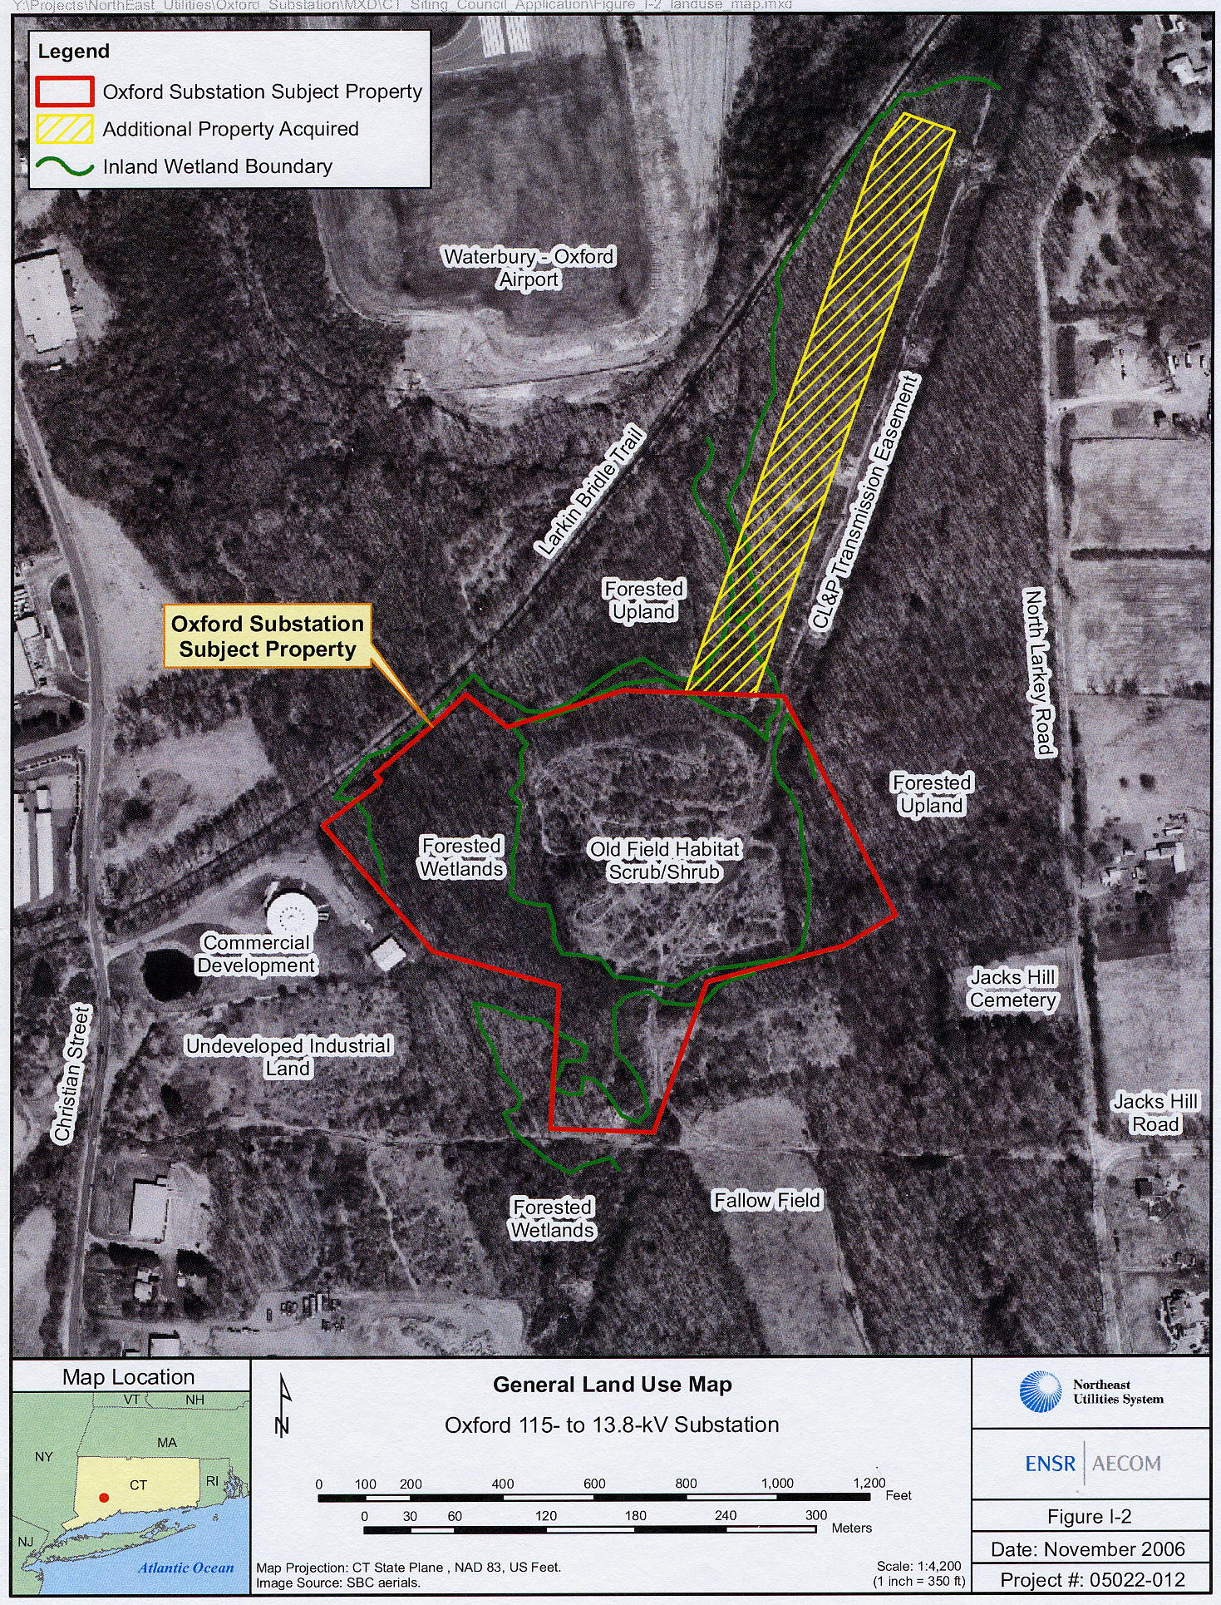

(CL&P 1, Vol. I, p. 39)
Figure 2
Site Layout

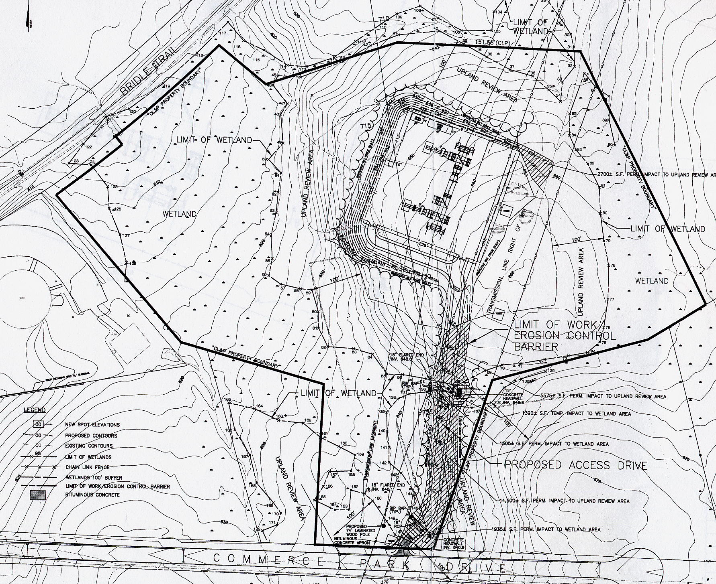

(CL&P 1, Vol. II., Appendix B)

