DOCKET NO. 309 - Cellco Partnership d/b/a Verizon Wireless application for a Certificate of Environmental Compatibility and Public Need for the construction, maintenance, and operation of a wireless telecommunications facility located at the Round Hill Community Church, 395 Round Hill Road, Greenwich, Connecticut. | }  }  } | Connecticut  Siting  Council  August 31, 2006

Findings of Fact

Introduction

- Cellco Partnership d/b/a Verizon Wireless (Cellco), in accordance with provisions of General Statutes §§ 16-50g through 16-50aa, applied to the Connecticut Siting Council (Council) on November 9, 2005 for the construction, operation, and maintenance of a wireless telecommunications facility at 395 Round Hill Road, Greenwich, Connecticut. (Cellco 1, p. 1)

- The party in this proceeding is the applicant. The intervenors in this proceeding are Omnipoint Communications, Inc. (T-Mobile), New Cingular Wireless PCS LLC (New Cingular), Mr. Cliff Berger, Sprint Nextel Corporation (Sprint Nextel), and Ms. Elizabeth Galt. (Transcript 1- 1/31/06, 3:00 p.m. [Tr. 1], pp. 5-6; Transcript 2- 3/28/06, [Tr. 2], pp. 3-10)

3. The purpose of the proposed facility is to provide wireless service to coverage gaps on the Merritt Parkway and local roads in the residentially developed Round Hill section of Greenwich. (Cellco 1, p. 1)

- Pursuant to General Statutes § 16-50m, the Council, after giving due notice thereof, held a public hearing on January 31, 2006, beginning at 3:00 p.m. and continuing at 7:00 p.m. at the Greenwich Town Hall, 101 Field Point Road, Greenwich, Connecticut. The public hearing was continued on March 28, 2006 and June 14, 2006 at the office of the Connecticut Siting Council, 10 Franklin Square, New Britain, Connecticut. (Council's Hearing Notice dated June 15, 2005; Tr. 1, p. 3; Tr. 2, p. 3; Transcript 3- 6/14/06, [Tr. 3] p. 3)

- The Council and its staff conducted an inspection of the proposed site on January 31, 2006, beginning at 2:00 p.m. During the field inspection, the applicant flew balloons at the site to simulate the heights of the proposed facility. (Council's Hearing Notice dated June 15, 2005)

- Notice of the application was provided to all abutting property owners by certified mail. Public notice of the application was published in the Greenwich Time on November 3 and 4, 2005. (Cellco 1, p. 5; Cellco 2)

- Pursuant to CGS § 16-50l (b), Cellco provided notice to all federal, state, regional, and local officials and agencies listed therein. (Cellco 1, p. 5, Attachment 2)

State Agency Comment

- Pursuant to CGS § 16-50j (h), on December 23, 2005 and June 15, 2006, the following State agencies were solicited by the Council to submit written comments regarding the proposed facility; Department of Environmental Protection (DEP), Department of Public Health (DPH), Council on Environmental Quality (CEQ), Department of Public Utility Control (DPUC), Office of Policy and Management (OPM), Department of Economic and Community Development (DECD), and the Department of Transportation (DOT). (Record)

- The Council received responses from the DOT’s Bureau of Engineering and Highway Operations on January 25, 2006 stating that the DOT has no comment on the proposed project. (Record)

- The following agencies did not respond with comment on the application: CEQ, DPUC, OPM, DPH, and the DECD. (Record)

Municipal Consultation

- From September 2004 to March 2005, Cellco representatives met with the Town of Greenwich First Selectman Jim Lash and Town Planner Diane Fox to discuss the proposed Round Hill facility and other potential telecommunications sites in Greenwich. (Cellco 8, p. 8)

- On September 8, 2005, Cellco initiated a formal consultation process with the Town of Greenwich by sending a technical report describing the proposed facility to Mr. Lash. Cellco representatives appeared before the Greenwich Planning and Zoning Commission (Commission) on September 27 and October 18, 2005 to discuss the proposal. (Cellco 1, p. 19)

- The Commission submitted written comments and recommendations regarding the proposed project to Cellco and the Council on November 1, 2005. (Cellco 3; Record)

- The Commission recommended that the Council require Cellco to explore alternative sites and strategies due to the sensitive nature of the Round Hill area, the impact on adjacent landowners, and the impact on existing vegetation at the site. The Commission further recommended a maximum tower height of 90 feet if alternatives were not feasible. (Cellco 3; Record)

Public Need for Service

- In 1996, the United States Congress recognized a nationwide need for high quality wireless telecommunications services, including cellular telephone service. Through the Federal Telecommunications Act of 1996, Congress seeks to promote competition, encourage technical innovations, and foster lower prices for telecommunications services. (Council Administrative Notice Item No. 7)

- In issuing cellular licenses, the Federal government has preempted the determination of public need for cellular service by the states, and has established design standards to ensure technical integrity and nationwide compatibility among all systems. Cellco is licensed by the Federal Communications Commission (FCC) to provide cellular and personal wireless communication service to Fairfield County, Connecticut. (Council Administrative Notice Item No. 7; Cellco 1, p. 7; Tr. 1, p. 14)

- The Telecommunications Act of 1996 prohibits local and state entities from discriminating among providers of functionally equivalent services. (Council Administrative Notice Item No. 7)

- The Telecommunications Act of 1996, a Federal law passed by the United States Congress, prohibits any state or local entity from regulating telecommunications towers on the basis of the environmental effects of radio frequency emissions to the extent that such towers and equipment comply with FCC’s regulations concerning such emissions. This Act also blocks the Council from prohibiting or acting with the effect of prohibiting the provision of personal wireless service. (Council Administrative Notice Item No. 7)
Site Selection

19. Three existing Cellco facilities are located within two-miles of the proposed site, as follows
a) monopole at 363 Riversville Road, 1.9 miles south of the site;
b) lattice tower at Butternut Hollow Road, 1.6 miles east of the site; and
c) steeple facility at 606 Riversville Road, 1.0 miles west of the site.
None of the sites provide adequate coverage to the area. (Cellco 1, Attachment 6; Sprint Nextel 3, Q. 5)

  - Cellco established a search area for the Round Hill section of Greenwich in 1994. Cellco initially investigated the possible use of two church steeples, one at the Round Hill Community Church and one at the Round Hill First Church. Neither church was interested in Cellco’s proposal. (Cellco 1, Attachment 8)

  - Cellco examined the potential use of a gas station/general store on Round Hill Road and a CL&P distribution substation adjacent the Merritt Parkway. Cellco could not come to terms with the property owner of the gas station/general store. CL&P rejected Cellco’s proposal due to property size constraints. (Cellco 1, Attachment 8; Cellco 18)

22. In 2003, Cellco joined with several other carriers to support a proposal by T-Mobile to construct a 150-foot monopole at the Round Hill Fire Department. In 2004, T-Mobile declined to pursue this site due to neighborhood opposition. (Cellco 1, Attachment 8; T-Mobile 1, Q. 11)

23. Except for the gas station/general store parcel, land in the Round Hill Area is zoned residential. (Cellco 1, Attachment 8)

Site Description

24. The proposed site is located on an 8.1-acre parcel owned by the Round Hill Community Church at 395 Round Hill Road in Greenwich. (Cellco 1, Attachment 1)

25. The site parcel is zoned residential, RA-4. The west side of the parcel is developed with the Church’s Community Building, Rectory, Caretakers’ residence and associated driveways and parking areas. (Cellco 1, p. 2)

26. The proposed telecommunications site is located in the eastern portion of the property at an elevation of 380 feet above mean sea level. The site development area is wooded with an average tree height of 60 feet. (Cellco 1, p. 2; Tr. 3, p. 40)

27. Cellco proposes to construct two 115-foot monopoles at the site, referred to as the easterly and westerly towers. The monopoles would be designed to accommodate three levels of internally mounted panel antennas with a ten-foot vertical separation. (Cellco 1, p. 2, Attachment 1)

28. The monopoles would be approximately four feet wide at the bottom tapering to 2.5 feet at the top. (Cellco 1, Attachment 1)

29. On the westerly tower, Cellco would install three PCS antennas at a centerline height of 110 feet and three cellular antennas at a centerline height of 100 feet. New Cingular would install three dual band antennas at a centerline height of 90 feet. (Cellco 1, Attachment 1; New Cingular 1, Q. 4, Q. 9)

30. On the easterly tower, T-Mobile would install three antennas at a centerline height of 110 feet; Sprint Nextel would install three cellular antennas at a centerline height of 100 feet and three PCS antennas at a centerline height of 90 feet. (Cellco 1, Attachment 1; T-Mobile 1, Q. 9; Sprint Nextel 1, Q. 3, Q. 4)

31. Cellco proposes to construct a 1,904 square-foot U shaped equipment building at the base of the towers within a 100-foot-by-100-foot lease area. The equipment building would be sectionalized to accommodate the radio equipment of four carriers. (Cellco 1, Attachment 1)

32. The U-shaped equipment building would appear as a wood frame structure with a cedar shingled pitched roof. A wood fence would enclose the two ends of the building to form a compound. Six air conditioning units and the utility board would be located within the compound. (Cellco 1, Attachment 1)

33. Access to the site would be provided by a 12-foot wide, 380-foot long driveway of new construction extending from an existing paved parking lot on the property. Underground utilities would be installed from a utility pole on Round Hill Road. (Cellco 1, Attachment 1)

34. Development of the site would require minimal grading and clearing. The site and access road are situated to minimize the clearing of significant trees and the disruption of a stone wall that forms the eastern boundary of the lease area. (Cellco 1, Attachment 1)

35. The nearest abutting property from the site is approximately 130 feet to the east and is owned by Jean Van Waveran. (Cellco 1, Attachment 1)

36. Land within a quarter-mile of the site is zoned residential. There are 13 residences within 1,000 feet of the proposed site. (Cellco 1, p. 14; Cellco 4, Q. 19)

37. The nearest residence from the proposed site is approximately 400 feet to the northwest, owned by Robert Weiss. (Cellco 1, Attachment 3; Cellco 4, Q. 19; Cellco 15)

38. The estimated cost of construction of the facility is:

Cell site radio equipment 525,000.
Tower, cable, and antennas 300,000.
Utilities 20,000.
Equipment building 150,000.
Site preparation, facility installation 150,000.

Total estimated cost $1,145,000.
(Cellco 1, p. 20)

Environmental Considerations

39. There are no known extant populations of Federal Threatened or Endangered Species at the proposed site. There are no known extant populations of state Endangered, Threatened or Special Concern Species at the proposed site. (Cellco 1, Attachment 10)

40. The proposed facility would have no effect on cultural or historic resources. The nearest historic district, the Round Hill Historic District is located approximately a half-mile north of the site. The district consists of five contiguous parcels. The Sylvanus Selleck Gristmill, listed in National Register of Historic Places, is approximately 0.25 miles south of the site at 124 Old Mill Road. (Cellco 1, Attachment 10; Cellco 11, Q. 20; Galt 5)

41. Development of the site would require the removal of 42 trees with a diameter of six inches at breast height. (Tr. 3, p. 50)

42. Development of the site would not directly affect any wetlands or watercourses. The nearest wetland is approximately 140 feet east of the site. The site is not located within a flood zone. (Cellco 1, p. 18)

43. Aircraft hazard obstruction marking or lighting would not be required. (Cellco 1, Attachment 11)

44. The maximum power density from the radio frequency emissions of the proposed Cellco, New Cingular, T-Mobile, and Sprint Nextel antennas are calculated to be 57.8% of the standard for Maximum Permissible Exposure, as adopted by the FCC, at the base of the proposed towers. This calculation was based on methodology prescribed by the FCC Office of Engineering and Technology Bulletin No. 65E, Edition 97-01 (August 1997) that assumes all antennas would be pointed at the base of the towers and all channels would be operating simultaneously. (Cellco 1, Attachment 1)

Visibility

45. The average height of the tree canopy within a two-mile radius of the site is 60 feet agl. (Cellco 1, Attachment 9; Berger 3)

46. The two towers would consist of galvanized steel with no color treatment. Cellco would be willing to paint the towers to blend in with the wooded surroundings. (Cellco 1, p. 2; Tr. 3, p. 45)

47. The facility would be visible above the tree canopy from approximately 18-acres within a two-mile radius of the site, an area containing 17 residences. Most of the views would be limited to the upper portions of the tower. Approximately 9-acres of this year-round visibility are within one-mile of the site (refer to Figure 1). (Cellco 11, Q. 18; Berger 3)

48. The facility would be seasonably visible from approximately 245-acres within a two-mile radius of the site, a majority of which is within a half-mile of the site (refer to Figure 1). The area of seasonal visibility includes 193 parcels. The entire facility would not be seasonally visible from any abutting residence. (Cellco 11, Q. 19; Berger 3)

49. The facility would have the greatest visual impact on three abutting residences located approximately 400 feet to the northwest; 500 feet to the southeast; and 590 feet to the east. The residence to the northwest (Weiss residence) would have year round views of the upper 40 to 70 percent of the structure. The other two residences would have seasonal views of portions of the facility and possibility year-round views of the very top of the facility. Limited views of the compound from these residences compound area are also possible. Views of the facility within 500 feet would include substantial portions of the two towers. The entire facility would not be visible due to surrounding vegetation. (Cellco 11, Q. 18; Cellco 15; Tr. 3, pp. 42-43; Tr. 4, p. 19, 30)

50. The top of the facility would be visible above the tree canopy from the remaining abutting properties to the south and east. (Tr. 3, pp. 42-44)

51. The facility would not be visible from the Round Hill Historic District or the Sylvanus Selleck Gristmill. (Cellco 21; Berger 3)

52. Visibility of the proposed facility from specific locations within a two-mile radius of the proposed site is presented in the table below:

Location | Visible | Approx. Portion of Tower Visible | Approx. Distance from Tower
Round Hill Road at south entrance to Round Hill Community Church | Yes | 20 feet-above trees &  20 feet-through trees | 0.16 miles west
Round Hill Road at north entrance to Round Hill Community Church | Yes | 50 feet-through trees | 0.17 miles west
7 Old Round Hill Lane, second floor | Yes | 15 feet-above trees | 0.45 miles west
Round Hill Road and Cherry Valley Road | Yes | 25 feet-through trees | 0.35 miles north
Old Round Hill Lane adjacent to #1 | Yes | 10 feet-through trees | 0.5 miles west
Old Mill Road adjacent to #115 | Yes | 40 feet-through trees | 0.2 miles south
Merritt Parkway north of Round Hill Road interchange | No |  | 0.6 miles south
Merritt Parkway at Round Hill Road | No |  | 0.85 miles south
Audubon Center, John Street | No |  | 1.3 miles west
Riversville Road at Porchuck Road | No |  | 1.3 miles west
Riversville Road adjacent to #555 | No |  | 1.3 miles west
Cherry Valley Road adjacent to #92 | No |  | 0.3 miles north
Cherry Valley Road adjacent to #88 | No |  | 0.35 miles north
Round Hill Road adjacent to #465 | No |  | 0.8 miles north
Round Hill Road adjacent to #435 | No |  | 0.45 miles north
Round Hill Road and Old Mill Road | No |  | 0.3 miles south
Moreland Road adjacent to # 20 | No |  | 0.3 miles west
Moreland Road adjacent to # 35 | No |  | 0.5 miles west
Moreland Road adjacent to #55 | No |  | 0.6 miles east
Moreland Road adjacent to # 28 | No |  | 0.45 miles west
(Cellco 1, Attachment 9; Cellco 17; Berger 3)

53. The facility would not be visible from the Babcock Preserve, an open space preserve approximately 0.9 miles east of the site, or the Fairchild Wildflower Garden, approximately 0.8 miles west of the site. The facility would be seasonally visible from two small isolated areas of the Greenwich Audubon Center property, approximately 0.9 miles west of the site. (Cellco 1, Attachment 9; Berger 3)

54. The facility would not be visible from two Town designated scenic roads, Buckfield Lane and Burying Hill Road, north of the site. (Cellco 1, Attachment 9; Berger 3)

55. The facility would be seasonably visible through trees from approximately 0.25-miles of the Merritt Parkway, a National Scenic By-way. (Cellco 1, Attachment 9; Cellco 17; Berger 3)

56. Views of the facility from Round Hill Road at the entrance of the church would be partially screened by the Community House on the site parcel. (Cellco 4, Q. 11)

Cellco - Existing and Proposed Wireless Coverage

57. Cellco operates at both the 800 MHz (cellular) and 1900 MHz (PCS) frequencies. Cellco is designing the site with a signal level threshold of -85 dBm, sufficient for in-vehicle coverage with a reliability factor of 99%. Cellco’s in-building signal level threshold is -75 dBm. (Cellco 9, pp. 2, 5; Tr. 1, pp. 76, 80, 82)

58. Cellco currently experiences an approximate 1.1-mile coverage gap on the Merritt Parkway at the cellular frequencies and a 1.4-mile coverage gap at the PCS frequencies (refer to Figure 2). Cellco’s current signal level on the Merritt Parkway ranges between -86 dBm to -95 dBm. (Cellco 4, Q. 2; Tr. 4, pp. 10-11)

59. PCS coverage objectives would be met on the Merritt Parkway by installing antennas at 110 feet agl (refer to Figure 3). (Cellco 10, Attachment 2, plot 4)

60. The facility would provide approximately 4.3 square miles of PCS coverage to the Round Hill area, including portions of Round Hill Road, Lake Avenue, Old Mill Road, Cherry Valley Road, and Will-Merry Lane, all residentially developed areas. (Cellco 4, Q. 9; Cellco 21; Tr. 4, p. 31)

61. Installing PCS antennas at 100 feet would result in a 0.2-mile gap (-86 to -90 dBm) on the Merritt Parkway east of Round Hill Road (refer to Figure 4). (Cellco 10, Attachment 2, plot 3)

62. Cellular coverage objectives could be met at an antenna height of 80 feet agl although potential interference from future tree growth in the area surrounding the facility would be a concern. (Cellco 10, Attachment 5, plot 7; Tr. 1, p 96; Tr. 4, pp. 11-12)

63. Cellco is proposing separate heights for the PCS antennas (110 feet) and cellular antennas (100 feet). Using dual-band antennas at 100-feet would reduce the signal strength throughout the area by 1.5 db resulting in a tenth of a mile gap on the Merritt Parkway west of Round Hill Road and a reduction in the coverage footprint from 4.3 square miles to 3.4 square miles. (Cellco 4, Q. 8; Tr. 4, p. 31)

Existing and Proposed Wireless Coverage – T-Mobile

64. T-Mobile operates in the PCS frequencies. T-Mobile is designing the site with a signal level threshold of -84 dBm, sufficient for in-vehicle coverage. T-Mobile’s in-building signal level threshold is -76 dBm. (T-Mobile 1, Q. 3)

65. T-Mobile’s primary coverage objective is the Merritt Parkway and the surrounding Round Hill area. (Tr. 4, p. 52)

66. Using a signal level of -84 dBm, T-Mobile currently experiences an approximate one-mile coverage gap on the Merritt Parkway and has minimal coverage in the surrounding Round Hill area (refer to Figure 6). Existing signal levels in the area are approximately -90 dBm or worse. (T-Mobile 1, Q. 1, Q. 5)
67. Existing adjacent T-Mobile sites that would interact with the proposed site are presented in the table below. None of these sites provides adequate coverage to the target service area.

Location | Antenna Height agl | Approximate Distance from Site
363 Riversville Road, Greenwich | 163 feet - monopole | 2.0 miles south
Butternut Hollow Road, Greenwich | 125 feet - lattice | 1.1 miles east
DeKraft Road, Greenwich | 122 feet - watertank | 1.6 miles southeast
(T-Mobile 1, Q. 5)

68. T-Mobile would meet coverage objectives with an antenna height of 110 feet at the proposed height (refer to Figure 7). (T-Mobile 4, plot 3)

69. Installing antennas at 100 feet would result in an approximate 0.25-mile coverage gap on the Merritt Parkway east of Round Hill Road. The signal in this area would range from -84 dBm to -90 dBm (refer to Figure 8). A call entering the gap area would experience call clarity problems but the call would most likely be maintained. (Tr. 4, pp. 46-47)

New Cingular - Existing and Proposed Wireless Coverage

70. New Cingular operates in both the cellular and PCS MHz frequency bands. New Cingular would install three 800/1900 MHz dual band antennas at a centerline height of 90 feet. (New Cingular 1, Q. 2, Q. 7, Q. 9)

71. New Cingular’s primary coverage objective is the Merritt Parkway and the surrounding Round Hill area. (New Cingular 1, Q. 1; Tr. 3, p. 85)

72. New Cingular’s existing signal level on the Merritt Parkway is -80 to -90 dBm at 800 MHz and -76 to -90 dBm at 1900 MHz (refer to Figure 9). Areas west of the site are less than -96 dBm at both the cellular and PCS frequencies. New Cingular seeks to provide coverage throughout the area at a signal level of -75 dBm, sufficient for in-building coverage with a 98% reliability factor. New Cingular’s in-vehicle signal level threshold is -80 dBm. (New Cingular 1, Q. 1, Q. 3, New Cingular 3)

73. Existing adjacent New Cingular sites that would interact with the proposed site are presented in the table below. None of these sites provides adequate coverage to the target service area.

Location | Antenna Height agl | Approximate Distance from Site
Butternut Hollow Road, Greenwich | 148 feet - lattice | 1.1 miles east
363 Riversville Road, Greenwich | 156 feet - monopole | 2.0 miles south

74. Coverage models depict adequate coverage to the area from the site at 70 feet agl; however, tree heights immediately west of the site could cause signal interference. Therefore, New Cingular is proposing an antenna height of 90 feet agl (refer to Figure 10). (New Cingular 4, plots 1, 8, 10; Tr. 3, pp. 94-98)

Existing and Proposed Wireless Coverage – Sprint Nextel

75. Sprint Nextel operates in the 800 MHz and 900 MHz frequencies (Sprint iDEN) and 1900 MHz frequencies (Sprint PCS). (Sprint 1, Q. 3; Sprint 3, Q. 3)

76. Sprint Nextel is designing the site for in-vehicle coverage, -82 dBm for Sprint iDEN and -94 dBm for Sprint PCS. (Sprint 1, Q. 1; Sprint 3, Q. 1)

77. Sprint Nextel’s primary coverage objective is the Merritt Parkway. (Tr. 4, p. 137)

78. The Sprint iDEN and Sprint PCS networks both experience an approximate 1.2-mile coverage gap on the Merritt Parkway and minimal coverage in the surrounding Round Hill area (refer to Figures 11 & 13). (Sprint Nextel 3, Q. 5; Sprint Nextel 2, Q. 15)

79. Existing adjacent Sprint Nextel sites that would interact with the proposed site are presented in the table below. None of these sites provides adequate coverage to the target service area.

Location | Antenna Height agl | Approximate Distance from Site
363 Riversville Road, Greenwich | 130 feet - monopole | 2.0 miles south
Butternut Hollow Road, Greenwich | 115 feet - lattice | 1.1 miles east
606 Riversville Road, Greenwich | 68 feet – church steeple  (PCS only) | 1.0 miles southeast
(Sprint Nextel 1, Sprint Nextel 3, Q. 5)

80. Coverage objectives for Sprint iDEN could be met at an antenna height of 70 feet agl. Sprint Nextel is proposing an antenna height of 100 feet agl (refer to Figure 12). (Sprint Nextel 1, Q. 4; Tr. 4, p. 139)

81. Coverage objectives for Sprint PCS would be met at 90 feet agl, the height proposed by Sprint Nextel (refer to Figure 14). Locating antennas at 80 feet would cause a degradation of coverage on the Merritt Parkway. (Tr. 4, pp. 124-127)

Alternative Technologies

Distributed Antenna System

82. Distributed Antenna System (DAS) is a general term used to describe several types of wireless systems. In this proceeding the term DAS is used to describe a series of small antennas and repeaters, called nodes, strategically located to provide coverage to the Merritt Parkway. Each node would be connected to each other and to a base station by fiber optic lines. Property easements would be needed for the installation of the nodes and fiber optic lines. (Cellco 9, pp. 7-9; Tr. 4, p. 58)

83. Each node distributes limited directional coverage to a specific geographic area, typically 0.2-miles of linear coverage along a roadway. (Cellco 9, p. 8; Tr. 4, 198)

84. A limited DAS is installed on the Hutchinson River Parkway in New York. The system consists of nodes mounted on four poles, providing coverage to a limited section of the roadway. (Tr. 4, pp. 35-36, 58-61)

85. Cellco considered using a design of a short structure at the proposed site with a limited DAS system but rejected this alternative due to the amount of nodes required to duplicate coverage provided by the proposed facility. (Tr. 3, p. 36)

86. Cellco would require approximately 30 nodes throughout the Round Hill area to provide the same coverage footprint as the proposed site. (Cellco 9, p. 8)

87. If a DAS served the Merritt Parkway in the Round Hill area, Cellco would probably seek to develop two facilities, one north of the proposed Round Hill site and one south of the Merritt Parkway to serve residential areas. (Tr. 4, pp. 203-204)

88. On July 25, 2006 (after the close of the evidentiary hearing), ClearLinx Network Corporation (ClearLinx) filed a Petition with the Council (Petition No. 782) to provide DAS over portions of the Merritt Parkway, including portions of Greenwich, in part, include the Round Hill site. (Administrative Notice of Council Records)

89. T-Mobile did not consider a DAS for the Round Hill area since DAS provides coverage to a limited area. In addition to the Merritt Parkway, T-Mobile is seeking to provide coverage to residential areas on the on the north and south sides of the Merritt Parkway. (T-Mobile 3, Q. 18; Tr. 4, p. 55)

90. New Cingular did not consider the use of a DAS for the Round Hill area. (New Cingular 2, Q. 18)

91. Sprint Nextel has not examined the feasibility of supplementing coverage from a shorter Round Hill facility with a DAS along the Merritt Parkway. (Tr. 4, pp. 137-138)

Combined and Dual Band Antennas

92. A combined antenna system, a system that consolidates all of the carriers transmit and receive needs onto one antenna, is not a viable alternative since there is no known manufacturer that markets such a product. (Cellco 19, p. 3; Cingular 2, Q. 17; Tr. 4, pp. 109-110)

93. Dual band antennas allow for the use of cellular and PCS frequencies on the same antenna. (Cellco 19, p. 2)

94. Cellco cannot use dual-band antennas in the Round Hill area since dual band technology would reduce coverage by 1.5 db. Installing dual-band antennas at 110 feet at the proposed site would reduce Cellco’s coverage footprint from 4.3 square miles to 3.3 square miles and would include a 0.1-mile gap in PCS coverage on the Merritt Parkway. (Cellco, Q. 8; Tr. 3, p. 60)

95. New Cingular proposes to use dual-band antennas at the site. (New Cingular 1, Q. 9)

96. Sprint Nextel operates an iDEN and PCS network. Each network would require separate antennas since a dual band antenna suitable for operation of both networks has not been found. (Tr. 4, pp. 141-142)

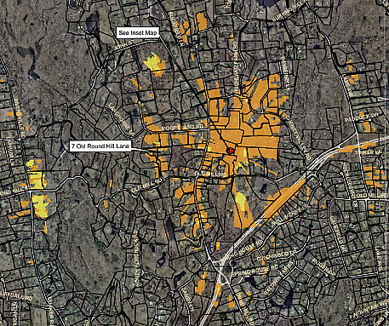

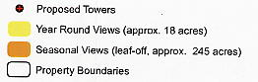

Figure 1. Location and projected visibility of proposed tower. (Berger 3, Visibility Analysis)

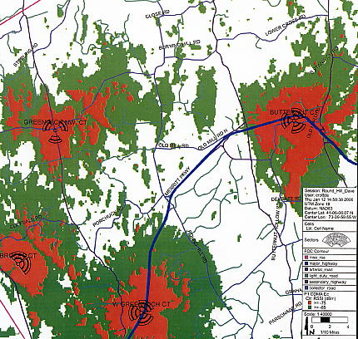

Figure 2. Cellco’s existing PCS coverage in the Round Hill area with a signal level threshold of -85 dBm. (Cellco 4, Tab 1)

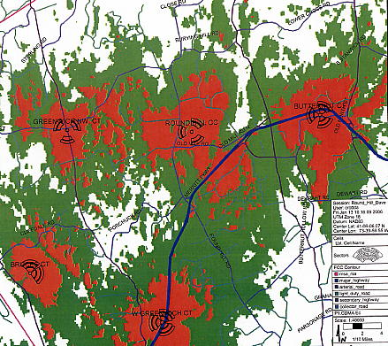

Figure 3. Cellco’s existing and proposed PCS coverage in the Round Hill area at an antenna height of 110 feet agl with a signal level threshold of -85 dBm. (Cellco 4, Tab 1)

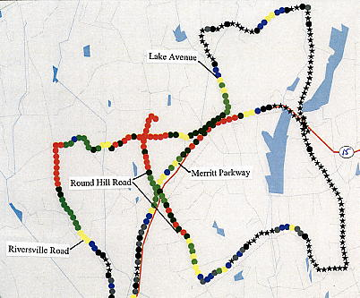

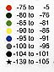

Figure 5. Drive test depicting PCS coverage from site with antennas at 100 feet agl. Drive test depicts a coverage gap on the Merritt Parkway east of Round Hill Road (blue and yellow bins). (Cellco 10, Tab 2)

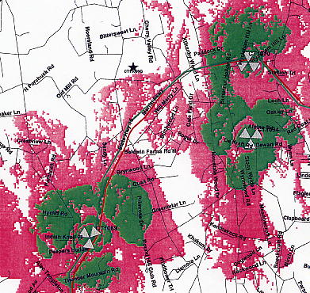
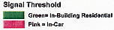
Figure 6. T-Mobile’s existing coverage in the Round Hill area. (T-Mobile 1, Tab 3)
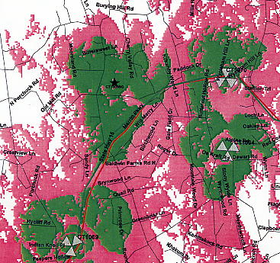

Figure 7. T-Mobile’s existing and proposed coverage with antennas at 110 feet agl. (T-Mobile 1, Tab 3)
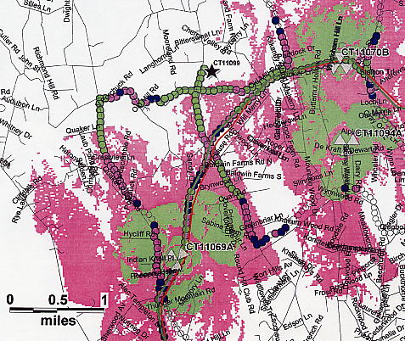

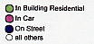

Figure 8. Drive test depicting T-Mobile PCS coverage from site with antennas at 100 feet agl. Drive test depicts a coverage gap on the Merritt Parkway east of Round Hill Road (dark blue bins). (T-Mobile 4)

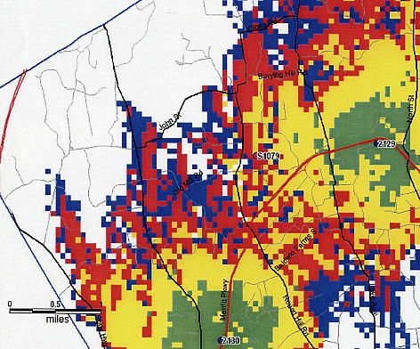
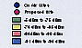
Figure 9. New Cingular’s existing PCS coverage in the Round Hill area. (New Cingular 4)

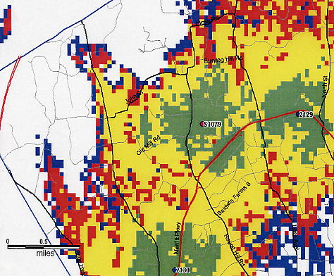

Figure 10. New Cingular’s existing and proposed PCS coverage in the Round Hill area with antennas at 90 feet agl. (New Cingular 4)
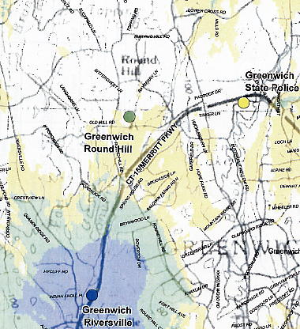
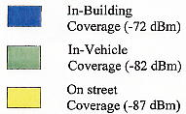

Figure 11. Sprint Nextel existing Sprint iDEN coverage in the Round Hill area. (Sprint Nextel 1, Q. 5)

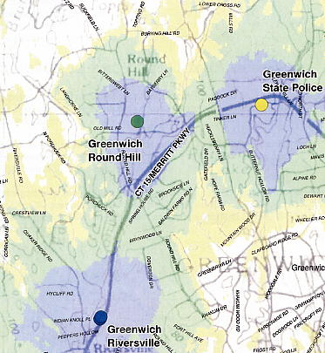

Figure 12. Sprint Nextel existing and proposed Sprint iDEN coverage in the Round Hill area with antennas at 100 feet agl. Sprint Nextel also intends to locate on the existing State Police tower. (Sprint Nextel 2)
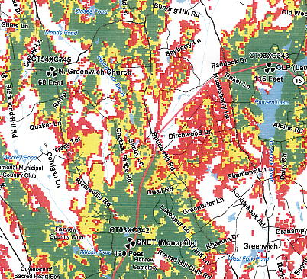
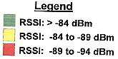

Figure 13. Sprint Nextel’s existing Sprint PCS coverage in the Round Hill area. (Sprint Nextel 1, Q. 5)

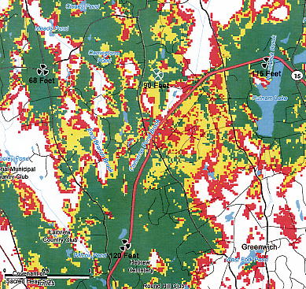

Figure 14. Sprint Nextel’s existing and proposed Sprint PCS coverage in the Round Hill area with antennas at 90 feet agl. (Sprint Nextel 3, Q. 6)

