DOCKET NO. 293 – Omnipoint Communications, Inc. application for a Certificate of Environmental Compatibility and Public Need for the construction, maintenance and operation of a wireless telecommunications facility at one of two locations off of Route 162, West Haven, Connecticut. | }  }  } | Connecticut  Siting  Council  May 11, 2005

Findings of Fact

Introduction

- Omnipoint Communications, Inc. (T-Mobile), in accordance with provisions of General Statutes §§ 16-50g through 16-50aa, applied to the Connecticut Siting Council (Council) on June 21, 2004 for the construction, operation, and maintenance of a wireless telecommunications facility at 600 Jones Hill Road, referred to as the Prime Site, or at 668 Jones Hill Road, referred to as the Alternate Site, in West Haven, Connecticut. (T-Mobile 1, pp. 1, 9; T-Mobile 4)

2. The party in this proceeding is the applicant. (Transcript 1- 4:00 p.m. [Tr. 1], p. 4)

3. The purpose of the proposed facility is to provide service to coverage gaps identified by T-Mobile in the Route 162/Ocean Avenue area of West Haven. (T-Mobile 1, p. 6, Attachment 1; Tr. 1, p. 46)

- Pursuant to General Statutes § 16-50m, the Council, after giving due notice thereof, held a public hearing on February 15, 2005, beginning at 4:00 p.m. and continuing at 7:00 p.m. at the West Haven City Hall, 355 Main Street, West Haven, Connecticut. (Council's Hearing Notice dated December 29, 2004; Tr. 1, p. 2; Transcript 2 – 7:00 p.m. [Tr. 2], p. 2)

- The Council and its staff conducted an inspection of the proposed sites on February 15, 2005, beginning at 3:00 p.m. During the field inspection, the applicant attempted to fly a balloon at each site to simulate the heights of the proposed towers. Strong winds prevented both balloons from attaining the intended heights. (Council's Hearing Notice dated December 29, 2004; Tr. 1, pp. 52-53)

- Notice of the application was provided to all abutting property owners by certified mail. Three return mail receipts were not received. Two notices were returned unclaimed. There was no record of receipt for the third notice. Public notice of the application was published in The New Haven Register on April 30 and May 7, 2004 and in the West Haven News on May 6 and May 13, 2004. (T-Mobile 1, p. 5, Attachment 10, Attachment 11; T-Mobile 2, Q. 1)

- T-Mobile notified the City of West Haven of the proposal on April 5, 2004 by sending a technical report to H. Richard Borer, Jr., Mayor of West Haven. T-Mobile subsequently met with Mr. Borer, City Planner Phil Bolduc, City Engineer Abdul Quadir, and Building Official Frank Gladwin to discuss the proposal. (T-Mobile 1, p. 20)

- The City of West Haven recognizes a need for service in this area and supports both sites for telecommunications use. (T-Mobile 1, p. 20, Attachment 8)

- T-Mobile would provide lease free space on the tower for any emergency use municipal antenna. The City of West Haven has not expressed an interest in using the tower. (Tr. 1, p.11)

- Pursuant to General Statutes § 16-50j (h), on December 29, 2004, the following State agencies were solicited to submit written comments regarding the proposed facility: Department of Environmental Protection (DEP), Department of Public Health (DPH), Council on Environmental Quality (CEQ), Department of Public Utility Control (DPUC), Office of Policy and Management (OPM), Department of Economic and Community Development (DECD), and the Department of Transportation (DOT). (Record)

- Comments were received from the DEP on February 4, 2005. (Record)

- The following agencies did not respond with comments on the application: DOT, DPH, CEQ, DPUC, OPM, and the DECD. (Record)

Telecommunications Act

- In 1996, the United States Congress recognized a nationwide need for high quality wireless telecommunications services, including cellular telephone service. Through the Federal Telecommunications Act of 1996, Congress seeks to promote competition, encourage technical innovations, and foster lower prices for telecommunications services. (Council Administrative Notice Item No. 7)

- In issuing cellular licenses, the Federal government has preempted the determination of public need for cellular service by the states, and has established design standards to ensure technical integrity and nationwide compatibility among all systems. T-Mobile is licensed by the Federal Communications Commission (FCC) to provide personal wireless communication service (PCS) to New Haven County, Connecticut. (Council Administrative Notice Item No. 7; T-Mobile 1, p. 3)

- The Telecommunications Act of 1996 prohibits local and state entities from discriminating among providers of functionally equivalent services. (Council Administrative Notice Item No. 7)

- The Telecommunications Act of 1996, a Federal law passed by the United States Congress, prohibits any state or local entity from regulating telecommunications towers on the basis of the environmental effects of radio frequency emissions to the extent that such towers and equipment comply with FCC’s regulations concerning such emissions. This Act also blocks the Council from prohibiting or acting with the effect of prohibiting the provision of personal wireless service. (Council Administrative Notice Item No. 7)

Site Selection

17. Prior to selecting the proposed sites, T-Mobile investigated the use of existing structures located within the search area. T-Mobile identified a water tank located at 40 Shingle Hill Road for possible telecommunications use. The owner of the tank, South Central Connecticut Regional Water Authority, declined to allow use of the tank, citing security concerns. (T-Mobile 1, p. 8; Tr. 1, pp. 44-45)

18. After determining there were no viable structures within the search area, T-Mobile searched for properties suitable for tower development. T-Mobile investigated five parcels and selected two for site development. The three rejected parcels and reasons for their rejection are as follows:
- 600 Shingle Hill Road – could not reach lease agreement.
- 85 Chase Lane, Irish American Club – did not meet coverage objectives.
- 430 Island Avenue – did not meet coverage objectives.
(T-Mobile 1, p. 9)

Site Description – Prime Site

19. The Prime Site is located on an approximately 10-acre parcel owned by the Our Lady of Victory Church Corporation at 600 Jones Hill Road in West Haven. The parcel contains a church, three other buildings, and associated parking areas. The parcel is west of Jones Hill Road. The site location is depicted on Figure 1. (T-Mobile 1, pp. 9-10, Attachment 3)

20. The site parcel is zoned Public Facilities, PF. (T-Mobile 1, Attachment 3)

21. The tower site is located in the northwest section of the property to the rear of the Parish House and an associated parking lot. The site is in a cleared, grassy area on a hillside. The tower location is at an elevation of 138 feet above mean sea level (amsl). (T-Mobile 1, Attachment 3)

22. T-Mobile would construct a 153-foot monopole at the site. The tower would be designed to support three levels of antennas with a 10-foot center-to-center vertical separation. The tower would be constructed in accordance with the American National Standards Institute TIA/EIA-222-F “Structural Standards for Steel Antenna Towers and Antenna Support Structures”. (T-Mobile 1, p. 10, Attachment 3)

23. T-Mobile would install nine panel antennas on a triangular platform at a centerline height of 150 feet above ground level (agl). The total height of the facility with antennas would be 153 feet agl. (T-Mobile 1, p. 12, Attachment 3; T-Mobile 4)

24. The tower would be placed in the center of a 48-foot by 48-foot equipment compound. The compound would be enclosed by a seven-foot high chain link and barb wire fence. T-Mobile would install three equipment cabinets on concrete pads within the compound. Evergreen plantings are proposed at the perimeter of the compound. (T-Mobile 1, p. 11, Attachment 3)

25. T-Mobile would construct a 10-foot wide, 185-foot long gravel access road extending from an existing parking lot to the site. Underground utilities would be installed to the compound along a utility easement north of the Parish House from a utility pole on Jones Hill Road. (T-Mobile 1, p. 11, Attachment 3; T-Mobile 2, Q. 3)

26. The tower setback radius would extend onto the adjacent Goffi property, west of the site, by 81 feet. The Goffi property is an approximate 27-acre residentially zoned parcel containing a single-family residence. T-Mobile is unwilling to relocate the tower site to prevent the tower setback radius from extending onto the Goffi property, stating that any relocation would cause the tower setback radius to include the existing Parish House or an existing playground on the property. (T-Mobile 1, Attachment 3; T-Mobile 2, Q. 11)

27. There are 150 residential structures within 1,000 feet of the proposed tower site. The nearest building to the tower site is the Parish House, located approximately 167 feet east of the tower site. The nearest residence to the tower that is not on the site parcel is located approximately 350 feet to the southeast. (T-Mobile 2, Q. 14)

28. The estimated construction cost for the Prime Site facility is:

Tower and equipment costs 96,000.
Tower foundation, compound, and access 45,000.
Antennas and cables 25,000.
Electrical 16,000.
Civil Engineering 14,000.

Total estimated cost $196,000.
(T-Mobile 1, p. 22)

Site Description – Alternate Site

29. The Alternate Site is located on an 11.4-acre parcel owned by Robert Newkirk at 668 Jones Hill Road. The eastern potion of the site parcel is developed with a residence, farm stand, greenhouse, and barn. The property is used primarily as a garden/greenhouse center. The western portion of the parcel contains an open field, wooded areas, and wetlands. The parcel is located west of Jones Hill Road and north of the Prime Site. The site location is depicted on Figure 1. (T-Mobile 1, pp. 2, 9-10, 18, Attachment 3; T-Mobile 2, Q. 11)

30. The site parcel is zoned residential, R-1. (T-Mobile 1, Attachment 3)

31. The tower site is located in a shrubby area on the eastern portion of the property, approximately 100 feet west of the barn. The tower site is at an elevation of 143 feet amsl. (T-Mobile 1, Attachment 3, Attachment 6D)

32. T -Mobile would construct a 153-foot monopole at the site. The tower would be designed to support three levels of antennas with a 10-foot center-to-center vertical separation. The tower would be constructed in accordance with the American National Standards Institute TIA/EIA-222-F “Structural Standards for Steel Antenna Towers and Antenna Support Structures”. (T-Mobile 1, p. 10, Attachment 3)

33. T-Mobile would install nine panel antennas on a triangular platform at a centerline height of 150 feet agl. The total height of the facility with antennas would be 153 feet agl. (T-Mobile 1, p. 12, Attachment 3; T-Mobile 4)

34. The tower would be placed in the center of a 48-foot by 48-foot equipment compound. The compound would be enclosed by a seven-foot high chain link and barb-wire fence. T-Mobile would install three equipment cabinets on concrete pads within the compound. Evergreen plantings are proposed for the perimeter of the compound. (T-Mobile 1, Attachment 3)

35. Access to the Alternate Site would be provided by an existing dirt road on the property. Underground utilities would be installed within the access road from a utility pole on Jones Hill Road. (T-Mobile 1, Attachment 3)

36. The tower setback radius would extend onto the adjacent Figlar property, north of the site, by 122 feet. Ten mobile homes on the Figlar property are within the setback radius. T-Mobile and the property owner would be willing to relocate the tower approximately 100 feet west of the proposed site to reduce the amount of the setback radius extending onto the Figlar property. Two mobile homes would be within the tower setback radius of the relocated site. (T-Mobile 1, Attachment 3; Tr. 2, pp. 24-26)

37. T-Mobile would be willing to install a yield point on the tower, as necessary, to prevent the tower from encroaching upon the Figlar property in the event of a tower failure. (Tr. 1, pp. 30, 48)

38. There are approximately 130 residences within 1,000 feet of the Alternate Site. The nearest occupied residence is a mobile home approximately 50 feet from the proposed tower site. (T-Mobile 2, Q. 14)

39. The estimated construction cost for the Alternate Site facility is:

Tower and equipment costs 96,000.
Tower foundation, compound, and access 45,000.
Antennas and cables 25,000.
Electrical 18,000.
Civil Engineering 18,000.

Total estimated cost $202,000.
(T-Mobile 1, p. 22)

Environmental Concerns

40. The proposed facilities would have no effect on historic, architectural, or archaeological resources listed on or eligible for the National Register of Historic Places or upon properties of traditional cultural importance to Connecticut’s Native American communities. (T-Mobile 1, Attachments 6A, 6B)

41. The proposed sites contain no known existing populations of Federal or State Endangered, Threatened or Special Concern Species. (T-Mobile 1, Attachments 6A, 6B)

42. Development of the Prime Site would not require the removal of any trees. The site is located in a cleared, grassy area. (T-Mobile 1, Attachment 3, Attachment 6A)

43. Development of the Alternate Site would require the removal of 11 trees with a diameter of six inches or greater at breast height. (Tr. 1, p. 29)

44. Development of either site would not directly affect any wetlands or watercourses. The nearest wetland to the Prime Site development area is approximately 200 feet to the west. The nearest wetland to the Alternate Site development area is approximately 300 feet to the west. (T-Mobile 1, pp. 18, 19)

45. Aircraft hazard obstruction marking or lighting of either tower would not be required. (T-Mobile 1, p. 21, Attachment 14; T-Mobile 5; Tr. 1, p. 8)

46. According to methodology prescribed by the FCC Office of Engineering and Technology Bulletin No. 65E, Edition 97-01 (August 1997), assuming all T-Mobile antennas would be pointed at the base of the tower and all channels would be operating simultaneously, the maximum power density at the base of either proposed tower would be 0.033 mW/cm² or 3.33% of the standard for Maximum Permissible Exposure as adopted by the FCC. (T-Mobile 1, p. 16)

Visibility

47. Visibility of the proposed Prime Site tower from specific locations within a half-mile radius of the site is presented in the table below:

Location | Visible | Approximate Portion of Tower Visible | Distance from Tower
Vicinity of 34 Morgan Lane | Yes | Entire structure and compound | 0.2 miles southwest
Vicinity of 662 Jones Hill Road | Yes | Entire structure and compound | 0.1 miles east
Vicinity of 585-587 Jones Hill Road | Yes | Entire structure and compound | 0.1 miles southeast
Arlington Park | Yes | 15 feet - unobstructed | 0.4 miles southeast
Intersection of High Meadow Lane and Shingle Hill Road | Yes | 100 feet - unobstructed | 0.3 miles west
Harry M. Bailey Junior High School | Yes | 80 feet - through vegetation | 0.3 miles west
(T- Mobile 1, Attachment 7A; T-Mobile 2, Q. 7)

48. Visibility of the proposed Alternate Site tower from specific locations within a half-mile radius of the site is presented in the table below:

Location | Visible | Approximate Portion of Tower Visible | Distance from Tower
Vicinity of 34 Morgan Lane | Yes | 70 feet - unobstructed | 0.4 miles southwest
Vicinity of 662 Jones Hill Road | Yes | 50 feet - unobstructed | 0.1 miles south
Vicinity of 585-587 Jones Hill Road | Yes | 30 feet - unobstructed | 0.2 miles south
Arlington Park | Yes | 10 feet - unobstructed | 0.4 miles southeast
Intersection of High Meadow Lane and Shingle Hill Road | Yes | 90 feet - unobstructed | 0.4 miles west
Harry M. Bailey Junior High School | Yes | 80 feet - through vegetation | 0.3 miles southwest
(T- Mobile 1, Attachment 7B; T-Mobile 2, Q. 7)

49. Approximately 24 residences on Morgan Lane and Jones Hill Road would have year-round visibility of the Prime Site tower. A majority of the residences would be able to view the entire facility due to the limited amount of screening present on the site parcel. (T-Mobile 2, Q. 9; Tr. 1, pp. 49-50)

50. Approximately 24 residences on Morgan Lane and Jones Hill Road would have year-round visibility of the Alternate Site tower. The view from these residences would be of the upper portion of the tower. Two bands of wooded areas are between a majority of the residences and the Alternate Site. (Tr. 1, pp. 49- 50)

51. Approximately 15 mobile homes on the Figlar Property, adjacent to the Alternate Site, would have year-round views of the Alternate Site tower through vegetation. (Tr. 1, pp. 42-43; Tr. 2, pp. 25-27)
52. Approximately six residences on Shingle Hill Road near the Morgan Lane intersection would have views of both towers above an intervening treeline. (T-Mobile 1, Attachment 7B; Tr. 1, p. 28)

53. In order to reduce the visual profile of the tower, T-Mobile would be willing to construct a monopole capable of supporting interior flush mounted antennas. (Tr. 1, pp. 20-22; Tr. 2, p. 47)

54. T-Mobile would be willing to install antennas on t-bar antenna mounts in lieu of a traditional antenna platform. (Tr. 1, pp. 22-23)

T-Mobile - Existing and Proposed Wireless Coverage

55. T-Mobile operates in the 1935 - 1945 MHz frequency bands and at a signal level service design of
-85 dBm for this area, sufficient for in-vehicle coverage. The signal level threshold for in-building coverage is -76 dBm. (T-Mobile 1, Attachment 1; Tr. 1, pp. 26-27)

56. T-Mobile currently experiences a coverage gap in the Jones Hill Road (Route 162) and Ocean Avenue area of West Haven (refer to Figure 2). (T-Mobile 3)

57. T-Mobile proposes an antenna height of 150 feet agl to provide coverage to the target service area and to provide sufficient hand-off to a proposed site (Site 11492B) in the South Street area of West Haven (refer to Figure 3). (T-Mobile 6)

58. Installing antennas at 130 feet agl at either proposed site would provide sufficient hand-off to existing adjacent sites to the north and east and to proposed site 11492B (refer to Figure 4). (T-Mobile 6; Tr. 1, pp. 42-43)

59. Installing antennas at 130 feet agl at the either site would result in an approximate 0.3-mile coverage gap on Ocean Drive southeast of the site (refer to Figure 4). (T-Mobile 6)

60. T-Mobile would be able to attain adequate coverage to the target service area using an internal flush mount antenna configuration within a 153-foot monopole. (Tr. 1, p. 47)
FIGURE 1
LOCATION OF PROPOSED SITES

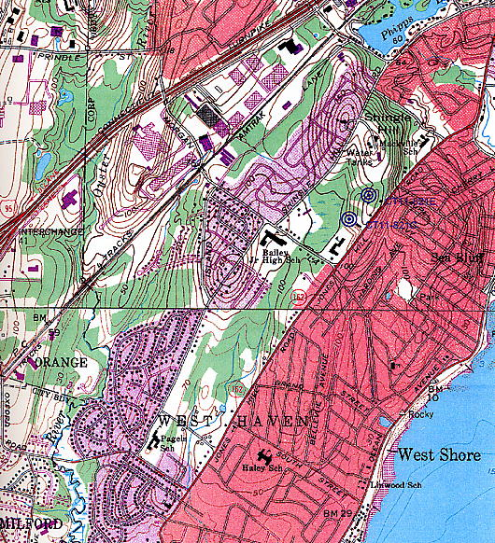
Alternate Site
Prime Site

(T-Mobile 1, Attachment 3)

FIGURE 2
T-MOBILE EXISTING COVERAGE

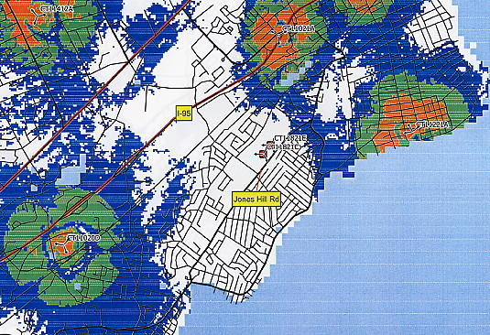
LEGEND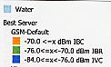

*Site CT14821C is the proposed Prime Site.
Site CT14821E is the proposed Alternate Site.

(T-Mobile 5)
FIGURE 3
T-MOBILE PROPOSED COVERAGE FROM PRIME SITE
AT 150 FEET

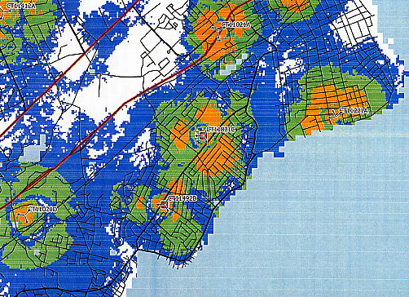
LEGEND

*Site CT14821C is the proposed Prime Site. Coverage from the Alternate Site is not significantly different.
Site CT11492B is a future proposed site.

(T-Mobile 5)
FIGURE 4
T-MOBILE PROPOSED COVERAGE FROM PRIME SITE
AT 130 FEET

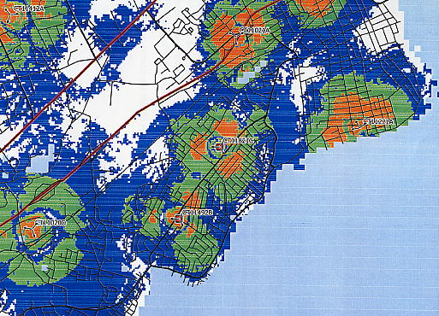
LEGEND

*Site CT14821C is the proposed Prime Site. Coverage from the Alternate Site is not significantly different.
Site CT11492B is a future proposed site.

(T-Mobile 5)

