DOCKET NO. 290 – AT&T Wireless PCS, LLC d/b/a AT&T Wireless application for a Certificate of Environmental Compatibility and Public Need for the construction, maintenance and operation of a wireless telecommunications facility at one of two locations on Durham Road (Route 79), Madison, Connecticut. | }  }  } | Connecticut  Siting  Council  August 26, 2004

Findings of Fact

Introduction

- AT&T Wireless PCS, LLC d/b/a AT&T Wireless, in accordance with provisions of General Statutes §§ 16-50g through 16-50aa, applied to the Connecticut Siting Council (Council) on March 29, 2004 for the construction, operation, and maintenance of a wireless telecommunications facility at 1749 Durham Road, referred to as Site A, or at the Elka Perez Trust property also on Durham Road, referred to as Site B. (AT&T Wireless 1, pp. 1-2)

2. The party in this proceeding is the applicant. An intervenor in this proceeding is Sprint Spectrum L. P. d/b/a Sprint PCS (Sprint). (Transcript 1- 3:00 p.m. [Tr. 1], p. 5)

3. The purpose of the proposed facility is to provide service to coverage gaps identified by AT&T Wireless and Sprint on Route 79 in the Rockland area of Madison. (AT&T Wireless 1, Attachment 3; Sprint 1, Q. 1)

- Pursuant to General Statutes § 16-50m, the Council, after giving due notice thereof, held a public hearing on June 29, 2004, beginning at 3:00 p.m. and continuing at 7:00 p.m. at the Madison Town Hall, 8 Campus Drive, Madison, Connecticut. (Council's Hearing Notice dated May 11, 2004; Tr. 1, p. 3; Transcript 2 – 7:00 p.m. [Tr. 2], p. 3)

- The Council and its staff conducted an inspection of the proposed sites on June 29, 2004, beginning at 2:00 p.m. During the field inspection, the applicant flew balloons at each site to simulate the heights of the proposed towers. (Council's Hearing Notice dated May 11, 2004)

- Notice of the application was provided to all abutting property owners by certified mail. All return mail receipts were received. Public notice of the application was published in The Source on March 25, 2004 and the Shoreline Times on March 24 and March 27, 2004. (AT&T Wireless 1, p. 4, Attachment 10; AT&T Wireless 2, Q. 1)

- AT&T Wireless notified the Town of Madison of the proposal on October 10, 2003 by sending a technical report to the First Selectman, Thomas Scarpati. AT&T Wireless met with the Planning and Zoning (P&Z) Commission on December 18, 2003 and January 15, 2004. AT&T Wireless slightly altered the location of each facility based on P&Z comments. The P&Z Commission endorsed the Site A location at a public hearing on February 19, 2004. (AT&T Wireless 1, pp. 19-20, Attachment 8; AT&T Wireless 2, Q. 9; Tr. 1, p. 9)

- The Town prefers a tower design that could accommodate an extension. (AT&T Wireless 1, Q. 9; Tr. 1, p. 9)

- The North Madison Volunteer Fire Department expressed an interest in placing whip antennas at the proposed site. Specific coverage needs and tower heights were not determined. The fire department may seek to place three whips up to 14 feet in length at the site. (Tr. 1, pp. 14-16)

- AT&T Wireless would provide space on the tower for the fire department and any other public safety entity for no compensation, provided such antennas are compatible with the structural integrity of the tower. (AT&T Wireless 1, p. 9; Tr. 1, p. 15)

- Pursuant to General Statutes § 16-50j (h), on May 11 and June 30, 2004, the following State agencies were solicited to submit written comments regarding the proposed facility; Department of Environmental Protection (DEP), Department of Public Health (DPH), Council on Environmental Quality (CEQ), Department of Public Utility Control (DPUC), Office of Policy and Management (OPM), Department of Economic and Community Development (DECD), and the Department of Transportation (DOT). (Record)

- Comments were received from the DOT’s Bureau of Engineering and Highway Operations on June 22, 2004 and the DEP on June 24, 2004. (Record)

- The following agencies did not respond with comments on the application: DPH, CEQ, DPUC, OPM, and the DECD. (Record)

Telecommunications Act

- In 1996, the United States Congress recognized a nationwide need for high quality wireless telecommunications services, including cellular telephone service. Through the Federal Telecommunications Act of 1996, Congress seeks to promote competition, encourage technical innovations, and foster lower prices for telecommunications services. (Council Administrative Notice Item No. 7, Telecom Act 1996)

- In issuing cellular licenses, the Federal government has preempted the determination of public need for cellular service by the states, and has established design standards to ensure technical integrity and nationwide compatibility among all systems. AT&T Wireless is licensed by the Federal Communications Commission (FCC) to provide personal wireless communication service (PCS) to New Haven County, Connecticut. (Council Administrative Notice Item No. 7, Telecom. Act 1996; AT&T Wireless 1, pp. 5-6)

- The Telecommunications Act of 1996 prohibits local and state entities from discriminating among providers of functionally equivalent services. (Council Administrative Notice Item No. 7, Telecom. Act 1996)

- The Telecommunications Act of 1996, a Federal law passed by the United States Congress, prohibits any state or local entity from regulating telecommunications towers on the basis of the environmental effects of radio frequency emissions to the extent that such towers and equipment comply with FCC’s regulations concerning such emissions. This Act also blocks the Council from prohibiting or acting with the effect of prohibiting the provision of personal wireless service. (Council Administrative Notice Item No. 7, Telecom. Act 1996)

Site Selection

18. Prior to selecting the proposed sites, AT&T Wireless investigated whether suitable structures were located within the search area. No suitable structures were identified. Two existing towers and two proposed structures are located within three miles of the proposed sites. AT&T Wireless is located on the two existing towers and intends to locate on the two proposed towers. The existing and proposed towers within three miles of the sites are as follows:
a) 864 Opening Hill Road, Madison – AT&T Wireless is located at 120 feet above ground level (agl).
b) 197 North Chestnut Hill Road, Killingworth – AT&T Wireless is located at 135 feet agl.
c) Durham Road – proposed tower on Town of Madison property (Rockland Preserve). AT&T Wireless intends to locate at the 140-foot level of this proposed site.
d) 370 Rockland Road, Guilford – Sprint tower approved in Docket 271. AT&T Wireless proposes to locate at the 140-foot level.
(AT&T Wireless 1, pp. 8-9; Attachment 9)

19. After determining there were no suitable structures within the search area, AT&T Wireless searched for properties suitable for tower development. AT&T Wireless investigated seven parcels/areas, two of which were selected for site development. The five rejected parcels/areas and reasons for their rejection are as follows:
- Hammonassett Fishing Association parcels – various parcels in vicinity of Route 79, would not provide adequate coverage to target service area.
- South Central Regional Water Authority property – no response from property owner. Class I and Class II watershed lands and passive recreation area.
- Route 79/Hathaway Lane – would not meet coverage objectives.
- Green Lots Road – would not meet coverage objectives.
- Parcels south of Hathaway Lane – dense residential area.
(AT&T Wireless 1, Attachment 4)

Site Description – Site A

20. Proposed Site A is located on a 32.8-acre parcel at 1749 Durham Road (Route 79) in Madison. The parcel, owned by Fred and Anita Ruge, contains an unoccupied residence. The parcel, west of Route 79, is zoned Rural Residence District (RU-1). The Site A location is depicted on Figure 1. (AT&T Wireless 1, Attachment 5; AT&T Wireless 2, Q. 3)

21. The tower site is located in the eastern portion of the property, at an elevation of 344 feet above mean sea level (amsl). The wooded site is dominated by oak, black birch, and hickory. (AT&T Wireless 1, p. 10, Attachment 5; DEP comments dated June 24, 2004)

23. The Site A facility would consist of a 120-foot monopole within a 100-foot by 80-foot leased area. The tower would be four feet wide at the base tapering to 1.5 feet at the top. The tower would be designed to support six levels of antennas with a 10-foot center-to-center vertical separation. The tower would be constructed in accordance with the American National Standards Institute TIA/EIA-222-F “Structural Standards for Steel Antenna Towers and Antenna Support Structures”. (AT&T Wireless 1, p. 10, Attachment 5)

24. AT&T Wireless would initially install three flush mounted antennas at a centerline height of 120 feet agl. AT&T Wireless may install up to 12 antennas on a platform as capacity demands increase. The total height of the facility with antennas would be 123 feet agl. (AT&T Wireless 1, p. 10 Attachment 5; AT&T Wireless 2, Q. 7)

25. A 60-foot by 75-foot equipment compound enclosed by an eight-foot high chain link fence would be established at the base of the tower. The size of the compound would be able to accommodate the equipment of six wireless carriers. AT&T Wireless would install equipment cabinets on a 12-foot by 24-foot concrete pad within the compound. (AT&T Wireless 1, p. 10, Attachment 5)

26. Access to Site A would be provided by a 12-foot wide, 275-foot long gravel drive of new construction extending from Route 79. From Route 79, the road would proceed in a westerly direction for 180 feet and then turn to the northwest to the compound. This route would shield visibility of the compound from Route 79. Underground utilities would be installed along the access road from Route 79. (AT&T Wireless 1, p. 10, Attachment 5)

27. The DEP recommends relocating the access road to the north of the abandoned residence on the property in order to improve sight lines on Route 79 and reduce the length of road required to access the site. A curve could be incorporated into the relocated access road to prevent an open view of the compound from Route 79. AT&T Wireless would be willing to relocate the access road provided the DOT approves a new curb cut along Route 79. (DEP comments dated June 24, 2004; Tr. 1, pp. 21-22)

28. The tower setback radius would be contained within the site parcel. (AT&T Wireless 1, Attachment 5)

29. There are three residential structures within 1,000 feet of the site, two of which are owned by the lessor. The nearest residence to the tower not owned by the lessor is approximately 720 feet to the south (Wilks residence). (AT&T Wireless 1, p. 14; Attachment 5)

30. Land use within a quarter mile of the site consists of residential, undeveloped woodlands, and protected watershed land. (AT&T Wireless 1, Attachment 5)

31. The estimated construction cost for the Site A facility is:

Electronic Equipment 70,000.
Tower and AT&T Wireless Antennas 142,100.
Site Development and Utilities 119,100.

Total $331,200.
(AT&T Wireless 1, p. 21)

Site Description – Site B

32. Proposed Site B is located in the central portion of an 18-acre parcel east of Route 79. The property, owned by the Elka Perez Trust, is identified in Town records as Map 154, Lot 6. The parcel is east and adjacent to Route 79. The Site B location is depicted on Figure 1. (AT&T Wireless 1, p. 12, Attachment 6)

33. The tower site is located in a wooded, level area between two rock outcrops, at an elevation of 332 feet amsl. Vegetation at the site consists of white oak, red oak, black birch, and bluebeech. (AT&T Wireless 1, Attachment 6; DEP comments dated June 24, 2004)

34. The Site B facility would consist of a 130-foot monopole within an 80-foot by 100-foot leased area. The tower would be designed to support six levels of antennas with a 10-foot center-to-center vertical separation. The tower would be four feet wide at the base tapering to 1.5 feet at the top and would be designed in accordance with the American National Standards Institute TIA/EIA-222-F “Structural Standards for Steel Antenna Towers and Antenna Support Structures. (AT&T Wireless 1, Attachment 6)

35. AT&T Wireless would initially install three flush mounted antennas at a centerline height of 130-feet above ground level (agl). The total height of the facility with antennas would be 133 feet agl. (AT&T Wireless 1, Attachment 6; AT&T Wireless 2, Q. 7)

36. A 60-foot by 75-foot equipment compound enclosed by an eight-foot high chain link fence would be established at the base of the tower. The size of the compound would be able to accommodate the equipment of six wireless carriers. AT&T Wireless would install equipment cabinets on a 12-foot by 24-foot concrete pad within the compound. (AT&T Wireless 1, p. 10, Attachment 6)

37. Access to Site B would be provided by a 12-foot wide, 225-foot long gravel drive of new construction extending from Route 79. The access drive is designed to prevent a view of the compound from Route 79 by proceeding in an easterly direction for 150 feet before turning to the north to the compound. Underground utilities would be installed along the access road from Route 79. (AT&T Wireless 1, Attachment 6; Attachment 8)

38. The tower setback radius would be contained within the site parcel. (AT&T Wireless 1, Attachment 6)

39. There are three residences within 1,000 feet of the site. The nearest occupied residence is 625 feet south of the tower site (Ruge residence). The Wilks residence is 815 feet south of the tower site. (AT&T Wireless 1, p. 14; Attachment 6)

40. Land use within a quarter mile of the site is residential, undeveloped woodland, and protected watershed land. (AT&T Wireless 1, Attachment 6)

41. The estimated construction cost for the Site B facility is:

Electronic Equipment 70,000.
Tower and AT&T Wireless Antennas 143,000.
Site Development and Utilities 119,100.

Total $332,100
(AT&T Wireless 1, p. 21)

Environmental Concerns

42. The proposed facilities would have no effect on archaeological resources listed on or eligible for the National Register of Historic Places or upon properties of traditional cultural importance to Connecticut’s Native American community. (AT&T Wireless Administrative Notice Item No. 1)

43. The proposed sites contain no known existing populations of Federal or State Endangered, Threatened or Special Concern Species. (AT&T Wireless 1, p. 15)

44. Approximately 12 trees with a diameter of six inches or greater at breast height would be removed for development of Site A. Approximately 23 trees with a diameter of six inches or greater at breast height would be removed to develop Site B. (AT&T Wireless 2, Q. 5)

45. Development of either site would not directly affect any wetlands or watercourses. The nearest wetland to the Site A development area is approximately 170 feet southwest of the proposed access road. The nearest wetland to the Site B development area is approximately 35 feet east of the lease area, the limit of site clearing. Site B clearing and grading activities would occur within a Town designated 50-foot wetland buffer zone. (AT&T Wireless 1, p. 18, Attachment 5, Attachment 6)

46. Aircraft hazard obstruction marking or lighting of either tower would not be required. (AT&T Wireless 1, p. 20, Attachment 5, Attachment 6)

47. The conservative worst-case approximation of electromagnetic radiofrequency power density, expressed as a percent Maximum Permissible Exposure limit established by the FCC, would be 7.5 % at Site A and 6.4% at Site B. (AT&T Wireless 1, p. 15)

Visibility

48. Both sites would be visible year-round from less than two acres within a two-mile radius of each site (refer to Figure 1). Seasonal visibility of both sites would be limited to less than six acres with a two-mile radius of each site (refer to Figure 1). (AT&T Wireless 2, Q. 3)

49. Visibility of both sites would be limited to the immediate area surrounding each site including a 0.2-mile section of Route 79. In addition to the immediate surrounding area, Site A would be visible from a 0.1-mile section of Route 79 approximately a half-mile south of the site. Neither tower would be visible from any other road with a two-mile radius of the sites. (AT&T Wireless 2, Q. 3, Q. 4; Tr. 1, p. 35)

50. Neither tower would be visible from the Wilks property. (Tr. 1, pp. 17-18)

51. Neither tower would be visible from the Genesee Recreation area, a permit use area owned by the South Central Regional Water Authority, approximately 0.4 miles northeast of the sites. (Tr. 1, pp. 24-26)

52. The Mattabessett Trail, a blue blazed public use hiking trail maintained by the Connecticut Forest and Park Association, is approximately 2.5 miles west of the sites. The proposed towers may be visible from the Bluff Head overlook portion of the trail approximately 4.5 miles west of the sites. (Tr. 2, pp. 4-5)

AT&T - Existing and Proposed Wireless Coverage

53. AT&T Wireless predicts a 2.5-mile gap in coverage on Route 79 between an existing facility at the North Madison Volunteer Fire Department (Site CT-666) and a site proposed at the Rockland Preserve (CT-847). Coverage from surrounding sites is depicted on Figure 2. (AT&T Wireless 1, Attachment 3)

54. AT&T Wireless is proposing to install antennas at a centerline height of 120 feet at Site A and a centerline height of 130 feet at Site B. Both sites as proposed would provide adequate coverage to Route 79 between site CT-666 and site CT-847 (refer to Figures 3 & 4). (AT&T Wireless 1, Attachment 3; Tr. 1, pp. 39-40)

55. The coverage models depict an area of signal weakness between the proposed sites and the site to the south, CT-666. Drive test data indicates however, there would be sufficient handoff between the proposed sites and site CT-666. (AT&T Wireless 1, Attachment 3; Tr. 1, pp. 39-40)

Sprint - Existing and Proposed Wireless Coverage

55. Sprint operates in the 1950 - 1965 MHz frequency bands and at a signal level service design of -94 dBm for this area. (Sprint 1, Q. 1, Q. 2)

56. Sprint has an existing facility at the North Madison Volunteer Fire Department that provides coverage to Route 79 in the vicinity of Route 80 (refer to Figure 5). Sprint has no service on Route 79 north of this site. The proposed AT&T facility would provide an additional 2.5 miles of service to Route 79. (Sprint 1, Q. 4, Q. 5)

57. Sprint has not committed to a specific antenna height at the proposed sites although coverage modeling indicates a minimum antenna height of 140 feet at either site would be required to provide sufficient coverage. Sprint would perform drive testing to confirm the coverage models before committing to a specific height. (Sprint 1, Q. 3; Tr. 1, pp. 46-47)

58. If Sprint needs an antenna height above the tower heights proposed in this application, Sprint would seek to modify the proposed tower by filing a petition for a declaratory ruling that no Certificate of Environmental Compatibility and Public Need would be required for the proposed modification. (Sprint 1, Q. 3)

59. As part of Sprint’s coverage objectives for the Route 79 corridor, Sprint intends to install a facility at the Rockland Preserve to provide continuous coverage north of the proposed sites. (Tr. 1, pp. 55-57)

FIGURE 1
LOCATION AND VISIBILITY OF PROPOSED SITES

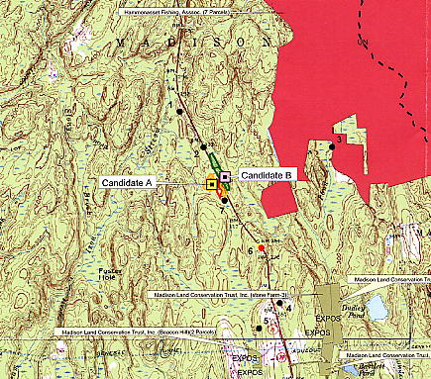
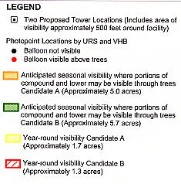
1” = 2000’

FIGURE 2
AT&T WIRELESS EXISTING COVERAGE

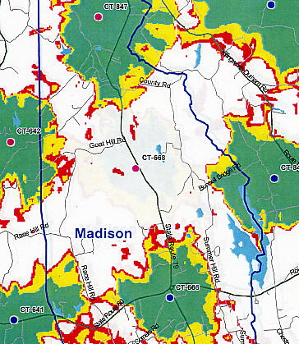

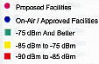

FIGURE 3
AT&T WIRELESS – EXISTING AND PROPOSED COVERAGE
FROM SITE A AT 120 FEET

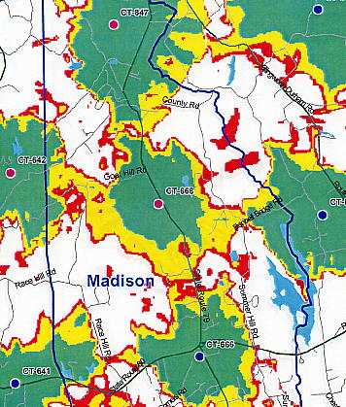

FIGURE 4
AT&T EXISTING AND PROPOSED COVERAGE
FROM SITE B AT 130 FEET

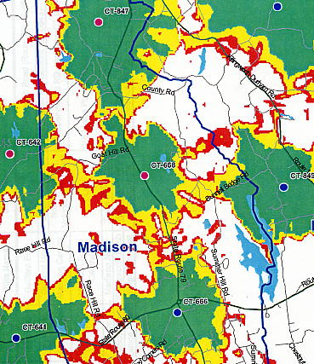

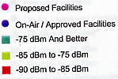

FIGURE 5
SPRINT EXISTING COVERAGE

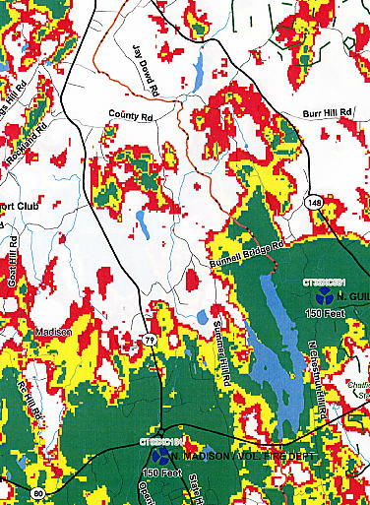

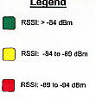

FIGURE 6
SPRINT EXISTING AND PROPOSED COVERAGE
FROM SITE A AT 140 FEET

