DOCKET NO. 284 – AT&T Wireless PCS, LLC d/b/a AT&T Wireless application for a Certificate of Environmental Compatibility and Public need for the construction, maintenance and operation of a wireless telecommunications facility at 259 Redding Road or 22 Wayside Lane in Redding, Connecticut. | }  }  }  } | Connecticut  Siting  Council  October 7, 2004

Findings of Fact
Introduction

- AT&T Wireless PCS, LLC d/b/a AT&T Wireless, in accordance with provisions of General Statutes §§ 16-50g through 16-50aa, applied to the Connecticut Siting Council (Council) on January 16, 2004, for the construction, operation, and maintenance of a wireless telecommunications facility in Redding, Connecticut. The proposed facility would provide wireless coverage to southeast Redding in the area surrounding Route 107 (Redding Road). Proposed Site A is located at 259 Redding Road and proposed Site B is located at 22 Wayside Lane in Redding, Connecticut. (AT&T 1, p. 1, 2)

- AT&T Wireless is a limited liability company, licensed by the Federal Communications Commission (FCC) to provide wireless personal communication service (PCS). (AT&T 1, p. 3)

- The parties in this proceeding are the applicant, Fred S. and Susan J. Baker, Lee Shull, the Town of Redding, William F. King and Jose Pereyra. The intervenor is Representative Hank Bielawa. (Transcript (Tr.) 1, 3:00 p.m., May 5, 2004, p. 5-7; Tr. 2, 7:00 p.m., May 5, 2004, p. 5-6)

- Pursuant to General Statutes § 16-50m, the Council, after giving due notice thereof, held a public hearing on May 5, 2004, beginning at 3:00 p.m., and continuing at 7:00 p.m. at the Redding Community Center, 37 Lonetown Road, Redding, Connecticut. The public hearing was continued at 10:30 a.m. on June 30, 2004 at the offices of the Connecticut Siting Council, Ten Franklin Square, New Britain, Connecticut. (Tr. 1, p. 3; Tr. 2, p. 3; Tr. 3, 10:30 a.m., June 30, 2004, p. 3)

- The Council and its staff made inspections of the proposed sites on May 5, 2004. During the field inspection, the applicant flew a blue balloon at proposed Site A and a red balloon at proposed Site B from 12:00 p.m. to 7:00 p.m. to simulate the height of the towers proposed at both locations. (Tr. 2, p. 50)

- On April 23, 2004, AT&T Wireless flew balloons at proposed Site A and Site B for the benefit of the Town of Redding. The balloons were flown and monitored from 10:30 a.m. to 7:00 p.m. and left at the sites unmonitored for the remainder of the weekend. (Tr. 2, p. 50)

- On September 30, 2002, AT&T Wireless filed a letter and technical report to the First Selectman of the Town of Redding regarding the construction of a facility at the proposed sites. The Town of Redding requested that AT&T Wireless investigate nine potential alternative sites for the proposed facility. AT&T Wireless investigated all of the potential sites at a height of 198 feet above ground level (agl) and determined that one of the sites would provide adequate coverage; however, the property owner declined to negotiate use of the property. (AT&T 1, p. 20; Tab 8)

- On February 12, 2003, the Town Zoning Commission held a public meeting at which the Zoning Commission expressed a preference for proposed Site A. (AT&T 1, p. 20, 21; Tab 8)

- On January 16, 2004, the application for the proposed project was sent to the Town of Redding officials, State and federal agencies. Public notice of the application was published in the Danbury News-Times, and The Hour (Norwalk) on January 13 and January 14, 2004, and in the Redding Pilot on January 15, 2004. Adjacent property owners were sent notification, certified mail, return receipt requested, that AT&T Wireless would file an application to the Council for a telecommunications facility at the proposed sites. Notice was unclaimed by three adjacent property owners and refused by one adjacent property owner. AT&T Wireless provided an additional notice to these property owners via first class mail. (AT&T 1, p. 4, 5; AT&T 2, Q. 1, 2)

- Pursuant to General Statutes § 16-50j (h), the following State agencies were notified of the project on March 2, 2004: Department of Environmental Protection (DEP), Department of Public Health (DPH), Council on Environmental Quality (CEQ), Department of Public Utility Control (DPUC), Office of Policy and Management (OPM), Department of Economic and Community Development (DECD), and the Department of Transportation (DOT). (record)

- The following agencies did not provide responses regarding the application; DEP, CEQ, DPUC, OPM, and the DECD. (record)

- Comments were received from the DOT on April 26, 2004 and from the DPH on April 27, 2004. (record)

Telecommunications Act

- In issuing cellular licenses, the federal government has preempted the determination of public need for cellular service by the states, and has established design standards to ensure technical integrity and nationwide compatibility among all systems. (Council Admin. Notice, no. 7, Telecom. Act 1996)

- In 1996, the United States Congress recognized a nationwide need for high quality wireless telecommunications services, including cellular telephone service. Through the Federal Telecommunications Act of 1996, Congress seeks to promote competition, encourage technical innovations, and foster lower prices for telecommunications services. (Council Admin. Notice, no. 7, Telecom Act 1996)

- The Telecommunications Act of 1996 prohibits local and State entities from discriminating among providers of functionally equivalent services. (Council Admin. Notice, no. 7, Telecom. Act 1996)

- The Telecommunications Act of 1996, a federal law passed by the United States Congress, prohibits any State or local entity from regulating telecommunications towers on the basis of the environmental effects of radio frequency emissions to the extent that such towers and equipment comply with Federal Communications Commission’s (FCC) regulations concerning such emissions. This Act also blocks the Council from prohibiting or acting with the effect of prohibiting the provision of personal wireless service. (Council Admin. Notice, no. 7, Telecom. Act 1996)

Site Search

- AT&T Wireless identified four existing towers within approximately two miles of the site search area; a 180-foot tower owned by Spectrasite, Inc, located 111 Old Redding Road, Redding; a 95-foot tower owned by the Georgetown Volunteer Fire Department located at 6 Portland Avenue, Georgetown; a 90-foot tower owned by T-Mobile Wireless located at 922 Route 7; a 95-foot tower owned by the Redding Police Department located on Route 107. AT&T Wireless is currently located on two of these towers, at 111 Old Redding Road and at 922 Route 7. The two remaining towers, located at 6 Portland Avenue and at the Redding Police Department on Route 107, would not provide adequate coverage to the area. (AT&T 1, p. 8, 9, Tab 4)

- AT&T Wireless identified and investigated ten potential properties, including the proposed Site A and Site B properties. The potential sites investigated and rejected by AT&T Wireless because they would not provide adequate coverage to the area include the Georgetown Fire Department, 96 Hill Road, Northeast Utilities Transmission Towers located throughout western Redding, Glen Hill Road, and Dayton Road. (AT&T 1, p. 8, 9; Tab 4)

- Two property owners on Apple Lane were not interested in leasing their property for the proposed facility. Redding Land Trust, Inc. properties were not pursued because they are reserved for open space and conservation. Land owned by Bridgeport Hydraulic Company (BHC) was rejected because it is designated as Class I Watershed, on which development is prohibited under State law. (AT&T 1, p. 8, 9; Tab 4)

- The Town of Redding suggested nine potential alternatives to the proposed sites that were investigated by AT&T Wireless. After analysis, AT&T Wireless rejected eight of the nine Town suggested sites because towers located at the potential sites would not provide adequate coverage to the area. Sites that would not provide adequate coverage to the area include: the Town Police Station, Mark Twain Library, Meadow Ridge Assisted Living Facility (Meadow Ridge), 55 Dorothy Road, Belholm and Fairview Roads, 32 Belholm Road, 23 Dayton Road, 331 Redding Road, and 65/67 Umpawaug Road. (AT&T 1, p. 19, 20; Tab 8)

- A site located at 325 Redding Road would provide adequate coverage to the area but the property owner was not interested in leasing a site on this property for the proposed facility. (AT&T 1, p. 20, Tab 8)

- At the request of the Town of Redding, AT&T Wireless further explored two locations on the Meadow Ridge property for the potential use as proposed sites. AT&T Wireless provided a coverage map using the rooftop of the Meadow Ridge building, at a centerline of 55 feet agl. AT&T Wireless also provided a coverage map using the Meadow Ridge property for a tower with a centerline of 198 feet agl. The two locations analyzed on the Meadow Ridge property would not provide adequate coverage to Route 107. The ground elevation at the Meadow Ridge building is approximately 580 feet above mean sea level (amsl). The location used to plot the 198-foot tower on the Meadow Ridge property was south of the building at an elevation of approximately 540 feet amsl. (AT&T 1, Tab 8; AT&T 4, Tab 8; Tr. 3, p. 59, 80)

Site and Equipment

- AT&T Wireless proposes to construct a 100-foot monopole at Site A, which would be designed to accommodate two additional carriers with a 10-foot center-to-center vertical separation. The total height at the top of the antennas would be 103 feet agl. (AT&T 1, p. 10, Tab 5; AT&T 2, Q. 3)

- Proposed Site A would include a 70-foot by 70-foot leased parcel on which AT&T Wireless would develop a 40-foot by 40-foot equipment compound. The proposed tower and equipment compound would be enclosed by an 8-foot high chain link fence. A gravel surface would be established within the tower compound and access road. AT&T Wireless would use a battery back up, which would operate for approximately eight hours, during power outages. During a substantial power outage, AT&T Wireless would temporarily use a portable diesel generator. (AT&T 1, p. 10, 11, Tab 5; AT&T 2, Q. 16)

- AT&T Wireless proposes to construct a 120-foot flagpole at proposed Site B, which would be designed to accommodate one or two additional carriers within the pole. AT&T Wireless would install six panel antennas inside the top sections of the pole at the 117-foot level and 109-foot level. Space would be available at the 99-foot level and 89-foot level. (AT&T 1, p. 12, Tab 6; AT&T 2, Q. 4)

- Proposed Site B would include a 70-foot by 70-foot leased parcel on which AT&T Wireless would develop a 50-foot by 50-foot equipment compound. The proposed tower and equipment compound would be enclosed by an 8-foot high chain link fence. A gravel surface would be established within the tower compound and access road. (AT&T 1, p. 11, 12, Tab 6)

- A flagpole, as proposed at Site B, would have antennas mounted internally and, because of space limitations, would require two mounting heights to accommodate transmit and receive antennas. In some cases, a taller flagpole may be necessary to provide the same amount of coverage as a shorter monopole. The flagpole would be painted white; however AT&T Wireless would be willing to paint the pole brown to reduce the visibility. (AT&T 2, Q. 6; Tr. 2, p. 64)

- No additional carriers have expressed an interest in using the proposed structure at Site A or Site B, to date. AT&T Wireless would make space available to the Town of Redding at no cost provided it was structurally and technically feasible. (AT&T 2, Q. 8, 9; Tr. 63)

- The tower setback radius of the proposed Site A tower would extend onto adjacent properties to the north (owned by Daniel M. and Paula Elaine Johnson) and east (owned by Brian and Wendy W. Aldershof). There is a storage building on the lessor’s property that is located 85 feet from the proposed Site A compound and is within the tower setback radius. (AT&T 1, p. 13, Tab 5)

- The tower setback radius of the proposed Site B would extend onto adjacent properties to the southwest (owned by Redding Land Trust, Inc.) and southeast (owned by Hilliard H. Pearlstein and Lee Shull). (AT&T 1, p. 13, Tab 6)

- The proposed Site A or Site B structure could be relocated so that the tower setback radius would not extend onto adjacent properties or with a yield point so that it would collapse upon itself. (Tr. 1, p. 40, 41)

- The approximate costs of construction for proposed Site A and Site B are estimated as follows:

 | Site A | Site B
Electronic Equipment | $ 70,000 | $ 70,000
Tower & Antenna | 138,900 | 140,500
Site Development | 83,800 | 76,200
Total Costs | $ 292,700 | $ 286,700
(AT&T 1, p. 22)

Proposed Site A/ Site B

- Proposed Site A would be located on an approximately two-acre parcel owned by William C. and Sigrid H. Wilson. The elevation of Site A is 570 feet amsl. Land uses surrounding proposed Site A include single family residences and dedicated open space. The average estimated tree height is 60 to 80 feet agl. (AT&T 1, p. 10, Tab 5)

- Proposed Site B would be located on an approximately five-acre parcel owned by Edward D. and Nancy Enright. The elevation of Site B is 578 feet amsl. Land uses surrounding proposed Site B include single family residences and dedicated open space. The average estimated tree height is 60 to 80 feet agl. (AT&T 1, p. 11, Tab 6)

- The proposed sites are located on properties that are zoned Residential (R-2). The Town of Redding’s Zoning Regulations express locating personal wireless telecommunications facilities within Service Business, Business Center and Office and Research Park zones is the most desirable option and locating personal wireless telecommunications facilities on private property within 500 feet of an existing dwelling is one of the least desirable options. There are no commercially zoned parcels within the site search area. (AT&T 1, p. 17)

- There are 24 residences within a 1,000-foot radius of proposed Site A, the nearest of which is approximately 205 feet to the west and owned by Fredrick and Susan Baker. The lessor’s residence is approximately 275 feet away from proposed Site A. (AT&T 1, p. 13, 18, Tab 5; AT&T 2, Q. 11; Tr. 1, p. 17, 18, 38)

- There are 12 residences within a 1,000-foot radius of proposed Site B, the nearest of which is the owner’s home located approximately 375 feet to the north. The next nearest residence to proposed Site B is located approximately 480 feet to the northwest and owned by William S. King and Jose F. Pereyra. (AT&T 1, p. 13, 18, Tab 6; AT&T 2, Q. 11)

- Access to proposed Site A would extend from Redding Road, along an existing paved driveway for approximately 280 feet, and then a new gravel access drive would continue for approximately 90 feet to the proposed Site A compound. Telephone and electrical utilities would be installed underground from Redding Road along the access road to the proposed compound at Site A. (AT&T 1, p. 10, Tab 5)

- Access to proposed Site B would extend from Wayside Lane along an existing driveway for approximately 600 feet, and then a new gravel access drive would continue approximately 120 feet to the proposed Site B compound. The existing access easement to 22 Wayside Lane is a right-of-way that crosses the property at 26 Wayside Lane. Telephone and electrical utilities would be upgraded above ground from Wayside Lane, along the existing portion of the access road, and installed underground along the proposed access road to the Site B compound. (AT&T 1, p. 11, Tab 6; Tr. 1, p. 111)

Environmental Considerations

- The Eastern box turtle was identified as potentially existing near proposed Site A. The Eastern box turtle is a species of State Special Concern. A herpetological survey was performed which did not identify any Eastern box turtles on the property and concluded that the property does not likely support turtle populations. The DEP recommended that all construction activities take place during the period from November 1 to April 1, which is the dormant period for the Eastern box turtle. There were no known populations of federal or State Endangered, Threatened or Special Concern Species at proposed Site B. (AT&T 1, p. 14)

- There are no wetlands or watercourses located near proposed Site A. The nearest wetlands to proposed Site B are approximately 142 feet from the proposed equipment compound and are located along the existing driveway to the property. Construction of the proposed compound and access road would not take place within these wetlands. A silt fence would be installed around the construction area in accordance with the 2002 Connecticut Guidelines for Soil Erosion and Sediment Control prior to the construction of the proposed sites. (AT&T 2, Q. 12, 13)

- The nearest hiking trails to the proposed sites are on properties including: Stormfield, which is approximately one mile northeast of proposed Site A and approximately ½ mile northeast of proposed Site B; Peter & Nell Fitzpatrick Preserve, which is approximately ¾ mile north-northeast of proposed Site A and approximately ¼ mile north of proposed Site B; Arthur F. Brinkerhoff Nature Preserve, which is approximately 1 ¼ miles south of proposed Site A and approximately one mile northwest of proposed Site B; and the Rock Lot & the Mary Evelyn Scott Nature Preserve, which is approximately one mile northwest of proposed Site A and one mile west-northwest of proposed Site B. (AT&T 2, Q. 24)

- Two parcels of open space, owned by the Redding Land Trust, are immediately adjacent to proposed Site B to the north and south. (Tr. 1, p. 15)

- The State Historic Preservation Office (SHPO) has determined that construction of the proposed sites would have no effect on historic, architectural, or archaeological resources listed on or eligible for the National Register of Historic Places. (AT&T 1, p. 14, Tab 7)

- Clearing of approximately six trees with six inches or greater diameter at breast height (dbh) at proposed Site A and 15 trees with six inches or greater dbh at proposed Site B would be required for the construction of the proposed access roads and compounds. (AT&T 2, Q. 10)

- AT&T Wireless used the FCC’s TOWAIR program to determine if proposed Site A or Site B would require registration with the Federal Aviation Administration (FAA). The analysis concluded that neither of the proposed towers would have to be registered with the FAA. (AT&T 1, p. 21)

- The electromagnetic radio frequency power densities, calculated using the FCC Office of Engineering and Technology Bulletin 65, using conservative worst-case approximation of radio frequency power density levels at the base of each tower assuming all antennas are pointed at the base of the tower and all chanels are operating simultaneously, would be 10.8 percent of the American National Standards Institute (ANSI) Standard for proposed Site A and 9.1 percent for proposed Site B. (AT&T 1, p. 15; AT&T 2, Q. 7)

- AT&T Wireless is willing to install flush mounted antennas or T-bars on the proposed Site A structure. Proposed Site A could also be constructed as a silhouette pole or as a tree tower. Proposed Site B is currently proposed as a stealth silhouette pole. (AT&T 2, Q. 14; 15)

Visibility

- A viewshed analysis, shown in Figure 1, was conducted for the proposed sites within a two mile radius, or 8,042 acre, study area. Proposed Site A would be visible from eight acres of the study area year round and an additional ten acres would have seasonal visibility. Proposed Site B would be visible from ten acres of the study area year round and an additional ten acres would have seasonal visibility. (AT&T 3, Q. 21; Tr. 2, p. 51-53)

- Proposed Site A would primarily be visible from areas within 600 feet of the proposed site, including Apple Lane and Redding Road; and would be seasonally visible from portions of Redding Road, Dayton Road and Wayside Lane. Proposed Site B would be visible from portions of Redding Road and seasonally visible from portions of Wayside Lane and Redding Road. Proposed Site A would be visible from approximately eight residences. Proposed Site B would be visible from approximately six residences. (AT&T 3, Q. 21)

- The Haley’s Comet Trail, which is within the Stormfield property, may potentially have a view of the proposed structures. The proposed towers would not be visible from any locations on the top of Topstone Mountain to the northeast of the proposed sites. (Tr. 2, p. 53, 54)

- Public hiking trails located at the Peter & Nell Fitzpatrick Preserve, Arthur F. Brinkerhoff Nature Preserve, Windy Hill, and the Rock Lot & The Mary Evelyn Scott Nature Preserve cross through forested areas with a limited number of prominent vistas that may be impacted by the construction of the proposed towers. (AT&T 3, Q. 21)

- The visibility of proposed tower at Site A from various locations in the area, according to photographic documentation, would be as follows:

Visibility of Proposed 100-foot Tower

Location | Visible | Approx. Portion of Tower Visible (ft.) | Approx. Distance (ft.) and Direction to Tower
Redding Road (at driveway for #259) | Yes | 35 | 400 N
Apple Lane (adjacent to #30 and #31) | Yes | 65 | 550 E
Intersection of Apple Lane and Redding Road | Yes | Through Trees | 1,050 NE
Dayton Road (adjacent to #8) | Yes | Through Trees | 1,425 W
Intersection of 7Wayside Lane and Redding Road | Yes | Through Trees | 740 W
Umpawaug Road (crest of Umpawaug Hill) | No |  | 9,400 S
(AT&T 3, Q. 21)

- The visibility of proposed tower at Site B from various locations in the area, according to photographic documentation, would be as follows:

Visibility of Proposed 120-foot Tower

Location | Visible | Approx. Portion of Tower Visible (ft.) | Approx. Distance (ft.) and Direction to Tower
Adjacent to 22 Wayside Lane | Yes | 25 | 350 S
Redding Road (adjacent to #303) | Yes | 20 | 1,425 W
Redding Road (adjacent to #285 and #295) | Yes | 60 | 1,215 NW
Wayside Lane (north of Redding Road) | Yes | 45 | 1,215 N
Umpawaug Road (crest of Umpawaug Hill) | No |  | 8,500 S
(AT&T 3, Q. 21)

- Proposed Site B has less views from residential receptors, overall, than proposed Site A. (Tr. 3, p. 71)

Site Relocation Options

- AT&T Wireless investigated relocation of the proposed facilities within the properties to minimize visual impacts of the proposed towers on the surrounding residential areas. Movement of the proposed Site A facility approximately 40 feet to the southwest would enable the tower setback radius to remain within the lessor’s property without resulting in a decrease of elevation. This movement would result in the location of the proposed tower closer to Apple Lane and the Baker residence and would not significantly change the visual impact from the residences. The nearest residence would be the Baker residence, which is approximately 178 feet to the west of the relocated site. (AT&T 4, Tab 3, Tab 5, Tab 6; Tr. 3, p. 62)

- Movement of the proposed Site A facility approximately 50 feet to the southeast would result in a 10-foot decrease in elevation, requiring a 110-foot tower to maintain the antenna height. This movement would not result in a significant change in visibility from Apple Lane and would move the tower closer to two residences along Wayside Lane, increasing visibility from those properties. The nearest residence would be the Baker residence, which is approximately 223 feet to the west of the relocated site. (AT&T 4, Tab 3, Tab 5; Tr. 3, p. 62)

- Shifting the proposed Site B facility approximately 50 feet to the north, on the edge of a row of evergreens, would maintain the elevation and enable the tower setback radius to remain within the lessor’s property. This shift, along with the addition of planting evergreens around the fenced compound would screen the compound and lower portion of the pole from the two adjacent residences. Due to a shorter access road and reconfiguration of the compound, the proposed relocation of Site B would allow several deciduous trees to remain that would have been removed for construction of the original proposed site. The pole and foundation would be located outside of the fenced compound. The nearest residence would be that of the property owner, which is located 277 feet to the northeast of the relocated site. The residence of William S. King and Jose F. Pereyra is located approximately 475 feet to the west. The residence of Hilliard H. Pearlstein and Lee Shull is located approximately 531 feet to the southeast. (AT&T 4, Tab 4, Tab 5, Tr. 3, p. 12, 13, 63, 75)

- A brown silhouette tower at the relocated Site B would be less visible from the residence to the southeast than a stealth tree or flagpole. (Tr. 3, p. 69)

Coverage Needs

AT&T Wireless

- Existing facilities in Redding, Weston (to the south), Wilton (to the southwest), and Ridgefield (to the west) leave gaps in wireless coverage in southwestern Redding. Gaps are defined as areas receiving less than –85 dBm coverage. The minimum signal level threshold for AT&T is –85 dBm, which is designed to provide in-vehicle coverage and, to a lesser extent, coverage within structures. The primary purpose of this application is to provide coverage to Route 107 and local roads within the Town of Redding. The existing coverage gap along Route 107 within a two mile radius of the proposed sites is approximately 2.7 miles, shown in Figure 2. (AT&T 1, p. 1, Tab 3; AT&T 2, Q. 17)

- Existing coverage combined with coverage from the proposed 100-foot Site A tower at 1900 MHz would leave an approximately 1.4 mile cumulative gap in coverage along Route 107 within a two mile radius of the proposed site, shown in Figure 3. Existing coverage combined with coverage from the proposed 120-foot silhouette tower at 1900 MHz would leave an approximately 1.3 mile cumulative gap in coverage along Route 107 within a two mile radius of the proposed site, shown in Figure 4. (AT&T 2, Q. 17, 18, 19)

- AT&T Wireless does not expect that an additional facility would be needed to provide adequate coverage along Route 107. (Tr. 2, p. 58)

- The relocation of the proposed Site A or Site B facilities, on their respective parcels, would not change the coverage provided to the area. (Tr. 3, p. 60)

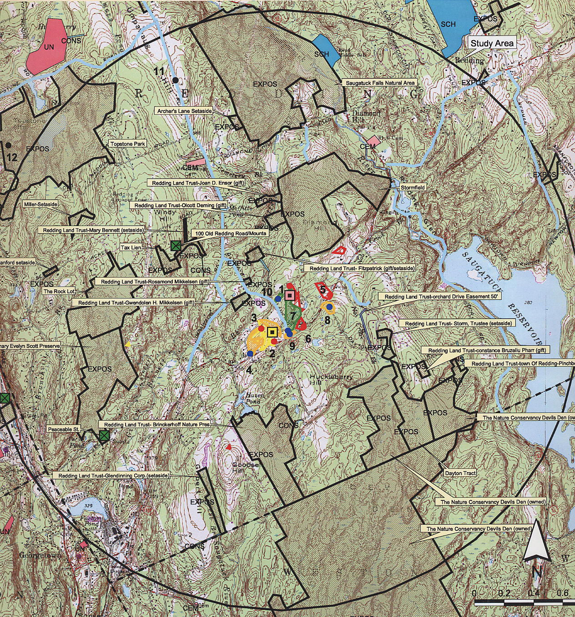

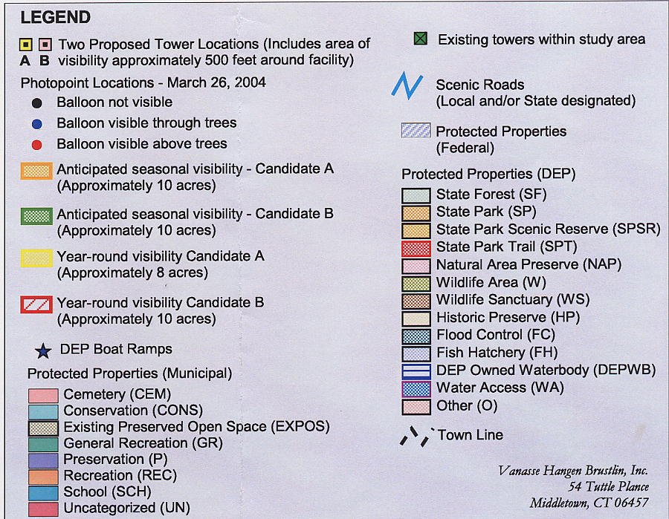

Figure 1. Viewshed Analysis of proposed Site A and Site B. (AT&T 3, Q. 21)

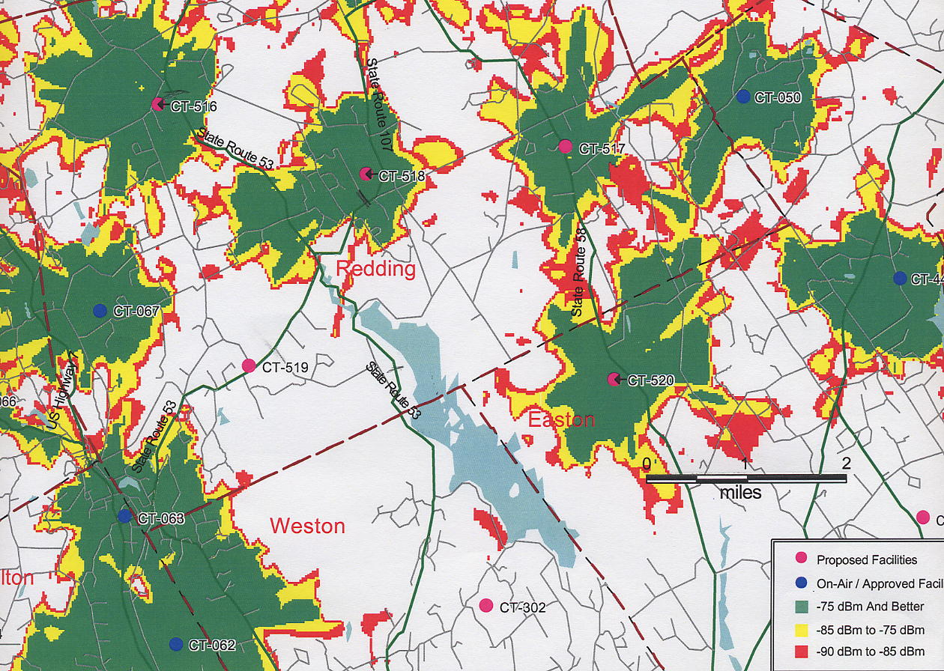

Figure 2. Existing AT&T Wireless coverage in the Town of Redding and surrounding area. (AT&T 2, Q.
17)

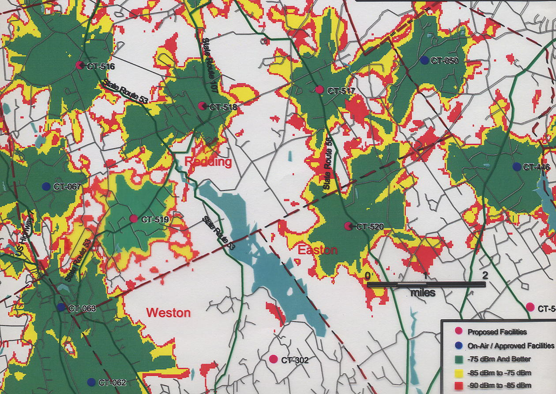

Figure 3. Existing coverage with coverage from proposed Site A at 100 feet agl. (AT&T 2, Q. 17, 18)

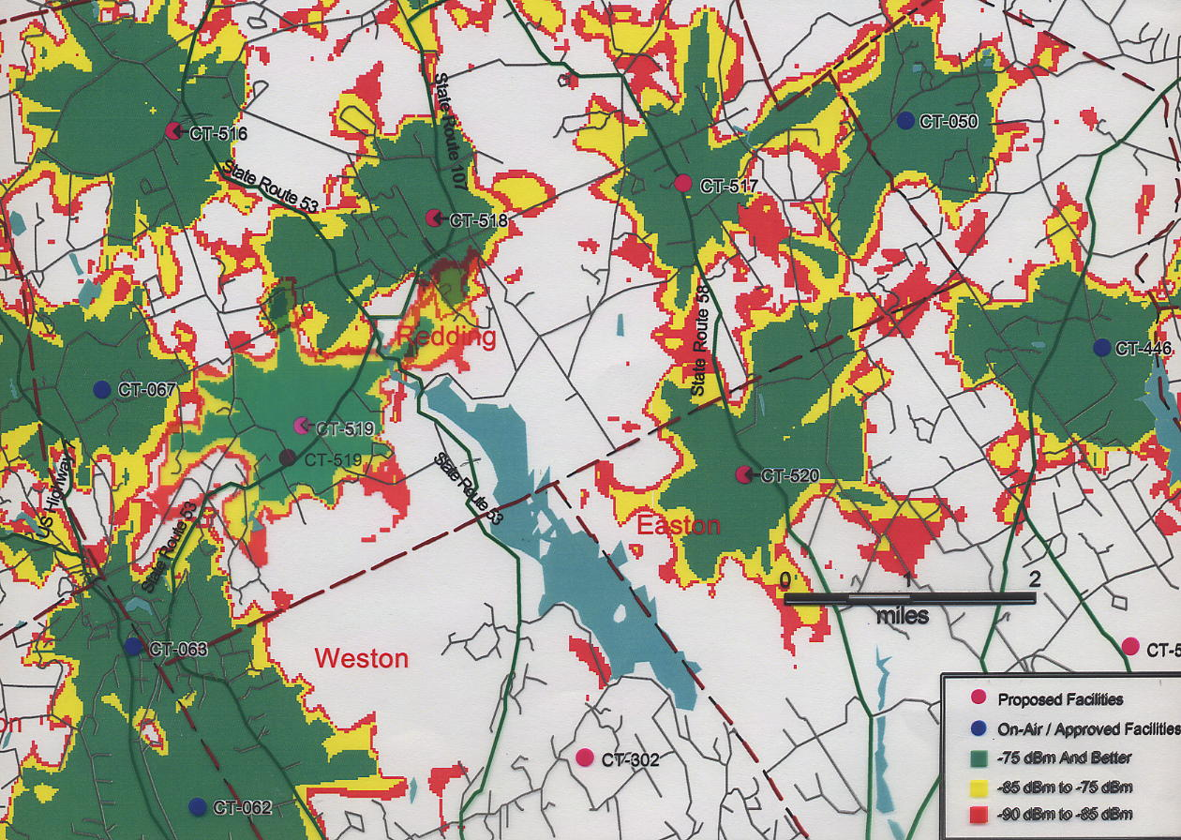

Figure 4. Existing coverage with coverage from proposed Site B at 120 feet agl. (AT&T 2, Q. 17, 19)

