DOCKET NO. 283 – AT&T Wireless PCS, LLC d/b/a AT&T Wireless application for a Certificate of Environmental Compatibility and Public need for the construction, maintenance and operation of a wireless telecommunications facility at one of two locations at 25 Klocek Road or at 280 Ross Road in Killingly, Connecticut. | }  }  }  } | Connecticut  Siting  Council  June 23, 2004

Findings of Fact
Introduction

- AT&T Wireless PCS, LLC d/b/a AT&T Wireless, in accordance with provisions of General Statutes §§ 16-50g through 16-50aa, applied to the Connecticut Siting Council (Council) on January 6, 2004, for the construction, operation, and maintenance of a wireless telecommunications facility in Killingly, Connecticut. The proposed facility would provide wireless coverage to existing gaps along Interstate 695 (I-695) and adjacent areas. Proposed Site A (shown in Figure 1) and Site B (shown in Figure 2) are located at 25 Klocek Road, Killingly and proposed Site C (shown in Figure 3) is located at 280 Ross Road, Killingly, Connecticut. (AT&T 1, p. 1, 2)

- AT&T Wireless is a Delaware limited liability company that is licensed by the Federal Communications Commission (FCC) to operate a personal wireless services system (PCS). (AT&T 1, p. 3)

- The party in this proceeding is the applicant. (Tr. 1, 3:00 p.m., p. 4; Tr. 2, 7:00 p.m., p. 4)

- Pursuant to General Statutes § 16-50m, the Council, after giving due notice thereof, held a public hearing on April 29, 2004, beginning at 3:00 p.m., and continuing at 7:00 p.m. at the Town Meeting Room, 172 Main Street, Danielson, Connecticut. (Tr. 1, p. 2; Tr. 2, p. 2)

- The Council and its staff made inspections of the proposed sites on April 29, 2004. During the field inspection, the applicant flew balloons at proposed Site A and proposed Site B at 150 feet above ground level (agl) to simulate the height of the proposed towers. A balloon was flown at 120 feet AGL at proposed Site C to simulate the height of the proposed tower. Windy conditions during the field review prevented the balloons from flying at a constant height. (Tr. 1, p. 39)

- On January 31, 2003, AT&T Wireless filed a letter and technical report to Marc A. Skocypec, the Town Manager of the Town of Killingly and to David C. Allard, the First Selectman of the Town of Plainfield. The Town of Plainfield is within 2,500 feet of the proposed sites. On March 10, 2003, AT&T Wireless representatives attended a Town of Killingly Planning and Zoning Commission meeting, during which AT&T Wireless discussed a need for the proposed facility, the site selection process, and visual assessment. The Planning and Zoning Commission submitted comments to regarding the proposed facility on April 8, 2003. (AT&T 1, p. 20, 21; Tab 9)

- Public notice of the application was published in the Norwich Bulletin on December 29 and 30, 2003. A notice was sent to all abutting landowners via certified mail, return receipt requested on December 22, 2003. Return receipts were received for all but one adjacent landowner, which was sent another copy of the notice via first class mail. (AT&T 1, p. 5, Tab 12; AT&T 2, Q. 1, 2)

- Pursuant to General Statutes § 16-50j (h), the following state agencies were notified of the project on February 20, 2004: Department of Environmental Protection (DEP), Department of Public Health (DPH), Council on Environmental Quality (CEQ), Department of Public Utility Control (DPUC), Office of Policy and Management (OPM), Department of Economic and Community Development (DECD), and the Department of Transportation (DOT). (record)

- Comments were received from the DOT on March 26, 2004 and from the DEP on April 28, 2004. (record)

- The following agencies did not offer comments on the application; DPH, CEQ, DPUC, OPM, and the DECD. (record)

Telecommunications Act

- In issuing cellular licenses, the federal government has preempted the determination of public need for cellular service by the states, and has established design standards to ensure technical integrity and nationwide compatibility among all systems. (Council Admin. Notice, no. 7, Telecom. Act 1996)

- In 1996, the United States Congress recognized a nationwide need for high quality wireless telecommunications services, including cellular telephone service. Through the Federal Telecommunications Act of 1996, Congress seeks to promote competition, encourage technical innovations, and foster lower prices for telecommunications services. (Council Admin. Notice, no. 7, Telecom Act 1996)

- The Telecommunications Act of 1996 prohibits local and State bodies from discriminating among providers of functionally equivalent services. (Council Admin. Notice, no. 7, Telecom. Act 1996)

- The Telecommunications Act of 1996, a federal law passed by the United States Congress, prohibits any State or local agency from regulating telecommunications towers on the basis of the environmental effects of radio frequency emissions to the extent that such towers and equipment comply with Federal Communications Commission’s (FCC) regulations concerning such emissions. This Act also blocks the Council from prohibiting or acting with the effect of prohibiting the provision of personal wireless service. (Council Admin. Notice, no. 7, Telecom. Act 1996)

Site Search

- AT&T Wireless identified one existing communications tower located within approximately two miles of the proposed sites, which is a 140-foot tower located at Connecticut State Police Troop D on Westcott Road in Killingly. This tower would not provide adequate coverage to this section of Killingly even with an increase in tower height. (AT&T 1, p. 9, Tab 4)

- AT&T Wireless identified and investigated eight potential sites, including the two properties on which Site A, Site B and Site C are proposed, within a site search area in Killingly. The potential sites include a site at the intersection of Ross Road and Kies Road, which was rejected because it is located in the immediate vicinity of Old Furnace State Park; a site on Hubbard Hill at Hubbard Road was rejected because it would not provide adequate coverage to the area; two existing towers located on North Road, which are approximately 4.5 miles to the northeast of the site search area, would not provide adequate coverage to the area; a site a 230 Ross Road and a site at 235 Ross Road were rejected because they are located in close proximity to Ross Pond State Park. (AT&T 1, Tab 4)

Site and Equipment

- AT&T Wireless proposes to construct a 150-foot monopole at Site A or Site B, or a 120-foot monopole at Site C, each of which would be designed to accommodate up to five additional carriers. AT&T Wireless would locate antennas with a centerline of 150 feet agl on a tower at proposed Site A or Site B or a centerline of 120 feet agl on a tower at proposed Site C. The total height at the top of the proposed antennas would be approximately 153 feet agl at proposed Site A or Site B and 123 feet agl at proposed Site C. (AT&T 1, p. 2, 10-12)

- Proposed Site A and Site B would include a 100-foot by 100-foot lease area on which AT&T Wireless would develop a 90-foot by 85-foot equipment compound. Proposed Site C would include a 100-foot by 100-foot lease area on which AT&T Wireless would develop a 75-foot by 90-foot equipment compound. The proposed tower and equipment compound at the proposed sites would be enclosed by an 8-foot high security fence. A gravel surface would be established within the tower compound and access road at each of the proposed sites. AT&T Wireless would be willing to have black cladding on the chain link fence surrounding the proposed compounds if the Town of Killingly made that preference known. (AT&T 1, p. 10-12, Tab 5, Tab 6, Tab 7; Tr. 1, p. 78)

- The compound size at each of the proposed sites could be reduced; however, a reduction in size may result in difficulty in making efficient use of the space inside the compound. (AT&T 2, Q. 5)

- AT&T Wireless would use a battery back up, which would operate for approximately eight hours, during power outages. During a prolonged power outage, AT&T Wireless would bring in a portable diesel powered generator. (AT&T 2, Q. 16)

- Sprint Spectrum and T-Mobile have expressed an interest in using the proposed facility. AT&T Wireless would provide space on the proposed tower for any municipal public safety communications antennas at no cost to the Town. (AT&T 2, Q. 10, Tab 5, Tab 6, Tab 7)

- The tower setback radius of the proposed Site A, Site B and Site C towers would remain on the lessor’s property. No existing or planned structures would be located within the tower setback radius of any of the proposed sites. (AT&T 1, Tab 5, Tab 6, Tab 7; AT&T 2, Q. 8)

- The approximate costs of construction for the proposed Site A, Site B, and Site C are estimated as follows:

Activity Description | Site A | Site B | Site C
Electronic Equipment | $ 70,000 | $ 70,000 | $ 70,000
Tower and antennas | 150,500 | 150,500 | 146,900
Site Development | 154,900 | 93,400 | 345,400
Total Costs | $ 375,400 | $ 313,900 | $ 562,300
(AT&T 1, p. 22)

Proposed Site A/ Site B/ Site C

- Proposed Site A and Site B would be located on an approximately 30-acre parcel owned by Robert V. Olson. The elevation of Site A is 537 feet above mean sea level (amsl). The elevation of proposed Site B is 549 feet amsl. Proposed Site C would be located on an approximately 27-acre parcel owned by The Snake Meadow Club. The elevation of Site C is 464 feet amsl. The forest canopy in the area has an average estimated height of 70 feet agl. (AT&T 1, p. 2, 10-12, Tab 5, Tab 6, Tab 7; AT&T 2, Q.10; Tr. 1, p. 70)

- Proposed Site A, Site B, and Site C are located within a Rural Development zone (RD). The Town of Killingly Zoning Regulations interprets wireless telecommunications facilities as a public service corporation, which is a special permit use within the RD zoning district. (AT&T p. 18)

- There are two residences within a 1,000-foot radius of proposed Site A, the nearest of which is owned by the lessor of the site, and is located approximately 500 feet to the north. The nearest home to proposed Site A that is not owned by the lessor is located approximately 900 feet to the north. There are three residences within a 1,000-foot radius of proposed Site B, the nearest of which is owned by the lessor of the site, and is located approximately 600 feet to the north. The nearest home to proposed site B that is not owned by the lessor is located approximately 1,100 feet to the north. There is one residence within a 1,000-foot radius of proposed Site C, which is located approximately 700 feet to the north. (AT&T 1, p. 14, 15; AT&T 2, Q. 11; Tr. 1, p. 31, 53)

- Access to proposed Site A would be a new twelve-foot wide gravel access road extending from Klocek Road for approximately 300 feet. Telephone and electrical utilities would be installed underground from Klocek Road, along the access road, to the proposed Site A compound. Access to proposed Site B would be an existing driveway for a distance of approximately 600 feet, then along a new twelve-foot wide gravel access road for a distance of approximately 80 feet. Telephone and electrical utilities would be installed underground from Klocek Road, along the access road, to the proposed Site B compound. Access to proposed Site C would be a new twelve-foot wide gravel access road extending from Ross Road for approximately 1,000 feet. The grade at the beginning of the proposed access road to Site C is 16 percent. AT&T Wireless would be willing to discuss paving options with the Town of Killingly prior to submitting the Development and Management Plan to the Council. Telephone and electrical utilities would be installed underground from Ross Road, along the access road, to the proposed Site C compound. (AT&T 1, p. 10-13; Tr. p. 77)

- AT&T Wireless could construct a stealth structure at the proposed sites if the proposed tower is visible, and would be willing to discuss this with the Town of Killingly. AT&T Wireless would be willing to install externally flush-mounted antennas or install antennas on a T-bar platform. (AT&T 2, Q. 14, 15; Tr. 1, p. 73)

Environmental Considerations

- Wetlands exist approximately 60 feet to the east and approximately 100 feet to the west of the proposed access road for Site C. AT&T Wireless would establish soil erosion control measures and other best management practices during construction of proposed Site C to protect the integrity of the wetlands. The nearest watercourse to proposed Site A and Site B is Meadow Brook, which is located approximately 2,100 feet to the southeast of proposed Site A and 1,675 feet to the southeast of proposed Site B. (AT&T 1, p. 13, 19; Tab 5, Tab 6, Tab 7; AT&T 2, 12)

- Proposed Site A and Site B are on a parcel that is surrounded by residential properties and agricultural land, and Ross Pond State Park, to the west. The nearest boundary of Ross Pond State Park is approximately 520 feet from proposed Site A, approximately 1,092 feet from proposed Site B, and approximately 635 feet from proposed Site C. Proposed Site C is located on a wooded parcel that is surrounded by developed and undeveloped residential property and agricultural land. Proposed Site C is approximately 300 feet from the nearest travel portion of I-695. (AT&T 1, p. 18, 19, Tab 7; AT&T 2, Q. 3, 4)

- The nearest hiking trail to proposed Site A and Site B is the Ross Cliff hiking trail, which is approximately 1,800 feet from proposed Site A and 1,970 feet from proposed Site B. The nearest trail to proposed Site C is a private trail that is part of the Snake Meadow Club, which is approximately 200 feet away. (AT&T 2, Q. 28)

- There are no known existing populations of federal or State Endangered, Threatened or Special Concern Species at the proposed sites. (AT&T 1, p. 16, Tab 8)

- AT&T Wireless conducted an archaeological survey for proposed Site A and Site B to determine if any archaeological resources existed, as requested by the Connecticut State Historic Preservation Office. No archaeological resources were identified in the surveys. Construction of the proposed Site A, Site B, or Site C facility would have no effect on archaeological resources. (AT&T 1, p. 15)

- No trees with six inches or greater diameter at breast height (dbh) would have to be removed for the construction of the proposed Site A and Site B compounds and access roads. Clearing of approximately 160 trees six inches or greater dbh at Site C would be required for the construction of the proposed compound and access road. (AT&T 2, Q. 9)

- Proposed Site A, Site B, and Site C would not require registration with the Federal Aviation Administration (FAA). No FAA lighting or marking would be required for the proposed structures. (AT&T 1, p. 21)

- The electromagnetic radio frequency power densities, calculated using the FCC Office of Engineering and Technology Bulletin 65, using conservative worst-case approximation of radio frequency power density levels at the base of each tower would total 4.8 percent of the American National Standards Institute (ANSI) Standard for Site A and Site B and 7.5 percent for Site C. (AT&T 2, Q. 7)

Visibility

- A visibility analysis of the proposed facility was performed by AT&T Wireless within a two mile radius, or 8,034 acre area. Proposed Site A would be visible, year-round, from approximately 63 acres of the study area, and an additional 32 acres would have seasonal visibility, shown in Figure 4. A photo-simulation of the proposed Site A tower from Ross Cliff is shown in Figure 5. (AT&T Wireless 2, Q. 25)

- Proposed Site B would be visible, year-round, from approximately 63 acres of the study area, and an additional 15 acres would have seasonal visibility, shown in Figure 6. A photo-simulation of the proposed Site B tower from Ross Cliff is shown in Figure 6. (AT&T Wireless 2, Q. 25)

- Proposed Site C would be visible, year-round, from approximately 42 acres of the study area, and an additional 46 acres would have seasonal visibility, shown in Figure 8. During the Council’s public hearing that took place on April 29, 2004, the Town of Killingly Planning and Zoning Commission indicated a preference for proposed Site C because it would have the least impact on the view from the parks and cliffs. The DEP also has indicated a preference for proposed Site C due to the visual impact of a tower at proposed Site A or Site B on the view from Ross Cliff in Ross Pond State Park. A photo-simulation of the proposed Site C tower is shown in Figure 9. (AT&T Wireless 2, Q. 25; Tr. 1, p. 18; Administrative Notice 13; DEP comments)

- The Town of Killingly Planning and Zoning Commission recommend that a field assessment of ecological environmental conditions be performed at the proposed site; that they have an opportunity to review the Development and Management Plan that includes the option of a tree tower; that any chain link fence that is visible to a public way be black PVC clad; and that slopes that exceed 10 percent on access roads be paved. (Tr. 1, p. 19-21, 23)

- The visibility of the proposed Site A tower from various locations in the area would be as follows:

Visibility of the Proposed 150-foot Site A Tower

Location | Visibility | Approx. Distance (ft.) and direction from proposed site
Ross Cliff | Yes | 3,000 W
Intersection of Ross Road and Connecticut Turnpike | Yes | 2,500 S
Intersection of Ross Road and Klocek Road | Yes | 600 NW
Intersection of Klocek Road and Hubbard Hill Road | Yes | 1,000 NE
(AT&T 1, Tab 5; AT&T 2, Q. 25)

- The visibility of the proposed Site B tower from various locations in the area would be as follows:

Visibility of the Proposed 150-foot Site B Tower

Location | Visibility | Approx. Distance (ft.) and direction from proposed site
Ross Cliff | Yes | 3,500 W
Intersection of Ross Road and Connecticut Turnpike | No | 2,850 SW
Intersection of Ross Road and Klocek Road | Yes | 1,100 W
Intersection of Klocek Road and Hubbard Hill Road | Yes | 700 NE
(AT&T 1, Tab 6; AT&T 2, Q. 25)

- The visibility of the proposed Site C tower from various locations in the area would be as follows:

Visibility of the Proposed 120-foot Site C Tower

Location | Visibility | Approx. Distance (ft.) and direction from proposed site
Ross Cliff | Yes | 4,200 NW
Intersection of Ross Road and Connecticut Turnpike | Yes | 700 NW
Intersection of Ross Road and Klocek Road | No | 2,700 N
Intersection of Klocek Road and Hubbard Hill Road | No | 3,500 NE
(AT&T 1, Tab 7, AT&T 2, Q. 25)

- Proposed Site A, Site B, and Site C would be visible from Ross Cliff, which is within Ross Pond State Park; however, a tower at proposed Site C would have the least visual impact. This reduced visual impact is attributed to a combination of lower tower height, lower ground elevation, greater distance from Ross Cliff and its juxtaposition. The elevation at the top of Ross Cliff is approximately 540 feet amsl. (AT&T 1, Tab 5, Tab 6, Tab 7; Tr. 1, p. 39, 40)

- Proposed Site A, Site B, and Site C would be visible throughout Klocek Road and Hubbard Road, and portions of Ross Road. Proposed Site A and Site B would be visible from approximately six residences. Proposed Site C would be visible from approximately five residences. (Tr. 2, p. 14; Tr. 2, p. 16)

Coverage Needs

AT&T Wireless

- Existing facilities in Killingly and Plainfield (to the south) leave gaps in wireless coverage in the southern Killingly area. Gaps are defined as areas receiving less than -85 dBm coverage. The minimum signal level threshold for AT&T Wireless is –85 dBm, which would provide a level of service consistent with in-vehicle coverage and some coverage within structures. The primary purpose of this application is to provide coverage to these gaps along I-695 and adjacent areas. (AT&T 1, p. 1, Tab 3; AT&T 2, Q. 17; Tr. 1, p. 44)

- Existing wireless coverage, at 1900 MHz, within a three mile radius of the proposed sites is as follows:

Existing Coverage

(see Figure 10)

Route | Existing Gaps (miles)  < -85 dBm | Total Road  Miles within a Three Mile Radius
I-695 | 2.1 | 4.1
I-395 | 1.0 | 5.7
Total | 3.1 miles | 9.8 miles
(AT&T 2, Q. 18)

- Existing coverage combined with antennas on the proposed Site A and Site B towers at 150 feet agl and the proposed Site C tower at 120 feet agl, at 1900 MHz, would leave the following gaps within a three mile radius of the proposed Site A, Site B, and Site C as follows:

Existing and Proposed Coverage

(see Figures 11, 12, 13)

Route | Gaps (miles) from Site A at 150 feet agl ,  < -85 dBm | Gaps (miles) from Site B at 150 feet agl, <-85 dBm | Gaps (miles) from Site C at 120 feet agl, <-85 dBm | Total Road Miles within a Three Mile Radius
I-695 | 0.3 | 0.2 | 0.2 | 4.1
I-395 | 0.9 | 0.9 | 1.0 | 5.7
Total | 1.2 miles | 1.1 miles | 1.2 miles | 9.8 miles

(AT&T 2, Q. 18, 19, 21, 23)

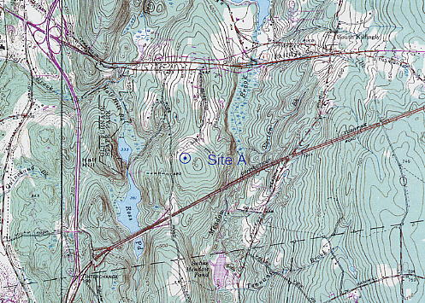

Figure 1. Location of proposed Site A. (AT&T 1, Tab 5)

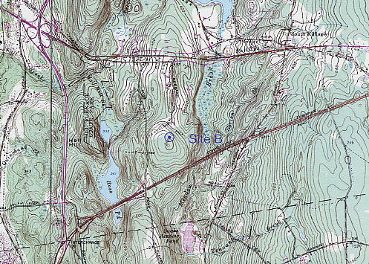

Figure 2. Location of proposed Site B. (AT&T 1, Tab 6)

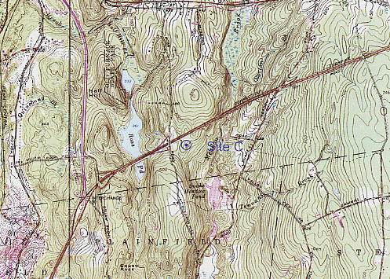

Figure 3. Location of proposed Site C. (AT&T 1, Tab 7)

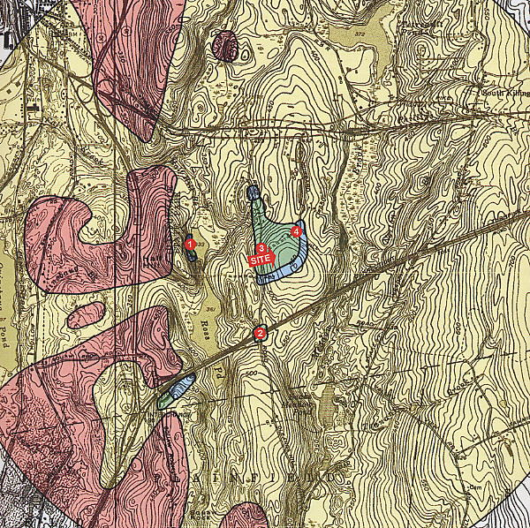

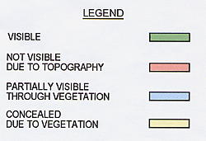

Figure 4. Viewshed map of a 150-foot tower at proposed Site A. (AT&T 2, Q. 25)

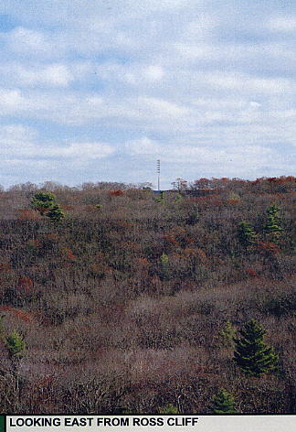

Figure 5. Photo-simulation of the proposed Site A tower from Ross Cliff.
(AT&T 2, Q. 25)

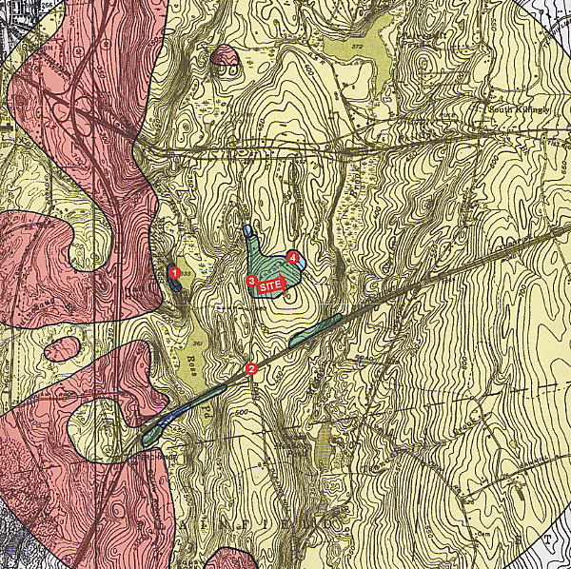

Figure 6. Viewshed map of a 150-foot tower at proposed Site B. (AT&T 2, Q. 25)
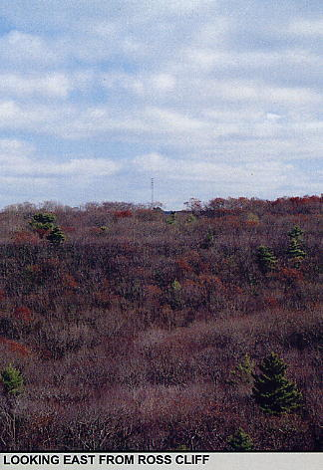

Figure 7. Photo-simulation of the proposed Site B tower from Ross Cliff.
(AT&T 2, Q. 25)
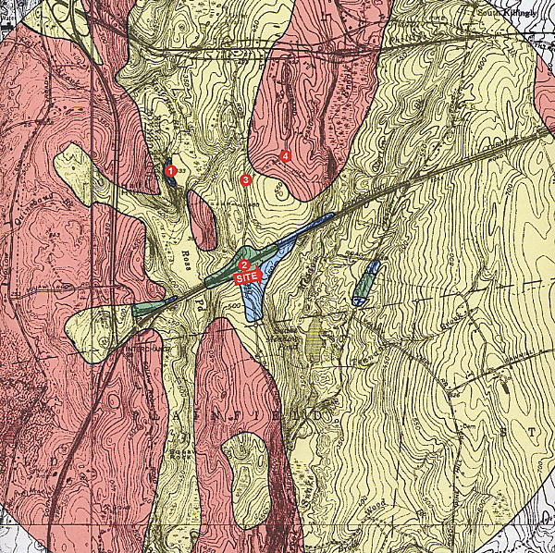

Figure 8. Viewshed map of a 120-foot tower at proposed Site C. (AT&T 2, Q. 25)
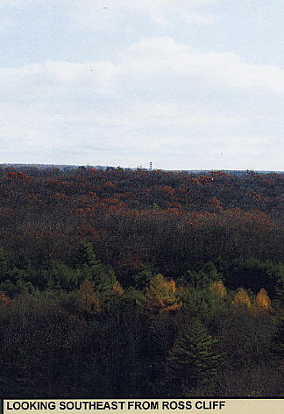

Figure 9. Photo-simulation of the proposed Site C tower from Ross Cliff.
(AT&T 2, Q. 25)

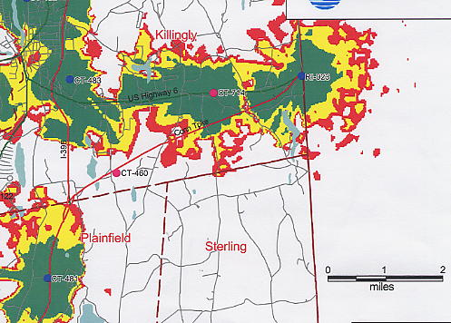

Figure 10. Existing AT&T Wireless coverage. (AT&T 2, Q. 18)

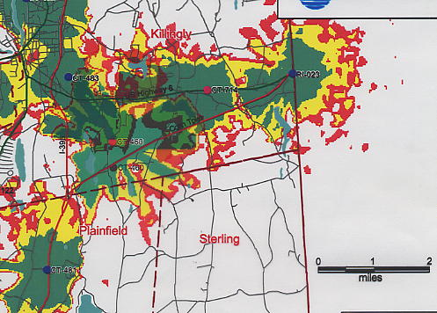

Figure 11. Existing and proposed AT&T Wireless coverage from Site A at 150 feet agl. (AT&T 2, Q. 18, 19)

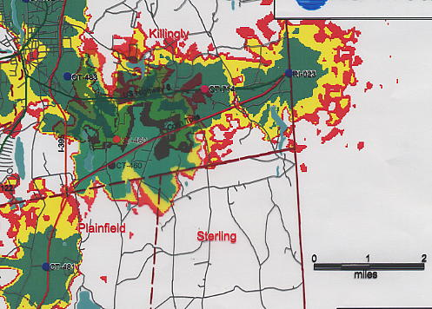

Figure 12. Existing and proposed AT&T Wireless coverage from Site B at 150 feet agl. (AT&T 2, Q. 18, 21)

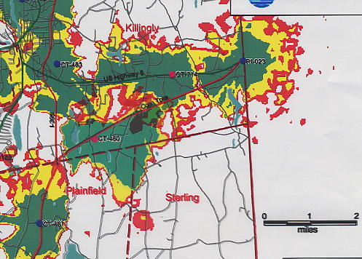
Figure 13. Existing and proposed AT&T Wireless coverage from Site C at 120 feet agl.
(AT&T 2, Q. 18, 23)

