DOCKET NO. 279 - Sprint Spectrum, L.P. d/b/a Sprint PCS application for a Certificate of Environmental Compatibility and Public Need for the construction, maintenance and operation of a wireless telecommunications facility at 530 Bushy Hill Road, Simsbury, Connecticut. | }  }  }  } | Connecticut  Siting  Council  June 23, 2004

Findings of Fact:

Introduction

- Sprint Spectrum L.P., d/b/a Sprint PCS (Sprint) in accordance with provisions of Connecticut General Statutes (CGS) §§ 16-50g through 16-50aa applied to the Connecticut Siting Council (Council) on December 4, 2003 for a Certificate of Environmental Compatibility and Public Need for the construction, operation, and maintenance of a wireless telecommunications facility at 530 Bushy Hill Road, Simsbury, Connecticut. (Sprint 1, p. 1)

- The proposed facility would provide coverage in the 1900 MHz frequency band to existing gaps in Sprint telecommunications coverage along Route 44 and Route 167, and provide in-building coverage to buildings in this area. (Sprint 1, p. 4, Tab 8, RF Engineering Information)

- Sprint is a wholly-owned subsidiary of Wireless Company, L.P., licensed by the Federal Communications Commission (FCC) to provide wireless personal communications services (PCS). (Sprint 1, p. 2)

- The parties in this proceeding are the applicant and AT&T Wireless PCS, d/b/a AT&T Wireless (AT&T). (Tr. 1, p. 5)

- Pursuant to CGS §§ 16-50m, the Council, after giving due notice thereof, held a public hearing on March 11, 2004, beginning at 3:00 p.m. and continued at 7:00 p.m. in the Simsbury Town Offices, 933 Hopmeadow Street, Simsbury, Connecticut. (Tr. 1, p. 3, p. 6)

- The Council and its staff made an inspection of the proposed site on March 11, 2004. During the field review, the applicant flew a red balloon at a height of 120 feet to simulate the height of the proposed tower. (Tr. 1, p. 14-15).

- Public notice of the application was published in the Hartford Courant on November 21, and 24, 2003, and in the Valley News and Farmington Valley Post on November 27, 2003. (Sprint 1, p. 3, Tab 2)

- All abutting landowners of the proposed site were provided notice of the filing of the application by certified mail. All return receipts were returned to Sprint with one exception. This party was sent another copy of the notice via first class mail, no return receipt requested. (Sprint 2, Q. 1; Sprint 1, p. 3; Tr. 1, p. 22)

- Pursuant to CGS §§ 16-50j(h), the following state agencies were notified of the project on December 24, 2003: the Department of Environmental Protection (DEP); the Department of Public Health (DPH); the Council on Environmental Quality (CEQ); the Department of Public Utility Control (DPUC); the Office of Policy and Management (OPM); the Department of Economic and Community Development (DECD); and the Department of Transportation (DOT). (Record)

- The following state agency responded to the request for comments: The DOT, on March 3, 2004. (Record)

- The following state agencies did not respond to the request for comments on the application: the DEP, DPH, CEQ, DPUC, OPM, and the DECD. (Record)

Telecommunications Act

- In issuing cellular licenses, the Federal government has preempted the determination of public need for cellular service by the states, and has established design standards to ensure technical integrity and nationwide compatibility among all systems. (Telecommunications Act of 1996)

- In 1996, the United States Congress recognized a nationwide need for high quality wireless telecommunications services, including cellular telephone service. Through the Federal Telecommunications Act of 1996, Congress seeks to promote competition, encourage technical innovations, and foster lower prices for telecommunications services. (Telecommunications Act of 1996)

- The Telecommunications Act of 1996, a Federal law passed by the United States Congress, prohibits any State or local agency from regulating telecommunications towers on the basis of environmental effects of radio frequency emissions to the extent that such towers and equipment comply with FCC’s regulations concerning such emissions. This Act also blocks the Council from prohibiting or acting with the effect of prohibiting the provision of personal wireless service. (Telecommunications Act of 1996)

- The Telecommunications Act of 1996 prohibits local and state bodies from discriminating among providers of functionally equivalent services. (Telecommunications Act of 1996)

Municipal Consultation

- On June 26, 2003, Sprint filed its 60-day notice to file an application with the Council with the Towns of Avon, Simsbury, and Canton. The towns of Avon and Canton are both within 2500 feet of the proposed site. Sprint representatives attended a public information hearing in Simsbury on August 13, 2003, as requested by the Town of Simsbury. Simsbury’s First Selectman indicated the Town’s support for the proposed tower in a letter dated August 12, 2003, to the Council. (Tr. 1, pp. 7-9; p. 30; Sprint 1, p. 6, Tab 8, Letter of August 18, 2003)

Site Search

- No existing towers in Sprint’s search area in the vicinity of the intersection of Route 10 and Route 44 in the Simsbury-Avon area met Sprint’s coverage objectives. (Sprint 1, p. 8, Tab 9, Search Ring)
- Sprint considered four potential tower sites in the Simsbury area. Three of the sites were rejected and one site became the proposed site. The property owners at 280 Arch Road and 245 West Avon Road were not interested. The property at 44 Dale Road was withdrawn from consideration because it is a small property with a sewage easement. (Tr. 1, p. 21; Sprint 1, p. 9)

The Proposed Site

- The proposed tower site is within a 27-acre parcel east of Bushy Hill Road, known as the Simsbury Commons Mall. This property is owned by Simsbury Commons North E and A, LLC. (Sprint 1, p. 4, p. 10)

- The proposed tower would be a 120-foot monopole designed as a flagpole. The flagpole would be capable of accommodating a total of three carriers. Sprint’s antennas would be mounted 118 feet above ground level (agl). Sprint would install three dual polarized panel antennas in a three sector array within the flagpole. (Sprint 1, p. 11; Sprint 1, Tab 8; Tr. 1, p. 38; Sprint 2, Q. 10)

- AT&T intends to co-locate its antennas on this tower. Sprint would allow the Town of Simsbury to place its antennas on this facility. The Town has not expressed an interest in attaching its antennas to this tower. A 10-feet separation between carriers is required. (Sprint 1, p. 5; Sprint 2, Q. 12; Tr. 1, p. 31)

- The proposed 21-foot by 45-foot compound and lease area would be located in the northeast corner of the Simsbury Commons Mall parking lot, behind existing commercial buildings. No clearing of vegetation would be required. (Sprint 1, Tab 5, Site Plan)

- The facility would be equipped with a battery back-up system capable of powering the system for six to eight hours at 50 percent load. If a power outage exceeded 24 hours in duration, Sprint could temporarily place a diesel-powered electrical generator on the site. (Sprint 1, pp. 11-12)

- Sprint would construct a nine foot six inch by ten foot concrete equipment pad at the base of the tower. On the equipment pad would be the power, battery, and radio cabinets. The tower compound would be surrounded by a 6-foot high stockade fence, as requested by the Town of Simsbury. Space would be reserved for two additional 9.5-foot by 18-foot concrete pads for future carriers. (Tr. 1, p. 21; Sprint 1, p. 7, pp. 10-11)

- There are 10 residences within a 1000-foot radius of the proposed site. The nearest residence is located approximately 604 feet to the northeast of the proposed tower site, on Joyce Lane. (Sprint 2, Q. 4, Abutters Map)

- Access to the proposed facility would be over an existing paved parking lot from Route 44. Sprint would have a 15-foot access easement through the Simsbury Commons parking lot. Electrical and telephone service would be brought into the site underground. (Sprint 1, p. 10, Tab 5, Site Plan)

- The proposed site has an elevation of 275 feet above mean sea level (amsl). The latitude of the proposed site is 41° 49’ 05.26” N and the longitude is 72° 51’ 46.93” W. (Sprint 1, Tab 8, RF Engineering Information)

Environmental Considerations

- The closest wetland to the proposed site is located approximately 50 feet to the east of the parking lot on which the proposed tower would be placed. An existing stockade fence presently protects this wetland. An existing catch basin in a corner of the parking lot would be protected with standard erosion control features during construction, and monitored. (Tr. 1, pp. 23-24; Sprint 1, pp. 15-16)

- The nearby forested wetland is at the toe of the existing parking lot fill slope. It is characterized as a disturbed wetland edge resulting from fill encroachment from the parking lot. (Sprint 1, Tab 17, Wetland Delineation, May 10, 2002)

- A species of special concern, the eastern ribbon snake (Thamnopis sauritus) occurs in the vicinity of the proposed site. However, since the tower would be constructed in a paved area, this project would not affect the snake. (Sprint 1, Tab 1;7, DEP letter of April 30, 2003)

- The State Historic Preservation Office has determined that construction of the proposed tower would not have an effect on historic, architectural or archaeological resources listed on or eligible for the National Register of Historic Places. (Sprint 1, Tab ;17, Connecticut Historical Commission letter of April 8, 2003)

- The electromagnetic radio frequency power density for the proposed Sprint antennas, at a height of 120 feet agl, calculated using conservative worst-case approximations of power density levels at the base of the tower, would be 10.97 percent of the American National Standards Institute (ANSI) level, based on FCC Office of Engineering and Technology Bulletin 65. Using the same assumptions, AT&T antennas mounted at 110 feet agl would be 4.6 percent of the ANSI level. The combined power density levels at the base of the tower would be 15.57 percent of the ANSI standard. (Sprint 1, Tab 8; AT&T 1, Q. 2)

Estimated Costs

- The estimated construction costs for the proposed site are shown below.

Site Work $20,000.00
Flagpole 28,000.00
Electrical and Telephone 15,000.00
Foundation 25,000.00
Landscaping 5,000.00
Parking Lot Stripping 2,000.00
Total $95,000.00

(Sprint 1, Tab 13)

Visibility

- A visual analysis using computer-aided special analysis and field studies was performed for a 120-foot flagpole tower. On May 5, 2003, a balloon float was conducted at the proposed site to evaluate visibility of the proposed tower, and photographs of the balloon were taken from different vantage points. (Sprint 1, Tab 15, Visual Resource Evaluation Report)

- The 120-foot tower would be at least partially visible from approximately 117 acres of the surrounding area, or approximately one percent of the two-mile radius study area. (Sprint 1, Tab 15, Visual Resource Evaluation Report)

- The proposed tower would be fully visible along the Route 44 corridor, which is generally a commercial area with little tree cover. From the intersection of Routes 44 and 167 and West Mountain Road there would be full tower visibility not only from roads but also from commercial parking lots in the area. Four homes along Joyce Lane (homes 2, 4, 5, and 6) would have visibility of the tower above the trees. There are two locations at the intersection of Joyce Lane and West Mary Drive where at least half of the tower would be visible. The tower would be visible to homes numbered 4, 6,7, 8, 12, and 16 along West Mary Drive. (Sprint 1, Tab 15, Visual Resource Evaluation Report; Tr. 1, pp. 15-21)

Coverage Needs

- Sprint has existing coverage gaps of approximately 1.4 miles along Route 44 and approximately 1.4 miles along Route 167. Sprint also currently lacks in-building coverage in the Simsbury Commons Mall and other shopping areas and office complexes along Route 44. (Sprint 1, Tab 8, RF Engineering Information; Sprint 2, Q. 6) (See Figure 1)

- Sprint has an acceptable signal strength of -85 dBm for in-building coverage and -94 dBm for in-vehicle coverage. Sprint customers currently experience levels of approximately -90 to -100 dBm within buildings in the area of the Simsbury Commons Mall. (Tr. 1, p. 24; Sprint 1, Tab 8, RF Engineering Information)

- Sprint currently experiences a dropped call rate of approximately 2 to 5 percent in the area of the proposed tower. Users of cell phones within buildings in the area would likely experience a higher dropped call rate. (Sprint 2, Q. 3)

- Sprint would not be able to provide its expected service with antennas at 110 feet agl. (Tr. 1, p. 29; Sprint 2, Q. 8, Coverage Propagation Maps) (See Figure 2 and Figure3)

- AT&T currently has a gap in service coverage for the 1900 MHz frequency band in the area surrounding the proposed site, especially along Route 44 and Route 167. With three AT&T antennas mounted on the proposed tower at a centerline of 108 feet agl, the proposed site would provide AT&T coverage for approximately 1.4 miles along Route 44 and approximately 2.5 miles along Route 167. (AT&T 1, Q. 1, Q. 3; Tr. 1, p. 64) (See Figure 5 and Figure 6)

- The proposed site would allow AT&T to provide in-building coverage at the Simsbury Commons Mall and other buildings in the area. (Tr. 1, p. 62) (See Figure 4)

FIGURE 1 EXISTING SPRINT COVERAGE

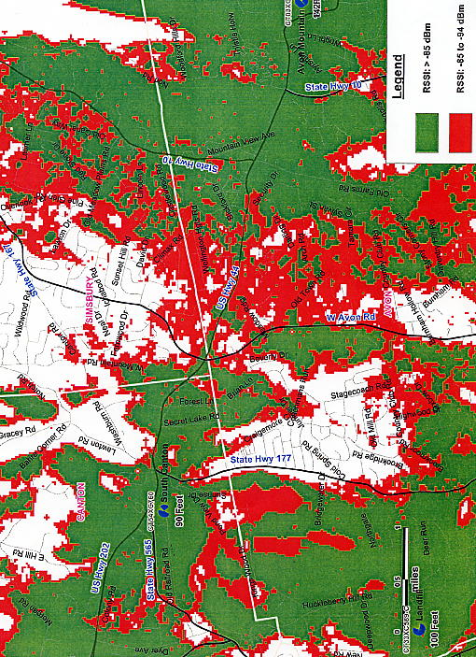
(Sprint 2, PHQ 8)
FIGURE 2 SPRINT COVERAGE FROM PROPOSED SITE AT 120 FEET

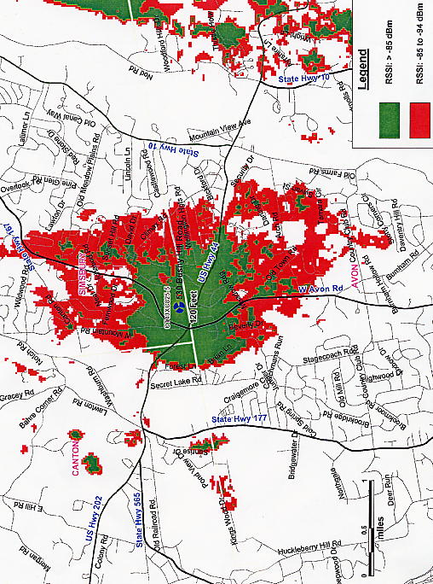
(Sprint 2, PHQ 8)
FIGURE 3 SPRINT COVERAGE FROM PROPOSED SITE AT 120 FEET

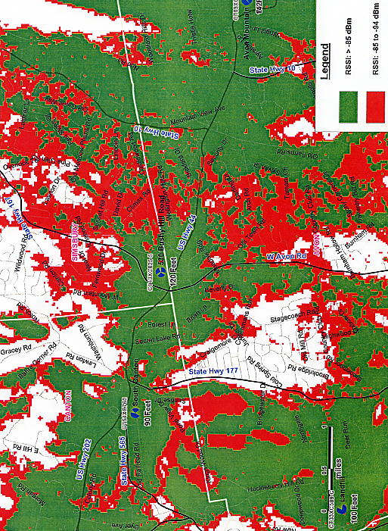
(Sprint 2, PHQ 8)
FIGURE 4 SPRINT COVERAGE FROM PROPOSED SITE AT 110 FEET

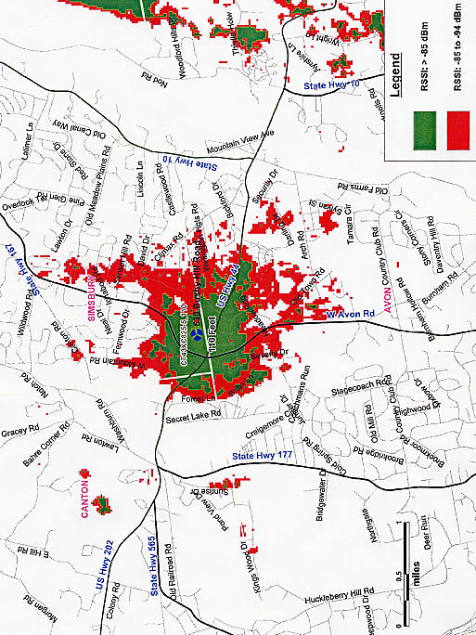
(Sprint 2, PHQ 8)
FIGURE 5 AT&T COVERAGE FROM PROPOSED SITE AT 108 FEET

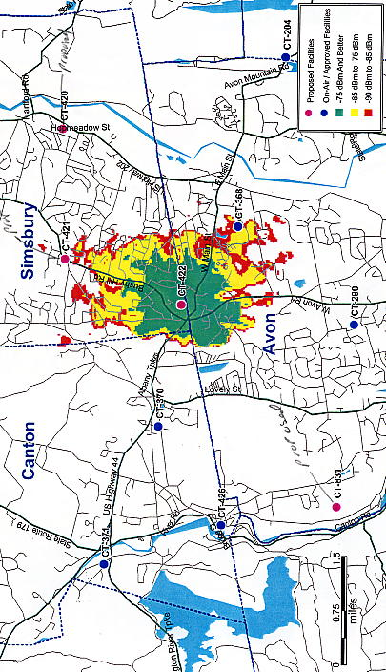
(AT&T Exhibit 1)
FIGURE 6 AT&T COMPOSITE COVERAGE FROM PROPOSED SITE AT 108 FEET

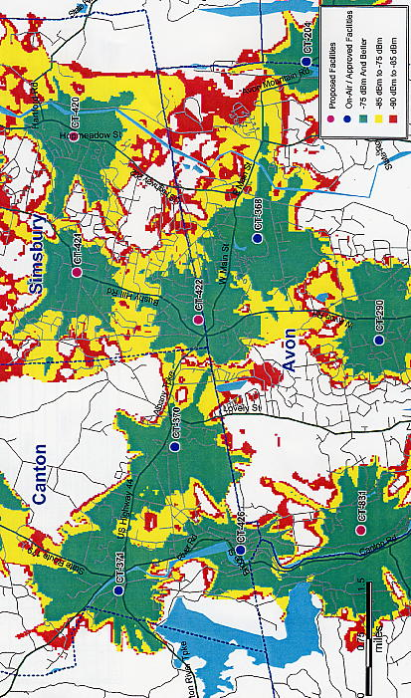
(AT&T Exhibit 1)

