DOCKET NO. 275 – AT&T Wireless PCS, LLC d/b/a AT&T Wireless application for a Certificate of Environmental Compatibility and Public Need for the construction, maintenance and operation of a wireless telecommunications facility at 10 North Ridge Road, Windham, Connecticut. | }  }  } | Connecticut  Siting  Council  April 26, 2004

Findings of Fact

Introduction

- AT&T Wireless PCS, LLC d/b/a AT&T Wireless (AT&T Wireless), in accordance with the provisions of General Statutes §§ 16-50g through 16-50aa, applied to the Connecticut Siting Council (Council) on October 30, 2003, for the construction, operation, and maintenance of a wireless telecommunications facility at 10 North Ridge Road, Windham, Connecticut. The purpose of the proposed facility is to service an existing coverage gap on Route 6 and Route 203 in northern Windham. (AT&T Wireless 1, pp. 1, 2, 6)

2. The party in this proceeding is the applicant. The intervenor in this proceeding is Omnipoint Communications d/b/a T-Mobile (T-Mobile). (Transcript 1 – March 9, 2004, 3:00 p.m. [Tr. 1], pp. 5-6)

3. Pursuant to General Statutes § 16-50m, the Council, after giving due notice thereof, held a public hearing on March 9, 2004, beginning at 3:00 p.m. and continued at 7:00 p.m., at the Windham Town Hall, 979 Main Street, Windham, Connecticut. (Council's Hearing Notice dated December 31, 2003; Tr. 1, p. 3; Transcript 2 – March 9, 2004, 7:00 p.m. [Tr. 2], p. 3)

4. The Council performed an inspection of the proposed site on March 9, 2004 beginning at 2:00 p.m. During the field inspection, the applicant flew a balloon at the proposed tower site to simulate the height of the tower. (AT&T Wireless 1, p. 13; Council's Hearing Notice dated December 31, 2003; Tr. 2, p. 8)

5. On January 30, 2003, AT&T Wireless submitted a notification and technical report describing the proposed facility to Michael Paulhus, the First Selectman of the Town of Windham and to the Town Manager of the Town of Mansfield, Martin Berliner. The Town of Mansfield is within 2,500 feet of the site. Neither Town submitted written comment regarding the merits of the proposal. (AT&T Wireless 1, p. 19, Attachment 8)

6. The Mansfield Town Planner, James Finger, made a limited appearance statement at the March 9, 2004 proceeding stating a preference for low profile antenna mounts and limiting the height of the tower to 109 feet as proposed. (Tr. 2, pp. 9-10, 13)

7. Notice of the application was provided to all abutting property owners by certified mail. All certified mail return receipts were received. Public notice of the application was published in the Willimantic Chronicle on October 28 and October 29, 2003. (AT&T Wireless 1, p. 4; AT&T Wireless 3, Q. 1; AT&T Wireless letter dated February 24, 2004)
8. Pursuant to General Statutes § 16-50j (h), the following state agencies notified of the proposed facility December 31, 2003 and March 10, 2004; Department of Environmental Protection (DEP), Department of Public Health (DPH), Council on Environmental Quality (CEQ), Department of Public Utility Control (DPUC), Office of Policy and Management (OPM), and Department of Economic and Community Development (DECD). (Record)

9. Written comments were received from the DOT Bureau of Engineering and Highway Operations on February 23, 2004, and the DEP on March 1, 2004. (Record)

10. The following agencies did not comment on the application: DPH, CEQ, DPUC, OPM, and the DECD. (Record)

Telecommunications Act of 1996

11. In 1996, the United States Congress recognized a nationwide need for high quality wireless telecommunications services, including cellular telephone service. Through the Federal Telecommunications Act of 1996, Congress seeks to promote competition, encourage technical innovations, and foster lower prices for telecommunications services. (Council Administrative Notice No. 7, Telecom Act 1996)

12. In issuing cellular licenses, the Federal government has preempted the determination of public need for cellular service by the states, and has established design standards to ensure technical integrity and nationwide compatibility among all systems. AT&T Wireless is licensed by the Federal Communications Commission (FCC) to provide personal wireless communication service (PCS) to Windham County, Connecticut. (Council Administrative Notice No. 7, Telecom. Act 1996, AT&T Wireless, p. 5)

13. The Telecommunications Act of 1996 prohibits local and state bodies from discriminating among providers of functionally equivalent services. (Council Administrative Notice No. 7, Telecom. Act 1996)

14. The Telecommunications Act of 1996, a federal law passed by the United States Congress, prohibits any State or local agency from regulating telecommunications towers on the basis of the environmental effects of radio frequency emissions to the extent that such towers and equipment comply with Federal Communications Commission’s (FCC) regulations concerning such emissions. This Act also blocks the Council from prohibiting or acting with the effect of prohibiting the provision of personal wireless service. (Council Administrative Notice No. 7, Telecom. Act 1996)

Site Selection

15. AT&T Wireless established a search ring to serve the identified coverage gap in the fall of 2001. (Tr. 1, p. 26)

- Within the search ring, AT&T Wireless investigated eleven parcels/areas in Windham, one of which was selected for site development. The ten rejected areas and reasons for their rejection are as follows:
- 577 Route 6 – FAA airspace issues, location would require 160-foot tower.
- 474 Route 6 (Wal-Mart building) – did not meet coverage objectives.
- 29 North Ridge Road (Sears building) – did not meet coverage objectives.
- Windham Airport beacon – did not meet coverage objectives, FAA and DOT concerns.
- Eastern Drive – existing tower over two miles from target service area.
- 579 North Windham Road – owners not interested.
- 603 Route 6 – Fire department not responsive and FAA issues, site would require 150-foot tower.
- Commerce Drive – FAA issues, close to residential areas.
- Route 6 – various parcels rejected due to wetland impacts.
- Windham Cemetery, Route 203 – did not meet coverage objectives.
(Applicant 1, p. 9, Attachment 4; Applicant 3, Q. 12, Q. 13)

Site Description

17. The proposed site is located in the northeast corner of a 23-acre parcel owned by Wal-Mart Stores Inc. The site parcel is developed with a Wal-Mart retail store and associated parking lots and is within the North Windham Shopping Center, served by North Ridge Drive. North Ridge Drive borders the site parcel to the west and south. The proposed facility is located on a cleared, grassy strip of land between the store and the North Ridge Drive cul-de-sac. The site parcel is zoned Industrial, M-1. A Sears Roebuck retail store is located south of the site. Two undeveloped parcels abut the site to the north and east. An application has been filed with the Town to construct a Home Depot store in this area. (AT&T Wireless 1, p. 2, Attachment 1, Attachment 5; Tr. 2, pp. 12-13)

18. AT&T Wireless proposes two tower heights at the same location, referred to as Alternative 1 and Alternative 2. (AT&T Wireless 1, p. 2)

- Alternative 1 consists of a lighted monopole facility with a maximum height of 109 feet above ground level (agl). The proposed facility includes a 107-foot monopole topped with a two-foot high steady red beacon light to be lit only at night. AT&T would initially install three flush mounted panel antennas at a centerline height of 105 feet. The tower would be painted in accordance with Federal Aviation Administration (FAA) marking standards which includes an alternating red and white five bar painting scheme. (AT&T Wireless 1, p. 10, Attachment 2, Attachment 9; AT&T Wireless 3, Q. 6; Tr. 1, pp. 22-23, 29-30)

- Alternative 2 consists of an 87-foot monopole with three flush mounted AT&T Wireless antennas at a centerline height of 85 feet agl. The total height of the facility would not exceed 89 feet agl with appurtenances. FAA tower lighting or marking is not proposed, based upon oral discussions with the FAA. (AT&T Wireless 1, pp. 2, 10, Attachment 9; Tr. 1, pp. 27-28)

- Both tower alternatives would be designed to support three levels of antennas. T-Mobile would install 9 panel antennas on a platform or T-arm mounts at a centerline height of 95 feet for the Alternative 1 candidate and a centerline height of 75 feet for the Alternative 2 candidate. (AT&T Wireless 1, p. 2; T-Mobile 1, Q. 5, Q. 6; Tr. 1, p. 67)

22. A 50-foot by 50-foot compound, enclosed by a six-foot high chain link fence is proposed to be constructed at the base of the tower. AT&T Wireless and T-Mobile would install equipment cabinets on concrete pads within the compound. (AT&T Wireless 1, Attachment 5; AT&T Wireless 3, Q. 8; T-Mobile 1, Q. 7)

- Access to the site would be from a 12-foot wide, 80-foot long gravel driveway extending from North Ridge Drive. Underground utilities would be installed along the access road from North Ridge Drive. (AT&T Wireless 1, p. 10, Attachment 5)

- The tower setback radius would be contained within the site parcel. (AT&T Wireless 1, Attachment 5)

- There are no residential structures within 1,000 feet of the site. The nearest residence is approximately 1,040 feet southwest of the site. Four commercial buildings are within 1,000 feet of the proposed site. (AT&T Wireless 1, p. 12; Tr. 2, p. 12)

26. The estimated cost to develop a facility at the proposed site is as follows:

Alternative 1 Alternative 2
Electronic equipment 70,000 70,000
Tower and antennas 151,600 138,600
Site development and utilities 81,300 81,300

Total $302,900 $289,900

(AT&T Wireless 1, p. 20)

AT&T - Existing and Proposed Wireless Coverage

27. AT&T Wireless operates in the FCC assigned D & E 1900 MHz frequency bands and has a service design minimum signal level threshold of -85 dBm. (AT&T Wireless 1, Attachment 2)

28. Adjacent AT&T Wireless facilities that would interact with the proposed facility are as follows:

Location | Antenna Height agl | Approximate Distance from Sites
106 Phoenixville Road, Chaplin | 125 feet - flagpole | 3.3 miles northeast
104 Tower Road, Willimantic | 57 feet - water tank | 3.1 miles southwest
560 Main Street, Willimantic | 54 feet - rooftop | 2.7 miles south
(AT&T Wireless 1, Attachment 3)

29. The proposed site is designed to provide service to Route 6 and Route 66 between the 560 Main Street, Willimantic, and 106 Phoenixville Road, Chaplin, facilities and to Route 203 in the vicinity of Route 6. Route 6 currently has a 3.5-mile gap in coverage, Route 66 a 0.9-mile gap, and Route 203 currently has no coverage (refer to Figure 1). (AT&T Wireless 1, Attachment 3)

30. Installing antennas at the 105-foot level of the proposed tower would provide coverage to approximately 2.5 miles of Route 6, 0.3 miles of Route 66, and 2.0 miles of Route 203. In addition, the site would provide approximately 0.8 miles of marginal coverage (-90 dBm to -85 dBm) to Route 6 northeast of the site in the vicinity of Lynch Road in Chaplin (refer to Figure 2). AT&T Wireless expects a stronger signal in this marginal area due to recent highway upgrades that have eliminated many signal blocking features. AT&T Wireless would not require a microcell site to provide further coverage to this area. (AT&T Wireless 1, Attachment 3; Tr. 1, pp. 15-18)

31. Installing antennas at the 85-foot level of the proposed tower would provide 1.9 miles of coverage to Route 6, 0.2 miles of coverage to Route 66 and 1.8 miles of coverage to Route 203. A 1.2 mile gap in coverage, at a signal level >/= -90 dBm would remain between the proposed site and the 106 Phoenixville Road, Chaplin site (refer to Figure 3). Although coverage to this remaining gap area may be slightly better than depicted on the coverage model, AT&T Wireless would most likely require a second site to provide additional coverage. (AT&T Wireless 1, Attachment 3; Tr. 1, 15-18)

32. An approximate two-mile gap in coverage exists on the expressway portion of Route 6 west of the site. The proposed site is not designed to provide coverage to this area. AT&T Wireless is currently conducting a site search to for a facility that would provide coverage to the Route 6 expressway gap and supplement coverage between the proposed site and the existing 566 Main Street, Willimantic site. (AT&T Wireless 1, Attachment 3; Tr. 1, pp. 19, 25-26)

T-Mobile - Existing and Proposed Wireless Coverage

33. T-Mobile service design operates in the 1900 MHz frequency band and has two signal level design thresholds for the area; -85 dBm for a majority of the area for In Car coverage and -70 dBm for the commercial area of Route 6 near the site for In Building Commercial coverage. (T-Mobile 1, Q. 2)

- Adjacent T-Mobile facilities that would interact with the proposed facility are as follows:

Location | Antenna Height agl | Approximate Distance from Sites
Palmer Road, Chaplin | 107 feet - tower | 3.6 miles northeast
560 Main Street, Willimantic | 54 feet - rooftop | 3.5 miles southwest
(T-Mobile 1, Q. 3, Q. 4)

- T-Mobile currently has a signal level ranging from -85 dBm to -100 dBm on Route 6 between the Willimantic site and Chaplin site. An approximate three mile length of Route 6 between the east end of the Route 6 expressway and Lynch Road in Chaplin has the weakest area of coverage (refer to Figure 4). (T-Mobile 1, Q. 1, Q. 4)

- Installing antennas at the proposed site at 75 feet agl would provide coverage at a signal level >= -85 dBm to 1.8 miles of Route 6. A signal level of >= -70 dBm would be attained in the commercial area in the vicinity of the site (refer to Figure 5). (T-Mobile 1, Attachment 5; Tr. 1, p. 65)

- There is no significant difference in coverage between antenna heights of 75 feet agl and 95 feet agl. Coverage objectives would be met with antennas mounted at 75 feet agl. (T-Mobile 1, Attachment 5; Tr. 1, p. 65)

Environmental, Historic, and Safety Concerns

- The proposed facility would have no effect upon historic or archaeological resources or properties of traditional cultural importance to Connecticut’s Native American community. (AT&T Wireless 1, Attachment 7)

39. The site is located in a cleared, grassy area adjacent to commercial development. No trees would be removed to develop the site. (DEP Comments dated March 1, 2004)

- The site is located within the range of the state endangered Grasshopper Sparrow (Ammodramus savannarum), and two state special concern species, Eastern Meadowlark (Sturnella magna) and Savannah Sparrow (Passerculus sandwichensis). (AT&T Wireless 1, Attachment 7)

- An ornithological survey documented the presence of a single Savannah Sparrow on the site parcel on May 14, 2003. (AT&T Wireless 3, Q. 9)

- To prevent disturbance to bird populations, site construction activities should be avoided from mid-May to early August. (AT&T Wireless 1, Attachment 7; AT&T Wireless 3, Q. 9)

- The DEP Wildlife Division recommends the planting of native shrubs around the compound to enhance wildlife habitat and restricting the tower height and tower lighting to the greatest extent possible to prevent bird strikes. (AT&T Wireless 1, Attachment 7)

- There are no wetlands or watercourses in the vicinity of the site. (AT&T Wireless 1, Attachment 5)

- There are no Town or State-designated scenic roads in the vicinity of the site.
(AT&T Wireless 3, Q. 4)

- An undeveloped portion of the Airline State Park Trail, an abandoned railroad bed, is approximately 1,000 feet south of the proposed site. A public hiking trail on a flood control dike within Mansfield Hollow State Park is approximately 0.5 miles north of the site. (AT&T Wireless 3, Q. 2, Q. 4)

- The conservative worst-case approximation of electromagnetic radiofrequency exposure from AT&T and T-Mobiles’ antennas at the base of the Alternative 1 tower would be 14.8% of the Maximum Permissible Exposure limit established by the Federal Communications Commission. The conservative worst-case approximation of electromagnetic radiofrequency exposure for the Alternative 2 tower would be 22.3% of the Maximum Permissible Exposure limit. (AT&T Wireless 1, p. 14; T-Mobile 1, Q. 9)

- The site is approximately 2,550 feet southeast of the Willimantic Airport. The 107-foot high Alternative 1 tower would require FAA marking and lighting. The 87-foot high Alternative 2 tower would most likely not require lighting or marking, based on oral assurances from the FAA. A final written determination from the FAA would be required. (AT&T Wireless 1, p. 2, Attachment 2; Tr. 1, pp. 27-28)

Visibility

49. Anticipated visibility of the proposed tower is depicted on Figure 6. (AT&T Wireless 3, Q. 3)

50. Both tower alternatives would be visible from the following roads within one mile of the site (refer to Figure 6).

Location | Nearest Distance/Direction from Proposed Site | Length of Road Visibility
Route 6 | 0.2 miles northwest | 0.7 miles
Route 66 | 0.7 miles southwest | 0.2 miles
Route 203 | 0.6 miles east | 0.1 miles
Tiny Avenue/Baker Drive | 0.3 miles northwest | 0.2 miles
Crystal Drive | 0.2 miles southwest | 0.4 miles
Hilltop Drive | 0.6 miles south | 0.1 miles
Skyline Drive | 0.6 miles south | 0.1 miles
Stonegate Drive | 0.6 miles south | 0.2 miles
North Ridge Drive | 80 feet east | 0.3 miles
(AT&T Wireless 3, Q. 3)

- The Alternative 1 tower would be visible year-round from approximately 403 acres within a two-mile radius of the site. (AT&T Wireless 3, Q. 3)

52. The Alternative 2 tower would be visible year-round from approximately 390 acres within a two-mile radius of the site. (AT&T Wireless 3, Q. 3)

- Both tower alternatives would be seasonally visible from approximately 122 acres within a two-mile radius of the site. (AT&T Wireless 3, Q. 3)

54. Land use with year-round visibility of either tower alternative in the immediate vicinity of the site consists of commercial property on Route 6 and North Ridge Drive, Windham Airport, and portions of residentially developed Crystal Drive and the Stonegate Manor trailer park. (AT&T Wireless 3, Q. 3; Tr. 1, pp. 31-35)

55. Eight out of 15 residences on Crystal Drive would have year-round views of the Alternative 1 tower. Five residences would have year-round views of the Alternative 2 tower (Refer to Figures 6 and 7). (Tr. 1, p. 31)

- Five residences in the Hilltop Drive/Skyline Drive neighborhood would have visibility of both tower alternatives. (Refer to Figure 6 and Figure 8). (Tr. 1, pp. 32-33)

- The beacon on the Alternative 1 tower may be visible, when lit, through vegetation from the Tiny Avenue/Baker Drive neighborhood. (AT&T Wireless 3, Q. 3; Tr. 1, p. 32)

- The Alternative 1 tower would be visible from three different sections of the flood control dike trail within Mansfield Hollow State Park. The closest section of the trail with visibility is approximately 0.5 miles north of the site. (AT&T Wireless 3, Q. 2)

- Neither tower alternative would be visible from the Airline State Park Trail or the Joshua’s Tract White Cedar Swamp Preserve. (AT&T Wireless 3, Q. 3; Tr. 1, p. 34)

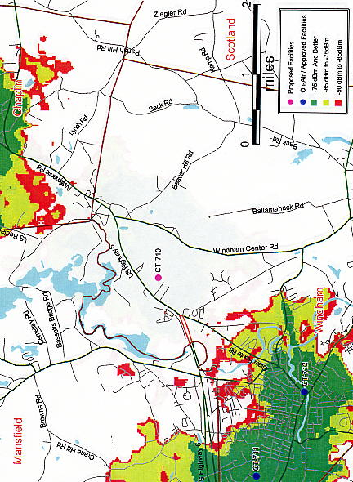
FIGURE 1
AT&T WIRELESS - EXISTING COVERAGE

(AT&T Wireless 1, Attachment 3)
FIGURE 2
AT&T WIRELESS - EXISTING AND PROPOSED COVERAGE WITH ANTENNAS AT 105 FEET

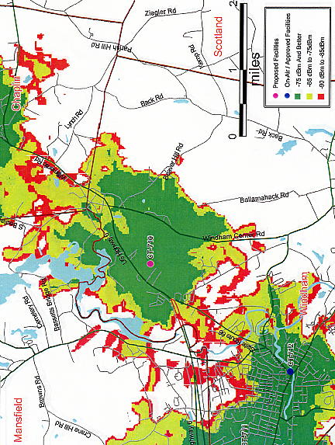
(AT&T Wireless 1, Attachment 3)

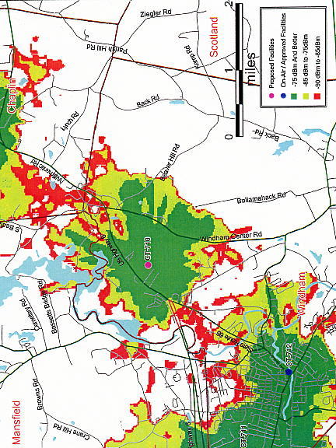
FIGURE 3
AT&T WIRELESS - EXISTING AND PROPOSED COVERAGE WITH ANTENNAS AT 85 FEET
(AT&T Wireless 1, Attachment 3)
FIGURE 4
T-MOBILE – EXISTING COVERAGE

Existing
Chaplin site

Route 203

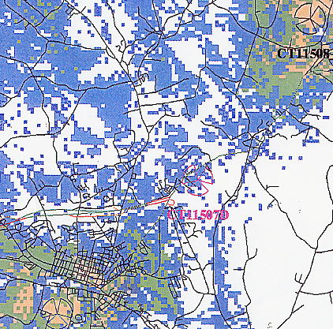
Route 6

Proposed Site

Route 203
Existing Willimantic Site

Route 203

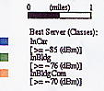

(T-Mobile 1, Q. 4)

FIGURE 5
T-MOBILE – EXISTING AND PROPOSED COVERAGE
WITH ANTENNAS AT 75 FEET
Existing Chaplin
Site
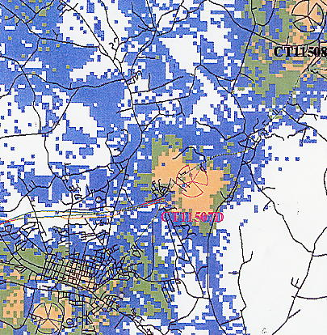
Route 6

Proposed Site

Route 203
Existing Willimantic
Site

(T-Mobile 1, Q. 5)

FIGURE 6
VISIIBILITY OF PROPOSED ALTERNATIVE 1
AND ALTERNATIVE 2 TOWERS

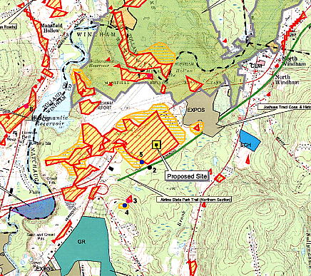

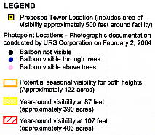
FIGURE 7
VISIBILITY OF ALTERNATIVE 1 AT NIGHT
FROM CRYSTYL DRIVE (MAP LOCATION 5)
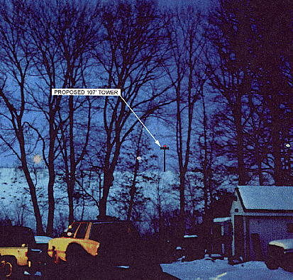

FIGURE 8
VISIBILITY OF ALTERNATIVE 1 AT NIGHT
FROM HILLTOP DRIVE (MAP LOCATION 3
