DOCKET NO. 270 – Wireless Solutions X, LLC Certificate of Environmental Compatibility and Public Need for the construction, maintenance and operation of a wireless telecommunications facility at 202 North Wawecus Hill Road, Norwich, Connecticut. | }  }  } | Connecticut  Siting  Council  September 28, 2005

Reopening Findings of Fact

Introduction

- AT&T Wireless PCS LLC (AT&T), in accordance with provisions of General Statutes §§ 16-50g through 16-50aa, applied to the Connecticut Siting Council (Council) on September 24, 2003, for the construction, operation, and maintenance of a wireless telecommunications facility at one of two locations at 202 North Wawecus Hill Road, Norwich, Connecticut. The proposed facility would provide wireless service to Interstate 395 (I-395) in southeastern Norwich. (Council Administrative Notice item No. 11, Record)

2. On April 15, 2004, the Council approved a 140-foot monopole at the Site B location at 202 North Wawecus Hill Road, Norwich, Connecticut based on the coverage needs of AT&T. (Council Administrative Notice item No. 11, Record)

3. On October 27, 2004, with the approval of the Federal Communications Commission (FCC), AT&T merged with wireless provider Springwich Cellular Limited Partnership (Cingular) to form New Cingular Wireless PCS, LLC (New Cingular). (Council Administrative Notice item No. 11, Record)

4. The Council granted New Cingular a six-month Certificate extension on March 3, 2005 with a new Certificate expiration date of October 15, 2005. (Council Administrative Notice item No. 11, Record)

5. On March 15, 2005, the Council approved a transfer of Certificate from New Cingular to Wireless Solutions X, LLC (Wireless Solutions). Wireless Solutions provides services to telecommunication carriers through the ownership and management of 24 telecommunications sites in Connecticut including a monopole approved by the Council in Old Lyme, Connecticut (Docket 209). (Council Administrative Notice item No. 11, Record; Wireless Solutions 3)

6. Wireless Solutions submitted a Development and Management Plan to the Council on June 1, 2005. Wireless Solutions proposed to construct a 140-foot monopole for use by Omnipoint Communications, Inc., (T-Mobile) and New Cingular. T-Mobile submitted a tower share request to the Council on June 1, 2005 for use of the 137-foot level of the tower. New Cingular submitted an exempt modification for use of the 127-foot level of the tower. (Wireless Solutions 1; Wireless Solutions Administrative Notice item 1; T-Mobile 1)

7. On June 8, 2005, the Council, pursuant to the provisions of Connecticut General Statute § 4-181a(b) which allow an agency to “reverse or modify the final decision, on “a showing of changed conditions”, reopened the final decision rendered in this docket. The “changed conditions” in this case consist of the merger of AT&T and Cingular to form New Cingular and the intent of T-Mobile to locate at this site. (Tr. 1, p. 4; Record)

8. Pursuant to General Statute § 16-50m, the Council, after giving due notice thereof, held a public hearing for the reopened proceeding on June 28, 2005, beginning at 3:40 p.m. at the Council’s office, 10 Franklin Square in New Britain, Connecticut. (Tr. 1, p. 3)

9. The parties in this proceeding are Wireless Solutions and Mary Nasi-Graham. An intervenor is T-Mobile. New Cingular did not apply for party or intervenor status and did not participate in the proceeding. (Tr. 1, p. 5)

10. Public notice of the reopening was published in the Norwich Bulletin and The Hartford Courant on June 22, 2005. (Record)

T-Mobile - Existing and Proposed Wireless Coverage

11. T-Mobile operates a personal communications service network using a 1900 MHz frequency signal allocated by the FCC. In this area, T-Mobile designed the network for in-vehicle coverage with a minimum signal level threshold of -84 dBm. The minimum signal level threshold for in-building coverage for this area is -76 dBm. (T-Mobile 2, Q. 2; Tr. 1, p. 31)

12. T-Mobile is located on the following towers within a two-mile radius of the site:
a) 255 Rogers Road, Norwich, 0.83 miles west of the site. T-Mobile is located at 164 feet above ground level (agl).
b) l50 Clinton Avenue, Norwich, 1.99 miles north of the site. T-Mobile is located at 100 feet agl.
(T-Mobile 2, Q. 3)

13. Existing T-Mobile facilities surrounding the site provide insufficient coverage to 1.8 miles of I-395 between routes 32 and 82 (refer to Figure 1). Existing coverage signal levels within the gap area range between -90 dBm to -102 dBm. (T-Mobile 2, Q. 1, Q. 3)

14. T-Mobile could meet coverage objectives with antennas mounted at 130 feet agl (refer to Figure 2). T-Mobile is seeking a height of 137 feet agl due to an existing lease between Wireless Solutions and New Cingular for use of the 127-foot level of the tower. (T-Mobile 2, Q. 4; Tr. 1, pp. 15, 33)

15. T-Mobile could not meet coverage objectives using an antenna height of 120 feet agl. Coverage on I-395 begins to degrade north of the site with approximately a tenth of a mile affected (refer to Figure 3). This degradation is indicative of the minimum acceptable level for signal downlink (from the tower to the phone). Signal uplink (from the phone to the tower), not depicted on the coverage plots, is weaker than the downlink and would be compromised to a greater extent. (Tr. 1, pp. 34-35)

16. According to methodology prescribed by the FCC Office of Engineering and Technology Bulletin No. 65E, Edition 97-01 (August 1997), assuming all T-Mobile antennas mounted at 137 feet agl are oriented towards the base of the tower and all channels are operating simultaneously, the maximum power density at the base of the tower would be 0.021 mW/cm² or 2.1% of the standard for Maximum Permissible Exposure as adopted by the FCC. (T-Mobile 1)

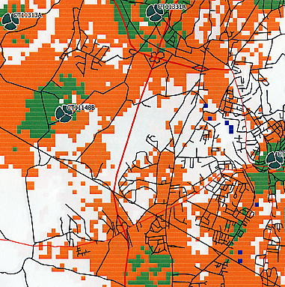
I-395
Figure 1. Existing T-Mobile coverage in southeast Norwich. (T-Mobile 2, Q. 3)

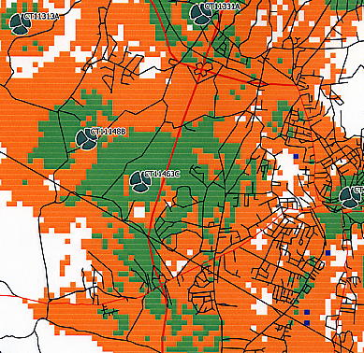
I-395
Figure 2. Existing T-Mobile coverage and proposed coverage from 202 North Wawecus Hill Road at 137 feet agl. (T-Mobile 2, Q. 4)

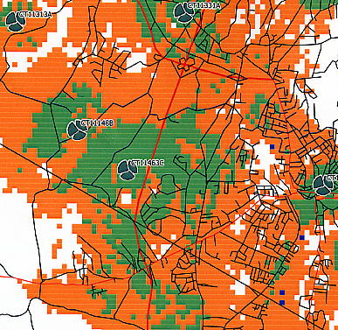
I-395
Figure 3. Existing T-Mobile coverage and proposed coverage from 202 North Wawecus Hill Road at 130 feet agl. (T-Mobile 2, Q. 4)

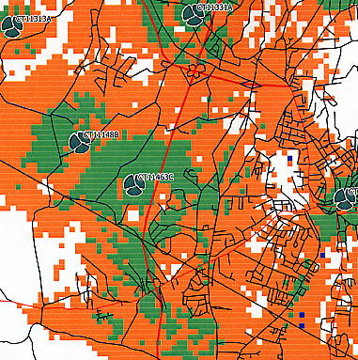
I-395
Figure 4. Existing T-Mobile coverage and proposed coverage from 202 North Wawecus Hill Road at 120 feet agl. (T-Mobile 2, Q. 4)

