DOCKET NO. 270 - AT&T Wireless PCS LLC d/b/a AT&T Wireless. application for a Certificate of Environmental Compatibility and Public Need for the construction, maintenance and operation of a wireless telecommunications facility at one of two locations at 202 North Wawecus Hill Road, Norwich, Connecticut. | }  }  } | Connecticut  Siting  Council  April 15, 2004

Findings of Fact

Introduction

- AT&T Wireless PCS LLC (AT&T), in accordance with provisions of General Statutes §§ 16-50g through 16-50aa, applied to the Connecticut Siting Council (Council) on September 24, 2003, for the construction, operation, and maintenance of a 140-foot monopole wireless telecommunications facility at one of two locations at 202 North Wawecus Hill Road, Norwich, Connecticut. The purpose of the proposed facility is to provide wireless service to Interstate 395 (I-395) in southeastern Norwich. (AT &T 1, p. 1)

2. The parties in this proceeding are the applicant and Mary C. Nasi-Graham, an abutting property owner residing at 138 North Wawecus Hill Road. (Transcript 1 – February 4, 2004, 3:00 p.m. [Tr. 1], p. 4)

- Pursuant to General Statutes § 16-50m, the Council, after giving due notice thereof, held a public hearing on February 4, 2004, beginning at 3:00 p.m. and continued at 7:00 p.m., at the Norwich City Hall, 100 Broadway, Norwich, Connecticut. (Council's Hearing Notice dated November 21, 2003; Tr. 1, p. 2; Transcript 2 – February 4, 2004, 7:00 p.m. [Tr. 2], p. 2)

- The Council and its staff conducted an inspection of the proposed sites on February 4, 2004, beginning at 2:00 p.m. During the field inspection, the applicant flew a balloon with a tether length of 155 feet at each site to represent the height of the proposed towers. The balloons flew at various heights during the field review due to windy conditions. (Tr. 2, pp. 52-55)

- AT&T submitted a technical report describing the proposal to the Mayor of Norwich, Arthur Lathrop, on October 8, 2002 and discussed the proposal with the Norwich City Planner, William Sweeney, on November 18, 2002. (AT&T 1, pp. 20-21; Attachment 8)

- Mr. Sweeny made a limited appearance statement at the February 4, 2004 proceeding stating the City’s concern regarding potential visual impacts of a tower in the North Wawecus Hill area. (Tr. 1, pp. 7-11)

- Pursuant to General Statute § 16-50l(b), public notice of the application was published in the Norwich Bulletin on September 22 and September 23, 2003. (AT&T letter dated February 24, 2004)

- Pursuant to General Statute § 16-50l(b), notice of the application was sent to all abutting landowners by certified mail on September 17, 2003. All return mail receipts have been received. After notice was sent out, two additional abutting parcels were created from the subdivision of a previously noticed parcel and a third abutting property changed ownership. The three new abutting property owners were notified of the proposal by certified mail on January 28, 2004. (AT&T 1, Attachment 5, Attachment 11; AT&T 5, Attachment D)

- Pursuant to General Statute § 16-50j(h), the following State agencies were solicited to submit written comments regarding the proposed facility on November 21, 2003 and February 5, 2004; Department of Environmental Protection (DEP), Department of Public Health (DPH), Council on Environmental Quality (CEQ), Department of Public Utility Control (DPUC), Office of Policy and Management (OPM), Department of Economic and Community Development (DECD), and the Department of Transportation (DOT). (Record)

- Comments were received from the DEP on January 27, 2004 and from the DOT on January 26, 2004. (Record)

11. The following agencies did not comment on the application: DPH, CEQ, DPUC, OPM, and DECD. (Record)

Telecommunications Act of 1996

- In 1996, the United States Congress recognized a nationwide need for high quality wireless telecommunications services, including cellular telephone service. Through the Federal Telecommunications Act of 1996, Congress seeks to promote competition, encourage technical innovations, and foster lower prices for telecommunications services. (Council Admin. Notice, no. 7, Telecom Act 1996)

- In issuing cellular licenses, the Federal government has preempted the determination of public need for cellular service by the states, and has established design standards to ensure technical integrity and nationwide compatibility among all systems. (Council Admin. Notice, no. 7, Telecom. Act 1996)

- The Telecommunications Act of 1996 prohibits local and state bodies from discriminating among providers of functionally equivalent services. (Council Admin. Notice, no. 7, Telecom. Act 1996)

- The Telecommunications Act of 1996, a federal law passed by the United States Congress, prohibits any State or local agency from regulating telecommunications towers on the basis of the environmental effects of radio frequency emissions to the extent that such towers and equipment comply with Federal Communications Commission’s (FCC) regulations concerning such emissions. This Act also blocks the Council from prohibiting or acting with the effect of prohibiting the provision of personal wireless service. (Council Admin. Notice, no. 7, Telecom. Act 1996)

Site Search

- AT&T established a one-mile diameter search ring along I-395 in the southeast portion of Norwich and examined large tracts of land and structures in and around the search ring deemed suitable for site development. All property within the search ring is zoned residential. (AT&T 1, p. 8, Attachment 1, Attachment 4; AT&T 2 c)

- Within the search ring, AT&T examined three parcels including the site parcel. The two rejected parcels include the Lebejko property at 158 North Wawecus Hill Road, rejected since the property owners were not interested, and the former Youngstrom property at 138 North Wawecus Hill Road, rejected due to wetland impacts. (AT&T 1, Attachment 4; Tr. 1, pp. 81, 84)

- AT&T investigated an existing 150-foot monopole on Rogers Road in Norwich, approximately 0.75-miles west of the proposed sites. Installing antennas at 160-feet at this location would not provide adequate coverage to I-395. (AT&T 1, p. 9, Attachment 4, Attachment 8; Tr. 1, p. 24)

- A developed commercial area is located approximately 1.1 miles south of the sites in the vicinity of I-395 Interchange 80. The commercially zoned property in this area is at a relatively low ground elevation, 90 feet above mean sea level (amsl), compared to the proposed sites which are approximately 288 feet amsl. AT&T investigated an existing 30-foot tower located on an 18-foot high commercial building in this area but rejected the site due to inadequate coverage. (AT&T 1, Attachment 4; AT&T 5, Q. 14)

- Existing CL&P transmission poles north and south of the sites were investigated and rejected due to inadequate coverage to I-395. Although the poles are approximately 50 feet in height, an analysis was conducted from these areas using an antenna height of 190 feet agl. (AT&T 3, Q. 5, Q. 6)

Tower and Compound Design

- AT&T would construct a 140-foot monopole at either site. The tower would be designed to support six levels of antennas with a 10-foot center-to-center vertical separation. The monopole would be approximately four feet wide at the base tapering to 1.5 feet at the top. (AT&T 1, Attachment 5, Attachment 6)

- AT&T would initially install six panel antennas on T-arm mounts at a centerline height of 140 feet above ground level (agl). (AT&T 1, Attachment 5, Attachment 6; Tr. 1, p. 27)

- At either site, an 85-foot by 90-foot compound would be established at the base of the tower. The compound would have a gravel surface and would be enclosed by an eight-foot high chain link fence. The compound would be able to accommodate the equipment of six wireless carriers. AT&T would install up to four equipment cabinets on a concrete pad within the compound. (AT&T 1, pp. 10-11; Attachment 5, Attachment 6)

- Underground utilities would be installed along the access road to either compound from a utility pole on North Wawecus Hill Road. (AT&T 1, pp. 10-11)

- The estimated cost to develop a facility at the proposed sites is as follows:

Site A Site B
Electronic equipment 70,000 70,000
Tower and antennas (including installation) 152,000 152,000
Site development and utilities 417,200 390,700

Total $639,200 $612,700

(AT&T 1, p. 21)
Site Description – Site A

- Proposed Site A is located on a 40-acre parcel owned by John Polaski. The parcel, used as a farm, slopes upward from North Wawecus Hill Road, levels, and slopes sharply downward to I-395. The proposed facility is located in a wooded area in the north-central portion of the property, east of several fields and west of a sharp slope extending to I-395. (AT&T 1, p. 2, Attachment 5; Tr. 1, p. 48)

- The ground elevation of the site is 288 feet amsl. (AT&T 1, Attachment 5)

- Access to the proposed site would be from a 12-foot wide, 1,200-foot long gravel drive of new construction extending from North Wawecus Hill Road. (AT&T 1, Attachment 5)

- Development of the site would require minimal grading and no filling. (AT&T 1, Attachment 5)

- The tower setback radius would be contained within the site parcel. (AT&T 1, Attachment 5)

- The site parcel and abutting parcels are zoned Residential, R-40. The nearest abutting property, owned by Michael and Susan Lebejko at 158 North Wawecus Hill Road, is approximately 195 feet north of the compound site. (AT&T 1, Attachment 5, AT&T 3, Q. 11)

- Five residences, including the lessors’, are located within 1,000 feet of the tower site. The nearest abutting residence, owned by Thayne and Anne Hutchins at 230 North Wawecus Hill Road, is approximately 825 feet west of the site. (AT&T 1, p. 18, Attachment 5; AT&T 3, Q. 11)

- The compound site is approximately 400 feet west of the rear property boundary of Mary Nasi-Graham, a party in this proceeding. The Nasi-Graham residence is approximately 1,800 feet north of the site. (AT&T 1, Attachment 5, AT&T 3, Q. 11; Tr. 2, pp. 44-45)

Site Description – Site B

- Proposed Site B is located in the south-central portion of the Polaski property, approximately 400 feet southeast of Site A. The compound site is located in a wooded area east of an open field. East of the compound, the property slopes downward to I-395. (AT&T 1, Attachment 6)

- The ground elevation of the site is 294 feet amsl. (AT&T 1, Attachment 6)

- Access to proposed Site B would be from a 12-foot wide, 1,100-foot long gravel drive of new construction extending from North Wawecus Hill Road. (AT&T 1, Attachment 6)

- Development of the site would require minimal grading and no filling. (AT&T 1, Attachment 6)

- The tower setback radius would be contained within the site parcel. (AT&T 1, Attachment 6)

- The nearest abutting property, owned by Bruce Adams at 291 North Wawecus Hill Road, is approximately 400 feet southwest of the compound site. (AT&T 1, Attachment 6)

- There are five residences, including the lessors’, within 1,000 feet of the tower site. The nearest abutting residence, owned by Thayne and Anne Hutchins at 230 North Wawecus Hill Road, is approximately 675 feet west of the site. (AT&T 1, p. 18; AT&T 3, Q. 11)

- The compound site is approximately 800 feet southwest of the rear property boundary of party Mary Nasi-Graham. The Nasi-Graham residence is approximately 2,200 feet north of site B. (AT&T 1, Attachment 6; Tr. 2, pp. 44-45)

Environmental and Cultural Considerations

42. The proposed sites contain no known existing populations of Federal or State Endangered, Threatened or Special Concern Species. (AT&T 1, Attachment 7)

43. Development of either site would not directly impact any wetlands or watercourses. A wetland area exists east and downgradient of both sites, approximately 165 feet from Site A and 300 feet from Site B. (AT&T 4, Q. 14)

44. There are no historic districts within one mile of the sites. (AT&T 2d, p. 41)

45. The proposed facilities would have no effect upon archaeological resources or upon properties of traditional cultural importance to Connecticut’s Native American community. (AT&T 1, Attachment 7)

46. Neither site would require aircraft hazard obstruction marking or lighting. (AT&T 1 p. 20, Attachment 5, Attachment 6)

47. The conservative worst-case approximation of electromagnetic radiofrequency exposure to AT&T antennas at the base of either tower would be 5.5 percent of the Maximum Permissible Exposure limit established by the Federal Communications Commission. (AT&T 1, pp. 14-15)

48 There are no City of Norwich or state designated hiking trails or scenic roads in the vicinity of the sites. (AT&T 3, Q. 10)

49. Vegetation at the sites consists of a dense stand of red cedar, the largest with a diameter of 18 inches at breast height (dbh). Trees surrounding the sites consist of a mix of deciduous and coniferous species with heights generally ranging from 60 to 80 feet. Approximately 35-40 trees six inches dbh would be removed to develop either site. (AT&T 1, Attachment 5, Attachment 6; Tr. 1, p. 16; DEP comments dated January 27, 2004)

Visibility

50. Year-round visibility of the Site A tower is anticipated from the following roads within two miles of the site (refer to Figure 1).

Location | Nearest Distance/Direction from Proposed Site | Length of Road Visibility
North Wawecus Hill Road | 0.2 miles west | 0.6 miles
Rogers Road | 0.6 miles northwest | 0.2 miles
Tillie’s Way | 0.2 miles west | 0.1 miles
Laura Boulevard | 1.1 miles south | 0.2 miles
(AT&T 3, Q. 7, Q. 8; AT&T 5, Attachment A, Attachment B)

51. Year-round visibility of the Site B tower is anticipated from the following roads within two miles of the site (refer to Figure 2).

Location | Nearest Distance/Direction from Proposed Site | Length of Road Visibility
North Wawecus Hill Road | 0.2 miles west | 0.8 miles
Rogers Road | 0.6 miles northwest | 0.2 miles
Tillie’s Way | 0.2 miles west | 0.1 miles
Laura Boulevard | 1.1 miles south | 0.2 miles
I-395 | 0.8 miles | 0.2 miles
(AT&T 3, Q. 7, Q. 8; AT&T 5, Attachment A, Attachment B)

52. The greatest visual impact of the proposed towers would be from residences in the North Wawecus Hill Road area in the immediate vicinity of the sites. Approximately 12 residences on North Wawecus Hill Road and three residences on Rogers Road would have year-round views of both towers. (AT&T 3, Q. 7, Q. 8; Tr. 1, pp. 40, 56-57; DEP comments dated January 27, 2004)

53. Residences on the east side of North Wawecus Hill Road in the vicinity the sites include #200, #198, #196, #158, and #138. The residence at #200 would have views of the upper portions of both towers, with Site B being more visible than Site A. 196 North Wawecus Hill Road would have views of both towers through trees. The residences at #158 and #138 North Wawecus Hill Road, north of the sites, would have views of both towers above trees. From #138, Site A would be more visible than Site B. No views are expected from #198 due to topography, vegetation, and existing structures. (Tr. 1, pp. 56-57, 79, 90; DEP comments dated January 27, 2004)

54. Residences with views on the west side of North Wawecus Hill Road in the vicinity the sites include #205, #199, #167, and one residence adjacent to #199. The residences at #205 and #199 would have mostly obscured views. The residence at #167 would have views of Site B above the trees and a mostly obscured view of Site A. A residence under construction north of #199 is well screened from Site B but would have views of Site A. (Tr. 1, pp. 56-57; DEP comments dated January 27, 2004)

55. Six residential lots fronting Tillie’s Way, part of the Fields at North Wawecus subdivision, approximately 1,110 feet west of the proposed sites, would have views of both towers. (AT&T 5, Attachment A, Attachment B; Tr. 1, pp. 36-39; DEP comments dated January 27, 2004)

AT&T - Existing and Proposed Wireless Coverage

56. AT&T operates in the FCC assigned D & E 1900 MHz frequency bands and has a service design minimum signal level threshold of -85 dBm, sufficient for in vehicle and in building coverage. (AT&T 1, Attachment 2; Tr. 1, p. 27)

57. Adjacent AT&T facilities that would interact with the proposed facility are as follows:

Location | Antenna Height agl | Approximate Distance from Sites
104 Richard Brown Road, Norwich | 76 feet - watertank | 2.8 miles south
206 Washington Street, Norwich | 71 feet - building | 2.0 miles east
101 Water Street, Norwich | 127 feet - building | 2.2 miles east
133 Gifford Lane, Bozrah | 152 feet - tower | 2.2 miles northwest
50 Clinton Avenue, Norwich | 130 feet - tower | 2.0 miles north
(AT&T 1, Attachment 3)

58. AT&T has identified a 2.7-mile gap in coverage on I-395 between Route 2 and Route 82 in Norwich (refer to Figure 3). (AT&T 1, Attachment 3)

59. Installing antennas at 140 feet agl at either Site A or Site B would provide adequate coverage to the target service area (refer to Figure 4 and Figure 5). (AT&T 3, Q. 13; Tr. 1, pp. 26-27, 66)

60. Installing antennas at 120 feet agl at either site would provide inadequate coverage to I-395 immediately south of Route 2 (refer to Figure 6 & Figure 7). AT&T would experience a signal level weaker than -90 dBm which would result in a high percentage of dropped calls. (AT&T 3, Q. 13; Tr. 1 pp. 26, 64)

FIGURE 1

VISIBILITY OF PROPOSED SITE A TOWER

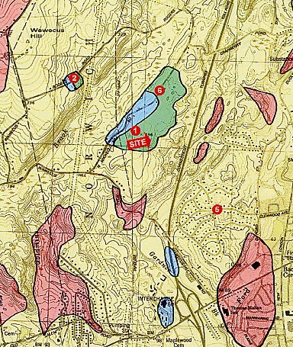

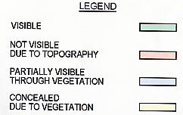
(AT&T 3, Q. 8)

FIGURE 2

VISIBILITY OF PROPOSED SITE B TOWER

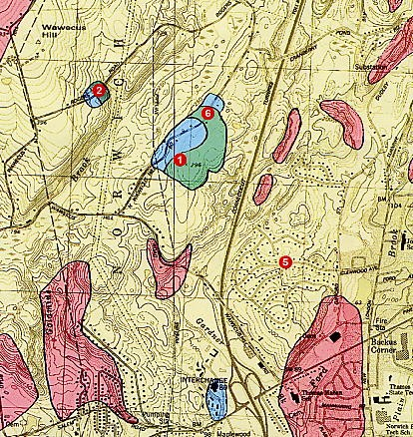

(AT&T 3, Q. 8)
FIGURE 3
AT&T - EXISTING COVERAGE

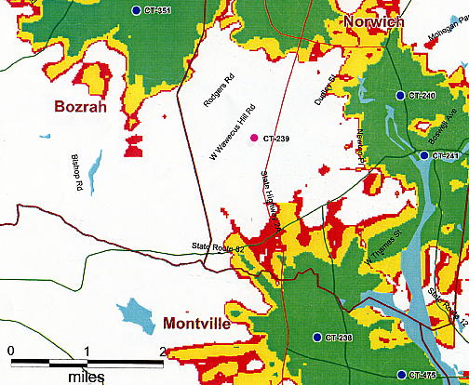

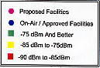

(AT&T 1, Attachment 3)
FIGURE 4
SITE A - PROPOSED AT&T COVERAGE AT 140 FEET AGL
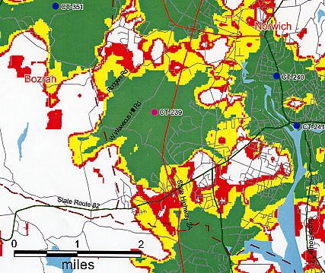

FIGURE 5
SITE B - PROPOSED AT&T COVERAGE AT 140 FEET AGL
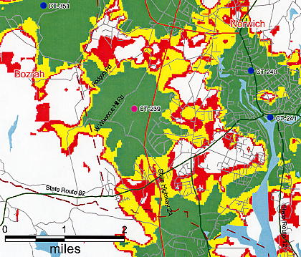
(AT&T 3, Q. 13)
FIGURE 6

SITE A - PROPOSED AT&T COVERAGE AT 120 AGL
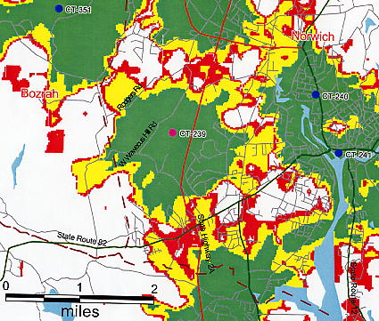

FIGURE 7

SITE B - PROPOSED AT&T COVERAGE AT 120 AGL
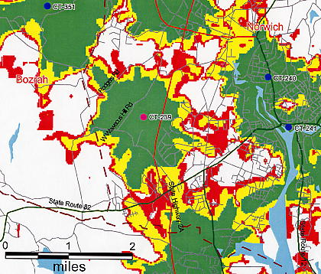
(AT&T 3, Q. 13)

