DOCKET NO. 258 - Sprint Spectrum, L.P. d/b/a Sprint PCS application for a Certificate of Environmental Compatibility and Public Need for the construction, maintenance and operation of a wireless telecommunications facility at one of two sites on Bantam Road, Litchfield, Connecticut. | }  }  } | Connecticut  Siting  Council  December 9, 2003

Findings of Fact

Introduction

- Sprint Spectrum L.P., d/b/a Sprint PCS (Sprint) in accordance with provisions of General Statutes §§ 16-50g through 16-50aa applied to the Connecticut Siting Council (Council) on May 13, 2003 for the construction, operation and maintenance of a wireless telecommunications facility at one of two sites off of Bantam Road (Route 202) in Litchfield, Connecticut. Proposed Site A is on Route 202 and is owned by Kathleen Higgins. Proposed Site B is at 1291-1293 Bantam Road and is owned by John Hammer, Jr. and Robert Hammer. (Sprint 1, p. 1, p. 4)

- The proposed facility would provide coverage to existing gaps in Sprint telecommunications coverage along Route 202 in Litchfield. (Sprint 1, p. 5)

- Sprint is a wholly-owned subsidiary of Wireless Company, L.P., licensed by the Federal Communications Commission (FCC) to provide wireless personal communications service (PCS). (Sprint 1, p. 2)

- The parties in this proceeding are the applicant and the Town of Litchfield (the Town). (Tr. 1, p. 5)

- Pursuant to General Statutes §§ 16-50m, the Council, after giving due notice thereof, held a public hearing on September 4, 2003, beginning at 3:00 p.m. and continued at 7:00 p.m. in the Bantam Borough Hall, 890 Bantam Road, Bantam, Connecticut. (Tr. 1, p. 3; Tr. 2, p. 3)

- The Council and its staff made inspections of proposed site A and proposed Site B on September 4, 2003. During the field review, Sprint flew a red balloon at proposed Site A at a height of 120 feet above ground level (agl) with a flag at 100 feet agl, to simulate the height of the proposed tower. Sprint flew a black balloon at 170 feet agl at proposed Site B; however this balloon was an estimated 250 to 300 feet southwest of the actual site B location, and 20 feet higher in ground elevation than the actual proposed Site B. This balloon was flown at the incorrect location from noon until approximately 3:00 p.m., and then moved to the correct Site B location and flown there until approximately 7:00 p.m.. (Tr. 1, pp. 10-11; Tr. 2, p.39, p.50, p.51)

- Sprint filed a letter with the First Selectman of the Town of Litchfield of its intent to construct a proposed tower site in Litchfield on January 23, 2003. The First Selectman of the Town of Morris also was provided with a copy of this letter, as proposed Site A lies approximately 1300 feet from the Town of Morris. (Sprint 1, pp. 6-7)

- On February 27, 2003, Sprint representatives attended a Litchfield public informational meeting held concerning the proposed Litchfield sites. On March 17, 2003, the Litchfield Planning and Zoning Commission held a hearing on the proposed application. On April 24, 2003, the Town of Litchfield provided comments to Sprint regarding this application, including a Notice of Denial dated March 25, 2003. On February 18, 2003, the Town of Morris Planning and Zoning Commission notified the Town of Litchfield it opposed the proposed site at 1291-1293 Bantam Road, Litchfield. (Sprint 1, Tab 9)

- Public notice of the application was published in the Waterbury Republican-American and the Litchfield Enquirer on April 18 and 25, 2003. (Sprint 1, p. 3, Tab 2)

- All abutting landowners of both proposed sites were provided notice of the filing of the application by certified mail. All return receipts were received by the applicant. (Sprint 1, p. 3, Tab 3)

- Pursuant to General Statutes §§ 16-50j(h), the following state agencies were notified of the project on June 25, 2003: the Department of Environmental Protection (DEP); the Department of Public Health (DPH); the Council on Environmental Quality (CEQ); the Department of Public Utility Control (DPUC); the Office of Policy and Management (OPM); the Department of Economic and Community Development (DECD); and the Department of Transportation (DOT). (Record)

- The following state agencies offered comments on the application: the DEP, on August 28, 2003, and on September 22, 2003, and the DOT, on July 2, 2003. (DEP letter of August 28, 2003; DOT letter of July 2, 2003)

- The following state agencies did not offer comments on the application: DPH, CEQ, DPUC, OPM, and the DECD. (Record)

Need

- Sprint located the proposed Litchfield facility to provide wireless telecommunications service to fill existing coverage gaps along Route 202 in the western portion of Bantam. Sprint has an average dropped call rate of approximately 7.5 percent in the area. ( Tr. 1, pp.56-57; Tr. 2, p. 7; Sprint 1, p. 5)

- In issuing cellular licenses, the Federal government has preempted the determination of public need for cellular service by the states, and has established design standards to ensure technical integrity and nationwide compatibility among all systems. ( Telecommunications Act of 1996)

- In 1996, the United States Congress recognized a nationwide need for high quality wireless telecommunications services, including cellular telephone service. Through the Federal Telecommunications Act of 1996, Congress seeks to promote competition, encourage technical innovations, and foster lower prices for telecommunications services. ( Telecommunications Act of 1996)

- The Telecommunications Act of 1996, a Federal law passed by the United States Congress, prohibits any State or local agency from regulating telecommunications towers on the basis of environmental effects of radio frequency emissions to the extent that such towers and equipment comply with FCC’s regulations concerning such emissions. This Act also blocks the Council form prohibiting or acting with the effect of prohibiting the provision of personal wireless service. (Telecommunications Act of 1996)

- The Telecommunications Act of 1996 prohibits local and state bodies from discriminating among providers of functionally equivalent services. (Telecommunications Act of 1996)

Site Search

- Sprint identified one existing tower within approximately three miles of the proposed Litchfield site, a 180-foot tower owned by the Department of Public Safety (State Police), which is approximately 2.8 miles from the mid-point of the proposed sites. Sprint has existing antennas mounted at 161.5 feet agl on this tower. (Sprint 1, p. 9, Tab 11; Tr. 1, p. 48)

- The proposed Litchfield site would be an expansion in Sprint coverage westward from the Litchfield State Police tower. (Tr. 1, p. 41)

- Sprint identified and investigated eight potential sites, including proposed Sites A and B, in the Litchfield area. The six sites investigated in addition to proposed Sites A and B are the Goggle property off of Goslee Road; property on Peach Orchard Road; the Mount Tom property; Bantam Road L.D.; the Bantam Copperworks; and 11 Cozy Hill Road. The Goggle and Peach Orchard Road properties were rejected as not meeting coverage objectives; the Mount Tom property was withdrawn by the real estate department; the Bantam Road L.D. and Bantam Copperworks would not meet coverage objectives; and the 11 Cozy Hill Road site was withdrawn by the real estate department. Sprint also considered the use of transmission line structures owned by the Connecticut Light and Power Company (CL&P) near proposed site B, but the owner of the property on which the transmission lines are located was unwilling to grant access to Sprint to use the structures. (Sprint 1, p. 9; Sprint 1, Tab 12; Tr.2, p.56)

Site and Equipment

- Both proposed Site A and Site B would consist of a 50-foot by 50-foot compound within a 100-foot by 100-foot lease area. Each compound would be surrounded by an eight-foot high chain link fence. Sprint would place equipment cabinets on an 8.5-foot by 20-foot concrete slab within the fenced compound. A Global Positioning System (GPS) antenna would be mounted on the proposed monopole 50 feet agl at site A and 75 feet agl at site B. ( Sprint 1,pp.11-12; Sprint 1, Tab 5, Tab 6)

- Each proposed site would be equipped with a battery back-up system capable of powering the system for six to eight hours at a fifty percent load. If a power outage exceeds 24 hours, Sprint might temporarily place a diesel-powered electrical generator at the facility. (Sprint 1, pp. 11-12; Sprint 1, Tab 5, Tab 6; Tr. 1, p.106)

- Sprint’s antennas would be placed on low profile platforms at the top of either tower, with four antennas per sector, for a total of 12 antennas. A flush-mounted tower would limit Sprint to three antennas. Sprint would provide colocation to any other interested carriers. Sprint would provide space on the tower to the Town at no charge. The proposed tower would be capable of supporting two additional platforms. No other carriers or the Town of Litchfield have expressed an interest in locating on a tower at proposed Site A or proposed Site B. (Sprint 4, PHQ, 21, PHQ, 22; Sprint 1, Tab 5, Tab 6; Tr.1, p. 32, p.35, p. 37; Tr. 2, p.32 )

- The tower setback radius of the towers as proposed, 120 feet at Site A, and 170 feet at Site B, would each be contained within each respective lessor’s property. There are no existing structures within the tower radius setback of proposed Site A or proposed Site B. (Sprint 1, Tab 5, Site Plan; Sprint 1, Tab 6, Site Plan)

- The proposed site would have E-911 capabilities. (Sprint 2, PHQ. 17)

- The estimated construction costs for proposed Site A and proposed Site B are similar, although Sprint expects the cost to build an access road at proposed Site B may be slightly higher. The estimated construction costs for proposed Site A are shown below.

Site Work . . . . . . . . . . . . . . .  Tower . . . . . . . . . . . . . . . . . .  Electrical and Telephone . . .  Foundation . . . . . . . . . . . . . .  Compound . . . . . . . . . . . . . .  Road . . . . . . . . . . . . . . . . . . .  Total | $11,000.00  25,000.00  29,965.00  21,000.00  6,300.00  19,500.00  $112,765.00
(Sprint 1, Tab 14; Sprint 4, PHQ. 25)

Proposed Site A

- Proposed Site A is located on a vacant 22.36 parcel of land north of Route 202 in Litchfield. The site is currently used for cordwood production. The site had once supported a deciduous forest which has since been mostly cleared. Remaining trees include pin cherry, aspen, paper birch, red maple and red oak. The site slopes mostly to the east and slightly to the south, with an elevation of 971 feet above mean sea level (amsl). (DEP comments; 8/28/03; p. 1; Sprint 1, Tab 5, drawing S-1; Sprint 2, PHQ. 13)

- Proposed Site A is within an R-80 Residential Zone. The geographic coordinates of Site A are: 41°42’46.05” latitude and 73°16’06.85” longitude. The nearest residence, which is on an adjacent parcel of land, is approximately 598 feet to the northeast. There are seven homes within a 1000-foot radius of the proposed site. (Sprint 1, Tab 5, Abutting Properties Site Plan, Title Sheet; Sprint 5)

- No homes are visible from Site A, but one home stands adjacent to the base of an existing access road. (DEP comments, 8/28/03)

- The access road to Site A is steep and hard packed with minimal signs of erosion. The proposed tower access road would follow this route. (Tr. 1, p. 53; DEP comments, 8/28/03)

- Sprint would improve the existing 720-foot gravel access road leading to Site A from Route 202. Sprint would add approximately 25 feet of access road leading to the site. (Sprint 1, p. 10)

- No wetlands were identified within the proposed area of development of Site A. An outlet stream flows from a pond at the base of the access road to the site, and wetland soils were identified along an approximately 80-foot long section of the existing access road within close proximity to Route 202. (Sprint 1, Tab 21, Wetlands Map; Sprint 1, p. 21; DEP comments, 8/28/03)

- Utilities would be brought into Site A overhead across Route 202 to a proposed utility pole at the beginning of the access road; from that point, utilities would continue underground to the tower compound. (Sprint 1, p. 10)

- Land use within the vicinity of Site A is comprised mostly of residential parcels with large tracts of undeveloped forested land. (Sprint 1, Tab 17, p. 1)

- An estimated 10 trees with a diameter of six inches at breast height (dbh) would be removed during the construction of the access road and compound. (Tr. 1, p. 34; Sprint 4, PHQ. 16)

- Sprint originally proposed a 120-foot tower at Site A; however, subsequent analysis has revealed that the minimum tower height required to provide adequate Sprint service from Site A is 100 feet. Accordingly, at the hearing Sprint revised the proposed height of this tower to 100 feet. (Tr. 1, p. 10, p. 38, pp. 45-46; Sprint 2, PHQ. 5, Site A Coverage Map at 100 feet)

Proposed Site B

- Proposed Site B is located on a 12.51-acre parcel of land behind the Gooseboro Drive-In in a wooded area off of Route 202 in Litchfield. Forest cover at this site includes sugar maple, red maple, red oak, white oak, and ironwood. Large boulders are located to the east and south of the proposed tower compound. Proposed Site B is located immediately west of a large swamp, a portion of which extends to the north of the site. Gentle to moderate slopes extend from the site to the wetlands in both directions. (Sprint 1, p. 4; DEP comments,8/28/03, p. 2)

- Proposed Site B has an elevation of 830 feet amsl, and is within an R-80 Residential Zone. The geographic coordinates of this site are 41°43’02.35” latitude, and 73°15’39.13” longitude. The nearest residence, which is on an adjacent parcel of land, is approximately 645 feet to the southwest. There are six homes within a 1000-foot radius of the proposed site. (Sprint 5; Sprint 1, Tab 6, Title Sheet, Drawing S-1; Tr. 2, pp.38-39)

- No homes are visible from Site B. The Looking Glass Hill Campground abuts the lessor’s property to the south, and a tower at this site would be visible from some of the campsites when looking up through the forest canopy. (DEP comments, 8/28/03, and 9/22/03; Tr. 1, pp.22-23)

- The 600-foot long access road which would be created for Site B would begin at the parking lot of the Gooseboro Diner. Blasting would not be expected for construction. Three large boulders in the area would be left in place. (Tr. 1, pp. 54-55; Sprint 2, PHQ. 7, Responses to Town Comments)

- Two wetlands systems were identified approximately 100 feet south of a portion of the access road and 20 feet north of the compound location. However, after consulting with the property owner Sprint has the flexibility to move the tower compound on the parcel, including to the south, onto higher ground farther away from the wetland. (Sprint 1, p. 16, p. 21; Sprint 2, PHQ. 7, Response to Town Comments; Tr. 2, p.30, pp.39-40)

- Sprint originally proposed a 170-foot tower at Site B; however, subsequent analysis revealed that the minimum tower height required to provide adequate Sprint service from Site B is 150 feet. Accordingly, at the hearing Sprint revised the proposed height of this tower to 150 feet. (Tr. 1, p.10, p. 38, pp. 45-46; Sprint 2, PHQ 5, Site B coverage at 150 feet)

- Utilities would be brought into Site B from an existing CL&P utility pole in the southern corner of the Gooseboro Diner parking lot and from there continue underground. (Sprint1, p.10, Tab 6, Site Plan Map)

- Sprint and the property owner would be willing to relocate the tower compound at proposed site B to a location approximately 250 feet to the southwest of the original proposed compound on the same parcel. This location, Site B-2, is the site from which the black balloon was first flown at the field review, and is estimated as being approximately 850 feet amsl in elevation which is 20 feet higher than the proposed site, and could require a shorter tower. Visibility at site B-2 is expected to be similar to that of the original site B location. This location would still meet Sprint coverage requirements, but such a relocation would place the tower closer to the nearest residence, which is located in the same direction. (Tr. 1, pp.10-11, pp.95-98; Tr. 2, pp.30-31, pp.39-41; Sprint 5, Abutters Map)

- The Town regulations for telecommunications towers require a buffer equal to at least 150 percent of the tower’s height from property lines, and that tower sites have no other uses of the property. (Tr.1, pp.102-103; Town of Litchfield Zoning Regulations, Article V, Section 31)

- A 150-foot tower at proposed site B would satisfy Town regulations for a 150 percent tower radius setback of 225 feet; a tower at relocated site B would not have sufficient room to satisfy this requirement. The Gooseboro Diner is on the same parcel as the proposed site, and under Town regulations, a subdivision of the property would be required. (Sprint 1, Tab 6, Site Plan, Compound Plan and Legend Map; Tr. 1, pp.102-103)

Environmental Considerations

- The State Historic Preservation Office (SHPO) has determined that construction of the proposed sites would not have an effect on historic, architectural or archaeological resources listed on or eligible for the National Register of Historic Places. (Sprint 1, Tab 21, Tab 22)

- To construct the proposed access road and tower compound at Site A, approximately 10 trees with a diameter of six inches or greater at breast height (dbh) would have to be removed. Approximately 42 trees six inches or greater dbh would have to be removed to construct the proposed access road and tower compound at Site B. (Sprint 4, Q. 16)

- Erosion and sediment controls would be established and maintained at either site throughout construction. (Sprint 1, p. 16; Sprint 1, Tab 5, Map SC-3; Tab 6, Map SC-2)

- The proposed towers would not require marking or lighting by the Federal Aviation Administration. (Sprint 1, p. 24; Tab 20)

- The electromagnetic radio frequency power densities for the proposed Sprint antennas, calculated using FCC Office of Engineering and Technology Bulletin 65, and using conservative worst-case approximation of power density levels at the base of each tower, would be 7.48 percent of the American National Standards Institute (ANSI) for Site A with a 120 foot tower or 10.76 percent for a 100-foot tower, and at Site B, 3.72 percent for a 170 foot tower or 4.78 percent for a 150-foot tower. (Sprint 1, p. 24, Tab 19; OET Bulletin 65, FCC, August 1997)

Visibility

- A visibility analysis of both proposed sites was performed using computer aided spatial analysis and field studies using balloons. A 120-foot tower at Site A would be visible from approximately 56 acres of the surrounding area. A 100-foot tower at Site A would be visible from approximately 25 acres. A 170-foot tower at Site B would be visible to approximately 48 acres, and a 150-foot tower at Site B would be visible to approximately 28 acres. (Sprint 1, Tab 16, 17, 18; Tr. 2, pp. 53-54; Tr. 1, pp. 61-62)

- Based on a 120-foot tower at proposed Site A, Sprint estimated the visibility of this tower from surrounding roads. This tower would be visible along Route 202 from east of the proposed site to the intersection with Goslee Hill Road, and along Route 202 between this site and proposed Site B. The tower would be fully visible along Goslee Hill Road north along this road to approximately 150 feet beyond the overhead transmission lines crossing the road. The tower would drop from view from approximately .25 to .50 miles, then regain visibility northbound on Goslee Road to Old Mt. Tom Road. Countryside Lane would experience some visibility east from the intersection with Goslee Hill Road, with year-round visibility for approximately .125 miles. The tower would be visible along a portion of Looking Glass Hill at the intersection with Route 202. The tower would not be visible from Old Turnpike Road, Prospect Mountain Road, or Cozy Hill Road. (Tr. 1, pp. 14-17, p. 33)

- Based on a 170-foot tower at proposed Site B, Sprint estimated the visibility of this tower from surrounding roads. This tower would be visible along Route 202 for approximately 0.125 miles at the intersection with Old Turnpike Road to the west, and approximately 0.125 miles along Old Turnpike Road. The tower would also be visible along Route 202 approximately 0.5 miles to the east from its intersection with Goslee Road for a 150 to 200 foot length, and along Route 202 near the intersection of Maple Avenue. Along Cozy Hill Road the tower would be visible for approximately 0.125 miles. The tower would be visible for a short distance along West Morris Road. The tower would not be visible from Looking Glass Hill Road. (Tr. 1, pp. 17-19, p. 33)

- The proposed Site A tower may be visible from the southwestern portion of Mount Tom State Park Pond; however, neither proposed tower would be visible from the picnic areas or hiking trails of this park. Both towers would be visible from the observation tower at Mt. Tom State Park at a distance of approximately 1.5 miles, but with a view which is downward against a background of trees. (Tr. 1, pp. 28-30; Sprint 3, p. 6, View Lines 8A, 8B, 9A, 9B)

- Tree heights surrounding proposed Site A are in the 65-foot range, and trees surrounding Site B are in the 75-foot range. (Tr. 1, p. 34)

- Proposed Site A would have greater visual impact than proposed Site B. (DEP Comments, 8/28/03, p.2)

Coverage Needs

- Existing Sprint facilities in the Litchfield area leave gaps in wireless coverage along Route 202 in the western portion of Litchfield, Bantam. Sprint considers an acceptable signal strength to be –94 dBm in rural areas and –79 dBm to –84 dBm for urban areas. Gaps are defined as areas receiving less than –94 dBm coverage. (Sprint 1, p. 4, p.13; Tr. 2, pp. 7-9; Sprint 1, Tab 15)

- Existing Sprint Wireless coverage gaps in the Bantam section of Litchfield are summarized in the table below.

Existing Coverage Gaps
Road | Existing Gap (in miles) | Total Road Miles
Prospect Mountain Rd. | 1.761 | 2.3
Cathole Road | 1.724 | 1.95
Goslee Road | 0.403 | 0.78
Route 202 | 2.392 | 4.1
(Sprint 4, PHQ. 15; Sprint 2, PHQ 5, coverage map)

- Existing Sprint coverage combined with antennas at proposed Site A at 120 feet agl or at 100 feet agl would leave the following gaps within approximately a two-mile radius of the proposed sites as follows:
Proposed Site A Coverage
Road | Primary 120’ gap (in miles) | Primary 100’ gap (in miles) | Total Road Miles
Prospect Mountain Rd. | 0.512 | 0.636 | 2.3
Cathole Road | 1.165 | 1.319 | 1.95
Goslee Road | 0.00 | 0.00 | 0.78
Route 202 | 0.00 | 0.00 | 4.1
(Sprint 4, PHQ. 15; Sprint 2, PHQ 5, coverage map)

- Existing Sprint coverage combined with antennas at alternate Site B at 170 feet agl or at 150 feet agl would leave the following gaps within approximately a two-mile radius of the proposed sites as follows:
Proposed Site B Coverage
Road | Alternate 170’ gap (in miles) | Alternate 150’ gap (in miles) | Total Road Miles
Prospect Mountain Rd. | 0.710 | 0.613 | 2.3
Cathole Road | 1.245 | 1.335 | 1.95
Goslee Road | 0.00 | 0.00 | 0.78
Route 202 | 0.00 | 0.00 | 4.1
(Sprint 4, PHQ. 15; Sprint 2, PHQ 5, coverage map)

- Sprint anticipates it will need a future site along Route 202 to the west in the Woodville area. (Tr. 1, p. 42; Sprint 1, Tab 15)
Figure 1
“Location of Proposed Sites A and B”
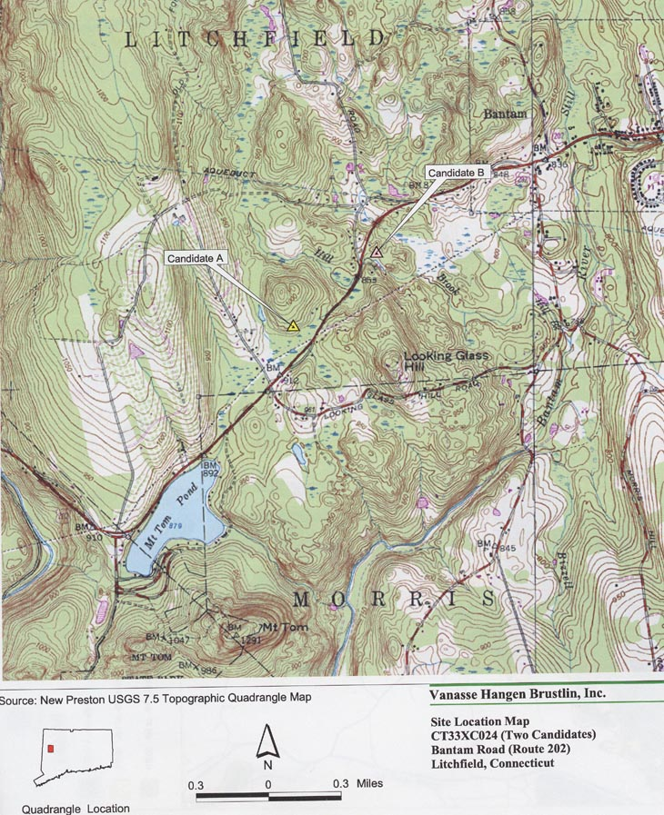
(Sprint 1, Tab 7)

Figure 2
“Existing and Proposed Sprint Coverage in the Litchfield Area”

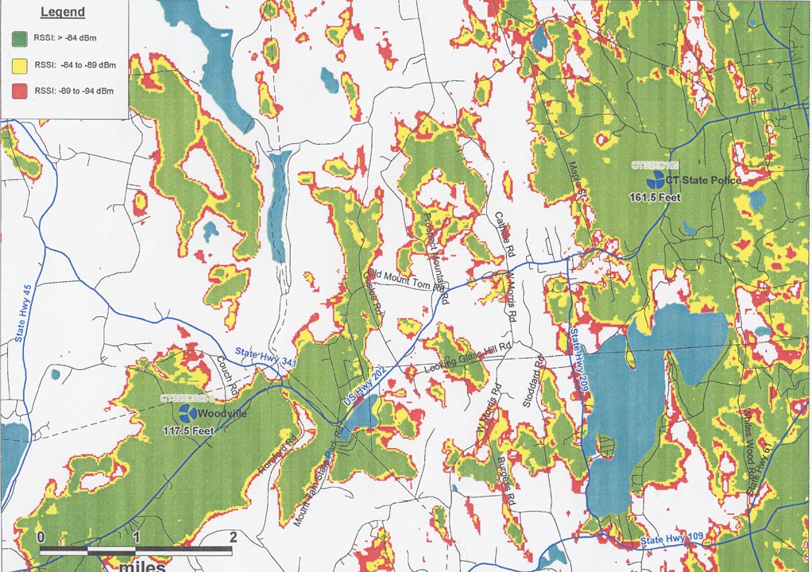
(Sprint 2, PHQ. 5)

Figure 3
“Coverage from proposed Site A at 100 feet”

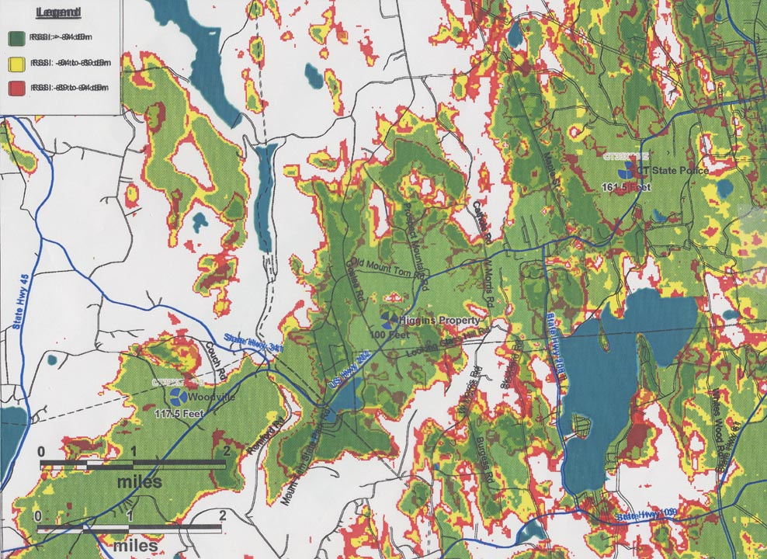
(Sprint 2, PHQ. 5)

Figure 4
“Coverage from proposed Site B at 150 feet”

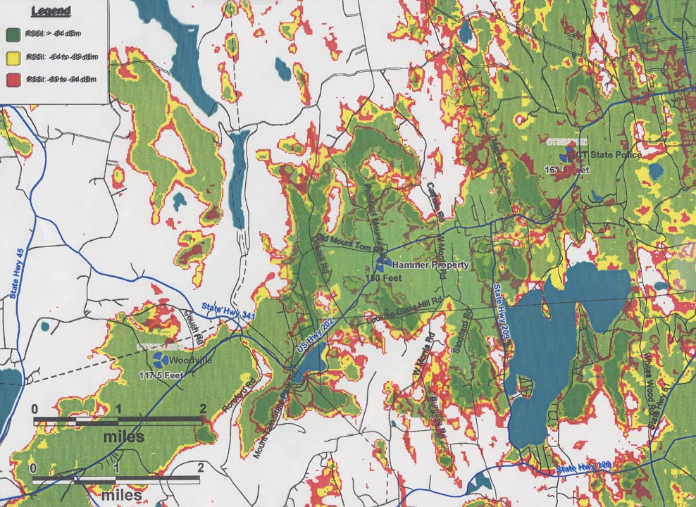
(Sprint 2, PHQ. 5)

