DOCKET NO. 251 - Sprint Spectrum, L.P. d/b/a Sprint PCS application for a Certificate of Environmental Compatibility and Public Need for the construction, maintenance and operation of a wireless telecommunications facility at 170 Southeast Road, New Hartford, Connecticut. | }  }  } | Connecticut  Siting  Council  November 20, 2003

Draft Findings of Fact

Introduction

- Sprint Spectrum, L.P. d/b/a Sprint PCS (Sprint), in accordance with the provisions of General Statutes §§ 16-50g through 16-50aa, applied to the Connecticut Siting Council (Council) on April 16, 2003 for the construction, operation, and maintenance of a wireless telecommunications facility at 170 Southeast Road, New Hartford, Connecticut. (Sprint 1, pp. 1-2)

- In 1996, the United States Congress recognized a nationwide need for high quality wireless telecommunications services, including cellular telephone service. Through the Federal Telecommunications Act of 1996, Congress seeks to promote competition, encourage technical innovations, and foster lower prices for telecommunications services. (Council Admin. Notice, no. 7, Telecom Act 1996)

- Sprint is licensed by the Federal Communications Commission (FCC) to provide wireless communication service in 32 major trading areas within the United States including Connecticut. Sprint seeks to provide wireless coverage to Route 202 in New Hartford which lies in Metropolitan Trading Area 1 (New York) and Basic Trading Area 318 (Litchfield). (Sprint 1, pp. 2-4)

- In issuing cellular licenses, the Federal government has preempted the determination of public need for cellular service by the states, and has established design standards to ensure technical integrity and nationwide compatibility among all systems. (Council Admin. Notice, no. 7, Telecom. Act 1996)

- The Telecommunications Act of 1996 prohibits local and state bodies from discriminating among providers of functionally equivalent services. (Council Admin. Notice, no. 7, Telecom. Act 1996)

- The party in this proceeding is the applicant. The intervenors in this proceeding are AT&T Wireless PCS, LLC d/b/a AT&T Wireless (AT&T) and Cellco Partnership d/b/a Verizon Wireless (Verizon), (Transcript 1- 7/16/03, 3:00 p.m. [Tr. 1], p. 5; Transcript 3- 10/23/03, 11:00 a.m. [Tr. 3], p. 4)

- Verizon intervened in this proceeding to propose a modification to the facility proposed in the application. Verizon withdrew the modification request after concerns were raised regarding notice requirements. Verizon intends to pursue the modification by filing a petition for a declaratory ruling that no Certificate of Environmental Compatibility and Public Need (Certificate) would be required for the proposed modifications contingent upon the Council granting a Certificate to Sprint for the proposed facility. (Tr. 3, pp. 26-31)

- Pursuant to General Statutes § 16-50m, the Council, after giving due notice thereof, held a public hearing on July 16, 2003, beginning at 3:15 p.m. and continuing at 7:00 p.m. at the New Hartford Town Hall, 530 Main Street, New Hartford, Connecticut and on September 23, 2003, beginning at 11:00 a.m., at the office of the Council, 10 Franklin Square, New Britain, Connecticut. (Council's Hearing Notices dated May 12 and August 13, 2003; Tr. 1, p. 2; Transcript 2- 7/16/03, 7:00 p.m. [Tr. 2], p. 3; Tr. 3, p. 3)

- The Council performed an inspection of the proposed site on July 16, 2003, beginning at 2:00 p.m. During the field inspection, the applicant flew a balloon at the proposed tower site to simulate the height of the tower. (Council's Hearing Notice dated May 12, 2003)

- Sprint submitted a technical report to the New Hartford First Selectman, William Baxter, and the New Hartford Town Planner, Thomas McGowen, on January 15, 2003. The Town did not provide written comment regarding the proposal. (Sprint 1, p. 6)

- The First Selectman made a limited appearance statement at the July 16, 2003 proceeding requesting that the Council consider town regulations regarding site selection of telecommunication facilities in the Town. (Tr. 1, p. 7)

- Notice of the application was provided to all abutting property owners by certified mail. Public notice of the application was published in The Winsted Journal and The Register Citizen on April 4 and April 11, 2003. (Sprint 1, p. 3, AT&T 3, Q. 1)

- Pursuant to General Statutes § 16-50j (h), on May 12 and September 25, 2003, the following state agencies were solicited to submit written comments regarding the proposed facility; Department of Environmental Protection (DEP), Department of Public Health (DPH), Council on Environmental Quality (CEQ), Department of Public Utility Control (DPUC), Office of Policy and Management (OPM), Department of Economic and Community Development (DECD), and the Department of Transportation (DOT). (Record)

- Written comments were received from the DOT’s Office of Environmental Planning on October 7, 2003 and the DEP on July 15, 2003. (Record)

- The following agencies did not comment on the application: DPH, CEQ, DPUC, OPM, and the DECD. (Record)

Site Selection

- Prior to selecting the proposed site, Sprint considered 13 other sites to provide coverage to the Route 202 corridor between existing Sprint facilities in New Hartford and Canton. The sites consisted of electric transmission structures, farm silos, a private radio tower and a church steeple. All of the sites were rejected due to inadequate coverage to the target service area. (Sprint 1, p. 8; Sprint 3, Q. 13, Q. 14)

- The search ring consists of an oval area, 0.5 miles at its widest, located south of Route 202 and north of an area of high elevation know as Garret Mountain. Two property owners are located within the search ring, Paul Miano and the Metropolitan District Commission (MDC). (Sprint 1, p. 3; Sprint 7, Q. 18)

- The proposed tower site is located in the northeast portion of the 64-acre Miano property. The site is located east of Spruce Brook, a tributary of the Nepaug River that drains into the Nepaug Reservoir, a public water supply reservoir. The site is within the search ring established for the target service area. Areas of the Miano property west of Spruce Brook are not within the search ring and would not meet coverage objectives on Route 202. (Sprint 1, p. 4; Sprint 7, Q. 18; Tr. 1, pp. 23-25, 32-36)

- The MDC would not consider the placement of a telecommunications tower on their watershed property. (Sprint 6; Tr. 2, pp. 13-14)

- Town regulations present a ranked system of three siting classes based on property ownership and distance to adjacent residences and schools with option one being most preferred, as follows:
Class 1 locations within municipal or state property no closer than 1,500 feet from residences or schools.
Class 2 locations within municipal or state property no closer than 1,500 feet from residences or schools.
Class 3 locations within municipal or privately owned land a minimum distance of 750 feet from residences or schools.
The selected site is located in a Class 3 area. Class 1 or Class 2 siting options are not within the search ring. (Sprint 2, a; Sprint 7, Q. 18; Tr. 2, pp. 11-12)

Site Description

- The Miano property is an undeveloped, heavily wooded 64-acre parcel traversed by woods roads and trails. The property owner may develop a residential subdivision on the parcel in the future. The immediate area surrounding the site consists of rolling hills ranging in elevation of 500 feet above mean sea level (amsl) to 1,000 feet amsl. Forest cover in the area consists of mixed deciduous hardwoods with an average height of 75 feet. (Sprint 1, p. 9, Attachment 5; Tr. 1, p. 15)

- Sprint proposes to develop a 150-foot monopole designed to support three antenna platforms, on a 100-foot by 100-foot lease area at the proposed site. The tower would be constructed of galvanized steel that would weather to a non-reflective gray finish. (Sprint 1, pp. 10, 16)

- Sprint would install twelve five-foot panel antennas at a centerline height of 150 feet above ground level (agl). AT&T would install six panel antennas at a centerline height of 140 feet. A GPS antenna would be mounted at a height of 75 feet agl. (Sprint 1, Attachment 5; AT&T 1, Q. 3)

24. A 40-foot by 40-foot compound, enclosed by a six-foot high chain link fence topped with barbed wire, would be constructed at the base of the tower. Sprint and AT&T would install equipment cabinets within the compound. (Sprint 12, Attachment 5; AT&T 1, Q. 6)

- Access to the site would be from a 12-foot wide, 2,650-foot long gravel road of new construction extending from Southeast Road. The proposed road would follow an existing woods road for approximately 188 feet. Above ground utilities would be installed from an existing utility pole on Southeast Road. The utility line would require the installation of 22 utility poles along the access road. An underground route could impact wetlands and wetland buffer zones, and would be problematic in crossing Spruce Brook. (Sprint 1, p. 10; Attachment 5; Sprint 3, Q. 5; Tr. 2, p. 87)

- Development of the site would require the removal of approximately 133 trees with a diameter six inches or greater at breast height (dbh) and would require approximately 220 cubic yards of cut and fill. Four trees scheduled for removal are within the compound area. Dominant trees in the development area include eastern hemlock, white pine, and red and black oak. (Sprint 3, Q. 9; Tr. 1, p. 12; Tr. 3, pp. 9, 13-14)

- The proposed road would cross Spruce Brook and an associated riparian wetland, impacting approximately 2,832 square feet of wetlands. The proposed crossing is located at the narrowest point of uplands on the Spruce Brook corridor. Areas to the north and south of the crossing contain wider areas of wetlands. (Sprint 3, Q. 6; Tr. 1, pp. 12, 84-85)

- Two forested groundwater seep wetlands not associated with Spruce Brook, Wetland 2 and Wetland 3, are located in the western portion of the parcel in close proximity to the proposed road. The proposed road is 80 feet from Wetland 2 and 40 feet from Wetland 3. The road extends through a town designated 50-foot wetland buffer zone associated with Wetland 3 for a distance of 70 feet. (Sprint 1, pp. 15, 18, Attachment 5, Attachment 8; Sprint 2, b)

- The Spruce Brook crossing would consist of a 48-inch diameter, 40-foot long culvert placed in the brook channel. (Sprint 3, Q. 6; Tr. 1, pp. 17-21)

- The design of the access road may result in the following adverse effects to the habitat and resources of Spruce Brook;
- Cause a permanent alteration of instream habitat;
- Create a barrier to fish migration;
- Cause a decrease in stream productivity; and
- Eradicate riparian habitat.
(DEP letter dated July 15, 2003)

- The DEP recommends installing a bridge or an arch culvert to reduce impacts to Spruce Brook. The DEP further recommends that the support elements for such a structure be located landward of the stream channel to eliminate in stream work and channel modification, and to maintain all or a portion of the riparian floodplain. (DEP letter dated July 15, 2003)

- The MDC’s primary concern regarding the proposal is the implementation and maintenance of proper erosion and sedimentation controls. The MDC would monitor construction activities during routine watershed inspections and would notify Sprint of any effects caused by construction. (MDC letter dated May 5, 2003)

- Sprint would install proper soil and erosion control measures prior to construction. (Tr. 1, p. 91)

- To address concerns raised by the DEP and Council, Sprint submitted an alternate road design on August 22, 2003 that follows more of the existing trail system and uses a bridge to cross Spruce Brook. The alternate access road is 2,865 feet in length and follows existing trails for approximately 2,400 feet. The alternate access road would require the removal of 74 trees six-inches or greater dbh and would require 180 yards of cut and fill. Spruce Brook would be crossed using a 30-foot open bottom bridge with bridge footings installed approximately 12 feet from the edge of the brook. The bridge design will not impact the bottom channel of the brook. Approximately 126 square feet of wetlands adjacent to Spruce brook would be impacted. (DEP comments dated July 15, 2003; Sprint 7, Attachment 1; Tr. 3, pp. 9-11, 14)

- The alternate access road is within 25 feet of Wetland 2 and extends through the wetland buffer zone for 180 feet. The alternate road is within 12 feet of Wetland 3 and extends 350 feet through the wetland buffer zone. (Sprint 7, Attachment 1)

- The nearest abutting property, owned by the MDC, is 150 feet to the north. Town regulations require a property line setback of 226 feet at this location (total tower height plus 50%). The nearest residence is approximately 1,753 feet southwest of the site. Town regulations require a minimum setback of 500 feet. (Sprint 2, a; Sprint 7, Attachment 1)

37. The estimated cost of construction for the proposed site is $503,000. The estimated construction cost utilizing the alternate access road and arch bridge is $551,000. (Tr. 3, p. 10)

- The proposed facility would have no effect upon historic or archaeological resources. (Sprint 1, p. 20, Attachment 18; Sprint 7, Q. 17)

- Bald eagles (Haliaeetus leucocephalus), a federally threatened and state endangered species, occur in the site area, specifically using the shoreline of the Nepaug Reservoir as habitat. The nearest shoreline is approximately 1,900 feet east of the site. The proposed tower would have no effect on resident eagles. (Sprint 1, p. 20, Attachment 18)

- Aircraft hazard obstruction marking or lighting of the proposed tower would not be required. A tower could be constructed to a height of 180 feet agl without further consultation with the Federal Aviation Administration. (Sprint 1, Attachment 17)

- Route 202, a state designated scenic road, is approximately 0.25 miles north of the site. (Sprint 7, Attachment 2)

- The Tunxis Trail, a public hiking trail maintained by the Connecticut Forest and Park Association (CFPA), is approximately 230 feet east of the tower site. (Tr. 1, pp. 71-72)

- The conservative worst-case approximation of electromagnetic radiofrequency emissions from AT&T and Sprint antennas at the proposed site would be 10.7% of the Maximum Permissible Exposure limit established by the Federal Communications Commission. (Sprint 1, Attachment 16; Council Admin. Notice no. 2)

- Sprint would allow lease free use of the tower for any local authority or emergency response system provided such installation is consistent with the structural integrity of the tower. (Sprint 1, p. 5)

Visibility

45. Anticipated visibility of the proposed tower is depicted on Figure 1. (Sprint 7, Attachment 2)

- The proposed tower would be visible year-round from 0.25 miles of Southeast Road, approximately 0.5 miles west of the site. Two residences are located in this area. (Sprint 1, Attachment 15; Tr. 1, p. 67)

- The proposed tower would be visible year-round from Route 202 from three separate locations ranging in length from 0.1 miles to 0.3 miles. (Sprint 7, Attachment 2; Tr. 1, pp. 67-68)

- The proposed tower would be visible from Browns Corner Park, a Town park containing ballfields located approximately 0.7 miles north of the site. (Sprint 7, Attachment 2; Tr. 1, p. 68)

- The proposed tower would not be visible from the Tunxis Trail or the Rome Spare Outlook, a prominent viewpoint on the Valley Outlook Trail, a trail maintained by the CFPA in the Nepaug State Forest. (Sprint 3, Q. 8; Tr. 1, pp. 71-75)

- The proposed tower would not be visible from Indian Hills Drive, a residential street south of the site, or from County Lane and Freedom Drive, residential streets approximately two miles east of the site. The tower would also not be visible from the proposed Sweetheart Mountain subdivision, approximately two miles east of the site. (Sprint 1, Attachment 15, Sprint 8; Tr. 1, p. 69; Tr. 2, p. 7; Tr. 3, pp. 49-50)

- The tower would be visible from open area of preserved open space along Southeast Road approximately 0.4 miles northwest of the site. The open space parcel is not open to the public. (Sprint 7, Q. 10, Attachment 2)

Sprint - Existing and Proposed Wireless Coverage

- Sprint operates at a minimum signal level threshold of -94 dBm and in the 1900 MHz frequency band. Sprint has identified a 2.0-mile gap in coverage on Route 202 between existing Sprint facilities in New Hartford and Canton (refer to Figure 2). (Sprint 1, p. 12, Attachment 14)

- Sprint is requesting a minimum antenna height of 150 feet agl. Installing antennas at 150 feet agl would provide coverage to 1.9 miles of the identified gap (refer to Figure 3). A 0.1-mile gap in coverage would occur where Route 202 crosses the northern extension of the Nepaug Reservoir on a causeway. A signal level of -96 dBm is expected in the gap area which could result in dropped calls during high cell traffic periods. Sprint would install a repeater in this area if a high percentage of calls were dropped in the gap area. (Sprint 1, Attachment 14; Tr. 1, pp. 53-59)

- Installing antennas at 130 feet agl at the proposed site would further weaken the signal in the causeway area. A signal level of -99 dBm is expected in the gap area. (Sprint 7, Q. 12; Tr. 1, pp. 57 -59)

AT&T - Existing and Proposed Wireless Coverage

- AT&T’ s service design operates at a minimum signal level threshold of -85 dBm. AT&T is licensed to operate in the 800 MHz and 1900 MHz frequency bands in Litchfield County and in the 1900 MHz frequency band in the remainder of the state. The proposed site is located in Litchfield County and is 1.3 miles west of the Town of Canton, located in Hartford County. (AT&T 1, Q. 2 Tr. 2, pp. 25-26)

- AT&T plans to install 800 MHz and 1900 MHz equipment at this site. (Tr. 2, p. 23)

- A 3.0 mile gap in coverage, defined as <-85 dBm at a frequency of 1900 MHz, exists on Route 202 between AT&T facilities east and west of the site (refer to Figure 4). (AT&T 1, Q. 1, Q. 4)

- Installing 800/1900 MHz dual band antennas at 140 feet agl at the proposed site would provide continuous coverage on Route 202 between existing AT&T facilities east and west of the site (refer to Figure 5. (AT&T 1, Q. 3; Tr. 2, pp. 21-23)

- Installing antennas at 120 feet agl would achieve coverage objectives. (Tr. 1, pp. 27-28)
FIGURE 1

VISIBILITY OF PROPOSED 150-FOOT TOWER

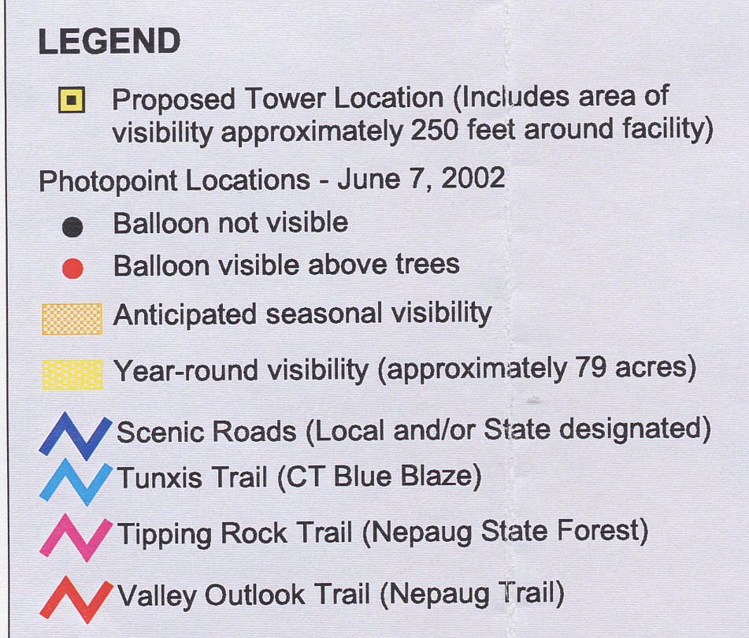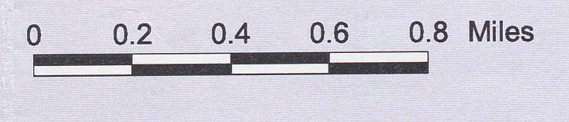
(Sprint 4)

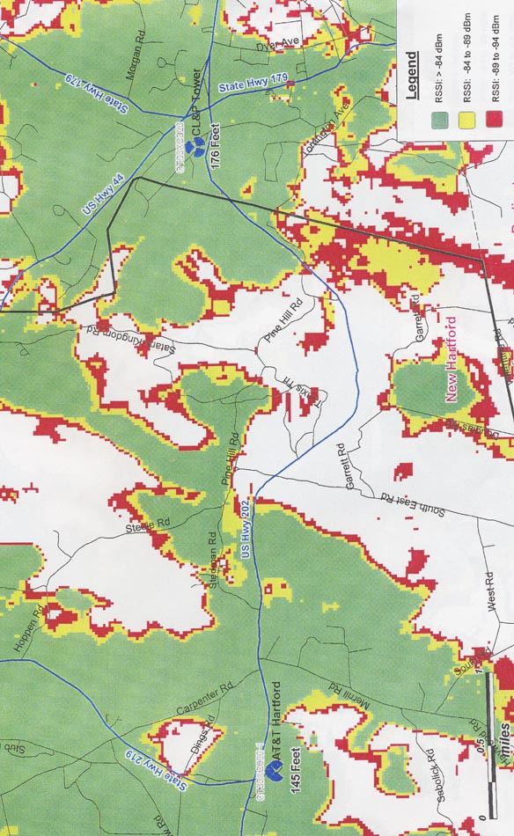
FIGURE 2

SPRINT EXISTING COVERAGE

(Sprint 1, Attachment 14)

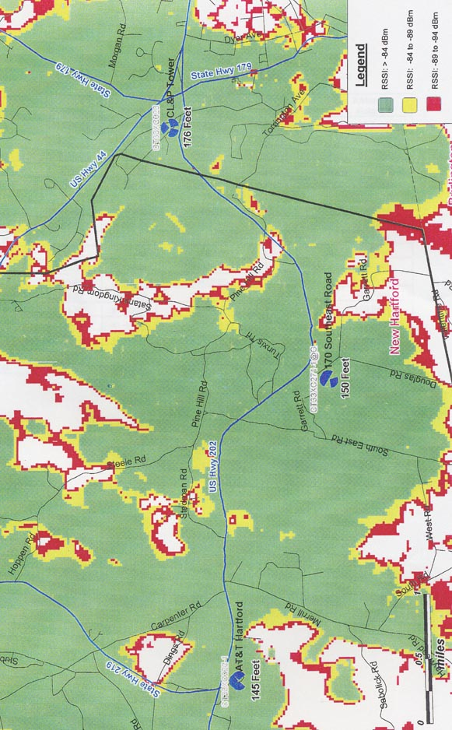
FIGURE 3

SPRINT EXISTING AND PROPOSED COVERAGE WITH ANTENNAS AT 150 FEET

(Sprint 1, Attachment 14)

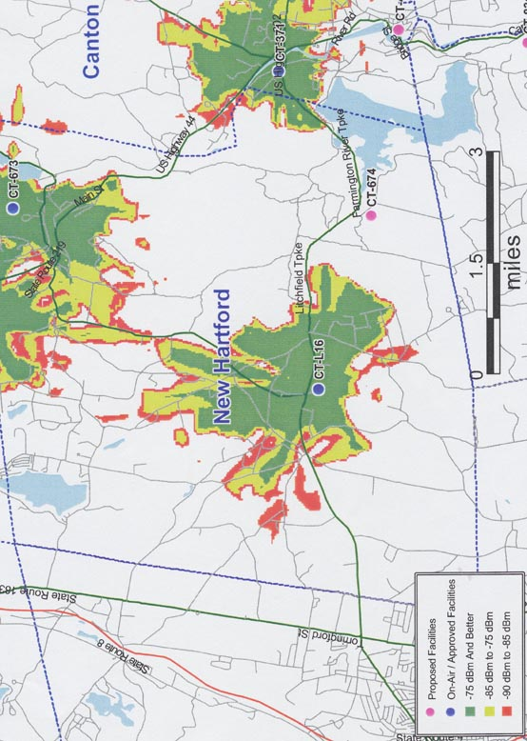
FIGURE 4

AT&T EXISTING COVERAGE

(AT&T 1, Q. 4)

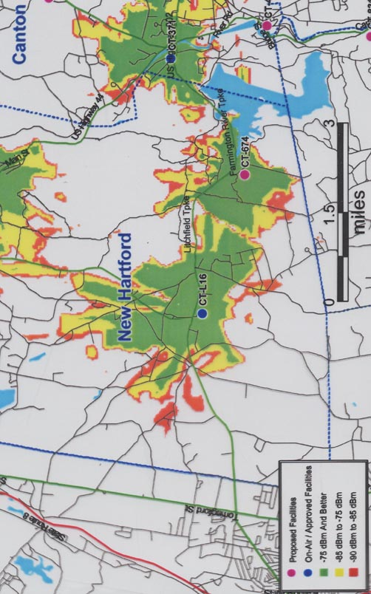
FIGURE 5

AT&T EXISTING AND PROPOSED COVERAGE WITH ANTENNAS AT 140 FEET

(AT&T 3, Q. 7)

