DOCKET NO. 248 - Tower Ventures II, LLC application for a Certificate of Environmental Compatibility and Public Need for the construction, maintenance and operation of a wireless telecommunications facility off of the Jonathan Trumbull Highway, Andover, Connecticut. | }  }  } | Connecticut  Siting  Council  October 29, 2003

Findings of Fact

Introduction

- Tower Ventures II, LLC (TV), in accordance with provisions of General Statutes §§ 16-50g through 16-50aa, applied to the Connecticut Siting Council (Council) on March 24, 2003 for the construction, operation, and maintenance of a wireless telecommunications facility at 155 Shoddy Mill Road (Town Transfer Station) or off of the Jonathan Trumbull Highway (Bunce Property), Andover, Connecticut. The applicant withdrew the site at 155 Shoddy Mill Road from Council consideration on May 30, 2003. (TV 1, p. 1; TV 6)

- The proposed site is one of three proposed to service the Route 6 corridor in Andover. The other two sites are proposed in Docket 242 by AT&T Wireless Services PCS, LLC d/b/a AT&T Wireless (AT&T) at the Andover Sportsmen Club property at 122 Jonathan Trumbull Highway (Route 6). All three sites are within 1,800 feet of each other. (TV 1, p. 7; AT&T 1, pp. 1, 2; AT&T 6, Q. 4)

- Tower Ventures is acting in the capacity of a tower developer to all wireless carriers by constructing wireless communication facilities in areas of coverage need. Two carriers, AT&T and Omnipoint Holdings, Inc. d/b/a T-Mobile (T-Mobile), have expressed a need for a facility in this area. T-Mobile has entered into a lease agreement with Tower Ventures. (TV 1, p. 6-7; TV 3, Q. 1; AT&T 1, p. 6, Attachment 3; T-Mobile 1, Q. 1)

- The parties in this proceeding are AT&T, Tower Ventures, and the Town of Andover. The intervenor in this proceeding is T-Mobile. (Transcript 1- 4:00 p.m. [Tr. 1], p. 6)

- Pursuant to General Statutes § 16-50m, the Council, after giving due notice thereof, held a public hearing on June 5, 2003, beginning at 4:00 p.m. and continuing at 7:00 p.m. in the Andover Elementary School, 35 School Road, Andover, Connecticut. (Council's Hearing Notice dated April 14, 2003; Tr. 1, p. 3)

- The Council and its staff made an inspection of the proposed site on June 5, 2003, beginning at 3:00 p.m. The applicant flew a balloon at a height of 150 feet above ground level to simulate the height of the tower during the field review. (Council's Hearing Notice dated April 14, 2003; TV 8)

- Tower Ventures discussed the proposal to construct a tower at the Bunce Property with the Andover First Selectman, Edward Turn, on November 26, 2002. Mr. Turn requested Tower Ventures to consider constructing a tower at the Town Transfer Station. Tower Ventures selected a suitable location and presented it to the Andover Planning and Zoning Commission and the Andover Board of Selectmen, both of which approved the proposal. The Town did not comment on the Bunce site except for the Inland Wetland Agent who noted the tower site might be within 100 feet of wetlands. The Town of Bolton, whose municipal boundary is located approximately 1,900 feet east of the proposed site, was notified of the proposal on February 13, 2003. Tower Ventures met with Bolton’s Building Official and Zoning Enforcement Officer, Ron Bastura, to discuss the proposal. The Town of Bolton did not comment on the application. (TV 1, pp. 21-22, Attachment E; TV 3, Q. 6; Record)

- Notice of the application was provided to all abutting landowners by certified mail. All return receipts from the certified mailings have been received. Public notice of the application was published in The Hartford Courant on March 19 and March 20, 2003 and the Willimantic Chronicle on March 18 and March 19, 2003. (TV 1, p. 3; TV 3, Q. 3)

- Pursuant to General Statutes § 16-50j (h), the following state agencies were solicited to submit written comments regarding the proposed facility on April 14 and June 6, 2003; Department of Environmental Protection (DEP), Department of Public Health (DPH), Council on Environmental Quality (CEQ), Department of Public Utility Control (DPUC), Office of Policy and Management (OPM), Department of Economic and Community Development (DECD), and the Department of Transportation (DOT). (Record)

- Comments were received from the DOT’s Office of Environmental Planning on April 7, 2003 and the DEP on June 4, 2003. The following agencies did not comment on the application: DPH, CEQ, DPUC, OPM, and the DECD. (Record)

Site Selection

- The application detailed a site search involving seven parcels, two of which were selected for site development. The five rejected sites and reasons for their rejection are as follows:
- 132 Route 6, Andover –insufficient lot size.
- 122 Route 6, Andover – leased by AT&T for sites proposed in Docket 242.
- 84 Route 6, Andover – insufficient lot size.
- Brandy Street, Bolton – difficult terrain.
- School Road, Bolton – owner unresponsive.
(TV 1, Attachment F)

- The application submitted to the Council contained two sites: the prime site, 155 Shoddy Mill Road (Town Transfer Station) and the alternate site off of the Jonathan Trumbull Highway (Bunce Property). The applicant withdrew the prime site after the DEP denied a request by the applicant to allow access from the Hop River Valley State Park Trail. No other suitable tower locations were identified on the transfer station property. (TV 5, Q. 9; TV 6)

Site Description – Bunce Property

- The proposed site is located in the southwestern portion of a 27-acre parcel owned by Donald R. Bunce. The parcel, east of Route 6 in Andover, is identified in Town records as Map 28, Block 5, Lot 3. The geographical location of the tower is identified with the latitude and longitude coordinates of 41° 45’ 18.21” N and 72° 24’ 8.86” W (NAD 1983). The elevation of the tower site is 418 feet above mean sea level (amsl). The parcel is used for the storage of timber for sale as firewood and contains an unpaved roadway extending from Route 6. The tower site is located in a wooded area southwest of the road. (TV 1, Attachment E; TV 3, Q. 4; Tr. 2, pp. 82-83)

- Access to the proposed site would be from a 12-foot wide, 360-foot long gravel drive of new construction extending from an existing dirt road on the property. Above ground utilities would be installed along the existing road from a utility pole on Route 6 for a distance of 290 feet and then underground along the road and along the east side of the access drive to the compound. The above ground utilities would require the installation of two utility poles along the existing dirt road. (TV 1, Attachment E)

- The proposed facility would consist of a 150-foot monopole within a 100-foot by 100-foot leased area. The tower would be designed to support 6 levels of flush-mounted antennas with a 10-foot center-to-center vertical separation. The tower would be painted brown. A 75-foot by 75-foot compound enclosed by an eight-foot high chain link fence would be established at the base of the tower. The size of the compound would be able to accommodate the equipment of six wireless carriers. (TV 1, pp. 5-6, Attachment E; Tr. 2, pp. 84-85)

- T-Mobile would place 3 flush-mounted panel antennas on the tower at a centerline height of 150-feet and install radio equipment on a 10-foot by 20-foot concrete slab within the compound. (TV 1, Attachment E; TV 3, Q. 1, Q. 9)

- The proposed site is zoned Industrial. The Town’s zoning regulations permit telecommunication towers in Industrial Zone districts, subject to issuance of a Special Permit. Town zoning regulations rank Industrial Zones fourth out of seven location preference categories. Land use in the area includes undeveloped land to the south and west, residential to the north, commercial development to the northeast along Route 6, agricultural and residential to the east, and commercial and residential to the southeast. The nearest property line from the compound site is 53 feet to the southwest. (TV 1, Attachment E; TV 2, b)

- The nearest building to the tower site, a commercial structure along Route 6, is approximately 750 feet to the northeast. The nearest residence is approximately 1,000 feet north of the tower site. (TV 1, p. 17, Attachment E)

- The tower setback radius would extend by 26 feet onto the Hop River Valley Railroad State Park Trail, located southwest of the site. Tower Ventures would design the tower with a pre-engineered fault at 120 feet agl. (TV 1, Attachment E; TV 9)

20. The estimated construction cost for the proposed facility is as follows:

Site Acquisition 10,000
Siting 43,000
Construction 157,621

Total $210,621
(TV 1, p.19)

Environmental, Historic, and Safety Concerns

- The proposed facility would have no effect on historic resources listed on the National Register of Historic Places. (TV 10; Tr. 2, pp. 61-62)

- The Wood Turtle (Clemmys insculpta), a State Species of Special Concern, occurs in the vicinity of the proposed site. Tower Ventures would address any concerns raised by the DEP to minimize potential impacts to turtle populations. (TV 1, p. 14, Attachment H)

23. Construction of the access road and compound would require the removal of approximately 22 trees six inches or greater in diameter at breast height. (TV 5, Q. 5)

- Construction of the access road and compound and the installation of utilities would not impact any designated wetland areas. The nearest wetland to the site development area is approximately 305 feet to the north. (TV 1, p. 10, Attachment E)

- The closest airfield to the proposed site is the Heckler Field Airport, approximately 3.48 nautical miles from the site. Obstruction marking and lighting of the tower would not be required. (TV 1, Attachment D)

- The electromagnetic radiofrequency power density, calculated using the FCC Office of Engineering and Technology Bulletin 65, August 1997, using conservative worst-case approximation of radiofrequency power density levels at the base of the tower, T-Mobile antennas transmitting simultaneously on all channels at full power, would be 2.8 percent of the American National Standards Institute (ANSI) and National Council on Radiation Protection and Measurements standards. (TV 1, Attachment E)

Visibility

- A visibility analysis of the proposed facility was performed using computer aided spatial analysis techniques and field studies. A facility at the Bunce site would be visible from approximately 38 acres of an 8,042-acre study area. Approximately 6,714 acres of the study area were classified as forested with an average estimated tree height of 65 feet. The tower is not considered visible from forested areas. A map depicting the visibility of the proposed tower is included as Figure 1. (TV 1, Attachment E)

- Seasonal visibility of the tower is anticipated from portions of the following roads:
- 0.25 mile section of Hutchinson Road (rural residential) approximately 0.2 miles east of the site.
- 0.1 mile section of Hendee Road (rural residential), approximately 0.5 miles east of the site.
- 0.1 mile section of Burnap Brook Road (rural residential), approximately 0.5 miles south of the site.
(TV 1, Attachment E)

- Year-round visibility of the proposed tower is anticipated from portions of the following roads:
- 0.1 mile section of Route 6 (commercial), approximately 0.25 miles north of the site.
- 0.1 mile section of Route 6 (commercial), approximately 0.15 miles east of the site.
- <0.1 mile section of South Road (agricultural), approximately 1.0 miles north of the site.
- <0.1 mile section of Pine Ridge Drive (residential), approximately 0.6 miles east of the site.
- <0.1 mile section of Hendee Road (agricultural), approximately 0.4 miles north of the site.
(TV 1, Attachment E; Tr. 2, pp. 31-33)

30. The tower would not be visible from Hickory Drive, a residential development 0.2 miles north of the site, or Aspinall Drive, a residential development 0.3 miles south of the site. (TV 1, Attachment E, Tr. 2, p. 33)

- The Hop River Valley Railroad State Park Trail is approximately 55 feet southwest of the compound. The compound area is at a slightly lower elevation than the trail. The tower site is 124 feet from the trail. The lower portion of the tower and compound area would be visible from approximately 200 feet of the trail. To mitigate potential views, Tower Ventures intends to paint the tower brown. Tower Ventures could reconfigure the compound in a linear arrangement to provide a greater buffer to the trail or install the compound at the base of a rock ledge immediately east of the tower to further reduce the visual impact as viewed from the trail. Vegetation or decorative fencing could be installed to provide screening. (TV 1; Attachment E; TV 4, Q. 6; Tr. 2, pp. 25-30, 67-68; 85-87)

32. Seasonal visibility of the tower is anticipated in the vicinity of White’s Tavern, a historically significant property approximately 0.3 miles east of the site. (TV 1, Attachment E)

33. The Town of Andover prefers a tower with a flush mounted antenna design. (Tr. 1, pp. 8-9)

T-Mobile - Existing and Proposed Wireless Coverage

- T-Mobile has identified an area of coverage need along the Route 6 corridor in Andover. A facility at one of the three sites proposed in Docket 242 and Docket 248 would allow for contiguous coverage from an approved AT&T facility at 49 South Road in Bolton (Docket 240), and an existing facility at 104 Bunker Hill Road in Andover. (T-Mobile 1, Q. 1; Tr. 2, p. 97-98

- T-Mobile’s system operates at a frequency of 1935-1945 MHz and a minimum signal level threshold of –85 dBm. (T-Mobile 1, Q. 2)

- T-Mobile identified a 2.0-mile gap in coverage on Route 6 between the approved Bolton facility and existing Andover facility (see Figure 2). (T-Mobile 1, Q. 4 – plot 11)

- Installing antennas at the 150-foot level of the Bunce site tower would reduce the gap in coverage between the approved Bolton facility and existing Andover facility to 0.4 miles (Figure 3). The remaining gap is the caused by a hill north of the site that prevents a signal from penetrating farther to the north. T-Mobile believes the gap would have a minor effect on service, probably not noticeable to the average wireless user. (T-Mobile 1, Q. 4 – plots 7, 11; Tr. 2, pp. 100, 102-103)

- Installing antennas at the 130-foot level of the Bunce site tower would result in a slight reduction in coverage on local roads east of the site and no reduction in coverage on Route 6. (T-Mobile 1, Q. 4 - plots 8, 11)

- T-Mobile does not have a preference for any of the three sites proposed in Docket 242 or Docket 248 since coverage does not differ significantly between the three. (Tr. 1, p. 101)

AT&T - Existing and Proposed Wireless Coverage

- AT&T has identified a gap in coverage on Route 6 in Andover between the approved Bolton facility and an existing Andover facility. AT&T subsequently conducted a site search and selected two sites for telecommunication development. The selected sites were submitted to the Council in a Certificate application designated as Docket 242. (AT&T 1, p. 1)

- AT&T operates in the FCC assigned D & E 1900 MHz frequency bands and at minimum signal level threshold of –85 dBm. (AT&T 1, Attachment 2; AT&T 3, Q. 2)

- AT&T identified a 2.4 mile gap in coverage on Route 6 in Andover between the approved Bolton facility and the existing Andover facility. (AT&T 3, Q. 1)

- Installing antennas at the 140-foot level of the Bunce site tower would provide 1.9 miles of coverage to the gap area – See Figure 4. A gap of 0.25 miles would be present between the Bunce site and the approved Bolton site to the north. Drive test data indicates there would be no gap in coverage between the Bunce site and the existing Andover site to the south. (AT&T 3, Q. 4; AT&T 6, Q. 5; AT&T 9; Tr. 1, pp. 19-21)

- AT&T prefers to locate antennas at one of the two sites proposed in Docket 242. The Docket 242 sites are at a higher ground elevation than the Bunce site which increases the probability a RF signal could surpass a hill to the north. (Tr. 1, pp. 32-34, 110-111)

- AT&T would utilize the proposed Bunce site if the site was approved by the Council and constructed. (Tr. 2, pp. 108-109)

FIGURE 1

VISIBILITY OF PROPOSED BUNCE SITE TOWER

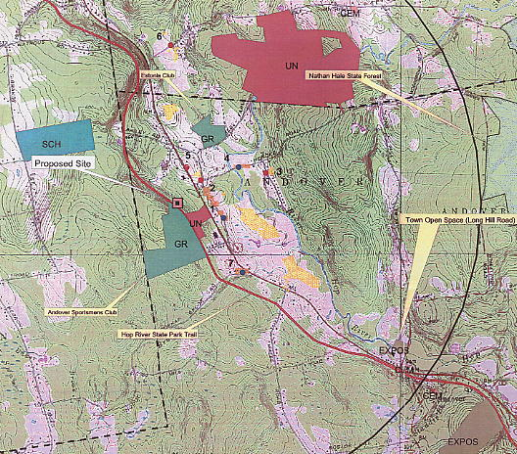

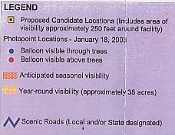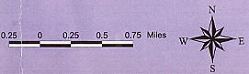

(TV 1, Attachment E)

FIGURE 2

T-MOBILE EXISTING COVERAGE

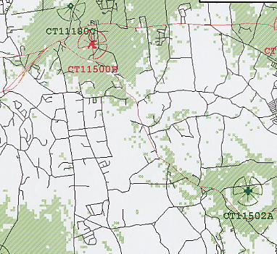

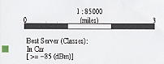

(T-Mobile 1, Q. 4)
FIGURE 3

T-MOBILE EXISTING AND PROPOSED COVERAGE WITH
ANTENNAS AT 150 FEET AGL

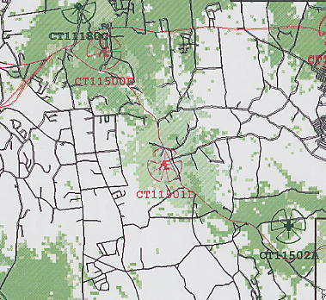

(T-Mobile 1, Q. 4)

FIGURE 4

AT&T EXISTING AND PROPOSED COVERAGE WITH
ANTENNAS AT 140 FEET AGL

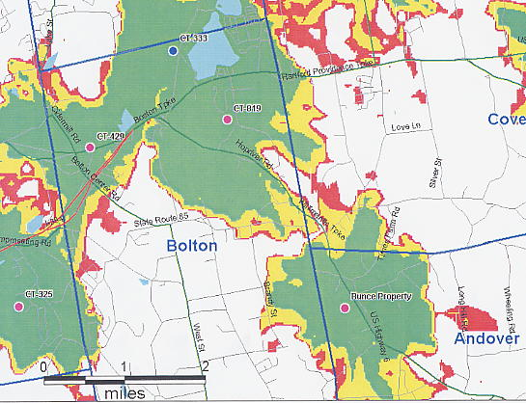

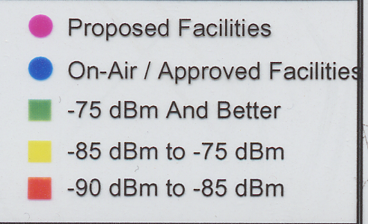

(AT&T 6, Q. 5)

