DOCKET NO. 243 - Omnipoint Facilities Network 2, L.L.C., a subsidiary of T-Mobile, USA, Inc. application for a Certificate of Environmental Compatibility and Public Need for the construction, maintenance and operation of a wireless telecommunications facility at 270 Valley Road, New Canaan, Connecticut. | }  }  } | Connecticut  Siting  Council  October 26, 2004

Findings of Fact (Reopening)
Introduction

- Omnipoint Facilities Network 2, LLC a subsidiary of T-Mobile, USA, Inc. (T-Mobile), in accordance with provisions of General Statutes §§ 16-50g through 16-50aa applied to the Connecticut Siting Council (Council) on February 25, 2003 for the construction, operation, and maintenance of a wireless telecommunications facility at 270 Valley Road, New Canaan, Connecticut. The application was denied by the Council on February 18, 2004. (T-Mobile 1, p. 1)

- On June 23, 2004, the Council voted to reopen this application for the limited purpose of considering a site for a tower facility at 208 Valley Road in New Canaan, on property owned by the Silver Hill Foundation, Inc. which is the location of Silver Hill Hospital (Silver Hill). (record)

- T-Mobile is licensed by the Federal Communications Commission (FCC) to provide wireless personal communication service (PCS) in Connecticut. T-Mobile is licensed to operate at 1900 MHz PCS frequencies. (T-Mobile 8, Tab 7)

- The purpose of the proposed Silver Hill facility is to provide coverage to the existing gap along Route 106. (T-Mobile 8, Tab 7)

- The parties in this proceeding are the applicant, Marie Louise Brown, Iona C. Hubbard, the Citizens for Responsible Cellular Planning, Dayton Ogden, Jr. and Margaret R. Ogden, the Town of New Canaan, and the First Taxing District of the City of Norwalk (Water Department). The intervenors are AT&T Wireless PCS, LLC d/b/a AT&T Wireless, Diane M. Baldwin, Janet Z. Congdon, John D. Hough and Sally N. Hough, and Nancy G. Neuser and Gary A. Neuser. (Transcript 5, 4:00 p.m., 07/15/04 (Tr. 5), pp. 5-7; Transcript 6, 7:00 p.m., 07/15/04 (Tr. 6), pp. 5, 6)

- Pursuant to General Statutes § 16-50m, the Council, after giving due notice thereof, held a public hearing for the reopened proceeding on July 15, 2004, beginning at 4:00 p.m. and continuing at 7:00 p.m. in the auditorium of the New Canaan Town Hall, 77 Main Street, New Canaan, Connecticut. (Tr. 5, p. 3; Tr. 6, p. 3)

- The Council and its staff made inspections of the proposed Silver Hill site on July 15, 2004, beginning at 3:00 p.m. The applicant flew a balloon, from 12:00 p.m. to 7:00 p.m., approximately 50 feet to the southwest of the proposed site to simulate the height of the tower proposed at this location. The balloon was flown to a height of 126 feet above ground level (agl) to compensate for the six foot decrease in elevation. (Tr. 6, p. 127)

- T-Mobile located the proposed facility to provide wireless telecommunications service to the eastern portion of New Canaan and the western portion of Wilton. (T-Mobile 1, p. 6)

- On June 14, 2004, notice of the proposed Silver Hill site was provided to all abutting landowners. Notice of the proposed Silver Hill site was sent to all parties and intervenors and local and State officials via Certified Mail on June 14, 2004. Public notice of the application was published in The Stamford Advocate on June 15, and June 16, 2004 and in the New Canaan News-Review on June 17, and June 24, 2004. (T-Mobile 8, Tab 5, Tab 6, Tab 7; Affidavit of Publications)

- Pursuant to General Statutes § 16-50j (h), the following State agencies were solicited to submit written comments regarding the proposed facility on June 29, 2004; Department of Environmental Protection (DEP), Department of Public Health (DPH), Council on Environmental Quality (CEQ), Department of Public Utility Control (DPUC), Office of Policy and Management (OPM), Department of Economic and Community Development (DECD), and the Department of Transportation (DOT). (record)

- Responses were received from the DPH on July 7, 2004 and the DOT on July 7, 2004 both stating that they have no comments on the reopened application. (record)

- The following agencies did not offer comments on the application: DEP, CEQ, DPUC, OPM, and DECD. (record)

Telecommunications Act

- In issuing cellular licenses, the federal government has preempted the determination of public need for cellular service by the states, and has established design standards to ensure technical integrity and nationwide compatibility among all systems. (Council Admin. Notice, no. 7, Telecom. Act 1996)

- In 1996, the United States Congress recognized a nationwide need for high quality wireless telecommunications services, including cellular telephone service. Through the Federal Telecommunications Act of 1996, Congress seeks to promote competition, encourage technical innovations, and foster lower prices for telecommunications services. (Council Admin. Notice, no. 7, Telecom Act 1996)

- The Telecommunications Act of 1996 prohibits local and State entities from discriminating among providers of functionally equivalent services. (Council Admin. Notice, no. 7, Telecom. Act 1996)

- The Telecommunications Act of 1996, a federal law passed by the United States Congress, prohibits any State or local agency from regulating telecommunications towers on the basis of the environmental effects of radio frequency emissions to the extent that such towers and equipment comply with Federal Communications Commission’s (FCC) regulations concerning such emissions. This Act also blocks the Council from prohibiting or acting with the effect of prohibiting the provision of personal wireless service. (Council Admin. Notice, no. 7, Telecom. Act 1996)

Site Search

- There are no existing structures within the search ring that would be suitable for the location of wireless telecommunications equipment. (T-Mobile 8, Tab 7)

- During the original Docket No. 243 proceeding, T-Mobile was aware that the Silver Hill site was technologically viable and the preferred option of the parties and intervenors of the docket. At the time, the Silver Hill property was not available for lease. (T-Mobile 8, Tab 7)

- T-Mobile has since reached an agreement with Silver Hill to construct, operate and maintain a wireless telecommunications facility on the Silver Hill Hospital property. T-Mobile, the Town of New Canaan, and the abutting landowners of Silver Hill Hospital are in agreement that this site has less visual impact than the originally proposed site. (T-Mobile 8, Tab 7)

- T-Mobile analyzed three locations on the Silver Hill property, including the proposed site. The rejected locations include a site on the southwest corner of the property and a site located approximately 50 feet to the southwest of the proposed site. (Tr. 6, p. 105)

Site Description

- T-Mobile proposes to construct a 120-foot silhouette pole at the proposed Silver Hill site, which would contain up to three sets of antennas within the pole. T-Mobile would locate antennas at the 117-foot level. Space would remain available at the 107-foot level and the 97-foot level for future carriers. The silhouette pole would be painted brown. (T-Mobile 8, Tab 1; Tr. 5, pp. 13, 30)

- T-Mobile could design the 120-foot silhouette pole to support a future additional extension if the Council so ordered. (Tr. 6, p. 114)

- The proposed Silver Hill site would include a 60-foot by 40-foot compound within a 75-foot by 75-foot leased area. The equipment compound would be enclosed by a six-foot high chain link fence with a stockade gate. Eight-foot high arborvitae or similar shrubs would be planted around the compound. T-Mobile would install equipment on a five-foot by ten-foot concrete pad. A gravel surface would be established within the tower compound. (T-Mobile 8, Tab 1, Tab 3; Tr. 5, p. 13)

- Utilities would run underground to the north of the access road from an existing utility pole located on Valley Road. (T-Mobile 8, Tab 1)

- The proposed Silver Hill site would be located on an approximately 42 acre parcel owned by the Silver Hill Foundation, Inc. The parcel is zoned as two-acre residential. (T-Mobile 8, Tab 3)

- The proposed Silver Hill site is located approximately 102 feet from the originally proposed site on the Water Department property at 270 Valley Road. (Tr. 5, p. 43)

- The ground elevation at the proposed Silver Hill site is approximately 265 feet above mean sea level (amsl). (T-Mobile 9, viewshed analysis)

- The proposed Silver Hill site is located approximately 94 feet south of the Water Department property. The tower setback radius would extend onto the Water Department property by approximately 26 feet. T-Mobile could design the silhouette pole with a yield point that would allow the tower to collapse upon itself and remain within the tower setback radius. (T-Mobile 8, Tab 1; Tr. 6, p. 135)

- Access to the proposed site would be from an existing paved drive extending from Valley Road for approximately 630 feet, then continuing an additional 42 feet to the compound. (T-Mobile 8, Tab 3)

- AT&T Wireless has expressed interest in locating equipment at the proposed facility. (Tr. 6, p. 113)

- T-Mobile would make reasonable space available on the proposed silhouette pole for municipal antennas, at no cost to the Town. (Tr. 6, pp. 115, 116)

- The Water Department has a need for a facility on which to locate a Supervisory Control and Data Acquisition (SCADA) antenna; however the Water Department prefers not to locate equipment outside of their property due to security concerns. If the proposed Silver Hill site was approved by the Council, the Water Department would give consideration to locating on that structure but currently intends to apply for an additional tower structure on the Water Department property. (Tr. 6, pp. 57, 60, 92)

- There are approximately 26 properties within a 1,000-foot radius of the proposed site. (T-Mobile 8, Tab 3)

Environmental Considerations

- The State Historic Preservation Office has determined that the proposed facility would have no effect on historic, architectural, or archaeological resources listed on or eligible for the National Register of Historic Places. (T-Mobile 8, Tab 8)

- The proposed project would not likely affect threatened or endangered species or critical habitats, based on a National Environmental Policy Act (NEPA) review using the Connecticut Department of Environmental Protection Natural Diversity Database. (T-Mobile 8, Tab 8)

- Approximately nine trees would have to be removed for the construction of the proposed Silver Hill site and access road. The number of trees to be removed could be reduced by building a retaining wall along the west side of the compound, which could be determined by the Council in the Development and Management (D&M) Plan. (T-Mobile 8, Tab 3; Tr. 5, pp. 16, 22-24)

- There are no wetlands in the vicinity of the proposed site. (T-Mobile 8, Tab 3)

- The applicant performed an air-space analysis for the originally proposed facility, which determined that the site would not constitute an obstruction or hazard to air navigation. The proposed tower would not require hazard lighting or paint striping. (T-Mobile 1, p. 26)

- The electromagnetic radio frequency power densities, calculated using the FCC Office of Engineering and Technology Bulletin 65, using conservative worst-case approximation of radio frequency power density levels at the base of each tower assuming all antennas are pointed at the base of the tower and all channels are operating simultaneously, would be 6.4 percent of the American National Standards Institute (ANSI) Standard for the proposed site. (T-Mobile 1, p. 13, Tab 1)

Visibility

- A field investigation was used to perform a viewshed analysis of an approximately 8,035-acre (two mile radius) area around the proposed facility. The analysis concludes that approximately 0.20% of the two-mile area would have at least a partial view of the proposed tower. Visibility of the proposed structure would primarily impact the immediate area; specifically a portion of Valley Road to the northwest and southeast of the proposed site. The surrounding tree height ranges from 70-95 feet agl and consists primarily of hardwoods and pines. A map depicting the visibility of the proposed tower is included as Figure 1. (T-Mobile 9, Viewshed Analysis)

- The proposed silhouette pole would be visible from approximately three to four residences. (Tr. 6, p. 128)

- The visibility of the proposed tower, based on photographs taken of a balloon flown at 120 feet agl from public roadways, would be as follows:

Visibility of Proposed 120-foot Tower

Location | Visibility | Approx. Portion of Tower Visible (ft.) | Approx. Distance (ft.) and direction
Valley Road | Yes | 25 | 475 NW
Valley Road | Yes | 50 | 317 E
Valley Road | Yes | 50 | 1,056 SE
Valley Road | No | None | 265 N
Valley Road | No | None | 898 SE
Wardwell Drive | No | None | 580 SW
Salem Road | No | None | 1,478 S
Devon Wood Lane | No | None | 2,006 SW
Intersection of Valley Road and Ferris Hill Road | No | None | 2,640 NW
Fawn Lane | No | None | 3,170 N
Turning Mill Lane | No | None | 1,162 NE
East Hills Drive | No | None | 7,392 SW
Intersection of Valley Road and Benedict Hill | No | None | 10,032 NW
Intersection of Old Kings Hwy. and Perry Avenue | No | None | 8,765 NW
(T-Mobile 9, Viewshed Analysis)

Existing and Proposed Wireless Coverage
T-Mobile Coverage

- T-Mobile operates a personal communications service network using a 1900 MHz frequency signal allocated by the FCC. T-Mobile designs the system for in-vehicle coverage with a minimum signal level threshold of -85 dBm, but also intends to provide coverage for in-building uses, with a minimum signal level threshold of -76 dBm for residential structures and -70 dBm for commercial structures. (T-Mobile 1, p. 3; T-Mobile 4 , Tr. 1, p. 89, 93)

- Adjacent existing T-Mobile facilities that would interact with the proposed facility are as follows:

Location | Antenna Height agl (ft)
39 Locust Avenue, New Canaan | 46
46 Fenwood Lane, Wilton | 122
(T-Mobile 2, Q. 2; T-Mobile 3, Q. 23)

- Use of alternative technologies like microcells, or the use of smart antennas or multiplexing, which would allow multiple carriers to share the same antenna, would not be adequate to provide coverage to this area. (T-Mobile 1, p. 24, 25)

- The proposed silhouette structure would provide coverage similar to a traditional monopole structure. A traditional monopole can accommodate multiple carriers with a ten-foot separation between each carrier. Some carriers prefer to occupy two levels on a silhouette pole to accommodate additional antennas allowing for greater capacity. A traditional monopole could accommodate more carriers than a silhouette structure of the same height. (T-Mobile 2, Q. 14; Tr. 6, p. 116, 133)

- To maintain operations during power outages, the proposed site would include a battery back-up system. During a substantial power outage, a gas generator may be brought to the proposed site. (T-Mobile 2, Q. 21)

- Existing T-Mobile facilities in New Canaan and Wilton leave gaps in wireless coverage in the eastern New Canaan and western Wilton area. T-Mobile uses the minimum signal level threshold of –85 dBm. Existing gaps in coverage, at 1900 MHz, within a three-mile radius of the proposed site are presented in the table below.

Existing Coverage

(see Figure 2)

Route | Existing Gaps (miles)  < -85 dBm | Total Road Miles within a Three Mile Radius
106 | 2.7 | 4.6
Total | 2.7 miles | 4.6 miles
(T-Mobile 8, Supplemental, Exhibit B)

- Existing coverage combined with antennas on the proposed tower at 139 feet agl, at 1900 MHz, would leave the following gaps within a three mile radius of the proposed site as follows:

Proposed Site at 117 Feet agl

(see Figure 3)

Route | Gaps (miles)  < -85 dBm | Total Road Miles within a Three Mile Radius
106 | 1.1 | 4.6
Total | 1.1 miles | 4.6 miles
(T-Mobile 8, Supplemental, Exhibit B)

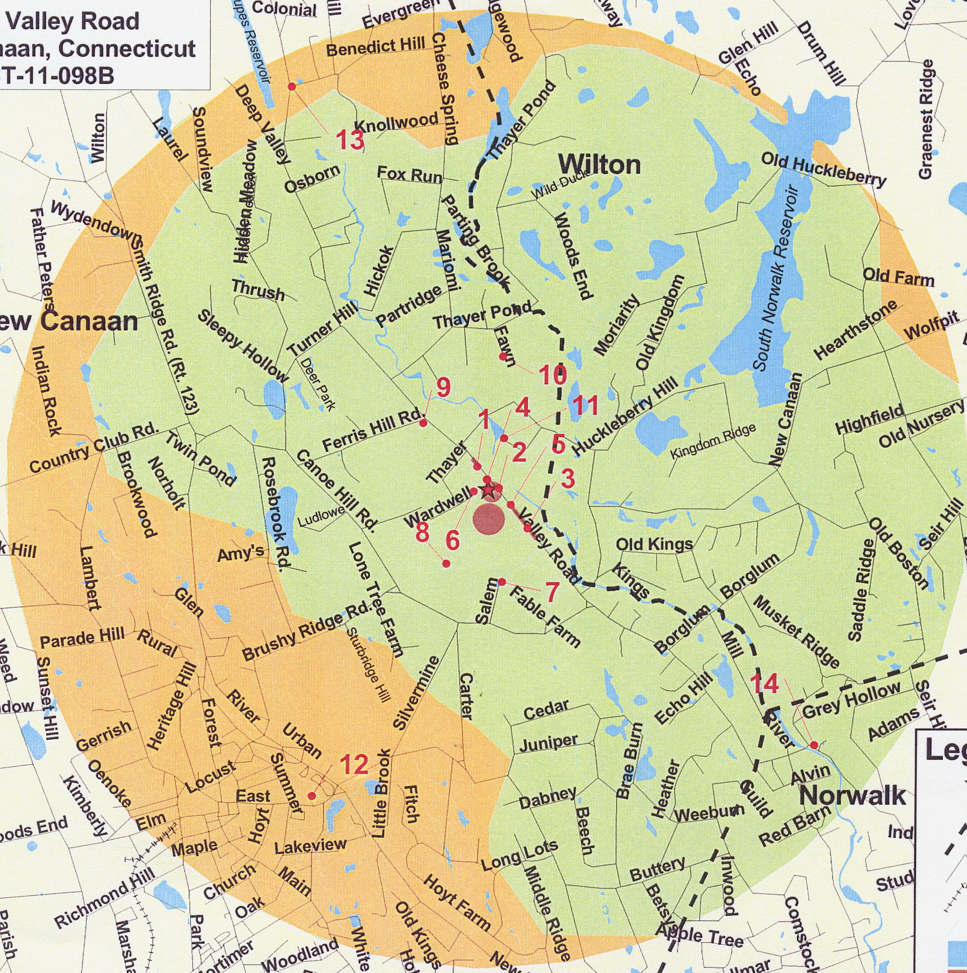

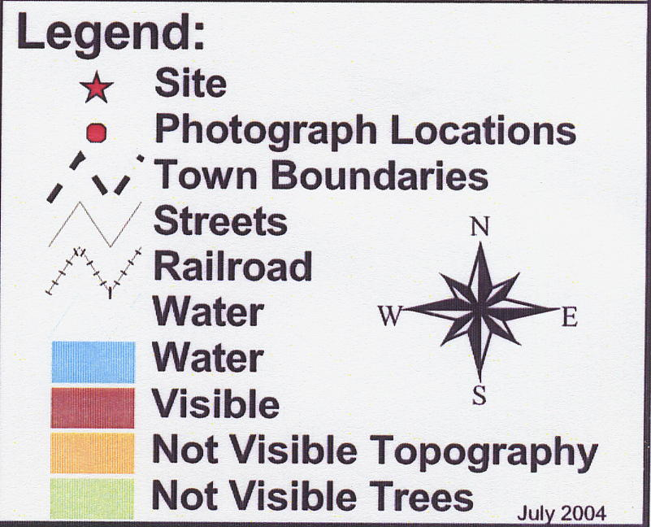

Figure 1. Viewshed Analysis for the proposed T-Mobile site. (T-Mobile 9, Viewshed Analysis)

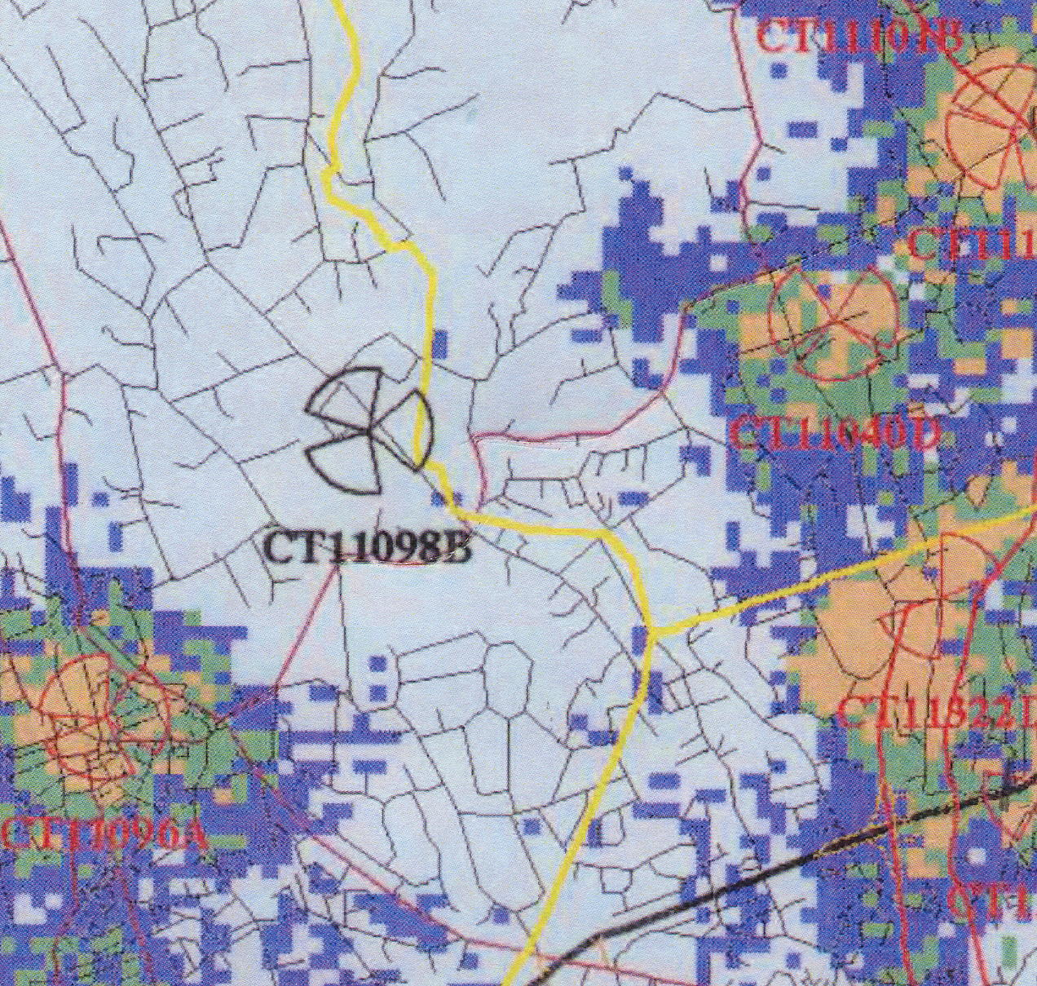

Figure 2. Existing T-Mobile Coverage in New Canaan at a scale of 1:60,000. (T-Mobile 8,
Supplemental, Exhibit B)

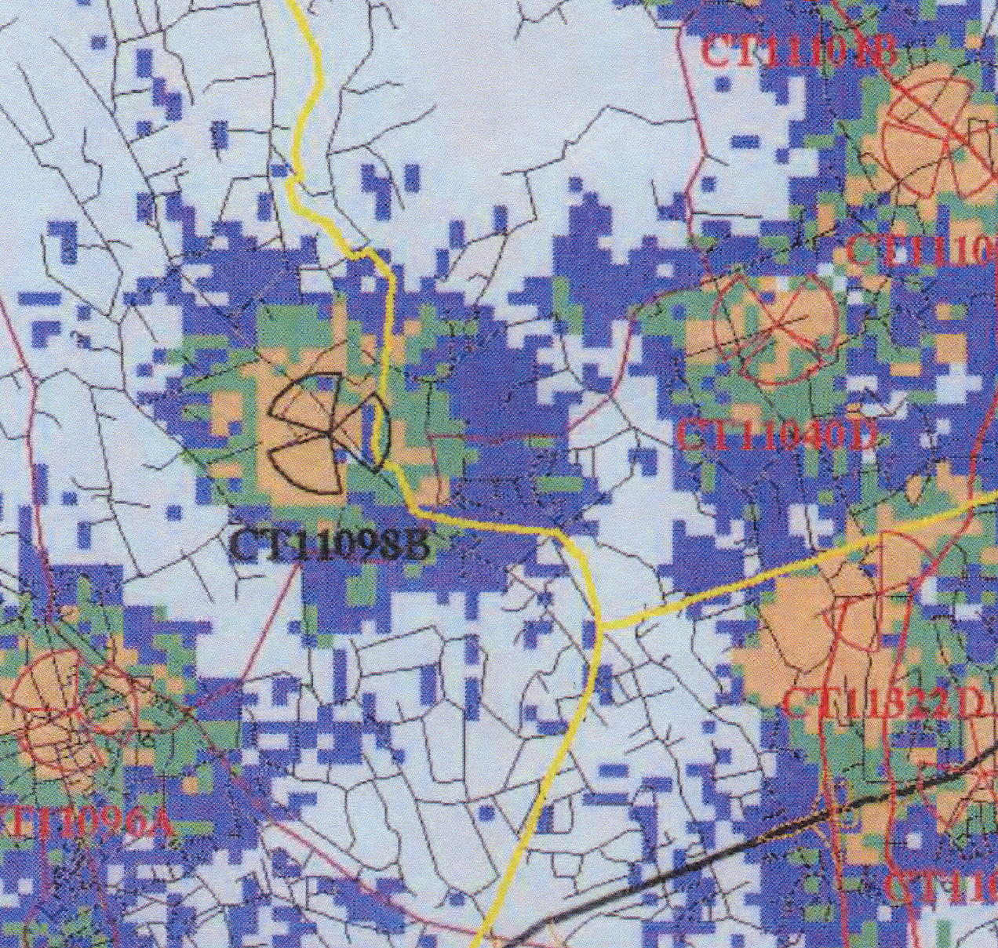

Figure 3. Existing T-Mobile coverage with coverage from the proposed site at 117 feet agl at a scale of
1:60,000. (T-Mobile 8, Supplemental, Exhibit B)

