DOCKET NO. 242 - AT&T Wireless PCS, LLC d/b/a AT&T Wireless application for a Certificate of Environmental Compatibility and Public Need for the construction, maintenance and operation of a wireless telecommunications facility at one of two sites at 122 Route 6 (Andover Sportsmen Club), Andover, Connecticut. | }  }  } | Connecticut  Siting  Council  October 14, 2003

Findings of Fact

Introduction

- AT&T Wireless PCS, LLC d/b/a AT&T Wireless (AT&T), in accordance with provisions of General Statutes §§ 16-50g through 16-50aa, applied to the Connecticut Siting Council (Council) on January 29, 2003 for the construction, operation, and maintenance of a wireless telecommunications facility at one of two locations at 122 Route 6 (Andover Sportsmen Club) Andover, Connecticut. (AT&T 1, pp. 1-2)

- The parties in this proceeding are AT&T, Tower Ventures II, LLC (Tower Ventures) and the Town of Andover. The intervenor in this proceeding is Omnipoint Holdings, Inc. d/b/a T-Mobile (T-Mobile). (Transcript 1- 4:00 p.m. [Tr. 1], p. 6)

- An area of coverage need on Route 6 has been identified by AT&T and T-Mobile. Three tower locations have been proposed to service this need, two of which have been presented by AT&T in this application and referred to as Site A and Site B. The third site, referred to as the Bunce Site, is proposed by Tower Ventures II, LLC in Docket 248 at the Bunce Property on Route 6 in Andover. All three sites are within 1,800 feet of each other. ( AT&T 1, pp. 1- 2; AT&T 6, Q. 4; TV 1, p. 7)

- Pursuant to General Statutes § 16-50m, the Council, after giving due notice thereof, held a public hearing on June 5, 2003, beginning at 4:00 p.m. and continuing at 7:00 p.m. in the Andover Elementary School, 35 School Road, Andover, Connecticut. (Council's Hearing Notice dated April 14, 2003; Tr. 1, p. 3)

- The Council and its staff made an inspection of the proposed site on June 5, 2003, beginning at 3:00 p.m. During the field inspection, the applicant flew at proposed Site A to a height of 150 feet above ground level (agl) and a balloon at proposed Site B to a height of 170 feet agl. (Council's Hearing Notice dated April 14, 2003; Transcript 2 – 7:00 p.m. [Tr. 2], pp. 33-34)

- AT&T submitted a technical report describing the proposal to the First Selectman of the Town of Andover, Edward Turn, on October 10, 2002. The Town’s Planning and Zoning Commission submitted written comments to AT&T on November 4, 2002. The correspondence requested that AT&T comply with the Town’s requirements for site landscaping, access drive construction, facility setbacks, lighting, signage, and noise. The Town’s Inland Wetlands Agent provided written comment to AT&T on December 10, 2002. The correspondence noted the proposal would require a wetlands permit if the town had jurisdiction in this matter. (AT&T 1, pp. 19-20, Attachment 8)

- The Town of Bolton, located approximately 1,100 feet west of proposed Site A, was notified on the proposal on October 10, 2002. AT&T submitted a technical report describing the proposal to Bolton’s First Selectman Robert Morra. The Town of Bolton did not comment on the application. (AT&T 1, pp. 19-20, Attachment 8)

- Notice of the application was provided to all abutting landowners by certified mail. Notice was unclaimed by two abutters and a third abutter refused mail delivery. Public notice of the application was published in The Hartford Courant on January 24 and January 26, 2003. (AT&T 1, p. 4; AT&T 3, Q. 4; AT&T letter dated May 19, 2003)

- Pursuant to General Statutes § 16-50j (h), the following state agencies were solicited to submit written comments regarding the proposed facility on February 27, April 14 and June 6, 2003; Department of Environmental Protection (DEP), Department of Public Health (DPH), Council on Environmental Quality (CEQ), Department of Public Utility Control (DPUC), Office of Policy and Management (OPM), Department of Economic and Community Development (DECD), and the Department of Transportation (DOT). (Record)

- Comments were received from the DOT’s Office of Environmental Planning on March 18, 2003 and the DEP on June 3, 2003. The following agencies did not comment on the application: DPH, CEQ, DPUC, OPM, and the DECD. (Record)

Site Selection

- The application detailed a site search involving six parcels in Andover, one of which was selected for site development. The five rejected sites and reasons for their rejection are as follows:
- 144 Route 6 (Andover Plaza) – limited area for development, adjacent to a residential area.
- 132 Route 6 (Hillside Storage) – limited area for development.
- 5 Hendee Road (Andover Country Garden) – unresponsive property owner.
- Burnap Brook Road (Town Transfer Station) – did not meet coverage objectives.
- Times Farm Road (Channel 3 Kids Camp) – did not meet coverage objectives.
(AT&T 1, Attachment 4)

Site Description – Site A

- Proposed Site A is located in the central portion of a 67-acre parcel owned by the Andover Sportsmen Club, Inc. The parcel, west of Route 6 in Andover, is identified in Town records as Map 28, Block 5, Lot 4 and Map 28, Block 4, Lot 3. The wooded property is used for recreation and contains shooting ranges, a clubhouse, several outbuildings, and a gravel driveway. The Hop River Valley Railroad State Park Trail traverses the eastern portion of the property. (AT&T 1, Attachment 5; AT&T 3, Q. 13; AT&T 6, Q. 1)

- The property is zoned Industrial from Route 6 to the state park trail. West of the state park trail, the property is zoned residential, R-40. Both the proposed Site A and Site B lease areas are within the R-40 Zone. Town’s zoning regulations permit telecommunication towers in R-40 Zone districts, subject to issuance of a Special Permit. Town zoning regulations use a scaled ranking system of seven categories for the preferred placement of telecommunication equipment. The scale, with one being most preferred and seven being least preferred, ranks residential zones adjacent to an industrial district, sixth. (AT&T 3, Q. 9; Tr. 1, pp. 13-14; AT&T 2, a)

14. The tower site is located in a black birch and white oak forest with an understory of hickory, chestnut, and beech. The surrounding terrain is wooded and level to the north, south, and west. The terrain slopes downward to the east. The site is approximately 100 feet south of the parking lot for the upper shooting range and clubhouse. The geographical location of the tower is identified with the latitude and longitude coordinates of 41° 45’ 00.46” N and 72° 24’ 9.63” W (NAD 83). The elevation of the tower site is 496 feet above mean sea level (amsl). (AT&T 1, Attachment 5; DEP comments dated June 3, 2003)

- Access to proposed Site A would be from a 12-foot wide, 95-foot long gravel drive of new construction extending from an existing dirt road on the property. Underground utilities would be installed from existing utility service on the property. (AT&T 1, Attachment 5; AT&T 5, Q. 2)

- The proposed Site A facility would consist of a 150-foot monopole within a 100-foot by 100-foot leased area. The tower would be designed to support 6 levels of antennas with a 10-foot center-to-center vertical separation. An 80-foot by 80-foot compound enclosed by an eight-foot high chain link fence would be established at the base of the tower. The size of the compound would be able to accommodate the equipment of six wireless carriers. (AT&T 1, pp. 9-10, Attachment 5)

- AT&T would place up to 12 panel antennas on a low profile antenna platform at a centerline height of 150-feet agl. Equipment cabinets would be installed on a 12-foot by 24-foot concrete slab within the compound. (AT&T 1, pp. 9-10, Attachment E)

- Land use in the area includes residential and commercial to the north and east, residential to the south and undeveloped land to the west. The nearest property line from the compound site is approximately 300 feet to the northwest. The nearest residence is approximately 770 feet south of the tower site. The tower setback radius would be contained within the site parcel. (AT&T 1, p. 17, Attachment 5; AT&T 3, Q. 13)

- The Hop River Valley Railroad State Park Trail is approximately 825 feet east of Site A. (AT&T 1, Attachment 5)

20. The estimated construction cost for the proposed Site A facility is as follows:

Electronic Equipment 89,500
Site Development 67,500
Tower and Antennas 150,000

Total $307,000
(AT&T 1, p. 21)

Site Description – Site B

- Proposed Site B is located in the eastern portion of the parcel, approximately 190 feet north of the lower gun range pavilion. The site is level and cleared. A wetland abuts the lease area to the northwest and a wooded area to the east and west. The property slopes steeply downward to the east and upward to the west and remains fairly level to the north and south. The geographical location of the tower is identified with the latitude and longitude coordinates of 41° 45’ 11.91” N and 72° 24’ 9.31” W (NAD 83). The elevation of the tower site is 482 feet amsl. (AT&T 1, Attachment 6; DEP comments dated June 3, 2003)

- Access to proposed Site B would be from a 12-foot wide, 295-foot long gravel drive of new construction extending from an existing dirt road on the property. The road would traverse a wooded ridge east of the gun pavilion and range. Access road development would require significant clearing and grading. Underground utilities would be installed from existing utility service on the property. (AT&T 1, Attachment 6; AT&T 5, Q. 2)

- The proposed Site B facility would consist of a 170-foot monopole within a 100-foot by 100-foot leased area. The tower would be designed to support 6 levels of antennas with a 10-foot center-to-center vertical separation. AT&T would place up to 12-panel antennas on a low profile platform at a centerline height of 170 feet. An 80-foot by 80-foot compound enclosed by an eight-foot high chain link fence would be established at the base of the tower. The size of the compound would be able to accommodate the equipment of six wireless carriers. (AT&T 1, pp. 11-12, Attachment 6)

- The nearest property line from the compound site is approximately 385 feet to the east. The nearest residence is approximately 1,325 feet south of the proposed tower site. The nearest off-site structure is a self-storage facility approximately 900 feet south of the proposed site. The tower setback radius would be contained within the site parcel. (AT&T 1, p. 13, Attachment 6; AT&T 3, Q. 7, Q. 13)

- The Hop River Valley Railroad State Park Trail is approximately and 175 feet east of Site B. (AT&T 1, Attachment 6)

26. The estimated construction cost for the proposed Site B facility is as follows:

Electronic Equipment 102,000
Site Development 152,000
Tower and Antennas 121,000

Total $375,000
(AT&T 1, p. 21)

Environmental, Historic, and Safety Concerns

- The proposed facility would have no effect on historic, architectural, or archaeological resources listed on or eligible for the National Register of Historic Places or upon properties of traditional cultural importance to Connecticut’s Native American community. (AT&T 1, Attachment 7)

- The Wood Turtle (Clemmys insculpta), a State Species of Special Concern, occurs in the vicinity of the proposed sites. To avoid potential impacts to turtle populations, AT&T would adhere to the DEP recommended construction schedule of November through March. (AT&T 1, p. 14, Attachment 7)

29. Approximately 16 trees greater than 6 inches in diameter at breast height (dbh) would be removed to develop Site A and associated its access road. Trees in the Site A area are approximately 60 feet in height. Approximately 6 trees greater than 6 inches dbh would be removed to develop Site B and associated access road. Trees in the vicinity of Site B range in height from 65 to 85 feet. (AT&T 3, Q. 10)

- There are no wetlands or watercourses in the vicinity of the Site A development area. (AT&T 1, p. 18, Attachment 5)

- A wetland supporting low brush and saplings is approximately 15 feet northwest of the Site B development area. The wetland may have been formed by the displacement of surficial soils into a berm. To reduce potential impacts to the wetland, AT&T could move the proposed compound site to the south and reduce the size of the compound. (AT&T 1, Attachment 6; Tr. 2, pp. 22-23)

- Aircraft hazard obstruction marking or lighting of either tower would not be required. (AT&T 1, Attachment 5, Attachment 6)

- The conservative worst-case approximation of electromagnetic radiofrequency power density would be 4.8 percent of Maximum Permissible Exposure limit established by the Federal Communications Commission at Site A and 6.4% at Site B. (AT&T 3, Q. 12)

Visibility

- A visibility analysis of the proposed facilities in an 8,042-acre study area was performed using computer aided spatial analysis techniques and field studies. A facility at Site A would be visible from approximately 48 acres of the study area and a facility at Site B would be visible from 58 acres of the study area. Approximately 6,673 acres of the study area were classified as forested with an average estimated tree height of 65 feet. The towers were not considered visible from forested areas. A map depicting the visibility of the proposed towers is included as Figure 1. (AT&T 5)

- Site A - Seasonal visibility of the Site A tower is anticipated from the following road:
- <0.1 miles of Hutchinson Road, approximately 0.4 miles east of the site.

Year-round visibility of the tower is anticipated from portions of the following roads:
- 0.1 miles of Route 6 (commercial), approximately 0.4 miles north of the site.
- 0.1 miles of Pine Ridge Road (residential) approximately 0.8 miles east of the site.
- 0.1 miles of South Road (rural residential), approximately 1.4 miles north of the site.
- 0.1 miles of Brandy Street (residential), approximately 1.0 miles west of the site.
(AT&T 1, Attachment 7; AT&T 5)

- Site B - Seasonal visibility of the tower is anticipated from portions of the following roads:
- 0.25 miles of Hutchinson Road (rural residential), approximately 0.4 miles east of the site.
- 0.1 miles of Hendee Road at junction with Route 6 (commercial), approximately 0.3 miles northeast of the site.
- 0.1 miles of Hendee Road (agricultural), approximately 0.5 mile northeast of the site.

Year-round visibility of the tower is anticipated from portions of the following roads:
- 0.1 mile of Route 6 (commercial), approximately 0.3 mile north of the site.
- 0.2 mile of Route 6 (commercial), approximately 0.2 mile east of the site.
- 0.25 mile of Route 6 (agricultural), approximately 0.5 mile south of the site.
- 0.1 mile of Pine Ridge Road (residential), approximately 0.7 mile east the site.
- 0.1 mile of Times Farm Road (rural residential), approximately 0.6 mile northeast of the site.
- 0.1 mile of South Road (rural residential), approximately 1.2 miles northeast of the site.
- 0.1 mile of Brandy Street (residential), approximately 1.0 mile west of the site
(AT&T 5; Tr. 2, pp. 31-33)

37. Neither tower would be visible from Hickory Drive, a residential development north of the site, or Aspinall Drive, a residential development south of the site. (AT&T 5, Tr. 2, p. 33)

- Site A would not be visible from the Hop River Valley Railroad State Park Trail. Site B is approximately 40 feet higher in elevation than the trail and would be visible from a few select locations along the trail if trail users were looking upward. (AT&T 1, Attachment 6; Tr. 2, pp. 25-26, 66-67)

39. Seasonal visibility of both towers is anticipated in the vicinity of White’s Tavern, a historically significant property on Hutchinson Road east of the sites. The proposed Site B tower would be visible from the Daniel Burnap House, a historically significant property on Route 6 south of the sites. The proposed Site A tower would not be visible from this location. (AT&T 1, Attachment 7, AT&T 5)

- The Town of Andover prefers a tower with a flush mounted antenna design. AT&T and T-Mobile could install flush mounted antennas at the proposed sites. This configuration will not negatively impact wireless service provided by AT&T and T-Mobile. (Tr. 1, pp. 8-9, 19-22; Tr. 2, pp. 47, 100-101, 112-113)

AT&T - Existing and Proposed Wireless Coverage

- AT&T has identified a 2.4 mile gap in coverage on Route 6 in Andover between an approved facility at 49 South Road in Bolton (Docket 240) and an existing facility at 104 Bunker Hill Road in Andover. (AT&T 1, p. 8, Attachment 3; AT&T 3, Q. 1)

- AT&T operates in the FCC assigned D & E 1900 MHz frequency bands and at minimum signal level threshold of -85 dBm. (AT&T 1, Attachment 2; AT&T 3, Q. 2)

- The minimum antenna height required by AT&T at Site A is 150 feet. A coverage gap, defined as <-85 dBm, of 0.25 miles would remain on Route 6 between proposed Site A and the approved Bolton site (refer to Figure 2). Drive test data indicates there would be no gap in coverage between the Site and the existing Andover site to the south. (AT&T 1, p. 9; AT&T 7; AT&T 9; Tr. 2, p. 39)

- The minimum antenna height required by AT&T at Site B is 130 feet agl. AT&T originally proposed a minimum height of 170 feet, however, the height was revised after AT&T surveyed the site and determined the proper coordinates of the tower. A coverage gap of less than a tenth of a mile would remain on Route 6 between proposed Site B and the approved Bolton site (refer to Figure 3). Drive test data indicates there would be no gap in coverage between Site B and the existing Andover site to the south. (AT&T 1, p. 11; AT&T 3, Q. 4; AT&T 6, Q. 5; AT&T 9; Tr. 1, p. 49; Tr. 2, p. 39)

- Installing antennas at the 140-foot level of the Bunce Site tower, proposed by Tower Ventures in Docket 248, would provide 1.9 miles of coverage to the gap area (refer to Figure 4). A gap of 0.25 miles would be present between the Bunce Site and the approved Bolton site to the north. Drive test data indicates there would be no gap in coverage between the Bunce Site and the existing Andover site to the south. (AT&T 3, Q. 4; AT&T 6, Q. 5; AT&T 9; Tr. 1, pp. 19-21)

- Site B provides the strongest coverage and covers the greatest area. The Bunce Site is the least desired location since it is at a lower elevation than Site A and Site B. (AT&T 7; Tr. 1, pp. 32-34, 44-47; Tr. 2, pp. 39, 42, 110-111)

- AT&T would utilize the proposed Bunce Site tower if the site was approved by the Council and constructed. (Tr. 2, pp. 108-109)

T-Mobile - Existing and Proposed Wireless Coverage

- T-Mobile has identified an area of coverage need along the Route 6 corridor in Andover. A facility at one of the three sites proposed in Docket 242 and Docket 248 would allow for continuous coverage from the approved facility in Bolton and the existing facility at 104 Bunker Hill Road in Andover. (T-Mobile 1, Q. 1; Tr. 2, p. 97-98)

- T-Mobile’s system operates at a frequency of 1935-1945 MHz and a minimum signal level threshold of –85 dBm. (T-Mobile 1, Q. 2)

- T-Mobile identified a 2.0-mile gap in coverage on Route 6 between the approved Bolton facility and existing Andover facility (refer to Figure 4). (T-Mobile 1, Q. 4 – plot 11)

- Installing antennas at the 140-foot level of the Site A facility would result in a coverage gap of 0.4 miles on Route 6 between this proposed site and the approved Bolton site (refer to Figure 5). The remaining gap is the caused by a hill north of the site that prevents a signal from penetrating farther to the north. The gap would have a minor effect on service, probably not noticeable to the average wireless user. (T-Mobile 1, Q. 4 – plots 2, 11; Tr. 2, pp. 100, 102-103)

- T-Mobile does not have a preference for any of the three sites proposed in Docket 242 or Docket 248 since coverage does not differ significantly between the three sites. (Tr. 1, p. 101)

FIGURE 1

VISIBILITY OF PROPOSED SITE A & SITE B TOWERS

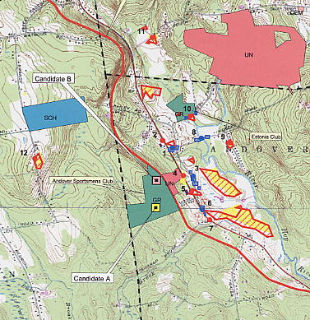

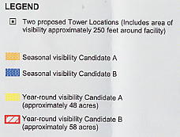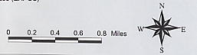

(AT&T 5)
FIGURE 2

AT&T EXISTING AND PROPOSED COVERAGE FROM SITE A
WITH ANTENNAS AT 150 FEET

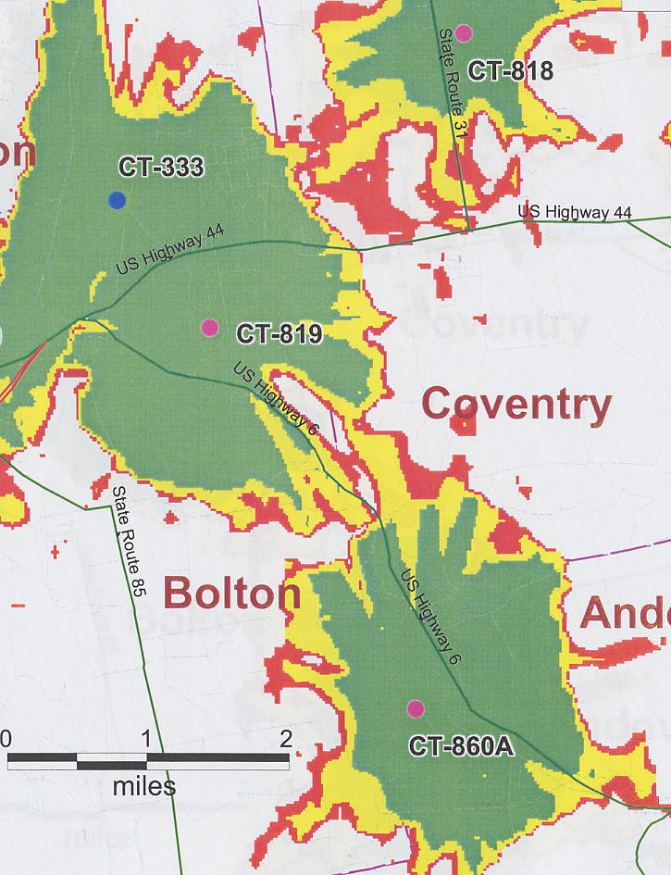

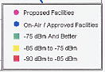
(AT&T 7)
FIGURE 3

AT&T EXISTING AND PROPOSED COVERAGE FROM SITE B
WITH ANTENNAS AT 130 FEET

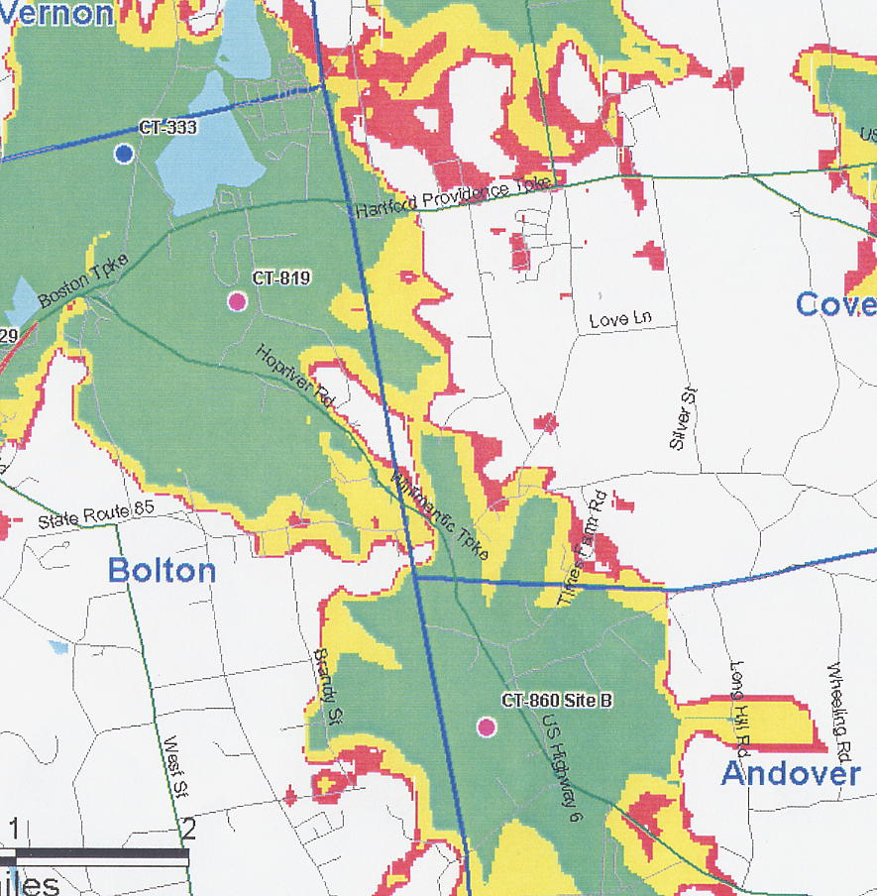

(AT&T 6, Q. 5)
FIGURE 4

T-MOBILE EXISTING COVERAGE

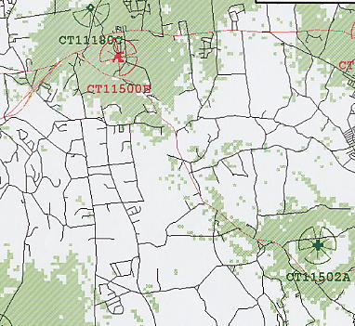

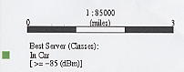

(T-Mobile 1, Q. 4)
FIGURE 5

T-MOBILE EXISTING AND PROPOSED COVERAGE FROM SITE A
WITH ANTENNAS AT 140 FEET AGL

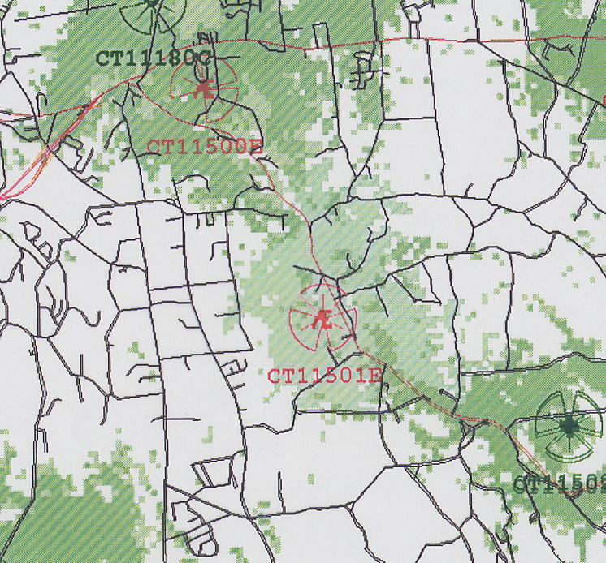

(T-Mobile 1, Q. 4)

