DOCKET NO. 237 - Tower Ventures II, LLC application for a Certificate of Environmental Compatibility and Public Need for the construction, maintenance and operation of a wireless telecommunications facility on one of two sites at 853R New Haven Road, Durham, Connecticut. | }  }  } | Connecticut  Siting  Council  December 9, 2003

Findings of Fact

Introduction

- On December 9, 2002, Tower Ventures II, LLC, (TV) applied to the Connecticut Siting Council (Council) for the construction, operation and maintenance of a 180-foot telecommunications tower at one of two locations at 853R New Haven Road in Durham, Connecticut. (TV1, p. 1)

- TV is a privately owned company providing wireless telecommunications facilities and infrastructure in New England. TV provides infrastructure to providers of personal wireless service such as cellular telephone service, personal communications services (PCS), and Enhanced Specialized Mobile Radio Service (ESMR). (TV1, p. 4)

- The purpose of the proposed facility is to provide wireless service to coverage gaps along Route 17 and surrounding areas in Durham and North Branford, Connecticut. (TV1, p. 7, Tab 7, coverage maps)

- Pursuant to General Statutes §§ 16-50m, the Council, after giving due notice thereof, held a public hearing on February 20, 2003, beginning at 3:00 p.m. and continued at 7:00 p.m. in the Lower Level Conference Room of the Durham Public Library, 7 Maple Avenue, Durham, Connecticut. (Transcript, 2/20/03, 3:00 p.m. [Tr. 1] p. 3; Transcript, 2/20/03, 7:00 p.m. [Tr. 2] p. 3)

- The Council and its staff made an inspection of the proposed site on February 20, 2003. During the field inspection, the applicant flew a 5.5-foot diameter balloon at each proposed site at 180 feet above ground level (agl) to simulate the height of the proposed tower. (Tr. 1, pp. 38-39)

- The party in this proceeding is the applicant. Intervenors are AT&T Wireless PCS, LLC, Kenneth and Mary Dandelski of Durham, and Sprint Spectrum L.P. (Sprint) (Tr. 1, pp. 4-5, Tr.3, p. 7)

- On December 5, 2002, TV provided notice of the application to the Council to all abutters of the proposed and alternate sites via Certified Mail Return Receipt Requested. Three abutters who were sent notice did not return receipts: Theodore and Elizabeth Tichy, 2209 Durham Road (no receipt returned); Jennifer and Michael Kelley, 938R New Haven Road (entire envelope returned damaged by the Postal Service); and Janine and Douglas Kozik, 24 Erika Court (envelope returned unclaimed). On January 28, 2003, TV re-sent notices to these three abutters. One of the three who were re-sent notice, Janine and Douglas Kozik, responded. (Tr. 1, pp. 36-37; TV 2, PHQ. 3; TV1, Tab 4)

- Pursuant to General Statutes §§ 16-50j(h) the following State agencies were requested to submit written comments regarding the proposed facility on January 10, 2003, and February 21, 2003: Department of Environmental Protection (DEP), Department of Public Health (DPH), Council on Environmental Quality (CEQ), Department of Public Utility Control (DPUC), Office of Policy and Management (OPM), Department of Economic and Community Development (DECD), and the Department of Transportation (DOT). (Record)

- Comments were received from the DOT on January 24, 2003, and from the DEP on February 19, 2003. (Record)

- The following agencies did not offer comments on the application: DPH, CEQ, DPUC, OPM, and the DECD. (Record)

- Public Notice of the application was published in the Middletown Press on December 2 and 3, 2002, and in The Hartford Courant on December 2 and 3, 2002. (Affidavits of Publication)

Reopening

- At a meeting held on August 26, 2003, the Council voted to reopen this docket for the limited purpose of: considering a new proposed alternate site (relocated site A-3) which is approximately 300 feet north of current alternate site A-2, with a new 150 foot flush-mounted tower; the visibility of a 150 foot flush mounted tower at the original prime site (A-1); and the visibility of a 150-foot flush-mounted tower at the original alternate site (A-2). Council Hearing Notice of 10/30/03 hearing; Council Meeting Minutes of 8/26/03)

- Pursuant to General Statute's §§ 16-50i(h) the following state agencies were requested to submit written comments regarding the proposed reopened docket on September 2, 2003: Department of Environmental Protection (DEP), Department of Public Health (DPH), Council on Environmental Quality (CEQ), Department of Public Utility Control (DPUC), Office of Policy and Management (OPM), Department of Economic and Community Development (DECD), and Department of Transportation (DOT). (Record)

- Comments were received from the DOT on September 15, 2003. The following agencies did not offer comments on the reopening: DPH, DEP, CEQ, OPM, and the DECD. (Record)

- Pursuant to General Statutes §§ 16-50m, the Council, after giving due notice there of, held a public hearing on the reopening on October 30, 2003, beginning at 3:00 p.m. and continued at 7:00 p.m. in the Lower Level Conference Room of the Durham Public Library, 7 Maple Avenue, Durham, Connecticut. (Transcript, 10/30/03, 3:00 p.m. [Tr. 3]; Transcript 10/30/03, 7:00 p.m. [Tr. 4] p. 3)

- The Council and its staff made an inspection of the proposed site on October 30, 2003. During the field inspection, the applicant flew the following balloons at a height of 150 feet: a 5.5 foot diameter blue balloon at the proposed prime (A-1) site; a 5.5 foot diameter red and white balloon at the alternate (A-2) site; and a 5.5 foot diameter red and yellow balloon at the relocated (A-3) site. (Tr. 3, pp. 22-23)

Municipal Consultation

- In accordance with C.G.S. §§ 16-50l(e) TV notified the First Selectman of the Town of Durham, Maryann Boord, of the plans to construct a tower in Durham on June 20, 2002, and Durham Town Planner Geoffrey Colegrove of the MidState Regional Planning Agency was also notified at that time. TV appeared before the Durham Planning and Zoning Commission on July 17, 2002 and August 18, 2002. TV conducted a balloon float at the proposed site on August 9, 2002, at the Town's request. (TV1, p. 18; TV3, Ciolfi Testimony, pp. 8-9)

- On February 13, 2003, the First Selectman of Durham provided correspondence to the Council which included concerns that the proposed Durham tower would be highly visible from Erica Court, the surrounding neighborhood, and the Town's Open Space property. The Durham First Selectman stated the Town’s opposition to the proposed towers at the hearings on February 20, 2003, and on October 30, 2003. (Town of Durham letter to S. Derek Phelps, February 13, 2003; Tr. 1, pp.7-9; Tr. 3, pp. 8-10)

Need

- The Telecommunications Act of 1996, a Federal law passed by the United States Congress, prohibits any state or local agency from regulating telecommunications towers on the basis of the environmental effects of radio frequency emissions to the extent that such towers and equipment comply with FCC's regulations concerning such emissions. This act also blocks the council from prohibiting or acting with the effect of prohibiting the provision of personal wireless service. (Telecommunications Act of 1996)

- The Telecommunications Act of 1996 prohibits local and state bodies from discriminating among providers of functionally equivalent services. (Telecommunications Act of 1996)

- In 1996 the Congress of the United States recognized a nationwide need for high quality wireless telecommunications services. Through the Federal Telecommunications Act of 1996 (the Act) Congress seeks to promote competition, reduce regulation to encourage technical innovation, and foster lower prices for wireless telecommunications services. The Act pre-empts any State or local determination of public need. (TV1, pp. 6-7)

- AT&T Wireless currently experiences a three-mile coverage gap along Route 17 in Durham, and has committed to TV to locate its antennas on the proposed tower. (TV1, p. 5; Tr. 1, pp. 83-84; TV3, Ciolfi Testimony, p. 8; TV1, Tab 7; Tr. 1, pp. 29-30)

Site Search

- TV identified a search area in the vicinity of Route 17 in Durham to locate existing towers and other sufficiently tall structures which may serve to hold antennas. In the Durham area, no such sites or structures were found that would achieve the carriers' desired objectives to cover existing gaps on Route 17. (TV1, p. 19)

- TV identified one tower in Durham, a 100-foot tower on Old Blue Hills Road, approximately 3.7 miles from the proposed site. AT&T has placed its antennas at the 75-foot level of this tower. (Tr. 1, pp. 83-84; TV2, PHQ. 9, Tab F, Council Telecommunications Database)

- TV investigated and rejected seven other potential tower sites in Durham: property of Debra Russell; property of the Wallingford Water Department; property of the Town of Durham; property owned by Mr. Tichy; commercial/residential lots on Route 17; land on New Haven Road, Erika Court and Stagecoach Road; and lots on Parmalee and Pent Street owned by the Town of Durham. The Russell property owners did not want to lease; the Wallingford Water Department property is in an undeveloped state and not likely to be developed; the property of the Town of Durham is retained as open space and its use was not a viable option; the Tichy property is lower in elevation than the proposed site, and is adjacent to a residence; the lots on Route 17 are too low and too far to the north; the land on New Haven Road, Erika Court and Stagecoach Road is heavily residential and lower in elevation than the proposed site; and the lots on Parmalee and Pent Streets are too far out of the search area to be considered. (TV1, Tab 9)

The Proposed Prime Site (A-1)

- The proposed A-1 site, A-2 site, and A-3 sites are located on an approximately 72.4-acre parcel of land owned by the New Haven Raccoon Club (Raccoon Club) at 853R New Haven Road, Durham, Connecticut. TV has entered into a lease with the Raccoon Club to construct the proposed facility. Large adjacent parcels are owned by the Town of Durham to the north, the Wallingford Water Company to the west, and Debra Russell to the east. (TV9, map; TV1, p. 7)

- The Raccoon Club lies within a Farm Residential (FR) zone. The property is used as a hunting club and is heavily wooded with some grass and hay fields. There is one primary building on the property, serving as a clubhouse/hall, with several outbuildings and sheds on the property. All three sites are located in a predominantly oak forest of light density understory. (TV1, p. 8; DEP Comments, 2/19/03, p. 1)

- The proposed A-1 site is located in the south central portion of the Raccoon Club property. The 100-foot by 100-foot leased parcel has an elevation of 442 feet above mean sea level (AMSL). (TV1, p. 8)

- The proposed 12-foot wide access road to the A-1 site from Route 17 would be approximately 1200 linear feet, with approximately 100 additional feet of access to the site compound. (Tr. 1, p. 25; TV1, Tab 10, compound plans, Site A-1; Tr. 3, p. 18)

- At the February 20, 2003 public hearing TV modified its application and now proposes to construct a 150-foot monopole tower at the proposed A-1 site, extendable to 180 feet total in the future. (Tr. 1, pp. 23-24; TV1, Tab 10 compound site plans)

- The 75-foot by 75-foot equipment compound would be surrounded by an 8-foot high chain link fence. The compound would be covered with gravel. A similar compound is proposed for the alternate site, and the relocated site. (TV1, PHQ. 14, Ex. D, Ex. E)

- To construct the proposed A-1 site and access road, 19 trees with a diameter breast height (dbh) of six inches or greater would be removed. (TV2, PHQ. 11)

- There are three residences on Route 17 within a 1000-foot radius of the proposed A-1 site, the nearest of which is approximately 950 feet to the southwest. (TV2, PHQ. 12)

- Electric and telephone utilities would be brought into the A-1 site underground from an existing pole on the Raccoon Club property. (TV2, PHQ. 14, Site Plan)

- The tower radius of the proposed A-1 site tower would be contained entirely within the lessor's property. (TV2, PHQ. 14, Site Plan)

Proposed Alternate Site (A-2)

- The proposed A-2 site is located in the center portion of the Raccoon Club property. The 100-foot by 100-foot leased area has an elevation of 404 feet amsl. (TV1, p. 8)

- The proposed 12-foot wide access road to the proposed A-2 site from Route 17 would be approximately 800 feet in length with approximately 100 feet of newly constructed access. (Tr. 1, p. 26)

- TV modified its application and now proposes to construct a 150-foot monopole tower at the A-2 site. (Tr. 4, p. 8; TV 16)

- To construct the proposed A-2 site and access road, 18 trees with a dbh of six inches or greater would be removed. (TV2, PHQ. 11)

- There are no residences within a 1000-foot radius of the proposed A-2 site. (TV2, PHQ. 12)

- Electric and telephone utilities would be brought into the A-2 site underground from existing SNET utility pole number 1304 on the Raccoon Club property. (TV2, PHQ. 14, Tab E)

- The tower radius of the proposed A-2 site tower would remain entirely within the lessor's property. (TV2, PHQ. 14, Site Plan)

Proposed Relocated Site (A-3)

- The relocated site, A-3, is approximately 300 feet north of alternate site A-2 on the Raccoon Club property. This site has an elevation of approximately 420 feet amsl, and consists of a 100 foot by 100 foot leased area with a 75 foot by 75 foot compound enclosed by an 8 foot high chain link fence. (TV 13; Ex. C, Drawings SK-2, SK-3; Tr. 4, p. 59)

- The access road from Route 17 would follow the access drive from Route 17 and then proceed along the edge of the Raccoon Club's archery range, then proceed into a wooded area to the A-3 site. The total length of the new 12-foot wide access road would be approximately 400 feet. An estimated 18 trees would be removed to develop this site. A portion of the access road crosses an intermittent watercourse, which is a state-regulated wetland. No 2-C survey was done for this site. (TV 13; Tr. 3, pp. 31-33; TV 16; TV 17)

- The proposed A-3 tower would be a 150-foot flush-mounted monopole capable of holding a total of 7 sets of telecommunications antennas, spaced 10 feet apart, between the 90 foot and 150 foot levels of the tower. AT&T would place 3 panel antennas at 150 feet agl. (TV 13, Ex. C, drawing sk-3; Tr. 3, p. 38)

- There are no residences within a 1000-foot radius of the A-3 site. The nearest home is approximately 1200 feet to the south along Route 17. (Tr. 4, p. 58, p. 60)

- Electric and telephone utilities would be brought into the A-3 site underground from existing SNET utility pole # 1305 on the Raccoon Club property. (TV 13, Ex. C, drawing sk-2)

- The tower radius of the A-3 site would be entirely within the Raccoon Club property. (TV 13, Ex. C, drawing sk-1)

Estimated Costs

- The estimated costs of the proposed A-1 and A-2 sites is as follows:

Access Road | $10,000.00
Site Preparation | 25,000.00
Tower and Foundation | 50,000.00
Utilities to Site | 15,000.00
Electrical costs | 10,000.00
Miscellaneous | 20,000.00
Total Estimated Cost | $130,000.00

(TV1, p. 20)

Environmental and Historic Considerations

- There are no known existing populations of federal or state endangered, threatened, or special concern species at the proposed sites. A species of special concern, the Jefferson salamander (Ambystoma jeffersonianum), is known to occur nearby. There are also historic records for two state-listed plant species in the area of Pistapaug Mountain, but the proposed facility would not be in conflict with these two plant species. (DEP Comments, attached letter of 2/13/03)

- The parcel of property owned by the Raccoon Club contains wetlands. There are no wetlands on the proposed A-1 or A-2 sites. However, the alternate site compound is located within a 100-foot wetland buffer zone. The location of the tower compound at the A-2 site could be modified or reconfigured so it is not within the 100-foot wetland buffer to the north and east. (Tr. 1, pp. 26-27; TV1, p. 17; TV1, Tab 10, Site A-2 site plan, compound plans)

- The Raccoon Club is near areas of archaeological sensitivity. A Phase I Archaeological Reconnaissance survey of the proposed A-1 and A-2 sites and access roads was conducted in September 2002. The survey revealed no positive traces of prehistoric activity, and no prehistoric artifacts were recovered from subsurface shovel tests. The State Historic Preservation Office (SHPO) reviewed the reconnaissance survey and concluded that no further archaeological investigations were needed. The proposed project would have no effect on Connecticut's archaeological heritage. (Town of Durham Plan of Conservation and Development, map following p. 4-9; TV1, Tab 13, pp. 1-4; SHPO letter of 11/19/02)

- There are two State Scenic Roads in the area of the proposed sites, Route 77 and Route 17. Route 77, north from the Durham/Guilford town line is designated as scenic for approximately 2.3 miles in distance. Route 17 north from the intersection of Route 17 and Route 77, is designated as scenic for approximately 1.4 miles. There are no town-designated scenic roads in the vicinity. (TV2, PHQ. 15, Ex. J)

- The proposed towers would not require marking or lighting under Federal Aviation Administration regulations. (TV1, p. 12, Tab 15)

- Based on conservative assumptions, including the main beam of the antennas pointing directly toward the ground at the base of the tower, the worst case radiofrequency power density calculations conclude the proposed AT&T antennas would result in a maximum permissible exposure level of approximately 3.3 percent at the base of the proposed tower for antennas at 180 feet agl, or 4.79 percent for antennas at 150 feet agl, based on FCC OET Bulletin 65 Edition 97-01. (TV4, Revised Power density Calculations Report, 1/27/03)

Visibility

A-1 and A-2 Sites

- A tower at either the proposed A-1or A-2 site would be visible to homes across Route 17, especially near the intersection with Coe Road. The foremost visual receptors would be six homes along Erika Court to the southeast. Site A-2 would be closer to Erika Court but the added ground elevation at the prime site would make A-1 the more conspicuous tower. There are six homes off of Route 17 in this vicinity. (DEP Comments, 2/19/03; TV2, PHQ. 12, Ex. D and Ex. 3, site plan maps)

- The proposed A-1 tower would be highly visible from Erika Court, facing northwest. The trees surrounding the site of the proposed tower vary in height. Erika Court is on a clear hillside dropping to the west and the site of the proposed tower is on the east side of the opposing hill, making the tower site more visible from this location. The A-1 tower would be the most visible of the three proposed towers. (Tr. 1, p. 40; TV 1, Tab 17, photosimulation 16; TV1, Tab 17, p. 2; Tr. 3, pp. 25-26, p.47)

- The proposed A-2 tower would have a similar degree of visibility as the proposed prime site tower from Erika Court. (Tr. 1, p. 48; TV 1, Tab 17, photosimulation 16)

- The proposed A-1 site tower would be visible from the intersection of Schoolhouse Lane and Stagecoach Road, at a distance of approximately 1.1 miles. The proposed A-2 site tower would be visible from the intersection of Schoolhouse Lane and Stagecoach Road at a distance of approximately 0.97 miles. Both the A-1 and A-2 towers would be visible to an estimated 36 residences within an approximate one mile radius. (TV2, PHQ. 13, Ex. H, sightline B, photosimulation B; Ex. I, sightline B, photosimulation B; TV 15, PHQ. 18)

- The proposed A-2 site tower would be visible from Dawn's Trail, at a distance of approximately 0.4 miles. (Tr. 1, p. 45; TV 1, Tab 17, photosimulation 15)

- The proposed A-1 and A-2 site towers would be visible from Christian Crossing R.O.W. (TV 1, Tab 17, photosimulation 14; Tr. 3, pp. 25-26)

- The proposed A-1 or A-2 site tower is not expected to be visible from Tri-Mountain State Park, the Mattabessett Trail on Mount Pisgah, or from the Mattabessett Trail on Pistapaug Mountain. (TV2, PHQ. 12)

A-3 Visibility

- The proposed A-3 tower would be partially visible from Dawn's Trail, and from Christian Crossing. It would be visible against a background of hillside trees from Stage Coach Road, and would not be visible from Route 17. An estimated 35 residences would have visibility of this tower within an approximate one mile radius. (TV15, PHQ. 18; TV15, PHQ. 17, photosimulations a-e)

- The visibility of the A-3 tower would be the least of the three proposed towers, although there would be visibility from Erika Court, from Coe Road's intersection with Stage Coach Road, and from the intersection of School House Lane and Route 17. It would not be visible from Tri-Mountain State Park, the Mattabessett Trail on Mount Pisgah, from the Mattabessett Trail on Pistapaug Mountain or from Route 77. ( TV17; TV15, PHQ 17, photosimulations a-e)

The Proposed Tower

- At each of the three proposed sites, Tower Ventures would construct a 150-foot steel monopole, 5 feet in diameter at the base, tapering to 18 inches in diameter at the top, with flush-mounted antennas. The tower would be painted light brown. The use of flush-mounted antennas would reduce the girth of the tower from 12-foot wide platforms to 2 to 3 foot wide panel antennas. (TV16; TV17)

- Tower Ventures has also considered the use of an RF-transparent flagpole tower at the Raccoon Club. Flagpoles are typically painted white. This type of tower has a surface transparent to radiofrequency waves, allowing the waves to pass through the exterior surface to hidden antennas mounted in the interior. Flagpole towers generally allow for fewer antenna choices to fit inside the cylinder than flush-mounted antennas. If a carrier needed additional antennas for coverage or capacity, the carrier may need to occupy more than one vertical slot on the tower, a procedure known as stacking. However, this site is considered more of a coverage site than a capacity site, so stacking may not be required. With flagpole antennas, three antennas can be placed at one level, and with flush-mount towers, six antennas may be placed at one level. (Tr. 3, p. 28, pp. 55-56, p.104; Tr.4, pp.64-65; TV 4, Tab J, p.84)

- The use of a flagpole tower would be acceptable to AT&T. (Tr. 4, p. 48)

- Tower Ventures has signed a lease with AT&T for its antennas, and is in negotiations with two other carriers. The Town of Durham would be interested in placing municipal antennas at the top of the tower with sufficient space near the base of the tower for equipment, after consultation with Town officials regarding utilities and equipment shelter space prior to construction. The applicant would provide free space on the tower to the Town. (Tr. 3, p. 37, p. 40, p.45; Town of Durham letter of November 4, 2003)

Wireless Telecommunications Coverage

- Verizon Wireless originally sought to co-locate on the proposed Durham tower at the 140-foot level of the tower. It was later determined that Verizon's corporate policy precluded them from locating on towers built on property owned by a gaming establishment, and therefore Verizon no longer proposes to place antennas on the proposed Durham tower. (TV3, Ciolfi testimony, p. 7)

- AT&T's network of antennas provide PCS coverage in the 1.9 gigahertz range, which broadcast signals which do not transmit as far as 800 megahertz cellular antennas. AT&T’s minimum signal strength is –90 bBm. (Tr. 1, p. 93; Appendix A)

- The following existing towers in the Durham area could interact with the proposed Durham tower.

Town | Address | Tower  Height (ft.) | AT&T Antennas AGL (ft.) | Distance to proposed Durham tower (miles)
Durham | Old Blue Hill Rd.(Verizon) | 100 | 75’ | 3.7
North Branford | Reeds Gap Rd. | 85 | 68' | 2.4
North Branford | Young Apple Orchard | 130 |  | 1.5
Wallingford | East Center St. | 130 |  | 3.5
Wallingford | Woodhouse Rd. | 150 | 128' | 3.8
Wallingford | Durham Rd.(Route 68) | 165 | 108' | 2.4
Guilford | Cook Lane (Totoket Mountain) | 182.5 |  | 1.5

(TV2, PHQ. 9; Tr., pp. 89-90, Tr. 3, p.60; TV19)

- AT&T views 150 feet as the minimum level at which it can place its antennas on the proposed Durham tower. (Tr. 1, pp. 84-85)

- The existing AT&T coverage in North Branford, the planned AT&T coverage from Blue Hill Road, and the addition of the proposed Durham site would still leave AT&T with a gap of approximately one mile along Route 17. (See Appendix B) (Tr. 1, pp. 86-87, p. 95)

- AT&T is not currently planning to place its antennas on a future tower proposed for Creamery Road (Docket 254) in Durham, 1.6 miles away. (Tr. 1, p. 89; Tr. 3, p. 60)

- The proposed AT&T antennas at the proposed Durham site would also provide coverage to local roads in Durham, including School House Lane, Old Washington Road, Trimountain Road, Meeting House Hill Road and Creamery Road. Route 77 and Route 79 would not receive AT&T coverage from this tower due to topography. (See Appendices B, C, D, and E) (Tr. 1, p. 91)

- Moving the site of the proposed Durham tower approximately 100 feet to the southeast of the proposed A-2 location closer to Route 17 would not result in any significant difference in propagation coverage. (Tr. 1, p. 100; TV 13, sheet SK-1)

Totoket Mountain Tower

- The Totoket Mountain tower, owned by Menuncketuck Communications Corporation, is a 182.5 foot self-supporting lattice tower at 500 Cooks Lane (Totoket Ridge) in Guilford, approximately 1.5 miles south of the proposed Tower Ventures site. The tower presently holds the following antennas; Cingular, Verizon, Connecticut State Police, WSHU Radio, CMED, Greater New Haven Transit District, South Central Connecticut Regional Water Authority, Town of Guilford, U.S. Department of Justice (FBI), U.S. Navy, Metro Cell, Weblink, Southern Connecticut Gas Company, and Transportation General. (Tr. 3, p. 60; TV19) (See Appendix I)

- The Totoket tower may not possibly have available antenna space available between the 170 to 180 foot levels; however, the FBI has antennas at the 182-foot agl, and Verizon has a 6-foot microwave dish attached at 178 feet agl. The tower owner does not have the ability to relocate the Verizon antenna and provide space to another carrier. No recent structural analysis of this tower has been performed, and there are concerns that placing cellular or PCS antennas at this level may cause interference with other users. (Tr.4, p.68, p. 69, p. 78, p. 79, pp. 90-91)

- Sprint, an intervenor in this docket, investigated the placement of antennas on this tower in 2003, entered into negotiations with the tower owner, but subsequently ceased negotiations after a radiofrequency evaluation of this site, which included a drive test. (Tr. 4, pp. 73-74, p. 75, p. 97)

- The Totoket tower is 30 feet in width at the base, 8 feet in width at the top, and capable of being extended by 40 feet. Space may be available on this tower at 100 feet agl and below. (Tr.4, pp. 71-72, p. 79)

- If AT&T placed antennas only on the Totoket Mountain tower, Route 17 would not receive coverage due to surrounding terrain. Use of the Totoket tower and the Creamery Road site in combination would not provide AT&T with sufficient coverage on Route 17, with a gap of about one mile. (Tr. 4, p. 33, p. 51)

- Use of one of the proposed Tower Ventures (Raccoon Club) sites and the Totoket tower in combination by AT&T may provide some coverage for both Routes 17 and 77. (Tr. 4, p. 56)

- If Sprint were to locate on both the proposed Tower Ventures tower and on the existing Totoket tower, this would provide some coverage to Route 77, assuming an antenna height of at least 160 feet agl is available. Sprint could receive minimal -94dbm coverage to the majority of Routes 17 and 77, with some gaps east of Totoket Mountain, along the southern border of Durham and at the intersection of Routes 17 and 77. (Tr. 4, p. 117) (See Appendix F)

A-3 Coverage

- Coverage from proposed site A-3 would be similar to that expected from the proposed A-1 or A-2 sites. (Tr. 3, p. 105) (Appendix G)

- At 150 feet agl, the A-3 tower would provide adequate AT&T coverage especially along the Route 17 corridor. (Tr. 3, pp. 100-101)

Coverage Scenarios

- Use of the Docket 254 Sprint Creamery Road site by AT&T would not provide coverage as far to the southwest along Route 17 for a link with coverage from an existing AT&T site at 83 Reeds Gap Road in North Branford. This could mean AT&T would have to cover two remaining gaps on Route 17, one to the southwest and one to the northeast. (Tr. 4, p. 50) (Appendix H)

- AT&T’s primary objective is to cover Route 17, with Route 77 a lower priority. (Tr. 3, p. 106; Tr. 4, p. 32, p. 53)

- The proposed Tower Ventures tower would not provide sufficient coverage to Sprint along Route 77 due to intervening hills, and therefore Sprint would not seek to place its antennas on this tower. (Tr. 4, p. 105)

Appendix A
(Existing Coverage)

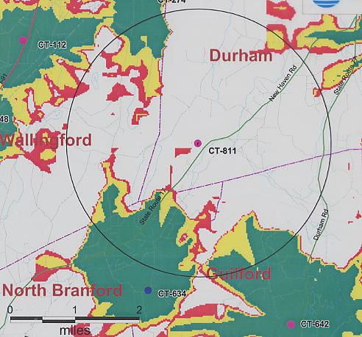
(AT&T 1, PHQ. 1a)
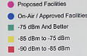

Appendix B
(Proposed Site A-1 Coverage at 150’)

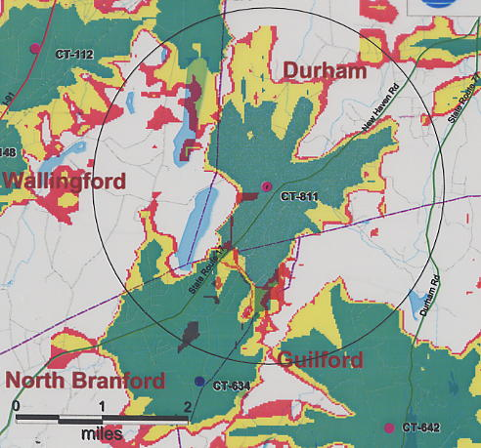

(AT&T 1, PHQ. 1a, 1b)

Appendix C
(Proposed Site A-1 Coverage at 130’)

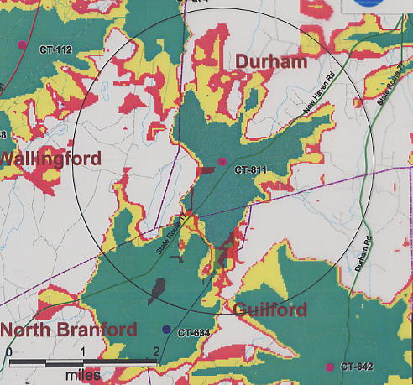

(AT&T1, PHQ. 1a, 1b)

Appendix D
(Proposed Site A-2 [alternate site] Coverage at 150’)

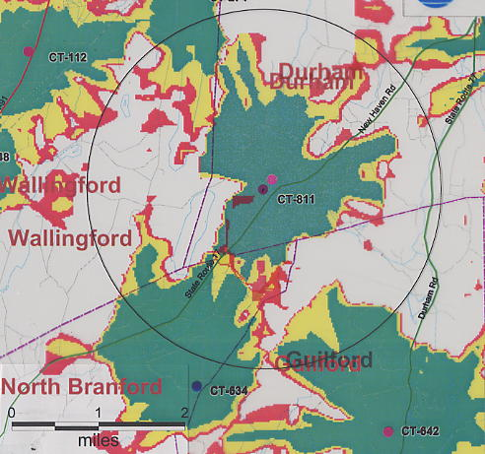

(AT&T1, PHQ. 1a, 1b)

Appendix E
(Proposed Site A-2 [alternate site] Coverage at 130’)

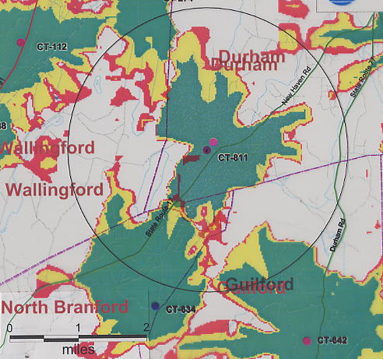

(AT&T1, PHQ. 1a, 1b)
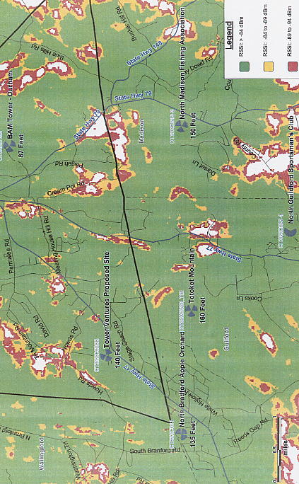
Appendix F
(Sprint Coverage from Surrounding Sites,
Tower Ventures Tower at 140 feet agl and
Totoket Mountain at 160 feet agl)

(Tower Ventures 14, Tab I)

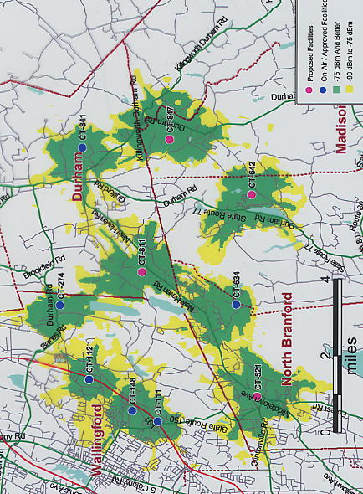
Appendix G
(AT&T Coverage from Site A-3 at 150 feet agl)

(AT&T 3, Coverage Plot at 150 feet)
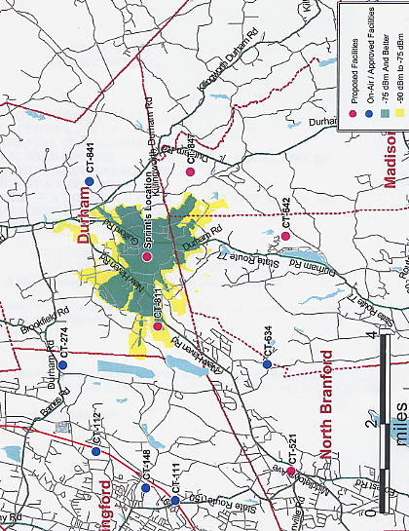
Appendix H
(AT&T Coverage from Creamery Road at 120 feet agl)

(AT&T 4, Coverage Plot)

Appendix I
(Proposed Sprint and Tower Ventures Sites with Surrounding Durham Terrain)

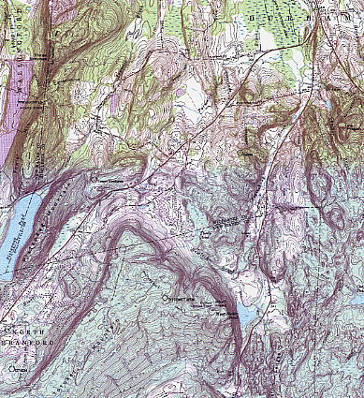

(AT&T 5)

