DOCKET NO. 235 - Sprint Spectrum L.P. application for a Certificate of Environmental Compatibility and Public Need for the construction, maintenance and operation of a wireless telecommunications facility at 186 Minortown Road or Main Street North, North Woodbury, Connecticut. | }  }  }  } | Connecticut  Siting  Council  June 19, 2003

Findings of Fact
Introduction

- Sprint Spectrum L.P., d/b/a Sprint PCS (Sprint), in accordance with provisions of General Statutes §§ 16-50g through 16-50aa, applied to the Connecticut Siting Council (Council) on November 27, 2002, for the construction, operation, and maintenance of a wireless telecommunications facility in Woodbury, Connecticut. The proposed facility would provide wireless coverage to existing coverage gaps in Woodbury and along Route 6. The metropolitan trading area (MTA) for proposed Site A and Site B is MTA 1, New York, and the basic trading area (BTA) is BTA 318, New Haven. Proposed Site A is located at 186 Minortown Road, Woodbury and Site B is located on Main Street North, Woodbury, Connecticut. (Sprint 1, p. 1, 5; Sprint 2, Q. 5)

- Sprint is a wholly owned subsidiary of Wireless Co, L.P., licensed by the Federal Communications Commission (FCC) to provide wireless personal communication service (PCS). Sprint operates in 32 major trading areas within the United States, including Connecticut. (Sprint 1, p. 2, 3)

- The parties in this proceeding are the applicant and Anthony J. Vallillo. The intervenor is AT&T Wireless PCS, LLC d/b/a AT&T Wireless (AT&T). (Tr. 1, 2:00 p.m., p. 5, 6; Tr. 2, 7:00 p.m., p. 5)

- Pursuant to General Statutes § 16-50m, the Council, after giving due notice thereof, held a public hearing on January 30, 2003, beginning at 2:00 p.m., and continuing at 7:00 p.m. in the Old Town Hall, 5 Mountain Road, Woodbury, Connecticut. (Tr. 1, p. 3, 7; Tr. 2, p. 3)

- The Council and its staff made inspections of the proposed sites on January 30, 2003. During the field inspection, the applicant flew a red balloon at proposed Site A and a black balloon at proposed Site B to simulate the height of the tower proposed at both locations. (Sprint 1, p. 27; Tr. 1, p. 18)

- On March 22, 2000, Sprint filed an application with the Town of Woodbury Zoning Commission for the construction of a tower on Town of Woodbury owned property at 281 Main Street, Woodbury. The Woodbury Zoning Commission denied this application. The decision is currently under appeal. Following input from the Town, Sprint has decided to propose two towers to fill the coverage gap along Route 6, rather than one. On April 30, 2002, Sprint notified First Selectman Richard W. Crane of its intent to submit an application to the Council for the proposed monopole in northern Woodbury. The Woodbury Zoning Commission scheduled a public hearing on June 11, 2002 regarding the proposed structure. On June 26, 2002, the First Selectman provided Sprint with specific recommendations and concerns from the Town Zoning Commission. (Sprint 1, p. 6, 7)

- On November 27, 2002, Sprint notified First Selectman Richard W. Crane, and the Planner/Zoning Enforcement Officer of the Town of Woodbury, Christopher S. Wood, of its intent of constructing a telecommunications facility at proposed Site A, or Site B. Public notice of the application was published in Waterbury Republican American on November 14 and 21, 2002 and Voices Sunday – The Weekly Star on November 13 and 17, 2002. (Sprint 1, Tab 2, Tab 4)

- Pursuant to General Statutes § 16-50j (h), the following state agencies were notified of the project on December 20, 2002: Department of Environmental Protection (DEP), Department of Public Health (DPH), Council on Environmental Quality (CEQ), Department of Public Utility Control (DPUC), Office of Policy and Management (OPM), Department of Economic and Community Development (DECD), and the Department of Transportation (DOT). Comments were received from the DOT on January 14, 2003 and from the DEP on January 29, 2003. The following agencies did not offer comments on the application; DPH, CEQ, DPUC, OPM, and the DECD. (Council letter to state agencies dated December 20, 2002; DOT comments dated January 14, 2003; DEP comments dated January 28, 2003)

Need

- Sprint located the proposed facility to facilitate the provision of wireless telecommunications service to Woodbury and along Route 6, Route 317, Route 47, and Route 132. (Sprint 1, p. 5; Tr. 1, p. 19)

- In issuing cellular licenses, the Federal government has preempted the determination of public need for cellular service by the states, and has established design standards to ensure technical integrity and nationwide compatibility among all systems. (Council Admin. Notice, no. 7, Telecom. Act 1996)

- In 1996, the United States Congress recognized a nationwide need for high quality wireless telecommunications services, including cellular telephone service. Through the Federal Telecommunications Act of 1996, Congress seeks to promote competition, encourage technical innovations, and foster lower prices for telecommunications services. (Council Admin. Notice, no. 7, Telecom Act 1996)

Site Search

- Sprint identified three existing communications towers located within approximately five miles of the proposed sites: a 130-foot tower owned by Sprint, located at 1440 Main Street North, Woodbury; a 150-foot tower owned by AT&T, located at 478 Good Hill Road, Woodbury; and a 160-foot tower owned by DPS, located at I-84 at South Avenue overpass, Middlebury. These towers would not provide adequate coverage to northern Woodbury. Sprint is not aware of any plans by other telecommunications entities to construct a new telecommunication facility within two miles of the search area. (Sprint 1, p. 10, Tab 11)

- Sprint identified and investigated ten potential sites, including proposed Site A and Site B, within a search ring in Woodbury. The potential sites investigated and rejected by Sprint include 13 Old Town Farm Road, the North Congregational Church, the Hotchkissville Fire Department, the Woodbury United Methodist Church, the Woodbury Fire Department on Quassak Road, a small silo off of Washington Street, a small silo on Swamp Road and the Fire Department. With the exception of Site A and Site B, none of the potential sites that were investigated would provide adequate coverage along Route 6. (Sprint 1, p. 11; Tr. 1, p. 13)

Site and Equipment

- Proposed Site A and Site B would include a 100-foot by 100-foot leased parcel on which Sprint would develop a 40-foot by 40-foot equipment compound. Sprint proposes to place equipment cabinets on a 10-foot by 20-foot equipment pad. The proposed tower and equipment compound would be enclosed by an 8-foot high chain link fence. The proposed monopole would have a global positioning system (GPS) antenna at 50 feet above ground level (agl), facing southwest. A gravel surface would be established within the tower compound and access road. Sprint would use a battery back up, which would operate for approximately four hours, during power outages. During a substantial power outage, Sprint would consider bringing in a diesel powered electrical generator temporarily. (Sprint 1, p. 13, 14, Tab 5, Tab 6)

- AT&T has expressed an interest in using the proposed facility at the 90-foot level of proposed Site A and the 70-foot level of proposed Site B. Sprint proposes to allow any local authority or emergency response system to use the proposed tower, provided it is consistent with the structural integrity of the tower. The Town of Woodbury has not indicated an interest in using the proposed site. (Sprint 1, p. 5, 6; Sprint 2, Q. 20)

- The tower radius setback of the proposed towers would be contained within the lessor’s property. There are no existing or planned structures within the tower radius setback of proposed Site A or Site B. (Sprint p. 11, 12; Sprint 2, Q. 10)

- The approximate costs of construction for the proposed Site A and Site B are estimated as follows:

Site Work | $ 75,000
Tower | 40,000
Electrical & Telephone | 35,000
Foundation | 15,000
Compound | 25,000
Road | 60,000
Total Costs | $ 250,000
(Sprint 1, Tab 16)

Proposed Site A/ Site B

- Proposed Site A would be located on an approximately 34.7-acre parcel owned by Raymond A. and Marilyn B. Hardisty. The elevation of Site A is 461 feet above mean sea level (amsl). Proposed Site B would be located on an approximately 56.29 acre parcel owned by Harold E. Cole. The elevation of Site B is 476 feet amsl. Vegetative cover in the area consists mainly of mixed deciduous hardwoods with an average estimated height of seventy-five feet agl. The surrounding topography consists of rolling hills. (Sprint 1, p. 11, 24, Tab 5, Tab 6 )

- Site A would be located within an Open Space Residence zone (OS-60). Site B would be located within an Open Space Residential zone (OS-100). The Town’s Zoning Regulations express that the location of a tower greater than 80 feet in height within an open space residential zone is the least desirable option for the location of a new tower. According to the Town of Woodbury Plan of Conservation and Development, the proposed sites are within parcels designated as “Vacant Land”. (Sprint 1, p. 11, 12, Tab 14; Sprint 2, Q. 2)

- There are no residences within a 1,000-foot radius of proposed Site A and one residence within a 1,000-foot radius of Site B. The nearest residence to Site A is approximately 1,300 feet to the west. The nearest residence to Site B is approximately 510 feet to the north. (Sprint 2, Q. 6; Tr. 1, p. 15)

- Sprint proposes to construct a 100-foot monopole at Site A or an 80-foot monopole at Site B, both of which would be designed to accommodate two additional carriers with a 10-foot center-to-center vertical separation. (Sprint 1, p. 4, Tab 5, Tab 6)

- Access to Site A would be an upgraded twelve-foot wide access road extending from Minortown Road along an existing driveway for 1,620 feet, then continuing to the site for an additional 40 feet. Sprint proposes to preserve and protect the existing culverts, which occur along the gravel road. Telephone and electrical utilities would be installed underground from an adjacent utility pole to the proposed compound at Site A. Access to Site B would be an upgraded twelve-foot wide access road beginning on a nearby parcel, owned by Joseph Volonino, and extending over two other parcels owned by Harold Cole. Approximately 60 feet of new access road would be installed to the site. Telephone and electrical utilities would run from a nearby utility pole above ground along approximately eight proposed utility poles then underground to the Site B compound. (Sprint 1, p. 12)

Environmental Considerations

- A vernal pool is located approximately 300 feet to the west of proposed Site A and adjacent to the south side of the existing gravel drive. Adult wood frogs and egg masses were observed in this pond, which confirms this as vernal pool breeding habitat. Sprint proposes to install redundant sedimentation control barriers during construction. The proposed sites contain no known existing populations of Federal or State Endangered, Threatened or Special Concern Species. (Sprint 1, p. 21, 22, 27)

- At Site A, a wetland follows the existing gravel drive that parallels and crosses a forested riparian system associated with Clark Brook, a perennial stream. The nearest wetland to Site B is approximately 350 feet to the southeast and is a forested riparian floodplain system associated with the Nonewaug River. (Sprint 1, p. 18; Sprint 2, Q. 23)

- The State Historic Preservation Office (SHPO) has determined that construction of the proposed sites would have no effect on historic, architectural, or archaeological resources listed on or eligible for the National Register of Historic Places. (Sprint 1, p. 26, Tab 21, Tab 22)

- Clearing of approximately 3 trees with diameters of six inches or greater at breast height at Site A and 18 trees with diameters of six inches or greater at breast height at Site B would be required to construct the proposed site compounds and access roads. (Sprint 2, Q. 11; Tr. 1, p. 15)

- Erosion and sediment controls would be established as required by the State of Connecticut Department of Environmental Protection. Erosion and sediment controls would minimize soil exposure, control runoff, shield and bind the soils, and trap sediments. Silt fencing would be placed immediately down slope of the project area prior to construction. Following completion of construction of the proposed project, all disturbed areas would be permanently stabilized with seed and mulch. (Sprint 1, p. 17; Sprint 2, Q. 11)

- Analysis of the site performed by the Airspace Safety Analysis Corporation determined that proposed Site A and Site B do not have to be registered with the Federal Aviation Administration (FAA). (Sprint 2, Q. 21)

- The electromagnetic radio frequency power densities, calculated using the FCC Office of Engineering and Technology Bulletin 65, using conservative worst-case approximation of radio frequency power density levels at the base of each tower, would be 9.88 percent of the American National Standards Institute (ANSI) Standard for Site A and 16.16 percent for Site B. (Sprint 1, p. 25)

- A stealth tree tower could be installed at either of the proposed sites while providing equivalent coverage to the area. Sprint would locate antennas at the same height on a tree tower as on a monopole structure. A tree tower would also accommodate the same amount of carriers. A stealth flagpole tower would result in limitation on capacity and future growth, and the ability to engineer the site by reorienting the antennas. Another stealth option may be to install a monopole and paint it brown or green to blend into the surrounding area, attaching antennas close to the structure. (Sprint 2, Q. 12; Tr. 1, p. 21, 22, 28, 33)

Visibility

- A visibility analysis of the proposed facility was performed by Sprint using computer aided spatial analysis techniques and field studies. The study area is a total of 10,127 acres. Approximately 7,382 acres of the study area consist of forest cover with an average estimated tree height of 75 feet. The proposed towers would not be visible from forested areas. According to the viewshed analysis, Site A at 100 feet would be visible from approximately 27 acres of the study area. Site B would be visible from approximately 69 acres of the study area. (Sprint 1, Tab 18)

- Based on the visibility diagram (see Figure 1) generated from the computer model and field studies, Site A would be visible from locations along Minortown Road, and Cat Swamp Road. Site B would be visible from locations along Route 6, Bacon Pond Road, Middle Road Turnpike, Pleasant Street, Minortown Road and Flanders Road. The visibility map is attached as Figure 1. (Sprint 1, Tab 18)

Coverage Needs

- Existing facilities in Woodbury, and Middlebury (to the south) leave gaps in wireless coverage in the northern Woodbury area. Gaps are defined as areas receiving less than –94 dBm coverage. The minimum signal level threshold for Sprint is –94 dBm for rural areas and –79 dBm to –84 dBm for urban areas. The primary purpose of this application is to provide coverage to these gaps along Route 6, Route 317, Route 47, Route 132 and local roads within northern Woodbury. (Sprint 2, Q. 14; Tr. 1, p. 19)

- Existing wireless coverage, at 1900 mhz, within a four mile radius of the proposed sites is as follows:

Existing Coverage

(see Figure 2)

Route | Existing Gaps (miles)  < -94 dBm | Total Road  Miles within a Four Mile Radius
6 | 2.6 | 9.2
317 | 0.9 | 2.7
132 | 1.5 | 4.4
Total | 5.0 miles | 16.3 miles
(Sprint 4, Re-opening interrogatories, Q. 1, 2)

- Existing coverage combined with antennas on the proposed towers at listed height above ground level, both at 1900 mhz, would leave the following gaps within a four mile radius of the proposed Site A and Site B as follows:

Proposed Site A at 100-Feet AGL

(see Figure 3)

Route | Gaps (miles)  < -94 dBm | Total Road Miles within a Four Mile Radius
6 | 1.9 | 9.2
317 | 0.0 | 2.7
132 | 1.7 | 4.4
Total | 3.6 miles | 16.3 miles

(Sprint 4, re-opening interrogatories, Q. 1, 2)

Proposed Site B at 80-Feet AGL

(see Figure 4)

Route | Gaps (miles)  < -94 dBm | Total Road Miles within a Four Mile Radius
6 | 2.1 | 9.2
317 | 0.0 | 2.7
132 | 1.6 | 4.4
Total | 3.7 miles | 16.3 miles

(Sprint 4, re-opening interrogatories, Q. 1, 2)

AT&T Coverage

- The proposed tower would provide AT&T with coverage to Route 6 and local roads. AT&T would locate antennas at the 90-foot level at Site A and the 70-foot level at Site B. Existing coverage combined with antennas on the proposed site tower at the listed heights above ground level, both at 1900 MHz, would leave the following gaps within a four mile radius of the proposed site as follows: (Sprint 2, Q. 20; AT&T 1, Q. 1)

Proposed Site A at 90 Feet AGL

(see Figure 5)

Route | Gaps (miles)  < -90 dBm | Total Road Miles within a Four Mile Radius
6 | 5.2 | 9.2
317 | 1.0 | 2.7
132 | 4.4 | 4.4
Total | 10.6 miles | 16.3 miles
(AT&T 1, Q. 2, 3)

Proposed Site B at 70 Feet AGL

(see Figure 6)

Route | Gaps (miles)  < -90 dBm | Total Road Miles within a Four Mile Radius
6 | 4.5 | 9.2
317 | 1.0 | 2.7
132 | 4.0 | 4.4
Total | 9.5 miles | 16.3 miles
(AT&T 1, Q. 2, 3)

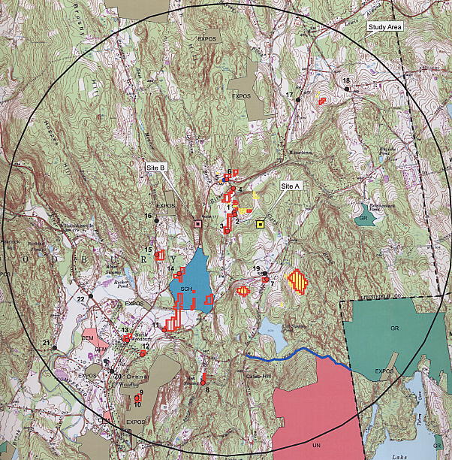

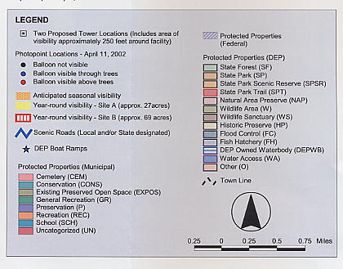
Figure 1. Visibility Analysis of the proposed sites.
(Sprint 1, Tab 18)

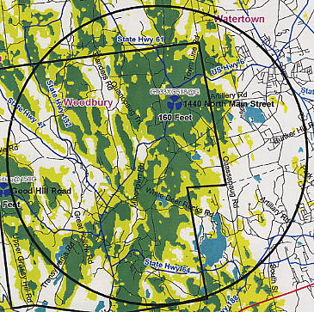

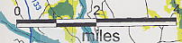

Figure 2. Existing Sprint coverage within a 4-mile radius in the Town of Woodbury.
(Sprint, Re-opening Interrogatories, Q. 1)

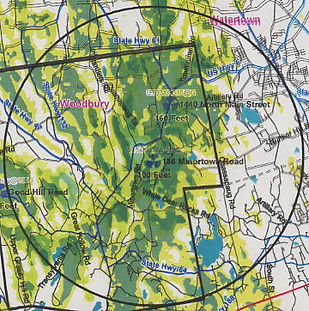

Figure 3. Existing coverage with coverage from proposed Site A at
100-feet AGL (1900 mhz). (Sprint, Re-opening Interrogatories, Q. 1, 2)

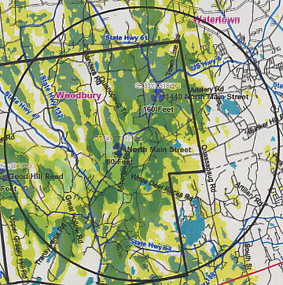

Figure 4. Existing coverage with coverage from proposed Site B at
80 feet AGL (1900 mhz). (Sprint, Re-opening Interrogatories, Q. 1, 2)

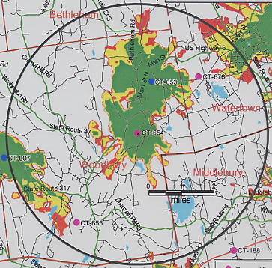

Figure 5. Existing coverage with coverage from proposed Site A at
90-feet AGL (1900 mhz). (AT&T 1, Q. 2, 3)

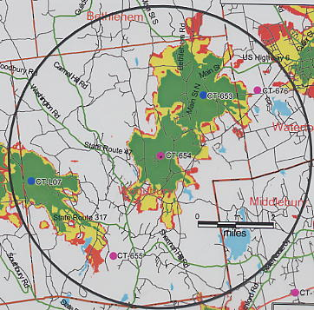

Figure 6. Existing coverage with coverage from proposed Site A at
70-feet AGL (1900 mhz). (AT&T 1, Q. 2, 3)

