DOCKET NO. 233 - Sprint Spectrum, L.P. application for a Certificate of Environmental Compatibility and Public Need for the construction, maintenance and operation of a wireless telecommunications facility at 399 Chestnut Land Road, New Milford, Connecticut. | }  }  }  } | Connecticut  Siting  Council  May 20, 2003

Findings of Fact

Introduction

- Sprint Spectrum, L. P. (Sprint), in accordance with provisions of General Statutes § 16-50g through 16-50aa, applied to the Connecticut Siting Council (Council) on October 2, 2002 for the construction, operation, and maintenance of a 160-foot telecommunications facility at 399 Chestnut Land Road in New Milford, Connecticut. The primary purpose of the proposed facility is to provide service to coverage gaps along US Route 202 in New Milford and State Route 109 in New Milford and Washington. (Sprint 1, pp. 1, 5, Attachment 8; Tr. 1, p. 61)

2. Sprint is a wholly owned subsidiary of WirelessCo L.P., licensed by the Federal Communications Commission (FCC) to provide wireless personal communication service (PCS). Sprint operates in 32 major trading areas within the United States including Connecticut. (Sprint 1, pp. 1, 2)

- Pursuant to General Statute § 16-50m, the Council, after giving due notice thereof, held a public hearing on January 7, 2003, beginning at 3:00 p.m. and continued at 7:00 p.m. in the New Milford Town Hall, 10 Main Street, New Milford, Connecticut. The parties in this proceeding are the applicant, the Town of Washington, and the Northville Residents’Association, Inc. The intervenors in this proceeding are AT&T Wireless PCS, LLC d/b/a AT&T Wireless (AT&T) and Mr. Fred Rickerich. (Council's Hearing Notice dated December 17, 2002; Transcript, January 7, 2003, 3:00 p.m. [Tr. 1], pp. 3, 5; Transcript, January 7, 2003, 7:00 p.m. [Tr. 2], pp. 4, 6)

- The Council and its staff made an inspection of the proposed site on January 7, 2003. The applicant was unable to fly a balloon to simulate the height of the tower during the field review due to high winds. The applicant agreed to re-schedule the balloon float and provide public notice of the event by February 6, 2003. (Council's Hearing Notice dated December 17, 2003; Tr. 1, p. 8; Tr. 2, p. 89)

- Sprint notified the Mayor of New Milford, Robert B. Gambino, and New Milford’s Zoning Enforcement Officer, Kathy Castagnetta, of its intent of constructing a telecommunications facility at the proposed site on May 10, 2002. The First Selectman of the Town of Washington, Elaine Luckey, and Washington’s Zoning Enforcement Officer, Janet Hill were also notified of the project on May 10, 2002. The Town of Washington is located approximately 2,800 feet east of the site. (Sprint 1, pp. 16-17, Attachment 5, Attachment 12)

- The Town of New Milford discussed the proposal at a Zoning Commission meeting on June 24, 2002 and at a public information hearing on June 25, 2002. The applicant received written comments from New Milford’s Office of the Zoning Commission, Office of Inland Wetland Commission, and Public Works Department. (Sprint 1 p. 17, Attachment 13, Attachment 14)

- Notice of the application was provided to all abutting landowners by certified mail. Public notice of the application was published in the Danbury News-Times on September 19 and 26, 2002, The Voices on September 18 and 22, 2002, and the New Milford Spectrum on September 20 and September 27, 2002. (Sprint 1, p. 3)
8. Pursuant to General Statutes § 16-50j (h), on October 25, 2002 and January 9, 2003, the following state agencies were requested to submit written comments regarding the proposed facility; Department of Environmental Protection (DEP), Department of Public Health (DPH), Council on Environmental Quality (CEQ), Department of Public Utility Control (DPUC), Office of Policy and Management (OPM), Department of Economic and Community Development (DECD), and the Department of Transportation (DOT). Comments were received from the DOT’s Office of Environmental Planning on November 27, 2002 and the DEP on December 9, 2002. The following agencies did not offer comments on the application: DPH, CEQ, DPUC, OPM, and the DECD. (Record)

Wireless Service Design

- Sprint operates a digital personal communications service network using a 1900-megahertz (MHz) frequency signal allocated by the FCC. This high frequency signal is twice that of traditional cellular service in the 800 MHz range and degrades quickly in areas of hilly terrain and dense foliage. To ensure adequate service and to accommodate the needs of other carriers in the hilly terrain of the search area, Sprint proposes a 160-foot facility. Topography surrounding the proposed site is characterized by rolling hills, ranging in elevation from approximately 450 feet to 1,060 feet above mean sea level (amsl). (Sprint 1, pp. 4, 17, 18)

10. Existing and proposed Sprint facilities that would hand off traffic with the proposed facility are as follows:

Location | Distance and Direction from the Proposed Site | Antenna Height (agl-ft)
86 Boardmand Road, New Milford | 4.0 miles west | 150
4 Elkington Farm Road, New Milford | 3.0 miles southwest | 140
(Sprint 2, Q. 2; Tr. 1, p. 49)

Site Alternatives

- Sprint issued a search ring to service this area of New Milford in May of 1999 and considered 25 sites to provide coverage to the Route 202 corridor. The Town of New Milford rejected a previous proposal by Sprint in 2001 to construct a tower southeast of the proposed site. For this proposal, Sprint investigated a total of ten potential sites in the western New Milford area, one of which was selected as the proposed site. Four sites were rejected due to inadequate coverage along Routes 109 and 202; two sites were rejected due to inadequate coverage to Route 109; and one site was rejected due to inadequate coverage to Route 202. The remaining two rejected sites were withdrawn due to real estate issues. (Sprint 1, p. 19; Sprint 2, Q. 5; Tr. 2, pp. 8, 91)

- Locating antennas on an existing tower facility off of Dairy Hill Road in New Milford, approximately 1.5 miles south of the proposed site, would provide coverage to Route 109 but would not provide adequate coverage to Route 202. Sprint produced a coverage model for this site with antennas located at 200 feet; however, this tower height may not be available for co-location. (Sprint 2, Q. 5; Tr. 1, p. 13; Tr. 2, pp. 11-12 )

- A 50-foot lattice emergency communications tower exists on Bear Hill in the Northville section of New Milford, west of Route 202. Sprint examined the possibility of placing a facility in this area during the summer of 2000 but ultimately rejected the site. The tower is below tree line and would not provide coverage to Route 202. Sprint did not examine the possibility of extending the Bear Hill tower since this location would not provide coverage to both Route 109 and Route 202. Coverage specific to Route 202 from this location was not examined in detail. (Sprint 10; Tr. 1, pp. 13-16)

- Locating antennas 75 feet above ground level (agl) on an existing Connecticut Light and Power Company (CL&P) H-mount would not provide adequate coverage to Route 202. The H-mount is located approximately 2 miles southwest of the proposed site in a CL&P right-of-way off of Route 109 in New Milford. (Sprint 5; Tr. 2, pp. 13, 15-17)

- Use of alternative technologies like microcells or repeaters are useful for providing coverage in small areas or providing service in buildings, but are limited as to coverage and capacity. These alternatives would not provide adequate coverage to the identified coverage gaps. (Sprint 1, p. 18; Tr. 2, p. 14)

- The lessor, Howard Kimberly, owns an additional parcel of land south of Route 109 that is more remote from neighboring residents; however, the area is lower in elevation and farther south of Route 202 than the proposed site which would result in a reduction of coverage on Route 202. (Sprint 1, Attachment 5, Attachment 7; Tr. 1, pp. 40-42)

Proposed Site

- The proposed site is located on a 14.41-acre parcel on the north side of Chestnut Land Road (Route 109). The proposed tower site is located at the base of a rocky knob in the central portion of the property. To access the site, Sprint would construct a 720-foot, 12-foot wide gravel road extending from an existing driveway on the lessor’s property. The existing driveway extends from Chestnut Land Road and provides access to several farm buildings. (Sprint 1, pp. 4, 8, Attachment 7; DEP comments dated December 9, 2002)

- Sprint would construct a 160-foot monopole, designed to support three antenna platforms, on a 100-foot by 100-foot lease area at the proposed site. The tower would be constructed of galvanized steel that would weather to a non-reflective gray finish. The tower would be designed in accordance with Electronic Industries Association Standard EIA/TIA 222-F, Structural Standards for Steel Antenna Towers and Support Structures. The final tower and foundation design has not been determined. (Sprint 1, pp. 6, 7, 13, Attachment 7)

- Sprint would install twelve 5-foot panel type directional antennas at a centerline height of 160 feet above ground level (agl). AT&T would install panel antennas at a centerline height of 150 feet. A GPS antenna would be mounted at a height of 75 feet agl. (Sprint 1, p. 8, Attachment 7; AT&T 1, Q. 3; Tr. 1, p. 29)

- The proposed tower would be located in a 60-foot by 60-foot compound area with a base elevation of 982 feet above mean sea level (amsl). The facility compound would contain a gravel surface and would be enclosed by a 6-foot high chain-link fence. Underground utilities to the proposed compound would be installed along the access road from an existing farm building on the property. Sprint would install six equipment cabinets on an 8.6-foot by 20-foot concrete pad within the compound. AT&T proposes to install up to four cabinets on a concrete pad with the compound. Vegetative screening would be installed on the southeast side of the compound. (Sprint 1, p. 7, Attachment 7; AT&T 1, Q. 6; Tr. 1, pp. 36-39)

21. The proposed site is zoned RU-60, residential. The town’s zoning regulations permit telecommunication towers in RU-60 zone districts, subject to issuance of a Special Permit. The tower site meets the setback requirement of 1.5 times the tower height. Land use in the vicinity of the site consists of residential and agricultural with areas of undeveloped woodland. There are 13 properties and five residences within 1,000 feet of the tower site. The lessor owns abutting property to the south and east. Abutting property to the north, approximately 580 feet from the tower site, consists of undeveloped land owned by Six Bells Farm, LLC. Abutting property to the west consists of residential parcels with the closest property boundary approximately 400 feet from the tower site. The nearest residence to the tower site is approximately 450 feet to the west and is owned by Frederick and Doris Rickerich. (Sprint 1, p. 14, Attachment 5, Attachment 6, Attachment 7, Bulk File Exhibit B, p. 112)

22. The estimated construction cost of the proposed facility is as follows:

Site work $13,000
Road installation 55,000
Electrical and telephone 55,000
Foundation 45,000
Compound 60,000
Tower 37,000

Total $265,000

(Sprint 1, Attachment 18; Sprint 2, Q. 8)

23. Sprint would be willing to construct a 110-foot tower on the summit of a knob located 250 feet west of the proposed site. The elevation of the knob is 1,030 feet, approximately 50 feet higher than the proposed site. Access to the knob site would require extending the proposed access road an additional 510 feet. A detailed field investigation of the knob site would be required to determine the actual placement of the access road, compound and tower. (Sprint 2, Q. 13; Tr. 1, pp. 19-20, 66, 73)

Environmental, Historic, and Safety Concerns

- The proposed facility would have no effect on historic, architectural, or archaeological resources listed on or eligible for the National Register of Historic Places. (Sprint 1, Attachment 20)

- There are no known existing populations of federal or state endangered, threatened or special concern species occurring at the proposed site. (Sprint 1, Attachment 21)

- The nearest airport, Candlelight Farms Airport, is 5.89 nautical miles from the proposed facility. Obstruction marking and lighting of the tower would not be required. (Sprint 1, Attachment 17)

- Approximately 15 to 20 trees of 6 to 12 inches in diameter at breast height (dbh) would be removed to develop the proposed site. Approximately 150 trees with a diameter greater than 6 inches dbh would be removed to develop the knob site. (Sprint 2, Q. 6, Q. 13)

- The compound development area at the proposed site and knob site contains no inland wetlands or watercourses. The access road to these sites is adjacent to two disturbed cut slope wetlands areas: Wetland 1, located at the base of a slope adjacent to a stone wall, and Wetland 2, located in an existing pasture. The proposed access road would be approximately eight feet from Wetland 1 and 20 feet from Wetland 2. Development of the access road and associated underground utility line would not directly disturb either wetland area. (Sprint 1, Attachment 7, Attachment 20; Tr. 1, p. 37)

- The total electromagnetic radio-frequency (RF) power density, calculated using FCC Office of Engineering Bulletin 65, using conservative worst-case exposures at the base of the proposed tower, would not exceed the American National Standards Institute (ANSI) standard and is estimated as 9.5% of the ANSI standard. (Sprint 1, Attachment 17; AT&T 1, Q. 8)

Visibility Impacts

- A visibility analysis of the proposed facility was performed by Sprint using computer aided spatial analysis techniques and field studies. The analysis concluded the facility would be visible from approximately 170 acres of an 8,042-acre study area. Approximately 5,163 acres of the study area were classified as forested with an average estimated tree height of 75 feet. The tower is not considered visible from forested areas. A map depicting the visibility of the proposed tower is included as Figure 1. (Sprint 1, Attachment 10)

- Based on the visibility diagram generated from the computer model and field studies, the visibility of the proposed tower from select public roads within a two-mile radius of the site is presented in the following table.

Location | Nearest Distance/Direction from Proposed Site | Length of Road Visibility
Chestnut Land Road (Route 109), New Milford | 0.14 miles south | 0.6 miles
West Church Hill Road, Washington | 0.84 miles southeast | 0.1 miles
Chapin Road, New Milford | 1.5 miles south | 0.2 miles
(Sprint 1, Attachment 10)

- The tower would be visible from select locations along residentially developed Washington Ridge Road. At least three homes would have views of the tower. (Tr. 1, pp. 47-48)

- A tower in the knob location would increase visibility due to the site’s high elevation and reduced vegetative screening. (Tr. 1, p. 21)

Stealth Technology

- Sprint would be willing to construct a 110-foot stealth tree tower on the knob site. A stealth tower designed as a pine tree would be an anomaly due to the low treeline (40-50 feet agl) and the predominance of hardwoods in this location. Visibility impacts would be reduced from select locations in the Town of Washington; however, a tree tower would be out of scale from views within a mile of the site. AT&T would be willing to locate on a tree tower at the knob site. Intervenor Fred Rickerich is opposed to a tree tower at the knob site since he believes it would look unrealistic and it would be closer to his property. (Tr. 1, pp. 20, 66-67, 75-76; Tr. 2, pp. 60, 79)

- A slim monopole or flagpole design would not meet coverage objectives on Route 202 due to the configuration of the antenna array. (Tr. 1, pp. 24-26, 80-83)
Sprint - Existing and Proposed Wireless Coverage

36. Sprint’s primary objective is to provide coverage to Route 202 and Route 109 in New Milford and Washington. Gaps are defined as areas receiving less than -94 dBm coverage. Gaps in existing and proposed wireless coverage on select roads within a two-mile radius of the proposed site are presented in the table below and on Figures 2 - 4.

Gaps in Coverage Within a Two-mile Radius of the Site
Road | Existing Road Gaps  (see Figure 2) | Gaps Remaining with Antennas at 160 feet  (see Figure 3) | Gaps Remaining with Antennas at 140 feet  (see Figure 4)
Route 109 | 2.7 | 0.3 | 0.3
Route 202 | 1.9 | 0.4 | 0.5
Wheaton Road | 1.5 | 0.5 | 0.6
Upland Road | 1.0 | 0.2 | 0.3
Buckingham Road | 0.5 | 0.1 | 0.2
Sawyer Hill Road | 0.8 | 0.0 | 0.0
Total | 8.4 | 1.5 | 1.9
approximate miles; signal strength -94 dBm

An analysis of the coverage plots and table above indicates a widening of existing gaps and the presence of a new gap of less that a tenth of a mile on Route 202 in the vicinity of Hipp Road when the antenna height is reduced from 160 feet to 140 feet. (Sprint 1, Attachment 8; Sprint 3)

37. Locating antennas at 140 feet would result in a degradation of signal reliability and quality on portions of Route 202 since a greater amount of coverage would be near the -94 signal level threshold. A call would be maintained in these areas, however. (Tr. 1, pp. 27-28)

AT&T - Existing and Proposed Wireless Coverage

38. AT&T has a lack of system coverage in the New Milford area and would use this site to design adjacent sites. AT&T currently has one site in New Milford, located at Elkington Farm Road. The minimum signal level threshold AT&T is planning to use in this area is -85 dBm. Gaps in existing and proposed wireless coverage on select roads within a two-mile radius of the proposed site is presented in the table below and on Figures 4 - 7.

Gaps in Coverage Within a Two-mile Radius of the Site
Road | Existing Road Gaps * | Gaps Remaining with Antennas at 150 feet *  (see Figure 5) | Gaps Remaining with Antennas at 130 feet*  (see Figure 6) | Gaps Remaining with Antennas at 110 feet *  (see Figure 7)
Route 109 | 3.8 | 1.9 | 2.0 | 2.2
Route 202 | 3.4 | 1.9 | 2.0 | 2.1
Wheaton Road | 1.3 | 0.9 | 1.0 | 1.2
Upland Road | 1.4 | 0.1 | 0.3 | 0.5
Buckingham Road | 1.3 | 0.6 | 0.7 | 0.7
Total | 11.2 | 5.4 | 6.0 | 6.7
* approximate miles; signal strength -85 dBm
(AT&T 1, Q. 4, Q. 5)

- The minimum height AT&T is willing to locate at this site is 110 feet agl. (Tr. 2, p. 63)

FIGURE 1

VISIBILITY OF PROPOSED 160-FOOT TOWER

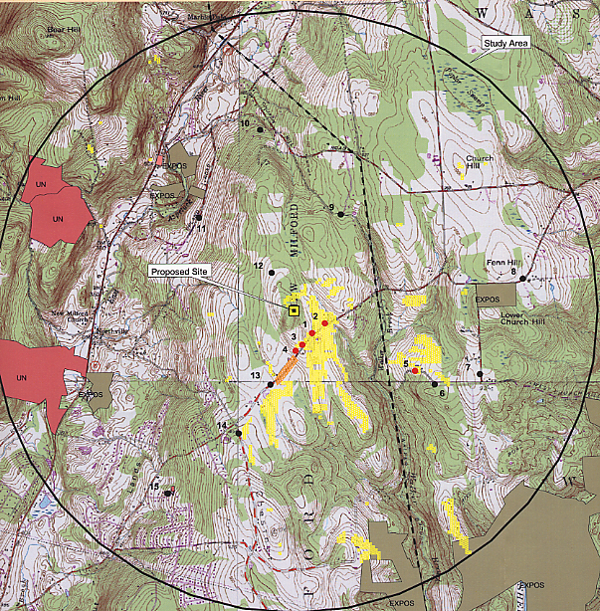

Visibility diagram prepared by Sprint. Areas highlighted in yellow represent areas with year-round visibility. Areas highlighted in orange represent areas with seasonal visibility. (Sprint 1, Attachment 10)

FIGURE 2

SPRINT EXISTING COVERAGE

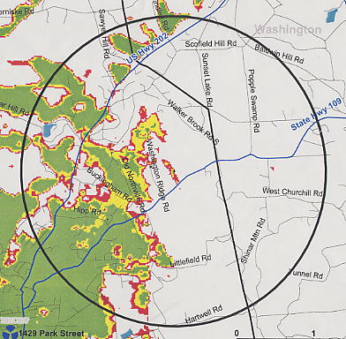

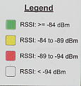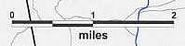

Two mile radius
(Sprint 1, Attachment 8)
FIGURE 3

SPRINT EXISTING AND PROPOSED COVERAGE WITH ANTENNAS AT
160 FEET AGL

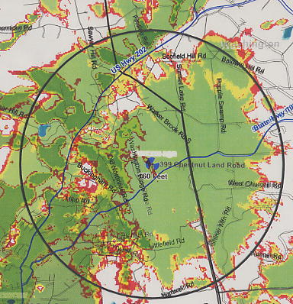

Two mile radius
(Sprint 1, Attachment 8; Sprint 3)
FIGURE 4

SPRINT EXISTING AND PROPOSED COVERAGE WITH ANTENNAS AT
140 FEET AGL

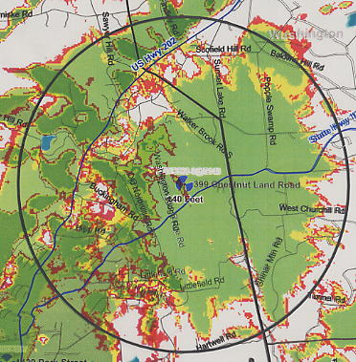

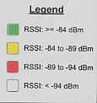

Two mile radius
(Sprint 1, Attachment 8; Sprint 3)
FIGURE 5

AT&T EXISTING AND PROPOSED COVERAGE WITH ANTENNAS AT
150 FEET AGL

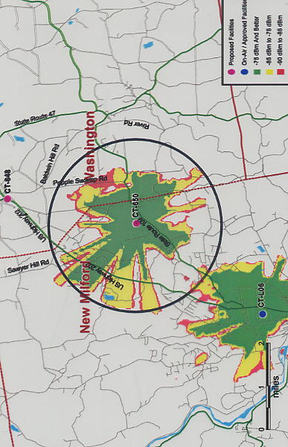

Two mile radius
(AT&T 1, Q. 5)
FIGURE 6

AT&T EXISTING AND PROPOSED COVERAGE WITH ANTENNAS AT
130 FEET AGL

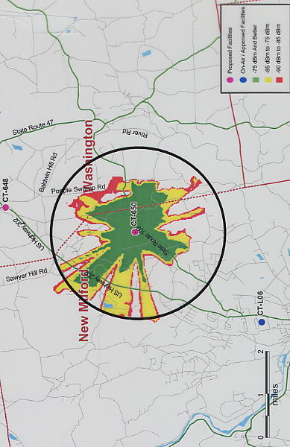

Two mile radius
(AT&T 1, Q. 5)
FIGURE 7

AT&T EXISTING AND PROPOSED COVERAGE WITH ANTENNAS AT
110 FEET AGL

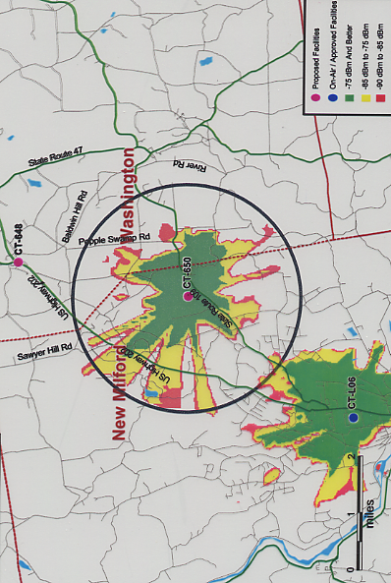

Two mile radius
(AT&T 1, Q. 5)

