DOCKET NO. 232 - Sprint Spectrum, L.P. application for a Certificate of Environmental Compatibility and Public Need for the construction, maintenance and operation of a cellular telecommunications facility at one of two sites located on Chaplin Road, Eastford, Connecticut. | }  }  } | Connecticut  Siting  Council  January 28, 2003

Findings of Fact

Introduction

- Sprint Spectrum L.P., d/b/a Sprint PCS (Sprint) in accordance with provisions of General Statutes §§ 16-50g through 16-50aa applied to the Connecticut Siting Council (Council) on August 22, 2002 for the construction, operation, and maintenance of a wireless telecommunications facility at one of two locations on Chaplin Road in Eastford, Connecticut. (Sprint 1, p. 1)

- Sprint is a wholly-owned subsidiary of WirelessCo L.P. licensed by the Federal Communications Commission (FCC) to provide wireless personal communication service (PCS). Sprint operates in 32 major trading areas within the United States including Connecticut. (Sprint 1, pp. 1-2)

- The party in this proceeding is the applicant. (Transcript 1 3:00 p.m. (Tr. 1), p. 4)

- Pursuant to General Statutes § 16-50m, the Council, after giving due notice thereof, held a public hearing on November 20, 2002, beginning at 3:00 p.m. and continuing at 7:00 p.m. in the Woodstock Town Hall, 415 Route 169, Woodstock, Connecticut. (Tr. 1, p. 2)

- The Council and its staff made inspections of proposed sites A and B on November 20, 2002, beginning at 1:45 p.m. During the field inspection, the applicant flew a balloon at the sites to simulate the heights of the towers proposed at these locations. (Council's Hearing Notice dated October 1, 2002)

- Sprint sent an informational package and a letter declaring it’s intent of constructing a telecommunications facility at one the proposed sites to the First Selectman of the Town of Eastford, Richard Woodward, and Susan Yorgansen, Zoning Enforcement Officer, on February 28, 2002. The Town of Eastford did not respond to Sprint’s request for a meeting. (Sprint 1, p. 18, Tr. 1, pp. 26-28)

- Notice of the application was provided to all abutting landowners by certified mail. All return receipts from the certified mailings have been received. Public notice of the application was published in the Norwich Bulletin, The Chronicle, and The Hartford Courant on July 29 and July 30, 2002. A revised notice that clarified the property location of Site B was published in the same papers on August 1 and August 2, 2002. (Sprint 1, p. 3; Tr. 1, p. 42)

- Pursuant to General Statutes § 16-50j (h), the following state agencies were solicited to submit written comments regarding the proposed facility on August 19 and October 1, 2002; Department of Environmental Protection (DEP), Department of Public Health (DPH), Council on Environmental Quality (CEQ), Department of Public Utility Control (DPUC), Office of Policy and Management (OPM), Department of Economic and Community Development (DECD), and the Department of Transportation (DOT). Comments were received from the DEP on November 19, 2002. The following agencies did not offer comments on the application: DPH, CEQ, DPUC, OPM, DECD, and the DOT. (Record)
Wireless Service Design

- Sprint operates a digital personal communications service network using a 1900-megahertz (MHz) frequency signal allocated by the FCC. This high frequency signal is twice that of traditional cellular service in the 800 MHz range and degrades quickly in areas of hilly terrain and dense foliage. To ensure adequate service to Route 198 in the southern part of Eastford and to accommodate the needs of other carriers in the hilly terrain of the search area, Sprint proposes a 150-foot facility at Site A and a 130-foot facility at Site B. Route 198 in this area is located in a valley surrounded by rolling hills ranging in elevation of approximately 650 feet to 800 feet above mean sea level (amsl). (Sprint 1, pp. 1, 5, 18, 19)

- Adjacent Sprint facilities that would interact with the proposed facility are as follows:

Location | Antenna Height AGL (ft)
36 Janoski Road, Ashford | 192
20 Seles Road, Ashford | 170
116 Grant Hill Road, Brooklyn | 150
203 Davis Road, Chaplin | 162
35 Old Route 44, Eastford | 165
71 Ashford Road, Eastford | 177
2 Fisk Road, Hampton | 195
82 North Eagleville Road, Mansfield | 247
62 Babbit Hill Road, Pomfret | 157
82 Pomfret Road, Pomfret | 170
1050 Buckley Highway, Union | 195
53 Cosgrove Road, Willington | 125
(Sprint 2, Q. 2)

- Use of alternative technologies like microcells or repeaters are useful for filling coverage in small areas or providing service in buildings, but are limited as to coverage and capacity. These alternatives would not provide adequate coverage to identified coverage gaps in the Eastford area along Route 198. (Sprint 1 pp. 18-19)

12. To maintain operations during power outages, the proposed sites would include a battery back-up system. If a power outage exceeds 6-8 hours in duration, a gasoline-powered electrical generator would be brought to the proposed site. (Sprint 1, pp. 8, 13; Tr. 1, pp. 76-77)

Site Search

- Sprint investigated a total of seven potential sites to construct a tower in the Eastford area, two of which were selected as the proposed sites. The remaining five sites were rejected due to unacceptable coverage along Route 198. (Sprint 1, pp. 20-21)

- Locating antennas on an existing 300-foot tower facility on Pumpkin Hill Road in Ashford, approximately 1.7 miles southwest of the proposed sites, would not provide adequate coverage to Route 198 due to area topography. (Sprint 1, Attachment 12; Sprint 2, Q. 9; Tr. 1, pp. 17-18)
Site Description – Site A

- Site A consists of a 100-foot by 100-foot lease area on an approximate 40-acre parcel located at 97 Chaplin Road in Eastford owned by the DeSiato Sand & Gravel Corp. The site is used as an active sand and gravel pit. The lease area is located on the west side of the property in a wooded area traversed by stone walls. The lease area slopes downward to the northeast. (Sprint 1, p. 4, Attachment 7)

- Access to proposed Site A would be from a 12-foot wide, 740-foot long gravel drive extending from Chaplin Road. Approximately 470 feet of the drive would be of new construction. A 2,300 square foot area of grading adjacent to the access road and the installation of a 460-foot long drainage ditch would be required for the construction of the access road. Utilities would be installed above ground from Chaplin Road to a new utility pole for a distance of 240 feet. From the pole, underground utilities would be installed along the access road to the compound. (Sprint 1, pp. 5, 9, Attachment 7)

- Sprint would construct a 150-foot monopole, designed to support three antenna platforms, at the site. The tower would be constructed of galvanized steel that would weather to a non-reflective gray finish. The tower would be designed in accordance with Electronic Industries Association Standard EIA/TIA 222-F, Structural Standards for Steel Antenna Towers and Support Structures. The final tower and foundation design has not been determined. (Sprint 1, pp. 7, 14, Attachment 7)

- Sprint would install twelve 5-foot panel type directional antennas at a centerline height of 147.5 feet agl. A GPS antenna would be mounted at a height of 75 feet agl. (Sprint 1, pp. 5, 10, Attachment 7)

- The proposed tower would be located in the central portion of a 75-foot by 75-foot compound area at an elevation of 515 feet amsl. The facility compound would contain a gravel surface and would be enclosed by a 6-foot high chain-link fence. Sprint would install six equipment cabinets on a 20-foot by 8.5-foot concrete pad within the compound. The cabinets would be approximately 5.5 feet tall. Site construction would include regrading of the area immediately southwest of the compound to direct stormwater runoff away from the site. No vegetative screening is proposed for the site. (Sprint 1, pp. 8, 14, Attachment 7)

- The southwest corner of the compound would extend through an existing stonewall. Sprint would be willing to move the compound location and associated drainage features approximately 60 feet to the northeast to avoid disturbing the stone wall. (Sprint 1, Attachment 7; Tr. 1, pp. 30, 33)

- The proposed site is located in a rural area in the Natchaug River valley. The Town of Eastford has no zoning regulations or zoning designations for this site. Adjacent property consists of undeveloped land, a few residences, a commercial campground, and an earthen materials storage and processing facility. The nearest on-site building is a residence approximately 550 feet east of the proposed tower site. The nearest off-site building is a residence, 89 Chaplin Road, approximately 790 feet northeast of the tower site. (Sprint 1, Attachment 5, Attachment 6; Sprint 2, Q. 4, Q. 5)

Site Description – Site B

- Site B consists of a 100-foot by 100-foot lease area on an approximate 8.3-acre parcel off of Chaplin Road in Eastford owned by Philip E. Willis. The lease area is located in the elevated western portion of the property in a wooded, level area. The eastern portion of the parcel is used as an earthen materials processing and storage facility. (Sprint 1, p. 4, Attachment 8)

- Access to proposed Site B would be from a 12-foot wide, 1,180-foot long gravel drive extending from Chaplin Road. The entire drive would be of new construction and extend through former gravel extraction areas and up a slope to the compound site. A three-quarter acre area of grading and the installation of 740 feet of rip rap lined drainage ditches would be required for construction of the access road. Utilities would be installed above ground to the site from Chaplin Road through a 10-foot wide, 670-foot long utility easement that traverses the site property north of the proposed access road. Two new utility poles would be installed in the easement. (Sprint 1, pp. 5, 9, Attachment 8; Tr. 1, p. 35)

- Sprint would construct a 130-foot monopole, designed to support three antenna platforms, at the site. The tower would be constructed of galvanized steel that would weather to a non-reflective gray finish. The tower would be designed in accordance with Electronic Industries Association Standard EIA/TIA 222-F, Structural Standards for Steel Antenna Towers and Support Structures. The final tower design has not been determined. (Sprint 1, pp. 7, 14, Attachment 8)

- Sprint would install twelve 5-foot panel type directional antennas at a centerline height of 127.5 feet agl. A GPS antenna would be mounted at a height of 75 feet agl. (Sprint 1, pp. 5, 10, Attachment 8)

- The proposed tower would be located in the central portion of a 75-foot by 75-foot compound area at an elevation of 503 feet amsl. The facility compound would contain a gravel surface and would be enclosed by a 6-foot high chain-link fence. Sprint would install six equipment cabinets on a 20-foot by 8.5-foot concrete pad within the compound. The cabinets would be approximately 5.5 feet tall. No vegetative screening is proposed for the site. (Sprint 1, pp. 8, 14, Attachment 8)

- The tower radius would extend by 18 feet onto an abandoned town road west of the site parcel. The legal status of the abandoned road is unknown and the road may be on property owned by Georgiana Walker. The Walker property is used as residential and contains woodland, a pond and a residential structure. (Sprint Attachment 6, Attachment 8; Sprint 2, Q. 5; Tr. 1, pp. 42-44)

28. The proposed site is located in a rural area in the Natchaug River valley. The Town of Eastford has not developed town-wide zoning regulations and has no zoning designation for this site. Adjacent property consists of undeveloped land, a few residences, and a sand and gravel extraction facility. The nearest off-site building is a residence, 139 Chaplin Road, approximately 410 feet southwest of the tower site. (Sprint 1, Attachment 5, Attachment 6; Sprint 2, Q. 4, Q. 5)

Estimated Construction Costs

29. The approximate costs of construction for the proposed facilities are as follows:

Site A Site B

Site work 40,000 50,000
Road installation 20,000 100,000
Electrical and telephone 75,000 75,000
Foundation 30,000 30,000
Compound 40,000 50,000
Tower 30,000 30,000

Total $235,000 $335,000

(Sprint 1, Attachment 17; Sprint 2, Q. 10; Tr. 1, pp. 39-40)
Environmental, Historic, and Safety Concerns

- The State Historic Preservation Office has determined that the proposed facilities would have no effect on historic, architectural, or archaeological resources listed on or eligible for the National Register of Historic Places. (Sprint 1, Attachment 19, Attachment 20; Tr. 1, pp. 35-37)

- There are no known existing populations of federal or state endangered, threatened or special concern species occurring at the proposed sites, based on a review of the Connecticut Department of Environmental Protection Natural Diversity Database. (Sprint 1, Attachment 19, Attachment 20)

- Site clearing and grading would be required for the construction of the access road and facility compound at each location. Development of Site B would require more site work and land disturbance due to existing grades and length of the access road. Mature hardwoods dominate both sites with Site A containing maple, oak and beechwood trees. Site B is dominated by white, red, and black oak tree species. The following table identifies the number of trees, having a diameters of six inches or greater at breast height, that would require removal for site development:

Tree Size | Site A | Site B
6-12” | 22 | 25
13”-19” | 9 | 12
20”+ | 1 | 2
Total | 32 | 39

Site B would require the removal of a greater number of trees less than six inches in diameter.
(Sprint 1, Attachment 7, Attachment 8; Sprint 2, Q. 11; Tr. 1, pp. 35, 50, 58-60)

- There are no wetlands or watercourses within the development area of both sites. The nearest wetland to Site A is a forested groundwater slope wetland with an associated intermittent watercourse approximately 200 feet to the north. The nearest wetland to Site B is a forested wetland approximately 300 feet to the west. The nearest watercourse to Site B is an unnamed pond approximately 400 feet to the southwest. (Sprint 1, Attachment 19; Sprint 2, Q. 6)

- The applicant performed an aeronautical study that determines the impact of the proposed facility on nearby airports in accordance with Federal Airspace Regulations. The analysis, performed by Airspace Safety Analysis Corporation, determined that Toutant Airport in the Town of Woodstock is 5.69 nautical miles from the Site A and 5.97 miles from Site B. Neither facility would require obstruction marking and lighting. (Sprint 2, Q. 7; Tr. 2, p. 6)

- The electromagnetic radiofrequency power density, calculated using the FCC Office of Engineering and Technology Bulletin 65, August 1997, using conservative worst-case approximation of radiofrequency power density levels at the base of the tower, with all Sprint antennas transmitting simultaneously on all channels at full power, would be 4.1 percent of the American National Standards Institute (ANSI) and National Council on Radiation Protection and Measurements standards at Site A and 6.1 percent at Site B. (Sprint 1, Attachment 16)

Visibility

36. A visibility analysis of an 8,042-acre area around the proposed facilities was performed by Sprint using computer aided spatial analysis techniques and field studies. The analysis concludes a facility at Site A would be visible from approximately 18 acres and a facility at Site B would be visible from approximately 20 acres of the study area. Approximately 6,724 acres of the study area were classified as forested with an average estimated tree height of 75 feet. The tower is not considered visible from forested areas. A map depicting the visibility of both towers is included as Figure 1. (Sprint 1, Attachment 11; Sprint 4)

- Based on the visibility diagram generated from the computer model and field studies, a facility at either site would be visible from four locations along Chaplin Road (Route 198) ranging in length from 0.1-0.2 miles, the closest of which is 0.14 miles from Site A and 0.13 miles from Site B. A tower at Site A is anticipated to be visible from a 0.1-mile section of Pilfershire Road in Eastford, approximately 0.5 miles east of the site, and from a 0.1 mile section of General Lyon Road in Eastford, approximately 0.6 miles northeast of the site. (Sprint 1, Attachment 11; Sprint 4)

- The Natchaug Hiking Trail is located east and north of both sites. The trail is routed through woodland except for a section north of both sites that follows Route 198 for a distance of 0.4 miles. Year round visibility of both towers is anticipated from this section, approximately 0.6 miles north of Site A and 0.9 miles north of Site B. Seasonal visibility of Site A is anticipated from a wooded section of the trail 0.3 miles north of Site A. Sprint solicited comment from the Connecticut Forest and Parks Association (CFPA) regarding potential impacts to the Natchaug Trail; however, the CFPA did not respond. (Sprint 1, Attachment 11; Sprint 4; Tr. 1, p. 18)

39. Both sites would be visible from the Charlie Brown Campground, approximately 0.15 miles east of Site A and approximately 0.25 miles northeast of Site B. Site A would have a greater visual impact on the campground than Site B due to open fields in the campground area and the proximity of Site A. Site B would be visible from the Peppertree campground, which is approximately 0.15 miles southeast of Site B and approximately 0.5 miles southeast of Site A. This campground contains more forest cover than the Charlie Brown Campground. (Sprint 1, Attachment 6; Sprint 4; Tr. 1 pp. 19-21, 41, 64-66, 69; DEP comments dated November 19, 2002)

Existing and Proposed Wireless Coverage

40. Existing Sprint facilities in Ashford and Chaplin leave gaps in wireless coverage along route 198 in Eastford. The minimum signal level threshold Sprint is planning to use in this area is -94 dbm. Gaps in existing and proposed wireless coverage on select roads within a two-mile radius of the proposed sites are presented in the table below and on Figures 2, 3 and 4.

Road | Existing Road Gaps *  (see Figure 2) | Site A – 150 feet  (see Figure 3) | Site B – 130 feet  (see Figure 4)
Route 44 | 0.4 | 0.0 | 0.0
Route 198 | 3.7 (Site A)  4.1 (Site B) | 0.0 | 0.2
Total | 4.1 (Site A)  4.5 (Site B) | 0.0 | 0.2
* approximate miles; signal strength -94 dbm
(Sprint 2, Q. 9

- Sprint’s coverage objectives could be met with antennas place at 130 feet at Site A and 110 feet at Site B. Sprint applied for a higher antenna height at each location to allow for improved signal intensity and to provide for a greater opportunity for tower sharing. (Sprint 5, Pre-filed Testimony of Anthony Welles; Tr. 1, pp. 10-12, 56-57)

FIGURE 1

VISIBILITY OF PROPOSED SITES

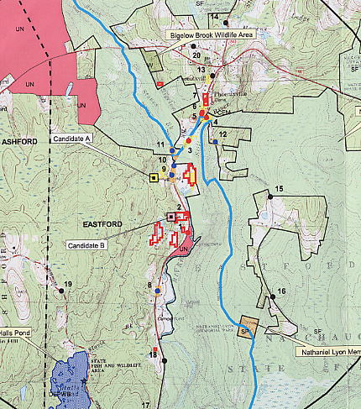

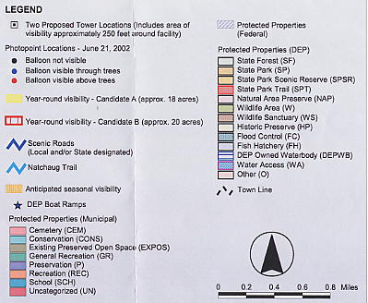

(Sprint 3)

FIGURE 2

SPRINT EXISTING COVERAGE
(- 94 dbm)

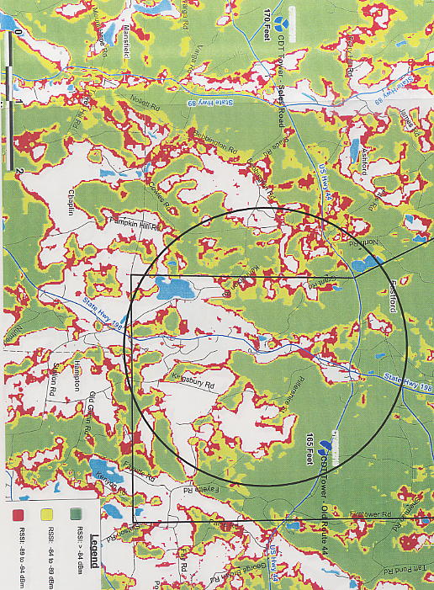
Two mile radius from Site B
(Sprint 1; Attachment 9)
FIGURE 3

SITE A - SPRINT EXISTING AND PROPOSED COVERAGE WITH
ANTENNAS AT 150 FEET AGL
(- 94 dbm)

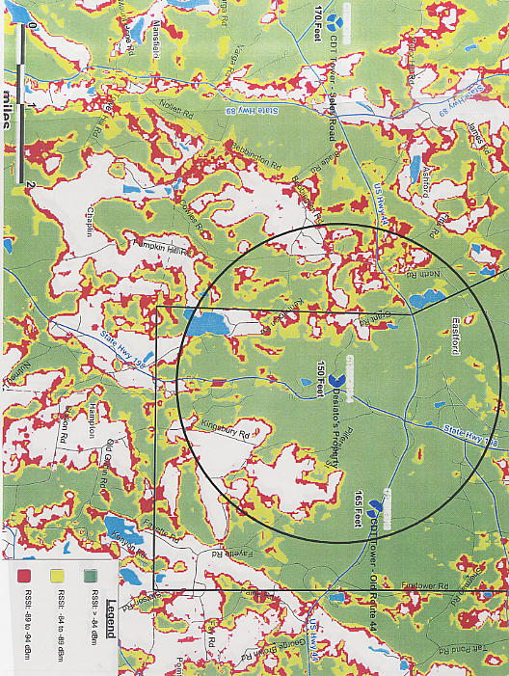
Two mile radius
(Sprint 1, Attachment 9)

FIGURE 4

SITE B - SPRINT EXISTING AND PROPOSED COVERAGE WITH
ANTENNAS AT 130 FEET AGL
(- 94 dbm)

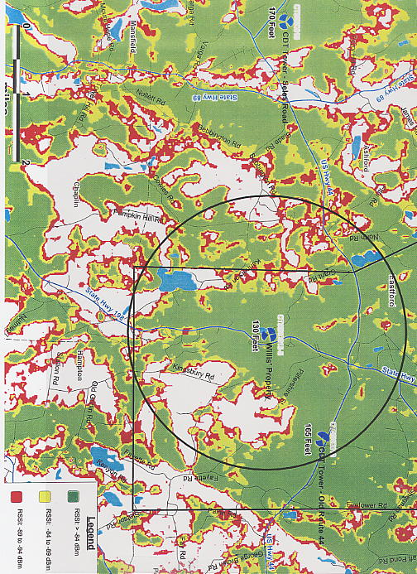
Two mile radius
(Sprint 1, Attachment 9)

