DOCKET NO. 228 – The Marcus Group, LLC application for a Certificate of Environmental Compatibility and Public Need for the construction, maintenance and operation of a cellular telecommunications facility at 148 Roberts Street, East Hartford, Connecticut. | }  }  }  } | Connecticut  Siting  Council  November 7, 2002

Findings of Fact

Introduction

- The Marcus Group, in accordance with provisions of General Statutes § 16-50g through 16-50aa, applied to the Connecticut Siting Council (Council) on May 30, 2002 for the construction, operation, and maintenance of a wireless telecommunications facility located at 148 Roberts Street, East Hartford, Connecticut. The facility would provide added capacity and wireless coverage to I-84 and the Roberts Street area of East Hartford. (Marcus 1, pp. 1, 6)

- Pursuant to General Statute § 16-50m, the Council, after giving due notice thereof, held a public hearing on September 10, 2002, beginning at 3:00 p.m. and continued at 7:05 p.m. in the East Hartford Town Hall, 740 Main Street, East Hartford, Connecticut. (Council's Hearing Notice dated July 19, 2002; Transcript, September 10, 2002, 3:00 p.m. [Tr. 1], p. 3; Transcript, September 10, 2002, 7:00 p.m. [Tr. 2], p. 3)

- The party in this proceeding is the applicant. The intervenor in this proceeding is Cellco Partnership d/b/a Verizon Wireless (Cellco). (Tr. 1, p. 5)

- The Council and its staff made inspections of the proposed prime and alternate sites on September 10, 2002. The proposed prime tower site is located approximately 705 feet north of Roberts Street on property owned by the Benevolent and Protective Order of Elks of the United States of America, Inc., East Hartford Lodge No. 2063 (Elks Lodge). The proposed alternate tower site is located approximately 75 feet west of the prime tower site on the same parcel. During the field inspection, the applicant flew balloons to simulate the heights of the towers proposed at these locations. (Council's Hearing Notice dated July 19, 2002; Marcus 1, Exhibit I; Marcus 9)

- Marcus is acting in the capacity of a tower developer to all wireless carriers by constructing wireless communication facilities in areas of coverage need. Three carriers, AT&T Wireless (AT&T), Cellco, and Nextel Communications of the Mid-Atlantic (Nextel), have committed to locate at this facility. (Marcus 1, p. 3; Marcus 4, Q. 1; Cellco 1, Q. 6; Tr. 1, p. 63)

- State Agency Comments were received from the Department of Environmental Protection (DEP) on August 30, 2002, and from the Office of Policy and Management on October 8, 2002. (Record)

Public Need for Wireless Service

- In 1996, the United States Congress recognized a nationwide public need for high quality wireless telecommunication services, including cellular telephone service. Through the Federal Telecommunications Act of 1996, Congress seeks to promote competition, encourage technical innovation, and foster lower prices for wireless telecommunications services. Furthermore, the Federal government has preempted the determination of public need for wireless service by the states,
and has established design standards to ensure technical integrity and nationwide compatibility among all systems. (Telecommunications Act of 1996, Definition of Act, Sections 256, and 704); Marcus 1, p. 6)
Proposed Prime and Alternate Sites

- The proposed prime and alternate sites are located in the wooded northwest corner of an approximately 6.47-acre parcel at 148 Roberts Street in East Hartford, Connecticut. The parcel, owned by the Elks Lodge, contains two structures; a meeting building surrounded by paved parking areas in the southwest corner and a seasonal use building near the western parcel boundary. The northern portion of the parcel contains recreation fields. The parcel is generally rectangular in shape and ranges in elevation from approximately 45 to 55 feet above mean sea level (amsl). A strip of wooded vegetation exists along the northern parcel boundary and portions of the eastern and western parcel boundaries. The remaining areas of the parcel are cleared and used for building or recreation purposes. (Marcus 1, pp. 4, 5, 18, Exhibit I)

9. The parcel is zoned industrial, I-2. The area surrounding the parcel is a mixture of residential, commercial, and industrial property and undeveloped land. Industrial buildings, an auto parts scrapyard, and a self-storage facility are present to the west of the parcel. Office buildings, warehouses, an indoor tennis facility, and self-storage buildings are located south of the parcel. Undeveloped land is present to the north and east of the parcel. There are 23 properties, including four residences, within a 1,000-foot radius of the proposed sites. The closest residential property to the prime site is 675 feet to the southeast. The closest residential property to the alternate site is 710 feet to the southeast. The nearest building to the proposed sites is a storage building located on the lessor’s parcel 195 feet southeast of the prime site and 225 southeast of the alternate site. The nearest building on an adjacent parcel is a manufacturing/light industrial building located approximately 270 feet southwest of both sites. (Marcus 1, pp. 5, 6, 18; Marcus 4, Q. 6, Q. 25)

- Marcus would construct a 120-foot monopole at the proposed prime or alternate site in accordance with Electronic Industries Association Standard EIA/TIA 222-F, Structural Standards for Steel Antenna Towers and Support Structures. The tower, designed to support four antenna platforms, would be approximately 49 inches in width at the base and 19 inches in width at the top. AT&T seeks to locate at the 120-foot level, Cellco seeks to locate at the 100-foot level, and Nextel seeks to locate at the 90-foot level. The 110-foot level would be available for a fourth telecommunications carrier. (Marcus1, pp. 5, 10, Exhibit I; Marcus 4, Q. 22)

- The prime site tower radius would extend by 74 feet to the north onto undeveloped land owned by the Town of East Hartford and to the west by 6 feet on land owned by Anthony Biase. The alternate tower radius would extend onto the same parcels of land by 76 feet and 75 feet, respectively. Relocating the tower so that the tower radius is wholly contained within the lessor’s property would prevent the use of the recreation field at the parcel. The tower could be moved to the east by six feet to prevent the tower radius from extending onto the privately owned property to the west. The tower will be designed with a tower load failure point of 80 feet above ground level (agl). (Marcus 1, Attachment I, Marcus 4, Q. 7, Q. 8; Marcus 7, Tr. 1, pp. 24- 26)

- Both the proposed prime and alternate sites would include a graveled surfaced, fenced compound located within a 7,200 square foot lease area at a ground elevation of 49 feet amsl. The compound at the prime site would measure 50 feet by 78.4 feet. The alternate site compound would measure 42 feet by 79.3 feet. A double row of pine trees would be established on the south and east sides of the compound. The compound would contain a 12-foot by 20-foot equipment shelter installed by Nextel, a 12-foot by 30-foot equipment shelter installed by Cellco, and a 5-foot by 6-foot equipment pad installed by AT&T. The tower and facility compound would be enclosed by a 10-foot high chain-link fence with privacy slats. (Marcus 1, pp. 4, 5, Exhibit I; Marcus 4, Q. 9)

- Access and underground utility service to the prime and alternate sites would extend from Roberts Street through an existing parking lot and along a proposed access road. The access road would be paved in order to satisfy the requirements of the town fire marshal and town zoning regulations regarding access to commercial properties. The twelve-foot wide access road would extend 240 feet to the prime site and 215 feet to the alternate site along the west edge of the parcel. The (Marcus 1, pp. 5, 10, Exhibit I; Tr. 1, pp. 53, 54)

14. A 12-foot wide by 53-foot long by 3.5-foot deep subsurface detention basin would be installed immediately to the east of the proposed site compound. A drainage swale would direct stormwater runoff from the paved access road to two catch basins located adjacent to the compound. The catch basins would direct water into the detention basin, which in turn would discharge north of the facility compound, upgradient of a wetland area. The town requested installation of the paved access road and associated drainage system. Marcus would be willing to install a gravel access road, which would allow stormwater to percolate directly into the soil. (Marcus 1, Exhibit I; Tr. 1, pp. 19-22, 51-57)

- The approximate cost of construction and materials for the proposed facility is estimated as follows:

Acquisition $7,500
Siting 43,000
Architectural & engineering 10,000
Tower 30,000
Other (includes paving, fencing, etc.) 70,000
Labor 145,000
Miscellaneous 5,000

Total $310,500

(Marcus 1, p. 20; Marcus 4, Q. 24)

Site Search

- The site search ring is a circular area approximately 0.5-miles in diameter. The size of the ring was determined from coverage need information obtained from wireless telecommunication providers. (Marcus 4, Q. 11)

- Marcus identified and investigated 13 potential sites, including the proposed site parcel. Except for the proposed prime and alternate sites, the remaining sites were rejected due to lack of screening vegetation, lack of space for tower placement, low ground elevation, and/or unacceptable coverage. The tallest building in the search ring area is approximately 35 feet agl. (Marcus 1, Exhibit E; Marcus 4, Q. 3)

- Marcus examined the viability of Connecticut Light & Power Company (CL&P) transmission line structures located south of 111-199 Roberts Street and determined the structures, at a height of 30 feet, were too low in elevation to provide adequate coverage and were not structurally capable of supporting a power mount above 50 feet agl. CL&P towers associated with a second transmission line located south of I-84 are outside of the search ring, difficult to access, and may be located in significant wetland areas. Nextel did not consider the CL&P structures south of I-84 since the structures were outside of its search ring. Cellco determined the CL&P towers south of I-84 were too far east of existing facilities in South Windsor and East Hartford to effectively off load cell traffic. (Marcus 1, Exhibit E; Marcus 4, Q. 32; Tr. 1, pp. 46, 88-90, 100)

- An existing SNET facility, located on Prestige Park Road in East Hartford and approximately 1.2 miles northeast of the site was rejected by Cellco since it would provide overlapping coverage to Cellco’s Burnham Street South Windsor site and would not provide coverage to portions of Silver Lane. (Marcus 1, Exhibit Q; Tr. 1, p. 92)
- An existing 140-foot lattice tower owned by the Town of East Hartford and located approximately 1.13 miles southeast of the proposed sites on Sunset Ridge was determined not to be viable by Nextel and Cellco due to its high elevation (200 feet amsl). Locating antennas at this facility would produce overlapping coverage and interference to existing facilities. (Marcus 4, Q. 10; Tr. 1, pp. 69, 84-85)

- Nextel examined the stadium under construction at the former Rentschler Airfield for telecommunications use and determined that the stadium site was not in their search ring for the target service area. Nextel is not presently pursing the stadium site but may consider locating at the stadium in the future. Cellco is proposing to locate at the stadium site. (Tr. 1, pp. 39-42, p. 99-100)

Municipal Consultation

- Marcus submitted an application and variance request to the Town of East Hartford land use departments in September 2001. The town’s Zoning Board of Appeals approved the prime site location on October 25, 2001. The town’s Inland Wetlands Commission approved the alternate site location on October 23, 2001 and the prime site location on January 22, 2002. Throughout the town application process, Marcus representatives met repeatedly with town officials to discuss the proposal. (Marcus 1, pp. 2, 23, 24)

- Marcus withdrew the special permit application pending before the Town of East Hartford’s Planning and Zoning Commission after the Council issued its directive that all privately-owned towers developed to provide space for personal communications service would be considered facilities and under the jurisdiction of the General Statutes. Prior to filing the application with the Council, Marcus representatives met with the Mayor of East Hartford, Honorable Timothy Larson, on April 1, 2002. (Marcus 1, pp. 1, 2, 12, 23, 24, Attachment J, Attachment L).

Environmental, Historic, and Safety Concerns

- The State Historic Preservation Office determined that construction of the proposed facility would have no effect on historic, architectural, or archaeological resources listed on or eligible for the National Register of Historic Places. Furthermore, the proposed facility would have no effect upon properties of traditional cultural importance to Connecticut’s Native American community. (Marcus 1, Exhibit O)

- There are no known existing populations of federal or state endangered, threatened or special concern species occurring at the proposed site, according to the Connecticut Department of Environmental Protection Natural Diversity Database. (Marcus 1, Exhibit M)

- There are no town or state designated scenic roadways in the vicinity of the sites. A public hiking trail exists 700 feet north of the proposed sites along the Hockanum River; however, the proposed facilities would not be visible from this trail. (Marcus 4, Q. 13, Q. 14)

- An aeronautical study, performed by the Federal Aviation Administration, determined the proposed facility would not require obstruction lighting or marking. (Marcus 1, Exhibit R)

- Approximately 15 to 20 trees of 8 to 20 inches in diameter at breast height (dbh) would be removed to develop the prime site equipment compound. Approximately ten to fifteen trees of 8 to 20 inch dbh would be removed to develop the alternate site compound. (Marcus 1, p. 15)

- No wetlands or watercourses were identified at the proposed sites. The Hockanum River is located approximately 0.1 miles north of the proposed sites. The nearest wetland area is located approximately 42 feet north of the prime site compound and approximately 44 feet north of the alternate site compound. Both proposed compound areas would extend into a town designated
100- foot wetland buffer area. The prime site compound would extend 55 feet into and cover 3,900 square feet of the buffer area. The alternate site compound would extend 58 feet into and cover 3,400 square feet of the buffer area. Existing vegetation in the wetland buffer area consists of deciduous trees and an understory of briars and vines. Prior to site construction, Marcus would install erosion and sediment controls in accordance with the 2002 Connecticut Erosion and Sediment Control Guidelines, as established by the Council for Soil and Water Conservation. (Marcus 1, Exhibit I; Marcus 4, Q. 4, Q. 20)

- The Connecticut Department of Environmental Protection (DEP) recommended that the proposed site be moved southward to enlarge buffer to the wetland area. Marcus would consider reducing the width of the compound by ten feet or move the compound by ten feet in order to increase the buffer to the wetland. Moving the compound southward may preserve additional trees. (DEP comments dated August 29, 2002; Tr. 1, pp. 22, 23, 47-49)

- The total electromagnetic radio-frequency (RF) power density, calculated using FCC Office of Engineering Bulletin 65, using conservative worst-case exposures at the base of the proposed tower would not exceed the American National Standards Institute (ANSI) standard, and is estimated as 17.16% of the ANSI standard. (Marcus 1, Exhibit P)

Visibility

32. A visibility analysis of the tower within a two-mile radius of the site was conducted using a computer model and field investigations. The analysis concludes the tower would be at least partially visible from 4.2% of the study area. Land uses in the tower visibility areas consist of commercial, industrial, and residential. The visibility of the proposed tower from select public roads within a two-mile radius of the site is presented in the following table and depicted on Figure 1.

Location Nearest Distance/Direction to Proposed Sites Length of Road Visibility
Roberts Street 0.1 miles south 0.9 miles
Silver Lane 0.6 miles south 0.1 miles
Nutmeg Lane 0.4 miles south 0.3 miles
Forbes Street 0.3 miles northeast 0.1 miles
Interstate 84 0.3 miles south 1.2 miles

(Marcus 1, Q. 20; Tr. pp. 30, 31)

33. Marcus did not consider installing a flagpole facility at this site. If a 120-foot flagpole facility was constructed, it could be designed to support four carriers. (Tr. 1, pp. 30, 31)

Cellco’s Coverage Needs

34. Existing Cellco facilities in East Hartford, Manchester, and South Windsor leave gaps in cellular coverage in the East Hartford region. The minimum signal level threshold Cellco is planning to use in this area is -85 dbm. Existing gaps in cellular coverage on select roads within a two-mile radius of the proposed site is presented in the table below and on Figure 2:

Cellco - Existing Coverage

(see Figure 2)

Road | Existing Road Gaps (approx. miles) -85 dbm
Interstate 84 | 0.8
Burnside Avenue (Rt. 6/44) | 1.2
Forbes Street | 0.3
Roberts Street | 0.4
Scotland Road | 0.1
Silver Lane | 1.2
Total | 4.0
(Cellco 1, Q. 2; Cellco 2, Q. 10)

35. Locating antennas at the 100-foot level of the proposed tower would allow Cellco to provide capacity relief to surrounding Cellco facilities and provide coverage to area roads. Coverage gaps remaining on select roads after the proposed installation is presented in the following table and on Figure 3.

Cellco - Proposed Coverage with Antennas at 100 Feet AGL

(see Figure 3)

Road | Road Gaps (approx. miles)  < -85 dbm
Interstate 84 | 0.3
Burnside Avenue (Rt. 6/44) | 1.1
Forbes Street | 0.0
Roberts Street | 0.0
Scotland Road | 0.0
Silver Lane | 0.5
Total | 1.9
(Cellco 2, Q. 10)

36. Coverage gaps remaining on Burnside Avenue and Interstate 84 after the proposed installation will be serviced by a proposed Cellco facility on an existing VoiceStream facility in Manchester. (Tr. 1, pp. 83-84)

37. Locating antennas at the 100-foot level of a flagpole facility would result in a reduction in coverage and reduced capacity relief for Cellco’s Burnham Street site. (Tr. 1, pp. 92-94)
AT&T’s Coverage Needs

38. Existing AT&T facilities in East Hartford, Hartford, and Manchester leave gaps in wireless coverage in the central East Hartford area. The minimum signal level threshold AT&T is planning to use in this area is -85 dbm. Existing gaps in wireless coverage on select roads within a two-mile radius of the proposed site are presented in the following table and on Figure 4.

AT&T - Existing Coverage

(see Figure 4)

Road | Existing Road Gaps (approx. miles) < -85 dbm
Interstate 84 | 1.9
Burnside Avenue (Rt. 6/44) | 2.5
Forbes Street | 2.3
Hillside Avenue | 0.5
Roberts Street | 0.6
Scotland Road | 1.1
Silver Lane | 1.2
Tolland Turnpike | 2.6
Total | 12.7
(Marcus 4, Q. 29, Q. 31)

39. Coverage gaps remaining on select roads after AT&T’s proposed installation at 120 feet agl are presented in the following table and on Figure 5.

AT&T - Proposed Coverage with Antennas at 120 Feet AGL

(see Figure 5)

Road | Road Gaps (approx. miles)  < -85 dbm
Interstate 84 | 0.6
Burnside Avenue (Rt. 6/44) | 0.2
Forbes Street | 0.6
Hillside Avenue | 0.0
Roberts Street | 0.0
Scotland Road | 0.0
Silver Lane | 0.0
Tolland Turnpike | 1.0
Total | 2.4
(Marcus 4, Q. 31)
Nextel’s Coverage Needs

40. Existing Nextel facilities in East Hartford, Manchester, and South Windsor leave gaps in wireless coverage in the central East Hartford area. The minimum signal level threshold Nextel is planning to use in this area is -85 dbm. Existing gaps in wireless coverage on select roads within a two-mile radius of the proposed site are presented in the following table and on Figure 6.

Nextel - Existing Coverage

(see Figure 6)

Road | Existing Road Gaps (approx. miles) < -85 dbm
Interstate 84 | 1.5
Burnside Avenue (Rt. 6/44) | 2.1
Forbes Street | 1.9
Roberts Street | 0.6
Scotland Road | 0.1
Silver Lane | 1.8
Tolland Turnpike | 1.0
Total | 9.0
(Marcus 1, Exhibit G; Marcus 4 Q. 31)

41. Coverage gaps remaining on select roads after Nextel’s proposed installation at 90 feet agl is presented in the following table and on Figure 7.

Nextel - Proposed Coverage with Antennas at 90 Feet AGL

(see Figure 7)

Road | Road Gaps (approx. miles)  < -85 dbm
Interstate 84 | 0.1
Burnside Avenue (Rt. 6/44) | 1.0
Forbes Street | 0.8
Roberts Street | 0.0
Scotland Road | 0.0
Silver Lane | 1.0
Tolland Turnpike | 0.5
Total | 3.4
(Marcus 4, Q. 31)

FIGURE 1

VISIBILITY OF PROPOSED 120-FOOT TOWER

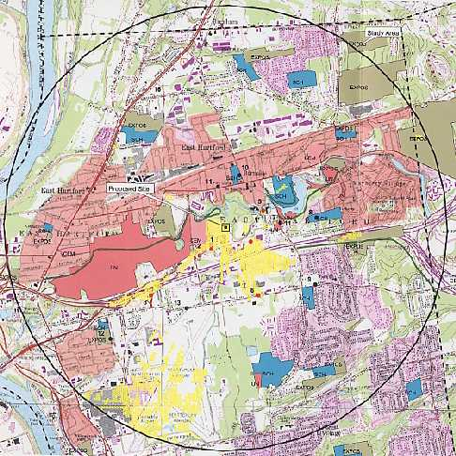

The areas highlighted in yellow on the above diagram denote visibility of the proposed tower within a two-mile radius of the site.

Scale 1:31,680

(Marcus 1, Q. 20)

FIGURE 2

CELLCO EXISTING COVERAGE
(- 85 dbm, 869-880, 890-891.5 MHz)

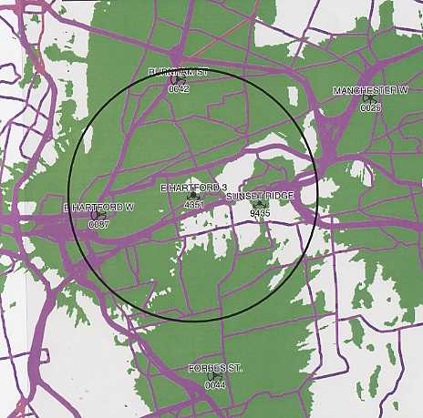Two mile radius
Scale 1:66,868

(Cellco 2, Q. 10)

FIGURE 3

CELLCO EXISTING AND PROPOSED COVERAGE WITH ANTENNAS AT
150 FEET AGL
(- 85 dbm, 869-880, 890-891.5 MHz)

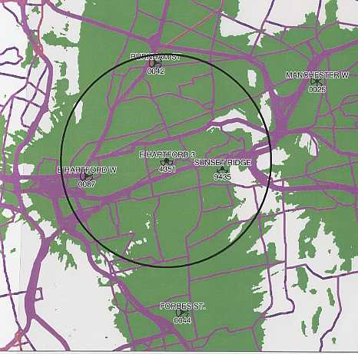
Two mile radius
Scale 1:66,868

(Cellco 2, Q. 10)

FIGURE 4

AT&T EXISTING COVERAGE
(- 85 dbm)

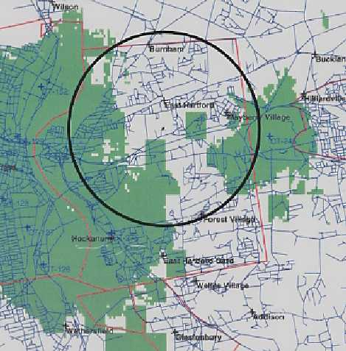
Two mile radius
Scale 1:100,00

(Marcus 4, Q. 31)

FIGURE 5

AT&T EXISTING AND PROPOSED COVERAGE WITH ANTENNAS AT
120 FEET AGL
(- 85 dbm)

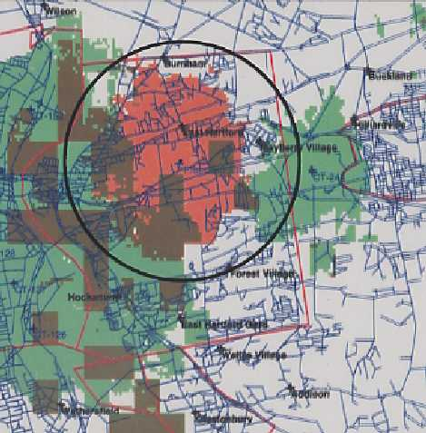
Two mile radius
Scale 1:100.000

(Marcus 4, Q. 31)

FIGURE 6

NEXTEL EXISTING COVERAGE
(- 85 dbm

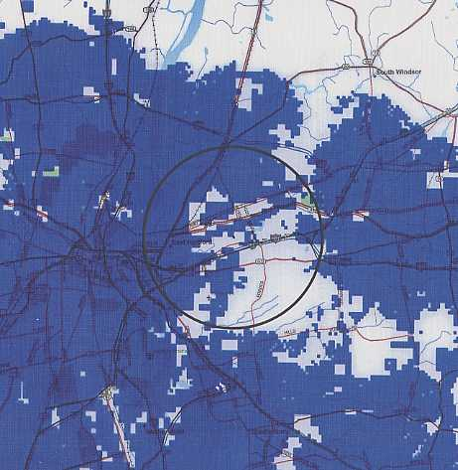
Two mile radius
Scale 1:100,00

(Marcus 4, Q. 31)

FIGURE 7

NEXTEL EXISTING AND PROPOSED COVERAGE WITH ANTENNAS AT
90 FEET AGL
(- 85 dbm)

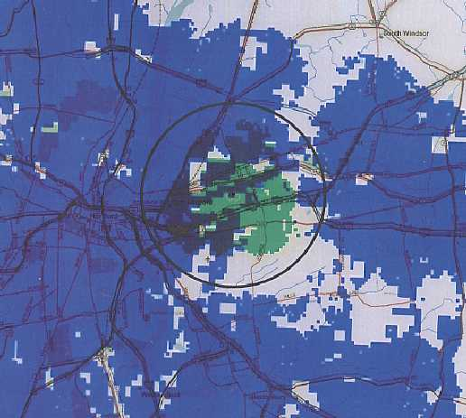
Two mile radius
Scale 1:100,000

(Marcus 4, Q. 31)

