DOCKET NO. 222A - Optasite, Inc. Certificate of Environmental Compatibility and Public Need for the construction, maintenance, and operation of a wireless telecommunications facility at 459 Burr Road, Southbury, Connecticut. | }  }  } | Connecticut  Siting  Council  January 4, 2006

Findings of Fact

Introduction

- On May 21, 2002, the Connecticut Siting Council (Council) approved an application filed by the James E. Dwyer Co., Inc. (Dwyer) for the construction, operation, and maintenance of a monopole wireless telecommunications facility at the prime site location at 459 Burr Road in Southbury, Connecticut. (Council Administrative Notice Item No. 13, Record)

2. At the time of the approval, no wireless telecommunications provider expressed interest in the site and therefore, an exact height of the facility was not specified in the Council’s Decision and Order (D&O). To accommodate future need, the Council incorporated the following condition into the D&O:

“Tower construction shall be contingent upon the Certificate Holder obtaining an executed lease agreement from a private telecommunications carrier who must petition the Council for a Declaratory Ruling that no Certificate of Environmental Compatibility and Public Need is required to locate at the facility. In the petition review process, the Council will review the carrier’s coverage objectives and antenna height justification and will make a determination on the tower height needed for this facility. However, the tower shall not exceed a height 150 feet above ground level including antennas and appurtenances. The tower shall be constructed as a monopole.”
(Council Administrative Notice Item No. 13, Record)

3. On August 1, 2002, the Council approved a Transfer of Certificate from Dwyer to Connecticut Architectural Towers, LLC (CAT). (Council Administrative Notice Item No. 13, Record)

4. On January 30, 2004, CAT submitted a combined Petition and Development and Management Plan (D&M Plan) to the Council for the construction of a 150-foot monopole at the site for use by Sprint Spectrum L.P. (Sprint) and AT&T Wireless PCS LLC (AT&T). New Cingular Wireless PCS LLC (New Cingular) acquired the existing AT&T lease once the Cingular-AT&T merger was complete. The site presented in the D&M Plan did not conform to the Council’s approved Findings of Fact. The site presented in the D&M plan was approximately 155 feet from the east property line rather than 327 feet as described in the Findings of Fact. (Council Administrative Notice Item No. 13, Record)

5. On April 5, 2004, CAT submitted a revised D&M Plan depicting the site in the center of the parcel, approximately 337 feet from the east property line. (Optasite Administrative Notice Item No. 3)
6. On May 19, 2004, the Council, pursuant to the provisions of Connecticut General Statute § 4-181a(b) allowing an agency to, on “a showing of changed conditions”, consider to “reverse or modify the final decision”, reopened the final decision rendered in this docket. The “changed conditions” in this case consist of a new location on the property for the facility and the proposed need of the facility by Sprint Spectrum L.P. (Transcript 1- October 18, 2005, 4:00 p.m. [Tr. 1], p. 4; Record)

7. On December 1, 2004, the Council approved a Transfer of Certificate from CAT to Optasite Inc. (Optasite). (Council Administrative Notice Item No. 13, Record)

8. Pursuant to General Statute § 16-50m, the Council, after giving due notice thereof, held a public hearing for the reopened docket on October 18, 2005, beginning at 4:00 p.m. at the Pomperaug Regional High School Auditorium, 234 Judd Road, Southbury, Connecticut. (Council's Hearing Notice dated June 15, 2005; Tr. 1, p. 3)

9. The Council and its staff conducted an inspection of the proposed site on October 18, 2005, beginning at 3:00 p.m. Windy conditions during the field review prevented Optasite from flying a balloon to simulate the height of the proposed tower. (Council's Hearing Notice dated June 15, 2005; Tr. 1, p. 15)

10. The party in this proceeding is Optasite. The intervenors in this proceeding are Sprint, New Cingular, and Omnipoint Communications, Inc, (T-Mobile). (Tr. 1, p. 6)

11. Public notice of the reopening was published in The Voices and the Waterbury Republican-American on September 28, 2005. (Record)

12. Pursuant to General Statutes § 16-50j (h), on September 16 and October 19, 2005, the following state agencies were solicited by the Council to submit written comments regarding the proposed facility; Department of Environmental Protection (DEP), Department of Public Health (DPH), Council on Environmental Quality (CEQ), Department of Public Utility Control (DPUC), Office of Policy and Management (OPM), Department of Economic and Community Development (DECD), and the Department of Transportation (DOT). (Record)

13. No state agencies responded with comment on the proceeding. (Record)

14. Optasite sent notice to the abutting landowners and town officials regarding the reopened proceeding. (Tr. 1, p. 22)

15. The Town of Southbury did not comment on the reopened proceeding. (Tr. 1, p. 22)

Relocated Site

16. The relocated site is within the center of a 37-acre parcel located at 459 Burr Road in Southbury, Connecticut. The parcel is on a long narrow ridge. The relocated tower site is approximately 185 feet west of the site described in the D&M plan submission of January 30, 2005. (Optasite Administrative Notice Item No. 3)

17. The relocated tower site is approximately 337 feet from the eastern property boundary and 375 feet from the western property boundary. The northern and southern property boundaries are approximately 750 feet and 900 feet, respectively, from the relocated tower site. (Optasite Administrative Notice Item No. 3)

18. The general site area is characterized by deciduous woodland with rock outcroppings. The relocated tower site is located on a rise at an elevation of 761 feet above mean sea level (amsl). The site described in the Councils’ approved Findings of Fact of May 21, 2002 was at an elevation of 759 feet amsl. (Optasite Administrative Notice Item No. 3)

19. The relocated tower site would be accessed by an existing woods road that extends northerly from Burr Hill Road for approximately 1980 feet before turning in a southerly direction for an additional 345 feet to the tower compound. The existing dirt woods road would be upgraded to a width of 12 feet and surfaced with gravel. (Optasite Administrative Notice Item No. 3; Tr. 1, p. 32)

20. Optasite proposes to construct a 150-foot monopole at the site. New Cingular would locate at the 147-foot level of the tower, Sprint would locate at the 137-foot level of the tower, and T-Mobile would locate at the 127-foot level of the tower. The overall height of the facility would be 150 feet agl with antennas. (Optasite Administrative Notice Item No. 3; T-Mobile 1, Q. 4; Tr. 1, p. 36)

21. Optasite proposes to construct a 60-foot by 80-foot fenced compound at the site. New Cingular proposes to install a 12-foot by 20-foot equipment shelter at the site. T-Mobile and Sprint both propose to install equipment cabinets on concrete pads within the compound. (Optasite Administrative Notice Item No. 3; New Cingular 1, Q. 8; Sprint 1, Q. 6; T-Mobile 1, Q. 8)

22. The nearest residence from the relocated tower site is approximately 724 feet to the northwest (Ryer property). (Transcript 2 - October 18, 2005, 7:00 p.m. [Tr. 2], p. 44)

Environmental Considerations

23. The relocated site contains no known existing populations of Federal or State Endangered, Threatened or Special Concern Species. (Optasite 3; Tr. 1, pp. 10-11)

24. Approximately 50 trees with a diameter six inches or greater at breast height would be removed to upgrade the access road and develop the relocated site compound. (Optasite Administrative Notice Item 4; Tr. 1, p. 18)

25. No wetlands would be impacted during construction of the site. The nearest wetlands are approximately 1,000 feet east and west of the site. (Optasite filing dated September 29, 2005)

26. The proposed site is within an area marked as locally high ground on the CT DEP Ridgeline and Summit Protection Policy Area maps. Field review of the parcel by CT DEP staff determined the proposed site is not on a ridgeline, bluff, or notable promontory that provides a locally or regionally significant scenic vista. (Council Administrative Notice Item No. 13, CT DEP letter dated March 5, 2002)

- The site would have no effect on historic, architectural, or archaeological resources listed on or eligible for the National Register of Historic Places. Furthermore, the proposed facility would have no effect upon properties of traditional cultural importance to Connecticut’s Native American community. (Council Administrative Notice Item No. 13)

28. Aircraft hazard obstruction marking or lighting of the tower would not be required. (Optasite 1, Q. 3)

29. According to methodology prescribed by the FCC Office of Engineering and Technology Bulletin No. 65E, Edition 97-01 (August 1997), assuming all New Cingular, Sprint, and T-Mobile antennas are oriented towards the base of the tower and all channels are operating simultaneously, the maximum power density at the base of proposed tower would be 0.143 mW/cm² or 16.5% of the standard for Maximum Permissible Exposure as adopted by the FCC. (New Cingular 1, Q. 2, Q. 10; Sprint 1, Q. 8; T-Mobile 1, Q. 10)

Visibility

30. The proposed tower would be visible year-round from approximately 25 acres within two-miles of the site (refer to Figure 1). The nearest area from the tower with year-round visibility is on Jacob Road, approximately 0.3 miles west of the site. (Optasite 2)

31. The proposed tower would be seasonally visible from approximately 16 acres within two-miles of the site. (Optasite 2)

32. The proposed tower would be seasonally visible from 0.2-miles of Rocky Mountain Road, a town designated scenic road approximately 0.3-miles east of the site. The road was designated scenic by the town on March 19, 2002. (Optasite Administrative Notice Item No. 4, Q. 4; Optasite 2)

33. The proposed tower would be visible from 18 residences including five residences on Toppenfjell Lane, four residences on Mapletree Hill Road, four residences on Jacob Road, three residences on Saddle Ridge Lane, and two residences on Cobbler Lane. (Optasite 2)

34. Visibility of the proposed tower from specific locations within a two-mile radius of the site is presented in the table below:

Location | Visible | Approx. Portion of Tower Visible | Distance from Tower
Toppenfjell Lane (vicinity of # 3) | Yes | 50 feet - unobstructed | 0.9 miles south
Mapletree Hill Road (vicinity of # 64) | Yes | 30 feet - unobstructed | 0.8 miles south
Jacob Road (vicinity of # 891) | Yes | 30 feet - unobstructed | 0.3 miles west
Saddle Ridge Lane | Yes | 25 feet - unobstructed | 0.3 miles west
Cobbler Lane at Stonegate Drive | Yes | 40 feet - unobstructed | 0.9 miles west
Southford Falls State Park (observation tower) | Yes | 35 feet - unobstructed | 1.1 miles east
(Optasite 2)

New Cingular – Existing and Proposed Wireless Coverage

35. New Cingular operates in both the 850 MHz and 1900 MHz frequency bands. New Cingular proposes to install six 800/1900 MHz dual band antennas at the 147-foot level of the tower. (New Cingular 1, Q, 2, Q. 7; Tr. 2, p. 13)

36. New Cingular seeks to provide in-building coverage to the Kettletown Road (Route 484) and the Georges Hill Road area of Southbury, at a signal level threshold of -75 dBm. Currently, approximately three miles of Kettletown Road/Georges Hill Road experiences a signal level of -80 dBm to -90 dBm at 850 MHz (refer to Figure 2). An additional mile of Georges Hill Road experiences a signal level less than -90 dBm at 850 MHz. (New Cingular 3)

37. New Cingular needs a minimum height of 100 feet to achieve coverage objectives at both 850 MHz and 1900 MHz but retains a lease for use of the 147-foot level of the tower. (New Cingular 1, Q. 2; Tr. 2 p. 13)

38. Installing antennas at 100 feet would improve 850 MHz coverage to the identified three mile gap on Kettletown Road/Georges Hill Road and surrounding areas (refer to Figure 3). Approximately 1.2-miles of Georges Hill Road would experience a signal level of -80 to -90 dBm. (New Cingular 3)

39. Installing antennas at 147 feet would not significantly increase coverage or the signal strength of existing coverage on Kettletown Road/Georges Hill Road (850 MHz), except for a 0.2-mile length of road north of the Burr Road/Kettletown Road intersection where coverage would improve from the -80 to -90 dBm range to the -75 to -80 dBm range (refer to Figure 4). (New Cingular 3)

Sprint – Existing and Proposed Wireless Coverage

40. Sprint operates at the FCC allocated 1950-1965 MHz frequency range. In this area, Sprint designed a network for in-vehicle coverage with a minimum signal level threshold of -94 dBm. (Sprint 1, Q. 2)

41. Sprint currently experiences an approximate 3.7-mile gap on Kettletown Road/Georges Hill Road (refer to Figure 5). (Sprint 1, Q. 4)

42. Installing antennas at a centerline height of 137 feet at the proposed site would provide adequate coverage to 3.5-miles of Kettletown Road/Georges Hill Road (refer to Figure 6). A tenth of a mile area of signal weakness would exist on both Kettletown Road and Georges Hill Road in the vicinity of Amos White Road; however, Sprint expects the signal to carry through these gaps. (Sprint 1, Q. 4; Tr. 1 p. 41)

43. Sprint could not meet coverage objectives using a lower antenna height at this location. Coverage in the two small gap areas would further degrade leading to the greater probability of dropped calls. (Tr. 1, pp. 39, 41-42, 49)

44. Sprint could not meet coverage objectives using a flush mount antenna design due to antenna orientation limitations. (Tr. 1, p. 41-44)

T-Mobile – Existing and Proposed Wireless Coverage

45. T-Mobile operates in the 1935-1945 FCC allocated frequency range. In this area, T-Mobile seeks in-vehicle coverage with a minimum signal level threshold of -84 dBm. (T-Mobile 1, Q. 2)

46. T-Mobile is currently developing a network for the Southbury area and would use the proposed site as a benchmark to design future adjacent sites. Although T-Mobile would prefer the 147-foot level of the tower to maximize coverage from this location, T-Mobile is contractually limited to the 127-foot level of the tower. (Tr. 2, pp. 22-24)

47. Installing nine antennas at a centerline height of 127 feet would provide coverage to approximately 2.5-miles of Kettletown Road/Georges Hill Road and approximately 2.3-miles of coverage to Jeremy Swamp Road and Hulls Hill Road in Southbury (refer to Figure 7). (T-Mobile 1, Q. 4)

48. T-Mobile prefers to use platform mounted antennas to maximize antenna spatial diversity. (Tr. 2, p. 29)

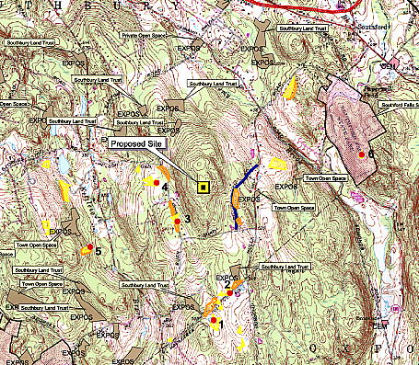

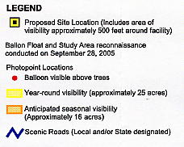

Figure 1. Visibility of proposed 150-foot tower proposed for 459 Burr Road, Southbury.

(Optasite 2)
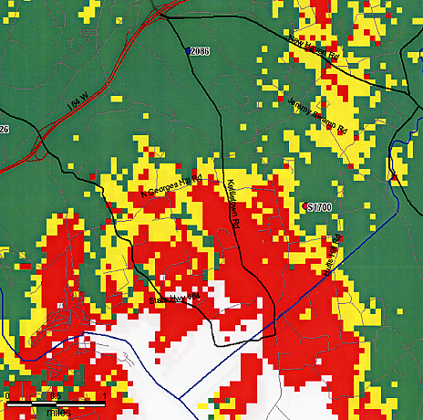

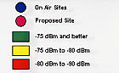

Figure 2. Existing New Cingular coverage in Southbury in the Kettletown Road (Route 484) area at 850 MHz.

(New Cingular 3)

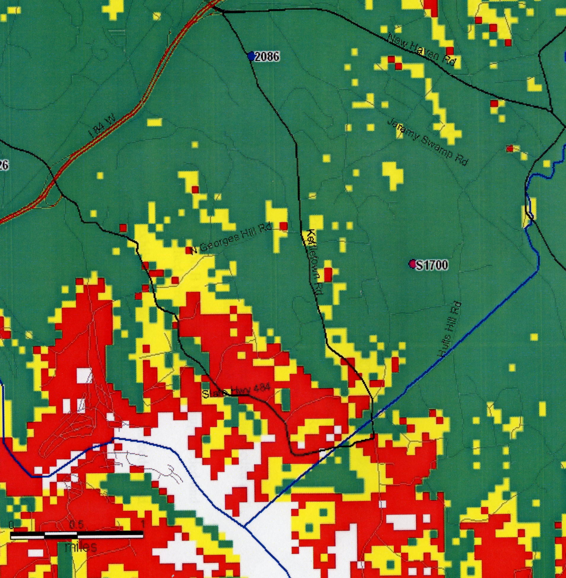

Figure 3. Existing and proposed coverage from the site at 100 feet at 850 MHz.

(New Cingular 3)

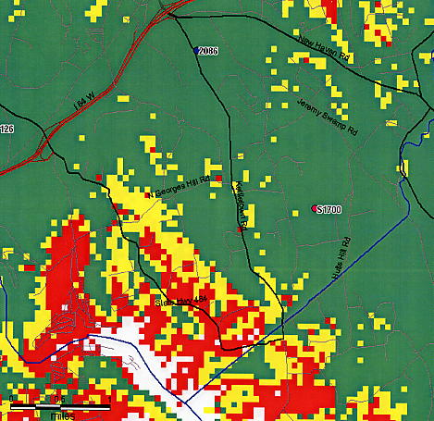

Figure 4. Existing and proposed coverage from the site at 147 feet at 850 MHz.

(New Cingular 3)

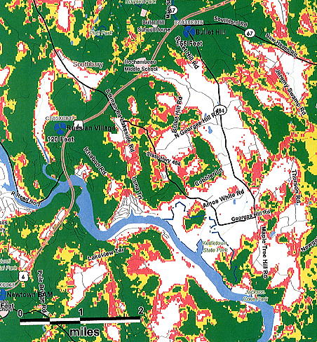

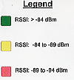

Figure 5. Existing Sprint coverage in Southbury in the Kettletown Road (Route 484) area at 1900 MHz.

(Sprint 1, Q. 4)
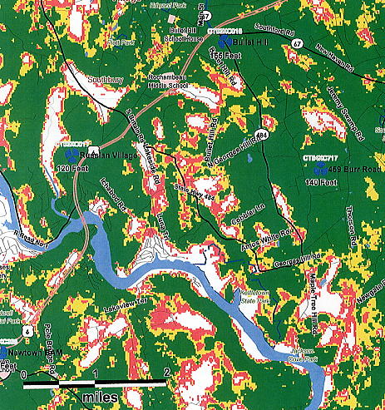

Figure 6. Existing and proposed Sprint coverage from the site at 137 feet at 1900 MHz.

(Sprint 1, Q. 4)
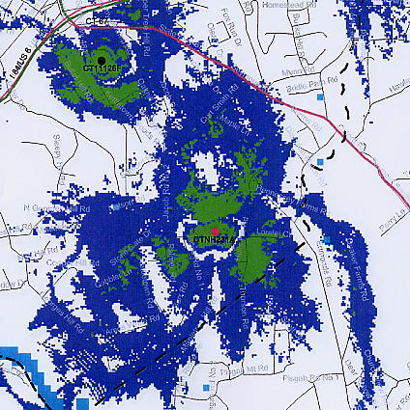

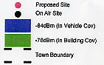

Figure 7. Existing and proposed T-Mobile coverage from the site at 127 feet at 1900 MHz.

(T-Mobile 1, Q. 4)

