

October 31, 2007

Mr. Daniel F. Caruso, Esq.
Chairman
Connecticut Siting Council
Ten Franklin Square
New Britain, CT 06051

RE: Docket No. 346 Implementation of Section 54 and Section 8 of Public Act 07-242, An Act Concerning Electricity and Energy Efficiency

Dear Chairman Caruso:

The Connecticut Energy Advisory Board (“CEAB”) files herewith a Motion to Intervene in the above captioned matter. The CEAB is interested in assisting the Siting Council and the Department of Public Utility Control in this matter to ensure the provision of reliable electric supply to infrastructure deemed critical to national defense and homeland security. To the extent the Siting Council determines there is no need for a hearing in this matter, please be advised that CEAB waives any requirement there may be to hold a hearing.

Thank you for your assistance. Please contact me with any questions related to this request.

Sincerely,
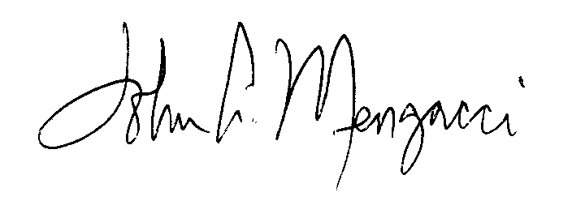
John A. Mengacci
Under Secretary,
Office of Policy and Management
Chairman,
Connecticut Energy Advisory Board
c/o Office of Policy and Management
450 Capitol Avenue #55ENR
Hartford, CT 06106
860-418-6374
John.mengacci@ct.gov

CC: CEAB Membership
Service List

STATE OF CONNECTICUT
SITING COUNCIL

Implementation of Section 8 and : Docket No. 346
54 and Section 54 of :
Public Act 07-242, An Act Concerning :
Electricity and Energy Efficiency : October 31, 2007

Connecticut Energy Advisory Board
Request for Intervenor Status

The Connecticut Energy Advisory Board (“CEAB”) hereby requests, pursuant to Connecticut General Statutes Section 16-50n(b) and R.C.S.A. 16-50j-15b, that the Connecticut Siting Council (“CSC”) designate it as intervenor in the above captioned matter. In support of this request, the CEAB represents as follows:

The CEAB is constituted pursuant Connecticut General Statutes Section 16a-3(a). Pursuant to Connecticut General Statutes Section 16a-3(b), the CEAB administers the Request for Proposal (“RFP”) process referenced in Section 54 of Public Act 07-242. As described by the CSC, the purpose of the hearing in this matter is for the CSC and the Department of Public Utility Control (“DPUC”) to hear evidence of any party with contentions that the CSC and the DPUC may act to exempt certain facilities from such RFP process. The CEAB is substantially and specifically affected by this proceeding as the CSC may make determinations that affect the CEAB RFP process. The CEAB is interested in assisting the CSC to ensure the provision of reliable electric supply to infrastructure deemed critical to national defense and homeland security.

The CEAB may participate at the hearing and file briefs and other comments as appropriate. The CEAB’s participation in this matter is in the public interest; its participation will promote the interests of justice and not impair the orderly conduct of the proceeding.

The CEAB’s mailing address is as follows:

CEAB
c/o Gretchen Deans
CERC
805 Brook Street, Bldg 4
Rocky Hill, CT 06067
Phone: 860 571-7147
Fax: 860 571-7150
gdeans@cerc.com

CEAB requests the following names be maintained on the Service List:

Mr. John Mengacci
Office of Policy and Management
450 Capitol Avenue #55ENR
Hartford, CT 06106
860-418-6374
John.mengacci@ct.gov

Julie Cammarata
Office of Policy and Management
450 Capitol Avenue #55ENR
Hartford, CT 06106
860-418-6296
Julie.cammaratat@ct.gov

Mr. Dan Peaco
La Capra Associates
20 Winthrop Square
Boston, MA 02110
617-367-6500
dpeaco@lacapra.com

Heather Hunt
Law Office of Heather Hunt
242 Whippoorwill Lane
Stratford, CT 06614
203-380-1477
HeatherHuntLawOffice@Gmail.com

Thank you for your consideration. Please contact me with any questions.

Respectfully Submitted,
John A. Mengacci
Under Secretary,
Office of Policy and Management
Chairman,
Connecticut Energy Advisory Board

