STATE OF CONNECTICUT

**BESB USE ONLY**

**SW**

**ID**

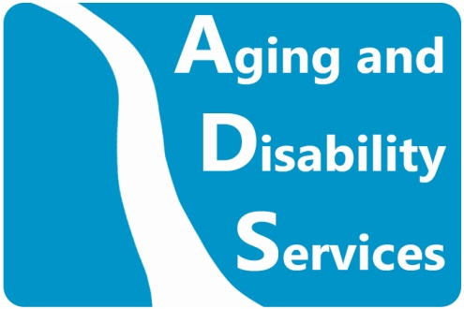

Department of Aging and Disability Services

Bureau of Education and Services for the Blind (BESB)

184 Windsor Avenue, Windsor, CT 06095-4536

Phone: 860-602-4000 Toll-free: 800-842-4510 Fax: 860-706-5809

<https://portal.ct.gov/aginganddisability>

|  |  |  |  |  |  |  |  |  |  |  |  |  |  |  |  |  |  |  |  |  |  |  |  |  |  |  |  |
| --- | --- | --- | --- | --- | --- | --- | --- | --- | --- | --- | --- | --- | --- | --- | --- | --- | --- | --- | --- | --- | --- | --- | --- | --- | --- | --- | --- |
| Per Section 10-305 of the Connecticut General Statutes, each physician, advanced practice registered nurse and optometrist shall report in writing to the Department of Aging and Disability Services not later than thirty days after a person who is blind comes under his or her private or institutional care within this state. The report of such person shall include the name, address, Social Security number, date of birth, date of diagnosis of blindness and degree of vision.  Connecticut General Statutes Section 10-294a: **Legal blindness. Impaired vision. Defined.**  (a) A person is legally blind if such person's central visual acuity does not exceed 20/200 in the better eye with correcting lenses, or if such person's visual acuity is greater than 20/200 but is accompanied by a limitation in the fields of vision such that the widest diameter of the visual field subtends an angle no greater than twenty degrees;  (b) A person has impaired vision if such person's central visual acuity does not exceed 20/70 in the better eye with correcting lenses. | | | | | | | | | | | | | | | | | | | | | | | | | | | |
| **PATIENT INFORMATION** | | | | | | | | | | | | | | | | | | | | | | | | | | | |
| Title: |  | First Name: | | | |  | | | | MI: |  | | Last Name: | | |  | | | | | | | | | **Suffix:** | |  |
| Date of Birth: | | |  | | | | Gender: | |  | | | | | | | | Social Security #: | | | | |  | | | | | |
| Street Address: | | |  | | | | | | | | | | | | | | | | | | | | Apt./Unit #: | | |  | |
| City: | | |  | | | | | | | | | | | | State/Zip: | | | | |  | | | | | | | |
| Best Phone#: | | | |  | | | | Other Phone #: | | | |  | | | | | | | Email: | |  | | | | | | |
|  | | | | | | | | | | | | | | | | | | | | | | | | | | | |
| **CONTACT PERSON** | | | | | Is this an Emergency Contact? **Y**  **N** | | | | | | | | | Relationship: | | | |  | | | | | | | | | |
| Full Name: | |  | | | | | | | | | | | | | | | | | | Phone #: | | | |  | | | |

|  |
| --- |
| **BESB USE ONLY** |
| Unknown  Known  Adult  Child  LB  VI  NVI  VIP |
|  |
|  |

|  |  |  |  |  |  |
| --- | --- | --- | --- | --- | --- |
| **Distance Acuity with Best Correction:** | |  | **Prognosis:** | Stable | Guarded |
| OD: |  |  | Recovering | Unknown |
| OS: |  | Progressive/Deteriorating | |

|  |  |  |  |
| --- | --- | --- | --- |
| Is this Patient **Legally Blind**? | **Y**  **N** | If not Legally Blind, does Patient have **Impaired Vision**? (central visual acuity does not exceed 20/70 in the better eye with correcting lenses) | **Y  N** |
| If unable to accurately measure acuity or visual field levels, does Patient’s **observed functional vision** meet the definition of: | | | |
| **Legally Blind: Y  N**  **Impaired Vision: Y**  **N** | | | |

|  |  |  |  |  |  |  |  |  |  |  |  |
| --- | --- | --- | --- | --- | --- | --- | --- | --- | --- | --- | --- |
| Date of Exam: | |  | | Discipline of Practitioner: | | | Ophthalmologist  Optometrist  Other M.D.  APRN | | | | |
| Practitioner Name: | |  | | | | | Name of Practice: |  | | | |
| Street: |  | | | | | | | | | | |
| City: |  | | | | State/Zip: |  | | | Phone #: | |  |
| Practitioner Signature: | | |  | | | | | | | Date: |  |

|  |  |  |  |  |  |
| --- | --- | --- | --- | --- | --- |
| **Visual Field: Unknown** | |  | **Diagnosis (ICD Code):** | | |
| No Limitation | | Primary: | OD: |  |
| Degrees Remaining OD: |  | OS: |  |
| Degrees Remaining OS: |  | Secondary: | OD: |  |
|  | | OS: |  |

|  |  |
| --- | --- |
| Reason exact measure of acuity or visual field levels could not be obtained: | |
| Nonverbal/Unresponsive:  Inconsistent/Inconclusive Results:  Other (specify): |  |